**Group Members**

* Deveraj A/L Mahalingam 1112702004
* Izat Shakrinal Bin Noordin 1102702506

**“Story of the Time when Gods were everywhere”**

**Art Attraction Installation**

**I. Analysis**

**1. Research**

This is a digital projection where participants take on the role of “God”. It is said that in ancient times there were gods in the forests, grasslands, mountains and rivers. People created pictographs in order to communicate with those gods. By touching the pictographs symbols (kanji/logographic Chinese character) of the participant “creates” all sorts of things from horses to elephants and even mountains, rain and fire. Narrative wise it tells a story of creation where each permutation of this story is never the same. Every experience is unique making this a very good example of generative art.

**a. Scope**

* A call for the viewer’s completes engagement of body and mind which is capacities to move and to explore something behind it.
* To expand art and that digital can create new relationship between people which is encouraging changes in the relationships among people in the same space, and to make the presence of other people a positive experience, through digital art.
* To change individual creative acts into positive creative experiences with other people, and to create a ‘co-creative’ space that can be enjoyed by everyone.
* To experience the connection between “characters” and “things we see in our world” through these characters.
* Learn the concept of characters, pattern recognition and ability to grasp causality from this project.
* Stimulate those children/users that had never learnt Kanji before or those who do not really know what the characters are.

**a. Timeline/Schedule**

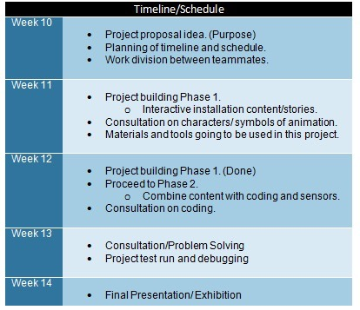

**b. Audit**

**1. Field (market) research**

In the past few years, a great amount of interest has been shown to develop indoor theme park in the shopping mall for the common user. The indoor theme park industry is healthy and growth is forecast due to increasing attendance numbers and greater per diem expenditures in park. However, theme parks can grow revenues further by incorporating other forms of leisure entertainment such as namely, gaming and the internet into their offering. Indoor theme parks also can improve guest satisfaction by alleviating wait times through technology and providing a more pleasant experience while waiting.

Some issues addressed in this matter include:

* Fewer teens visiting theme parks compared with five years ago
* Most of the attractions games applied is bored towards audience
* Art-based attractions could attract a new audience

Applying this type of installation over there can help to improvise the visiting of the theme parks.

**2. Competitors / alternatives / replacement**

**VRCADE** (A New Generation)

* Strap on a headset and be transported to a new dimension of gaming as you battle zombies in a full-motion, wireless, virtual reality world.

[http://www.segarepublic.com/en/Explore/attractionsdetail.aspx?block=0#.V-lwiLKqqko](http://www.segarepublic.com/en/Explore/attractionsdetail.aspx?block=0%2523.V-lwiLKqqko)

**LAZERACE** (Battle the laser rays)

* It’s a interactive battle to test your brains and brawn where its navigate through a web of intricate lasers to reach the stop button at the end.

[http://www.segarepublic.com/en/Explore/attractionsdetail.aspx?block=0#.V-lwiLKqqko](http://www.segarepublic.com/en/Explore/attractionsdetail.aspx?block=0%2523.V-lwiLKqqko)

**3. Other technology**

Using the latest digital technology, we want children to enjoy moving their bodies about freely in a shared space, interacting with each other, collaboratively creating in a “co-creative” experience. And we want them to become the kind of people who can enjoy creative collaboration

**c. Stakeholder Interviews (internal / external)**

**Project Vision**

With interactive art works the viewer’s actions and behavior can decide the artwork at any particular moment. The border line between the artwork and the viewer has become more ambiguous. The viewer has become a part of the artwork itself.

**1. Risk**

* The audience might not really interact with our installation.
* The risk will be mainly get into which is children easily gets tired once they move around
* Children will get too lazy and bored if the artwork is not interesting since they love to explore something different and new.
* Technical error (Fluctuation or unstable of touch sensor).

**2. Obstacles**

* The obstacles might happen where customers or management from the shopping mall not interested with our project.
* There’s not enough space for the project to exhibit inside a shopping mall.
* Not enough manpower to create this big project.
* Requires a dark space area in order to see projected visual clearly (might not suit every event or occasion).

**3. Constraints**

* Internal limitations

1. Variable technologies

* Projection mapping to create extensive art installations.
* Larger amounts of space, allowing viewers to experience artworks more directly

**4. Opportunities**

* Project Strength

1. The objects that are born from the characters influence each other by children`s actions.
2. Children using their bodies and changing the world together can create a story.

* Persisting Problem

1. Children have to ask their permission from parents to participate in this project.
2. Children might not have chance to go for this exhibition if their parents is not interested.
3. The children might fail to understand the purpose of the artwork because they will just play with it since it’s something new to explore on it.

**d. User Observation**

**User**

User which is mainly for kids and children/students and parents

**1. Potential User**

* Kids naturally love art and they can use descriptive words to discuss their own creations or to talk about what feelings are elicited when they see different styles of artwork.
* Children love art because it's fun and provides them with authentic self-expression which is the freedom of choice, thought and feeling.
* The kids will enjoy moving their bodies about freely in a shared space, interacting with each other and changing the world together to create a story.

**2. Behaviors**

* Children have become much more interested in character of cartoons over many years and it has become a primary action to some lives.
* Kids are easily influenced or inspired with interesting character like cartoons and they very smart to understand the things like this and they will be imagines to be one of them.
* They will be playing and walking on the stage and figuring out to choose several characters to see what’s happening on the screen.

**3. Attitudes**

* Children love to play with something that attracts them and they will do a lot of experimenting when they interact with this project
* Children act out their hopes and fears in creative play.
* They are better able to hold onto their own hopes and dreams if we encouraged telling their own stories, acting out their own feelings, or building their own pretend world.

**4. Aptitudes**

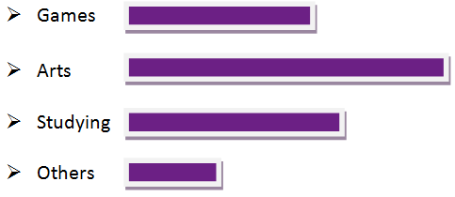

**5. Motivations**

* Children can easily get motivated when it comes with fun type of things.
* Children’s imaginative play can be positively affected by cartoon content where cartoon on television can teach specific attention skills and strategies
* Motivate them as they touch the characters and a story begins to emerge throughout their creativity skills.

**6. Goals**

* Exploring each one of the character and watching those story each of it.
* They will be moving around and try to find something that attracts them.
* Learn and to understand each of the kanji characters meaning by giving out the animations.

**7. Environment**

* Children love to be in a big space of environment.
* Children can move around and play with that symbol character in a big space to explore more in this project.
* Children able to manipulate and use much larger amounts of space, allowing viewers to experience artworks more directly.
* Spaces such as shopping mall or theme park.

**8. Tools**

* Children easily use their finger to touch on the character to gives out a story of it

**9. Challenges**

* The challenges that can be created by the children which is having a competition between others users
* Children using their bodies and changing the world together can create a story.
* Challenging between to those users to create different stories.

**2. Modeling**

**a. Personas**

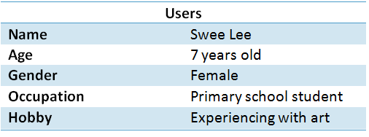

Swee Lee is a student of primary school and just started her first year of primary school. Throughout the entire subject being offered from the school, her favorite subject is art education where she loves to draw and paint or create a different kind of artwork. After school, she will spend most of her time watching cartoons and animations series. On the evening, she will attend her art class where she will create an artwork based on whatever in her imagination that represents a memory. Besides that, her parents wants her to focus on her chinese subject education but she’s weak on that due to lack of interest. The reason why is because its their mother tougue language to be learn and have her ability to speak chinese well. Therefore, Swee Lee is a playfull girl where she loves to visit the theme park with her cousins and family.

**1. Goal**

* To encourage her to think creatively by letting her to explore the interactive artwork.
* To acknowledge her about an interactive technology based on artwork produced
* Discovers that there is more than one right answer, multiple points of view.
* Learns to collaborate with other children and with adults..
* Learns to think more creatively, with an open mind.
* To encourage her learning those kanji symbols ( Chinese character) of making her understand better of those meanings.

**2. Attitudes**

* She is a playful girl.
* She likes to try new things such as exploring artwork and drawings.
* She is a fast learner and hyperactive.

**3. Aptitudes**



**4. Environments**

* This project will be placed in a public space such as shopping mall (Entertainment centre).
* Indoor Theme Park (Shopping Mall)

**5. Tools**

* The tools that being used for this project is Kinect to detect human motion.
* A projector will display an image of different character/symbol on the wall.
* Touch interaction using finger sense.

**6. Challenges**

* She will be having a competition between others users once she interacts with the project by creating a stories.

**7. Motivations**

* The ability to express her thoughts and emotions long before she can fully express herself with words.
* Observe the world carefully and discard preconceptions in order to envision something and then create it.

**b. Other Models**

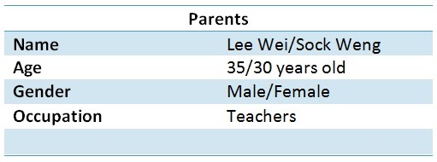

Lee Wei (Father) and Sock Weng (Mother) both were teachers in a secondary schools where Lee Wei is teaching Chinese subjects and Sock Weng is teaching Art subject. Both of them is really strictly about their daughter (Swee Lee) education. But Swee Lee is closed to her mom since she loves to teach her daughter about arts. Unfortunately, her father wants her to focus on the Chinese subject at the same time. Besides that, both of them will bring their daughter out for shopping’s and indoor theme park since she loves to be there on the weekends. The reason why is because they will fulfill what the daughter wants all the time. They want her daughter to be free by not controlling her into a deep stage. They just want their daughter lives with full of happiness.

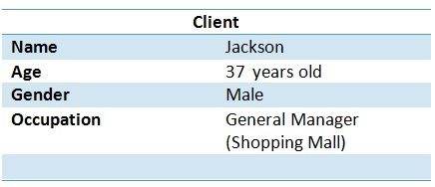

Jackson is a manager of one shopping mall where he’s role were assume overall responsibility for the smooth functioning, management and operation of the shopping mall covering daily administration, human resources, finance, leasing and external relationship. Therefore, he will monitor all asset management functions including leasing, marketing & promotion, property management, tenant relationship management and customer services. Recently, he is having problem due to decreasing attendance numbers of customers visiting the indoor theme park. He found out that issues addressed in this matter where most of the attractions games applied is bored towards audience. To overcome this problem, he came up with an idea where Art-based attractions could attract a new audience.

# II. Synthesis

## 1. Requirements Definition

### Context Scenarios 1. Swee lee was getting ready to school , she just finished breakfast with her mom, Sock weng . They’re waiting for her dad to be ready to go to school. While waiting , her mom used her phone to check on any new news about art. 2. While checking the news , she notice a poster about art installation where it held in a mall . The art installation is also about chinese symbols and there’s a space where she thinks her daughter can enjoy and also learn. She also shared the poster to the father , Lee wei . The father thinks that the installation art is very interesting because there’s chinese symbols on it . 3. On the afternoon , after Swee lee got back home after school . Swee Lee’s parent decided to go to the mall and visit the installation art. After lunch , they heads their way to the mall and when they reach the mall . they seem can’t find where the installation art located. 4. Swee lee’s mom decided to ask the information centre for the direction to the installation art. The mall manager , jackson gives the direction to the location. When they reach the installation art.Swee lee saw a colourful scenery where it really caught her eyes. 5. Swee lee try to enter the installation area where she can see clearly a chinese symbol. She asked her that what does the symbol means since her dad is really familiar with it.Swee Lee’s dad told her that is a kanji symbol. 6.Swee lee try to touch one of the kanji symbol and the symbol turns to an animal . The animation is really beautiful and interesting so it did really feels enjoyable for Swee lee because she can interact with each symbol and a different animation will appear. 7.Swee lee’s dad explained the meaning of each symbols so that her daughter can learn while playing with the animation. Each symbol he make sure that her daughter will learn so he decided to spend more time on the installation so her daughter can learn. 8.In a big space , Swee lee can move around and play with other kids too since the installation is projected in a big screen. And days goes by quickly when Swee lee’s enjoying the installation art , the parents thinks Swee lee had learn enough so they decided to go back home.

### b. Requirements

### Functional and Data Needs

* Different kind of animation being created behind the kanji symbol of those characters.
* The animation gives out a meaning behind on it to create out stories based on their imagination.

### User Mental Models

* Kids and children between the age of 4 to 10 years old.
* Student can touch on the artwork by using their fingers to explore the content of the project.

**Design Imperatives**

* The digital artwork provides animation stories once its touch on the kanji symbol character.
* It uses a sensor touch technologies for them to interact easily with the artwork.
* The project provides larger amounts of space for allowing them to experience artworks more directly.

**Product Vision**

* The border line between the artwork and the viewer has become more ambiguous.
* The viewer has become a part of the artwork itself.

**Technology**

* Kids can access or explore the artwork by using fingers sense to interact with it.
* It’s a human motion sensor being used in this project.

**2. Design Framework**

**a. Elements**

**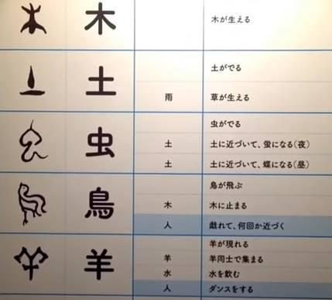  
  
example for the kanji symbols**

A multi-media art attraction installation used kanji symbol/character and the most advanced digital technologies to ethically engage the audience. Kanji which are used in today’s society and characters which become as beautiful symbols that connects with nature. We want children to experience the connection between “characters” and “things we see in our world” through these characters. Touching characters fluttering down, seeing how they react, or watching those characters changing into things that can be found in nature will stimulate those children who had never learnt Kanji before or those who do not really know what the characters are. After playing with the exhibit for a while, there might be a child who can visualize what forms of characters would mean what. In addition, we want children to have the opportunity to think how things that seem to be unrelated interact with one another by seeing the interaction of things in nature after the characters change.

**Information**

* It is said that in ancient times there were gods in the forests, grasslands, mountains and rivers. People created pictographs in order to communicate with those gods. Through the characters the world that you have created and the world called up by people around you continuously interact.

**Functions**

* Design of the installation in way works when children touch the characters the world contained in those characters opens up and the story begins. The objects that are born from the characters influence each other and are influenced by children`s actions. Children using their bodies and changing the world together can create a story. The objects that emerge from the symbols influence one another and are influenced by the actions of other people.

**Mechanism**

* The system that being carried out throughout this project which is projection will display an image of different character/symbol on the wall.
* Kinect being used to detect human motion for the touch interaction using finger sense.

**Actions**

* About the project are the interactivity and its reliance on audience participation. As spectators touch using finger point onto the wall to see the projected content, characters the world contained in those characters opens up and the story begins.

### Framework 1. Sketch Design

**Design Overall Structure of the Installation art**

The setup for this project is above. With the help of the projection and kinect sensor (human motion. The projection will be place on the top back of the ceiling and will be projected to the wall while the kinect will be place top of the wall ceiling above the wall screen. The most interesting thing about the project is the interactivity and its reliance on audience participation. As spectators touch using finger point onto the wall to see the projected content, characters the world contained in those characters opens up and the story begins

### 2. Keypath Scenario

### Once reach, she wondering of what’s going on with the exhibition and she saw other users touching on the wall and playing with animation.

### Later on, she tried to play with it by touching those symbols being created on the wall. Then, she touches of the symbol and realizing that the symbol gives out animation behind on it. Firstly, she saw a bird lands on a tree. Then she continuously keeps on touching on the other symbols since she wants to know what’s going on with the other symbol and there are varieties animation being produced such as a sheep runs away from a dog, and a sheep dances. She started to smile and begun to start her imagination to create some stories in it by using the animation being displayed on the wall.

### Later on, she creates a story of her imaginations and started to compete with other users interacting with it. Throughout these technologies, she created a new relationship between people which is encouraging changes in the relationships among people in the same space, and to make the presence of other people a positive experience.

### Moreover, she started to explore more on giving out her own stories and she finds out that there’s something she gain behind this where It is said that in ancient times there were gods in the forests, grasslands, mountains and rivers. People created pictographs in order to communicate with those gods. Through the characters the world that you have created and the world called up by people around you continuously interact. This made her behavior and those of people around her were influences how the story is created. Lastly, she gain something interesting that can improvised her creative skills for creating an artwork throughout her imagination.

### 

### 