USE CASE DIAGRAM:-
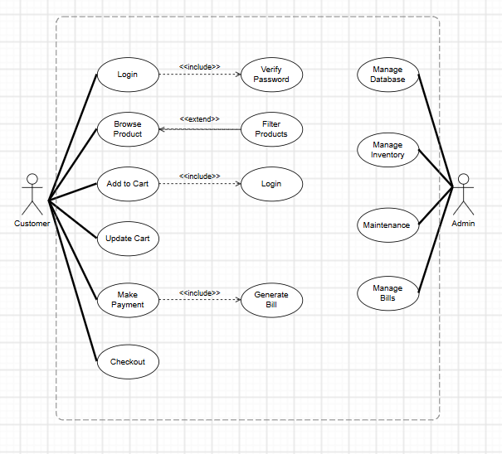

CLASS DIAGRAM
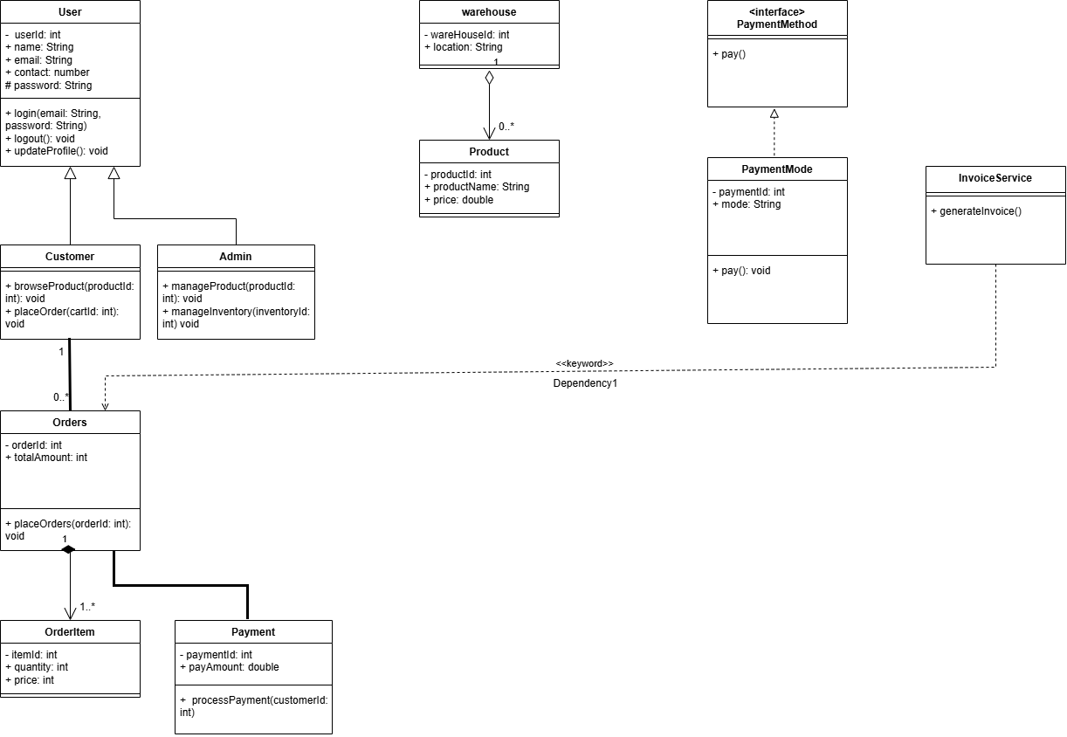

- Association: Represents a relationship between two classes where their objects are connected, usually shown by a solid line.
- Directed Association: Represents a relationship between two classes with a specific direction, showing that one class is associated with another.
- Aggregation: Represents a weak whole-part relationship where the part can exist independently of the whole, shown by a hollow diamond.
- Composition: Represents a strong whole-part relationship where the part cannot exist independently of the whole, shown by a filled diamond.
- Generalization (Inheritance): Represents an is-a relationship where a subclass inherits properties and behaviors from a superclass.
- Realization (Interface Implementation): Represents a relationship where a class implements the features or operations defined by an interface.
- Dependency Relationship: Represents a weak relationship where one class depends on another class for some functionality.
- Usage (Dependency) Relationship: Represents a dependency where one class uses the services or functionality provided by another class.
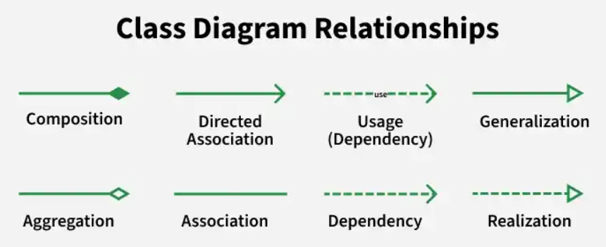

SEQUENCE DIAGRAM
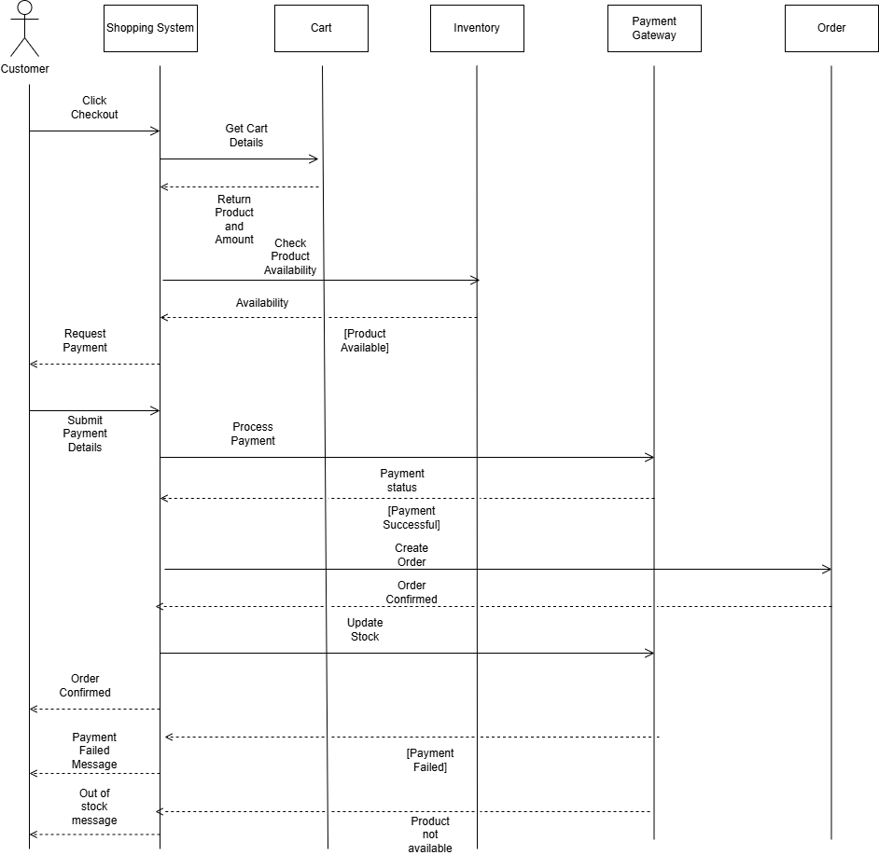

COLLOBORATION DIAGRAM
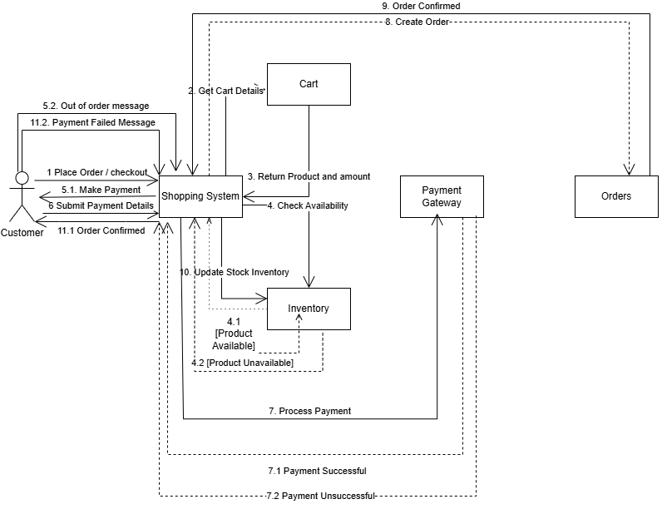

ACTIVITY DIAGRAM
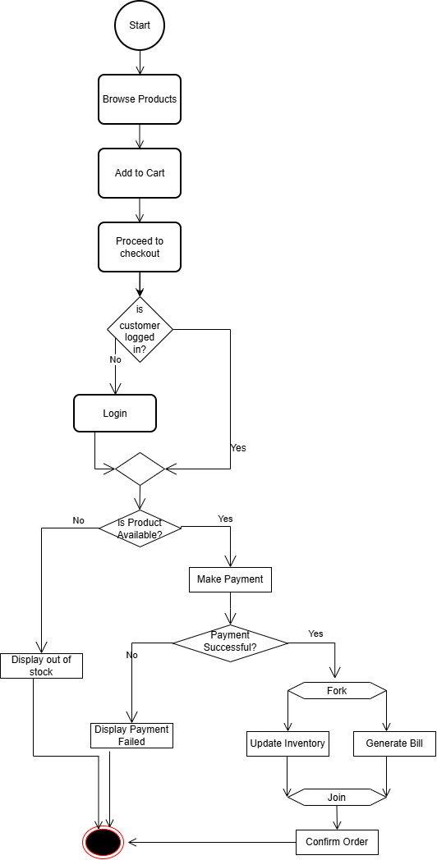

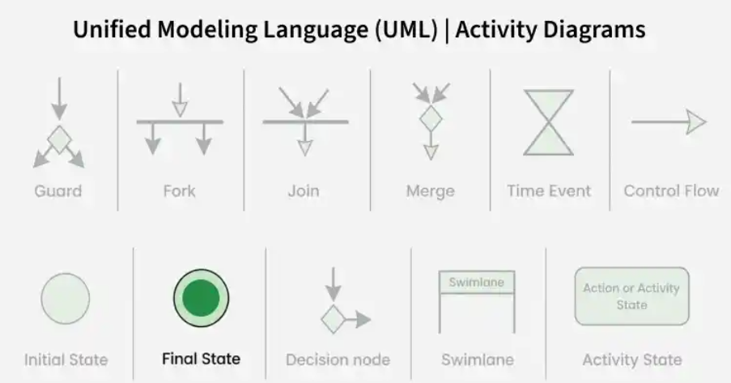

DATA FLOW DIAGRAM:
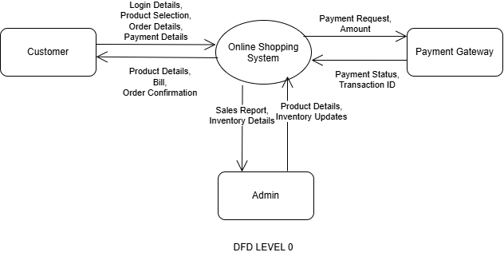
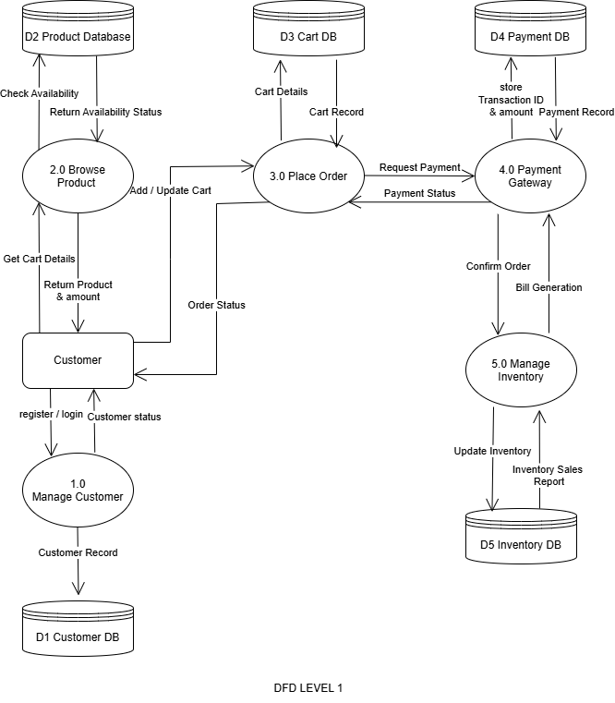
GANTT CHART:


