DATA SCIENCE PROJECT
PLANNING & STRATEGY
A Python-Based Plan for Waste Collection Demand Forecasting
Week 1 Conceptual Planning Deliverable
Project type: Hypothetical • Dataset required in this planning phase: No
Prepared as a structured project blueprint covering objectives, scope, methodology,
timeline, tools, evaluation, risks, and expected outcomes.

Executive Summary
This document proposes a hypothetical data science project that estimates the amount of municipal waste likely to be collected from community zones on a future day. The plan uses Python as the primary analysis environment and is designed for the planning stage: no dataset needs to be collected or modeled during Week 1. The eventual solution would combine historical collection records with calendar, zone, weather, and event information where available. The analysis would identify patterns, establish a simple baseline, compare forecasting approaches, and communicate results through interpretable metrics and a decision-support report.
The intended value is better collection scheduling, more informed vehicle and staff allocation, and fewer overflow incidents. The project will be considered successful if its plan is reproducible, its evaluation avoids data leakage, its recommendations are understandable to municipal stakeholders, and its limitations are explicitly documented.

1. Introduction and Project Background

1.1 Problem statement
Community waste generation varies by location and time. Residential areas may generate different amounts on weekdays and weekends, while festivals, public events, rainfall, seasonal changes, or missed pickups can affect collected quantities. If collection schedules rely only on fixed assumptions, some routes may be over-serviced while other areas experience overflowing bins or delayed collection.
The proposed project is to forecast daily waste quantity for each service zone using historical collection records and relevant contextual variables. The output is a planning estimate, not an automated instruction to change municipal services.

1.2 Motivation and justification
- Operational efficiency: forecasts can help planners anticipate high-demand zones and allocate vehicles and staff.
- Service quality: early identification of likely high-volume days may reduce overflow and missed collection.
- Sustainability: better planning may reduce unnecessary trips, fuel use, and avoidable emissions.
- Evidence-based decisions: analysis can replace informal estimates with measurable trends and uncertainty-aware recommendations.
- Learning value: the project demonstrates the complete Python data science lifecycle without requiring data during the planning week.

1.3 Intended stakeholders
- Municipal sanitation and route-planning teams.
- Community or apartment management committees.
- Operations supervisors who monitor daily collection performance.
- Residents, who may benefit indirectly from more reliable service.

2. Project Objectives and Scope

2.1 SMART-style objectives
- Define a reliable target variable: daily collected waste quantity per zone, measured in kilograms or tonnes, subject to data availability.
- Design a data inventory describing required fields, likely sources, data owners, update frequency, and quality checks.
- Plan an exploratory analysis to study trend, seasonality, zone-level differences, missingness, and unusual observations.
- Specify a baseline forecast and at least two candidate regression or time-series approaches for later comparison.
- Define a time-aware evaluation plan using MAE and RMSE, with a simple baseline as the reference point.
- Produce stakeholder-facing recommendations and a reproducible workflow that can be implemented in Python after data access is approved.

2.2 In scope
- Daily or weekly forecasting of waste quantity by service zone.
- Planning for historical data collection, validation, cleaning, feature creation, exploration, modeling, and evaluation.
- Comparison of a naïve or seasonal baseline with candidate models such as Random Forest Regressor and gradient boosting; a time-series model may be considered if the data structure supports it.
- A concise report and a proposed dashboard design for forecasts, error metrics, trends, and high-demand zones.
- Privacy, data governance, reproducibility, and limitations planning.

2.3 Out of scope
- Building or deploying a production system, mobile application, or live municipal dashboard during Week 1.
- Installing IoT sensors, cameras, GPS devices, or new physical infrastructure.
- Automatically assigning routes or controlling vehicles without human review.
- Identifying individual households or predicting resident behavior.
- Claiming measured model accuracy before real data is available.
- Guaranteeing reductions in cost, fuel use, or overflow before a pilot evaluation.

3. Research Questions and Success Criteria
- How do waste quantities vary by zone, day of week, month, and season?
- Which available contextual features are associated with higher or lower collection volumes?
- Can a model outperform a simple historical-average or last-period baseline on unseen future dates?
- Where are forecast errors largest, and what operational caveats should accompany the estimates?
Proposed success criteria (to be finalized after data profiling):
- Data readiness: key fields, units, dates, and zone identifiers are documented; data quality issues are quantified.
- Evaluation integrity: training data precedes validation/test data chronologically, with no future information leaking into features.
- Forecast quality: at least one candidate model improves on the baseline MAE on a held-out time period, or the report explains why it does not.
- Usability: results are communicated with clear units, an explanation of error, and a list of assumptions.
- Reproducibility: the workflow, package versions, data dictionary, and analysis decisions are documented.

4. Data Strategy

4.1 Planned data sources
Data source | Potential fields | Purpose | Cautions
Collection logs | Date, zone, measured quantity, pickup status | Primary target and history | Units and missing pickups must be consistent
Calendar data | Weekday, public holiday, festival/event flag | Capture recurring demand patterns | Use only events known at forecast time
Weather records | Rainfall, temperature, weather category | Test possible contextual relationships | Check coverage and timestamp alignment
Zone reference table | Zone ID, zone type, approximate population band | Group records and compare zones | Avoid personally identifying details
Operations logs (optional) | Vehicle availability, service interruptions | Explain unusual values | Potentially incomplete or inconsistently recorded
All sources are hypothetical candidates at this stage. The project should begin with a data access and feasibility review rather than assuming that every source exists or is approved for use.

4.2 Proposed data dictionary
- collection_date: date of service or measurement, stored in a consistent date format.
- zone_id: non-identifying service-area code.
- waste_quantity: numeric quantity collected; the unit must be standardized.
- pickup_completed: indicator for whether collection was completed.
- holiday_or_event: optional indicator based on a published calendar.
- rainfall_mm and temperature: optional weather variables aligned to the relevant date and zone.

4.3 Data governance and ethics
- Use aggregated zone-level operational data and avoid personal household identifiers.
- Confirm permission, retention rules, data ownership, and acceptable use before accessing records.
- Restrict access to authorized project members and store credentials outside notebooks or source control.
- Document missingness, changes in collection practices, and possible measurement bias.
- Present forecasts as estimates with uncertainty; human operators retain responsibility for service decisions.

5. Methodology and Technical Strategy
The project will follow an iterative lifecycle. Each stage produces an artifact that can be reviewed before the next stage begins. If data access or quality is inadequate, the plan will pause modeling and prioritize data remediation or a narrower, defensible question.
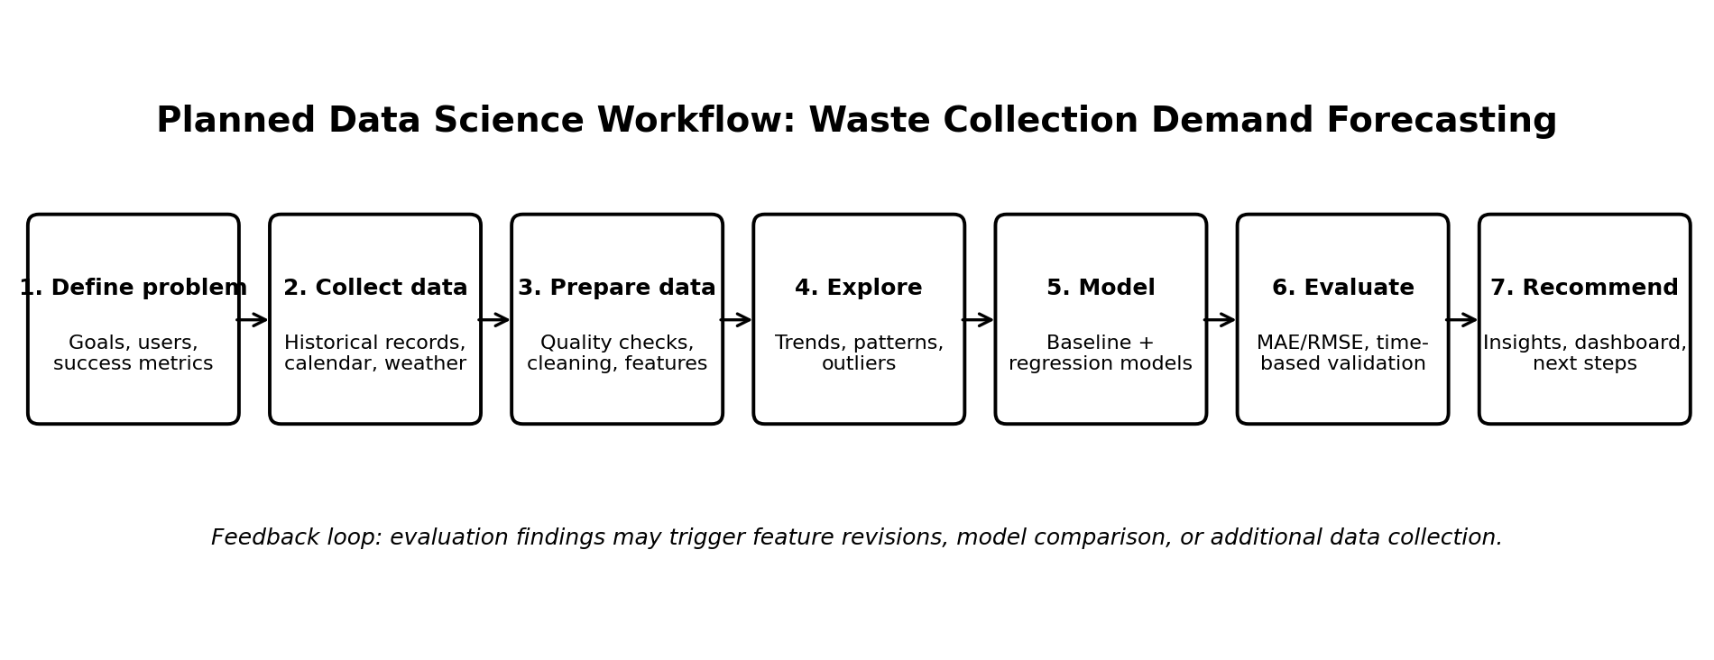
Figure 1. Planned end-to-end workflow for the forecasting project.

5.1 Stage-by-stage plan
Stage | Planned activities | Methods / checks | Deliverable
1. Problem framing | Confirm user decisions, forecast horizon, unit, granularity, and constraints. | Stakeholder questions; written assumptions; success metrics. | Problem statement and acceptance criteria
2. Data collection | Inventory candidate sources and request an approved sample when the project moves to implementation. | Source/field mapping; date coverage; ownership and permission check. | Data inventory and collection plan
3. Data cleaning | Check duplicates, invalid dates, missing values, inconsistent units, and zone IDs. | Type checks; range checks; duplicate report; missingness summary. | Clean-data specification and quality log
4. Exploration | Inspect trends, seasonality, zone differences, distributions, and unusual values. | Summary statistics; line plots; histograms; box plots; correlation only where appropriate. | EDA plan and key questions
5. Feature engineering | Create calendar variables and lag/rolling features where valid. | Features must use only information available at prediction time; rolling windows shifted appropriately. | Feature list and leakage checklist
6. Modeling | Build baseline, then compare candidate models. | Historical mean/last-period baseline; Random Forest; gradient boosting or suitable time-series method. | Model comparison table
7. Evaluation | Test on later dates and inspect performance by zone and period. | MAE, RMSE, error plots; chronological split or rolling-origin validation. | Evaluation report and error analysis
8. Communication | Summarize expected use, uncertainty, limitations, and next actions. | Readable charts; units; model card-style summary; human review. | Final report and dashboard concept

5.2 Data cleaning decisions
- Missing target values: do not automatically impute without understanding why measurements are missing; distinguish zero collection from no recorded measurement.
- Duplicates: identify duplicate zone-date records and decide whether to aggregate or remove them based on the source definition.
- Outliers: investigate extreme values with operations context; retain valid unusual events rather than deleting them only because they are large.
- Inconsistent units: convert all target values to one documented unit before analysis.
- Date alignment: define whether the date represents pickup date, weigh-in date, or reporting date.
- Missing predictors: choose an explicit approach (for example, missing category or imputation fitted on training data only) and document it.

5.3 Exploratory data analysis
- Profile record count, date coverage, zone coverage, missing values, and duplicate frequency.
- Plot daily or weekly totals to identify trend, seasonality, disruptions, and possible structural changes.
- Compare distributions across zones and weekdays; use medians and spread as well as averages.
- Check relationships between waste quantity and available contextual variables without interpreting correlation as causation.
- Investigate unusual peaks with calendar and operations records where available.

5.4 Feature engineering and leakage prevention
- Calendar features: weekday, month, weekend, and known holiday/event flags.
- Lag features: previous-day or previous-week quantities, only when those values would be available at prediction time.
- Rolling statistics: rolling mean or median calculated from prior observations and shifted so the target day is excluded.
- Optional contextual features: weather forecast values available before collection, not later observed weather if that would be unavailable operationally.
- Fit transformations, imputers, and encoders on training data only; apply the fitted transformations to validation and test data.

5.5 Modeling strategy
Model / approach | Role | Reason for inclusion
Naïve or historical baseline | Reference benchmark | Simple and interpretable; establishes whether complexity adds value.
Random Forest Regressor | Candidate model | Can capture nonlinear patterns and feature interactions with limited preprocessing.
Gradient boosting regressor | Candidate model | Often effective on tabular data; compare using the same validation design.
Time-series method (conditional) | Alternative if history is sufficiently regular | Can model temporal patterns, but suitability depends on data volume and structure.
The project will not assume that the most complex model is best. Model selection will prioritize performance on future periods, interpretability, operational usefulness, and maintenance effort.

5.6 Evaluation strategy
The dataset, once available, should be divided chronologically. For example, earlier dates may be used for training, a subsequent period for validation, and the most recent period for final testing. Exact proportions will depend on the amount of history. Random shuffling is inappropriate for a forward-looking forecast when it allows future patterns to influence training.
- MAE (Mean Absolute Error): average absolute forecast error in the same unit as waste quantity; easy to explain.
- RMSE (Root Mean Squared Error): penalizes large errors more strongly and helps reveal damaging misses.
- Baseline comparison: report absolute metrics and improvement relative to the baseline, not just a standalone score.
- Segment analysis: inspect errors by zone, weekday, season, and high-volume periods to identify uneven performance.
- Residual analysis: look for systematic under-forecasting, over-forecasting, and errors concentrated around events.
- Operational review: ask sanitation planners whether the forecast horizon and error size are useful for actual scheduling.
No numerical performance result is claimed in this planning document because no dataset has been analyzed. Targets should be set after understanding the target's scale, baseline difficulty, and operational tolerance.

6. Python Tools and Working Environment
Tool / library | Planned use | Reason
Python 3.x | Main programming language | Widely used for data preparation, modeling, and reporting.
Jupyter Notebook / Google Colab | Exploration and experiments | Supports step-by-step analysis and explanatory notes.
pandas | Tabular data handling | Cleaning, joins, grouping, date operations, and summaries.
NumPy | Numerical operations | Array calculations and supporting data transformations.
Matplotlib / Seaborn | Charts and EDA | Trend plots, distributions, comparisons, and error analysis.
scikit-learn | Preprocessing, baseline and regression models, metrics | Consistent model pipelines and evaluation tools.
Statsmodels (optional) | Statistical summaries and selected time-series methods | Useful where assumptions and temporal structure justify it.
Git / GitHub | Version control | Tracks code and decisions; keeps collaboration reproducible.
Excel / CSV tools | Initial inspection and stakeholder exchange | Accessible formats for data inventory and review.
Power BI / Looker Studio (optional) | Future stakeholder dashboard | Can communicate forecasts and trends after model validation.

6.1 Proposed project structure
waste-forecast-project/
├── README.md
├── requirements.txt
├── data/
│ ├── raw/ # restricted; not committed to public Git
│ └── processed/
├── notebooks/
│ ├── 01_data_profile.ipynb
│ ├── 02_eda.ipynb
│ └── 03_model_comparison.ipynb
├── src/
│ ├── cleaning.py
│ ├── features.py
│ ├── train.py
│ └── evaluate.py
├── reports/
│ ├── figures/
│ └── findings.md
└── docs/
├── data_dictionary.md
└── model_card.md

7. Timeline and Work Allocation (33 Hours)
The schedule below allocates 33 hours to Week 1 planning and design. It is an effort estimate, not a promise that data access or implementation work will be completed during this week.
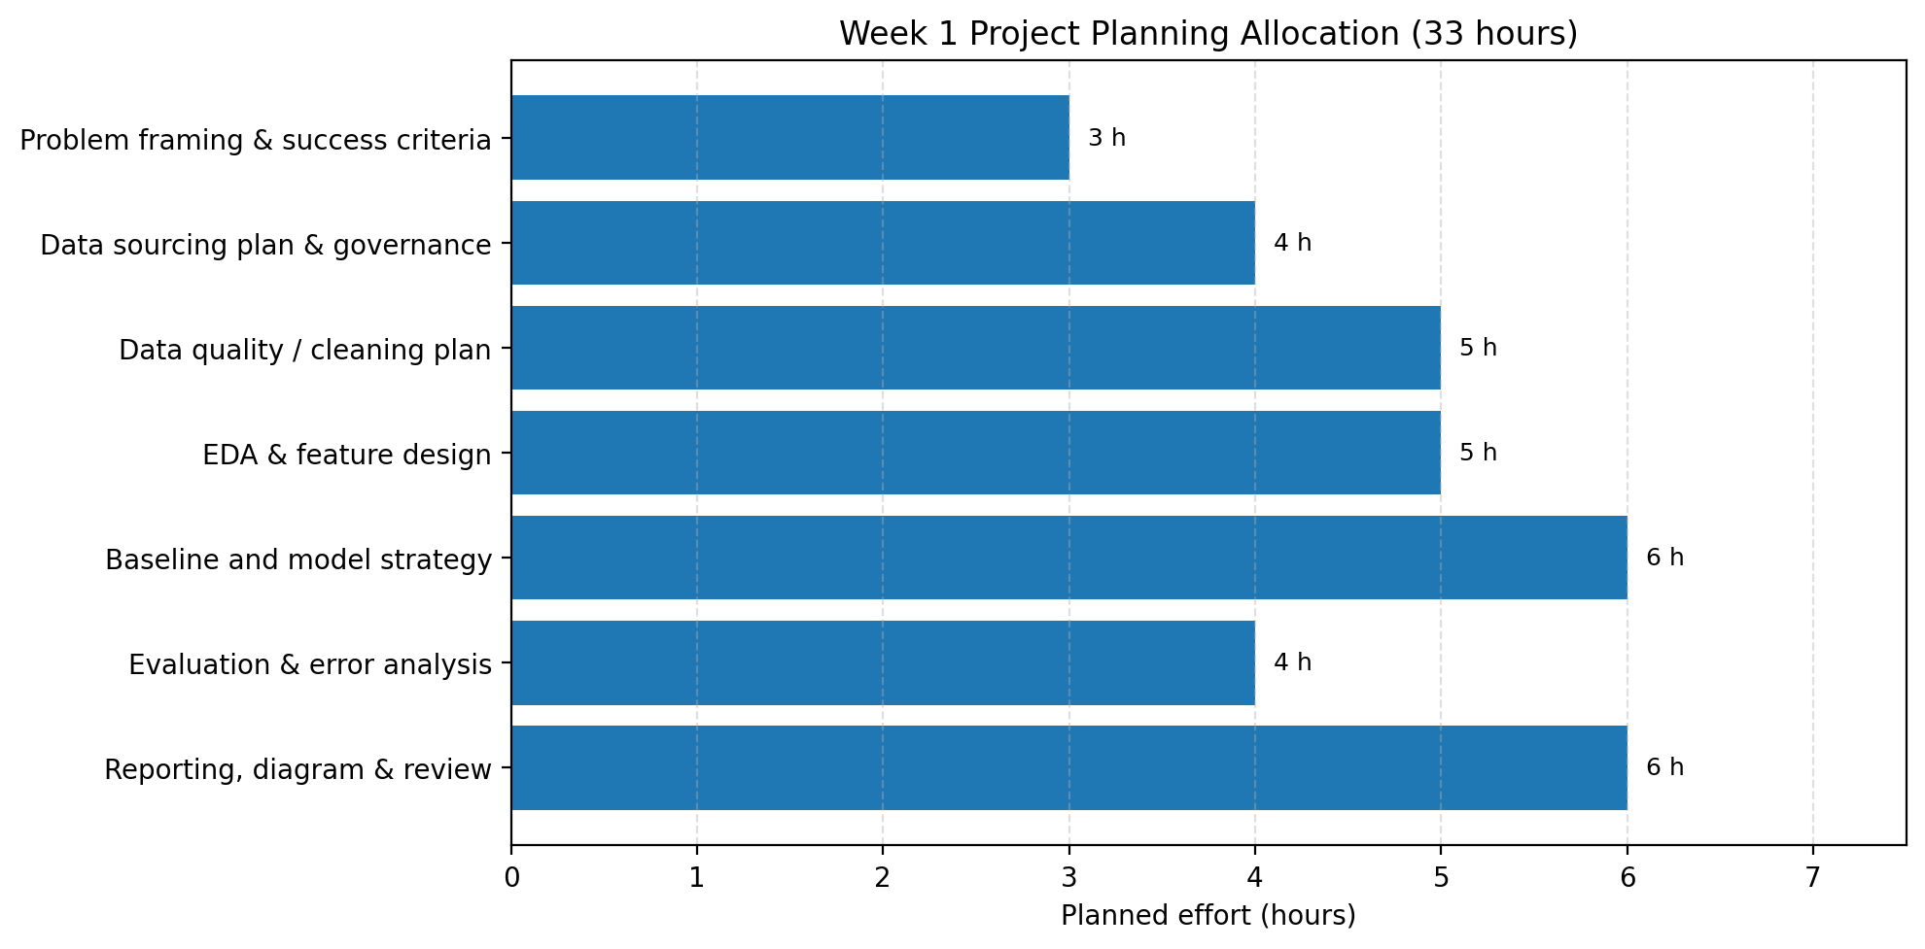
Figure 2. Planned effort allocation across the Week 1 planning tasks.
Task | Hours | Activities | Output
Problem framing and success criteria | 3 | Define stakeholders, target, horizon, and acceptance criteria. | Project charter
Data sourcing plan and governance | 4 | Inventory sources, fields, permissions, privacy, and feasibility. | Data plan and dictionary
Data quality and cleaning strategy | 5 | Specify validation rules, missingness handling, duplicates, and unit checks. | Cleaning checklist
EDA and feature design | 5 | Plan trend, seasonality, zone comparisons, and leakage-safe features. | EDA and feature plan
Baseline and model strategy | 6 | Select baseline, candidate models, and chronological validation design. | Modeling plan
Evaluation and risk analysis | 4 | Define metrics, segment analysis, risks, and mitigations. | Evaluation and risk plan
Reporting, diagrams, and final review | 6 | Create workflow, timeline, review document, and presentation-ready outputs. | Completed planning document
TOTAL | 33 | — | Week 1 deliverable

8. Expected Outcomes and Benefits
- A documented and repeatable plan for the full data science lifecycle.
- A data inventory and data dictionary that clarify the minimum data needed before implementation.
- A defensible evaluation approach that compares models against a baseline and avoids temporal leakage.
- An eventual forecast table showing expected waste quantity by zone and date, with error information.
- Potential operational benefits such as improved planning, earlier identification of high-demand periods, and more informed staffing decisions—subject to pilot evidence.
- A report or dashboard concept that translates technical findings into practical planning questions.

9. Anticipated Challenges and Mitigation
Challenge | Potential impact | Mitigation strategy
Incomplete or inconsistent records | Biased analysis or unreliable target values | Profile missingness early, clarify definitions, document exclusions, and request data-owner review.
Limited historical coverage | Seasonality may not be learnable | Start with a baseline, narrow claims, use simpler models, and gather more history before deployment.
Changes in service operations | Past patterns may no longer apply | Record operational changes, evaluate recent periods, and monitor forecast error after rollout.
Data leakage | Overly optimistic test performance | Use chronological splits, time-aware feature construction, and pipelines fitted only on training data.
Rare events and demand spikes | Models may under-forecast unusual days | Analyze event periods separately, use known calendar inputs, and communicate uncertainty.
Model complexity and low interpretability | Stakeholders may not trust outputs | Compare with simple baselines, explain key drivers carefully, and include human review.
Privacy or access restrictions | Data may be unavailable or inappropriate to use | Use aggregated non-identifying records and obtain approval before collection.
Forecast mistaken for certainty | Poor operational decisions | Show error metrics, assumptions, update frequency, and clear warnings that estimates support rather than replace judgment.

10. Deliverables and Review Checklist
- Project charter: problem, motivation, stakeholders, target, and forecast horizon.
- Scope statement: included work, exclusions, assumptions, and constraints.
- Data plan: potential sources, data dictionary, governance, and feasibility checks.
- Methodology: cleaning, EDA, feature engineering, modeling, and evaluation strategy.
- Visuals: workflow diagram and 33-hour timeline chart embedded in this document.
- Tools list: Python libraries, development environment, version control, and optional reporting tools.
- Risk register: major challenges, impact, and mitigations.
- Review sign-off: confirm the plan is understandable, feasible, ethical, and measurable before technical implementation.

11. Conclusion
This plan establishes a practical route from a clearly defined municipal operations question to a testable data science solution. Python provides the core environment for data preparation, exploration, model development, and evaluation. The project deliberately begins with source feasibility, data quality, and a simple baseline rather than assuming that machine learning will automatically improve operations. Once approved data becomes available, the next phase should implement the data profile and cleaning checks, perform exploratory analysis, build a baseline, compare candidate models with chronological validation, and review findings with operational stakeholders. Any real-world benefit must be demonstrated through measured performance and a controlled pilot.

Appendix A. Initial Assumptions
- The forecasting unit is daily waste quantity per service zone; it may be revised after data feasibility review.
- At least one historical collection record source can potentially be requested, but its existence and quality are unconfirmed.
- The work is educational and planning-focused; there is no live deployment in Week 1.
- The target metric and operational tolerance will be confirmed with stakeholders before model training.
- Weather and event data are optional and will only be used if relevant, lawful, and available at prediction time.

Appendix B. Suggested Next-Phase Sequence
- Obtain approval and a small sample of historical data.
- Run data profiling and confirm the target definition and units.
- Create a clean, versioned analysis dataset with documented transformations.
- Complete EDA and finalize features using only information available at forecast time.
- Train the baseline and candidate models with chronological validation.
- Review errors and limitations with stakeholders before considering a pilot.

