EXPLORATORY DATA ANALYSIS
& VISUALIZATION FRAMEWORK
A Reusable Python-Based Plan for Dataset Exploration
Week 2 Deliverable • Planning and methodology only
Includes exploration techniques, chart selection, data-quality checks,
Python tools, a 33-hour work plan, and reporting templates.

Executive Summary
Exploratory Data Analysis (EDA) is the structured process of inspecting, summarizing, and visualizing data before making formal statistical or machine-learning decisions. This framework is designed to work across many dataset types because the actual dataset is not supplied. It describes how an analyst would establish context, inspect schema and data types, assess quality, explore individual variables and relationships, choose appropriate visualizations, and document findings with caveats and recommended next steps.
Python is the primary analysis environment. pandas and NumPy support data inspection and computation; Matplotlib and Seaborn support static plots; Plotly supports interactive exploration; and Jupyter Notebook or Google Colab provides a reproducible workspace. The process is iterative: unexpected results may require revisiting assumptions, cleaning rules, or the question being asked.

1. Introduction to EDA

1.1 What is EDA?
EDA is the initial analytical investigation of a dataset using descriptive statistics, tables, and visual representations. Its purpose is to understand the data's structure, quality, distributions, relationships, and limitations before selecting statistical tests or building predictive models.

1.2 Why EDA matters
- Reveals errors such as invalid values, duplicated records, inconsistent categories, and incorrect data types.
- Shows how variables are distributed and whether they are skewed, sparse, imbalanced, or unusually concentrated.
- Identifies possible relationships, clusters, trends, seasonality, and unusual observations for further investigation.
- Helps determine whether assumptions behind later statistical methods or models are plausible.
- Supports sound decisions about cleaning, feature engineering, chart selection, and the next analysis step.
- Makes findings understandable to technical and non-technical stakeholders through evidence-based visuals.

2. General EDA Workflow
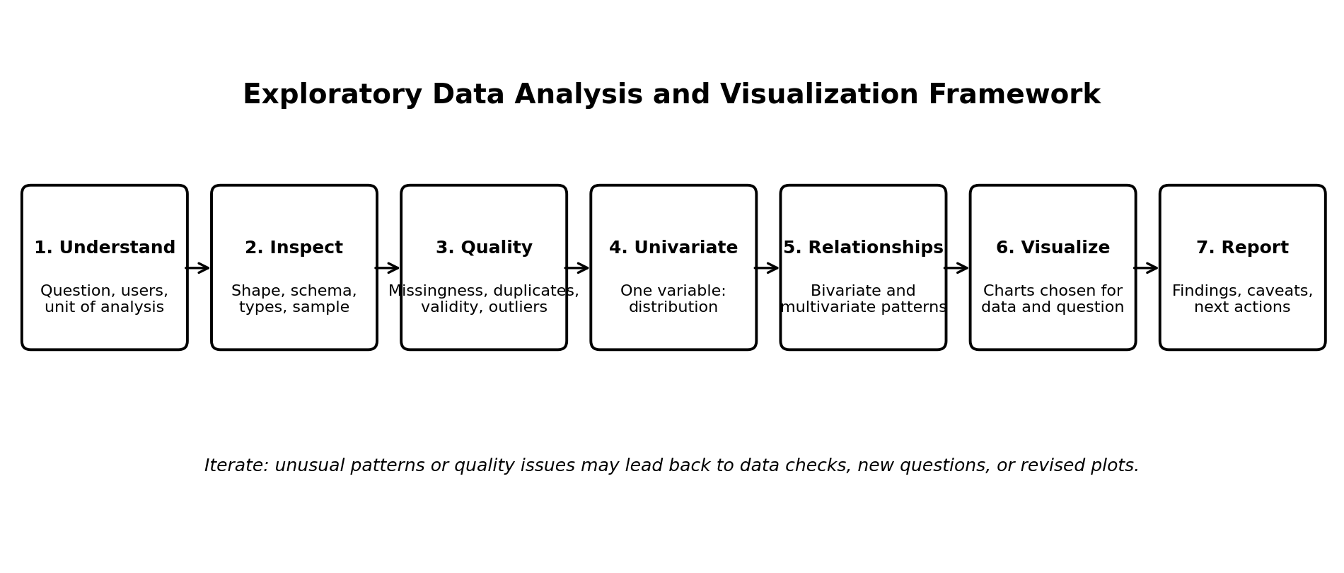
Figure 1. Iterative EDA workflow from problem context to reporting.
The workflow is a guide rather than a rigid sequence. For example, a missing-value review may change the choice of chart, while a trend discovered in a plot may lead to new questions about data collection or time coverage.

3. Understand the Dataset and Data Types
Before calculating statistics, define the unit of analysis (what one row represents), the meaning of each column, the target question, the time period, and any known collection limitations. A data dictionary should record each field's definition, type, valid range, units, and source.
Data type | Examples | Useful checks | Common visuals
Numerical — continuous | Height, temperature, income | Range, skew, spread, outliers, units | Histogram, KDE, box plot, scatter plot
Numerical — discrete/count | Number of visits, defects | Integer-like values, zero frequency, count range | Bar chart, histogram, line plot
Categorical — nominal | City, product type, department | Unique labels, inconsistent spelling, rare groups | Count plot, bar chart, stacked bar
Categorical — ordinal | Low/medium/high, rating levels | Correct order and category definitions | Ordered bar chart, box plot by level
Datetime / time series | Transaction time, daily sales | Parsing, time zone, gaps, duplicates, cadence | Line chart, seasonal plot, calendar heat map
Boolean / binary | Yes/no, success/failure | Allowed values, class balance, missingness | Count plot, stacked bar
Text / unstructured | Comments, descriptions | Empty strings, language, length, privacy | Length histogram, term frequency summaries
Identifiers / keys | Customer ID, order ID | Uniqueness, joins, accidental numeric treatment | Duplicate summary; usually not a distribution chart

3.1 Initial inspection checklist
- Record file format, dimensions (rows and columns), column names, and sample records.
- Inspect inferred types and convert fields only after confirming their meaning.
- Check whether each row is a unique entity, event, measurement, or time-period summary.
- Review the data dictionary, source, collection method, date range, units, and known limitations.
- Separate identifiers from meaningful numeric measurements; an ID such as 1002 is not necessarily a quantity.

4. Data Quality Assessment and Preparation

4.1 Missing data
Calculate missing counts and percentages for each column and row. Look for patterns across groups or time periods and ask why values are absent. Missingness may be random, related to observed variables, or related to the unobserved value itself; the reason influences the appropriate response.
- Do not replace every missing value with zero: zero may be a valid observation and is not equivalent to unknown.
- For numerical fields, consider median or model-based imputation only when justified; compare with complete-case analysis where appropriate.
- For categorical fields, consider an explicit 'Unknown' category if it is meaningful, or use a suitable imputation strategy.
- For time series, investigate gaps before interpolation or forward filling; never fill across long gaps without justification.
- Fit imputation rules on training data only if the dataset will later be used for predictive modeling.
- Document the number of affected records, chosen treatment, and sensitivity of findings to that choice.

4.2 Duplicates and inconsistent records
- Check exact duplicate rows and key-based duplicates separately.
- Determine whether repeated records are errors or valid repeated events before removing them.
- Standardize category spelling, whitespace, casing, units, and date formats using documented rules.
- Validate key relationships across joined tables and identify unmatched records.
- Preserve a raw copy and apply changes in a reproducible cleaning pipeline.

4.3 Outlier detection
An outlier is an observation that differs markedly from the rest of the data. It may represent a data-entry error, a rare but valid event, a different population, or an important signal. Statistical flags should prompt investigation rather than automatic deletion.
- Visual methods: box plots, histograms, scatter plots, and time-series plots.
- Rule-based checks: domain limits, impossible values, and known operational constraints.
- IQR method: flag values below Q1 − 1.5 × IQR or above Q3 + 1.5 × IQR as potential outliers, not definitive errors.
- Z-scores: useful for some roughly symmetric distributions, but sensitive to skew and extreme values.
- Robust methods: median and MAD can be useful when distributions are skewed or contaminated.
- Decision: correct, retain, cap, transform, or exclude only with a documented reason and stakeholder/domain context.

4.4 Other quality checks
- Validity: values fall within permitted ranges and category sets.
- Consistency: related fields agree (for example, start date is not after end date).
- Completeness: required fields are present for the intended analysis.
- Timeliness: records cover the relevant period and use consistent timestamps.
- Representativeness: check whether some groups, locations, or periods are under-recorded.
- Privacy: remove or protect personal identifiers and avoid exposing sensitive records in plots or reports.

5. Exploration Techniques

5.1 Univariate analysis
Univariate analysis studies one variable at a time to understand its distribution and quality.
- Numerical summaries: count, mean, median, standard deviation, minimum, maximum, quartiles, and selected percentiles.
- Distribution shape: skewness, possible multiple peaks, floor/ceiling effects, and concentration at zero.
- Categorical summaries: frequency, proportion, number of distinct categories, and rare levels.
- Recommended visuals: histogram, density curve, box plot, bar chart, or missingness bar chart.

5.2 Bivariate analysis
Bivariate analysis examines how two variables vary together. The method depends on their data types.
- Numerical vs numerical: scatter plot, correlation coefficient, and trend line where justified.
- Numerical vs categorical: grouped summaries, box plots, violin plots, or strip plots.
- Categorical vs categorical: contingency table, grouped/stacked bar chart, and normalized proportions.
- Time vs numerical: line chart, change over time, and comparisons across periods.
- Use correlation as evidence of association, not proof of causation; check confounding and sample size.

5.3 Multivariate analysis
Multivariate analysis explores several variables together to identify interactions, structure, or confounding.
- Correlation matrix and heat map for selected numeric variables; remove irrelevant IDs and interpret nonlinear limits.
- Pair plots for a manageable subset of numeric variables, with color by a meaningful category if useful.
- Faceting or small multiples to compare patterns across groups without overcrowding a single chart.
- Grouped summaries and pivot tables to compare several dimensions at once.
- Optional dimensionality reduction (such as PCA) only when justified by the question and data scale; standardize features when required.
- For predictive tasks, use domain knowledge and leakage checks before treating observed relationships as useful predictors.

5.4 Time-oriented exploration
- Parse timestamps, verify time zones, sort observations, and check gaps or duplicate timestamps.
- Plot the series at its native cadence before resampling.
- Compare weekday, month, season, or event periods when those distinctions matter.
- Use rolling summaries to smooth short-term variation while preserving the original series for context.
- Distinguish trend, seasonality, one-off events, and possible changes in measurement or business processes.

6. Visualization Strategy and Chart Selection
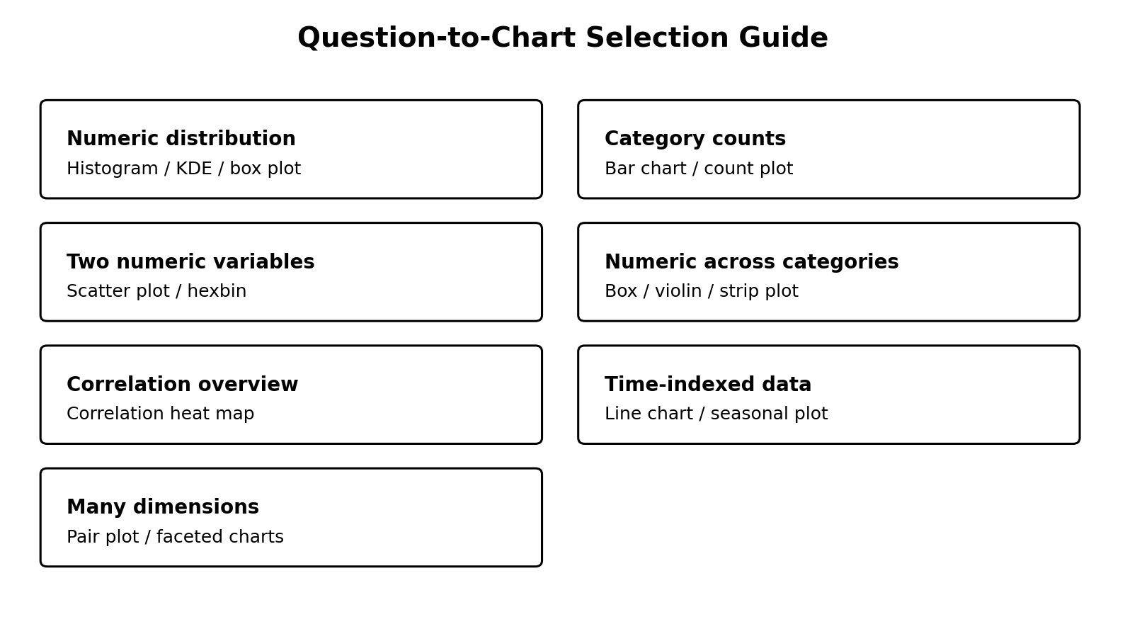
Figure 2. A practical mapping from analytical question to visualization type.
Analytical question | Recommended chart | What it can reveal | Caution
What is the distribution of a numeric variable? | Histogram; optionally KDE; box plot | Spread, skew, peaks, potential extreme values | Bin width and smoothing affect appearance
Which categories are most common? | Sorted bar/count plot | Frequency and imbalance | Avoid too many categories; group rare values thoughtfully
Do two numeric variables relate? | Scatter plot; hexbin for dense data | Association, clusters, nonlinearity, outliers | Overplotting can hide density
Does a numeric outcome differ by group? | Box, violin, or strip plot | Median, spread, shape, individual points | Violin shapes may mislead with small samples
How do numeric variables correlate? | Correlation heat map | Direction and strength of selected linear relationships | Correlation is not causation; missing data can affect values
How does a metric change over time? | Line chart | Trend, seasonality, shifts, spikes | Use correct time ordering and honest axis scales
How do two categorical variables combine? | Stacked or grouped bar chart; mosaic plot | Counts or proportions by group | Normalize when group sizes differ
Where are missing values concentrated? | Missingness bar chart or matrix | Columns/rows with incomplete records | A chart does not explain why data is missing
How do patterns differ across many groups? | Faceted small multiples | Group comparisons with less clutter | Keep scales comparable where comparison requires it

6.1 Visualization design principles
- Every chart should answer a clear question and have a descriptive title.
- Label axes, units, time range, and categories; use legends only when they add value.
- Choose a chart based on variable types and analytical purpose, not visual decoration.
- Use consistent scales and category order when comparing panels or groups.
- Use color accessibly and consistently; do not rely on color alone to communicate meaning.
- Avoid 3D effects, excessive gridlines, truncated axes that exaggerate differences, and overloaded legends.
- Show sample size or uncertainty where relevant, and annotate important events only when supported by evidence.
- For large datasets, use sampling for exploration carefully, aggregation, transparency, or density plots.

7. Python Libraries and Tools
Library / tool | Role in EDA | Example use
pandas | DataFrames, inspection, cleaning, grouping, pivot tables, dates | shape, info(), describe(), isna(), groupby(), value_counts()
NumPy | Numerical operations and array handling | percentiles, numerical transformations, missing-value utilities
Matplotlib | Fine-grained static chart control | line plots, histograms, scatter plots, chart layout
Seaborn | Statistical visualizations with concise syntax | histplot, boxplot, scatterplot, pairplot, heatmap
Plotly | Interactive charts for detailed exploration | hoverable scatter plots, zoomable time-series, interactive bars
SciPy (optional) | Selected statistical functions | Distribution summaries and statistical calculations when appropriate
missingno (optional) | Missing-data visualization | Missingness matrix and completeness patterns
Jupyter Notebook / Google Colab | Interactive analysis and narrative documentation | Code, outputs, charts, and markdown in one notebook
Git / GitHub | Version control and collaboration | Track notebook/code changes and document project decisions
HTML / Markdown export | Structured reports and shareable documentation | Export notebook or report with headings, tables, and figures

7.1 Example analysis sequence (illustrative)
The following is a generic template. Column names and decisions must be adapted to the actual dataset.
import pandas as pd
import matplotlib.pyplot as plt
import seaborn as sns
df = pd.read_csv("your_dataset.csv")
# Initial inspection
print("Shape:", df.shape)
display(df.head())
df.info()
display(df.describe(include="all").T)
# Missing values and duplicates
missing_pct = df.isna().mean().mul(100).sort_values(ascending=False)
print(missing_pct)
print("Exact duplicate rows:", df.duplicated().sum())
# Univariate exploration (replace with a real numeric column)
numeric_col = "numeric_column"
sns.histplot(data=df, x=numeric_col, kde=True)
plt.title(f"Distribution of {numeric_col}")
plt.tight_layout()
plt.show()
# Bivariate exploration (replace column names)
sns.scatterplot(data=df, x="numeric_x", y="numeric_y", hue="group_column")
plt.tight_layout()
plt.show()
# Correlation heat map for numeric columns
corr = df.select_dtypes(include="number").corr()
sns.heatmap(corr, cmap="vlag", center=0)
plt.title("Correlation Heat Map")
plt.tight_layout()
plt.show()
Note: the example uses placeholder column names. It is a starting pattern, not a complete cleaning pipeline. Always verify column meanings, types, privacy constraints, and chart suitability before running or interpreting it.

8. Reporting and Documentation Plan

8.1 Recommended report structure
- 1. Executive summary: dataset purpose, most important findings, and recommended next actions.
- 2. Context and questions: stakeholder needs, analysis goals, and boundaries.
- 3. Dataset overview: source, row/column counts, unit of analysis, date range, data dictionary, and permissions.
- 4. Quality assessment: missingness, duplicates, invalid values, outliers, transformations, and unresolved issues.
- 5. Univariate findings: distributions, category frequencies, and notable imbalances.
- 6. Relationship findings: bivariate and multivariate patterns, including alternative explanations.
- 7. Visual findings: clearly titled figures with units, sample sizes, and concise interpretation.
- 8. Limitations and risks: representativeness, measurement issues, privacy, uncertainty, and potential bias.
- 9. Recommendations and next steps: additional data, cleaning decisions, hypotheses, or modeling readiness.
- 10. Appendix: code, environment/package versions, data dictionary, detailed tables, and reproducibility instructions.

8.2 Figure and finding log
ID | Question | Evidence / chart | Interpretation | Caveat / action
To be completed | To be completed | To be completed | To be completed | To be completed
To be completed | To be completed | To be completed | To be completed | To be completed
To be completed | To be completed | To be completed | To be completed | To be completed
For every reported finding, separate observation from interpretation. For example: 'Group A has a higher median in this sample' is an observation; 'membership in Group A causes the increase' is a causal claim and requires a different design and evidence.

8.3 Reproducibility and file organization
eda-project/
├── README.md
├── requirements.txt
├── data/ # access-controlled; do not commit sensitive raw data
├── notebooks/
│ └── 01_eda.ipynb
├── src/
│ ├── data_checks.py
│ └── plotting.py
├── reports/
│ ├── figures/
│ └── eda_report.html
└── docs/
├── data_dictionary.md
└── decisions_log.md
- Record the data source/version, run date, Python version, and package versions.
- Keep raw data unchanged; make cleaning steps explicit and repeatable.
- Use relative paths and avoid hard-coded secrets or personal information.
- Export key figures and a report so findings can be reviewed without rerunning every notebook cell.
- Use a decisions log to record exclusions, imputation choices, chart choices, and unresolved questions.

9. Timeline: 33 Hours
This allocation is for designing the framework and documentation, not for analyzing an actual dataset.
Task | Hours | Planned activities | Output
EDA concepts and analysis questions | 4 | Define goals, unit of analysis, variable types, and EDA stages. | EDA checklist
Data type and quality framework | 5 | Plan type checks, missingness, duplicates, validity, and outlier handling. | Quality assessment plan
Univariate, bivariate, multivariate methods | 6 | Choose summaries and techniques based on data types. | Exploration matrix
Visualization strategy | 6 | Map questions to plots and define visual design standards. | Chart guide and examples
Python libraries and workflow | 4 | Plan pandas/NumPy/plotting tools and notebook structure. | Tool and code template
Reporting and reproducibility | 4 | Create report outline, finding log, and documentation practices. | Reporting template
Review and final document | 4 | Check clarity, diagrams, consistency, and completeness. | Final DOCX
TOTAL | 33 | — | Week 2 deliverable

10. Evaluation Checklist
- The framework explains the purpose and importance of EDA.
- Common data types and their relevant checks are described.
- Univariate, bivariate, multivariate, and time-oriented techniques are included.
- Missing values, duplicates, outliers, validity, and privacy are addressed.
- Chart choices are linked to analytical questions with benefits and cautions.
- Python libraries and tools have clear roles.
- Reporting, reproducibility, and limitations are covered.
- The workflow is adaptable to different datasets and does not assume data-specific findings.
- The document includes a realistic 30–35 hour schedule and integrated diagrams.

11. Conclusion
This framework provides a reusable, question-driven approach to EDA and visualization. It starts with context and data understanding, establishes quality before interpretation, explores variables at increasing levels of complexity, and selects charts according to the question and data type. Careful documentation, reproducibility, privacy protection, and explicit caveats make the results more reliable and useful. Once a real dataset is provided, the framework can be adapted to its structure, domain, and analytical goals.

