Week 3: Machine Learning Model Development and Evaluation Plan
Conceptual Python-based plan | No code execution or real dataset required

1. Executive Overview
This document proposes a step-by-step machine learning plan for predicting whether a neighborhood will experience high municipal waste-collection demand on a particular day. The plan covers problem definition, data preprocessing, feature engineering, model selection, training, validation, evaluation, and possible deployment. Since no dataset is supplied, all steps are planned conceptually and no results are claimed.

2. Problem Definition and Relevance
Municipal teams need to allocate vehicles and staff despite changes in waste volume across neighborhoods and days. The model will classify each neighborhood-day as High Demand or Normal Demand, based on an operational threshold agreed with municipal stakeholders. The output is intended to support planning, not replace human judgment.
- Potential inputs: historical collection volume, neighborhood type, weekday, season, holidays, previous missed pickups, citizen reports, and approved weather information.
- Expected benefit: identify likely peaks earlier, improve resource allocation, and reduce missed collections.
- Success means useful performance on future unseen dates, understandable outputs, and practical value after operational review.

3. Data Collection and Preprocessing
- Inventory data sources, time coverage, units, ownership, update frequency, and permitted use.
- Inspect schema, row counts, missingness, duplicate neighborhood-date records, invalid dates, inconsistent area names, and impossible volumes.
- Investigate outliers against source logs; correct confirmed errors but preserve genuine unusual peaks.
- Impute missing numerical values and encode categorical variables using transformations fitted only on training data.
- Create calendar features, past-volume lags, rolling summaries, and recent service indicators only when they would be available at prediction time.
- Define the target threshold transparently and exclude any feature recorded after the prediction cutoff to prevent data leakage.
- Select relevant features using domain reasoning and training/validation evidence; do not use the held-out test set for feature selection.
Challenge | Planned solution
Missing or inconsistent records | Document data dictionary; quantify missingness; impute or flag using training-only rules.
Extreme values | Check operational records and distinguish errors from genuine high-demand events.
Imbalanced classes | Report class distribution; use class weights if justified; evaluate with precision, recall and F1.
Data leakage | Set a prediction cutoff and exclude post-outcome information.
Seasonality or changing service patterns | Use chronological splits and evaluate results across time periods.

4. Candidate Models and Selection
Model | Role and strengths | Limitations
Dummy / majority baseline | Simple benchmark; checks whether ML adds value. | Not a useful operational predictor.
Logistic regression | Interpretable baseline; estimates probabilities. | May miss complex nonlinear patterns.
Decision tree | Readable rules; captures nonlinear relationships. | Can overfit without depth/leaf limits.
Random forest | Ensemble of trees; robust nonlinear patterns. | Less transparent than a single tree.
Gradient-boosted trees | Often strong on structured tabular data. | Needs careful tuning and explanation.

Recommended plan: compare logistic regression, random forest, and gradient-boosted trees against a simple baseline. Choose based on validation results, operational error costs, probability quality, interpretability, and maintainability—not accuracy alone.

5. Training, Validation, and Tuning
- Define the prediction time and high-demand label with operations stakeholders.
- Split data chronologically: older dates for training, a later period for validation, and the most recent untouched period for testing.
- Use time-aware cross-validation within the training period; every validation fold must occur after its training window.
- Fit imputers, encoders, scalers, feature selection, and models inside each training fold to avoid leakage.
- Tune a documented range of hyperparameters such as logistic-regression regularization, tree depth, minimum leaf size, number of trees, and boosting learning rate.
- Select a model and decision threshold using validation data; evaluate once on the final test period.
- Record split dates, class balance, model version, assumptions, and limitations.

6. Evaluation Metrics
Metric | Meaning | Use in this project
Precision | Share of high-demand alerts that are correct. | Avoids unnecessary extra deployments.
Recall | Share of actual high-demand cases identified. | Helps reduce missed collection peaks.
F1-score | Harmonic mean of precision and recall. | Balances both error types.
ROC-AUC | How well the model ranks positive cases across thresholds. | Compares ranking ability; consider precision-recall analysis if positives are rare.
Accuracy | Share of all predictions that are correct. | Useful but may mislead with imbalanced classes.
Confusion matrix | Counts true/false positives and negatives. | Shows operational types of error.
Calibration | Whether predicted probabilities match observed frequencies. | Helps select risk thresholds responsibly.

Cross-validation estimates how consistently a model performs across multiple training/validation periods. A separate final test set provides a less biased estimate of performance on unseen data. If missing a high-demand day is more costly than a false alarm, recall may be prioritized, while precision and deployment cost are still monitored.

7. Workflow Diagram
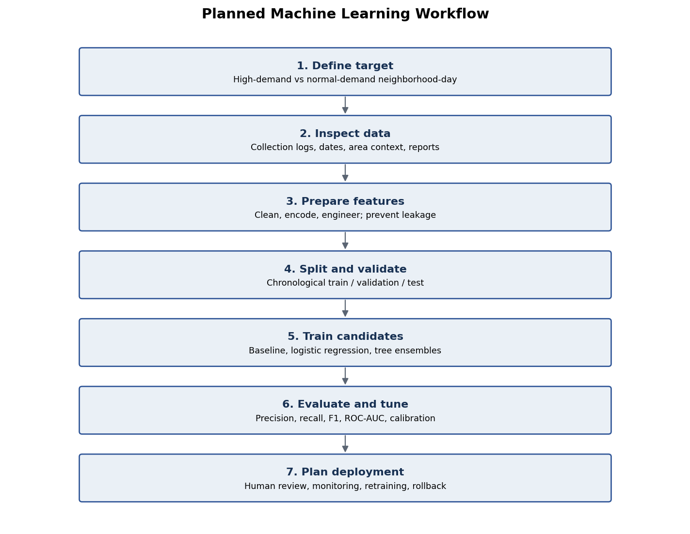

8. Deployment and Maintenance (Conceptual)
- Package preprocessing and the chosen model as a versioned pipeline; expose predictions through a controlled batch process or API.
- Show risk probability, timestamp, model version, and a human-review route to dispatchers.
- Log predictions and eventual outcomes subject to privacy and retention rules.
- Monitor data completeness, input drift, recall, false-alarm rate, and calibration.
- Retrain only with verified recent labels and compare the new version against the current model on a time-based holdout.
- Maintain access controls, documentation, rollback capability, and a clear model owner.

9. Proposed 33-Hour Work Plan
Activity | Hours
Problem definition and success criteria | 3
Data inventory and quality checks | 5
Preprocessing and feature engineering plan | 6
Candidate model comparison | 4
Training, validation, and tuning plan | 5
Metrics and error analysis plan | 4
Deployment and risk planning | 3
Diagram and final review | 3
Total | 33

10. Conclusion
A robust ML system depends on an operationally meaningful target, reliable preprocessing, leakage-safe validation, fair model comparison, and metrics linked to real costs. This plan provides a guide for future implementation. Actual performance and model choice can only be established after suitable data is collected and the planned evaluation is carried out.

