Week 4: Comprehensive Data Science Report and Insights Presentation Plan
Stakeholder-focused reporting plan | Illustrative mock-ups, not real findings

1. Executive Summary
This report plan describes how a data science study could help a municipality plan waste collection more proactively. It outlines how historical collection records and neighborhood context could be analyzed to identify demand patterns, areas needing attention, and practical actions to test. No real dataset has been analyzed for this document; the charts are mock-ups and all potential findings must be verified before being reported as facts.

2. Context and Decision to Support
Waste collection demand can vary by weekday, season, neighborhood, holidays, and service disruptions. A report should help managers decide when capacity may need adjustment, which areas require review, and whether an early-warning model is reliable enough to support operational decisions.
- Primary audience: municipal operations managers and planning officers.
- Secondary audience: route supervisors, community representatives, and public-service decision makers.
- Key decision: improve route planning, vehicle allocation, staffing, and early identification of high-demand periods.
- Clearly label every statement as an observed result, model prediction, recommendation, or illustration.

3. Methodology Overview
A full study would combine collection logs with neighborhood metadata, calendar information, and approved contextual data. It would standardize units and dates, check missing and duplicate records, investigate unusual values, and document exclusions. Exploratory analysis would summarize demand by day, area, and season. A binary classification model could estimate high-demand risk, evaluated on later unseen dates using precision, recall, F1-score, ROC-AUC, and a confusion matrix. Findings would be reviewed with operations staff before decisions are made.
- Define the business question, target, prediction horizon, and success criteria.
- Review data coverage, quality, representativeness, privacy, and limitations.
- Explore distributions, temporal trends, area variation, and relationships.
- Validate candidate models on future periods without data leakage.
- Translate verified results into recommendations with owners and measurable success criteria.
- Evaluate any operational change through a pilot and monitor its effects.

4. Insights to Investigate
These are analysis questions, not confirmed findings. Replace them with evidence-backed statements after real analysis.
Question | Analysis planned | Possible action if evidence supports it
Are some weekdays busier? | Compare demand distributions by weekday and season. | Adjust staffing or capacity on repeatably busy days.
Does demand differ by area? | Compare area-level rates, accounting for size and collection frequency. | Review route schedules and vehicle assignment.
Are peaks linked to holidays/events? | Compare similar periods and inspect calendar indicators. | Plan temporary capacity in advance.
Can high-demand days be flagged early? | Evaluate classification results on later dates. | Use risk flags as decision support if performance is sufficient.
Are there data gaps or anomalies? | Review missing records, outliers, missed pickups, and complaints. | Improve recording procedures or investigate service issues.

5. Mock-up Visualizations

5.1 Weekly demand trend
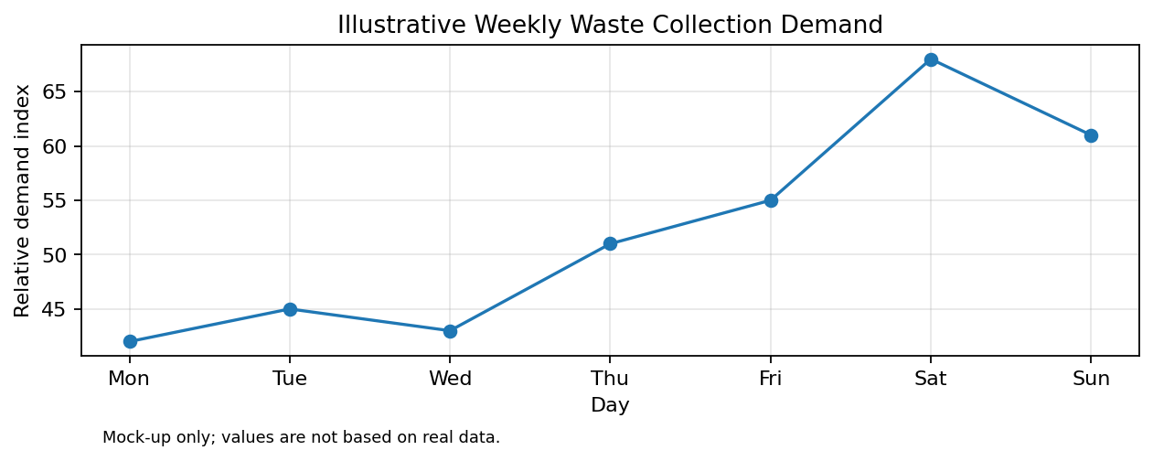
Why use it: a line chart makes recurring weekday patterns and peaks easier to see. A final chart should state the time period, units, source, and limitations. Values above are illustrative only.

5.2 Collection priority by area
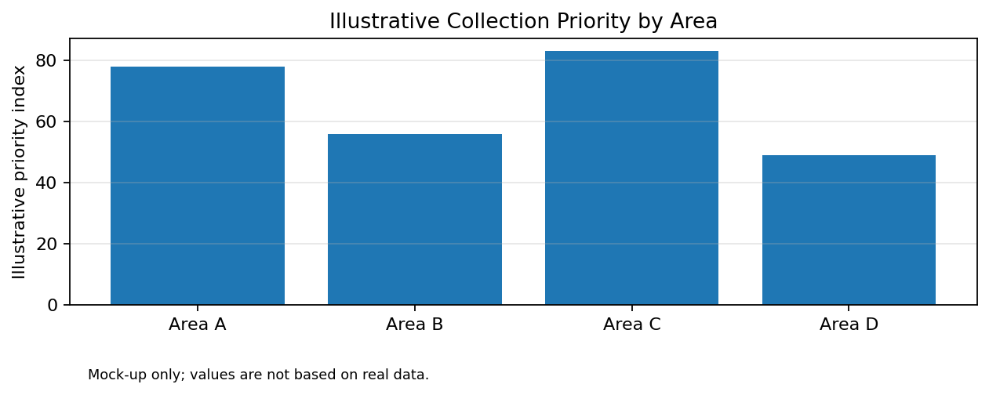
Why use it: a bar chart compares areas using a clearly defined measure. Avoid comparing raw totals when area size, population, or collection frequency differs. Values above are illustrative only.

5.3 Additional visuals for a completed analysis
- Missing-data summary to show evidence quality.
- Distribution plot or box plot to show variation and unusual values.
- Confusion matrix to explain model errors in practical terms.
- Precision-recall or ROC curve to show the trade-off between detection and false alarms.
- Map or heatmap only when location data is reliable, permitted, and privacy-safe.

6. Turning Evidence into Recommendations
Evidence to look for | Potential recommendation | How to measure a pilot
Repeatable high-demand periods | Pilot adjusted shifts or extra capacity at those times. | Track missed pickups, overflow reports, cost, and collected volume.
Consistent area-level pressure | Review route sequence, frequency, and vehicle assignment. | Compare service levels across comparable weeks.
Reliable early-warning predictions | Give dispatchers risk flags for human review. | Measure recall, alert precision, response time, and user acceptance.
Frequent data-quality gaps | Standardize record keeping and assign data owners. | Track completeness and correction rates over time.

Recommendations should be proportional to evidence. Where uncertainty is high, begin with a small reversible pilot rather than a city-wide change. State expected benefits, cost, risk, responsible owner, and success measure.

7. Communicating to a Non-Technical Audience
Use a simple story: describe the service challenge, show what the evidence says, explain what the model can and cannot predict, and end with a practical action to test. Avoid leading with algorithm names. Explain metrics in plain language—for example, recall describes how many actual high-demand cases were identified in the evaluation sample. Use that explanation only with a verified metric value and clearly state the evaluation period.
- Start with the decision and why it matters to residents and collection teams.
- Show one clear visual at a time, with a message-style headline and labeled units.
- Separate observed results from predictions, assumptions, and illustrative examples.
- Explain false alarms and missed peaks as operational trade-offs.
- Give a recommendation, its expected trade-off, and a low-risk pilot plan.
- Include limitations and invite questions to build trust.

8. Suggested Report / Presentation Structure
Section | Content | Audience takeaway
Title and decision question | Purpose, reporting period, owner. | What decision is being supported?
Executive summary | Three to five evidence-backed points and recommended action. | What matters most?
Data and methodology | Sources, coverage, preparation, analysis and validation. | How reliable is the evidence?
Findings | Verified trends, differences, anomalies, model results. | What did the analysis show?
Operational implications | Possible effects on schedules, routes, and costs. | Why does it matter?
Recommendations | Prioritized actions, owners, timelines, success measures. | What should happen next?
Limitations and next steps | Uncertainty, data gaps, pilot and monitoring plan. | What remains unknown?

9. Limitations, Ethics, and Future Work
- Records may underrepresent unreported overflow or areas with weaker reporting.
- Seasonal changes can make historical patterns less reliable in future periods.
- Prediction does not prove causation; avoid causal claims without an appropriate study design.
- Compare areas fairly by considering size, population, and collection frequency.
- Use only necessary data, restrict access, and avoid exposing resident-identifiable information.
- Future work may include a controlled pilot, cost-benefit analysis, calibration, and ongoing monitoring.

10. Proposed 33-Hour Work Plan
Activity | Hours
Define audience and decision question | 3
Review data sources and methodology | 4
Plan analyses and evidence requirements | 5
Design chart mock-ups and captions | 5
Draft insights and recommendations | 5
Prepare plain-language presentation narrative | 4
Review visuals and evidence labels | 4
Final editing and quality check | 3
Total | 33

11. Conclusion
A strong data science report connects reliable evidence to a decision, explains uncertainty clearly, and recommends actions that can be tested and measured. The plan is intended to guide a professional report and presentation. The charts are illustrative; real findings, performance figures, and recommendations must be based on actual analysis.

