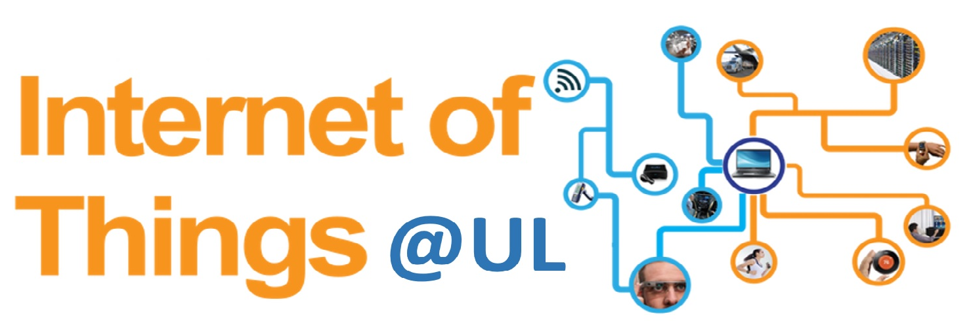

IoT Summer School

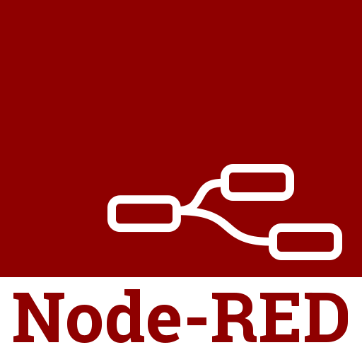

Lab

Table of Contents
1 About Node-RED 3
2 Background Knowledge 4
2.1 MQTT 4
2.3 JSON 5
2.4 Cloudant 6
2.5 Node-RED Messages 7
2.5.1 Payload 7
3 What are we trying to do? 8
3.1 Learning outcomes 8
3.2 Topic structure 8

1 About Node-RED

2 Background Knowledge

2.1 MQTT

2.1.1 About

2.1.2

2.1.3

2.1.4

2.3 JSON

2.4 Cloudant

2.5 Node-RED Messages

2.5.1 Payload

3 What are we trying to do?

3.1 Learning outcomes
On successful completion of the lab you will have learned about
- MQTT pub/sub protocol and QoS
- Controlling data through MQTT topics using Node-RED flows
- Sensor readings represented in JSON format
- Cloudant database nodes
- Watson Analytics nodes

3.2 Topic structure
→ iot-summer-school
→ group-1-iotp
→ Ann
→ Bob
→ Joe
→ group-2-iotp
→ Jim
→ …

Flow 1: Subscribe and publish to the summer school class topic
Everyone subscribes to the topic “iot-summer-school”
Everyone publishes to the topic “iot-summer-school”

What is going to happen when my device publishes to the broker?
Flow 1 will publish a message to the topic “iot-summer-school”
msg.payload = “hi from <insert your name>”

What will happen to the devices/flows subscribed to the “iot-summer-school” topic?
Anyone who is subscribed to that topic will receive the message
“hi from <insert your name>”

Will my flow also receive the message it just published?
Yes, because you are subscribed to the topic you are publishing to.

Can devices with the same id publish to the same topic?
No, this is a restriction in the MQTT protocol.
Because everyone will be publishing to the same topic with the same id, a node in the sample flow provided below will need to be modified.

How do I import flows?

I have too many flows, how do I delete/remove a flow?
Whats the difference between the deploy button options?

Flow 2: Subscribe and publish to your group topic
Only members of your group subscribe to the topic
“iot-summer-school/group-<insert group number>”

What will happen when I publish?
Only your group will receive messages that are published to that topic.

Flow 3: Publish to your own topic
Only you should publish and not subscribe to the topic
“iot-summer-school/group-<insert group number>/<insert your name>”

Why am I not subscribing in flow 3?
Flow 3 is for sending data as JSON.
Flow 4 processes this data by subscribing to this topic.
Flow 3 is known as an uplink/upstream service
Flow 4 is known as a downlink/downstream service.
Where is the broker?
The broker is running on IBM Bluemix (PaaS).
What should I change?
Instead of publishing the message “hi from <insert your name>”
You are now publishing pseudo generated sensor readings.
These sensor readings will be in JSON.

Flow 4: Store data in Cloudant
This flow has a node that subscribes to the topic
iot-summer-school/group-<insert group number>/<insert your name>
The subscribe node passes the data into the Cloudant Node.

