API使用文档
Sandbox测试：
花旗参赛以来,我们团队对花旗开发的api进行了深入研究.
我们根据citi developer hub的操作指南,进行了一系列的api测试.
首先,根据要求,注册了一个花旗账号.
然后,登陆花旗账号,就开始进行api的测试.在Apps导航栏下,开始创建第一个app,记录下app的clientID和clientSecret.
随后,进入花旗api的AUTHORIZE,获取access token,用于能够访问客户们的数据以及使用花旗提供的服务.花旗平台提供5组客户样本数据,为了测试,我们先获得客户一的access token.
最后,得到了access token和clientID,花旗api就可以测试了.(需要注意的是,不同类型的api需要不同的OAuth).血泪的教训:切记要选用Hong Kong地区的api.
鉴于我们组做的项目是知识产权交易池,我们组能使用的花旗api局限于money movement,account模块的api.对于money movement模块,我初步决定使用Create personal Transfer,Confirm personal Transfer以及Retireve payee list三个api.前两个方法用于交易转账,最后一个方法用于查询支付清单.对于accout模块,初步决定使用Retrieve transactions方法.为了呼应我们的区块链技术,检索交易事件在我们看来是有必要的.
对我们需要使用的api,我们进行了测试.测试结果如下:
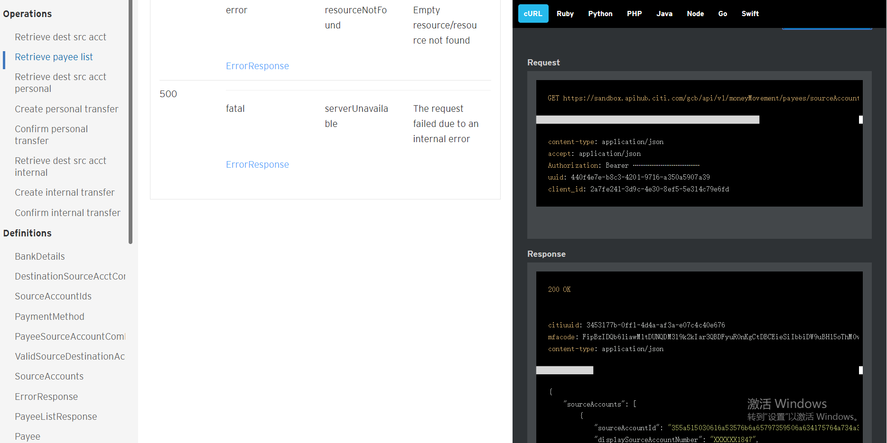

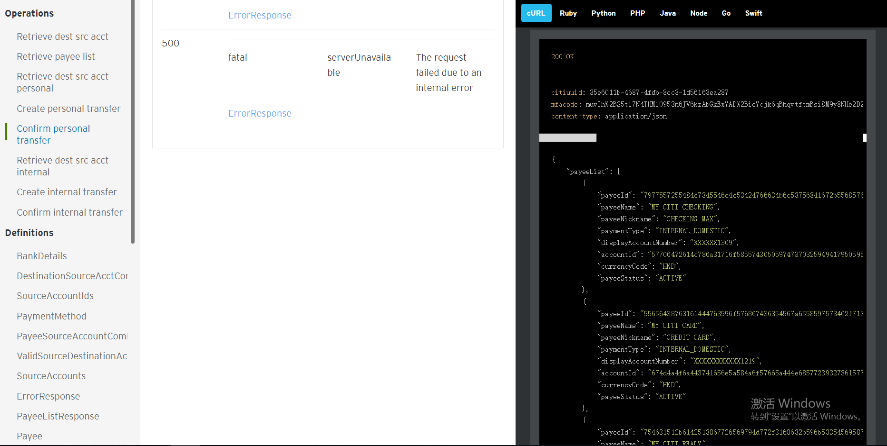

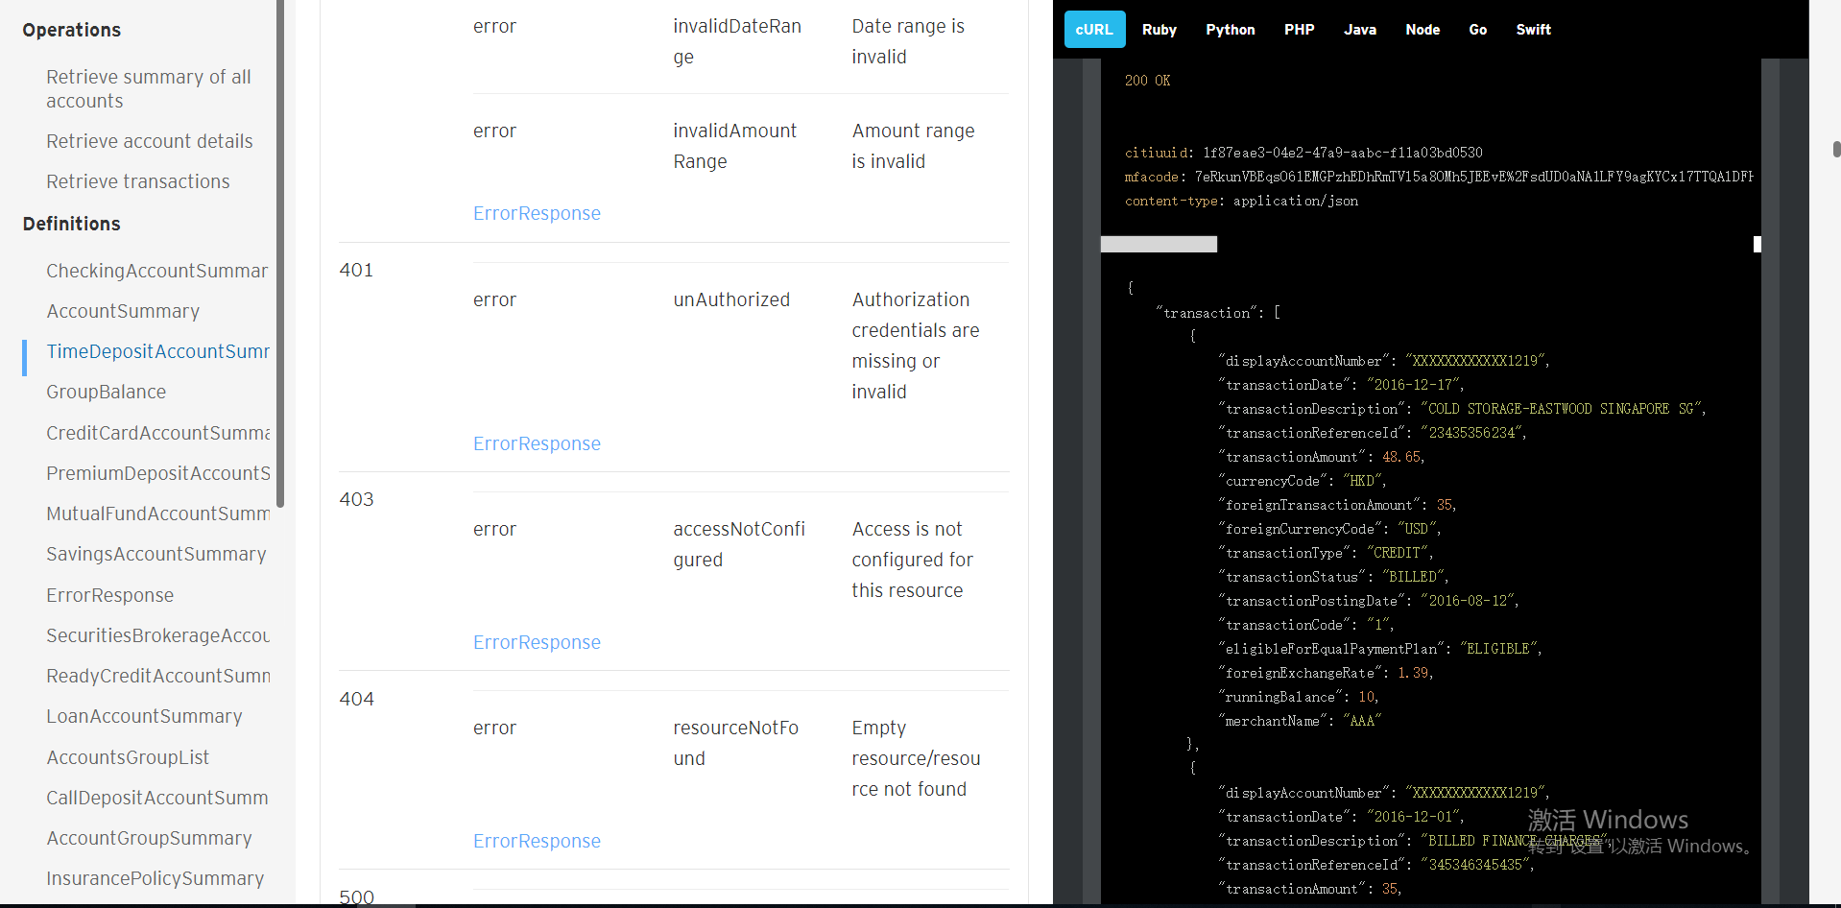

实现两个用户之间的转帐，以HK API为例，使用 /v1/moneyMovement/internalDomesticTransfers/preprocess 接口来实现不同用户(user)下的帐户(account)之间的转帐.
1.首先使用GET /v1/moneyMovement/payees/sourceAccounts接口获取可转帐对象帐户的信息，此处以sandUserBox1为例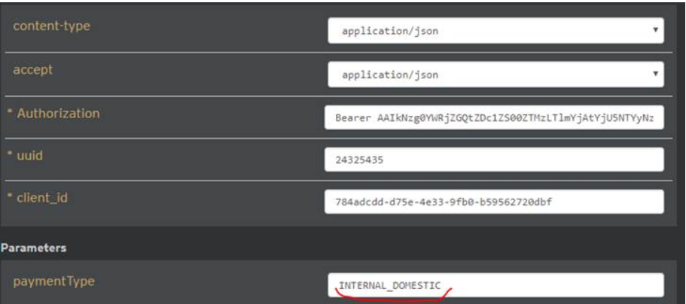

从其中找出sourceAccountId属于sandUserBox1的帐户。
2. 使用 /v1/moneyMovement/internalDomesticTransfers/preprocess 接口进行转帐，挑选上图中第一个对象中的payeeId和属于sandboxUser1的accountId传入请求参数，如下图
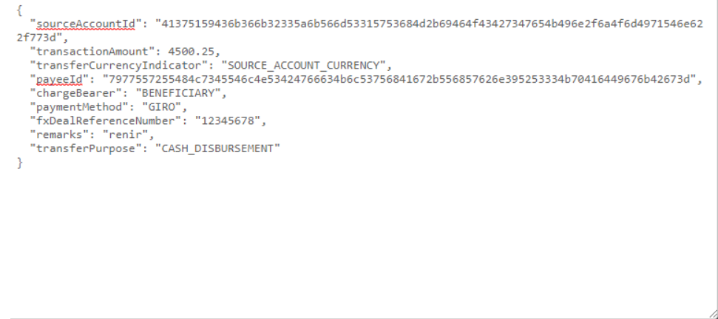
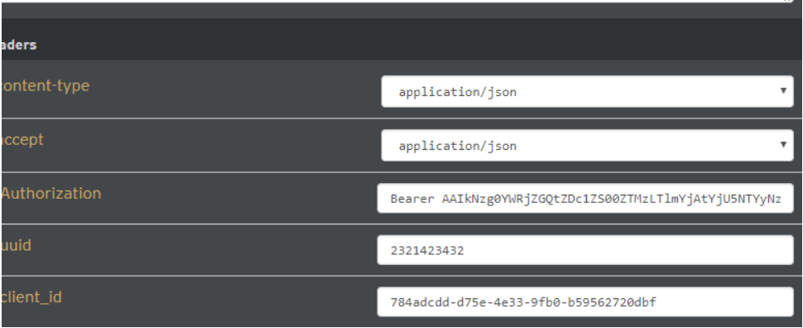

最后response:
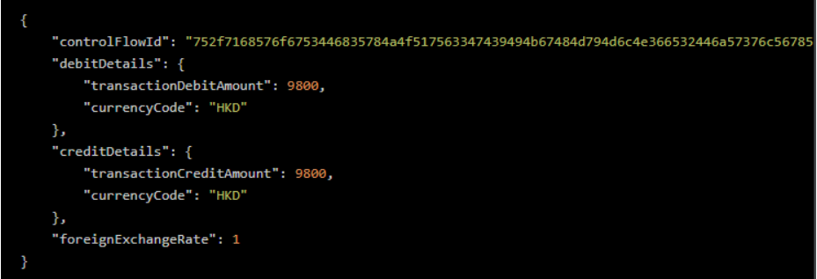
3.因为花旗api是模拟数据，所以转帐完成后，账户中的金额并不会发生改变。HK API中目前只有Internal transfer，而转帐操作中的收款人帐户也只能是数据库中预设好的帐户，也就是基本通过/v1/moneyMovement/payees或/v1/moneyMovement/payees/sourceAccounts可以查询到的帐户。

API demo演示：
基于上述的支付转账思路：我们制定了如下的接口：
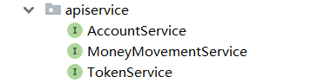

AccountService: 主要负责显示账户的账户信息以及交易的职能。
MoneyMovementService：主要负责支付转账交易的职能。
TokenService：主要负责获得用户授权的职能。
（TokenService是辅助类，方便AccountService和MoneyMovementService得到用户的token）;

MoneyMovementService的接口方法。

1.RetrieveDestacc方法：获取用户相应的SourceAccount和PayeeId。我们暂且输入SandBoxUser1的用户信息。得到的结果如下：
(屏幕大小无法呈现全部，json字符串如下所示)
{"sourceAccounts":[{"sourceAccountId":"355a515030616a53576b6a65797359506a634175764a734a3238314e4668627349486a676f7449463949453d","displaySourceAccountNumber":"XXXXXX1847","sourceAccountCurrencyCode":"HKD","accountGroup":"SAVINGS_AND_INVESTMENTS","availableBalance":13642.83,"productName":"Personal Savings Account","accountNickName":"SAVINGS"},{"sourceAccountId":"3739334c4d3463614356474f6d7650667a737656664652677747796855646c5552745a43346d37423653553d","displaySourceAccountNumber":"XXXXXX7918","sourceAccountCurrencyCode":"HKD","accountGroup":"CHECKING","availableBalance":202.19,"productName":"NRI DOLLAR CHECKING","accountNickName":"CHECK"},{"sourceAccountId":"41375159436b366b32335a6b566d53315753684d2b69464f43427347654b496e2f6a4f6d4971546e622f773d","displaySourceAccountNumber":"XXXXXX5840","sourceAccountCurrencyCode":"HKD","accountGroup":"SAVINGS_AND_INVESTMENTS","availableBalance":11562.5,"productName":"CASH PLUS","accountNickName":"CASH"}],"payeeSourceAccountCombinations":[{"payeeId":"7977557255484c7345546c4e53424766634b6c53756841672b556857626e395253334b70416449676b42673d","displayPayeeAccountNumber":"XXXXXX1369","payeeAccountCurrencyCode":"HKD","payeeNickName":"CHECKING_MAX","sourceAccountIds":[{"sourceAccountId":"3739334c4d3463614356474f6d7650667a737656664652677747796855646c5552745a43346d37423653553d"},{"sourceAccountId":"355a515030616a53576b6a65797359506a634175764a734a3238314e4668627349486a676f7449463949453d"},{"sourceAccountId":"41375159436b366b32335a6b566d53315753684d2b69464f43427347654b496e2f6a4f6d4971546e622f773d"}]},{"payeeId":"6a563747494e793478424a5a6e575a524e3831435977386d4767345a363837324b5a4a56514f54714f32413d","displayPayeeAccountNumber":"XXXXXX7961","payeeAccountCurrencyCode":"HKD","payeeNickName":"SAVING_TRADING","sourceAccountIds":[{"sourceAccountId":"3739334c4d3463614356474f6d7650667a737656664652677747796855646c5552745a43346d37423653553d"}]},{"payeeId":"73145159436b366b32335a6b566d53315753684d2b69464f43427347654b496e2f6a4f6d4971546e622f996c","displayPayeeAccountNumber":"XXXXXX5840","payeeAccountCurrencyCode":"USD","payeeNickName":"CHPS","sourceAccountIds":[{"sourceAccountId":"355a515030616a53576b6a65797359506a634175764a734a3238314e4668627349486a676f7449463949453d "}]},{"payeeId":"754631512b6142513867726569794d772f3168632b596b5335456958714a426c5956362f5533356b654a733d","displayPayeeAccountNumber":"XXXXXX8943","payeeAccountCurrencyCode":"HKD","payeeNickName":"READYCREDIT","sourceAccountIds":[{"sourceAccountId":"355a515030616a53576b6a65797359506a634175764a734a3238314e4668627349486a676f7449463949453d"},{"sourceAccountId":"3739334c4d3463614356474f6d7650667a737656664652677747796855646c5552745a43346d37423653553d"}]},{"payeeId":"7a4872316674763154617559434d6c696579313673577a30653632624570596862564d76633347727664633d","displayPayeeAccountNumber":"XXXXXX2001","payeeAccountCurrencyCode":"HKD","payeeNickName":"LOAN_HOME","sourceAccountIds":[{"sourceAccountId":"3739334c4d3463614356474f6d7650667a737656664652677747796855646c5552745a43346d37423653553d"},{"sourceAccountId":"355a515030616a53576b6a65797359506a634175764a734a3238314e4668627349486a676f7449463949453d"},{"sourceAccountId":"41375159436b366b32335a6b566d53315753684d2b69464f43427347654b496e2f6a4f6d4971546e622f773d"}]},{"payeeId":"55656438763161444763596f576867436354567a6558597578462f71375754485578694d30372b523039453d","displayPayeeAccountNumber":"XXXXXXXXXXXX1219","payeeAccountCurrencyCode":"HKD","payeeNickName":"CREDIT CARD","sourceAccountIds":[{"sourceAccountId":"3739334c4d3463614356474f6d7650667a737656664652677747796855646c5552745a43346d37423653553d"},{"sourceAccountId":"355a515030616a53576b6a65797359506a634175764a734a3238314e4668627349486a676f7449463949453d"}]}],"destinationSourceAcctCombinations":[{"destinationAccountId":"57706472614c786a31716f5855743050597473703259494179505959776a377370614b364167516a57336b3d","displayDestinationAccountNumber":"XXXXXX1369","destinationAccountCurrencyCode":"HKD","availableBalance":4467.15,"productName":"HKD CASH TRADING ACCOUNT","accountNickName":"HKTRADING","sourceAccountIds":[{"sourceAccountId":"3739334c4d3463614356474f6d7650667a737656664652677747796855646c5552745a43346d37423653553d"},{"sourceAccountId":"355a515030616a53576b6a65797359506a634175764a734a3238314e4668627349486a676f7449463949453d"},{"sourceAccountId":"41375159436b366b32335a6b566d53315753684d2b69464f43427347654b496e2f6a4f6d4971546e622f773d"}]},{"destinationAccountId":"674d4a4f6a443741656e5a584a6f57665a444e685772393273615777397a4c665073305a5a2b51356f76513d","displayDestinationAccountNumber":"XXXXXX1219","destinationAccountCurrencyCode":"HKD","availableBalance":5876.87,"nextPaymentAmount":1380.87,"outstandingBalance":1380.87,"minimumDueAmount":150,"lastStatementDate":"2016-08-20","paymentDueDate":"2016-09-05","productName":"CITI PRESTIGE CARD","accountNickName":"CREDIT","sourceAccountIds":[{"sourceAccountId":"3739334c4d3463614356474f6d7650667a737656664652677747796855646c5552745a43346d37423653553d"},{"sourceAccountId":"355a515030616a53576b6a65797359506a634175764a734a3238314e4668627349486a676f7449463949453d"}]},{"destinationAccountId":"4a6b792b33324a5858686a354c4546314a367437386e77386e377152387875426a7770736f6c6643724a6b3d","displayDestinationAccountNumber":"XXXXXX8943","destinationAccountCurrencyCode":"HKD","availableBalance":7400.22,"productName":"READY CREDIT","accountNickName":"READY","sourceAccountIds":[{"sourceAccountId":"3739334c4d3463614356474f6d7650667a737656664652677747796855646c5552745a43346d37423653553d"},{"sourceAccountId":"355a515030616a53576b6a65797359506a634175764a734a3238314e4668627349486a676f7449463949453d"}]},{"destinationAccountId":"4b484730396761544977444139687062412b57484239354779702b67747a357537477770584262315073493d","displayDestinationAccountNumber":"XXXXXX2001","destinationAccountCurrencyCode":"HKD","availableBalance":900000,"productName":"TERM/TIME LOAN P-I (360)","accountNickName":"LOAN","sourceAccountIds":[{"sourceAccountId":"3739334c4d3463614356474f6d7650667a737656664652677747796855646c5552745a43346d37423653553d"},{"sourceAccountId":"355a515030616a53576b6a65797359506a634175764a734a3238314e4668627349486a676f7449463949453d"},{"sourceAccountId":"41375159436b366b32335a6b566d53315753684d2b69464f43427347654b496e2f6a4f6d4971546e622f773d"}]},{"destinationAccountId":"41375159436b366b32335a6b566d53315753684d2b69464f43427347654b496e2f6a4f6d4971546e622f773d","displayDestinationAccountNumber":"XXXXXX5840","destinationAccountCurrencyCode":"USD","availableBalance":11562.5,"productName":"CASH PLUS","accountNickName":"CASH CHPS","sourceAccountIds":[{"sourceAccountId":"355a515030616a53576b6a65797359506a634175764a734a3238314e4668627349486a676f7449463949453d"}]},{"destinationAccountId":"51327a46437565374770547776786c4348367545397331453164414177505a4e6d2b7131566d39476942303d","displayDestinationAccountNumber":"XXXXXX3034","destinationAccountCurrencyCode":"HKD","availableBalance":15619.75,"productName":"AUD GLOBAL FCY AC (GCB IND)","accountNickName":"AUGLOBAL","sourceAccountIds":[{"sourceAccountId":"3739334c4d3463614356474f6d7650667a737656664652677747796855646c5552745a43346d37423653553d"},{"sourceAccountId":"355a515030616a53576b6a65797359506a634175764a734a3238314e4668627349486a676f7449463949453d"}]},{"destinationAccountId":"2f65316954666337464e6c4647334c527a7877594c576b784650576c737a564854502f554c4d6d56664a633d","displayDestinationAccountNumber":"XXXXXX9001","destinationAccountCurrencyCode":"HKD","availableBalance":0,"productName":"MOBILE RECHARE CARD","accountNickName":"RECHARGECARD","sourceAccountIds":[{"sourceAccountId":"3739334c4d3463614356474f6d7650667a737656664652677747796855646c5552745a43346d37423653553d"},{"sourceAccountId":"355a515030616a53576b6a65797359506a634175764a734a3238314e4668627349486a676f7449463949453d"}]}]}

- 通过第一步获取到用户的所有信息，使用CombinationsAccountandPayee方法，进行json串解析。这里我新建了一个类Combinations，存放一个内部json字符串所对应的payeeId和acountId组合。
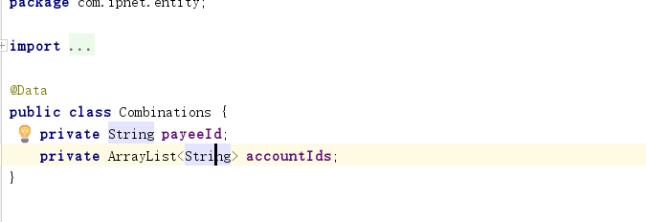

这是打印出来的提取结果：
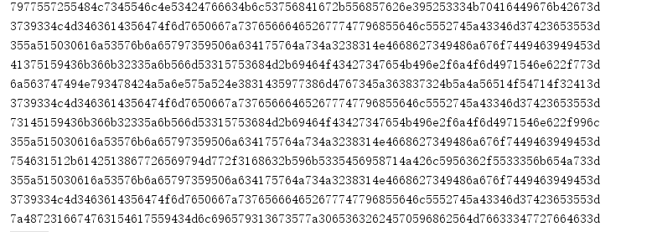

根据前端选择的accountId,payeeId以及转账金额，调用createTranfer进行转账；我们暂且传入SandUser1的accountId："355a515030616a53576b6a65797359506a634175764a734a3238314e4668627349486a676f7449463949453d"
payeeId: "7977557255484c7345546c4e53424766634b6c53756841672b556857626e395253334b70416449676b42673d"

返回结果如下：

完整的信息：
{"debitDetails":{"transactionDebitAmount":4000,"currencyCode":"HKD"},"controlFlowId":"45534b7438634c567a566777354c5861486d59616c4665467a624e61724c73574b4c50494f386664306d6f3d","creditDetails":{"transactionCreditAmount":4000,"currencyCode":"HKD"},"foreignExchangeRate":1}

3.通过createTransfer得到的返回值controlFlowId属性，进行confirm验证：
大概流程如下，就能确定支付是否成功。

