API usage documentation
Sandbox test:
Since Citigroup, our team has conducted in-depth research on the api developed by Citi.
We conducted a series of api tests based on the citi developer hub's operating guide.
First, a Citi account was registered upon request.
Then, log in to the Citi account and start testing the api. Under the Apps navigation bar, start creating the first app and record the appID and clientSecret of the app.
Then, enter api Citigroup's AUTHORIZE, obtain access token, for customers to access their data and the use of services provided by Citi. Citi platform provides customers five groups of sample data, in order to test, we first get a client's access token.
Finally, to get the access token and clientID, Citigroup api can be tested (It should be noted that different types of api require different OAuth) blood and tears of the lesson: Remember to choose api Hong Kong region.
Since the project we are working on is an intellectual property transaction pool, the Citi api that our group can use is limited to the money movement, the api of the account module. For the money movement module, I initially decided to use Create personal Transfer, Confirm personal Transfer and Retireve payee list three. The first two methods are used for transaction transfer, and the last method is used to query the payment list. For the accout module, the Retrieve transactions method is initially decided. In order to echo our blockchain technology, the search transaction event is in our opinion. necessary.
We tested the api we need to use. The test results are as follows:
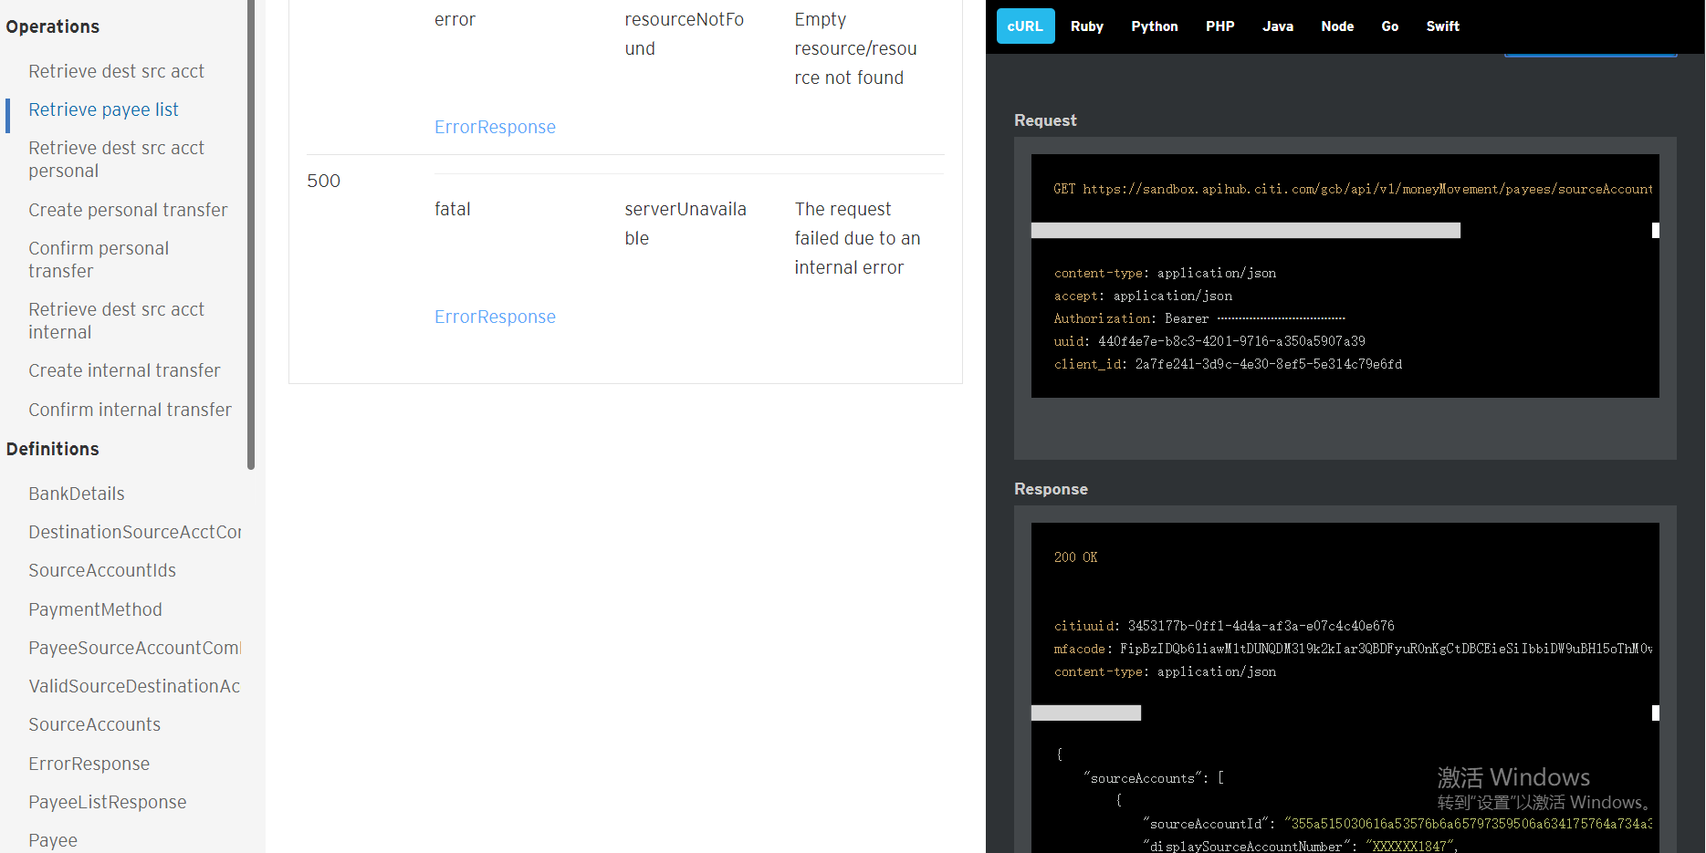
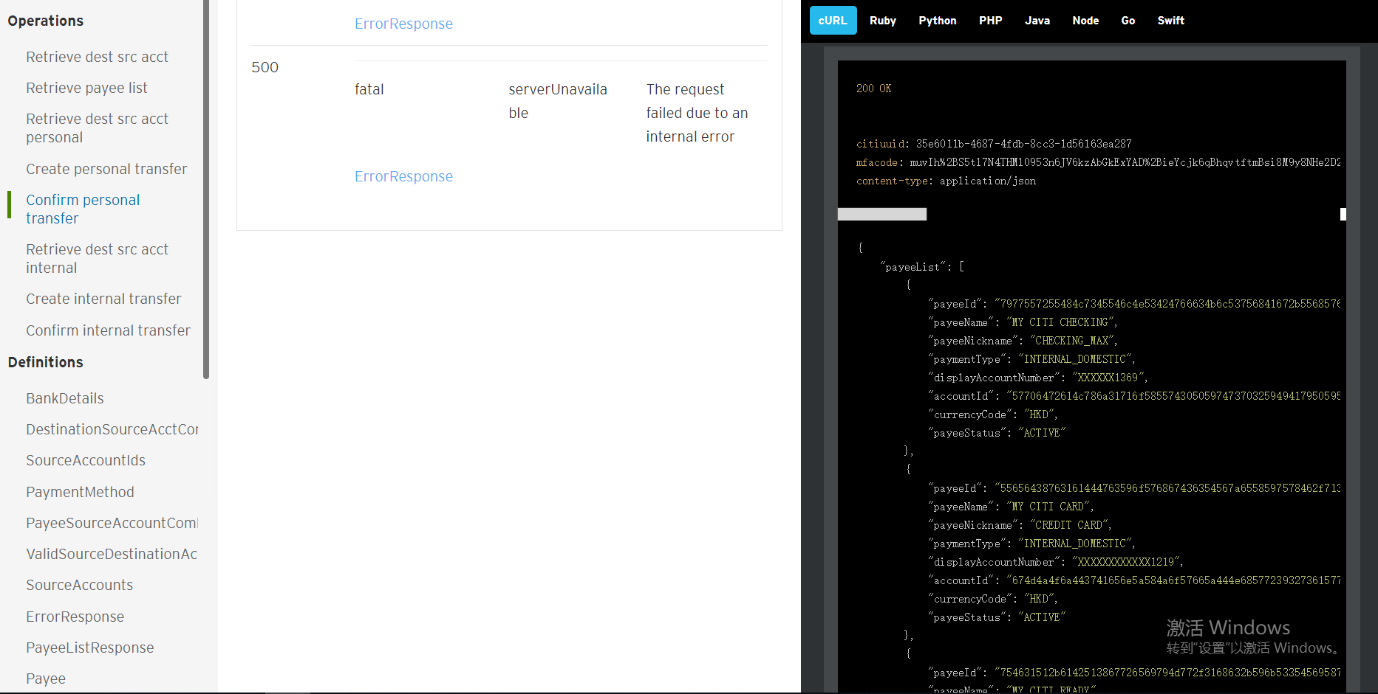
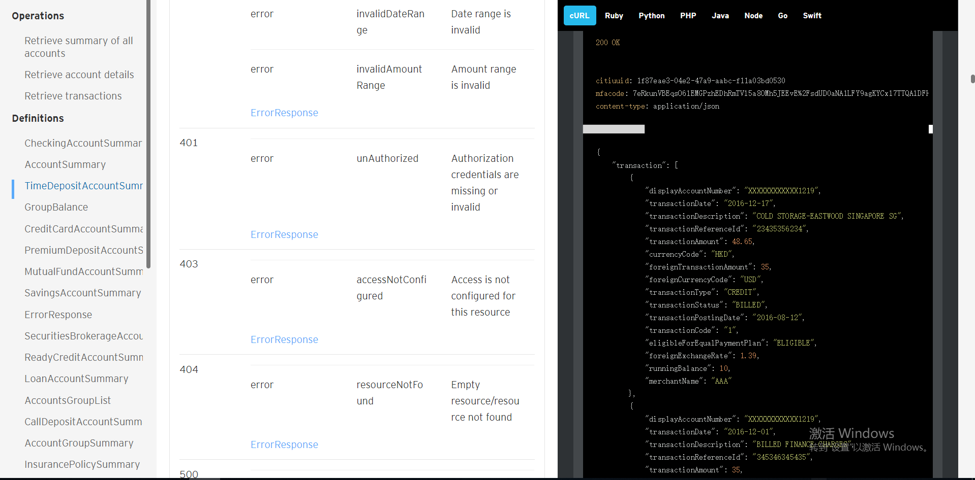
To implement the transfer between two users, using the HK API as an example, use the /v1/moneyMovement/internalDomesticTransfers/preprocess interface to implement the transfer between accounts under different users (users).

1. First use the GET /v1/moneyMovement/payees/sourceAccounts interface to get the information of the transferable object account, here is the example of sandUserBox1
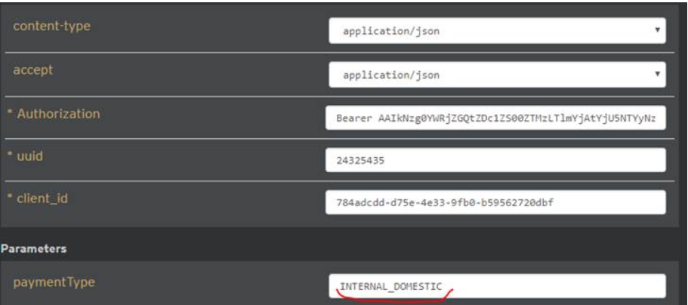
Find out the account whose sourceAccountId belongs to sandUserBox1.

- Use the /v1/moneyMovement/internalDomesticTransfers/preprocess interface to transfer the account, select the payeeId in the first object in the above figure and the accountId incoming request parameter belonging to the sandboxUser1, as shown below.
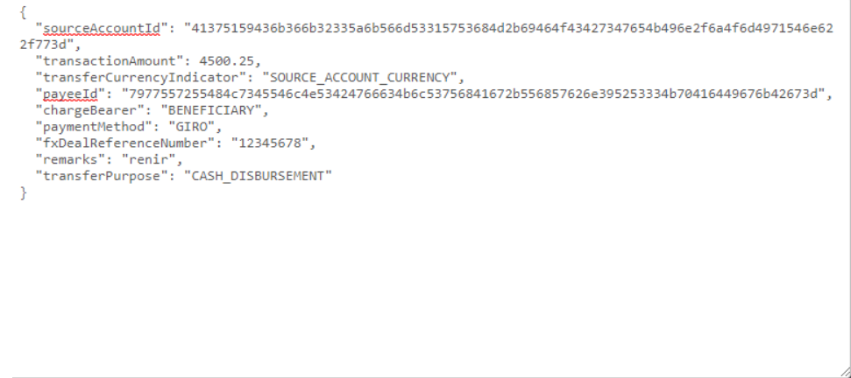

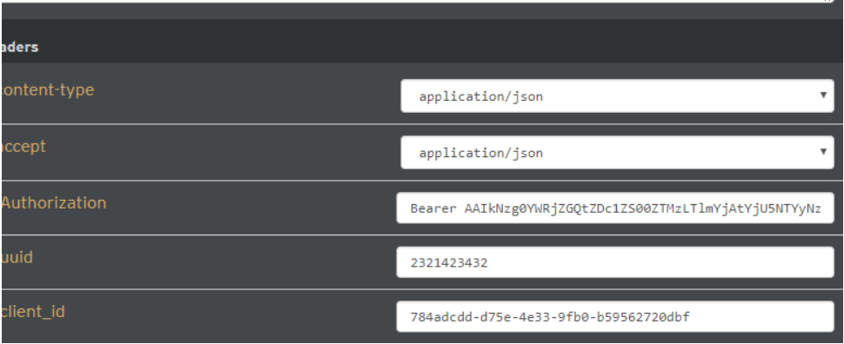
Last response:

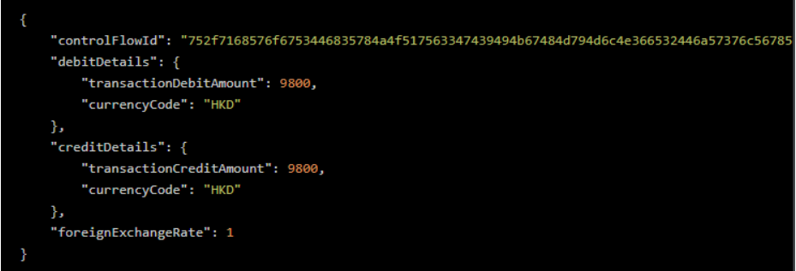

- Because Citi api is analog data, the amount in the account will not change after the transfer is completed. HK API currently only Internal transfer, and the transfer operation of the payee account can only be a good default database account, that is, basically by / v1 / moneyMovement / payees or / v1 / moneyMovement / payees / sourceAccounts can query To the account.

API demo:
Based on the above payment transfer ideas: We have developed the following interfaces:
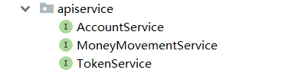
AccountService: Mainly responsible for displaying the account information of the account and the function of the transaction.
MoneyMovementService: Mainly responsible for paying the transfer transaction function.
TokenService: Mainly responsible for obtaining the authorization of the user.(TokenService is a helper class that facilitates the AccountService and MoneyMovementService to get the user's token);
The interface method of MoneyMovementService.
- RetrieveDestacc Method: obtaining a user respective SourceAccount and PayeeId. Let us enter the user's information SandBoxUser1. The results obtained are as follows:
(The screen size cannot be rendered completely, the json string is as follows)
{"sourceAccounts":[{"sourceAccountId":"355a515030616a53576b6a65797359506a634175764a734a3238314e4668627349486a676f7449463949453d","displaySourceAccountNumber":"XXXXXX1847","sourceAccountCurrencyCode":"HKD","accountGroup":"SAVINGS_AND_INVESTMENTS","availableBalance":13642.83,"productName":"Personal Savings Account","accountNickName":"SAVINGS"},{"sourceAccountId":"3739334c4d3463614356474f6d7650667a737656664652677747796855646c5552745a43346d37423653553d","displaySourceAccountNumber":"XXXXXX7918","sourceAccountCurrencyCode":"HKD","accountGroup":"CHECKING","availableBalance":202.19,"productName":"NRI DOLLAR CHECKING","accountNickName":"CHECK"},{"sourceAccountId":"41375159436b366b32335a6b566d53315753684d2b69464f43427347654b496e2f6a4f6d4971546e622f773d","displaySourceAccountNumber":"XXXXXX5840","sourceAccountCurrencyCode":"HKD","accountGroup":"SAVINGS_AND_INVESTMENTS","availableBalance":11562.5,"productName":"CASH PLUS","accountNickName":"CASH"}],"payeeSourceAccountCombinations":[{"payeeId":"7977557255484c7345546c4e53424766634b6c53756841672b556857626e395253334b70416449676b42673d","displayPayeeAccountNumber":"XXXXXX1369","payeeAccountCurrencyCode":"HKD","payeeNickName":"CHECKING_MAX","sourceAccountIds":[{"sourceAccountId":"3739334c4d3463614356474f6d7650667a737656664652677747796855646c5552745a43346d37423653553d"},{"sourceAccountId":"355a515030616a53576b6a65797359506a634175764a734a3238314e4668627349486a676f7449463949453d"},{"sourceAccountId":"41375159436b366b32335a6b566d53315753684d2b69464f43427347654b496e2f6a4f6d4971546e622f773d"}]},{"payeeId":"6a563747494e793478424a5a6e575a524e3831435977386d4767345a363837324b5a4a56514f54714f32413d","displayPayeeAccountNumber":"XXXXXX7961","payeeAccountCurrencyCode":"HKD","payeeNickName":"SAVING_TRADING","sourceAccountIds":[{"sourceAccountId":"3739334c4d3463614356474f6d7650667a737656664652677747796855646c5552745a43346d37423653553d"}]},{"payeeId":"73145159436b366b32335a6b566d53315753684d2b69464f43427347654b496e2f6a4f6d4971546e622f996c","displayPayeeAccountNumber":"XXXXXX5840","payeeAccountCurrencyCode":"USD","payeeNickName":"CHPS","sourceAccountIds":[{"sourceAccountId":"355a515030616a53576b6a65797359506a634175764a734a3238314e4668627349486a676f7449463949453d "}]},{"payeeId":"754631512b6142513867726569794d772f3168632b596b5335456958714a426c5956362f5533356b654a733d","displayPayeeAccountNumber":"XXXXXX8943","payeeAccountCurrencyCode":"HKD","payeeNickName":"READYCREDIT","sourceAccountIds":[{"sourceAccountId":"355a515030616a53576b6a65797359506a634175764a734a3238314e4668627349486a676f7449463949453d"},{"sourceAccountId":"3739334c4d3463614356474f6d7650667a737656664652677747796855646c5552745a43346d37423653553d"}]},{"payeeId":"7a4872316674763154617559434d6c696579313673577a30653632624570596862564d76633347727664633d","displayPayeeAccountNumber":"XXXXXX2001","payeeAccountCurrencyCode":"HKD","payeeNickName":"LOAN_HOME","sourceAccountIds":[{"sourceAccountId":"3739334c4d3463614356474f6d7650667a737656664652677747796855646c5552745a43346d37423653553d"},{"sourceAccountId":"355a515030616a53576b6a65797359506a634175764a734a3238314e4668627349486a676f7449463949453d"},{"sourceAccountId":"41375159436b366b32335a6b566d53315753684d2b69464f43427347654b496e2f6a4f6d4971546e622f773d"}]},{"payeeId":"55656438763161444763596f576867436354567a6558597578462f71375754485578694d30372b523039453d","displayPayeeAccountNumber":"XXXXXXXXXXXX1219","payeeAccountCurrencyCode":"HKD","payeeNickName":"CREDIT CARD","sourceAccountIds":[{"sourceAccountId":"3739334c4d3463614356474f6d7650667a737656664652677747796855646c5552745a43346d37423653553d"},{"sourceAccountId":"355a515030616a53576b6a65797359506a634175764a734a3238314e4668627349486a676f7449463949453d"}]}],"destinationSourceAcctCombinations":[{"destinationAccountId":"57706472614c786a31716f5855743050597473703259494179505959776a377370614b364167516a57336b3d","displayDestinationAccountNumber":"XXXXXX1369","destinationAccountCurrencyCode":"HKD","availableBalance":4467.15,"productName":"HKD CASH TRADING ACCOUNT","accountNickName":"HKTRADING","sourceAccountIds":[{"sourceAccountId":"3739334c4d3463614356474f6d7650667a737656664652677747796855646c5552745a43346d37423653553d"},{"sourceAccountId":"355a515030616a53576b6a65797359506a634175764a734a3238314e4668627349486a676f7449463949453d"},{"sourceAccountId":"41375159436b366b32335a6b566d53315753684d2b69464f43427347654b496e2f6a4f6d4971546e622f773d"}]},{"destinationAccountId":"674d4a4f6a443741656e5a584a6f57665a444e685772393273615777397a4c665073305a5a2b51356f76513d","displayDestinationAccountNumber":"XXXXXX1219","destinationAccountCurrencyCode":"HKD","availableBalance":5876.87,"nextPaymentAmount":1380.87,"outstandingBalance":1380.87,"minimumDueAmount":150,"lastStatementDate":"2016-08-20","paymentDueDate":"2016-09-05","productName":"CITI PRESTIGE CARD","accountNickName":"CREDIT","sourceAccountIds":[{"sourceAccountId":"3739334c4d3463614356474f6d7650667a737656664652677747796855646c5552745a43346d37423653553d"},{"sourceAccountId":"355a515030616a53576b6a65797359506a634175764a734a3238314e4668627349486a676f7449463949453d"}]},{"destinationAccountId":"4a6b792b33324a5858686a354c4546314a367437386e77386e377152387875426a7770736f6c6643724a6b3d","displayDestinationAccountNumber":"XXXXXX8943","destinationAccountCurrencyCode":"HKD","availableBalance":7400.22,"productName":"READY CREDIT","accountNickName":"READY","sourceAccountIds":[{"sourceAccountId":"3739334c4d3463614356474f6d7650667a737656664652677747796855646c5552745a43346d37423653553d"},{"sourceAccountId":"355a515030616a53576b6a65797359506a634175764a734a3238314e4668627349486a676f7449463949453d"}]},{"destinationAccountId":"4b484730396761544977444139687062412b57484239354779702b67747a357537477770584262315073493d","displayDestinationAccountNumber":"XXXXXX2001","destinationAccountCurrencyCode":"HKD","availableBalance":900000,"productName":"TERM/TIME LOAN P-I (360)","accountNickName":"LOAN","sourceAccountIds":[{"sourceAccountId":"3739334c4d3463614356474f6d7650667a737656664652677747796855646c5552745a43346d37423653553d"},{"sourceAccountId":"355a515030616a53576b6a65797359506a634175764a734a3238314e4668627349486a676f7449463949453d"},{"sourceAccountId":"41375159436b366b32335a6b566d53315753684d2b69464f43427347654b496e2f6a4f6d4971546e622f773d"}]},{"destinationAccountId":"41375159436b366b32335a6b566d53315753684d2b69464f43427347654b496e2f6a4f6d4971546e622f773d","displayDestinationAccountNumber":"XXXXXX5840","destinationAccountCurrencyCode":"USD","availableBalance":11562.5,"productName":"CASH PLUS","accountNickName":"CASH CHPS","sourceAccountIds":[{"sourceAccountId":"355a515030616a53576b6a65797359506a634175764a734a3238314e4668627349486a676f7449463949453d"}]},{"destinationAccountId":"51327a46437565374770547776786c4348367545397331453164414177505a4e6d2b7131566d39476942303d","displayDestinationAccountNumber":"XXXXXX3034","destinationAccountCurrencyCode":"HKD","availableBalance":15619.75,"productName":"AUD GLOBAL FCY AC (GCB IND)","accountNickName":"AUGLOBAL","sourceAccountIds":[{"sourceAccountId":"3739334c4d3463614356474f6d7650667a737656664652677747796855646c5552745a43346d37423653553d"},{"sourceAccountId":"355a515030616a53576b6a65797359506a634175764a734a3238314e4668627349486a676f7449463949453d"}]},{"destinationAccountId":"2f65316954666337464e6c4647334c527a7877594c576b784650576c737a564854502f554c4d6d56664a633d","displayDestinationAccountNumber":"XXXXXX9001","destinationAccountCurrencyCode":"HKD","availableBalance":0,"productName":"MOBILE RECHARE CARD","accountNickName":"RECHARGECARD","sourceAccountIds":[{"sourceAccountId":"3739334c4d3463614356474f6d7650667a737656664652677747796855646c5552745a43346d37423653553d"},{"sourceAccountId":"355a515030616a53576b6a65797359506a634175764a734a3238314e4668627349486a676f7449463949453d"}]}]}

2. Get all the information of the user through the first step, and use the CombinationsAccountandPayee method to perform json string parsing. Here I created a new class Combinations, which stores a combination of payeeId and acountId corresponding to an internal json string.
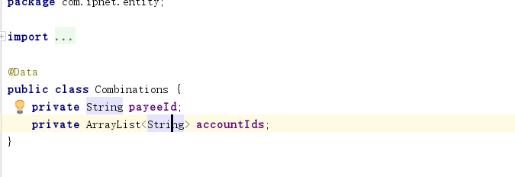
This is the printed extraction result:
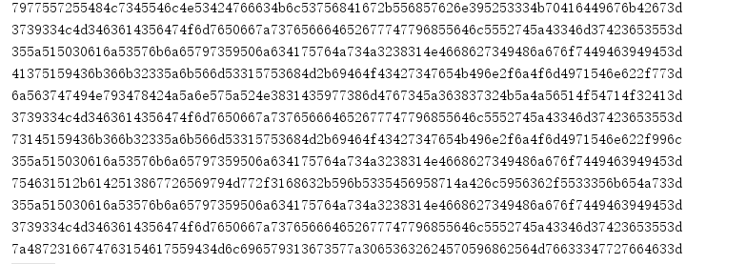
According to accountId, payeeId transfer amount and choose the tip, call the createTranfer make transfers; Let us pass SandUser1 of accountId: "355a515030616a53576b6a65797359506a634175764a734a3238314e4668627349486a676f7449463949453d"
payeeId: "7977557255484c7345546c4e53424766634b6c53756841672b556857626e395253334b70416449676b42673d"
Returned the following results:
complete information:
{ "DebitDetails": { "transactionDebitAmount": 4000, "currencyCode": "HKD"}, "controlFlowId": "45534b7438634c567a566777354c5861486d59616c4665467a624e61724c73574b4c50494f386664306d6f3d", "creditDetails": { "transactionCreditAmount": 4000, "currencyCode": "HKD"}, " foreignExchangeRate ": 1}
3. The return value obtained by createTransfer controlFlowId attribute for validation confirm:
Probably process is as follows, you will be able to determine whether the payment was successful.

