**3-legged Auth**

1. User will login with proper user id and password
2. Choose the country .
3. Click on Authorize
4. Click on Authorize Code grant: Retrieve authorization code

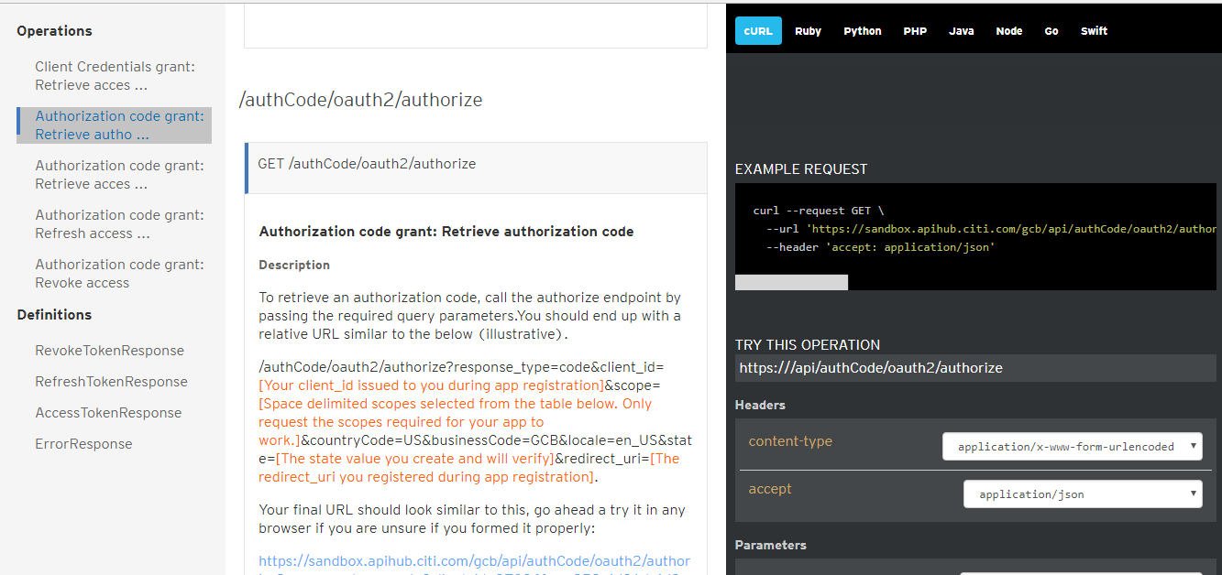

1. Provide the required parameters and hit call operation:

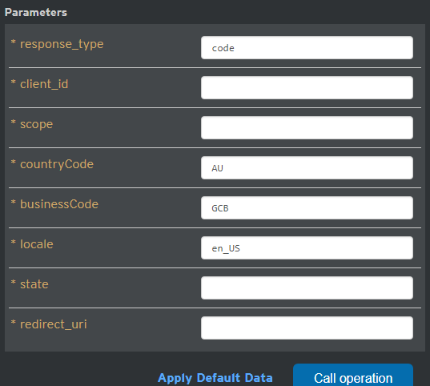

1. Provide the static credentials:

SandboxUser1 P@ssUser1$

SandboxUser2 P@ssUser2$

SandboxUser3 P@ssUser3$

SandboxUser4 P@ssUser4$

SandboxUser5 P@ssUser5$

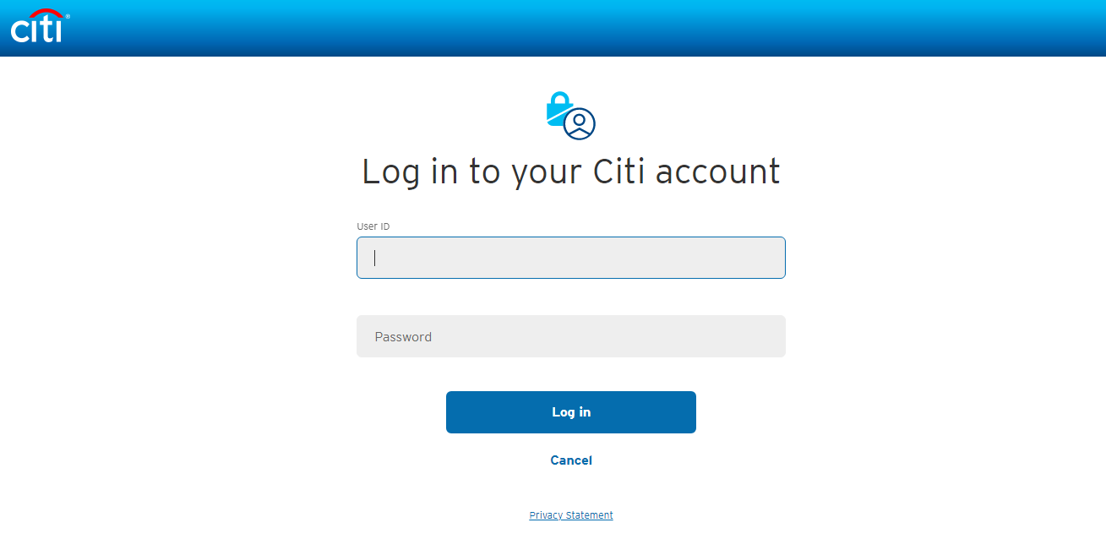

1. Click on authorize

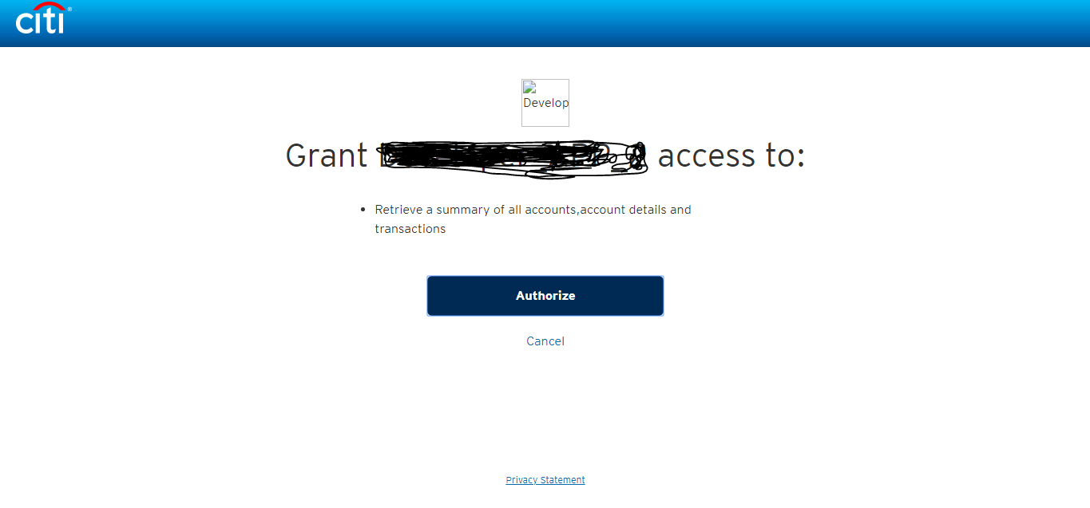

1. You will get the code value
2. Then hit Authorization code grant: Retrieve access token

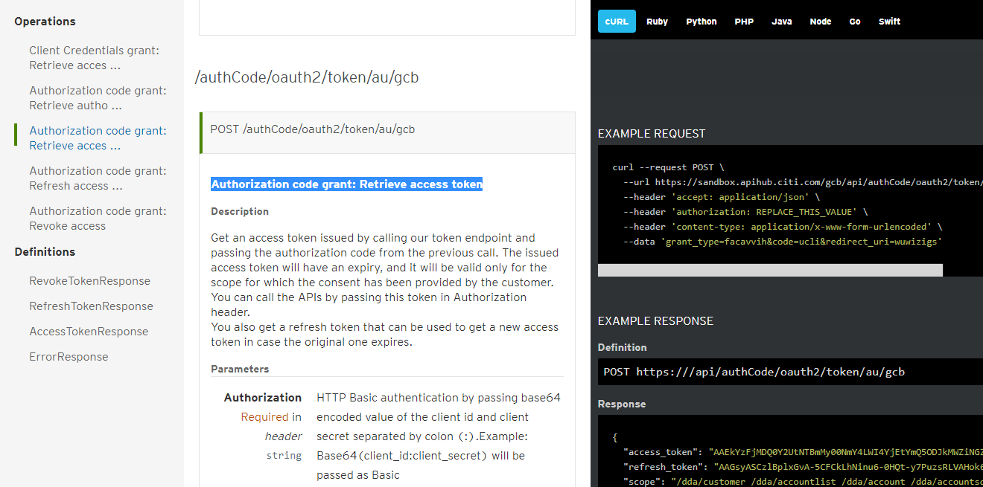

1. Provide below details and hit call operation:

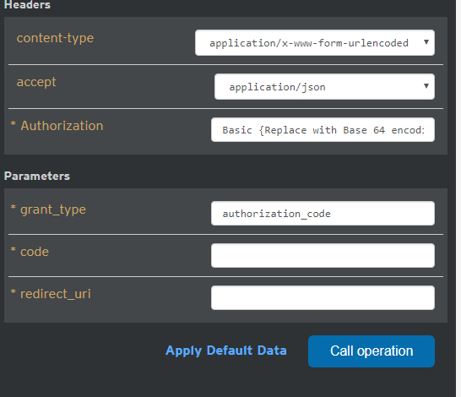

1. With the help of (<https://www.base64encode.org/>) we can convert to base 64:

Clientid:clientsecret

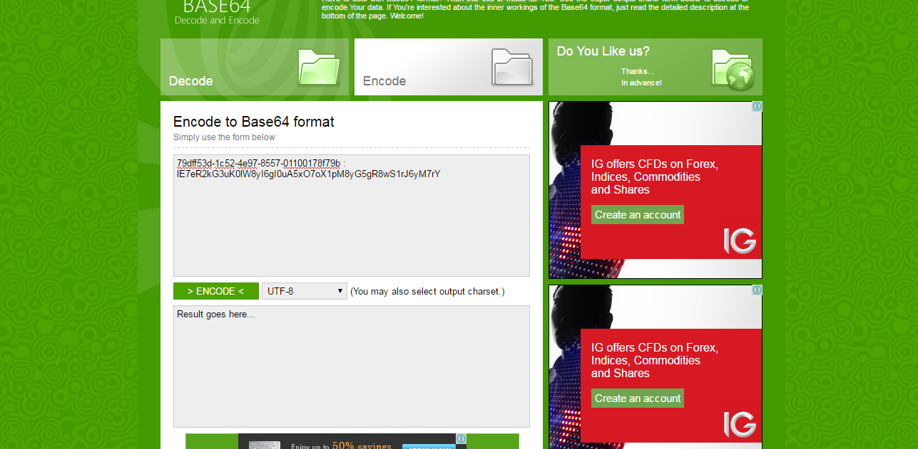

1. Click on encode:



(NzlkZmY1M2QtMWM1Mi00ZTk3LTg1NTctMDExMDAxNzhmNzliOmxFN2VSMmtHM3VLMGxXOHlJNmdJMHVBNXhPN29YMXBNOHlHNWdSOHdTMXJKNnlNN3JZ) Paste on authorization as Basic base64