# Question Section

1. First need to know the model of the business or purpose the system
2. How many user use the system (Admin and User Management, Bidder, Publisher, and Investor)?
3. What the User role (Admin and User Management, Bidder, Publisher, and Investor)?
4. Must be User Profile section dynamic?
5. What is the profile-required field? (Like Company TIN, BIN, Income TAX Certificate, Company profile and Brochure etc.?)
6. Will continue any advertisement or campaigning?
7. There will be any payment gateway?
8. Have any fees or charge for an account holder (like Bidder, Publisher, and Investor)?
9. How many opportunities for (Bidder, Publisher, Investor)?
10. How many fields are required for profile build-up?
11. Have any reference systems or websites?
12. Have any data?
13. Have any training sessions?
14. How is the user interface (like top header, navigation bar, body, and footer)?
15. Describe the style of the website you want?
16. How many pages for Sub-contract.com? (Like About us, Privacy & Policy, FAQ etc.)?
17. Can you provide the Pantone numbers for your company colours?
18. you want to upload a video or audio file
19. Do you require online chat features?
20. Do you need multi-language support?
21. Do you need any social sharing features built in (tweet, like, +1, share, etc.)?
22. Do you have any subscription services?
23. Do you have any logo?

# Simple Process for sub-contract.com

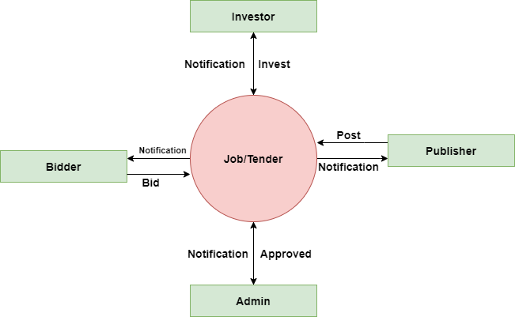

# User Module

1. Admin Module
2. Bidder Module
3. Publisher Module
4. Investor Module

# 1. Admin Module

1. View real dashboard (Number of post, cancel post, pending post complete post)
2. Will approve user account
3. Will approve the tenders post
4. Will approve user/company profile
5. Update profile and details
6. Will set user privilege or role
7. Will add new service
8. Will filter bidder proposal file and investor file than send or show publisher.
9. Edit/ Cancel/Update any kind of information
10. Active or deactivate any user account
11. Setting
12. Will any Marketing
13. Will use Google analytic
14. Will make strong FAQ & Policy
15. Will check payment status (have any fees or charge or membership charge)
16. Create/add new member

# 2. Bidder Module

1. Sign-up/Sign In
2. Manage Profile
3. Dashboard (How many apply/send proposal, Cancel proposal, Approve proposal, and pending Work)
4. Update Profile
5. Change Password
6. View profile and download
7. Bid tender/Job
8. Tender bid cancel
9. Submit proposal (for single tender)
10. List of complete work
11. Give Feedback (Contact Publisher)
12. How many tenders bidded (Monthly, Early)
13. View Status (Bidded tender) Real time view
14. View related tender
15. View my tender/job
16. Search option (location wise, category wise, tender name wise, company wise)
17. Advance Search option
18. Help and Support
19. Review
20. Get Award
21. Get Certificate (From Sub-contract.com)
22. Check Payment status
23. Settings
24. Notification (Gmail or other social media)
25. SMS Tender alert (pay Extra charge (if have any policy))
26. Deactivate Account
27. Profile lock (Yes or Not)
28. Logout

# 3. Publisher

1. Sign-up/Sign In
2. Manage Profile
3. Dashboard (How many post, Cancel post, Approve post, and pending post)
4. Update Profile
5. Change Password
6. View profile and download
7. Post tender/Job
8. Post cancel (Tender)
9. View the required project files (included proposal) from the bidder
10. List of post tender
11. Complete tender/job (Use Sub-contract.com)
12. Give Feedback (Contact Bidder)
13. List of bidder (profile and proposal)
14. Search service (how many service available for publisher)
15. Advance Search option
16. Help and Support
17. Review
18. Get Award
19. Get Certificate (From Sub-contract.com)
20. Check Payment status
21. Settings
22. Notification (Gmail or other social media) get for new service
23. Set Premium tender/job (pay Extra charge (if have any policy)) (short deadline)
24. Deactivate Account
25. Profile lock (Yes or Not)
26. Logout

# 4. Investor

1. Sign-up/Sign In
2. Manage Profile
3. Dashboard (How many invest, Cancel invest, Approve invest, and pending invest)
4. Update Profile
5. Change Password
6. View profile and download
7. Invest tender/Job
8. Invest cancel (Tender)
9. View the required tender files from the publisher
10. List of invest tender
11. Complete tender/job (Use Sub-contract.com)
12. Give Feedback (Contact publisher)
13. Search option (location wise, category wise, tender name wise, company wise)
14. Advance Search option
15. Help and Support
16. Can view review of the publisher
17. Get Certificate (From Sub-contract.com) for best investor
18. Check Payment status
19. Settings
20. Notification (Gmail or other social media) get for new tender or job
21. Deactivate Account
22. Profile lock (Yes or Not)
23. Logout

# Logging Form:

**Click Button**

# Registration Form:

**Full Name:**

**Email Address:**

**Phone Number:**

**NID/Passport:**

**Address Permanent:**

**Address Current:**

**Set Password:**

**Click Button**

# Create Profile:

When you create your company profile. You need to enter the following information.

## 1. General Business Information

* Business Name
* Head Office Address
* Office Phone Number
* Website Address/Url:
* Contact Information of the Person in Charge (His Name, Phone, Email, Address etc.)

## 2. Business Details

1. Date of Creation
2. Main Areas of Activities of Business
3. Main Products
4. Main Services

## 3. Business Capacity

* Number of Employees
* Financial Statement
* Company Capacity for the Project in Terms of Qualifications and Certifications

## 4. Add Mission and Vision Section:

## 5. Document Submit section:

1. Update Trade License (Updated)
2. TIN, BIN, (Updated)
3. Income TAX Certificate (Updated)
4. BASIS Membership Certificate must be
5. Company Profile & Brochure (doc file)
6. National award certificate (If)
7. Joint Venture (JV)
8. Work experience (portfolio link or dock file)
9. Others required file

## 6. Work order Section

## 7. Bank Details Section

## 8. Bailor Information