Assignment

Q. What are top 5 insights from this dataset.

Sol. Top 5 Insights from this dataset are-

1. Lead Generation Trends Over Time
2. Lead Conversion Rate
3. Lead Type Distribution
4. Geographic and Channel Analysis
5. Payment Delays and Lead Follow-up

Analysis of dataset .

-Number of lead vs Channel Group

Lead Generated over time

Correlation between graduation year and lead type

Lead by course vs channel group

Lead by course and lead type.

Lead Generated By course

Converted vs Uncoverted Leads

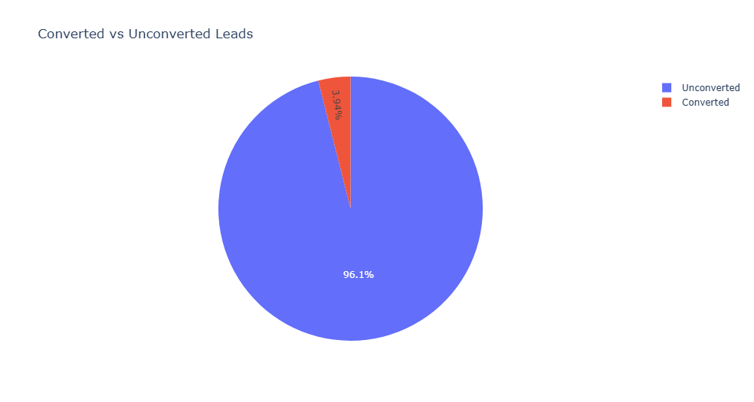

Lead by Course vs Channel Group

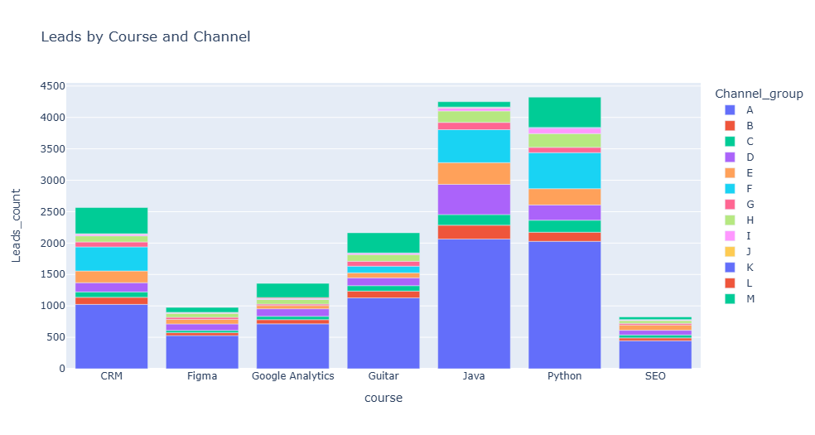

Payment Delay Distribution



