Article
Spatial validation and clinical association of a plasma-secretory bone marrow program in multiple myeloma
Zhuang Jiang
1. Guangdong University of Petrochemical Technology (GDUPT), 139 Guandu 2nd Road, Maoming 525000, Guangdong, China
ORCID: https://orcid.org/0009-0007-4388-5901

Abstract
Background: Multiple myeloma develops within a spatially organized bone marrow niche. Bulk genomic studies have defined molecular subtypes and risk features, but the spatial localization and clinical relevance of transcriptional programs remain less clear.
Methods: We integrated public spatial transcriptomics, Xenium spatial profiling, single-cell RNA sequencing, external bulk cohorts, MMRF-COMMPASS/GDC RNA-seq, and public CoMMpass molecular annotations. Module scores were tested across GSE269875, GSE299193, GSE271107, GSE24080, GSE2658, CoMMpass/GDC, and NG2024/Skerget public CoMMpass supplementary annotations. Survival associations were evaluated using log-rank tests and Cox proportional hazards models adjusted for age, sex, ISS stage, and 1q21 status.
Results: In GSE269875, the plasma-secretory score was higher in myeloma than control bone marrow, with sample-level median difference 0.709, Cohen's d 3.129, and Mann-Whitney p=0.0256. Independent Xenium validation in GSE299193 reproduced this program-level signal across 22 samples; active myeloma or relapsed myeloma samples had higher plasma-secretory scores than Ctrl/MGUS/SM samples, with median difference 0.766 and FDR=5.75e-04. In GSE271107 single-cell data, TXNDC5 was consistently expressed in marker-inferred plasma cells. The POU2AF1/XBP1/JCHAIN module was associated with 1q21 amplification in GSE2658, and XBP1 was associated with 24-month overall survival death in GSE24080. In 762 baseline MMRF-COMMPASS/GDC CD138+ RNA-seq samples, the plasma-secretory score was associated with overall survival event, ISS stage, and median-split survival. Public NG2024 annotations linked the score to PR RNA-subtype probability and 1q21 gain or amplification. In an adjusted Cox model, the score remained associated with overall survival, with hazard ratio 1.460 per standard deviation, 95% CI 1.069-1.993, and FDR=0.0445.
Conclusions: These results support a reproducible plasma-secretory bone marrow program in multiple myeloma. TXNDC5 is best framed as a spatial and single-cell localization candidate, whereas POU2AF1, XBP1, and JCHAIN better support the clinical subtype axis. Current public data do not complete R-ISS, PFS, or treatment-response validation.
Keywords: multiple myeloma; spatial transcriptomics; Xenium; single-cell RNA-seq; CoMMpass; overall survival; 1q21

1. Introduction
Multiple myeloma is a plasma-cell malignancy of the bone marrow. Its clinical course varies widely across patients. Genomic profiling has linked this heterogeneity to recurrent copy-number events, structural alterations, and expression subtypes [1-9]. These bulk profiles are clinically informative. They also lose spatial context.
The bone marrow niche is not uniform. Malignant plasma cells coexist with immune, stromal, endothelial, and hematopoietic compartments. Spatial organization may shape local transcriptional states. It may also influence disease progression. Spatial and single-cell technologies can resolve this context [10,11]. However, most public spatial datasets remain small and clinically sparse.
A defensible translational analysis must therefore connect several evidence layers. Spatial data can identify a tissue-level program. Single-cell data can localize the program. Bulk clinical cohorts can test outcome and risk associations. Molecular annotation can then place the program within known myeloma biology [12].
We applied this strategy to public multiple myeloma datasets. The initial spatial discovery analysis identified a plasma-secretory program enriched in myeloma bone marrow. This program included canonical plasma-cell and secretory pathway genes. Such biology is expected in myeloma, so a single-gene biomarker claim would be weak. We therefore framed the project around a broader plasma-secretory subtype axis.
Within this framework, TXNDC5 serves as a localization candidate. It links the spatial discovery result to plasma-cell expression in single-cell data. POU2AF1, XBP1, and JCHAIN form a more clinically useful subtype module. We tested this axis across spatial, Xenium, single-cell, bulk, and CoMMpass evidence layers.

2. Materials and Methods

2.1. Study design
This was a retrospective public-data integrative analysis. The workflow used six evidence layers and was designed as a claim-bounded evidence chain rather than as a de novo clinical biomarker study.
The layers were spatial discovery, second spatial validation, single-cell localization, external bulk validation, CoMMpass/GDC validation, and NG2024 annotation [1,10,11,13-20].
The primary biological construct was a plasma-secretory bone marrow program. The clinical module contained POU2AF1, XBP1, and JCHAIN.
TXNDC5 was evaluated as a spatial and single-cell localization candidate. It was not treated as a standalone prognostic classifier.
All analyses used public data or open processed resources. No private MMRF clinical table was used for completed claims.
Analyses were run with Python 3.13.9. Key packages were pandas 2.3.3, numpy 2.3.5, scipy 1.16.3, matplotlib 3.10.6, scanpy 1.12, seaborn 0.13.2, statsmodels 0.14.5, and h5py 3.15.1 [21,22].

2.2. Score construction and missing-data rules
Expression values were analyzed in the normalized scale available for each public dataset or after log transformation where count-like values were provided. Within each cohort, gene-level values used for module scoring were standardized before score construction.
Module scores were calculated as the mean of available standardized genes. Genes absent from a platform were not imputed. A module was scored only when at least one prespecified gene was present, and platform coverage was reported when absent genes affected interpretation.
For spatial and Xenium datasets, spot-level or cell-level gene values were summarized to sample-level scores before group comparisons. For single-cell data, candidate genes and module scores were summarized by marker-inferred cell category and sample-aware strata where available.
Missing clinical, cytogenetic, subtype, or covariate fields were handled by endpoint-specific complete-case analysis. Denominators therefore differ across analyses and are reported with each result when they affect interpretation.

2.3. Spatial discovery
GSE269875 human bone marrow spatial matrices were used for discovery [15]. Processed matrices were checked with scripts/08_processed_spatial_matrix_qc.py.
Preliminary clustering and marker summaries were generated with scripts/09_preliminary_spatial_clustering.py.
Sample-aware program discovery used scripts/10_sample_aware_spatial_signatures.py. The analysis scored curated marrow and immune programs.
Programs included plasma-secretory, myeloid-inflammatory, T/NK cytotoxic, stromal, endothelial, erythroid, and cycling states.
Scores were summarized at sample level. MM and control samples were compared using median differences, Cohen's d, and Mann-Whitney tests.
Spatial discovery outputs were stored in analysis/spatial_candidate_signatures.

2.4. Xenium validation
GSE299193 raw Xenium files were downloaded from GEO [10,16]. The raw tar file matched the expected byte size.
Validation used scripts/18_gse299193_xenium_validation.py. The script avoided full extraction of large image and transcript files.
Only cell_feature_matrix.h5 files and lightweight cell metadata were extracted. Twenty-two matrices were included.
Sample groups were Ctrl, MGUS, SM, MM, and RM. Active disease was defined as MM or RM.
Non-active comparison samples were Ctrl, MGUS, and SM. Sample-level scores used genes present in each Xenium matrix.
The panel-covered clinical module used POU2AF1 and XBP1. TXNDC5, JCHAIN, and SDC1 were absent from these matrices.
Active and non-active samples were compared using Mann-Whitney tests. FDR was controlled across the Xenium association family.
Outputs were stored in analysis/gse299193_xenium_validation.

2.5. Single-cell localization
GSE271107 single-cell RNA-seq data were used for localization [11,17]. The workflow used scripts/11_gse271107_scrna_validation.py.
Cells were summarized by marker-inferred broad cell categories. Candidate genes and module scores were compared across compartments.
The primary localization endpoint was expression in marker-inferred plasma cells. Detection fraction was calculated as the fraction above zero.
Single-cell outputs were stored in analysis/scrna_gse271107_validation.

2.6. Bulk validation
GSE24080 and GSE2658 were used as external bulk expression cohorts [18,19,23,24]. Initial analyses used scripts/12_bulk_clinical_validation.py.
The clinical subtype refinement used scripts/13_plasma_secretory_subtype_refinement.py. That step centered POU2AF1, XBP1, and JCHAIN.
Available clinical and cytogenetic annotations were parsed from public sample records. These included 24-month OS status and FISH 1q21 amplification.
Mann-Whitney tests compared binary endpoint groups. Median-split Fisher tests were used for binary high-versus-low score summaries.
Where time-to-event information was available, log-rank tests were used. FDR correction was applied within tested association families.
Bulk outputs were stored in analysis/bulk_clinical_validation and analysis/plasma_secretory_subtype_refinement.

2.7. CoMMpass/GDC validation
MMRF-COMMPASS/GDC RNA-seq validation used scripts/14_commppass_gdc_validation.py [14,20].
RNA-seq files were filtered to baseline visit-1 bone marrow CD138+ samples. The final validation table contained 762 samples.
Gene-level TPM values were log-transformed and z-scored. Module scores were calculated as mean z scores across available genes.
OS event associations used Mann-Whitney tests. ISS ordinal associations used Spearman correlation.
Median-split survival analyses used log-rank tests. FDR correction was applied across the CoMMpass association family.
CoMMpass/GDC outputs were stored in analysis/commppass_gdc_validation.

2.8. NG2024 molecular annotation
Public Skerget et al. NG2024 supplementary tables were downloaded and audited with scripts/19_skerget_ng2024_public_supplement_audit.py [1].
Molecular annotation validation used scripts/20_skerget_ng2024_molecular_annotation_validation.py.
Tables were joined by CoMMpass patient identifier. Supplementary Table 1 matched all 762 local baseline samples.
RNA-subtype probability analyses used complete cases. The PR subtype association contained 707 complete samples.
Associations tested RNA subtype, 1q21 gain or amplification, 17p13 deletion, and cytogenetic high-risk features.
Continuous subtype probabilities used Spearman correlation. Binary annotations used Mann-Whitney tests.
Categorical RNA subtype tests used Kruskal-Wallis tests. FDR correction used the Benjamini-Hochberg method.
Adjusted models used scripts/21_commppass_ng2024_adjusted_models.py. Cox models used statsmodels proportional hazards regression.
The prespecified OS model adjusted for age, sex, ISS stage, and 1q21 status. Logistic and linear models used analogous covariates.
NG2024 outputs were stored in analysis/skerget_ng2024_public_supplement and analysis/commppass_ng2024_adjusted_models.

2.9. Statistical analysis
All tests were two-sided unless stated otherwise. No parametric distribution was assumed for group comparisons.
Mann-Whitney tests compared continuous scores between binary groups. Spearman correlation tested ordinal or monotonic associations.
Kruskal-Wallis tests compared scores across RNA-subtype categories. Fisher exact tests assessed median-split binary score summaries.
Survival analyses used log-rank tests and Cox proportional hazards models. Cox models reported hazard ratios per one-standard-deviation score [25].
Logistic models reported odds ratios per one-standard-deviation score. Linear models reported beta coefficients for continuous subtype probabilities.
Multiple testing was controlled using Benjamini-Hochberg FDR. FDR correction was applied within each analysis family [26].
Analysis families were defined by cohort and endpoint class. Separate FDR families were used for spatial discovery, Xenium validation, single-cell localization, external bulk associations, CoMMpass/GDC clinical associations, NG2024 molecular annotations, and adjusted model families.
The adjusted OS model used samples with complete age, sex, ISS, 1q21, OS time, and OS event fields.
The primary adjusted Cox model tested OS as a retrospective association endpoint. It was not trained, tuned, or validated as a prospective risk-prediction model.
Schoenfeld residual screening did not detect an FDR-significant PH violation for the primary score terms. The 1q21 covariate showed time-related residual structure.
Cox results are therefore reported as adjusted association models. They are not presented as prospective risk-prediction models.

2.10. Figure generation and integrity checks
Manuscript figures were generated with scripts/15_build_manuscript_figures.py. Outputs were stored in analysis/manuscript_figures.
The cross-cohort evidence table was generated with the same script. It links each evidence layer to a primary statistic.
Numeric traceability was checked in reports/review/STAGE2_NUMERIC_INTEGRITY_CHECK_2026-04-30.md.
A supplementary reproducibility appendix lists accession-level inputs, main scripts, output directories, and figure-panel traceability.

3. Results

3.1. Cross-cohort design defined a bounded evidence chain
The study was organized as a sequential evidence chain rather than as a single-cohort biomarker screen (Fig. 1). Spatial discovery was performed in GSE269875, independent spatial reproducibility was tested in GSE299193 Xenium data, single-cell localization was assessed in GSE271107, external bulk support was evaluated in GSE24080 and GSE2658, and clinical and molecular-risk associations were tested in MMRF-COMMPASS/GDC and public NG2024 CoMMpass annotations.
Table 1 summarizes the evidence levels and the claim boundary assigned to each dataset. The complete editable Table 1 is provided in the submission package rather than embedded in the running text to preserve manuscript readability. The analysis supports a spatially reproducible and clinically associated plasma-secretory program. It does not establish a prospective clinical classifier, a treatment-selection marker, or completed R-ISS, PFS, or treatment-response validation.

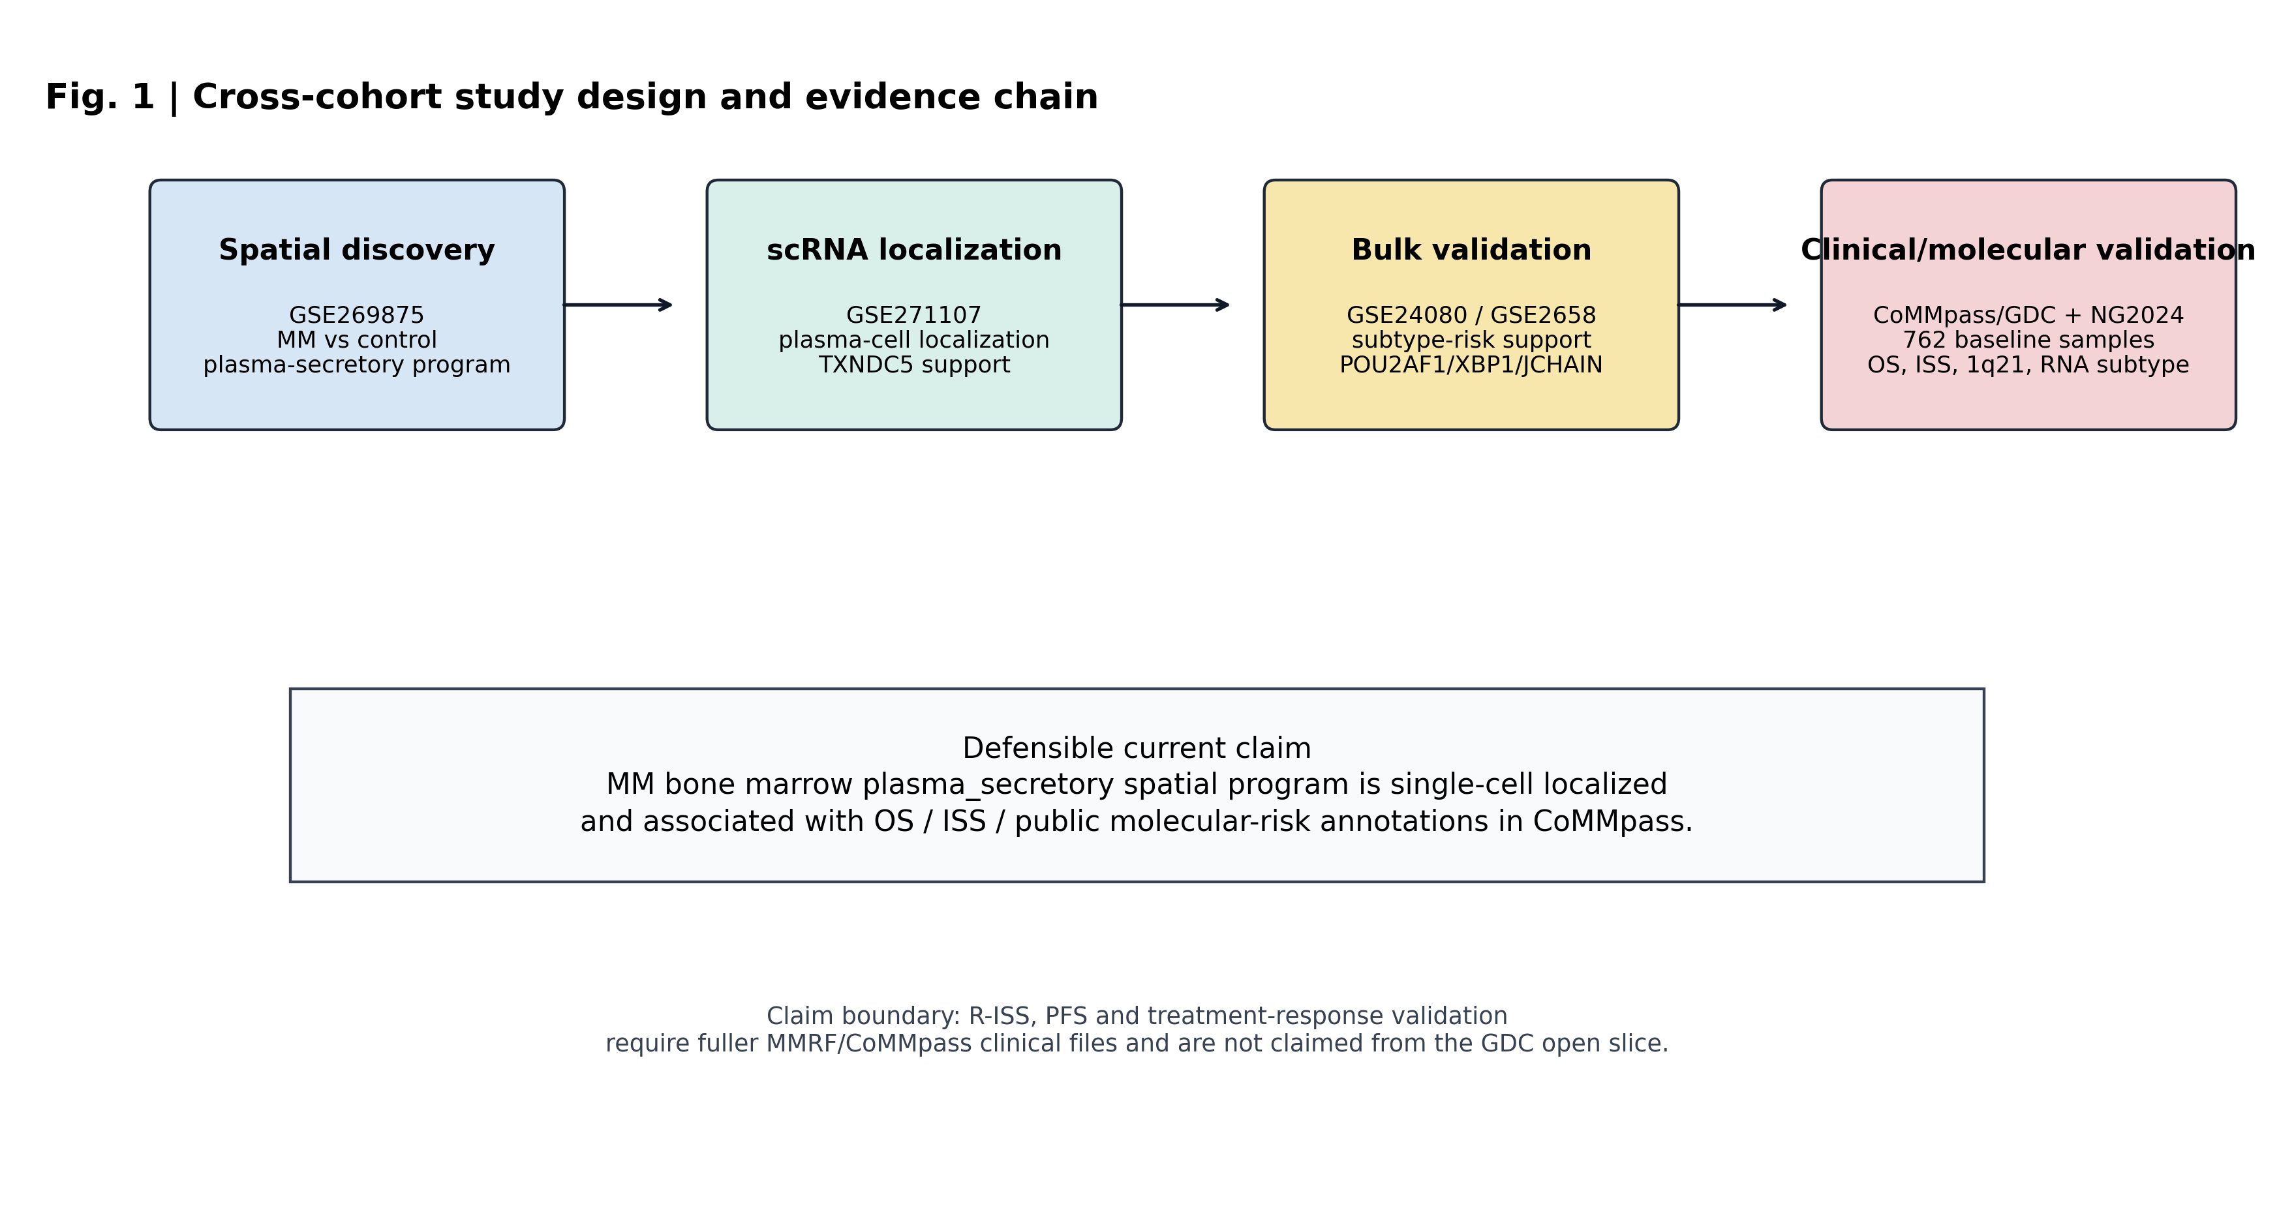
Figure 1. Cross-cohort study design and evidence chain. The workflow starts with spatial discovery in GSE269875. It then tests independent spatial reproducibility in GSE299193 Xenium data. Single-cell localization is evaluated in GSE271107. External bulk support is evaluated in GSE24080 and GSE2658. Clinical and molecular validation uses MMRF-COMMPASS/GDC RNA-seq and public NG2024 CoMMpass annotations. The lower annotation summarizes the current claim boundary. The study supports a spatially reproducible and clinically associated program. It does not establish a prospective treatment-selection biomarker.

Table 1. Cross-cohort evidence chain and manuscript claim boundary
Evidence layer | Figure | Cohort | Main result | Claim boundary
Study design | Fig. 1 | Seven public/open data resources | Sequential spatial, single-cell, bulk, and molecular annotation workflow | Integrative public-data framework
Spatial discovery | Fig. 2 | GSE269875, 9 spatial samples | MM-control plasma-secretory median difference 0.709; Cohen's d 3.129; p=0.0256 | Discovery signal
Second spatial validation | Fig. 6 | GSE299193, 22 Xenium samples | Active MM/RM versus Ctrl/MGUS/SM median difference 0.766; FDR=0.000575 | Program-level spatial validation
Single-cell localization | Fig. 3 | GSE271107, 8007 cells | TXNDC5 detected in 94.86% of marker-inferred plasma-cell observations | Localization support
External bulk support | Fig. 4 | GSE2658 and GSE24080 | Clinical module associated with 1q21 amplification; XBP1 associated with 24-month OS death | Subtype/risk association
CoMMpass/GDC clinical association | Fig. 5 | 762 baseline CD138+ RNA-seq samples | Plasma-secretory score associated with OS event, ISS stage, and median-split OS | Retrospective clinical association
Public NG2024 annotation | Fig. 5 | Public CoMMpass molecular annotations | Score associated with PR subtype probability and 1q21 gain/amplification | Molecular-risk context
Adjusted models | Fig. 5 | 660 complete cases | OS HR 1.460 per 1-SD plasma-secretory score after age, sex, ISS, and 1q21 adjustment | Covariate-adjusted association
Note: Table 1 is intended as a main manuscript table. It may be uploaded as a separate editable table file or inserted near the end of the manuscript after final journal formatting decisions.

3.2. Spatial transcriptomics identified the plasma-secretory program (Fig. 2)
In GSE269875, sample-level module scoring showed that the plasma-secretory program was the most enriched curated program in myeloma bone marrow spatial samples. Myeloma samples had higher plasma-secretory scores than control bone marrow samples, with a median difference of 0.709, Cohen's d of 3.129, and Mann-Whitney p=0.0256 (Fig. 2A,B).
The spatial candidate ranking also prioritized plasma-cell and secretory-pathway genes, including XBP1, TXNDC5, POU2AF1, SDC1, MZB1, and JCHAIN (Fig. 2C). This result defined the discovery axis used in later analyses. It was not interpreted as evidence that any single gene is a standalone clinical biomarker.

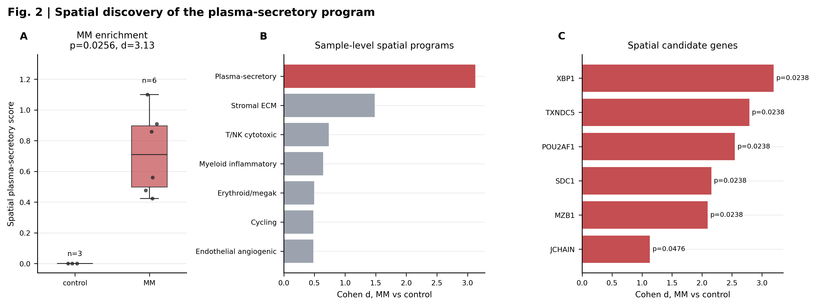
Figure 2. Spatial discovery of the plasma-secretory program in GSE269875. A, Sample-level plasma-secretory scores in MM and control bone marrow spatial samples. The comparison uses median difference, Cohen's d, and a Mann-Whitney test. B, Effect-size ranking of curated spatial programs. Programs include plasma-secretory, myeloid-inflammatory, T/NK cytotoxic, stromal, endothelial, erythroid, and cycling signatures. C, Candidate gene ranking within the spatial discovery analysis. Plasma-cell and secretory genes include XBP1, TXNDC5, POU2AF1, SDC1, MZB1, and JCHAIN.

3.3. Single-cell data localized the axis to plasma-cell compartments (Fig. 3)
GSE271107 single-cell RNA-seq data were used to localize the spatial program across marker-inferred cell categories. Plasma-cell compartments showed the strongest plasma-secretory program score among broad cell groups (Fig. 3B).
TXNDC5 was consistently expressed in marker-inferred plasma cells, with mean log-normalized expression 2.196 and detection fraction 94.86% across summarized plasma-cell observations (Fig. 3A). This supports TXNDC5 as a spatial and single-cell localization candidate within the plasma-secretory axis. It does not support presenting TXNDC5 as a standalone prognostic biomarker.

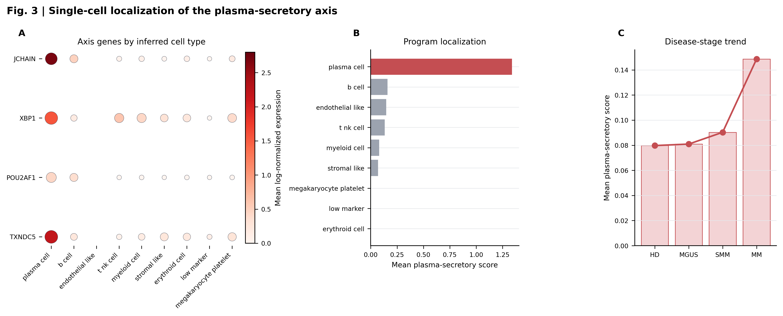
Figure 3. Single-cell localization of the plasma-secretory axis in GSE271107. A, Candidate gene expression across marker-inferred cell types. Dot size represents detection fraction. Color represents mean log-normalized expression. B, Plasma-secretory program localization across broad cell categories. Plasma-cell compartments show the strongest program enrichment. C, Disease-stage trend summary for the axis. The plot provides localization support rather than a survival endpoint. TXNDC5 is interpreted as a plasma-cell localization candidate. It is not treated as a standalone prognostic biomarker.

3.4. External bulk cohorts supported a clinical subtype module (Fig. 4)
External GEO bulk cohorts were used to test whether the spatially identified axis connected to clinical or cytogenetic annotations outside the spatial datasets. In GSE2658, the POU2AF1/XBP1/JCHAIN module was associated with FISH 1q21 amplification (FDR=1.65e-05). In GSE24080, XBP1 was associated with 24-month overall survival death (FDR=0.0362; Fig. 4).
These findings supported the use of a broader clinical subtype module rather than a TXNDC5-only interpretation. Because the GSE2658 module effect direction was not identical to the CoMMpass direction, this result is described as external association support rather than uniform directional replication across all platforms.

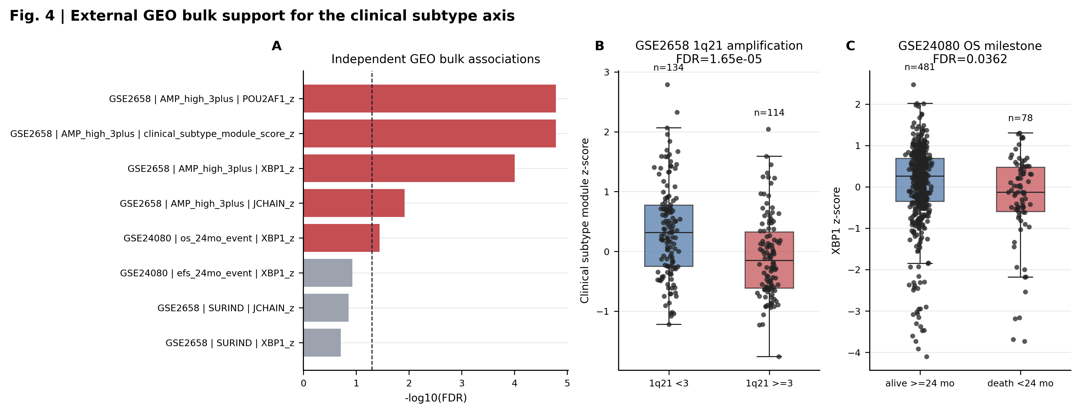
Figure 4. External GEO bulk support for the clinical subtype axis. A, Ranked association statistics from GSE24080 and GSE2658. The panel summarizes tested gene, module, cytogenetic, and outcome associations. B, GSE2658 association between the POU2AF1/XBP1/JCHAIN clinical subtype module and FISH 1q21 amplification. The result is interpreted as an association, not as directional replication across every platform. C, GSE24080 association between XBP1 and 24-month OS death. The analysis uses public milestone outcome annotation.

3.5. CoMMpass/GDC linked the axis to OS, ISS, and molecular risk (Fig. 5)
The axis was next evaluated in 762 baseline MMRF-COMMPASS/GDC bone marrow CD138+ RNA-seq samples. The plasma-secretory score was associated with overall survival event, with event-versus-nonevent median difference 0.346 and FDR=9.31e-06 (Fig. 5A,B). Median-split survival analysis also supported an OS association, with log-rank p=0.00668 and FDR=0.0401 (Fig. 5C).
The same score showed an ordinal association with ISS stage (Spearman rho=0.132, p=0.000316, FDR=0.0019). These analyses link the axis to retrospective clinical risk features, but they do not test R-ISS, PFS, or treatment response.
Public NG2024 CoMMpass molecular annotations further placed the axis in a known molecular-risk context. Local baseline CoMMpass samples matched public Supplementary Table 1 for 762 of 762 patients, and 707 complete cases were available for RNA-subtype probability analyses. The plasma-secretory score correlated with PR RNA-subtype probability (Spearman rho=0.340, FDR=5.43e-19) and was higher in samples with 1q21 gain or amplification (median difference 0.268, FDR=1.24e-05; Fig. 5E,F).
Gene-level NG2024 analyses were consistent with the candidate framing. TXNDC5 expression was associated with 1q21 gain or amplification (median difference 0.231, FDR=0.00843), and POU2AF1 was associated with 17p13 deletion (median difference 0.337, FDR=0.00533). These observations provide molecular annotation support for the axis, not a completed clinical assay.

3.6. Adjusted models supported covariate-adjusted OS association (Fig. 5D)
Finally, we tested whether the CoMMpass survival association persisted after basic adjustment. The prespecified Cox model included age, sex, ISS stage, and 1q21 status. In 660 complete cases, the plasma-secretory score remained associated with overall survival, with hazard ratio 1.460 per standard deviation, 95% CI 1.069-1.993, p=0.0173, and FDR=0.0445 (Fig. 5D).
The POU2AF1/XBP1/JCHAIN clinical module showed a similar adjusted association, with hazard ratio 1.434, 95% CI 1.090-1.886, and FDR=0.0299. A logistic model also linked the plasma-secretory score to 1q21 status after adjustment for age, sex, and ISS, with odds ratio 1.873 per standard deviation and FDR=0.000213. These models support covariate-adjusted association. They do not establish clinical utility or prospective risk-prediction performance.

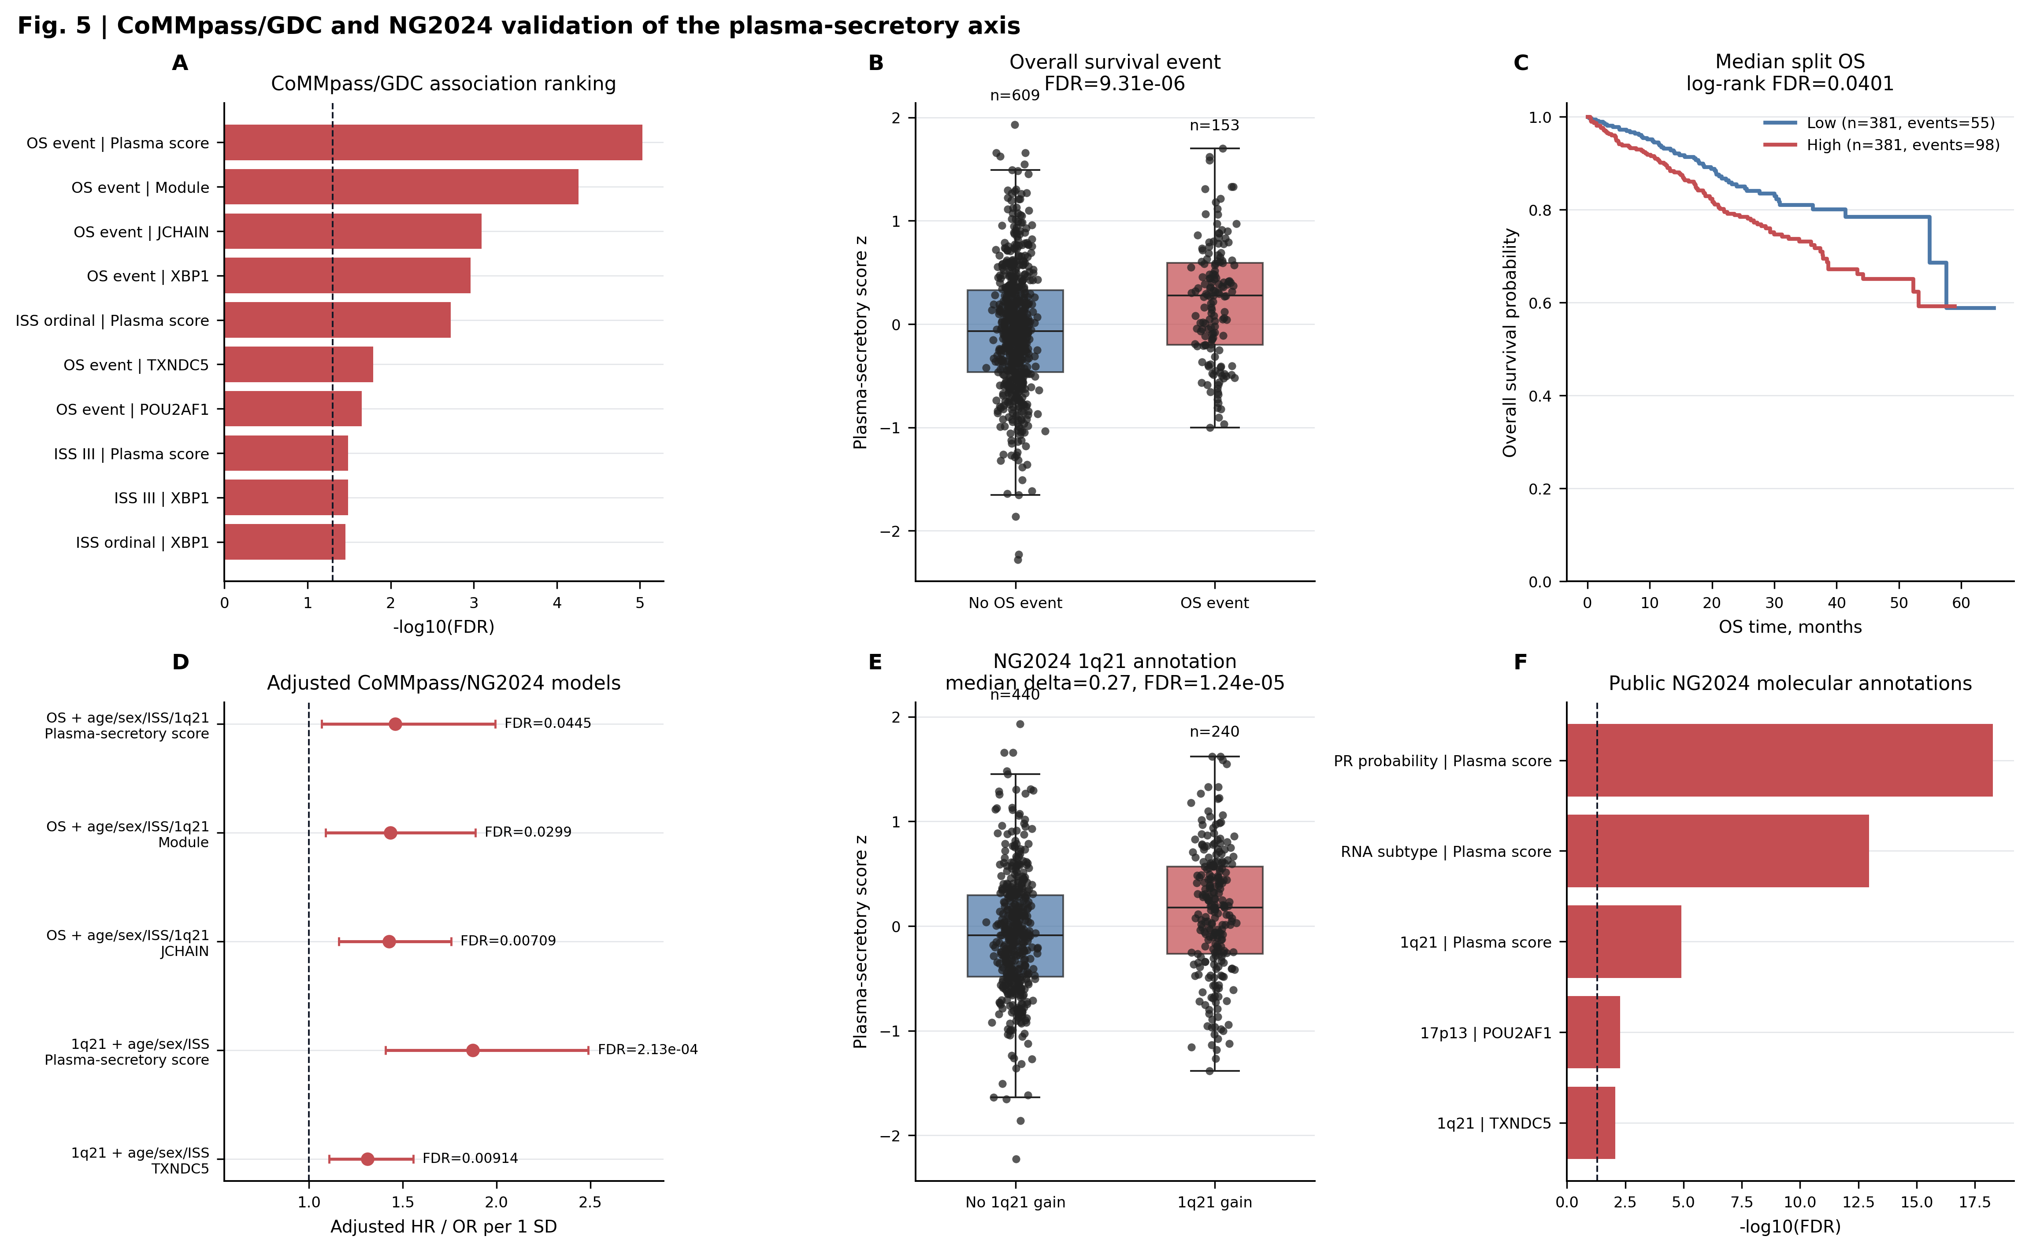
Figure 5. CoMMpass/GDC clinical validation and public NG2024 molecular annotation. A, CoMMpass/GDC association ranking for plasma-secretory and related gene scores. The cohort contains baseline visit-1 bone marrow CD138+ RNA-seq samples. B, Plasma-secretory score distribution by OS event status. The comparison uses a Mann-Whitney test with FDR correction. C, Median-split overall survival analysis. The survival comparison uses a log-rank test. D, Adjusted CoMMpass/NG2024 models. Cox models estimate OS association after adjustment for age, sex, ISS, and 1q21. E, NG2024 1q21 copy-number annotation association. Public CoMMpass molecular annotations are joined to local RNA-seq scores by patient identifier. F, Public NG2024 molecular annotation summary. The panel links the axis to PR RNA subtype probability and molecular-risk features. These analyses support adjusted association. They do not prove clinical utility.

3.7. Independent Xenium data reproduced the program-level spatial signal (Fig. 6)
The spatial discovery signal was then tested in GSE299193, an independent Xenium dataset containing 22 human bone marrow samples from Ctrl, MGUS, SM, MM, and relapsed MM groups. Active MM/RM samples showed higher plasma-secretory scores than Ctrl/MGUS/SM samples, with a median difference of 0.766, Mann-Whitney p=0.000182, and FDR=0.000575 (Fig. 6, left).
A Xenium panel-covered POU2AF1/XBP1 module showed a concordant active-disease pattern, with median difference 1.068, p=0.000287, and FDR=0.000575 (Fig. 6, middle). The extracted Xenium matrices contained MZB1, TNFRSF17, SLAMF7, IRF4, PIM2, POU2AF1, and XBP1, but not TXNDC5, JCHAIN, or SDC1 (Fig. 6, right). GSE299193 therefore strengthens the spatial reproducibility claim at program level, while not directly validating the absent genes.

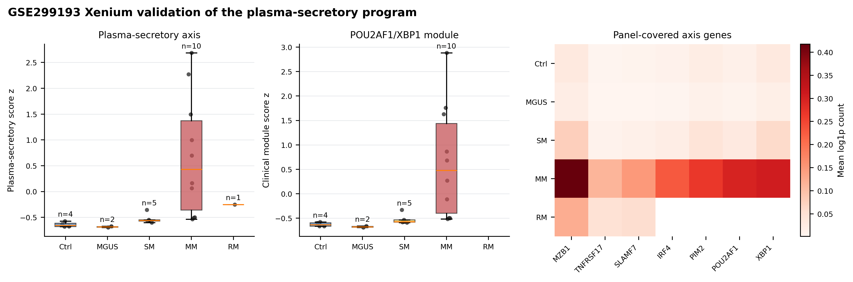
Figure 6. Independent GSE299193 Xenium spatial validation. Left panel, sample-level plasma-secretory scores across Ctrl, MGUS, SM, MM, and RM groups. Active disease is defined as MM or RM. Middle panel, panel-covered POU2AF1/XBP1 module scores across disease groups. The module is calculated only from genes present in the Xenium feature matrices. Right panel, heatmap of axis genes covered by the Xenium panel. Covered genes include MZB1, TNFRSF17, SLAMF7, IRF4, PIM2, POU2AF1, and XBP1. TXNDC5, JCHAIN, and SDC1 are absent from the extracted Xenium matrices. GSE299193 therefore validates the program-level spatial signal. It does not directly validate those absent genes.

4. Discussion
This study identifies a plasma-secretory bone marrow program in multiple myeloma. The program was discovered in spatial transcriptomics. It was reproduced in an independent Xenium cohort. It localized to plasma-cell compartments in single-cell data. It was also associated with survival, ISS, RNA subtype, and 1q21 status in bulk cohorts.
The main contribution is cross-platform coherence. Plasma-cell biology alone is not novel in myeloma. The stronger finding is that a spatially enriched program connects to clinical and molecular-risk annotations. This connection persists after basic adjustment for age, sex, ISS, and 1q21.
The analysis also clarifies the role of TXNDC5. TXNDC5 is supported by spatial discovery and single-cell localization. It should be presented as a localization candidate. The clinical risk signal is better carried by the broader axis. POU2AF1, XBP1, and JCHAIN are more suitable for clinical-subtype framing.
GSE299193 materially strengthens the spatial component. It reduces dependence on the small GSE269875 discovery cohort. However, the Xenium panel lacks TXNDC5, JCHAIN, and SDC1. This limits gene-level validation. The result should therefore be described as program-level spatial validation.
Several limitations remain. First, this is a retrospective public-data analysis. Second, single-cell labels were marker-inferred rather than harmonized with a full reference atlas. Third, external bulk cohorts differ in platform and endpoint definitions. Fourth, the axis may partly reflect plasma-cell abundance. Fifth, public GDC and NG2024 files did not support complete PFS, R-ISS, or treatment-response validation.
These limitations define the next extension. Fuller MMRF clinical files could test PFS, R-ISS, treatment response, and therapy-line effects. Until then, the current manuscript should make a bounded claim. The data support a spatially reproducible, plasma-cell localized, clinically associated program. They do not support a prospective classifier or treatment-selection biomarker.

5. Conclusions
This public-data integrative analysis supports a plasma-secretory bone marrow program in multiple myeloma. The program was spatially enriched in GSE269875 and reproduced at program level in GSE299193 Xenium data. Single-cell data localized the axis to plasma-cell compartments. CoMMpass/GDC and NG2024 annotations connected the axis to OS, ISS, PR subtype probability, and 1q21 status. TXNDC5 should be framed as a localization candidate. POU2AF1, XBP1, and JCHAIN are more suitable for clinical subtype framing.

Declarations

Ethics approval and consent to participate
Not applicable. This study analyzed publicly available, de-identified datasets and did not involve new recruitment of human participants, new collection of human specimens, or access to directly identifiable private information.

Consent for publication
Not applicable.

Availability of data and materials
The datasets supporting the conclusions of this article are available in public repositories. Spatial discovery used GEO accession GSE269875. Xenium spatial validation used GEO accession GSE299193. Single-cell validation used GEO accession GSE271107. Bulk validation used GEO accessions GSE24080 and GSE2658. CoMMpass/GDC RNA-seq and open clinical data were obtained from the NCI Genomic Data Commons MMRF-COMMPASS project. Public CoMMpass molecular annotations were obtained from the supplementary tables of Skerget et al. Nature Genetics 2024. Dataset accessions and primary source links are listed in the References.

Code availability
Analysis scripts, compact result tables, manuscript figures, and validation reports are publicly available at https://github.com/1627626277-cyber/secondary.

Competing interests
The author declares that there are no competing interests.

Funding
No specific funding was received for this work.

Authors' contributions
Z.J. conceived the study, designed the analysis strategy, curated public datasets, interpreted the results, prepared the manuscript, and approved the submitted version. This statement should be revised if additional authors are added before submission.

Acknowledgements
The author(s) acknowledge the investigators and participants associated with the public GEO, GDC, and CoMMpass resources used in this study.

References
1. Skerget S, Penaherrera D, Chari A, Jagannath S, Siegel DS, Vij R, et al. Comprehensive molecular profiling of multiple myeloma identifies refined copy number and expression subtypes. Nat Genet. 2024;56(9):1878-1889. doi:10.1038/s41588-024-01853-0.
2. Maura F, Bolli N, Angelopoulos N, Dawson KJ, Leongamornlert D, Martincorena I, et al. Genomic landscape and chronological reconstruction of driver events in multiple myeloma. Nat Commun. 2019;10(1):3835. doi:10.1038/s41467-019-11680-1.
3. Palumbo A, Avet-Loiseau H, Oliva S, Lokhorst HM, Goldschmidt H, Rosinol L, et al. Revised International Staging System for Multiple Myeloma: A Report From International Myeloma Working Group. J Clin Oncol. 2015;33(26):2863-2869. doi:10.1200/JCO.2015.61.2267.
4. Rajkumar SV, Dimopoulos MA, Palumbo A, Blade J, Merlini G, Mateos MV, et al. International Myeloma Working Group updated criteria for the diagnosis of multiple myeloma. Lancet Oncol. 2014;15(12):e538-e548. doi:10.1016/S1470-2045(14)70442-5.
5. Chapman MA, Lawrence MS, Keats JJ, Cibulskis K, Sougnez C, Schinzel AC, et al. Initial genome sequencing and analysis of multiple myeloma. Nature. 2011;471(7339):467-472. doi:10.1038/nature09837.
6. Rajkumar SV. Multiple myeloma: 2022 update on diagnosis, risk stratification, and management. Am J Hematol. 2022;97(8):1086-1107. doi:10.1002/ajh.26590.
7. Greipp PR, San Miguel J, Durie BG, Crowley JJ, Barlogie B, Blade J, et al. International staging system for multiple myeloma. J Clin Oncol. 2005;23(15):3412-3420. doi:10.1200/JCO.2005.04.242.
8. Zhan F, Huang Y, Colla S, Stewart JP, Hanamura I, Gupta S, et al. The molecular classification of multiple myeloma. Blood. 2006;108(6):2020-2028. doi:10.1182/blood-2005-11-013458.
9. Hanamura I, Stewart JP, Huang Y, Zhan F, Santra M, Sawyer JR, et al. Frequent gain of chromosome band 1q21 in plasma-cell dyscrasias detected by fluorescence in situ hybridization: incidence increases from MGUS to relapsed myeloma and is related to prognosis and disease progression following tandem stem-cell transplantation. Blood. 2006;108(5):1724-1732. doi:10.1182/blood-2006-03-009910.
10. Yip RKH, Er J, Qin L, Nguyen QH, Motyer A, Rimes JS, et al. Profiling the spatial architecture of multiple myeloma in human bone marrow trephine biopsy specimens with spatial transcriptomics. Blood. 2025;146(15):1837-1849. doi:10.1182/blood.2025028896.
11. Yu W, Zhan J, Wang Y, Cao X, Yu A, Rao Y, et al. Single-cell transcriptomics identifies PDIA4 as a marker of progression and therapeutic vulnerability in multiple myeloma. J Transl Med. 2025;23(1):1136. doi:10.1186/s12967-025-07098-7.
12. McShane LM, Altman DG, Sauerbrei W, Taube SE, Gion M, Clark GM, et al. Reporting recommendations for tumor marker prognostic studies (REMARK). J Natl Cancer Inst. 2005;97(16):1180-1184. doi:10.1093/jnci/dji237.
13. Barrett T, Wilhite SE, Ledoux P, Evangelista C, Kim IF, Tomashevsky M, et al. NCBI GEO: archive for functional genomics data sets - update. Nucleic Acids Res. 2013;41(Database issue):D991-D995. doi:10.1093/nar/gks1193.
14. Zhang Z, Hernandez K, Savage J, Li S, Miller D, Agrawal S, et al. Uniform genomic data analysis in the NCI Genomic Data Commons. Nat Commun. 2021;12(1):1226. doi:10.1038/s41467-021-21254-9.
15. National Center for Biotechnology Information. GEO Series GSE269875: Spatial transcriptomics unveils novel potential disease mechanisms associated with the microenvironment in multiple myeloma. https://www.ncbi.nlm.nih.gov/geo/query/acc.cgi?acc=GSE269875. Accessed 1 May 2026.
16. National Center for Biotechnology Information. GEO Series GSE299193: Profiling the spatial architecture of multiple myeloma in human bone marrow trephines with spatial transcriptomics. https://www.ncbi.nlm.nih.gov/geo/query/acc.cgi?acc=GSE299193. Accessed 1 May 2026.
17. National Center for Biotechnology Information. GEO Series GSE271107: Single-cell RNA sequencing of bone marrow aspirate samples from multiple myeloma and its precursor conditions. https://www.ncbi.nlm.nih.gov/geo/query/acc.cgi?acc=GSE271107. Accessed 1 May 2026.
18. National Center for Biotechnology Information. GEO Series GSE24080: MAQC-II Project: Multiple myeloma data set. https://www.ncbi.nlm.nih.gov/geo/query/acc.cgi?acc=GSE24080. Accessed 1 May 2026.
19. National Center for Biotechnology Information. GEO Series GSE2658: Gene expression profiles of multiple myeloma. https://www.ncbi.nlm.nih.gov/geo/query/acc.cgi?acc=GSE2658. Accessed 1 May 2026.
20. National Cancer Institute Genomic Data Commons. Multiple Myeloma Research Foundation CoMMpass Study. https://gdc.cancer.gov/about-gdc/contributed-genomic-data-cancer-research/foundation-medicine/multiple-myeloma-research-foundation-mmrf. Accessed 1 May 2026.
21. Wolf FA, Angerer P, Theis FJ. SCANPY: large-scale single-cell gene expression data analysis. Genome Biol. 2018;19(1):15. doi:10.1186/s13059-017-1382-0.
22. Seabold S, Perktold J. Statsmodels: econometric and statistical modeling with Python. Proceedings of the 9th Python in Science Conference. 2010;92-96. https://www.statsmodels.org/. Accessed 1 May 2026.
23. Shi L, Campbell G, Jones WD, Campagne F, Wen Z, Walker SJ, et al. The MicroArray Quality Control (MAQC)-II study of common practices for the development and validation of microarray-based predictive models. Nat Biotechnol. 2010;28(8):827-838. doi:10.1038/nbt.1665.
24. Liu Q, Sung AH, Chen Z, Liu J, Huang X, Deng Y. Feature selection and classification of MAQC-II breast cancer and multiple myeloma microarray gene expression data. PLoS One. 2009;4(12):e8250. doi:10.1371/journal.pone.0008250.
25. Cox DR. Regression models and life-tables. J R Stat Soc Series B Stat Methodol. 1972;34:187-220.
26. Benjamini Y, Hochberg Y. Controlling the false discovery rate: a practical and powerful approach to multiple testing. J R Stat Soc Series B Stat Methodol. 1995;57:289-300. doi:10.1111/j.2517-6161.1995.tb02031.x.

