中国矿业大学

**课程设计**

**课程名称： 《数据库与信息系统基础》课程设计**

**学 院： 环境与测绘学院 专 业： 地理信息科学**

**姓 名： 李熙健 学 号： 08203711**

**年 级： 2020级 任课教师： 张华**

**2022年 2月 18日**

# 目录

目录.....................................................................................................................................................1

任务书.................................................................................................................................................2

摘要.....................................................................................................................................................6

正文.....................................................................................................................................................6

第一章 概述.........................................................................................................................6

项目背景.........................................................................................................................6

编写目的.........................................................................................................................6

软件定义.........................................................................................................................6

开发环境.........................................................................................................................6

第二章 需求分析.................................................................................................................7

用户需求.........................................................................................................................7

系统功能.........................................................................................................................7

数据流图与数据字典.....................................................................................................8

第三章 软件概要设计.........................................................................................................8

系统目标.........................................................................................................................8

总体设计.........................................................................................................................8

第四章 数据库设计.............................................................................................................8

数据库概念设计.............................................................................................................8

数据库逻辑设计...........................................................................................................10

第五章 详细设计...............................................................................................................10

向导...............................................................................................................................10

登录界面.......................................................................................................................12

主界面...........................................................................................................................14

创建用户.......................................................................................................................17

修改密码.......................................................................................................................20

进货登记……...............................................................................................................24

进货表查看……...........................................................................................................30

销售登记……...............................................................................................................33

销售表查看……...........................................................................................................38

退货登记……...............................................................................................................41

退货表查看……...........................................................................................................46

添加员工……...............................................................................................................48

员工表查看……...........................................................................................................51

添加进货商…...............................................................................................................56

进货商表查看…….......................................................................................................59

员工业绩统计…….......................................................................................................64

按月度/季度员工业绩统计…......................................................................................67

商品活动轨迹（总表）...............................................................................................80

通过时间查询商品活动轨迹（通过时间查询的总表）...........................................82

第六章 用户使用说明书...................................................................................................93

第七章 结束语（附参考文献）.......................................................................................93

课程设计编号：P07203

**《数据库与信息系统基础》课程设计**

**任务书**

**学院 环境与测绘学院 专业 地理信息科学 班级 20-1班**

**学号 08203711 姓名 李熙健 指导教师 张华**

**环境与测绘学院**

**2022年 2 月 18日**

**一、课程设计目的**

《数据库与信息系统基础》课程设计是《数据库与信息系统基础》课程的后续实践性课程，是一门独立开设的实践性课程，也是毕业设计等后续课程的基础。《数据库与信息系统基础》课程设计对于巩固数据库知识，加强学生的实际动手能力和提高学生综合素质十分必要。

《数据库与信息系统基础》课程设计的主要目标是：

1、加深对数据库系统原理及程序设计的理论知识的理解和应用。

2、通过设计实际的数据库系统课题，进一步熟悉数据库管理系统的操作技术，提高动手能力，提高分析问题和解决问题的能力。

3、学习基本的数据库编程方法。掌握利用某种语言环境进行程序设计与调试的方法。（注：软件开发语言为C#或ASP或python或C++或Java或JavaScript，后台数据库为SQL server等）。

**二、选题依据**

本课程设计是对《数据库与信息系统基础》课堂教学的一个重要补充，与理论学习起着相辅相成的作用，是实施《数据库与信息系统基础》教学的一个重要组成部分。通过本课程设计，

**三、课程设计的题目要求**

能体现《数据库与信息系统基础》基本内容。

**四、课程设计的任务**

背景资料：

无论是一个销售公司还是一个销售商店，都有很多的销售数据需要管理。手工管理这些繁琐复杂的数据方式已经不适应时代的潮流，实现数据的规范化、自动化的计算机管理，是一个管理规范、运作高效的企事业单位的必然要求。本课程设计就是为了实现给销售单位高效管理而设计的。

本系统主要考虑了最为普遍的销售管理需求：

1. 进货时入库登记，以便日后查看和统计进货情况；
2. 销售时把相应数量的商品从现存商品库中减去，并记录于另外的一个销售库中，以便日后查看和统计销售信息；
3. 是销售就难免会有顾客退货情况发生，因此还需建立一个相应的退货管理，把退回来的货加入现存商品库，再从销售库中减去，进行退货登记。
4. 还要能够随时查看各种信息表，如员工信息、进货信息、销售信息、退货信息。
5. 除了以上一些基本的需求外，实际中公司用来进行决策和管理分析的数据才是用得最多的数据。因此还需要有一些相应的关于以上数据的统计信息。如希望查看各个时间段（如今日、本月、本年度等）的进货和销售情况，以便对以后的运作进行一个准确的预测和正确的决断。
6. 为了调动员工的积极性，员工的薪水应该和他的销售情况挂钩的，因此还需要能够查看各员工的销售情况，以便对他们的业绩进行考核和评比。

以上数据如果用传统的方法管理，则显得繁琐且容易出错，透明度也不高，容易使人有机可乘，造成公司账目混乱。本设计正是针对一般销售公司都有的以上需求而设计的，可以有效管理数据。

主要功能有:

1、交易管理，包括进货登记管理、销售登记管理、退货登记管理；进货统计管理，其中包括有关进货的各种统计数据表，如今日进货统计、本月进货统计、本季度进货统计、本年度销售统计等：销售统计管理，其中包括有关销售的各种统计数据表，如今日销售统计、本月销售统计、本季度销售统计、本年度销售统计等；员工销售业绩的考核，可以很方便地查看各员工的销售情况，以便对各员工的业绩进行考核比较。

2、内容：学生根据所学的数据库原理与程序设计的知识，针对销售管理信息系统，进行系统的需求分析，系统设计，数据库设计，编码，测试等，完成题目要求的功能，从而达到掌握开发一个小型数据库的目的。

3、操作过程：

1. 进行系统调查，搜集资料。
2. 进行系统需求分析和系统设计，写出系统分析和系统设计报告。
3. 设计数据库模型并进行优化，确定数据库结构、功能结构和系统安全性和完整性要求。
4. 完成数据库定义工作，实现系统数据的数据录入和数据处理。
5. 实现应用程序的设计、编程、优化功能，实现数据安全性、数据完整性和并发控制技术等功能，并针对具体课题问题提出解决方法。
6. 对系统的各个应用程序进行集成调试和测试，进一步优化系统性能，改善系统用户界面。

**五、设计技术要求**

本设计总体的系统功能是实现销售公司销售管理的系统化的功能有：规范化和自动化。

1. 系统登录：包括用户登录、添加用户、修改密码、退出系统等。
2. 交易管理：包括进货登记、销售登记、退货登记等。其中进货登记中还包含进货厂商的登记，如果是新的进货厂商，可以在此登记入库。进货和销售的主要交易都是在此进行：每次交易(包括进货、销售和退货)都需要对商品名、生产厂商、商品型号、单价、数量、总金额、交易日期、经手业务员编号等各项进行记录。
3. 进货统计：包括今日进货统计、本月进货统计、本季度进货统计、本年度进货统计等。其中每次进货统计都是按进货厂商和进货金额顺序排列的。使用一个表格显示所选时间段的全部进货数据，包括进货编号、商品名、生产厂商、产品型号、单价、数量、总金额、进货日期、业务员编号等；再使用另一表格显示分别从各个厂商进货的金额，还有一个文本框用于显示此时间段的总进货金额。
4. 销售统计：包括今日销售统计、本月销售统计、本季度销售统计、本年度销售统计等。其中每次销售统计都是按产品厂商和销售金额顺序排列的，用户可以一目了然地看出各种型号产品的销售额。使用一个表格显示所选时间段的全部销售数据，包括销售编号、商品名、生产厂商、产品型号、单价、数量、总金额、销售日期、业务员编号等；再使用另一表格分别显示各个厂商产品的销售金额，还有一个文本框用于显示此时间段的总销售金额。
5. 业绩查看：实现各员工销售情况的统计，可以一次性显示所有员工的销售情况，也可以根据员工编号查看各个员工的销售情况。
6. 查看数据表：实现各种数据表的浏览，包括进货表、销售表、退货表、员工表、进货商表。浏览时此数据表的所有信息项全部显示。如果是员工信息或进货商信息有变化，还可以对员工表和进货商表进行修改，其他的表则不能进行修改，防止有人为造假数据。
7. 以上的数据库、表结构设计、菜单设计、窗体设计可参考附件《数据库与信息系统基础课程设计参考》，但编程语言必须用C#语言。

**六、课程设计报告要求**

1、设计报告应包括封面、任务书、目录、摘要及关键字、正文、参考文献(资料)等内容，以及附图或附件等材料。

2、题目字体用小三，黑体，正文字体用五号字，宋体，小标题用四号及小四，宋体，并用A4纸打印。

3、页眉写上数据库课程设计报告，页脚写上页码。

4、报告具体格式如下：

1. 封面 见附1。
2. 任务书
3. 目录 目录页中每行均由标题名称和页码组成。
4. 中英文摘要 扼要叙述本设计的主要内容、特点，文字要精练。英文摘要与中文摘要对应。
5. 正文

第一章 概述

包括项目背景、编写目的、软件定义、开发环境等内容。

第二章 需求分析

陈述用户的功能、性能等的需求，画出数据流图，给出数据字典等。

第三章 软件概要设计

给出系统目标、总体设计、运行设计等，画出软件功能图，描述每一个功能所完成的任务。

第四章 数据库设计

包括：数据库概念设计（画出E－R图），数据库逻辑设计（把E－R图转换为关系模型并进行优化，要求所有关系达到3NF，定义视图、索引、主关键字、权限等。）

第五章 详细设计

说明每个功能模块具体是怎么实现的。

第六章 用户使用说明书。

第七章 结束语

写出完成本课程设计的心得，领会数据库理论与软件开发实践的关系，有哪些收获。介绍整个系统中自己认为最满意、最得意的地方，介绍应用程序中重点创意的技术实现技巧、核心程序等。指出软件还需要哪些改进。

1. 参考文献

参考文献只选用最主要的列入，未公开发表的资料或协作成果，应征得有关方面的同意，以脚注方式顺序标明。

# 摘要

本次课程设计是开发一个非常典型的销售管理信息系统，目的是让我们对实际的网络数据库应用项日从需求分析、系统设计，到开发实现的开发全过程有一个具体的认识。本次设计将使用Microsoft SQL Server Management Studio 作为后台的数据库系统。通过本次课程设计，我们将更深入了解SQL Server 数据库的创建和客户端动态连接数据的方法、如何使用数据库后台存储过程和触发器、如何利用数据集缓存技术提供访问效率以及如何利用Microsoft Visual Studio 2022与Microsoft SQL Server Management Studio实现数据库的事务处理等比较高级的数据库实用技术。

关键词：销售管理信息系统Microsoft SQL Server Management Studio数据库实用技术Microsoft Visual Studio 2022

# 正文

## 第一章 概述

### 项目背景

无论是一个销售公司还是一个销售商店都有很多的销售数据需要管理。手工管理这些繁琐复杂的数据方式已经不适应时代的潮流，实现数据的规范化、自动化的计算机管理，是一个管理规范、运作高效的企事业单位的必然要求。

### 编写目的

实现数据的规范化，自动化，提供一个高效便捷的数据管理平台。

### 软件定义

简化繁杂信息的助手。

### 开发环境

系统开发语言：C#

开发系统：Windows 11

数据库管理软件：Microsoft SQL Server Management Studio

系统开发平台：Microsoft Visual Studio 2022

## 第二章 需求分析

### 用户需求

1. 进货时入库登记，以便日后查看和统计进货情况；
2. 销售时把相应数量的商品从现存商品库中减去，并记录于另外的一个销售库中，以便日后查看和统计销售信息；
3. 是销售就难免会有顾客退货情况发生，因此还需建立一个相应的退货管理，把退回来的货加入现存商品库，再从销售库中减去，进行退货登记。
4. 还要能够随时查看各种信息表，如员工信息、进货信息、销售信息、退货信息。
5. 除了以上一些基本的需求外，实际中公司用来进行决策和管理分析的数据才是用得最多的数据。因此还需要有一些相应的关于以上数据的统计信息。如希望查看各个时间段（如今日、本月、本年度等）的进货和销售情况，以便对以后的运作进行一个准确的预测和正确的决断。
6. 为了调动员工的积极性，员工的薪水应该和他的销售情况挂钩的，因此还需要能够查看各员工的销售情况，以便对他们的业绩进行考核和评比。

### 系统功能

1. 系统登录：包括用户登录、添加用户、修改密码、退出系统等。
2. 交易管理：包括进货登记、销售登记、退货登记等。其中进货登记中还包含进货厂商的登记，如果是新的进货厂商，可以在此登记入库。进货和销售的主要交易都是在此进行：每次交易(包括进货、销售和退货)都需要对商品名、生产厂商、商品型号、单价、数量、总金额、交易日期、经手业务员编号等各项进行记录。
3. 进货统计：包括今日进货统计、本月进货统计、本季度进货统计、本年度进货统计等。其中每次进货统计都是按进货厂商和进货金额顺序排列的。使用一个表格显示所选时间段的全部进货数据，包括进货编号、商品名、生产厂商、产品型号、单价、数量、总金额、进货日期、业务员编号等；再使用另一表格显示分别从各个厂商进货的金额，还有一个文本框用于显示此时间段的总进货金额。
4. 销售统计：包括今日销售统计、本月销售统计、本季度销售统计、本年度销售统计等。其中每次销售统计都是按产品厂商和销售金额顺序排列的，用户可以一目了然地看出各种型号产品的销售额。使用一个表格显示所选时间段的全部销售数据，包括销售编号、商品名、生产厂商、产品型号、单价、数量、总金额、销售日期、业务员编号等；再使用另一表格分别显示各个厂商产品的销售金额，还有一个文本框用于显示此时间段的总销售金额。
5. 业绩查看：实现各员工销售情况的统计，可以一次性显示所有员工的销售情况，也可以根据员工编号查看各个员工的销售情况。
6. 查看数据表：实现各种数据表的浏览，包括进货表、销售表、退货表、员工表、进货商表。浏览时此数据表的所有信息项全部显示。如果是员工信息或进货商信息有变化，还可以对员工表和进货商表进行修改，其他的表则不能进行修改，防止有人为造假数据。

### 数据流图与数据字典

数据流图：见下页图。

数据字典：此系统共包含五大主体，即厂商，商品，销售，员工，退货。

厂商：厂商编号，厂商名称，法人代表，电话，厂商地址。

商品：商品编号，生产厂商，商品名，型号，单价，数量，总金额，进货年，进货月，进货日，业务员编号。

销售：商品编号，生产厂商，商品名，型号，单价，数量，总金额，销售年，销售月，销售日，业务员编号。

员工：员工编号，员工姓名，员工电话，员工地址。

退货：退货编号，厂商，商品名，型号，单价，数量，总金额，退货年，退货月，退货日，业务员编号。

## 第三章 软件概要设计

### 系统目标

实现一个销售管理系统数据的规范化、自动化的计算机管理

### 总体设计

* 1. 系统登录：包括用户登录、添加用户、修改密码、退出系统。
  2. 交易管理：包括进货登记、销售登记、退货登记。
  3. 进货统计：包括今日进货统计、本月进货统计、本年度进货统计。
  4. 销售统计：包括今日销售统计、本月销售统计、本年度销售统计。
  5. 退货统计：包括今日退货统计、本月退货统计、本年度退货统计。
  6. 业绩查看：实现各员工销售情况的统计。
  7. 查看数据表：实现各种数据表的浏览，包括进货表、销售表、退货表、员工表、进货商表。
  8. 其他：实现的一些如商品轨迹查看等拓展功能。

## 第四章 数据库设计

### 数据库概念设计

见下页图

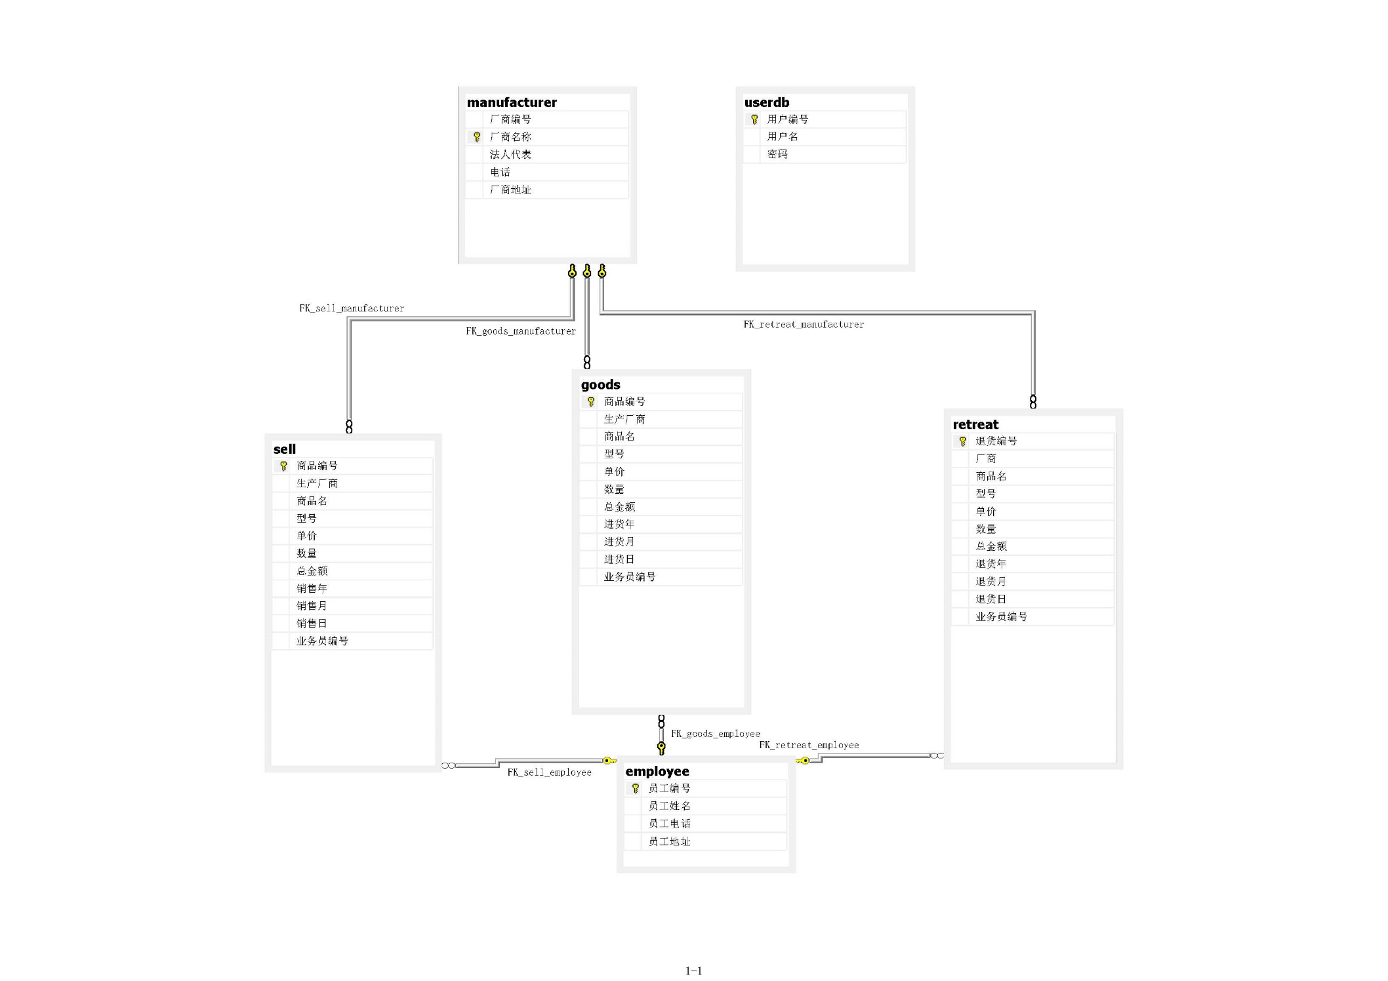

### 数据库逻辑设计

employee(员工编号，员工姓名，员工电话，员工地址)

goods（商品编号，生产厂商，商品名，型号，单价，数量，总金额，进货年，进货月，进货日，业务员编号）

manufacturer(厂商编号，厂商名称，法人代表，电话，厂商地址)

retreat(退货编号，厂商，商品名，型号，单价，数量，总金额，退货年，退货月，退货日，业务员编号)

sell（商品编号，生产厂商，商品名，型号，单价，数量，总金额，销售年，销售月，销售日，业务员编号）

userdb(用户编号，用户名，密码)

## 第五章 详细设计

### 向导

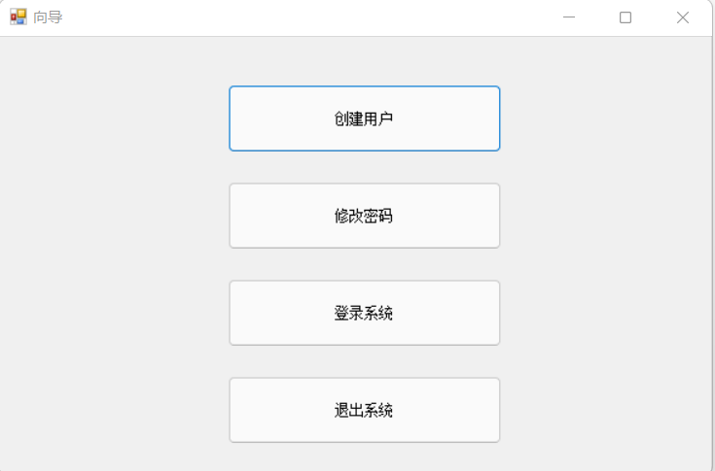

namespace 课程设计1

{

public partial class main1 : Form

{

public main1()

{

InitializeComponent();

}

private void button1_Click(object sender, EventArgs e)

{

adduser open= new adduser();

open.Show();

}

private void button2_Click(object sender, EventArgs e)

{

Application.Exit();

}

private void button3_Click(object sender, EventArgs e)

{

alteruser open = new alteruser();

open.Show();

}

private void button4_Click(object sender, EventArgs e)

{

login open = new login();

open.Show();

}

}

}

### 登录界面

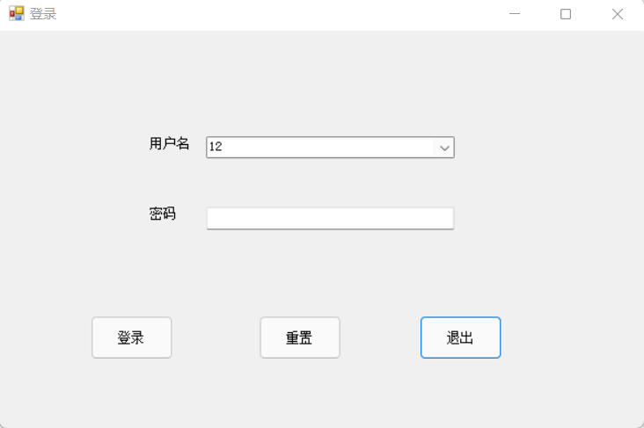

namespace 课程设计1

{

public partial class login : Form

{

public login()

{

InitializeComponent();

}

public static string userName;

public static string userRight;

SqlConnection conn;

SqlCommand com;

SqlDataAdapter da;

DataSet ds;

private void ClearText()

{

textBox2.Clear();

}

private void cbx()

{

conn = new SqlConnection("server=(local);integrated security=true;database=sells1");

com = new SqlCommand("select 用户名 from userdb ", conn);

conn.Open();

DataTable dt = new DataTable();

da = new SqlDataAdapter(com);

da.Fill(dt);

comboBox1.DataSource = dt;

comboBox1.DisplayMember = "用户名";

conn.Close();

}

private void button1_Click(object sender, EventArgs e)

{

this.Close();

}

private void button2_Click(object sender, EventArgs e)

{

this.ClearText();

}

private void button3_Click(object sender, EventArgs e)

{

conn = new SqlConnection("server=(local);integrated security=true;database=sells1");

da = new SqlDataAdapter("select * from userdb where 用户名='" + comboBox1.Text.Trim() + "' and 密码='" + textBox2.Text.Trim() + "'", conn);

ds = new DataSet();

if (conn.State == ConnectionState.Closed)

{

conn.Open();

}

da.Fill(ds, "userdb");

conn.Close();

if (ds.Tables["userdb"].Rows.Count > 0)

{

userName = comboBox1.Text;

main2 frmmain = new main2();

this.Close();

frmmain.Show();

}

else

{

MessageBox.Show("用户名或密码错误！", "提示", MessageBoxButtons.OK, MessageBoxIcon.Information);

textBox2.Text = "";

comboBox1.Focus();

}

}

private void login_Load_1(object sender, EventArgs e)

{

cbx();

}

}

}

### 主界面

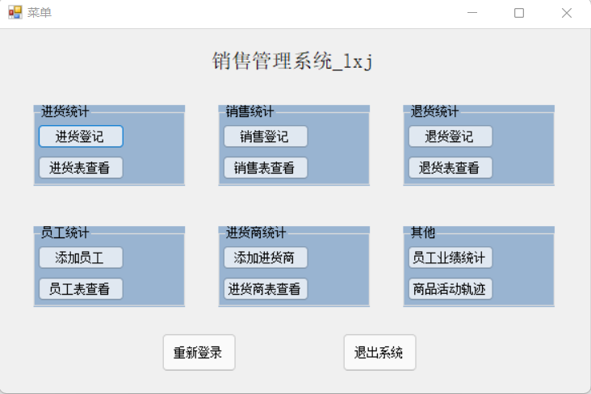

namespace 课程设计1

{

public partial class main2 : Form

{

public main2()

{

InitializeComponent();

}

private void main2_Load(object sender, EventArgs e)

{

}

private void groupBox1_Enter(object sender, EventArgs e)

{

}

private void groupBox2_Enter(object sender, EventArgs e)

{

}

private void button1_Click(object sender, EventArgs e)

{

addgoods ag = new addgoods();

ag.Show();

}

private void button2_Click(object sender, EventArgs e)

{

goodsprint gp = new goodsprint();

gp.Show();

}

private void button4_Click(object sender, EventArgs e)

{

addsell ads = new addsell();

ads.Show();

}

private void button3_Click(object sender, EventArgs e)

{

sellprint sp = new sellprint();

sp.Show();

}

private void button6_Click(object sender, EventArgs e)

{

addretreat ar = new addretreat();

ar.Show();

}

private void button5_Click(object sender, EventArgs e)

{

retreatprint rp = new retreatprint();

rp.Show();

}

private void button8_Click(object sender, EventArgs e)

{

addemployee ade = new addemployee();

ade.Show();

}

private void button7_Click(object sender, EventArgs e)

{

employeeprint ep = new employeeprint();

ep.Show();

}

private void button10_Click(object sender, EventArgs e)

{

addmanufacturer am = new addmanufacturer();

am.Show();

}

private void button9_Click(object sender, EventArgs e)

{

manufacturerprint mp = new manufacturerprint();

mp.Show();

}

private void button12_Click(object sender, EventArgs e)

{

employeesell es = new employeesell();

es.Show();

}

private void button13_Click(object sender, EventArgs e)

{

login login1 = new login();

this.Close();

login1.Show();

}

private void button14_Click(object sender, EventArgs e)

{

Application.Exit();

}

private void button11_Click(object sender, EventArgs e)

{

goodstrails gt = new goodstrails();

gt.Show();

}

}

}

### 创建用户

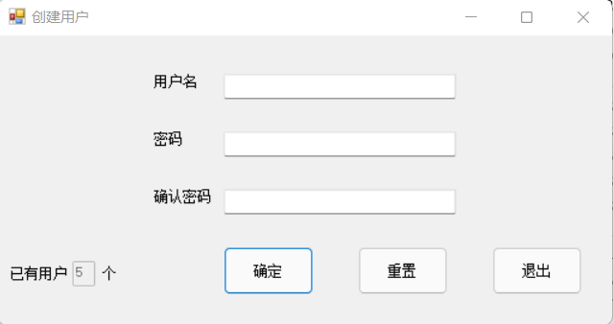

namespace 课程设计1

{

public partial class adduser : Form

{

public adduser()

{

InitializeComponent();

}

public static string userName;

public static string userRight;

SqlConnection conn;

SqlCommand com;

SqlDataAdapter da;

//SqlDataReader dr;

//DataSet ds;

private void ClearText()

{

textBox1.Clear();

textBox2.Clear();

textBox3.Clear();

}

private void LockedTextBox()

{

textBox1.Enabled = false;

textBox2.Enabled = false;

textBox3.Enabled = false;

}

private void js()

{

conn = new SqlConnection("server=(local);integrated security=true;database=sells1");

da = new SqlDataAdapter("select count(*) as " + "计数" + " from userdb ", conn);

DataSet ds = new DataSet();

if (conn.State == ConnectionState.Closed)

{

conn.Open();

}

da.Fill(ds);

conn.Close();

textBox4.Text = ds.Tables[0].Rows[0]["计数"].ToString();

textBox4.Enabled = false;

}

private void adduser_Load(object sender, EventArgs e)

{

conn = new SqlConnection();

conn.ConnectionString = "server=(local);integrated security=true;database=sells1;";

da = new SqlDataAdapter("select * from userdb", conn);

js();

}

private void button1_Click(object sender, EventArgs e)

{

if (textBox1.Text == "")

{

MessageBox.Show("用户名不能为空！");

return;

}

if (textBox2.Text == "")

{

MessageBox.Show("密码不能为空！");

return;

}

if (textBox3.Text == "")

{

MessageBox.Show("密码不能为空！");

return;

}

da = new SqlDataAdapter("select * from userdb where 用户名='" + textBox1.Text.Trim() + "'", conn);

DataSet ds = new DataSet();

if (conn.State == ConnectionState.Closed)

{

conn.Open();

}

int count = da.Fill(ds, "用户表");

conn.Close();

if (count != 0)

{

MessageBox.Show("该用户已存在，请重新输入！");

textBox1.Focus();

return;

}

if (textBox2.Text.Trim() != textBox3.Text.Trim())

{

MessageBox.Show("两次密码输入不相同，请重新输入！");

textBox1.Focus();

return;

}

com = new SqlCommand("insert into userdb(用户名,密码)values('"+textBox1.Text.Trim()+"','"+textBox2.Text.Trim()+"')", conn);

if (conn.State == ConnectionState.Closed)

{

conn.Open();

}

com.ExecuteNonQuery();

conn.Close();

MessageBox.Show("添加用户成功！");

button1.Enabled = false;

button2.Enabled = false;

LockedTextBox();

js();

}

private void button2_Click(object sender, EventArgs e)

{

this.ClearText();

js();

}

private void button3_Click(object sender, EventArgs e)

{

this.Close();

}

}

}

### 修改密码

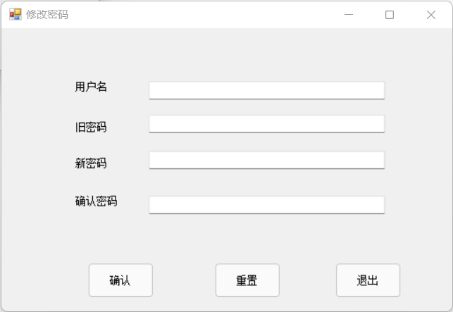

namespace 课程设计1

{

public partial class alteruser : Form

{

public alteruser()

{

InitializeComponent();

}

public static string userName;

public static string userRight;

SqlConnection conn;

SqlCommand com;

SqlDataAdapter da;

//SqlDataReader dr;

//DataSet ds;

private void ClearText()

{

textBox1.Clear();

textBox2.Clear();

textBox3.Clear();

textBox4.Clear();

}

private void LockedTextBox()

{

textBox1.Enabled = false;

textBox2.Enabled = false;

textBox3.Enabled = false;

textBox4.Enabled = false;

}

private void alteruser_Load(object sender, EventArgs e)

{

conn = new SqlConnection();

conn.ConnectionString = "server=(local);integrated security=true;database=sells1;";

da = new SqlDataAdapter("select * from userdb", conn);

}

private void button1_Click(object sender, EventArgs e)

{

if (textBox1.Text == "")

{

MessageBox.Show("用户名不能为空！");

return;

}

if (textBox2.Text == "")

{

MessageBox.Show("旧密码不能为空！");

return;

}

if (textBox3.Text == "")

{

MessageBox.Show("新密码不能为空！");

return;

}

if (textBox3.Text == textBox2.Text)

{

MessageBox.Show("新旧密码不能相同！");

return;

}

if (textBox4.Text != textBox3.Text)

{

MessageBox.Show("确认密码需要与新密码一致！");

return;

}

da = new SqlDataAdapter("select * from userdb where 用户名='" + textBox1.Text.Trim() + "'", conn);

DataSet ds = new DataSet();

if (conn.State == ConnectionState.Closed)

{

conn.Open();

}

int count = da.Fill(ds, "用户表");

conn.Close();

if (count!=0)

{

com = new SqlCommand("update userdb set 用户名='" + textBox1.Text.Trim() + "',密码='" + textBox3.Text.Trim()+"' where 用户名='" + textBox1.Text.Trim() +"' and 密码='"+textBox2.Text.Trim()+"'", conn);

da = new SqlDataAdapter("select * from userdb where 用户名='" + textBox1.Text.Trim() + "' and 密码='" + textBox2.Text.Trim() + "'", conn);

if (conn.State == ConnectionState.Closed)

{

conn.Open();

}

da.Fill(ds, "userdb");

com.ExecuteNonQuery();

conn.Close();

if (ds.Tables["userdb"].Rows.Count > 0)

{

MessageBox.Show("修改密码成功！");

button1.Enabled = false;

button2.Enabled = false;

LockedTextBox();

}

else

{

MessageBox.Show("旧密码错误，请重新输入！");

}

}

}

private void button2_Click(object sender, EventArgs e)

{

this.ClearText();

}

private void button3_Click(object sender, EventArgs e)

{

this.Close();

}

}

}

### 进货登记

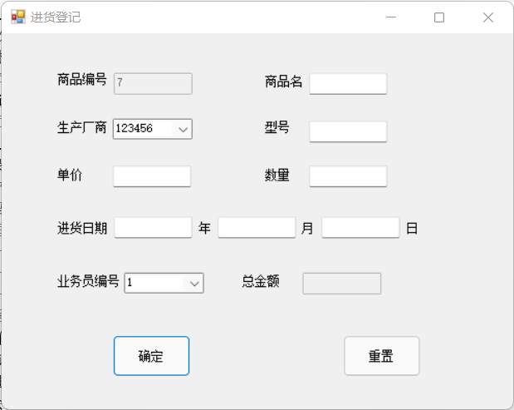

namespace 课程设计1.进货向

{

public partial class addgoods : Form

{

public addgoods()

{

InitializeComponent();

}

SqlConnection conn;

SqlCommand com;

SqlDataAdapter da;

public int cnt1,cnt2;

private void bh()

{

conn = new SqlConnection("server=(local);integrated security=true;database=sells1");

da = new SqlDataAdapter("select top 1 商品编号 from goods order by 商品编号 desc", conn);

DataSet ds = new DataSet();

if (conn.State == ConnectionState.Closed)

{

conn.Open();

}

da.Fill(ds);

int count = da.Fill(ds);

conn.Close();

if (count == 0)

{

textBox1.Text = "1";

textBox1.Enabled = false;

}

else

{

string s1 = ds.Tables[0].Rows[0]["商品编号"].ToString();

int a;

int.TryParse(s1, out a);

cnt1 = a;

a++;

string s2 = "" + a;

textBox1.Text = s2;

textBox1.Enabled = false;

}

}

/*private void fill_sell()

{

conn = new SqlConnection("server=(local);integrated security=true;database=sells1");

da = new SqlDataAdapter("select top 1 商品编号 from sell order by 商品编号 desc", conn);

DataSet ds = new DataSet();

if (conn.State == ConnectionState.Closed)

{

conn.Open();

}

da.Fill(ds);

int count = da.Fill(ds,"销售表");

cnt2 = count;

for(int i=cnt2;i<=cnt1;i++)

{

da = new SqlDataAdapter("select count(*) from sell where 商品编号="+i, conn);

DataSet ds10 = new DataSet();

if (conn.State == ConnectionState.Closed)

{

conn.Open();

}

da.Fill(ds10);

int count1 = da.Fill(ds10,"销售表1");

conn.Close();

da = new SqlDataAdapter("select count(*) from goods where 商品编号=" + i, conn);

DataSet ds20 = new DataSet();

if (conn.State == ConnectionState.Closed)

{

conn.Open();

}

da.Fill(ds20);

int count2 = da.Fill(ds20,"销售表2");

conn.Close();

da = new SqlDataAdapter("select * from sell where 商品编号=" + i, conn);

DataSet ds1 = new DataSet();

if (conn.State == ConnectionState.Closed)

{

conn.Open();

}

da.Fill(ds1);

conn.Close();

da = new SqlDataAdapter("select * from goods where 商品编号=" + i, conn);

DataSet ds2 = new DataSet();

if (conn.State == ConnectionState.Closed)

{

conn.Open();

}

da.Fill(ds2);

conn.Close();

textBox3.Text = count1.ToString();

if (count1==0)

{

if(count2!=0)

{

conn.Open();

com = new SqlCommand("insert into sell(生产厂商,商品名,型号,单价,数量,总金额)values('" + ds2.Tables[0].Rows[0]["生产厂商"] + "','" + ds2.Tables[0].Rows[0]["商品名"] + "','" + ds2.Tables[0].Rows[0]["型号"] + "','" + ds2.Tables[0].Rows[0]["单价"] + "','" + 0 + "','" + 0 + "')", conn);

conn.Close();

}

else

{

conn.Open();

com = new SqlCommand("insert into sell(生产厂商,商品名,型号,单价,数量,总金额)values('" + 0 + "','" + 0 + "','" + 0 + "','" + 0 + "','" + 0 + "','" + 0 + "')", conn);

conn.Close();

}

}

}

}*/

private void cbx()

{

conn = new SqlConnection("server=(local);integrated security=true;database=sells1");

com = new SqlCommand("select 厂商名称 from manufacturer ", conn);

conn.Open();

DataTable dt = new DataTable();

da = new SqlDataAdapter(com);

da.Fill(dt);

comboBox1.DataSource = dt;

comboBox1.DisplayMember = "厂商名称";

conn.Close();

com = new SqlCommand("select 员工编号 from employee", conn);

conn.Open();

DataTable dt1 = new DataTable();

da = new SqlDataAdapter(com);

da.Fill(dt1);

comboBox2.DataSource = dt1;

comboBox2.DisplayMember = "员工编号";

conn.Close();

}

private void ClearText()

{

textBox4.Clear();

textBox2.Clear();

textBox6.Clear();

textBox5.Clear();

textBox6.Clear();

textBox7.Clear();

textBox8.Clear();

textBox9.Clear();

textBox11.Clear();

}

private void compute()

{

if(textBox5.Text!=""&&textBox6.Text!="")

{

double num1 = double.Parse(textBox5.Text);

double num2 = double.Parse(textBox6.Text);

double num3 = num1 * num2;

textBox11.Text = num3.ToString();

}

else

{

textBox11.Clear();

}

}

private void addgoods_Load(object sender, EventArgs e)

{

conn = new SqlConnection();

conn.ConnectionString = "server=(local);integrated security=true;database=sells1";

da = new SqlDataAdapter("select * from goods", conn);

textBox11.Enabled = false;

cbx();

bh();

//fill_sell();

}

private void label4_Click(object sender, EventArgs e)

{

}

private void button1_Click(object sender, EventArgs e)

{

da = new SqlDataAdapter("select * from goods where 商品编号='" + textBox1.Text.Trim() + "'", conn);

DataSet ds = new DataSet();

if (conn.State == ConnectionState.Closed)

{

conn.Open();

}

int count = da.Fill(ds, "商品表");

conn.Close();

if (count != 0)

{

MessageBox.Show("该商品编号已存在，请重新输入！");

textBox1.Focus();

return;

}

com = new SqlCommand("insert into goods(生产厂商,商品名,型号,单价,数量,总金额,进货年,进货月,进货日,业务员编号)values('" + comboBox1.Text.Trim() + "','" + textBox2.Text.Trim() + "','" + textBox4.Text + "','" + textBox5.Text.Trim() + "','" + textBox6.Text.Trim() + "','" + textBox11.Text.Trim() + "','" + textBox7.Text.Trim() + "','" + textBox8.Text.Trim() + "','" + textBox9.Text.Trim() + "','" + comboBox2.Text.Trim() + "')", conn);

if (conn.State == ConnectionState.Closed)

{

conn.Open();

}

com.ExecuteNonQuery();

conn.Close();

MessageBox.Show("添加数据成功！");

}

private void textBox11_TextChanged(object sender, EventArgs e)

{

}

private void textBox5_TextChanged(object sender, EventArgs e)

{

compute();

}

private void textBox6_TextChanged(object sender, EventArgs e)

{

compute();

}

private void button2_Click(object sender, EventArgs e)

{

ClearText();

// fill_sell();

}

}

}

### 进货表查看

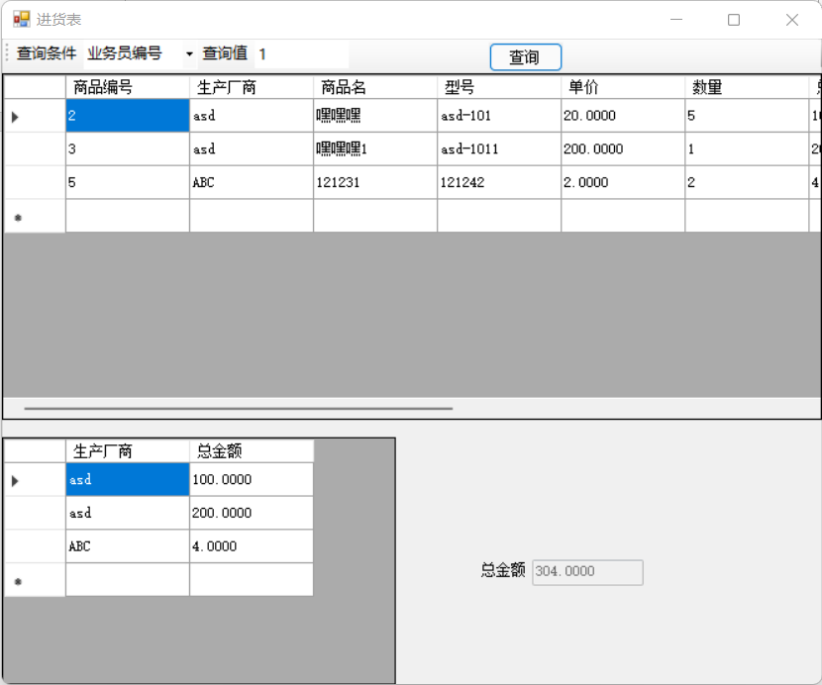

namespace 课程设计1.进货向

{

public partial class goodsprint : Form

{

public goodsprint()

{

InitializeComponent();

}

SqlConnection conn;

SqlCommand com;

SqlDataAdapter da;

private void FillDataGridView()

{

da = new SqlDataAdapter("select * from goods order by 商品编号", conn);

DataSet ds = new DataSet();

if (conn.State == ConnectionState.Closed)

{

conn.Open();

}

da.Fill(ds, "进货表");

conn.Close();

dataGridView1.DataSource = ds.Tables["进货表"];

}

private void goodsprint_Load(object sender, EventArgs e)

{

conn = new SqlConnection();

conn.ConnectionString = "server=(local);integrated security=true;database=sells1";

toolStripComboBox1.Text = "业务员编号";

da = new SqlDataAdapter("select * from goods", conn);

FillDataGridView();

dataGridView1.ReadOnly = true;

dataGridView2.ReadOnly = true;

textBox1.Enabled = false;

}

private void button1_Click(object sender, EventArgs e)

{

if (toolStripComboBox1.Text.Length != 0)

{

if (toolStripTextBox1.Text.Length == 0)

{

this.FillDataGridView();

}

else

{

string fieldName = toolStripComboBox1.Text;

string findValue = toolStripTextBox1.Text.Trim();

da = new SqlDataAdapter("select * from goods where " + fieldName + " ='" + findValue + "'", conn);

DataSet ds = new DataSet();

conn.Open();

int count = da.Fill(ds, "进货表");

conn.Close();

if (count != 0)

{

dataGridView1.DataSource = ds.Tables["进货表"];

}

else

{

MessageBox.Show("没有查询到符合条件的记录！");

}

da = new SqlDataAdapter("select 生产厂商,总金额 from goods where " + fieldName + " ='" + findValue + "'", conn);

DataSet dd = new DataSet();

conn.Open();

int count1 = da.Fill(dd, "进货表1");

conn.Close();

if (count1 != 0)

{

dataGridView2.DataSource = dd.Tables["进货表1"];

}

else

{

MessageBox.Show("没有查询到符合条件的记录！");

}

conn.Open();

com = new SqlCommand("select sum(总金额) as '总金额' from goods where " + fieldName + " = '" + findValue + "'", conn);

string text1 = com.ExecuteScalar().ToString();

conn.Close();

textBox1.Text = text1;

}

}

else

{

MessageBox.Show("请选择查询条件");

}

}

private void toolStripComboBox1_Click(object sender, EventArgs e)

{

}

}

}

### 销售登记

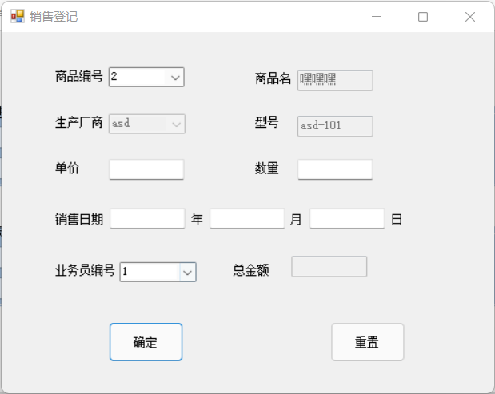

namespace 课程设计1.销售向

{

public partial class addsell : Form

{

public addsell()

{

InitializeComponent();

}

SqlConnection conn;

SqlCommand com;

SqlDataAdapter da;

private void cbx()

{

conn = new SqlConnection("server=(local);integrated security=true;database=sells1");

com = new SqlCommand("select 厂商名称 from manufacturer ", conn);

conn.Open();

DataTable dt = new DataTable();

da = new SqlDataAdapter(com);

da.Fill(dt);

comboBox1.DataSource = dt;

comboBox1.DisplayMember = "厂商名称";

conn.Close();

com = new SqlCommand("select 员工编号 from employee", conn);

conn.Open();

DataTable dt1 = new DataTable();

da = new SqlDataAdapter(com);

da.Fill(dt1);

comboBox2.DataSource = dt1;

comboBox2.DisplayMember = "员工编号";

conn.Close();

com = new SqlCommand("select 商品编号 from goods", conn);

conn.Open();

DataTable dt2 = new DataTable();

da = new SqlDataAdapter(com);

da.Fill(dt2);

comboBox3.DisplayMember = "商品编号";

comboBox3.DataSource = dt2;

}

private void ClearText()

{

textBox4.Clear();

textBox2.Clear();

textBox6.Clear();

textBox5.Clear();

textBox6.Clear();

textBox7.Clear();

textBox8.Clear();

textBox9.Clear();

textBox11.Clear();

}

private void compute()

{

if(textBox5.Text!=""&&textBox6.Text!="")

{

double num1 = double.Parse(textBox5.Text);

double num2 = double.Parse(textBox6.Text);

double num3 = num1 * num2;

textBox11.Text = num3.ToString();

}

else

{

textBox11.Clear();

}

}

public double num11;

private void compute_1()

{

conn = new SqlConnection("server=(local);integrated security=true;database=sells1");

com = new SqlCommand("select 单价 from goods where 商品编号=" + comboBox3.Text, conn);

conn.Open();

DataSet dt = new DataSet();

da = new SqlDataAdapter(com);

da.Fill(dt, "销售表");

string s1 = dt.Tables[0].Rows[0]["单价"].ToString();

num11 = double.Parse(s1);

}

private void _fill()

{

conn = new SqlConnection("server=(local);integrated security=true;database=sells1");

com = new SqlCommand("select * from goods where 商品编号=" + comboBox3.Text, conn);

conn.Open();

DataSet dt = new DataSet();

da = new SqlDataAdapter(com);

da.Fill(dt,"销售表");

textBox2.Text = dt.Tables[0].Rows[0]["商品名"].ToString();

comboBox1.Text = dt.Tables[0].Rows[0]["生产厂商"].ToString();

textBox4.Text = dt.Tables[0].Rows[0]["型号"].ToString();

textBox2.Enabled = false;

comboBox1.Enabled = false;

textBox4.Enabled = false;

conn.Close();

}

private void addgoods_Load(object sender, EventArgs e)

{

textBox11.Enabled = false;

cbx();

}

private void label4_Click(object sender, EventArgs e)

{

}

private void button1_Click(object sender, EventArgs e)

{

if (MessageBox.Show("确定该商品已售出吗？", "删除提示", MessageBoxButtons.OKCancel, MessageBoxIcon.Question) == DialogResult.OK)

{

try

{

compute_1();

double num12 = double.Parse(textBox6.Text);

double num13 = num12 * num11;

com = new SqlCommand("update goods set 总金额 = 总金额-" + num13 + "where 商品编号=" + comboBox3.Text.Trim(), conn); ;

if (conn.State == ConnectionState.Closed)

{

conn.Open();

}

com.ExecuteNonQuery();

conn.Close();

com = new SqlCommand("update goods set 数量 = 数量-" + textBox6.Text.Trim() + "where 商品编号=" + comboBox3.Text.Trim(), conn);

if (conn.State == ConnectionState.Closed)

{

conn.Open();

}

com.ExecuteNonQuery();

conn.Close();

MessageBox.Show("删除数据成功！");

com = new SqlCommand("insert into sell(生产厂商,商品名,型号,单价,数量,总金额,销售年,销售月,销售日,业务员编号)values('" + comboBox1.Text.Trim() + "','" + textBox2.Text.Trim() + "','" + textBox4.Text.Trim() + "','" + textBox5.Text.Trim() + "','" + textBox6.Text.Trim() + "','" + textBox11.Text.Trim() + "','" + textBox7.Text.Trim() + "','" + textBox8.Text.Trim() + "','" + textBox9.Text.Trim() + "','" + comboBox2.Text.Trim() + "')", conn);

if (conn.State == ConnectionState.Closed)

{

conn.Open();

}

com.ExecuteNonQuery();

conn.Close();

MessageBox.Show("修改数据成功！");

}

catch (Exception ex)

{

MessageBox.Show(ex.Message.ToString());

}

}

}

private void textBox11_TextChanged(object sender, EventArgs e)

{

}

private void textBox5_TextChanged(object sender, EventArgs e)

{

compute();

}

private void textBox6_TextChanged(object sender, EventArgs e)

{

compute();

}

private void button2_Click(object sender, EventArgs e)

{

ClearText();

}

private void comboBox3_SelectedIndexChanged(object sender, EventArgs e)

{

_fill();

}

}

}

### 销售表查看

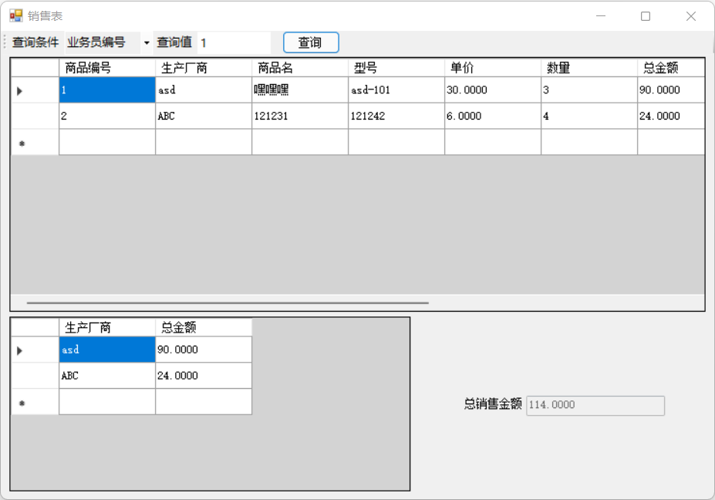

namespace 课程设计1.销售向

{

public partial class sellprint : Form

{

public sellprint()

{

InitializeComponent();

}

SqlConnection conn;

SqlCommand com;

SqlDataAdapter da;

private void FillDataGridView()

{

da = new SqlDataAdapter("select * from sell order by 商品编号", conn);

DataSet ds = new DataSet();

if (conn.State == ConnectionState.Closed)

{

conn.Open();

}

da.Fill(ds, "销售表");

conn.Close();

dataGridView1.DataSource = ds.Tables["销售表"];

}

private void sellprint_Load(object sender, EventArgs e)

{

conn = new SqlConnection();

conn.ConnectionString = "server=(local);integrated security=true;database=sells1";

toolStripComboBox1.Text = "业务员编号";

da = new SqlDataAdapter("select * from sell", conn);

FillDataGridView();

dataGridView1.ReadOnly = true;

dataGridView2.ReadOnly = true;

textBox1.Enabled = false;

}

private void button1_Click(object sender, EventArgs e)

{

if (toolStripComboBox1.Text.Length != 0)

{

if (toolStripTextBox1.Text.Length == 0)

{

this.FillDataGridView();

}

else

{

string fieldName = toolStripComboBox1.Text;

string findValue = toolStripTextBox1.Text.Trim();

da = new SqlDataAdapter("select * from sell where " + fieldName + " ='" + findValue + "'", conn);

DataSet ds = new DataSet();

conn.Open();

int count = da.Fill(ds, "销售表");

conn.Close();

if (count != 0)

{

dataGridView1.DataSource = ds.Tables["销售表"];

}

else

{

MessageBox.Show("没有查询到符合条件的记录！");

}

da = new SqlDataAdapter("select 生产厂商,总金额 from sell where " + fieldName + " ='" + findValue + "'", conn);

DataSet dd = new DataSet();

conn.Open();

int count1 = da.Fill(dd, "销售表1");

conn.Close();

if (count1 != 0)

{

dataGridView2.DataSource = dd.Tables["销售表1"];

}

else

{

MessageBox.Show("没有查询到符合条件的记录！");

}

conn.Open();

com = new SqlCommand("select sum(总金额) as '总金额' from sell where " + fieldName + " = '" + findValue + "'", conn);

string text1 = com.ExecuteScalar().ToString();

conn.Close();

textBox1.Text = text1;

}

}

else

{

MessageBox.Show("请选择查询条件");

}

}

}

}

### 退货登记

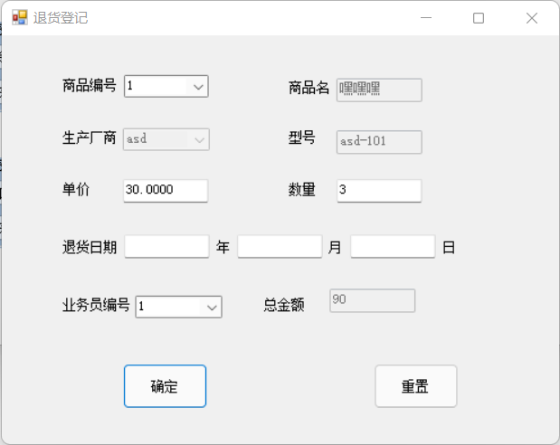

namespace 课程设计1.退货向

{

public partial class addretreat : Form

{

public addretreat()

{

InitializeComponent();

}

SqlConnection conn;

SqlCommand com;

SqlDataAdapter da;

private void cbx()

{

conn = new SqlConnection("server=(local);integrated security=true;database=sells1");

com = new SqlCommand("select 厂商名称 from manufacturer ", conn);

conn.Open();

DataTable dt = new DataTable();

da = new SqlDataAdapter(com);

da.Fill(dt);

comboBox1.DataSource = dt;

comboBox1.DisplayMember = "厂商名称";

conn.Close();

com = new SqlCommand("select 员工编号 from employee", conn);

conn.Open();

DataTable dt1 = new DataTable();

da = new SqlDataAdapter(com);

da.Fill(dt1);

comboBox2.DataSource = dt1;

comboBox2.DisplayMember = "员工编号";

conn.Close();

com = new SqlCommand("select 商品编号 from sell", conn);

conn.Open();

DataTable dt2 = new DataTable();

da = new SqlDataAdapter(com);

da.Fill(dt2);

comboBox3.DisplayMember = "商品编号";

comboBox3.DataSource = dt2;

}

private void _fill()

{

conn = new SqlConnection("server=(local);integrated security=true;database=sells1");

com = new SqlCommand("select * from sell where 商品编号=" + comboBox3.Text, conn);

conn.Open();

DataSet dt = new DataSet();

da = new SqlDataAdapter(com);

da.Fill(dt, "销售表");

textBox2.Text = dt.Tables[0].Rows[0]["商品名"].ToString();

comboBox1.Text = dt.Tables[0].Rows[0]["生产厂商"].ToString();

textBox4.Text = dt.Tables[0].Rows[0]["型号"].ToString();

textBox5.Text = dt.Tables[0].Rows[0]["单价"].ToString();

textBox6.Text = dt.Tables[0].Rows[0]["数量"].ToString();

textBox2.Enabled = false;

comboBox1.Enabled = false;

textBox4.Enabled = false;

conn.Close();

}

private void ClearText()

{

textBox4.Clear();

textBox2.Clear();

textBox6.Clear();

textBox5.Clear();

textBox6.Clear();

textBox7.Clear();

textBox8.Clear();

textBox9.Clear();

textBox11.Clear();

}

private void compute()

{

if(textBox5.Text!=""&&textBox6.Text!="")

{

double num1 = double.Parse(textBox5.Text);

double num2 = double.Parse(textBox6.Text);

double num3 = num1 * num2;

textBox11.Text = num3.ToString();

}

else

{

textBox11.Clear();

}

}

public double num11;

private void compute_1()

{

conn = new SqlConnection("server=(local);integrated security=true;database=sells1");

com = new SqlCommand("select 单价 from sell where 商品编号=" + comboBox3.Text, conn);

conn.Open();

DataSet dt = new DataSet();

da = new SqlDataAdapter(com);

da.Fill(dt, "销售表");

string s1 = dt.Tables[0].Rows[0]["单价"].ToString();

num11 = double.Parse(s1);

}

private void addgoods_Load(object sender, EventArgs e)

{

textBox11.Enabled = false;

cbx();

}

private void label4_Click(object sender, EventArgs e)

{

}

private void button1_Click(object sender, EventArgs e)

{

if (MessageBox.Show("确定该商品已被退货吗？", "删除提示", MessageBoxButtons.OKCancel, MessageBoxIcon.Question) == DialogResult.OK)

{

compute_1();

double num12 = double.Parse(textBox6.Text);

double num13 = num12 * num11;

com = new SqlCommand("update sell set 数量 = 数量-" + textBox6.Text.Trim() + " where 商品编号=" + comboBox3.Text.Trim(), conn);

if (conn.State == ConnectionState.Closed)

{

conn.Open();

}

com.ExecuteNonQuery();

conn.Close();

com = new SqlCommand("update sell set 总金额 = 总金额-" + num13 + " where 商品编号=" + comboBox3.Text.Trim(), conn);

if (conn.State == ConnectionState.Closed)

{

conn.Open();

}

com.ExecuteNonQuery();

conn.Close();

MessageBox.Show("删除数据成功！");

com = new SqlCommand("insert into retreat(商品名,厂商,型号,单价,数量,总金额,退货年,退货月,退货日,业务员编号) values('" + textBox2.Text.Trim() + "', '" + comboBox1.Text.Trim() + "','" + textBox4.Text.Trim() + "','" + textBox5.Text.Trim() + "','" + textBox6.Text.Trim() + "','" + textBox11.Text.Trim() + "','" + textBox7.Text.Trim() + "','" + textBox8.Text.Trim() + "','" + textBox9.Text.Trim() + "','" + comboBox2.Text.Trim() + "')", conn);

if (conn.State == ConnectionState.Closed)

{

conn.Open();

}

com.ExecuteNonQuery();

conn.Close();

MessageBox.Show("修改数据成功！");

}

}

private void textBox11_TextChanged(object sender, EventArgs e)

{

}

private void textBox5_TextChanged(object sender, EventArgs e)

{

compute();

}

private void textBox6_TextChanged(object sender, EventArgs e)

{

compute();

}

private void button2_Click(object sender, EventArgs e)

{

ClearText();

}

private void comboBox3_SelectedIndexChanged(object sender, EventArgs e)

{

_fill();

}

}

}

### 退货表查看

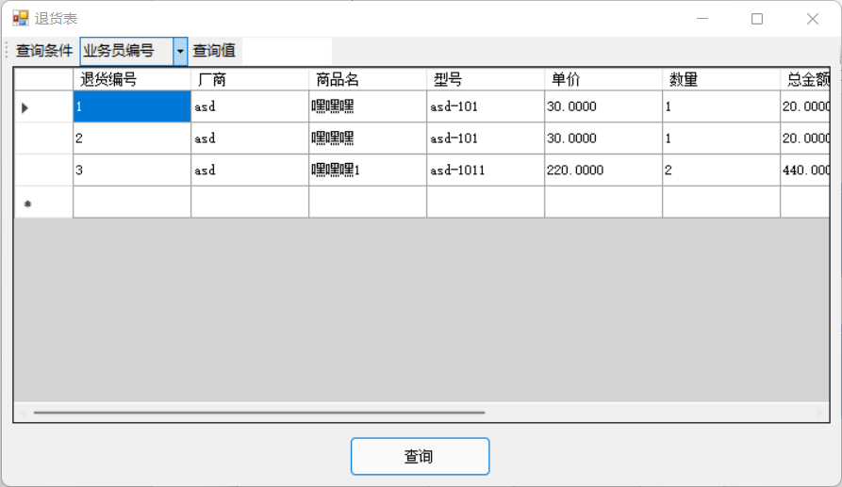

namespace 课程设计1.退货向

{

public partial class retreatprint : Form

{

public retreatprint()

{

InitializeComponent();

}

SqlConnection conn;

SqlDataAdapter da;

private void FillDataGridView()

{

da = new SqlDataAdapter("select * from retreat order by 退货编号", conn);

DataSet ds = new DataSet();

if (conn.State == ConnectionState.Closed)

{

conn.Open();

}

da.Fill(ds, "退货表");

conn.Close();

dataGridView1.DataSource = ds.Tables["退货表"];

}

private void retreatprint_Load(object sender, EventArgs e)

{

conn = new SqlConnection();

conn.ConnectionString = "server=(local);integrated security=true;database=sells1";

da = new SqlDataAdapter("select * from retreat", conn);

FillDataGridView();

}

private void button1_Click(object sender, EventArgs e)

{

if (toolStripComboBox1.Text.Length != 0)

{

if (toolStripTextBox1.Text.Length == 0)

{

this.FillDataGridView();

}

else

{

string fieldName = toolStripComboBox1.Text;

string findValue = toolStripTextBox1.Text.Trim();

da = new SqlDataAdapter("select * from retreat where " + fieldName + " ='" + findValue + "'", conn);

DataSet ds = new DataSet();

conn.Open();

int count = da.Fill(ds, "退货表");

conn.Close();

if (count != 0)

{

dataGridView1.DataSource = ds.Tables["退货表"];

}

else

{

MessageBox.Show("没有查询到符合条件的记录！");

}

}

}

else

{

MessageBox.Show("请选择查询条件");

}

}

}

}

### 添加员工

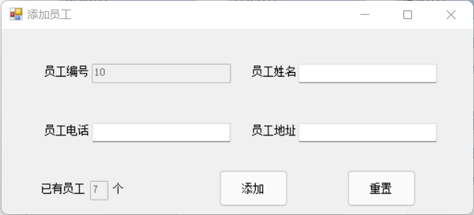

namespace 课程设计1.员工向

{

public partial class addemployee : Form

{

public addemployee()

{

InitializeComponent();

}

SqlConnection conn;

SqlCommand com;

SqlDataAdapter da;

private void js()

{

conn = new SqlConnection("server=(local);integrated security=true;database=sells1");

da = new SqlDataAdapter("select count(*) as " + "计数" + " from employee ", conn);

DataSet ds = new DataSet();

if (conn.State == ConnectionState.Closed)

{

conn.Open();

}

da.Fill(ds);

conn.Close();

textBox5.Text = ds.Tables[0].Rows[0]["计数"].ToString();

textBox5.Enabled = false;

}

private void bh()

{

conn = new SqlConnection("server=(local);integrated security=true;database=sells1");

da= new SqlDataAdapter("select top 1 员工编号 from employee order by 员工编号 desc", conn);

DataSet ds = new DataSet();

if (conn.State == ConnectionState.Closed)

{

conn.Open();

}

da.Fill(ds);

conn.Close();

string s1 = ds.Tables[0].Rows[0]["员工编号"].ToString();

int a;

int.TryParse(s1, out a);

a++;

string s2 = "" + a;

textBox1.Text=s2;

textBox1.Enabled=false;

}

private void ClearText()

{

textBox4.Clear();

textBox2.Clear();

textBox3.Clear();

}

private void textBox1_TextChanged(object sender, EventArgs e)

{

}

private void addemployee_Load(object sender, EventArgs e)

{

bh();

conn = new SqlConnection();

conn.ConnectionString = "server=(local);integrated security=true;database=sells1";

da = new SqlDataAdapter("select * from employee", conn);

js();

}

private void button2_Click(object sender, EventArgs e)

{

ClearText();

js();

}

private void textBox5_TextChanged(object sender, EventArgs e)

{

}

private void button1_Click(object sender, EventArgs e)

{

if (textBox2.Text == "")

{

MessageBox.Show("员工名称不能为空！");

return;

}

da = new SqlDataAdapter("select * from employee where 员工电话='" + textBox3.Text.Trim() + "'", conn);

DataSet ds = new DataSet();

if (conn.State == ConnectionState.Closed)

{

conn.Open();

}

int count = da.Fill(ds, "员工表");

conn.Close();

if (count != 0)

{

MessageBox.Show("该员工已存在，请重新输入！");

textBox2.Focus();

return;

}

com = new SqlCommand("insert into employee(员工姓名,员工电话,员工地址)values('" + textBox2.Text.Trim() + "','" + textBox3.Text.Trim() + "','" + textBox4.Text + "')", conn);

if (conn.State == ConnectionState.Closed)

{

conn.Open();

}

com.ExecuteNonQuery();

conn.Close();

MessageBox.Show("添加数据成功！");

ClearText();

js();

bh();

}

}

}

### 员工表查看

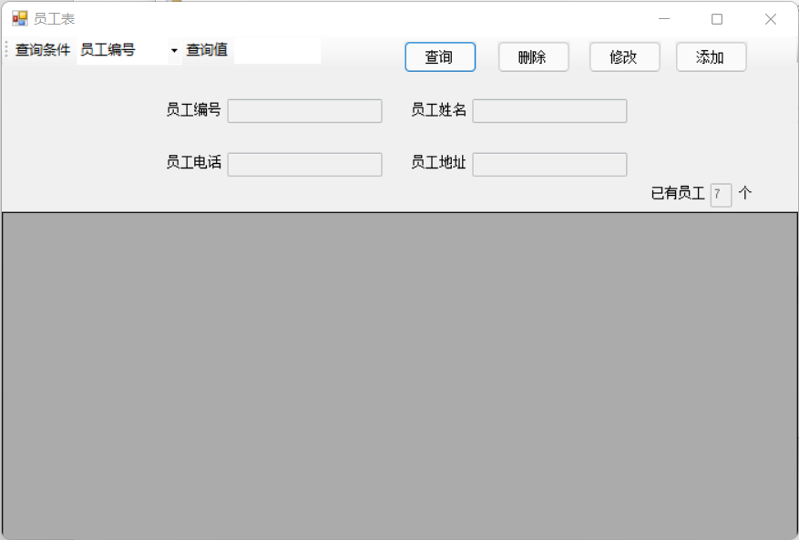

namespace 课程设计1.员工向

{

public partial class employeeprint : Form

{

public employeeprint()

{

InitializeComponent();

}

SqlConnection conn;

SqlCommand com;

SqlDataAdapter da;

private void ClearText()

{

textBox1.Clear();

textBox2.Clear();

textBox3.Clear();

textBox4.Clear();

}

private void js()

{

conn = new SqlConnection("server=(local);integrated security=true;database=sells1");

da = new SqlDataAdapter("select count(*) as "+"计数"+" from employee ", conn);

DataSet ds = new DataSet();

if (conn.State == ConnectionState.Closed)

{

conn.Open();

}

da.Fill(ds);

conn.Close();

textBox5.Text = ds.Tables[0].Rows[0]["计数"].ToString();

textBox5.Enabled = false;

}

private void LockedTextBox()

{

textBox1.Enabled = false;

textBox2.Enabled = false;

textBox3.Enabled = false;

textBox4.Enabled = false;

}

private void UnLockedTextBox()

{

textBox2.Enabled = true;

textBox3.Enabled = true;

textBox4.Enabled = true;

}

private void bt_check()

{

string fieldName = toolStripComboBox1.Text;

string findValue = toolStripTextBox1.Text.Trim();

conn = new SqlConnection("server=(local);integrated security=true;database=sells1");

da = new SqlDataAdapter("select * from employee where " + fieldName + " ='" + findValue + "'", conn);

DataSet ds = new DataSet();

conn.Open();

int count = da.Fill(ds, "员工表");

conn.Close();

if (count != 0)

{

dataGridView1.DataSource = ds.Tables["员工表"];

if (count == 1)

{

textBox2.Text = Convert.ToString(dataGridView1[1, dataGridView1.CurrentCell.RowIndex].Value).Trim();

textBox3.Text = Convert.ToString(dataGridView1[2, dataGridView1.CurrentCell.RowIndex].Value).Trim();

textBox4.Text = Convert.ToString(dataGridView1[3, dataGridView1.CurrentCell.RowIndex].Value).Trim();

textBox1.Text = Convert.ToString(dataGridView1[0, dataGridView1.CurrentCell.RowIndex].Value).Trim();

UnLockedTextBox();

textBox1.Enabled = false;

}

}

else

{

MessageBox.Show("没有查询到符合条件的记录！");

}

}

private void FillDataGridView()

{

conn = new SqlConnection("server=(local);integrated security=true;database=sells1");

da = new SqlDataAdapter("select * from employee order by 员工编号", conn);

DataSet ds = new DataSet();

if (conn.State == ConnectionState.Closed)

{

conn.Open();

}

da.Fill(ds, "员工表");

conn.Close();

dataGridView1.DataSource = ds.Tables["员工表"];

}

private void toolStripLabel1_Click(object sender, EventArgs e)

{

}

private void button1_Click(object sender, EventArgs e)

{

dataGridView1.ReadOnly = true;

if (toolStripComboBox1.Text.Length != 0)

{

if (toolStripTextBox1.Text.Length == 0)

{

this.FillDataGridView();

}

else

{

bt_check();

}

}

else

{

MessageBox.Show("请选择查询条件");

}

js();

}

private void button2_Click(object sender, EventArgs e)

{

if (MessageBox.Show("确定要删除该员工信息吗？", "删除提示", MessageBoxButtons.OKCancel, MessageBoxIcon.Question) == DialogResult.OK)

{

com = new SqlCommand("delete from employee where 员工编号=" + Convert.ToString(dataGridView1[0, dataGridView1.CurrentCell.RowIndex].Value).Trim(), conn);

//string dd = "delete from employee where 员工编号=" + Convert.ToString(dataGridView1[0, dataGridView1.CurrentCell.RowIndex].Value).Trim();

if (conn.State == ConnectionState.Closed)

{

conn.Open();

}

com.ExecuteNonQuery();

conn.Close();

MessageBox.Show("删除数据成功！");

ClearText();

js();

bt_check();

}

}

private void dataGridView1_CellContentClick(object sender, DataGridViewCellEventArgs e)

{

}

private void toolStripComboBox1_Click(object sender, EventArgs e)

{

}

private void button4_Click(object sender, EventArgs e)

{

com = new SqlCommand("update employee set 员工姓名='" + textBox2.Text.Trim() + "',员工电话='" + textBox3.Text.Trim() + "',员工地址='" + textBox4.Text.Trim() + "' where 员工编号=" + Convert.ToString(dataGridView1[0, dataGridView1.CurrentCell.RowIndex].Value).Trim(), conn);

if (conn.State == ConnectionState.Closed)

{

conn.Open();

}

com.ExecuteNonQuery();

conn.Close();

MessageBox.Show("修改数据成功！");

js();

bt_check();

}

private void button3_Click(object sender, EventArgs e)

{

addemployee ade = new addemployee();

ade.Show();

}

private void toolStrip1_ItemClicked(object sender, ToolStripItemClickedEventArgs e)

{

}

private void employeeprint_Load_1(object sender, EventArgs e)

{

conn = new SqlConnection();

da = new SqlDataAdapter("select * from employee", conn);

toolStripComboBox1.Text = "员工编号";

js();

LockedTextBox();

}

}

}

### 添加进货商

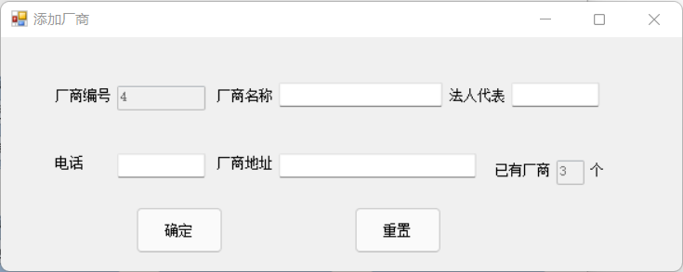

namespace 课程设计1.厂商向

{

public partial class addmanufacturer : Form

{

public addmanufacturer()

{

InitializeComponent();

}

SqlConnection conn;

SqlCommand com;

SqlDataAdapter da;

//SqlDataReader dr;

//DataSet ds;

private void bh()

{

conn = new SqlConnection("server=(local);integrated security=true;database=sells1");

da = new SqlDataAdapter("select top 1 厂商编号 from manufacturer order by 厂商编号 desc", conn);

DataSet ds = new DataSet();

if (conn.State == ConnectionState.Closed)

{

conn.Open();

}

da.Fill(ds);

conn.Close();

string s1 = ds.Tables[0].Rows[0]["厂商编号"].ToString();

int a;

int.TryParse(s1, out a);

a++;

string s2 = "" + a;

textBox1.Text = s2;

textBox1.Enabled = false;

}

private void js()

{

conn = new SqlConnection("server=(local);integrated security=true;database=sells1");

da = new SqlDataAdapter("select count(*) as " + "计数" + " from manufacturer ", conn);

DataSet ds = new DataSet();

if (conn.State == ConnectionState.Closed)

{

conn.Open();

}

da.Fill(ds);

conn.Close();

textBox6.Text = ds.Tables[0].Rows[0]["计数"].ToString();

textBox6.Enabled = false;

}

private void ClearText()//清除控件内容

{

textBox4.Clear();

textBox2.Clear();

textBox3.Clear();

textBox5.Clear();

}

private void addmanufacturer_Load(object sender, EventArgs e)

{

bh();

conn = new SqlConnection();

conn.ConnectionString = "server=(local);integrated security=true;database=sells1";

da = new SqlDataAdapter("select * from manufacturer", conn);

js();

}

private void button2_Click(object sender, EventArgs e)

{

ClearText();

js();

}

private void button1_Click(object sender, EventArgs e)

{

if (textBox2.Text == "")

{

MessageBox.Show("厂商名称不能为空！");

return;

}

da = new SqlDataAdapter("select * from manufacturer where 电话='" + textBox3.Text.Trim() + "'", conn);

DataSet ds = new DataSet();

if (conn.State == ConnectionState.Closed)

{

conn.Open();

}

int count = da.Fill(ds, "厂商表");

conn.Close();

if (count != 0)

{

MessageBox.Show("该厂商已存在，请重新输入！");

textBox2.Focus();

return;

}

com = new SqlCommand("insert into manufacturer(厂商名称,法人代表,电话,厂商地址)values('" + textBox2.Text.Trim() + "','" + textBox3.Text.Trim() + "','" + textBox4.Text.Trim() + "','"+ textBox5.Text.Trim() +"')", conn);

if (conn.State == ConnectionState.Closed)

{

conn.Open();

}

com.ExecuteNonQuery();

conn.Close();

MessageBox.Show("添加数据成功！");

ClearText();

bh();

js();

}

}

}

### 进货商表查看

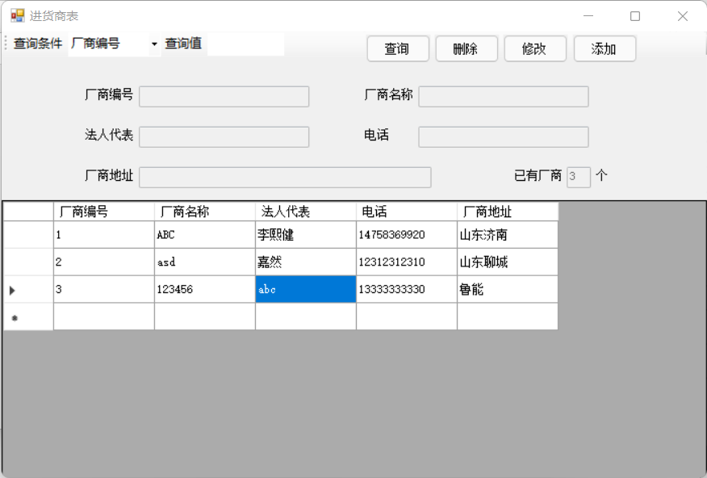

namespace 课程设计1.厂商向

{

public partial class manufacturerprint : Form

{

public manufacturerprint()

{

InitializeComponent();

}

SqlConnection conn;

SqlCommand com;

SqlDataAdapter da;

private void ClearText()//清除控件内容

{

textBox1.Clear();

textBox2.Clear();

textBox3.Clear();

textBox4.Clear();

}

private void js()

{

conn = new SqlConnection("server=(local);integrated security=true;database=sells1");

da = new SqlDataAdapter("select count(*) as " + "计数" + " from manufacturer ", conn);

DataSet ds = new DataSet();

if (conn.State == ConnectionState.Closed)

{

conn.Open();

}

da.Fill(ds);

conn.Close();

textBox6.Text = ds.Tables[0].Rows[0]["计数"].ToString();

textBox6.Enabled = false;

}

private void LockedTextBox()

{

textBox5.Enabled = false;

textBox2.Enabled = false;

textBox3.Enabled = false;

textBox4.Enabled = false;

textBox1.Enabled = false;

}

private void UnLockedTextBox()

{

textBox2.Enabled = true;

textBox3.Enabled = true;

textBox4.Enabled = true;

textBox5.Enabled = true;

}

private void FillDataGridView()

{

conn = new SqlConnection("server=(local);integrated security=true;database=sells1");

da = new SqlDataAdapter("select * from manufacturer order by 厂商编号", conn);

DataSet ds = new DataSet();

if (conn.State == ConnectionState.Closed)

{

conn.Open();

}

int count = da.Fill(ds, "厂商表");

conn.Close();

dataGridView1.DataSource = ds.Tables["厂商表"];

}

private void bt_check()

{

string fieldName = toolStripComboBox1.Text;

string findValue = toolStripTextBox1.Text.Trim();

conn = new SqlConnection("server=(local);integrated security=true;database=sells1");

da = new SqlDataAdapter("select * from manufacturer where " + fieldName + " ='" + findValue + "'", conn);

DataSet ds = new DataSet();

conn.Open();

int count = da.Fill(ds, "员工表");

conn.Close();

if (count != 0)

{

dataGridView1.DataSource = ds.Tables["员工表"];

if (count == 1)

{

textBox2.Text = Convert.ToString(dataGridView1[1, dataGridView1.CurrentCell.RowIndex].Value).Trim();

textBox3.Text = Convert.ToString(dataGridView1[2, dataGridView1.CurrentCell.RowIndex].Value).Trim();

textBox4.Text = Convert.ToString(dataGridView1[3, dataGridView1.CurrentCell.RowIndex].Value).Trim();

textBox1.Text = Convert.ToString(dataGridView1[0, dataGridView1.CurrentCell.RowIndex].Value).Trim();

textBox5.Text = Convert.ToString(dataGridView1[4, dataGridView1.CurrentCell.RowIndex].Value).Trim();

UnLockedTextBox();

textBox1.Enabled = false;

}

}

if (count == 0)

{

MessageBox.Show("没有查询到符合条件的记录！");

}

}

private void toolStripComboBox1_Click(object sender, EventArgs e)

{

}

private void manufacturerprint_Load(object sender, EventArgs e)

{

conn = new SqlConnection();

da = new SqlDataAdapter("select * from manufacturer", conn);

toolStripComboBox1.Text = "厂商编号";

js();

LockedTextBox();

FillDataGridView();

dataGridView1.ReadOnly = true;

}

private void button4_Click(object sender, EventArgs e)

{

addmanufacturer am = new addmanufacturer();

am.Show();

}

private void button1_Click(object sender, EventArgs e)

{

dataGridView1.ReadOnly = true;

if (toolStripComboBox1.Text.Length != 0)

{

if (toolStripTextBox1.Text.Length == 0)

{

this.FillDataGridView();

}

else

{

bt_check();

}

}

else

{

MessageBox.Show("请选择查询条件");

}

js();

}

private void button2_Click(object sender, EventArgs e)

{

if (MessageBox.Show("确定要删除该员工信息吗？", "删除提示", MessageBoxButtons.OKCancel, MessageBoxIcon.Question) == DialogResult.OK)

{

com = new SqlCommand("delete from manufacturer where 厂商编号=" + Convert.ToString(dataGridView1[0, dataGridView1.CurrentCell.RowIndex].Value).Trim(), conn);

//string dd = "delete from manufacturer where 厂商编号=" + Convert.ToString(dataGridView1[0, dataGridView1.CurrentCell.RowIndex].Value).Trim();

if (conn.State == ConnectionState.Closed)

{

conn.Open();

}

com.ExecuteNonQuery();

conn.Close();

MessageBox.Show("删除数据成功！");

ClearText();

js();

bt_check();

}

}

private void button3_Click(object sender, EventArgs e)

{

com = new SqlCommand("update manufacturer set 厂商名称='" + textBox2.Text.Trim() + "',法人代表='" + textBox3.Text.Trim() + "',电话='" + textBox4.Text.Trim() + "',厂商地址='"+ textBox5.Text.Trim() +"' where 厂商编号=" + Convert.ToString(dataGridView1[0, dataGridView1.CurrentCell.RowIndex].Value).Trim(), conn);

if (conn.State == ConnectionState.Closed)

{

conn.Open();

}

com.ExecuteNonQuery();

conn.Close();

MessageBox.Show("修改数据成功！");

js();

bt_check();

}

}

}

### 员工业绩统计

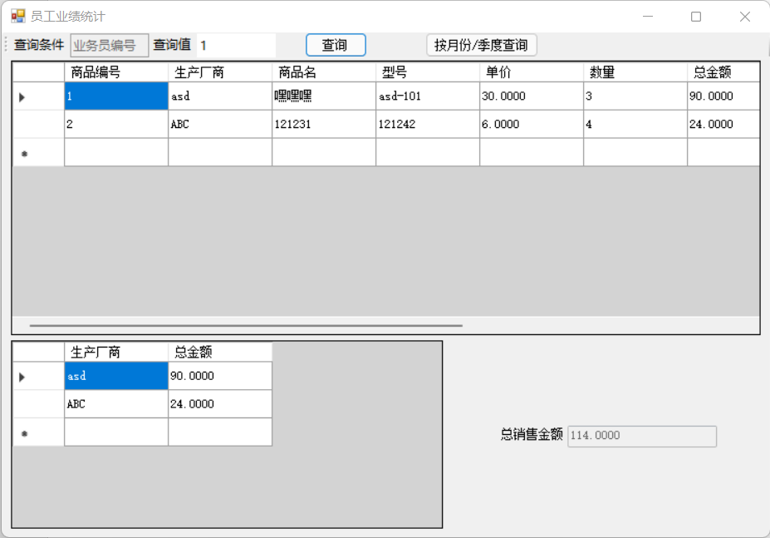

namespace 课程设计1.员工向

{

public partial class employeesell : Form

{

public employeesell()

{

InitializeComponent();

}

SqlConnection conn;

SqlCommand com;

SqlDataAdapter da;

private void FillDataGridView()

{

da = new SqlDataAdapter("select * from sell order by 商品编号", conn);

DataSet ds = new DataSet();

if (conn.State == ConnectionState.Closed)

{

conn.Open();

}

int count = da.Fill(ds, "销售表");

conn.Close();

dataGridView1.DataSource = ds.Tables["销售表"];

}

private void sellprint_Load(object sender, EventArgs e)

{

conn = new SqlConnection();

conn.ConnectionString = "server=(local);integrated security=true;database=sells1";

da = new SqlDataAdapter("select * from sell", conn);

FillDataGridView();

dataGridView1.ReadOnly = true;

dataGridView2.ReadOnly = true;

toolStripTextBox2.Text = "业务员编号";

toolStripTextBox2.Enabled = false;

textBox1.Enabled = false;

}

private void button1_Click(object sender, EventArgs e)

{

if (toolStripTextBox1.Text.Length == 0)

{

this.FillDataGridView();

}

else

{

string fieldName = toolStripTextBox2.Text.Trim();

string findValue = toolStripTextBox1.Text.Trim();

da = new SqlDataAdapter("select * from sell where " + fieldName + " ='" + findValue + "'", conn);

DataSet ds = new DataSet();

conn.Open();

int count = da.Fill(ds, "销售表");

conn.Close();

if (count != 0)

{

dataGridView1.DataSource = ds.Tables["销售表"];

}

else

{

MessageBox.Show("没有查询到符合条件的记录！");

}

da = new SqlDataAdapter("select 生产厂商,总金额 from sell where " + fieldName + " ='" + findValue + "'", conn);

DataSet dd = new DataSet();

conn.Open();

int count1 = da.Fill(dd, "销售表1");

conn.Close();

if (count1 != 0)

{

dataGridView2.DataSource = dd.Tables["销售表1"];

}

else

{

MessageBox.Show("没有查询到符合条件的记录！");

}

conn.Open();

com = new SqlCommand("select sum(总金额) as '总金额' from sell where " + fieldName + " = '" + findValue + "'", conn);

string text1 = com.ExecuteScalar().ToString();

conn.Close();

textBox1.Text = text1;

}

}

private void button2_Click(object sender, EventArgs e)

{

monthcheck mc = new monthcheck();

mc.Show();

}

}

}

### 按月度/季度员工业绩统计

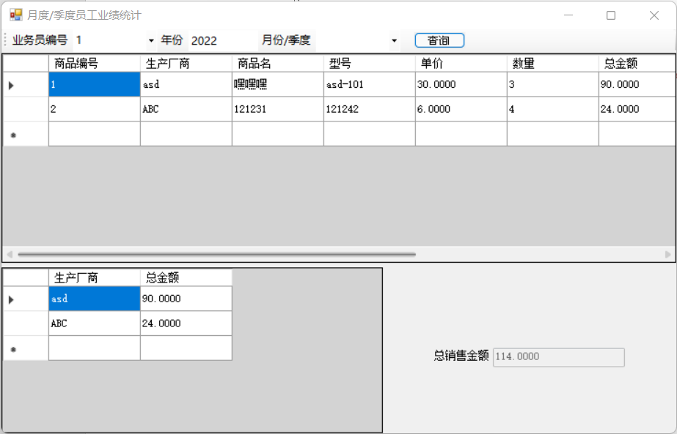

namespace 课程设计1.员工向

{

public partial class monthcheck : Form

{

public monthcheck()

{

InitializeComponent();

}

SqlConnection conn;

SqlCommand com;

SqlDataAdapter da;

private void FillDataGridView()

{

da = new SqlDataAdapter("select * from sell order by 商品编号", conn);

DataSet ds = new DataSet();

if (conn.State == ConnectionState.Closed)

{

conn.Open();

}

int count = da.Fill(ds, "销售表");

conn.Close();

dataGridView1.DataSource = ds.Tables["销售表"];

}

private void monthcheck_Load(object sender, EventArgs e)

{

conn = new SqlConnection("server=(local);integrated security=true;database=sells1");

com = new SqlCommand("select 员工编号 from employee", conn);

conn.Open();

DataTable dt1 = new DataTable();

da = new SqlDataAdapter(com);

da.Fill(dt1);

toolStripComboBox2.ComboBox.DataSource = dt1;

toolStripComboBox2.ComboBox.DisplayMember = "员工编号";

conn.Close();

FillDataGridView();

textBox1.Enabled = false;

}

private void button1_Click(object sender, EventArgs e)

{

if(toolStripComboBox2.Text.Length==0)

{

FillDataGridView();

}

else

{

if (toolStripTextBox2.Text.Length==0)

{

if(toolStripComboBox1.Text.Length==0)

{

da = new SqlDataAdapter("select * from sell where 业务员编号 ='" + toolStripComboBox2.Text.Trim() + "'", conn);

DataSet ds = new DataSet();

conn.Open();

int count = da.Fill(ds, "销售表");

conn.Close();

if (count != 0)

{

dataGridView1.DataSource = ds.Tables["销售表"];

}

else

{

MessageBox.Show("没有查询到符合条件的记录！");

}

da = new SqlDataAdapter("select 生产厂商,总金额 from sell where 业务员编号 ='" + toolStripComboBox2.Text.Trim() + "'", conn);

DataSet dd = new DataSet();

conn.Open();

int count1 = da.Fill(dd, "销售表1");

conn.Close();

if (count1 != 0)

{

dataGridView2.DataSource = dd.Tables["销售表1"];

}

else

{

MessageBox.Show("没有查询到符合条件的记录！");

}

conn.Open();

com = new SqlCommand("select sum(总金额) as '总金额' from sell where 业务员编号 ='" + toolStripComboBox2.Text.Trim() + "'", conn);

string text1 = com.ExecuteScalar().ToString();

conn.Close();

textBox1.Text = text1;

}

else

{

if(toolStripComboBox1.Text=="第一季度")

{

da = new SqlDataAdapter("select * from sell where 业务员编号 ='" + toolStripComboBox2.Text.Trim() + "' and (销售月='1' or 销售月='2' or 销售月='3')", conn);

DataSet ds = new DataSet();

conn.Open();

int count = da.Fill(ds, "销售表");

conn.Close();

if (count != 0)

{

dataGridView1.DataSource = ds.Tables["销售表"];

}

else

{

MessageBox.Show("没有查询到符合条件的记录！");

}

da = new SqlDataAdapter("select 生产厂商,总金额 from sell where 业务员编号 ='" + toolStripComboBox2.Text.Trim() + "' and (销售月='1' or 销售月='2' or 销售月='3')", conn);

DataSet dd = new DataSet();

conn.Open();

int count1 = da.Fill(dd, "销售表1");

conn.Close();

if (count1 != 0)

{

dataGridView2.DataSource = dd.Tables["销售表1"];

}

else

{

MessageBox.Show("没有查询到符合条件的记录！");

}

conn.Open();

com = new SqlCommand("select sum(总金额) as '总金额' from sell 业务员编号 ='" + toolStripComboBox2.Text.Trim() + "' and (销售月='1' or 销售月='2' or 销售月='3')", conn);

string text1 = com.ExecuteScalar().ToString();

conn.Close();

textBox1.Text = text1;

}

else if (toolStripComboBox1.Text == "第二季度")

{

da = new SqlDataAdapter("select * from sell where 业务员编号 ='" + toolStripComboBox2.Text.Trim() + "' and (销售月='4' or 销售月='5' or 销售月='6')", conn);

DataSet ds = new DataSet();

conn.Open();

int count = da.Fill(ds, "销售表");

conn.Close();

if (count != 0)

{

dataGridView1.DataSource = ds.Tables["销售表"];

}

else

{

MessageBox.Show("没有查询到符合条件的记录！");

}

da = new SqlDataAdapter("select 生产厂商,总金额 from sell where 业务员编号 ='" + toolStripComboBox2.Text.Trim() + "' and (销售月='4' or 销售月='5' or 销售月='6')", conn);

DataSet dd = new DataSet();

conn.Open();

int count1 = da.Fill(dd, "销售表1");

conn.Close();

if (count1 != 0)

{

dataGridView2.DataSource = dd.Tables["销售表1"];

}

else

{

MessageBox.Show("没有查询到符合条件的记录！");

}

conn.Open();

com = new SqlCommand("select sum(总金额) as '总金额' from sell where 业务员编号 ='" + toolStripComboBox2.Text.Trim() + "' and (销售月='4' or 销售月='5' or 销售月='6')", conn);

string text1 = com.ExecuteScalar().ToString();

conn.Close();

textBox1.Text = text1;

}

else if (toolStripComboBox1.Text == "第三季度")

{

da = new SqlDataAdapter("select * from sell where 业务员编号 ='" + toolStripComboBox2.Text.Trim() + "' and (销售月='7' or 销售月='8' or 销售月='9')", conn);

DataSet ds = new DataSet();

conn.Open();

int count = da.Fill(ds, "销售表");

conn.Close();

if (count != 0)

{

dataGridView1.DataSource = ds.Tables["销售表"];

}

else

{

MessageBox.Show("没有查询到符合条件的记录！");

}

da = new SqlDataAdapter("select 生产厂商,总金额 from sell where 业务员编号 ='" + toolStripComboBox2.Text.Trim() + "' and (销售月='7' or 销售月='8' or 销售月='9')", conn);

DataSet dd = new DataSet();

conn.Open();

int count1 = da.Fill(dd, "销售表1");

conn.Close();

if (count1 != 0)

{

dataGridView2.DataSource = dd.Tables["销售表1"];

}

else

{

MessageBox.Show("没有查询到符合条件的记录！");

}

conn.Open();

com = new SqlCommand("select sum(总金额) as '总金额' from sell where 业务员编号 ='" + toolStripComboBox2.Text.Trim() + "' and (销售月='7' or 销售月='8' or 销售月='9')", conn);

string text1 = com.ExecuteScalar().ToString();

conn.Close();

textBox1.Text = text1;

}

else if (toolStripComboBox1.Text == "第四季度")

{

da = new SqlDataAdapter("select * from sell where 业务员编号 ='" + toolStripComboBox2.Text.Trim() + "' and (销售月='10' or 销售月='11' or 销售月='12')", conn);

DataSet ds = new DataSet();

conn.Open();

int count = da.Fill(ds, "销售表");

conn.Close();

if (count != 0)

{

dataGridView1.DataSource = ds.Tables["销售表"];

}

else

{

MessageBox.Show("没有查询到符合条件的记录！");

}

da = new SqlDataAdapter("select 生产厂商,总金额 from sell where 业务员编号 ='" + toolStripComboBox2.Text.Trim() + "' and (销售月='10' or 销售月='11' or 销售月='12')", conn);

DataSet dd = new DataSet();

conn.Open();

int count1 = da.Fill(dd, "销售表1");

conn.Close();

if (count1 != 0)

{

dataGridView2.DataSource = dd.Tables["销售表1"];

}

else

{

MessageBox.Show("没有查询到符合条件的记录！");

}

conn.Open();

com = new SqlCommand("select sum(总金额) as '总金额' from sell where 业务员编号 ='" + toolStripComboBox2.Text.Trim() + "' and (销售月='10' or 销售月='11' or 销售月='12')", conn);

string text1 = com.ExecuteScalar().ToString();

conn.Close();

textBox1.Text = text1;

}

else

{

da = new SqlDataAdapter("select * from sell where 业务员编号 ='" + toolStripComboBox2.Text.Trim() + "' and 销售月='"+toolStripComboBox1.Text.Trim()+"' ", conn);

DataSet ds = new DataSet();

conn.Open();

int count = da.Fill(ds, "销售表");

conn.Close();

if (count != 0)

{

dataGridView1.DataSource = ds.Tables["销售表"];

}

else

{

MessageBox.Show("没有查询到符合条件的记录！");

}

da = new SqlDataAdapter("select 生产厂商,总金额 from sell where 业务员编号 ='" + toolStripComboBox2.Text.Trim() + "' and 销售月='" + toolStripComboBox1.Text.Trim() + "' ", conn);

DataSet dd = new DataSet();

conn.Open();

int count1 = da.Fill(dd, "销售表1");

conn.Close();

if (count1 != 0)

{

dataGridView2.DataSource = dd.Tables["销售表1"];

}

else

{

MessageBox.Show("没有查询到符合条件的记录！");

}

conn.Open();

com = new SqlCommand("select sum(总金额) as '总金额' from sell where 业务员编号 ='" + toolStripComboBox2.Text.Trim() + "' and 销售月='" + toolStripComboBox1.Text.Trim() + "' ", conn);

string text1 = com.ExecuteScalar().ToString();

conn.Close();

textBox1.Text = text1;

}

}

}

else

{

if (toolStripComboBox1.Text.Length == 0)

{

da = new SqlDataAdapter("select * from sell where 业务员编号 ='" + toolStripComboBox2.Text.Trim() + "'and 销售年='"+toolStripTextBox2.Text.Trim()+"'", conn);

DataSet ds = new DataSet();

conn.Open();

int count = da.Fill(ds, "销售表");

conn.Close();

if (count != 0)

{

dataGridView1.DataSource = ds.Tables["销售表"];

}

else

{

MessageBox.Show("没有查询到符合条件的记录！");

}

da = new SqlDataAdapter("select 生产厂商,总金额 from sell where 业务员编号 ='" + toolStripComboBox2.Text.Trim() + "'and 销售年='" + toolStripTextBox2.Text.Trim() + "'", conn);

DataSet dd = new DataSet();

conn.Open();

int count1 = da.Fill(dd, "销售表1");

conn.Close();

if (count1 != 0)

{

dataGridView2.DataSource = dd.Tables["销售表1"];

}

else

{

MessageBox.Show("没有查询到符合条件的记录！");

}

conn.Open();

com = new SqlCommand("select sum(总金额) as '总金额' from sell where 业务员编号 ='" + toolStripComboBox2.Text.Trim() + "'and 销售年='" + toolStripTextBox2.Text.Trim() + "'", conn);

string text1 = com.ExecuteScalar().ToString();

conn.Close();

textBox1.Text = text1;

}

else

{

if (toolStripComboBox1.Text == "第一季度")

{

da = new SqlDataAdapter("select * from sell where 业务员编号 ='" + toolStripComboBox2.Text.Trim() + "' and 销售年='"+toolStripTextBox2.Text.Trim()+"'and (销售月='1' or 销售月='2' or 销售月='3')", conn);

DataSet ds = new DataSet();

conn.Open();

int count = da.Fill(ds, "销售表");

conn.Close();

if (count != 0)

{

dataGridView1.DataSource = ds.Tables["销售表"];

}

else

{

MessageBox.Show("没有查询到符合条件的记录！");

}

da = new SqlDataAdapter("select 生产厂商,总金额 from sell where 业务员编号 ='" + toolStripComboBox2.Text.Trim() + "' and 销售年='" + toolStripTextBox2.Text.Trim() + "'and (销售月='1' or 销售月='2' or 销售月='3')", conn);

DataSet dd = new DataSet();

conn.Open();

int count1 = da.Fill(dd, "销售表1");

conn.Close();

if (count1 != 0)

{

dataGridView2.DataSource = dd.Tables["销售表1"];

}

else

{

MessageBox.Show("没有查询到符合条件的记录！");

}

conn.Open();

com = new SqlCommand("select sum(总金额) as '总金额' from sell where 业务员编号 ='" + toolStripComboBox2.Text.Trim() + "' and 销售年='" + toolStripTextBox2.Text.Trim() + "'and (销售月='1' or 销售月='2' or 销售月='3')", conn);

string text1 = com.ExecuteScalar().ToString();

conn.Close();

textBox1.Text = text1;

}

else if (toolStripComboBox1.Text == "第二季度")

{

da = new SqlDataAdapter("select * from sell where 业务员编号 ='" + toolStripComboBox2.Text.Trim() + "' and 销售年='"+toolStripTextBox2.Text.Trim()+"'and (销售月='4' or 销售月='5' or 销售月='6')", conn);

DataSet ds = new DataSet();

conn.Open();

int count = da.Fill(ds, "销售表");

conn.Close();

if (count != 0)

{

dataGridView1.DataSource = ds.Tables["销售表"];

}

else

{

MessageBox.Show("没有查询到符合条件的记录！");

}

da = new SqlDataAdapter("select 生产厂商,总金额 from sell where 业务员编号 ='" + toolStripComboBox2.Text.Trim() + "' and 销售年='" + toolStripTextBox2.Text.Trim() + "'and (销售月='4' or 销售月='5' or 销售月='6')", conn);

DataSet dd = new DataSet();

conn.Open();

int count1 = da.Fill(dd, "销售表1");

conn.Close();

if (count1 != 0)

{

dataGridView2.DataSource = dd.Tables["销售表1"];

}

else

{

MessageBox.Show("没有查询到符合条件的记录！");

}

conn.Open();

com = new SqlCommand("select sum(总金额) as '总金额' from sell where 业务员编号 ='" + toolStripComboBox2.Text.Trim() + "' and 销售年='" + toolStripTextBox2.Text.Trim() + "'and (销售月='4' or 销售月='5' or 销售月='6')", conn);

string text1 = com.ExecuteScalar().ToString();

conn.Close();

textBox1.Text = text1;

}

else if (toolStripComboBox1.Text == "第三季度")

{

da = new SqlDataAdapter("select * from sell where 业务员编号 ='" + toolStripComboBox2.Text.Trim() + "' and 销售年='" +toolStripTextBox2.Text.Trim()+"'and (销售月='7' or 销售月='8' or 销售月='9')", conn);

DataSet ds = new DataSet();

conn.Open();

int count = da.Fill(ds, "销售表");

conn.Close();

if (count != 0)

{

dataGridView1.DataSource = ds.Tables["销售表"];

}

else

{

MessageBox.Show("没有查询到符合条件的记录！");

}

da = new SqlDataAdapter("select 生产厂商,总金额 from sell where 业务员编号 ='" + toolStripComboBox2.Text.Trim() + "' and 销售年='" + toolStripTextBox2.Text.Trim() + "'and (销售月='7' or 销售月='8' or 销售月='9')", conn);

DataSet dd = new DataSet();

conn.Open();

int count1 = da.Fill(dd, "销售表1");

conn.Close();

if (count1 != 0)

{

dataGridView2.DataSource = dd.Tables["销售表1"];

}

else

{

MessageBox.Show("没有查询到符合条件的记录！");

}

conn.Open();

com = new SqlCommand("select sum(总金额) as '总金额' from sell where 业务员编号 ='" + toolStripComboBox2.Text.Trim() + "' and 销售年='" + toolStripTextBox2.Text.Trim() + "'and (销售月='7' or 销售月='8' or 销售月='9')", conn);

string text1 = com.ExecuteScalar().ToString();

conn.Close();

textBox1.Text = text1;

}

else if (toolStripComboBox1.Text == "第四季度")

{

da = new SqlDataAdapter("select * from sell where 业务员编号 ='" + toolStripComboBox2.Text.Trim() + "' and 销售年='"+toolStripTextBox2.Text.Trim()+"'and (销售月='10' or 销售月='11' or 销售月='12')", conn);

DataSet ds = new DataSet();

conn.Open();

int count = da.Fill(ds, "销售表");

conn.Close();

if (count != 0)

{

dataGridView1.DataSource = ds.Tables["销售表"];

}

else

{

MessageBox.Show("没有查询到符合条件的记录！");

}

da = new SqlDataAdapter("select 生产厂商,总金额 from sell where 业务员编号 ='" + toolStripComboBox2.Text.Trim() + "' and 销售年='" + toolStripTextBox2.Text.Trim() + "'and (销售月='10' or 销售月='11' or 销售月='12')", conn);

DataSet dd = new DataSet();

conn.Open();

int count1 = da.Fill(dd, "销售表1");

conn.Close();

if (count1 != 0)

{

dataGridView2.DataSource = dd.Tables["销售表1"];

}

else

{

MessageBox.Show("没有查询到符合条件的记录！");

}

conn.Open();

com = new SqlCommand("select sum(总金额) as '总金额' from sell where 业务员编号 ='" + toolStripComboBox2.Text.Trim() + "' and 销售年='" + toolStripTextBox2.Text.Trim() + "'and (销售月='10' or 销售月='11' or 销售月='12')", conn);

string text1 = com.ExecuteScalar().ToString();

conn.Close();

textBox1.Text = text1;

}

else

{

da = new SqlDataAdapter("select * from sell where 业务员编号 ='" + toolStripComboBox2.Text.Trim() + "' and 销售月='" + toolStripComboBox1.Text.Trim() + "'and 销售年='"+toolStripTextBox2.Text.Trim()+"'", conn);

DataSet ds = new DataSet();

conn.Open();

int count = da.Fill(ds, "销售表");

conn.Close();

if (count != 0)

{

dataGridView1.DataSource = ds.Tables["销售表"];

}

else

{

MessageBox.Show("没有查询到符合条件的记录！");

}

da = new SqlDataAdapter("select 生产厂商,总金额 from sell where 业务员编号 ='" + toolStripComboBox2.Text.Trim() + "' and 销售月='" + toolStripComboBox1.Text.Trim() + "'and 销售年='" + toolStripTextBox2.Text.Trim() + "'", conn);

DataSet dd = new DataSet();

conn.Open();

int count1 = da.Fill(dd, "销售表1");

conn.Close();

if (count1 != 0)

{

dataGridView2.DataSource = dd.Tables["销售表1"];

}

else

{

MessageBox.Show("没有查询到符合条件的记录！");

}

conn.Open();

com = new SqlCommand("select sum(总金额) as '总金额' from sell where 业务员编号 ='" + toolStripComboBox2.Text.Trim() + "' and 销售月='" + toolStripComboBox1.Text.Trim() + "'and 销售年='" + toolStripTextBox2.Text.Trim() + "'", conn);

string text1 = com.ExecuteScalar().ToString();

conn.Close();

textBox1.Text = text1;

}

}

}

}

}

}

}

### 商品活动轨迹（总表）

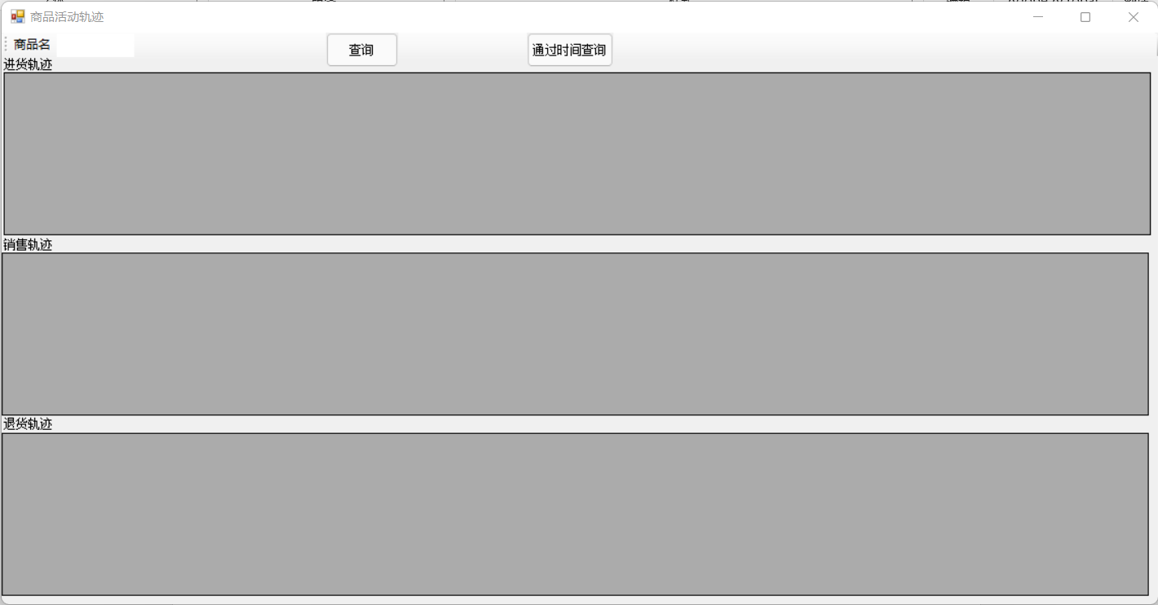

namespace 课程设计1.销售向

{

public partial class goodstrails : Form

{

public goodstrails()

{

InitializeComponent();

}

SqlConnection conn;

SqlDataAdapter da1,da2,da3;

private void button2_Click(object sender, EventArgs e)

{

this.Hide();

timecheck tc = new timecheck();

tc.Show();

}

private void button1_Click(object sender, EventArgs e)

{

int flag1 = 0, flag2 = 0, flag3 = 0;

if (toolStripTextBox1.Text.Length == 0)

{

MessageBox.Show("请输入查询商品");

}

else

{

string findValue = toolStripTextBox1.Text.Trim();

da1 = new SqlDataAdapter("select * from goods where 商品名='" + findValue +"'", conn);

DataSet ds1 = new DataSet();

conn.Open();

int count1 = da1.Fill(ds1, "进货表");

conn.Close();

if (count1 != 0)

{

dataGridView1.DataSource = ds1.Tables["进货表"];

}

else

{

flag1 = 1;

}

da2 = new SqlDataAdapter("select * from sell where 商品名='" + findValue + "'", conn);

DataSet ds2 = new DataSet();

conn.Open();

int count2 = da2.Fill(ds2, "销售表");

conn.Close();

if (count2 != 0)

{

dataGridView2.DataSource = ds2.Tables["销售表"];

}

else

{

flag2 = 1;

}

da3 = new SqlDataAdapter("select * from retreat where 商品名='" + findValue + "'", conn);

DataSet ds3 = new DataSet();

conn.Open();

int count3 = da3.Fill(ds3, "退货表");

conn.Close();

if (count3 != 0)

{

dataGridView3.DataSource = ds3.Tables["退货表"];

}

else

{

flag3 = 1;

}

if(flag1==1&&flag2==1&&flag3==1)

{

MessageBox.Show("未查询到结果");

}

}

}

private void goodstrails_Load(object sender, EventArgs e)

{

conn = new SqlConnection();

conn.ConnectionString = "server=(local);integrated security=true;database=sells1";

da1 = new SqlDataAdapter("select * from goods", conn);

da2 = new SqlDataAdapter("select * from sell", conn);

da2 = new SqlDataAdapter("select * from retreat", conn);

dataGridView1.ReadOnly = true;

dataGridView2.ReadOnly = true;

dataGridView3.ReadOnly = true;

}

}

}

### 通过时间查询商品活动轨迹（通过时间查询的总表）

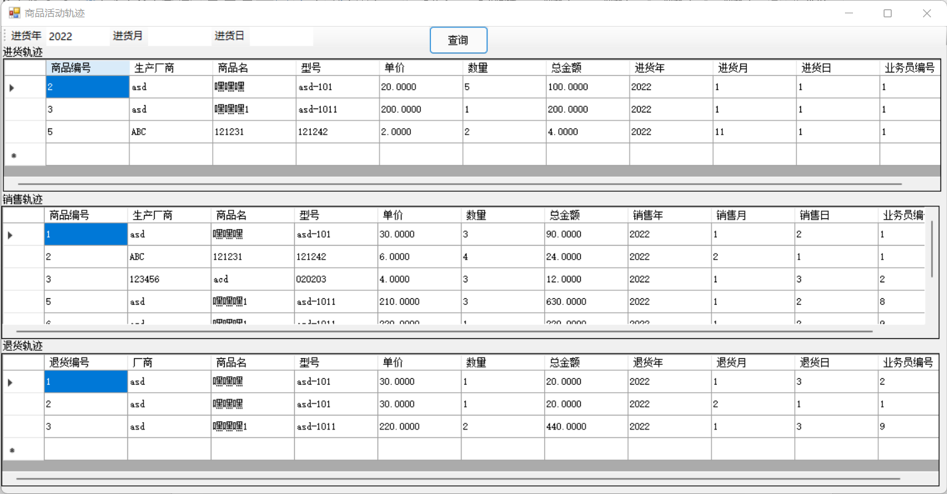

namespace 课程设计1.销售向

{

public partial class timecheck : Form

{

public timecheck()

{

InitializeComponent();

}

SqlConnection conn;

SqlDataAdapter da1,da2,da3;

private void FillDataGridView()//填充表格数据

{

SqlDataAdapter da1 = new SqlDataAdapter("select * from goods order by 商品编号", conn);//

DataSet ds1 = new DataSet();

if (conn.State == ConnectionState.Closed)

{

conn.Open();

}

da1.Fill(ds1, "进货表");

conn.Close();

dataGridView1.DataSource = ds1.Tables["进货表"];

SqlDataAdapter da2 = new SqlDataAdapter("select * from sell order by 商品编号", conn);//

DataSet ds2 = new DataSet();

if (conn.State == ConnectionState.Closed)

{

conn.Open();

}

da2.Fill(ds2, "销售表");

conn.Close();

dataGridView2.DataSource = ds2.Tables["销售表"];

SqlDataAdapter da3 = new SqlDataAdapter("select * from retreat order by 退货编号", conn);//

DataSet ds3 = new DataSet();

if (conn.State == ConnectionState.Closed)

{

conn.Open();

}

da3.Fill(ds3, "退货表");

conn.Close();

dataGridView3.DataSource = ds3.Tables["退货表"];

}

private void button1_Click(object sender, EventArgs e)

{

int flag1 = 0, flag2 = 0, flag3 = 0;

if (toolStripTextBox1.Text.Length == 0 && toolStripTextBox2.Text.Length == 0 && toolStripTextBox3.Text.Length == 0 )

{

FillDataGridView();

}

else if(toolStripTextBox1.Text.Length!=0 && toolStripTextBox2.Text.Length == 0 && toolStripTextBox3.Text.Length == 0 )

{

string findValue = toolStripTextBox1.Text.Trim();

da1 = new SqlDataAdapter("select * from goods where 进货年='" + findValue +"'", conn);

DataSet ds1 = new DataSet();

conn.Open();

int count1 = da1.Fill(ds1, "进货表");

conn.Close();

if (count1 != 0)

{

dataGridView1.DataSource = ds1.Tables["进货表"];

}

else

{

flag1 = 1;

}

da2 = new SqlDataAdapter("select * from sell where 销售年='" + findValue + "'", conn);

DataSet ds2 = new DataSet();

conn.Open();

int count2 = da2.Fill(ds2, "销售表");

conn.Close();

if (count2 != 0)

{

dataGridView2.DataSource = ds2.Tables["销售表"];

}

else

{

flag2 = 1;

}

da3 = new SqlDataAdapter("select * from retreat where 退货年='" + findValue + "'", conn);

DataSet ds3 = new DataSet();

conn.Open();

int count3 = da3.Fill(ds3, "退货表");

conn.Close();

if (count3 != 0)

{

dataGridView3.DataSource = ds3.Tables["退货表"];

}

else

{

flag3 = 1;

}

if(flag1==1&&flag2==1&&flag3==1)

{

MessageBox.Show("未查询到结果");

}

}

else if (toolStripTextBox1.Text.Length == 0 && toolStripTextBox2.Text.Length != 0 && toolStripTextBox3.Text.Length == 0)

{

string findValue = toolStripTextBox2.Text.Trim();

da1 = new SqlDataAdapter("select * from goods where 进货月='" + findValue + "'", conn);

DataSet ds1 = new DataSet();

conn.Open();

int count1 = da1.Fill(ds1, "进货表");

conn.Close();

if (count1 != 0)

{

dataGridView1.DataSource = ds1.Tables["进货表"];

}

else

{

flag1 = 1;

}

da2 = new SqlDataAdapter("select * from sell where 销售月='" + findValue + "'", conn);

DataSet ds2 = new DataSet();

conn.Open();

int count2 = da2.Fill(ds2, "销售表");

conn.Close();

if (count2 != 0)

{

dataGridView2.DataSource = ds2.Tables["销售表"];

}

else

{

flag2 = 1;

}

da3 = new SqlDataAdapter("select * from retreat where 退货月='" + findValue + "'", conn);

DataSet ds3 = new DataSet();

conn.Open();

int count3 = da3.Fill(ds3, "退货表");

conn.Close();

if (count3 != 0)

{

dataGridView3.DataSource = ds3.Tables["退货表"];

}

else

{

flag3 = 1;

}

if (flag1 == 1 && flag2 == 1 && flag3 == 1)

{

MessageBox.Show("未查询到结果");

}

}

else if (toolStripTextBox1.Text.Length == 0 && toolStripTextBox2.Text.Length == 0 && toolStripTextBox3.Text.Length != 0)

{

string findValue = toolStripTextBox3.Text.Trim();

da1 = new SqlDataAdapter("select * from goods where 进货日='" + findValue + "'", conn);

DataSet ds1 = new DataSet();

conn.Open();

int count1 = da1.Fill(ds1, "进货表");

conn.Close();

if (count1 != 0)

{

dataGridView1.DataSource = ds1.Tables["进货表"];

}

else

{

flag1 = 1;

}

da2 = new SqlDataAdapter("select * from sell where 销售日='" + findValue + "'", conn);

DataSet ds2 = new DataSet();

conn.Open();

int count2 = da2.Fill(ds2, "销售表");

conn.Close();

if (count2 != 0)

{

dataGridView2.DataSource = ds2.Tables["销售表"];

}

else

{

flag2 = 1;

}

da3 = new SqlDataAdapter("select * from retreat where 退货日='" + findValue + "'", conn);

DataSet ds3 = new DataSet();

conn.Open();

int count3 = da3.Fill(ds3, "退货表");

conn.Close();

if (count3 != 0)

{

dataGridView3.DataSource = ds3.Tables["退货表"];

}

else

{

flag3 = 1;

}

if (flag1 == 1 && flag2 == 1 && flag3 == 1)

{

MessageBox.Show("未查询到结果");

}

}

else if (toolStripTextBox1.Text.Length != 0 && toolStripTextBox2.Text.Length != 0 && toolStripTextBox3.Text.Length == 0)

{

string findValue1 = toolStripTextBox1.Text.Trim();

string findValue2 = toolStripTextBox2.Text.Trim();

da1 = new SqlDataAdapter("select * from goods where 进货年='" + findValue1 + "' and 进货月='"+findValue2+"'", conn);

DataSet ds1 = new DataSet();

conn.Open();

int count1 = da1.Fill(ds1, "进货表");

conn.Close();

if (count1 != 0)

{

dataGridView1.DataSource = ds1.Tables["进货表"];

}

else

{

flag1 = 1;

}

da2 = new SqlDataAdapter("select * from sell where 销售年='" + findValue1 + "' and 销售月='" + findValue2 + "'", conn);

DataSet ds2 = new DataSet();

conn.Open();

int count2 = da2.Fill(ds2, "销售表");

conn.Close();

if (count2 != 0)

{

dataGridView2.DataSource = ds2.Tables["销售表"];

}

else

{

flag2 = 1;

}

da3 = new SqlDataAdapter("select * from retreat where 退货年='" + findValue1 + "' and 退货月='" + findValue2 + "'", conn);

DataSet ds3 = new DataSet();

conn.Open();

int count3 = da3.Fill(ds3, "退货表");

conn.Close();

if (count3 != 0)

{

dataGridView3.DataSource = ds3.Tables["退货表"];

}

else

{

flag3 = 1;

}

if (flag1 == 1 && flag2 == 1 && flag3 == 1)

{

MessageBox.Show("未查询到结果");

}

}

else if (toolStripTextBox1.Text.Length != 0 && toolStripTextBox2.Text.Length == 0 && toolStripTextBox3.Text.Length != 0)

{

string findValue1 = toolStripTextBox1.Text.Trim();

string findValue3 = toolStripTextBox3.Text.Trim();

da1 = new SqlDataAdapter("select * from goods where 进货年='" + findValue1 + "' and 进货日='" + findValue3 + "'", conn);

DataSet ds1 = new DataSet();

conn.Open();

int count1 = da1.Fill(ds1, "进货表");

conn.Close();

if (count1 != 0)

{

dataGridView1.DataSource = ds1.Tables["进货表"];

}

else

{

flag1 = 1;

}

da2 = new SqlDataAdapter("select * from sell where 销售年='" + findValue1 + "' and 销售日='" + findValue3 + "'", conn);

DataSet ds2 = new DataSet();

conn.Open();

int count2 = da2.Fill(ds2, "销售表");

conn.Close();

if (count2 != 0)

{

dataGridView2.DataSource = ds2.Tables["销售表"];

}

else

{

flag2 = 1;

}

da3 = new SqlDataAdapter("select * from retreat where 退货年='" + findValue1 + "' and 退货日='" + findValue3 + "'", conn);

DataSet ds3 = new DataSet();

conn.Open();

int count3 = da3.Fill(ds3, "退货表");

conn.Close();

if (count3 != 0)

{

dataGridView3.DataSource = ds3.Tables["退货表"];

}

else

{

flag3 = 1;

}

if (flag1 == 1 && flag2 == 1 && flag3 == 1)

{

MessageBox.Show("未查询到结果");

}

}

else if (toolStripTextBox1.Text.Length == 0 && toolStripTextBox2.Text.Length != 0 && toolStripTextBox3.Text.Length != 0)

{

string findValue3 = toolStripTextBox3.Text.Trim();

string findValue2 = toolStripTextBox2.Text.Trim();

da1 = new SqlDataAdapter("select * from goods where 进货日='" + findValue3 + "' and 进货月='" + findValue2 + "'", conn);

DataSet ds1 = new DataSet();

conn.Open();

int count1 = da1.Fill(ds1, "进货表");

conn.Close();

if (count1 != 0)

{

dataGridView1.DataSource = ds1.Tables["进货表"];

}

else

{

flag1 = 1;

}

da2 = new SqlDataAdapter("select * from sell where 销售日='" + findValue3 + "' and 销售月='" + findValue2 + "'", conn);

DataSet ds2 = new DataSet();

conn.Open();

int count2 = da2.Fill(ds2, "销售表");

conn.Close();

if (count2 != 0)

{

dataGridView2.DataSource = ds2.Tables["销售表"];

}

else

{

flag2 = 1;

}

da3 = new SqlDataAdapter("select * from retreat where 退货日='" + findValue3 + "' and 退货月='" + findValue2 + "'", conn);

DataSet ds3 = new DataSet();

conn.Open();

int count3 = da3.Fill(ds3, "退货表");

conn.Close();

if (count3 != 0)

{

dataGridView3.DataSource = ds3.Tables["退货表"];

}

else

{

flag3 = 1;

}

if (flag1 == 1 && flag2 == 1 && flag3 == 1)

{

MessageBox.Show("未查询到结果");

}

}

else if (toolStripTextBox1.Text.Length != 0 && toolStripTextBox2.Text.Length != 0 && toolStripTextBox3.Text.Length != 0)

{

string findValue1 = toolStripTextBox1.Text.Trim();

string findValue2 = toolStripTextBox2.Text.Trim();

string findValue3 = toolStripTextBox3.Text.Trim();

da1 = new SqlDataAdapter("select * from goods where 进货年='" + findValue1 + "' and 进货月='" + findValue2 + "' and 进货日='"+findValue3+"'", conn);

DataSet ds1 = new DataSet();

conn.Open();

int count1 = da1.Fill(ds1, "进货表");

conn.Close();

if (count1 != 0)

{

dataGridView1.DataSource = ds1.Tables["进货表"];

}

else

{

flag1 = 1;

}

da2 = new SqlDataAdapter("select * from sell where 销售年='" + findValue1 + "' and 销售月='" + findValue2 + "'and 销售日='" + findValue3 + "'", conn);

DataSet ds2 = new DataSet();

conn.Open();

int count2 = da2.Fill(ds2, "销售表");

conn.Close();

if (count2 != 0)

{

dataGridView2.DataSource = ds2.Tables["销售表"];

}

else

{

flag2 = 1;

}

da3 = new SqlDataAdapter("select * from retreat where 退货年='" + findValue1 + "' and 退货月='" + findValue2 + "'and 退货日='" + findValue3 + "'", conn);

DataSet ds3 = new DataSet();

conn.Open();

int count3 = da3.Fill(ds3, "退货表");

conn.Close();

if (count3 != 0)

{

dataGridView3.DataSource = ds3.Tables["退货表"];

}

else

{

flag3 = 1;

}

if (flag1 == 1 && flag2 == 1 && flag3 == 1)

{

MessageBox.Show("未查询到结果");

}

}

}

private void goodstrails_Load(object sender, EventArgs e)

{

conn = new SqlConnection();

conn.ConnectionString = "server=(local);integrated security=true;database=sells1";

da1 = new SqlDataAdapter("select * from goods", conn);

da2 = new SqlDataAdapter("select * from sell", conn);

da2 = new SqlDataAdapter("select * from retreat", conn);

dataGridView1.ReadOnly = true;

dataGridView2.ReadOnly = true;

dataGridView3.ReadOnly = true;

}

}

}

## 第六章 用户使用说明书

在向导界面可以进行创建用户、修改密码、登录系统等操作，在输入账号密码之后即可登录本销售系统并进入主菜单界面，在主页面下可以登录另一个账号、退出系统和进行一系列的销售管理操作。在不同的区域中分别有对进货、销售、退货、进货厂商和员工的登记和数据表的查看，其中进货厂商和员工表查看中也可对其进行添加、删除、查询、修改。同时，销售和退货界面还可以根据数据库中已有信息对其商品名称、厂商、型号、单价等信息进行相应的填充，尽可能地提高效率。此外，进货表查看、销售表查看以及退货表查看可以进行对应表的查询并分别显示各个厂商产品的销售金额，还有一个文本框用于显示总销售金额，可按照年、月、日、业务员编号和生产厂商分别进行查询。在“其他”区域中，可进行员工业绩统计，查看其销售总金额，更进一步，也可点击“月度\季度查询”按钮查询其在某年（或所有年份）某月\季度的销售额。也可以查看各商品从进货到销售（再到退货）的完整流程，形成一个总表，使商品的流动过程更直观。当然也可以使用其“通过时间查询”按钮查询某年、月、日（均为非必填项，未填处即为所有年、月、日）的进货、销售、退货记录。

## 第七章 结束语（附参考文献）

通过这次课程设计，最终设计出了一个销售管理系统。从一开始看到任务书时的一头雾水，到最终成功设计出这个销售系统，中间付出了很多汗水。一点都不懂c#的编程小白，经过老师的指导和自身在寒假的不断学习，逐渐调试程序，最终成功搞定了本次课程设计。

在这次系统设计中，我也加入了许多自己的创意。比如灵活使用combobox而尽可能少的使用textbox；填充功能省去了填充的按钮，而是通过textbox和combobox的文本变化来进行识别填充；在入库时通过单价和数量自动计算出总金额等等，都是一些比较小的优化，但积少成多，或许也能一定程度上提高工作效率。

这次课程设计我认为最大的创新点在于自己拓展的一些如商品轨迹追踪（以及在它基础上可以对任意日期任意操作进行查询）等功能，形成了一个集进货、销售、退货于一体的总表，可以在管理归纳时更直观。因为年月日均可以不填来代表任意值，所以需要考虑所以情况（其他功能中也有需要考虑的情况），导致代码很长。一个窗口就500多行的代码写的时候虽然很痛苦，但看着它能够按照自己的想法跑起来时成就感更高（谁让寒假时间给足呢）。

当然，作为一名初学者以及能力所限，这个软件还有许多不足之处，还不够完善。但是我会继续学习，努力加强个人能力，争取在之后的编程方面有更大的进步。

不足：

1. 对于表中数量为0的商品，应该对其进行标记。
2. 没有办法设置多重条件的查询，如给出商品编号+时间+业务员编号的条件进行查询（理论上是可以的，但工程量太大，还要考虑文本框为空，毕竟一个业务员编号+时间的查询就需要分好多种情况，在复用了很多函数的情况下都写了500多行。。。）

### 参考文献

* 1. 景雪琴.数据库技术与应用系统开发[M].北京:清华大学出版社,2013:407
  2. 李俊民.SQL Server数据库开发自学经典[M].北京:清华大学出版社,2015:375
  3. 启明工作室.数据库应用实例完全解析[M].北京:人民邮电出版社,2006:336
  4. 徐明华.SQL Server基础与案例开发详解[M].北京:清华大学出版社,2014:349