**Varsha Ganesh Bhong**

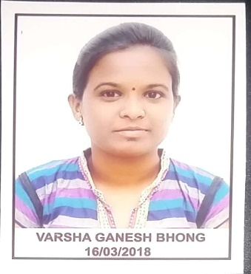

|  |  |
| --- | --- |
| **Title:** | **Analyst / Software Engineer** |
| **Location:** | **Pune, Maharashtra, India** |
| **Languages:** | Marathi(native),English,Hindi(fluent) |

# Experience Summary

The 90 days training at Capgemini(Banglore) provided a great foundation for any kind of real time projects . Cricbuzz project was developed using agile methodology and an end to end application was delivered in which the front end were done using Angular JS

**KEY SKILLS:**

* **Functional :** Excellent time management, Project Management, Team Building, Strategic/Tactical Planning
* **Technical :** Core Java, Advanced Java, Spring framework, Spring Boot, Micro services, Angular JS, Mongo DB, JavaScript, SQL, HTML, CSS.

# Experience

< This area is where you list out your Experience – not limited to what you did at Capgemini. Please list out by the type of industry and your role. Bullets should not be more than three lines; if more detail is required please do sub-bullets as noted below. > (Please write in third person.)

|  |  |  |
| --- | --- | --- |
| **01** | **Type of Industry:** | Software Development |
|  | **Project Description:** |  |
|  | **Role/Title:** | Java Developer |
|  | **Project Duration:** | 3 Weeks |
|  | **Responsibilities:** | * High-level bullet points (in past tense) describing your responsibilities, accomplishments for each position   + Sub-bullet, if needed |
|  | **Operating Systems:** | Windows 10 |
|  | **Software / Languages:** | Java, Angular, MongoDB |
|  | **Special Tools:** | Spring tool Suit, RoboMongo, Postman, Visual Code |

|  |  |  |
| --- | --- | --- |
| 02 | Type of Industry | **(No Client Names or Project Names)** |
|  | **Project Description:** |  |
|  | **Role/Title:** |  |
|  | **Project Duration:** |  |
|  | **Responsibilities:** | * High-level bullet points (in past tense) describing your responsibilities, accomplishments for each position   + Sub-bullet, if needed |
|  | **Operating Systems:** |  |
|  | **Software / Languages:** |  |
|  | **Special Tools:** |  |

##### 

# Training, Certifications & Affiliations

* Full stack development training from Capgemini.

# Higher Education

* Saraswati bhuwan high school, Jalna (S.S.C.)
* Dr. Badrinarayan Barwale College, Jalna (H.S.C.)
* Matsyodari Shikshan Sanstha’s College of Enggineering And Technology, Jalna (B.E.)