**Prathyusha Carakatti**

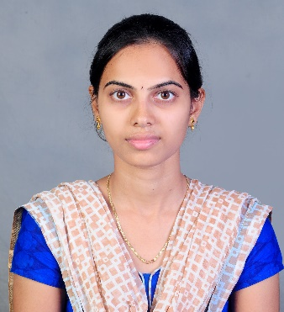

|  |  |
| --- | --- |
| **Title:** | **Analyst/ Software Engineer** |
| **Location:** | **Tirupati, Andhra Pradesh, India** |
| **Languages:** | **Telugu(native), English, Hindi** |

# Experience Summary

The training at Capgemini provided a great foundation for any kind of real time projects. Make my trip project was developed using agile methodology and an end to end application was delivered in which the front end validations were done using Angular JS which connected to the Spring Boot application for the backend implementation which interact with the NOSQL database Mongo DB.

**KEY SKILLS:**

* **Functional:** Leadership skills, Excellent time management, Project Management, Team Building, Strategic/Tactical Planning, and Business Development**.**
* **Technical:** Core Java, Advanced Java, Spring framework, Spring Boot, Micro services, Angular JS, Mongo DB, JavaScript, SQL, HTML, CSS, Git and Unit Testing .

Experience

Developed a Make my trip application using spring boot micro services in the back-end and angular as front-end technology.

|  |  |  |
| --- | --- | --- |
|  | **Type of Industry:** | **Software Development** |
|  | **Project Description:** | An end to end application for a buying & selling website using micro services architecture using spring boot and various spring features like spring security, swagger, Mockito, hystrix, HATEOAS and spring cloud interacting with the database Mongo DB. |
|  | **Role/Title:** | Java Developer |
|  | **Project Duration:** | 3 weeks |
|  | **Responsibilities:** | * Created model, repository, services and controller classes for each micro services using spring boot and Mongo DB. * Implemented Hystrix and Spring Security. * Implemented Spring Cloud by including Eureka Server, Netflix Zuul. * Validations in Angular JS * Integrated database and spring boot. |
|  | **Operating Systems:** | Windows 10 |
|  | **Software / Languages:** | Java, Angular JS, Spring boot. |
|  | **Special Tools:** | Spring Tool Suite, Postman, RoboMongo, Visual Studio Code, Git-hub, and Maven. |

# Training, Certifications & Affiliations

* Full stack development training from Capgemini.

# Higher Education

* Sri Venkateswara College Of Engineering, (affiliate to Jawaharlal Nehru Technological University Anantapur) Tirupati. (B.E)
* Sri Gayatri Junior College, Tirupati. (H.S.C)
* Sri Chaitanya Children’s Academy, Tirupati. (S.S.C)