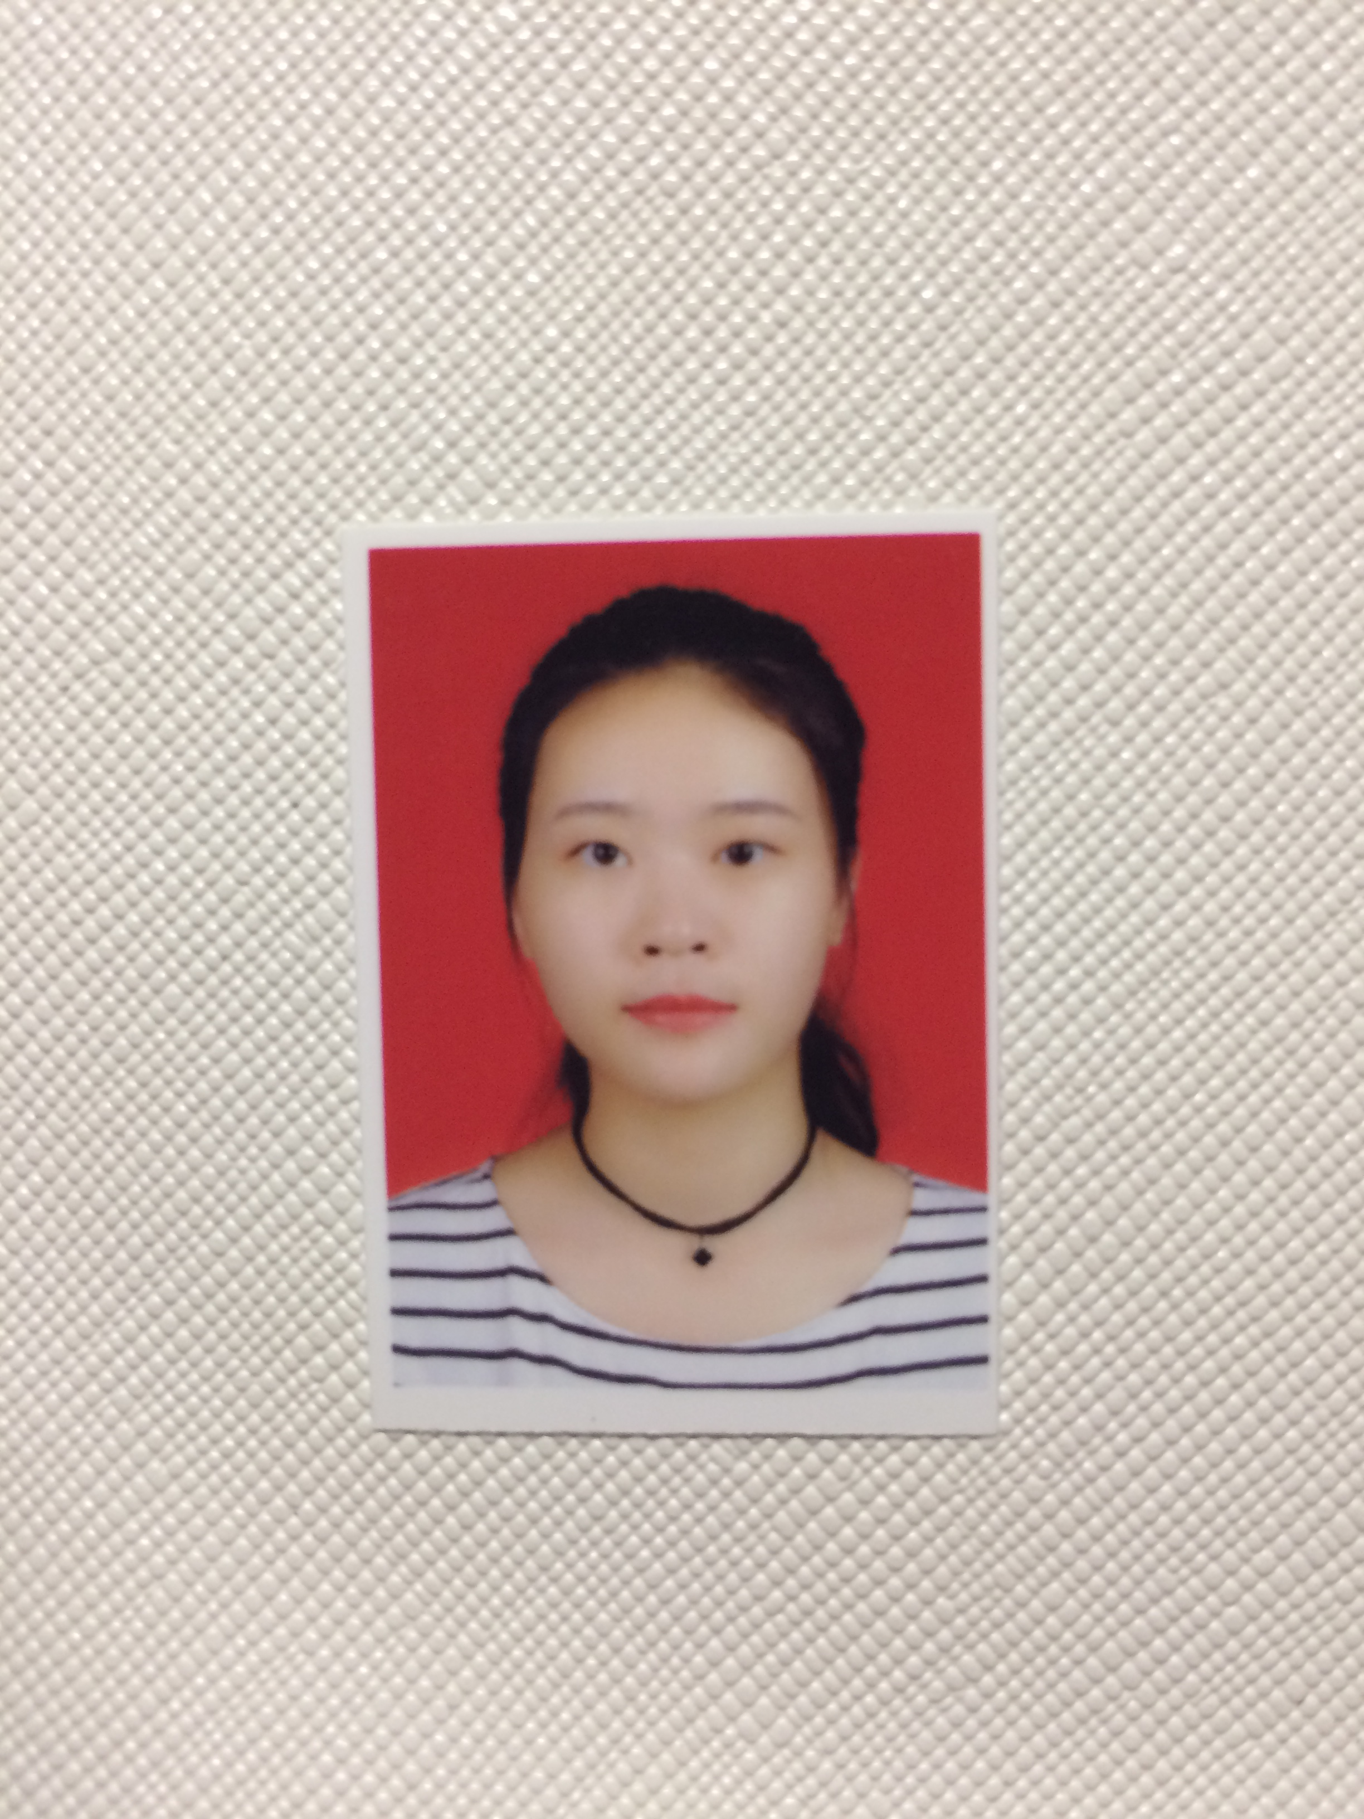

**I am warm and cheerful,friendly,sincere and modest.Able to work hard,dutiful-and patient.Study hard and earnest, honest, diligent and studious, down-to-earth, aggressive, dare to challenge. Strong team spirit, active, diligent and earnest.Have good compression ability and strong sense of responsibility.**

EDUCATION

**2017.09 -2020.06**

**Chongqing three gorges college | Undergraduate course**

**Major courses:computer operating system, database, computer composition principle,linear algebra, Java, data structure, C language, HTML.**

AWARD

**Certificate of general skills:cet-4certificate,putonghua level 2certificate,motor vehicle driving license.**

**Professional skills certificate:teacher certificate**

1. **Leaflets have been posted outside the school.**
2. **I went to work part-time during the summer vacation.**
3. **I worked part time in China telecommunication.**
4. **During the summer vacation,I worded as a tutor at education for one month.**

WORK EXPERIENCE

Job intention:bank staff

**SKILLS**

**Name:Tian Dongmei**

**Now living in：Chongqing**

**T1607953810**

**13212527510**

**1607953810@qq.com**

WORD

PPT

EXCEL

PS

Other

**Certificate of general skills: cet-4 certificate,putonghua level 2certificate, motor vehicle driving license.**

**Language skills: CET4 certificate, putonghua level 2 certificate**