**C Programming Language**

**SECTION A ( x 15 =)**

1. The format character %d used to print

A) Character

B) String

C) integer

D) float

1. x=5; y=x++;

A) assigns a value 5 to y

B) gives an error message

C) assigns a value 6 to y

D) assigns a value 7 to y

1. The logical operator ! is used for doing

A) Logical AND B) Logical OR

C) Logical NOT D) None of above

1. 4.Which character is used to read short integer  
   A) d  
   B) hd

C) ld  
D) None of the mentioned

1. The file opening mode “r” is used

A) Read the file

B) Write into the file

C) Read and write operation

D) None of the above

1. Which operator is used to terminate the statement(结束说明)

A) !  
B) ;  
C) :  
D) }

1. The value 32767 can represented using which data type?  
   A) double  
   B) void  
   C) int  
   D) bool
2. The length of the string correct is “correct”  
   a) 7 b) 8  
   c) 6 d)9
3. Which of the function that must contain in all C program

A) system() B) main() C) scanf() D) printf()

1. What is a array?  
   a) An array is a series of elements of the same type in contiguous memory locations  
   b) An array is a series of element  
   c) An array is a series of elements of the same type placed in non-contiguous memory locations  
   d) None of the mentioned
2. Which symbol must be used to signal the beginning and ending of the C program  
   a) < , >  
   b) (, )  
   c) {, }  
   d) [ ]
3. 12.What punctuation must be used to end the C statement  
   a) : colon b) ; semi colon

c) % d) . dot

1. The length of the string correct is “JIANGXI UNIVERSITY”  
   a) 17 b) 18  
   c) 16 d)19
2. The directive of the preprocessor begin with   
   a) Ampersand symbol(&)  
   b) Two slashes(//)  
   c) Number sign(#)

d) Less than symbol(<)

1. Which one of the following is Boolean operator for logical AND

A) system() B) main() C)scanf() D)printf()

**SECTION B (5 x 6 =30)**

1. write a note on integer constant? (P34)

① Decimal integer小数整数 Decimal Integer consists of a set of digits 0 to 9 preceded by an optional + or - sign.由一组数字0到9组成，前面带有可选的+或 - 符号。 Spaces, commas and non digit characters are notpermitted between digits. 数字之间不允许使用空格，逗号和非数字字符。 Example  int y=123; //here 123 is a decimal integer constant 这里123是十进制整数常数

②Octal Integers八进制整数 Octal Integers constant consists of any combination of digits from 0 through 7 with a O at the beginning. 八进制整数常数由0到7之间的任意数字组合组成，开头有一个O examples of octal integers are int X=O123; // here 0123 is a octal integer constant .这里0123是八进制整数常数。 ③Hexadecimal integer十六进制整数There are 16 Hexadecimal digits.有16个十六进制数字。 They are the same as the decimal digits up to 9,but then there are the letters A, B, C, D, E andF in place of the decimal numbers 10 to 15:它们与十进制数字相同，最多可以为9，但是有字母A，B，C，D，E和F代替十进制数字10到15Example of valid hexadecimal integers Hexadecimal:0123456789ABCDEF Decimal:0123456789101112131415

1. Write any six escape sequence character(转义字符)?

\b Backspace \f Form feed \n Newline

\r Return \t Horizontal tab \v Vertical tab

\\ Backslash \' Single quotation mark

\" Double quotation mark \? Question mark

\0 Null character

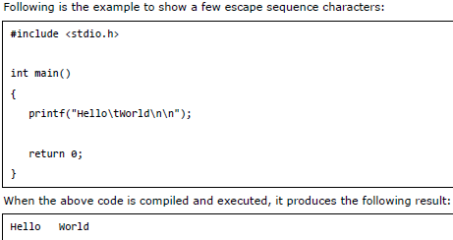

1. Give an example to describe the Structure in C?

struct score

{

int Math;

int Phy;

Int Eng;

};

struct student

{

int Id;

char Name[20];

char Gender[3];

char Class[20];

Struct score Score;

};

1. What is Compiler? Write a C program to print “hello world”?

Compiler is a program that translates source code into object code.

#include <stdio.h>

int main()

{

printf("Hello world!\n");

return 0;

}

1. What is the name of “ ?” “ : ”(条件运算符) operator ? Explain with an example?(P95)

Conditional operator

#include <stdio.h>

int main()

{

int a=3,b=2,c;

c=a>b? a:b;

printf("%d",c);

return 0;

}

1. What is variable? What are the rules followed during the creation of variable name?

A variable is a name for a place in the computer’s memory where you store some data.

在C语言中，用户自定义的标识符需要符合以下规则

user-defined identifiers need to conform to the following rules

（1）必须以字母或下划线（_）开头，C语言区分大小写，ABC,Abc和abc是不相同的。Must begin with a letter or underscore (_), the C language is case-sensitive, ABC, Abc, and abc are not the same

（2）只能由字母、数字或下划线组成，不能有空格，小数点等特殊字符。Can only be composed of letters, numbers or underscores, can not have spaces, decimal points and other special characters

（3）不能和C中的系统保留的关键字重名 can not re-name a keyword with a system in C

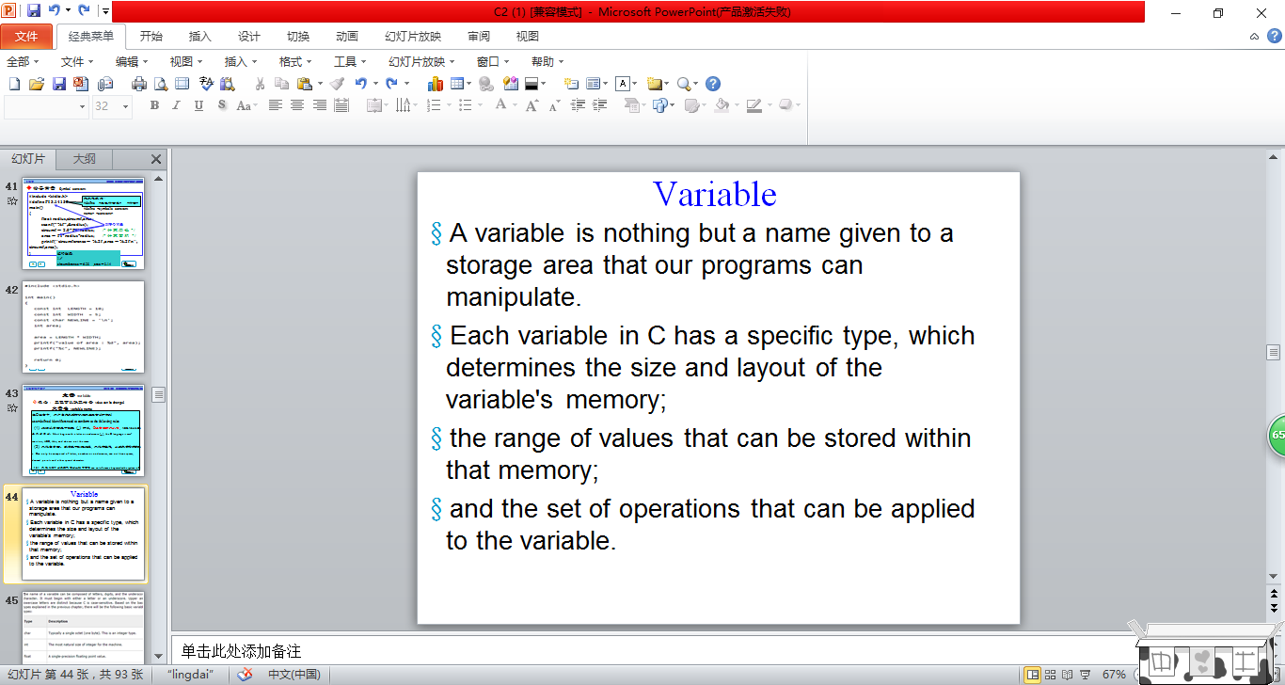

1. What is relational expression(关系表达式)? Write the relational operator(关系操作符) used in C.(P53)

<、 >、==、>=、……

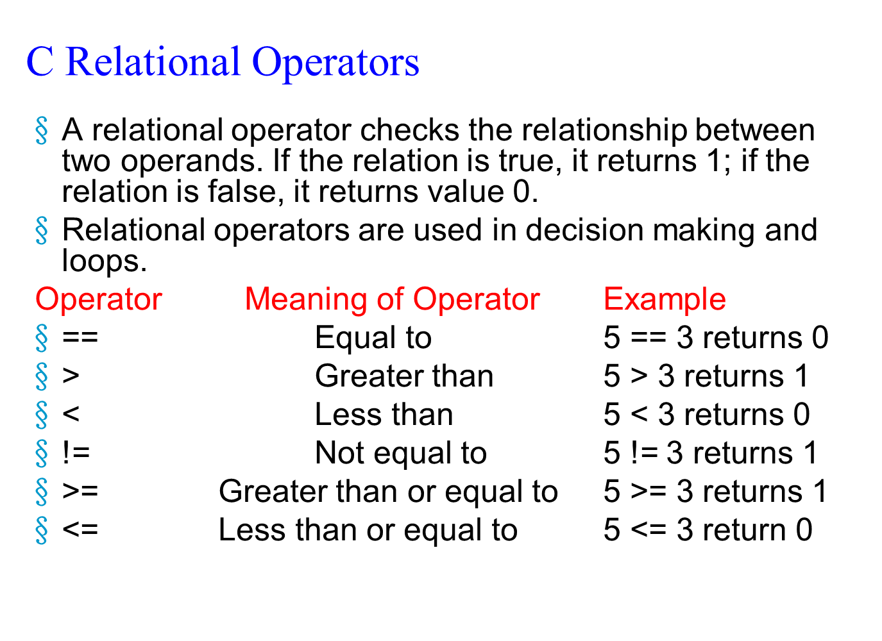

另有:

算数表达式：a/b .

赋值表达式：a=10 .复合赋值运算符：.与算数运算符复合。+=,/=.与位运算符复合。<<=, |=

逗号表达式：a=(2+5,a*5,10*4).(“ps:从左到右的顺序逐个计算，且最后表达式的值就是逗号表达式的值。”)

1. Write any 12 keywords used in C?(P269)

“int”“char”“float”“double”“FILE”“scanf”“printf”“getc”“putc”“define”“switch”“case”“default”“break”“goto”“if”“else”“while”“for”“struct”……

1. What are Increment and Decrement Operator? Write a C program example?

**pre-increment (++ variable) post-increment (variable ++)**

**pre-decrement (-- variable) post-decrement (variable --)**

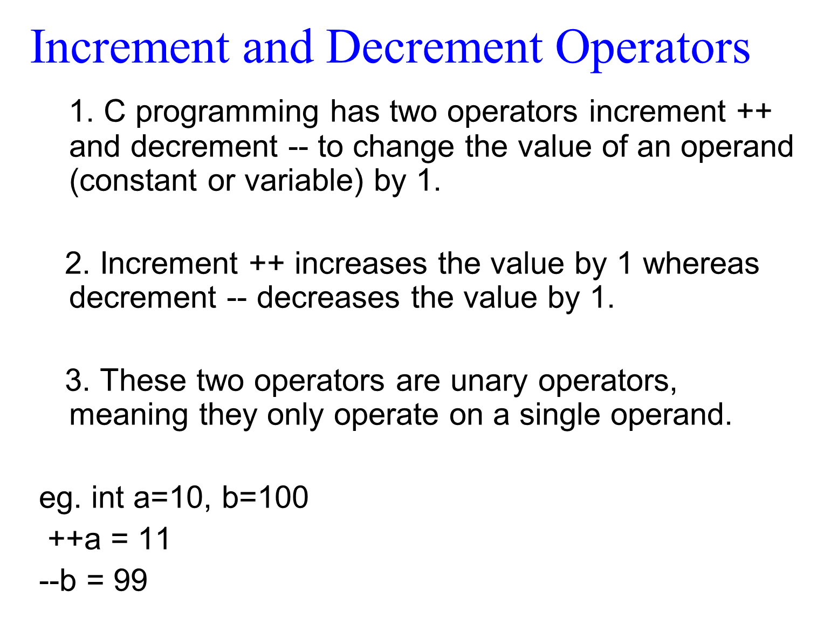

1. Explain the bitwise(按位) operator with program example?
2. Explain about the character and string constant used in C?

String constant字符串常数

A string constant is a set of characters enclosed in

double quotation marks.

字符串常量是用双引号括起来的一组字符 “ ”

The characters in a string constant sequence may be a

Alphabet, number, special character and blank space.

字符串常数序列中的字符可以是字母，数字，

特殊字符和空格

“ Ni hao” “1234”

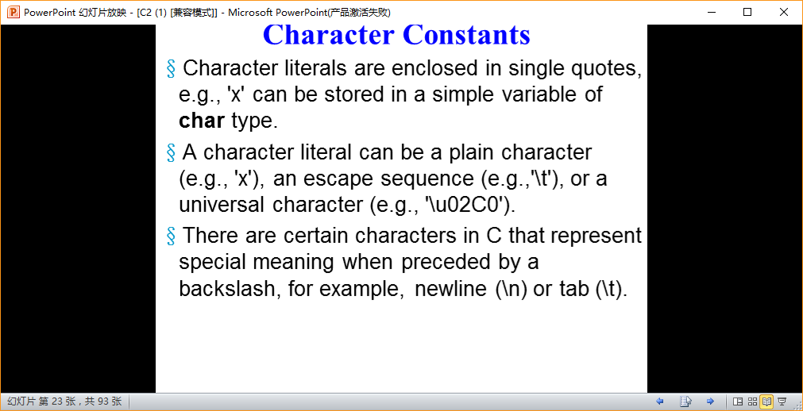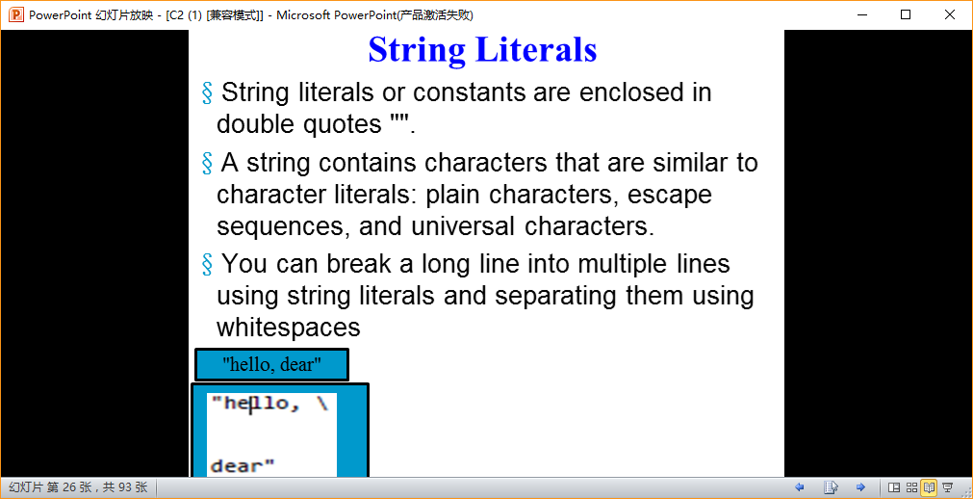

1. Write an user defined function and implement in your program.?
2. Write a note on preprocessor directives with example?

**SECTION C (3 x 10=30)**

1. Write a c program to create single dimentional array to store 10 numbers and print the sum of the numbers?
2. Give the general syntax structure to write the function and Write a program to add any two integer number by using function?
3. What is Union? Give an example?

Several variables together occupy a segment of memory.

union data

{

int i;

char ch;

double d;

}a;

1. Explain enumeration data type with simple example?

#include<stdio.h>

int main()

{

int a,b,c;

a=3&&4;

b=0||1;

c=!1;

printf("%d,%d,%d",a,b,c);

return 0;

}

1. What is Pointer?(P187) Declare five different type of pointer?

In C, variables used to hold memory addresses are referred to as pointer variables, or Pointers.

1. Write a detail note on preprocessor directive?
2. Write a c program to implement the concept(概念) function call by value and call by reference（交换函数，用赋值和指针）(P158.P189)?

#include <stdio.h>

void swap(int x,int y)

{

int z;

z=x;

x=y;

y=z;

printf("x=%d,y=%d\n",x,y);

}

int main()

{

int a,b;

printf("Please enter a,b:\n");

scanf("%d%d",&a,&b);

swap(a,b);

printf("a=%d,b=%d\n",a,b);

return 0;

}

#include <stdio.h>

void swap(int *px,int *py)

{

int z;

z=*px;

*px=*py;

*py=z;

printf("*px=%d,*py=%d\n",*px,*py);

}

int main()

{

int a,b;

printf("Please enter a,b:\n");

scanf("%d%d",&a,&b);

swap(&a,&b);

printf("a=%d,b=%d\n",a,b);

return 0;

}

1. Explain logical operator With C program implementation?

#include <stdio.h>

main()

{

int a = 5, b = 5, c = 10, result;

result = (a == b) && (c > b);

printf("(a == b) && (c > b) equals to %d \n", result);

result = (a == b) || (c < b);

printf("(a == b) || (c < b) equals to %d \n", result);

}

1. Write the various file opening modes in C?

“r”,“w”,“a”,“b”,“+”,“r+” ,“w+”,“a+”

**Answer the following questions in detail with necessary examples SECTION D**

1. Write a C program to illustrate three different looping control structure?

#include<stdio.h>

int main(){

int a=0,b=0,c=0,i,j,k;

i=3;

while(i--)

{

a++;

printf("%d",a);

}

printf("\n");

for(j=0;j<3;j++){

b++;

printf("%d",b);

}

printf("\n");

k=3;

do{

c++;

printf("%d",c);

}while(k--);

printf("\n");

return 0;

}

(ps:由于空格问题建议写成三个)

1. What are the file opening modes? Write a simple c program to create a file?

“r”,“w”,“a”,“b”,“+”

1. What is an Array? Give an example program to declare, initialize, and Access an Array?

什么是数组？给出一个声明、初始化和访问数组的示例程序

The simplest type of data structure .

#include<stdio.h>

int a[10]={0};

int i=0 ;

for(;i<10;i++)

scanf(“%d”,&a[ i ]);

for(i=0 ;i<10 ;i++)

printf(“%d”,a[ i ]);

return 0;

}

1. What are the file opening modes? Write a simple C program to read the content of the a file?

“r”,“w”,“a”,“b”,“+”

#include <stdio.h>

int main()

{

FILE *fp;

int ch;

fp=fopen(“c:\\windows\\system.ini”,“r”);

If(fp!=NULL)

{

while(!feof(fp))

{

ch=fgetc(fp);

putchar(ch);

}

}

fclose(fp);

return 0;

}

1. Explain the various conditional control structure with example?(P85)

举例说明各种条件控制结构？

If switch elseif

1. Explain the various string handling function in C? Write the various function used to do input and output operation in file? 用C解释各种字符串处理函数？编写各种函数，在文件中进行输入和输出操作？

“gets” “puts” “strlen ‘长度’” “strcat‘连接’” “strcpy‘复制’” “strcmp‘比较’” “strlwr‘小写’” “strupr‘大写’” .

P140

#include <stdio.h>

int main()

{

FILE *fp;

char buf[30]={0};

fp=fopen("F:/new.txt","a+");

gets(buf);

fputs(buf,fp);

rewind(fp);

if(fp!=NULL)

{

while(!feof(fp))

{

fgets(buf,60,fp);

puts(buf);

}

}

fclose(fp);

return 0;

}

P245

//说明字符串连接函数strcat的使用.

#include <stdio.h>

#include <string.h>//用到了字符串函数

int main()

{

char dest[]="Hello," , src[]="Beijing!";

strcat(dest, src);

puts(dest);

return 0;

}

输出如下：

