1.The format character %d used to print

A) Character

B) String

C integer

D) float

2. x=5; y=x++;

A) assigns a value 5 to y

B) gives an error message

C) assigns a value 6 to y

D) assigns a value 7 to y

3. The logical operator ! is used for doing

A) Logical AND B) Logical OR

C) Logical NOT D) None of above

4.Which character is used to read short integer  
a) d  
b) hd

c)ld  
d) None of the mentioned

5.The file opening mode “r” is used

|  |  |
| --- | --- |
| A | Read the file |
| B | Write into the file |
| C | Read and write operation |
| D | None of the above |

1. Which operator is used to terminate the statement  
a) !  
b) ;  
c) :  
d) }

2.The value 32767 can represented using which data type?  
a) double  
b) void  
c) int  
d) bool

4. The length of the string correct is “correct”  
a) 7 b) 8  
c) 6 d)9

5.What is a array?  
a) An array is a series of elements of the same type in contiguous memory locations  
b) An array is a series of element  
c) An array is a series of elements of the same type placed in non-contiguous memory locations  
d) None of the mentioned

5,Which of the function that must contain in all C program

A) system() B) main() C)scanf() D)printf()

1. 1. Which symbol must be used to signal the beginning and ending of the C program  
   a) < , >  
   b) (, )  
   c) {, }  
   d) [ ]
2. What punctuation must be used to end the C statement  
   a) : colon b) ; semi colon

c) % d) . dot

1. The length of the string correct is “JIANGXI UNIVERSITY”  
   a) 17 b) 18  
   c) 16 d)19
2. The directive of the preprocessor begin with   
   a) Ampersand symbol(&)  
   b) Two slashes(//)  
   c) Number sign (#)  
   d) Less than symbol(<)
3. Which one of the following is Boolean operator for logical AND

A) system() B) main() C)scanf() D)printf()

**C Programming Language**

1. write a note on integer constant?

2. What is meant Type casting? Give an example?

4. Write any six escape sequence character?

5. Give an example to describe the Structure in C?

6. What is Compiler? Write a C program to print “hello world”?

7. What is the name of ? : operator ? Explain with an example?

8. What is variable? What are the rules followed during the creation of variable name?

8a)Define the data structure to store any five characteristics of student by using structure in c wth example?

9. What is relational expression? Write the relational operator used in C

10.Write any 12 keywords used in C?

11.What are Increment and Decrement Operator? Write a C program example?

12.Explain the bitwise operator with program example?

13.Explain about the character and string constant used in C?

14. Write an user defined function and implement in your program.?

15. Write a note on preprocessor directives with example?

**.Answer the following SECTION C (3 x 10=30)**

16. Write a c program to create single dimentional array to store 10 numbers and print the sum of the numbers?

17. Give the general syntax structure to write the function and Write a program to add any two integer number by using function?

18. What is Union? Give an example?

19. Explain enumeration data type with simple example?

20 What is Pointer? Declare five different type of pointer?

21. Write a detail note on preprocessor directive?

11. Write a c program to implement the concept function call by value and call by reference?

22. Explain logical operator With C program implementation?

23.Write the various file opening modes in C?

**四. Answer the following questions in detail with necessary examples SECTION D**

**24. Write a C program to illustrate three different looping control structure?**

**25. What are the file opening modes? Write a simple c program to create a file?**

**26. What is an Array? Give an example program to declare, initialize, and Access an Array?**

**27. What are the file opening modes? Write a simple C program to read the content of the a file?**

**28. Explain the various selective conditional control structure with example?**

**29. Explain the various string handling function in C? Write the various function used to do input and output operation in file?**

6. write a note on integer constant?

Ans

1. Decimal Integer constant

Any valid number formed by using the symbol 0 to 9 digits

Special symbol are not allowed except + or –

Example 300, 657 (anynumber)

2.Octal Integer constant

The first digit must be 0(zero) followed by digit from 0 to 7

Example 067, 054

3.Hexa decimal Integer

Example 0xA, 0x9

7. What is meant Type casting? Give an example?

**Ans:**

Changing one data type value into another type

Two types (1.implicit type casting 2. Explicit casting)

float f;

double d;

Int i;

i = (int) f;// Expilcit casting

d=i;// implicit type casting

8. What is variable? What are the rules followed during the creation of variable name in C ?

Ans Variable is a name, given to store values in particular memory location

**Rules for naming variables:**

1. All **variable names** must begin with a letter of the alphabet or an. underscore( _ ). ...
2. After the first initial letter, **variable names** can also contain letters and numbers and underscore
3. Uppercase characters are distinct from lowercase characters. ...
4. You cannot use a C keyword (reserved word) as a **variable name**.

9. Write any six escape sequence character?

Ans(any six)

\a Alarm or Beep

\b Backspace

\f Form Feed

\n New Line

\r Carriage Return

\t Tab (Horizontal)

\v Vertical Tab

\\ Backslash

\' Single Quote

\" Double Quote

\? Question Mark

\ooo octal number

\xhh hexadecimal number

\0 Null

10. Give an example to describe the Structure in C?

Structure Student

{ char Name[10];

Int age;

Char bloodgroup[2] ;

} stud1;

6.What is Compiler? Write a C program to print first 100 natural numbers?

Ans: compiler is Software , Which converts source program into object program

Program for first 100 natural numbers

#include<stdio.h>

main()

{int firstnatno;

For(firstnatno=1; firstnatno<=100; firstnatno++)

{

Printf(“%d”, firstnatno);

}

}

7. What is the name of ? : operator? Explain with an example? And represent same by using if statement?

Name Conditional operator or ternary operator

Big=(a>b)?a : b

**Using if**

if(a>b)

big=a;

else big=b;

9. Write down the relational operator and bitwise operator in C?

Relational Operator: > , <, >=, <=, ==, !=

Bitwise operator :&, |,^,~,>>,<<

10.Write any 12 keywords used in C?

break, continue, const, case,char,double,default,enum,float,int,long,short

**三.Answer the following SECTION C (3 x 10=30)**

11. Write a c program to create single dimensional array to store 10 numbers and print the sum of the numbers?

#include<stdio.h>

Int main()

{ int I; sum=0;

Int number[10]={1,2,3,4,5,6,7,8,l,9};

For(i = 0 ; i<=9; i++)

{ sum = sum +number[i];}

Printf(“Sum is ==%d”, sum);

}

12. Give the general syntax structure to write the function and Write a program to add any two integer number by using function?

Syntax

Returntype functionname(formal arguments)

{

statements;

}

#include<stdio.h>

Int add(int,int)

int main()

{

int a,b,sum;

scanf(“ent 1st number = %d”, &a);

scanf(“ent 2nd number = %d”, &b);

sum=add(a,b);

printf (“result =%d”, sum);

}

Int add(int a, int b)

{ return(a+b); }

13. What is Union? Give an example?

#include <stdio.h>

// Declaration of union is same as structures

union test

{

int x, y;

};

int main()

{

// A union variable t

union test t;

t.x = 2; // t.y also gets value 2

printf ("After making x = 2:\n x = %d, y = %d\n\n",

t.x, t.y);

t.y = 10; // t.x is also updated to 10

printf ("After making Y = 'A':\n x = %d, y = %d\n\n",

t.x, t.y);

return 0;

}

11. Explain enumeration data type with simple example?

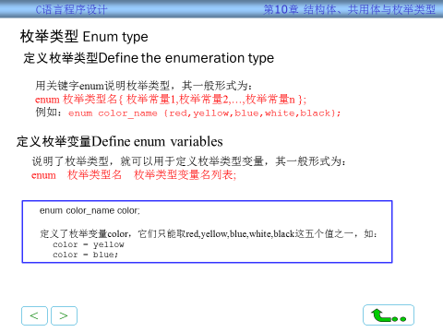

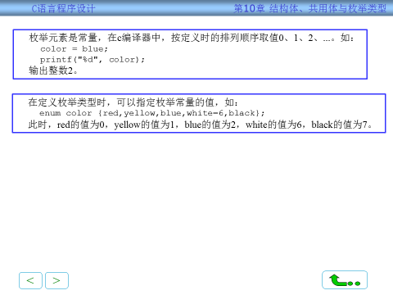

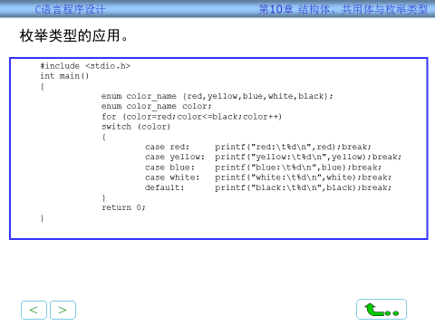

12. What is Pointer? Declare any five different type of pointer?

Ans Pointer is variable which holds address of memory location

Int *p,x;

P=&x;

Char *pc,c;

pc=&c;

Float *fp,f;

Fp=&f;

Double *dp,d;

dp=&d;

**四. Answer the following questions in detail with necessary examples SECTION D ( 2 x 15 = 30 marks**

**14. Write a C program to illustrate three different looping control structure?**

**Three different looping control structure**

**Syntax:**

1. For(loopControlVariable=0; Condition ; IncrementStatement)

{

//Statements;

}

1. While(condition)

{

//statements

}

Do

{

//Statements

}while(condition)

**Program Implementation**

**#include<stdio.h>**

**Int main()**

**{ int a[]={1,2,3,4,5};sum=0;**

**For(i=0; i<5; i++)**

**{ sum=sum+a[i]; }**

**Printf(“sum val by for=%d”, sum);**

**I=0;**

**Do { sum=sum+a[i];**

**}while(i<5)**

**Printf(“sum val by do while loop=%d”, sum);**

**I=0;**

**While(I<5)**

**{ sum=sum+a[i];**

**I++’**

**}**

**Printf(“sum val by while loop=%d”, sum);**

**return 0;**

**}**

**15. What are the file opening modes? Write a simple c program to create a file?**

Ans w,r,a, w+, r+, a+, wb,rb,ab

C Program to print contents of file

[fopen()](http://www.cplusplus.com/reference/cstdio/fopen/) is used to open and [fclose()](http://www.cplusplus.com/reference/cstdio/fclose/) is used to close a file in C

|  |
| --- |
| #include <stdio.h>  #include <stdlib.h> // For exit()   int main()  {      FILE *fptr;       char filename[100], c;       printf("Enter the filename to open \n");      scanf("%s", filename);       // Open file      fptr = fopen(filename, "r");      if (fptr == NULL)      {          printf("Cannot open file \n");          exit(0);      }       // Read contents from file      c = fgetc(fptr);      while (c != EOF)      {          printf ("%c", c);          c = fgetc(fptr);      }       fclose(fptr);    return 0;} |

1. What are Increment and Decrement Operator? Write a C program example?

++, --

#include<stdio.h>

int main()

{ int a=5,b,c,d,e;

b=++a;

c=a++;

d=a--;

e=--a;

printf(“%d %d %d %d “, b ,c , d, e);

return 0;

}

1. Explain the bitwise operator with program example?

#include <stdio.h>

Int main() {

unsigned int a = 60;

unsigned int b = 13; int c = 0;

c = a & b;

printf("Line 1 - Value of c is %d\n", c );

c = a | b;

printf("Line 2 - Value of c is %d\n", c );

c = a ^ b;

printf("Line 3 - Value of c is %d\n", c );

c = ~a;

printf("Line 4 - Value of c is %d\n", c );

c = a << 2;

printf("Line 5 - Value of c is %d\n", c );

c = a >> 2;

printf("Line 6 - Value of c is %d\n", c );

}

1. Explain about the character and string constant used in C?

Ans:

**Character Constant**: (a)Single character constant (b) Escape Sequence

(a) Any valid ASCII character enclosed in single quote

Example char charconst=’A’;

char charconst=’a’;

(b)Escape Sequence

‘\b’ , ‘\t’

**String**

Any character enclosed in “ ”

Example

“Jiangxi University”

4.Write an user defined function and implement in your program?

The C programmer can write their own function is called UDF

Syntax Structure

return_type function_name( parameter list ) {

// body of the function

}

Implementation(Any Example Function)

#include <stdio.h>

int addNumbers(int a, int b); // function prototype

int main()

{

int n1,n2,sum;

printf("Enters two numbers: ");

scanf("%d %d",&n1,&n2);

sum = addNumbers(n1, n2); // function call

printf("sum = %d",sum);

return 0;

}

int addNumbers(int a,int b) // function definition

{

int result;

result = a+b;

return result; // return statement

}

1. **Write a note on preprocessor directives with example?**

**Ans:**

The Preprocessor process all **directives** and the output will be given to main processor

Example

#include –to include the specific header file in the c program #include<stdio.h>

#define – to define symbolic constant and any other

Example

#define PI 3.11678

To specify conditional compilation

### **#ifdef, #ifndef, #if, #endif, #else and #elif**

**三.Answer the following SECTION C (3 x 10=30)**

1. Write a c program to implement the concept function call by value and call by reference?

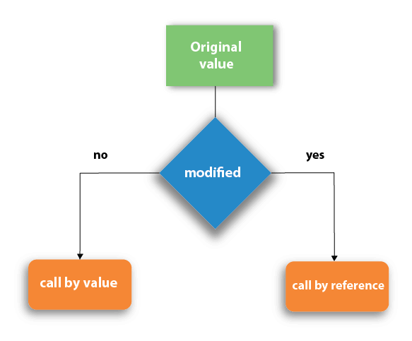

**Call By Value**:

#include<stdio.h>

**void** change(**int** num) {

     printf("Before adding value inside function num=%d \n",num);

        num=num+100;

     printf("After adding value inside function num=%d \n", num);

}

**int** main() {

**int** x=100;

    printf("Before function call x=%d \n", x);

    change(x);//passing value in function

    printf("After function call x=%d \n", x);

**return** 0;

}

Call By refrence:

1. #include<stdio.h>
2. **void** change(**int** *num) {
3. printf("Before adding value inside function num=%d \n",*num);
4. (*num) += 100;
5. printf("After adding value inside function num=%d \n", *num);
6. }
7. **int** main() {
8. **int** x=100;
9. printf("Before function call x=%d \n", x);
10. change(&x);//passing reference in function
11. printf("After function call x=%d \n", x);
12. **return** 0;
13. }     (or)

Call by Value Example: Swapping the values of the two variables

1. #include <stdio.h>
2. **void** swap(**int** , **int**); //prototype of the function
3. **int** main()
4. {
5. **int** a = 10;
6. **int** b = 20;
7. printf("Before swapping the values in main a = %d, b = %d\n",a,b); // printing the value of a and b in main
8. swap(a,b);
9. printf("After swapping values in main a = %d, b = %d\n",a,b); // The value of actual parameters do not change by changing the formal parameters in call by value, a = 10, b = 20
10. }
11. **void** swap (**int** a, **int** b)
12. {
13. **int** temp;
14. temp = a;
15. a=b;
16. b=temp;
17. printf("After swapping values in function a = %d, b = %d\n",a,b); // Formal parameters, a = 20, b = 10
18. }

Call by reference Example: Swapping the values of the two variables

1. #include <stdio.h>
2. **void** swap(**int** *, **int** *); //prototype of the function
3. **int** main()
4. {
5. **int** a = 10;
6. **int** b = 20;
7. printf("Before swapping the values in main a = %d, b = %d\n",a,b); // printing the value of a and b in main
8. swap(&a,&b);
9. printf("After swapping values in main a = %d, b = %d\n",a,b); // The values of actual parameters do change in call by reference, a = 10, b = 20
10. }
11. **void** swap (**int** *a, **int** *b)
12. {
13. **int** temp;
14. temp = *a;
15. *a=*b;
16. *b=temp;
17. printf("After swapping values in function a = %d, b = %d\n",*a,*b); // Formal parameters, a = 20, b = 10
18. }
19. Explain logical operator With C program implementation?

|  |  |  |
| --- | --- | --- |
| && | Called Logical AND operator. If both the operands are non-zero, then the condition becomes true. | (A && B) is false. |
| || | Called Logical OR Operator. If any of the two operands is non-zero, then the condition becomes true. | (A || B) is true. |
| ! | Called Logical NOT Operator. It is used to reverse the logical state of its operand. If a condition is true, then Logical NOT operator will make it false. | !(A && B) is true. |

#include <stdio.h>

Int main() {

int a = 5;

int b = 20;

int c ;

if ( a && b ) {

printf("Line 1 - Condition is true\n" );

}

if ( a || b ) {

printf("Line 2 - Condition is true\n" );

}

/* lets change the value of a and b */

a = 0;

b = 10;

if ( a && b ) {

printf("Line 3 - Condition is true\n" );

} else {

printf("Line 3 - Condition is not true\n" );

}

if ( !(a && b) ) {

printf("Line 4 - Condition is true\n" );

}

}

3.Write the various file opening modes in C?

W write only(when we want to create new file can use this mode, suppose if the file already exists, the existing content will be deleted)

r read only(if the file already exists , open it for reading otherwise it open new file with the specified name)

a append(open the existing file for adding more records and the file pointer will be moved to the end of the file)

w+,r+,a+,wb,rb,ab

+ to specify more operation with basic file opening mode

B binary format with basic file opening mode

**四. Answer the following questions in detail with necessary examples SECTION D ( 2 x 15 = 30 marks**

1. Explain the various conditional control structure with example?

if(expression){

//code to be executed

}

|  |  |
| --- | --- |
|  | [**if statement**](https://www.tutorialspoint.com/cprogramming/if_statement_in_c.htm)  An **if statement** consists of a boolean expression followed by one or more statements.   1. #include<stdio.h> 2. **int** main(){ 3. **int** number=0; 4. printf("Enter a number:"); 5. scanf("%d",&number); 6. **if**(number%2==0){ 7. printf("%d is even number",number); 8. } 9. **return** 0; 10. } |
| 2 | [**if...else statement**](https://www.tutorialspoint.com/cprogramming/if_else_statement_in_c.htm)  An **if statement** can be followed by an optional **else statement**, which executes when the Boolean expression is false.   1. Syntax **if**(expression){ 2. //code to be executed if condition is true 3. }**else**{ 4. //code to be executed if condition is false 5. } 6. #include<stdio.h> 7. **int** main(){ 8. **int** number=0; 9. printf("enter a number:"); 10. scanf("%d",&number); 11. **if**(number%2==0){ 12. printf("%d is even number",number); 13. } 14. **else**{ 15. printf("%d is odd number",number); 16. } 17. **return** 0; 18. } |
| 3 | If else-if ladder Statement  You can use one **if** or **else if** statement inside another **if** or **else if** statement(s).   1. **if**(condition1){ 2. //code to be executed if condition1 is true 3. }**else** **if**(condition2){ 4. //code to be executed if condition2 is true 5. } 6. **else** **if**(condition3){ 7. //code to be executed if condition3 is true 8. } 9. ... 10. **else**{ 11. //code to be executed if all the conditions are false 12. } 13. #include<stdio.h> 14. **int** main(){ 15. **int** number=0; 16. printf("enter a number:"); 17. scanf("%d",&number); 18. **if**(number==10){ 19. printf("number is equals to 10"); 20. } 21. **else** **if**(number==50){ 22. printf("number is equal to 50"); 23. } 24. **else** **if**(number==100){ 25. printf("number is equal to 100"); 26. } 27. **else**{ 28. printf("number is not equal to 10, 50 or 100"); 29. } 30. **return** 0; 31. } |
| 4 | [**switch statement**](https://www.tutorialspoint.com/cprogramming/switch_statement_in_c.htm)  A **switch** statement allows a variable to be tested for equality against a list of values.   1. **switch**(expression){ 2. **case** value1: 3. //code to be executed; 4. **break**;  //optional 5. **case** value2: 6. //code to be executed; 7. **break**;  //optional 8. ...... 10. **default**: 11. code to be executed **if** all cases are not matched; 12. } 13. #include<stdio.h> 14. **int** main(){ 15. **int** number=0; 16. printf("enter a number:"); 17. scanf("%d",&number); 18. **switch**(number){ 19. **case** 10: 20. printf("number is equals to 10"); 21. **break**; 22. **case** 50: 23. printf("number is equal to 50"); 24. **break**; 25. **case** 100: 26. printf("number is equal to 100"); 27. **break**; 28. **default**: 29. printf("number is not equal to 10, 50 or 100"); 30. } 31. **return** 0; 32. }   Output  enter a number:4  number is not equal to 10, 50 or 100  enter a number:50  number is equal to 50  Switch case example 2   1. #include <stdio.h> 2. **int** main() 3. { 4. **int** x = 10, y = 5; 5. **switch**(x>y && x+y>0) 6. { 7. **case** 1: 8. printf("hi"); 9. **break**; 10. **case** 0: 11. printf("bye"); 12. **break**; 13. **default**: 14. printf(" Hello bye "); 15. } 17. }   **Output**  hi  C Switch statement is fall-through  In C language, the switch statement is fall through; it means if you don't use a break statement in the switch case, all the cases after the matching case will be executed.  Let's try to understand the fall through state of switch statement by the example given below.   1. #include<stdio.h> 2. **int** main(){ 3. **int** number=0; 5. printf("enter a number:"); 6. scanf("%d",&number); 8. **switch**(number){ 9. **case** 10: 10. printf("number is equal to 10\n"); 11. **case** 50: 12. printf("number is equal to 50\n"); 13. **case** 100: 14. printf("number is equal to 100\n"); 15. **default**: 16. printf("number is not equal to 10, 50 or 100"); 17. } 18. **return** 0; 19. } |
| 5 | [**nested switch statements**](https://www.tutorialspoint.com/cprogramming/nested_switch_statements_in_c.htm)  You can use one **switch** statement inside another **switch** statement(s).   1. #include <stdio.h> 2. **int** main () { 4. **int** i = 10; 5. **int** j = 20; 7. **switch**(i) { 9. **case** 10: 10. printf("the value of i evaluated in outer switch: %d\n",i); 11. **case** 20: 12. **switch**(j) { 13. **case** 20: 14. printf("The value of j evaluated in nested switch: %d\n",j); 15. } 16. } 18. printf("Exact value of i is : %d\n", i ); 19. printf("Exact value of j is : %d\n", j ); 21. **return** 0; 22. } |

1. Explain the various string handling function in C? Write the various function used to do input and output operation in file?

Any Three Function

|  |  |  |
| --- | --- | --- |
| **No.** | **Function** | **Description** |
| 1) | [strlen(string_name)](https://www.javatpoint.com/c-strlen) | returns the length of string name. |
| 2) | [strcpy(destination, source)](https://www.javatpoint.com/c-strcpy) | copies the contents of source string to destination string. |
| 3) | [strcat(first_string, second_string)](https://www.javatpoint.com/c-strcat) | concats or joins first string with second string. The result of the string is stored in first string. |
| 4) | [strcmp(first_string, second_string)](https://www.javatpoint.com/c-strcmp) | compares the first string with second string. If both strings are same, it returns 0. |
| 5) | [strrev(string)](https://www.javatpoint.com/c-strrev) | returns reverse string. |
| 6) | [strlwr(string)](https://www.javatpoint.com/c-strlwr) | returns string characters in lowercase. |
| 7) | [strupr(string)](https://www.javatpoint.com/c-strupr) | returns string characters in uppercase. |

File handling function

Fgetc, fputc, fgets,fputs,fscanf,fprintf,fread,fwrite