吃豆人实验手册

概述
本实验基于UC Berkeley 为人工智能课程开发的吃豆人（Pac-Man）（http://ai.berkeley.edu.）项目改编而成。本实验运用一系列人工智能技术来玩吃豆人游戏。然而，这些项目并不专注于为电子游戏开发AI，而是用来教授基本的人工智能概念，如状态空间搜索、概率推理和强化学习等。这些概念是自然语言处理、计算机视觉和机器人等实际应用领域的基础。
这些项目的设计基于三个目标。这些项目能够明确展示出实现技术结果。项目中还包含代码示例和明确的引导，不需要花费过多精力在代码框架上。最后，Pac-Man提供了一个具有挑战性的问题环境，需要创造性的解决方案。现实世界中的人工智能问题具有挑战性，Pac-Man也是如此。

实验目录
实验0：Python学习
  - 简要学习Python语言
实验1：Search
  - 学生将实现宽度优先、深度优先、代价一直、A*搜索算法。这些算法用于求解Pacman世界中的路径规划和旅行商问题。
竞赛1（选做）：Multi-Agent Pacman
  - 学生将应用搜索算法和项目1中实现的问题来处理更困难的场景，包括控制多个pacman agent和在时间约束下进行规划。
实验2：Multi-Agent Search
  - 经典的吃豆人模型是一个对抗性和随机搜索问题。学生们实现多Agent极小极大和期望极大算法，以及设计评估函数。
竞赛2（选做）：Multi-Agent Adversarial Pacman
  - 这个竞赛涉及到一个多玩家的Pacman”抓旗”问题，在这个问题中，Agents通过协调的团队策略来控制Pacman和ghost。每支队伍将尝试吃地图远端的食物，同时保卫自己家乡的食物。

实验0：Python学习

简要介绍
本课程所有的实验项目建议使用Python 3.6或3.7。
实验0主要包括以下几个方面：
- 简短的Unix/Linux基础学习；
- Python环境安装；
- 简短的Python基础学习；
- 实验成绩计算：每一次实验的发布都包括了自动计算成绩，可以自己运行来进行计算。
需要编辑并提交的文件：填充压缩包tutorial.zip 中如下三个文件的相应部分： addition.py、buyLotsOfFruit.py 和 shopSmart.py 。最终提交包括了代码和注释的这三个文件。请不要修改其他的文件，也不要提交除此之外的其他文件。
评价:提交的代码将根据技术正确性自动评分。请不要在代码中更改任何提供的函数或类的名称，否则将对autograder造成严重破坏。然而，执行正确性并不是自动评分能够判断的。如有需要，我们会单独检查并给与评分，以确保你的工作得到应有的学分。
学术不诚实:我们将检查你的代码与其他提交在类逻辑冗余。如果复制别人的代码然后只做很小的修改，将会被检测出来。这些作弊探测器很难被骗，所以请不要尝试。我们相信大家只提交自己的作品。
寻求帮助:如果你发现自己卡在什么东西上，联系课程实验助教寻求帮助。办公时间、微信群等都有您的支持。希望这些实验项目是有益的和指导性的。

1、Unix/Linux基础（选用windows平台的同学可以跳过这一节）：
Here are basic commands to navigate UNIX and edit files.

File/Directory Manipulation
When you open a terminal window, you’re placed at a command prompt:
[cs188-ta@nova ~]$
The prompt shows your username, the host you are logged onto, and your current location in the directory structure (your path). The tilde character is shorthand for your home directory. Note your prompt may look slightly different. To make a directory, use the mkdir command. Use cd to change to that directory:
[cs188-ta@nova ~]$ mkdir foo
[cs188-ta@nova ~]$ cd foo
[cs188-ta@nova ~/foo]$
Use ls to see a listing of the contents of a directory, and touch to create an empty file:
[cs188-ta@nova ~/foo]$ ls
[cs188-ta@nova ~/foo]$ touch hello_world
[cs188-ta@nova ~/foo]$ ls
hello_world
[cs188-ta@nova ~/foo]$ cd ..
[cs188-ta@nova ~]$
Download python_basics.zip into your home directory (note: the zip file’s name may be slightly different when you download it). Use unzip to extract the contents of the zip file:
[cs188-ta@nova ~]$ ls *.zip
python_basics.zip
[cs188-ta@nova ~]$ unzip python_basics.zip
[cs188-ta@nova ~]$ cd python_basics
[cs188-ta@nova ~/python_basics]$ lsforeach.py
helloWorld.py
listcomp.py
listcomp2.py
quickSort.py
shop.py
shopTest.py
Some other useful Unix commands:
- cp copies a file or files
- rm removes (deletes) a file
- mv moves a file (i.e., cut/paste instead of copy/paste)
- man displays documentation for a command
- pwd prints your current path
- xterm opens a new terminal window
- firefox opens a web browser
- Press “Ctrl-c” to kill a running process
- Append & to a command to run it in the background
- fg brings a program running in the background to the foreground

The Emacs text editor
Emacs is a customizable text editor which has some nice features specifically tailored for programmers. However, you can use any other text editor that you may prefer (such as vi, pico, or joe on Unix; or Notepad on Windows; or TextWrangler on OS X; and many more).
To run Emacs, type emacs at a command prompt:
[cs188-ta@nova ~/python_basics]$ emacs helloWorld.py &[1] 3262
Here we gave the argument helloWorld.py which will either open that file for editing if it exists, or create it otherwise. Emacs notices that this is a Python source file (because of the .py ending) and enters Python-mode, which is supposed to help you write code. When editing this file you may notice some of that text becomes automatically colored: this is syntax highlighting to help you distinguish items such as keywords, variables, strings, and comments. Pressing Enter, Tab, or Backspace may cause the cursor to jump to weird locations: this is because Python is very picky about indentation, and Emacs is predicting the proper tabbing that you should use.
Some basic Emacs editing commands (C- means “while holding the Ctrl-key”):
- C-x C-s Save the current file
- C-x C-f Open a file, or create a new file it if doesn’t exist
- C-k Cut a line, add it to the clipboard
- C-y Paste the contents of the clipboard
- C-_ Undo
- C-g Abort a half-entered command
You can also copy and paste using just the mouse. Using the left button, select a region of text to copy. Click the middle button to paste.
There are two ways you can use Emacs to develop Python code. The most straightforward way is to use it just as a text editor: create and edit Python files in Emacs; then run Python to test the code somewhere else, like in a terminal window. Alternatively, you can run Python inside Emacs: see the options under “Python” in the menubar, or type C-c ! to start a Python interpreter in a split screen. (Use C-x o to switch between the split screens, or just click if C-x doesn’t work).
If you want to spend some extra setup time becoming a power user, you can try an IDE like Eclipse (Download the Eclipse Classic package at the bottom). Check out PyDev for Python support in Eclipse.

2、Python环境安装（以windows系统为例，其他系统类型，可以网上搜索安装方案）
Anaconda 是一个基于 Python 的数据处理和科学计算平台，它已经内置了许多非常有用的第三方库，装上Anaconda，就相当于把 Python 和一些如 Numpy、Pandas、Scrip、Matplotlib 等常用的库自动安装好了，使得安装比常规 Python 安装要容易。如果选择安装Python的话，那么还需要 pip install 一个一个安装各种库，安装起来比较痛苦，还需要考虑兼容性，非如此的话，就要去Python官网（https://www.python.org/downloads/windows/）选择对应的版本下载安装,可以选择默认安装或者自定义安装,为了避免配置环境和安装pip的麻烦，建议勾选添加环境变量和安装pip选项。
推荐直接安装Anaconda+Pycharm就可以了。下面介绍下载、安装和配置过程：
1.Anaconda下载安装（目前网站最新的版本是3.7，文中图片例子是3.5，方法步骤是一样的）
步骤一：进入官网（https://www.anaconda.com/download/#windows）下载对应正确的版本，这里选择的是Windows 64bit；
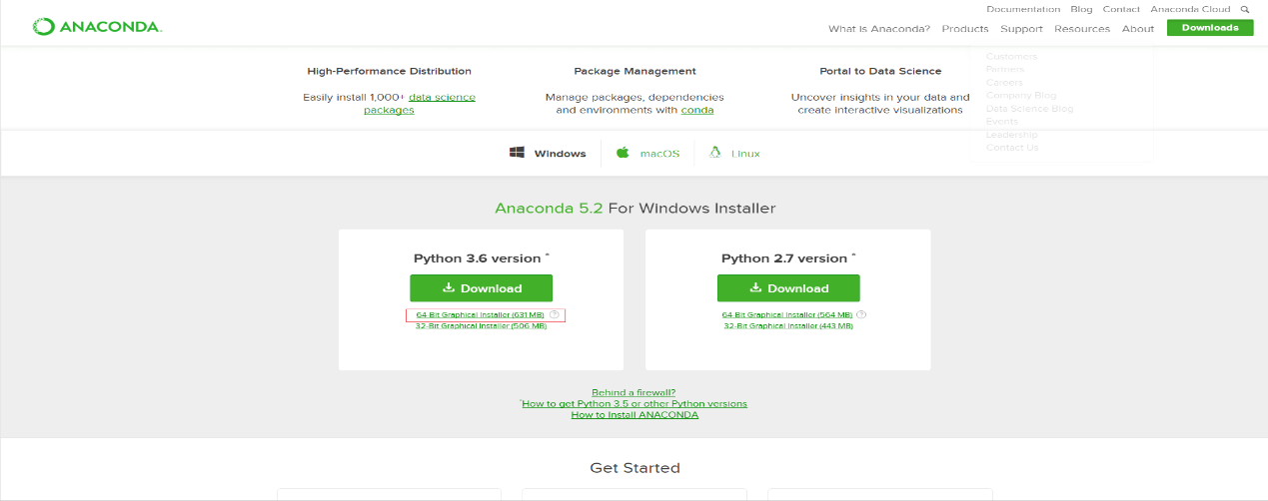
步骤二：双击下载好的exe文件进行安装，点击next,点击i agree，选择just for me点击next，点击browse选择安装目录，勾选红色框点击install等待完成，点击next，点击skip，取消两个勾选框点击finish；
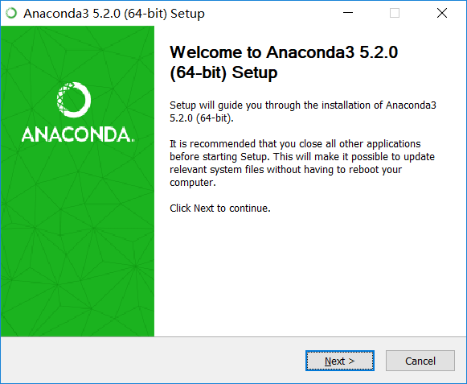
下面对话框中“Add Anaconda to my PATH Environment Variable”
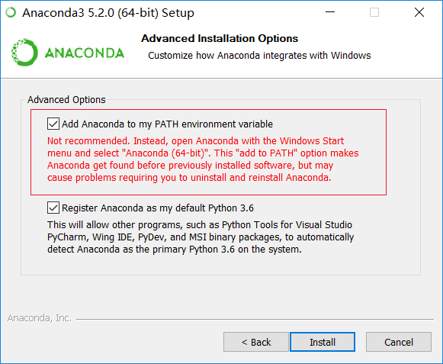
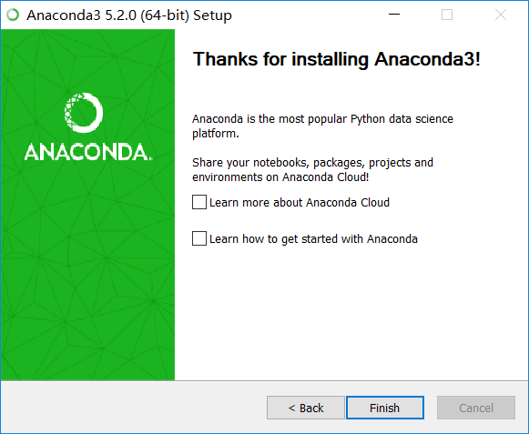
步骤三：按win+R,输入cmd进入终端，输入python，如果出现Python版本信息说明安装成功（如果看不到尝试先进入安装目录在输入python），然后再次进入终端切换盘符到Anaconda安装目录输入conda list 就可以查询现在安装了哪些库，初次安装的包一般比较老，为了避免之后使用报错，可以输入 conda update --all 命令，把所有包进行更新，在提示是否更新的时候输入 y（Yes）让更新继续，等待完成即可。
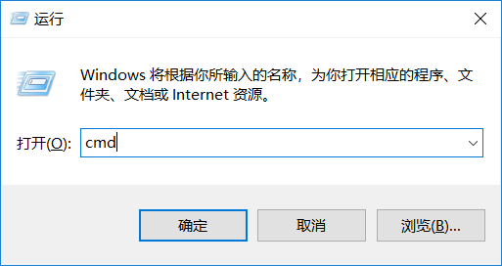
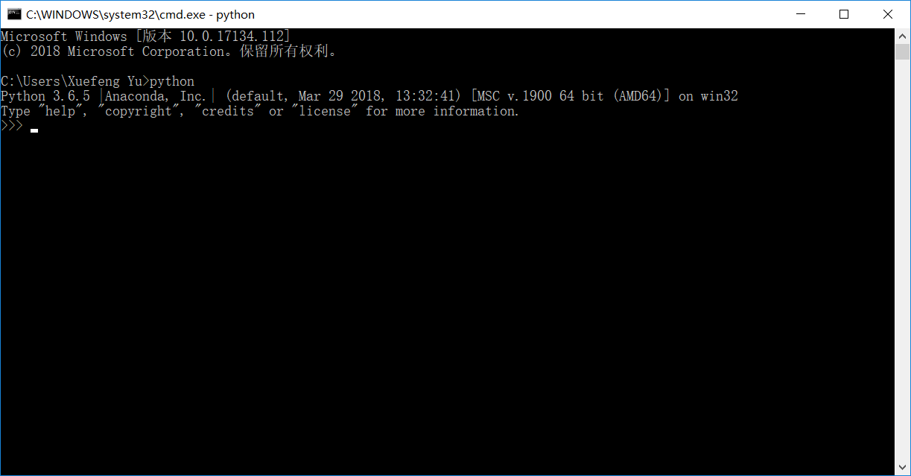
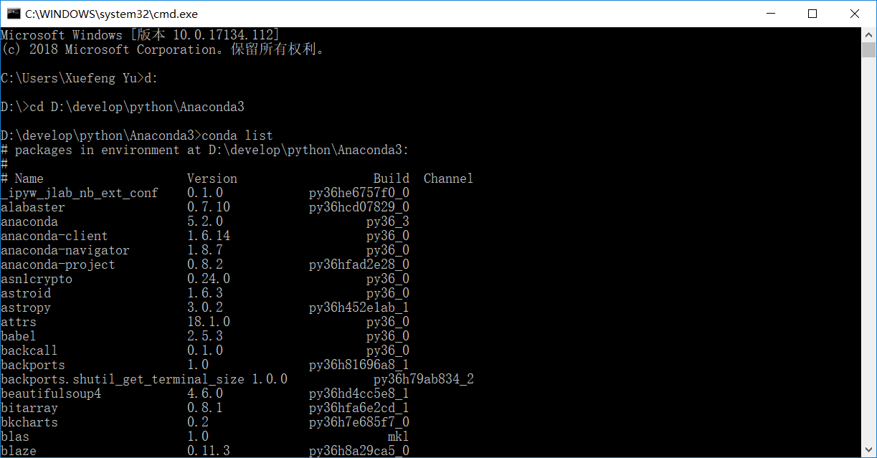
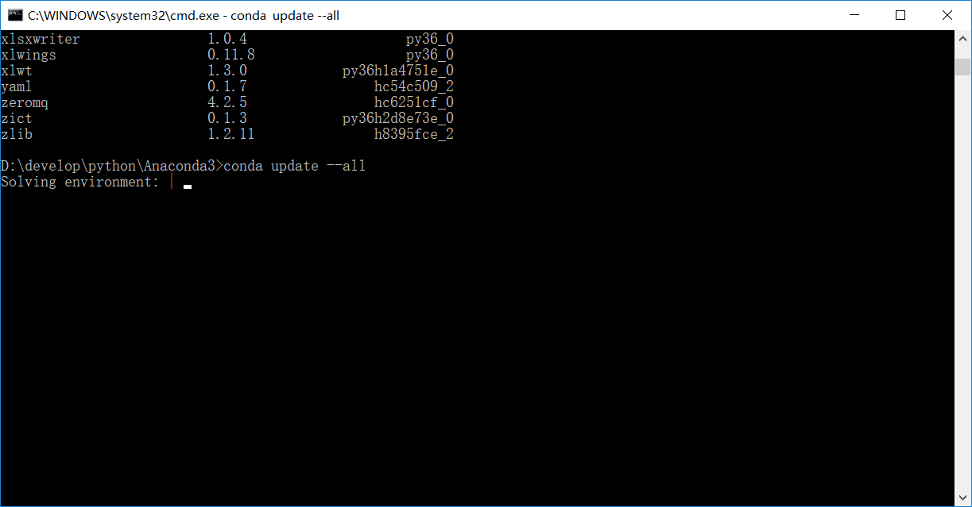
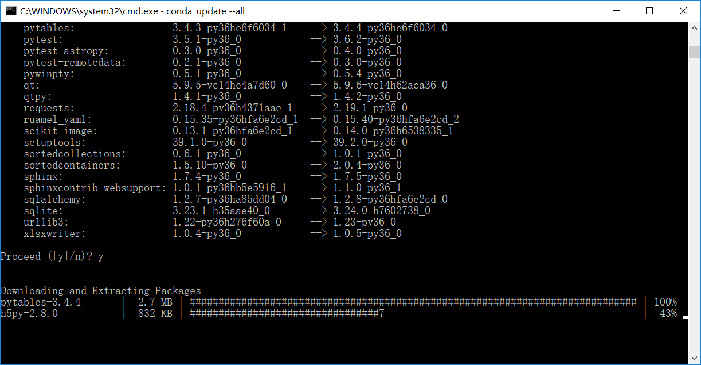
2.Pycharm下载安装、破解、配置
步骤一：进入官网（http://www.jetbrains.com/pycharm/download/#section=windows）下载对应正确的版本，这里选择专业版，专业版是收费的，之后会讲解破解步骤，社区版是免费的；
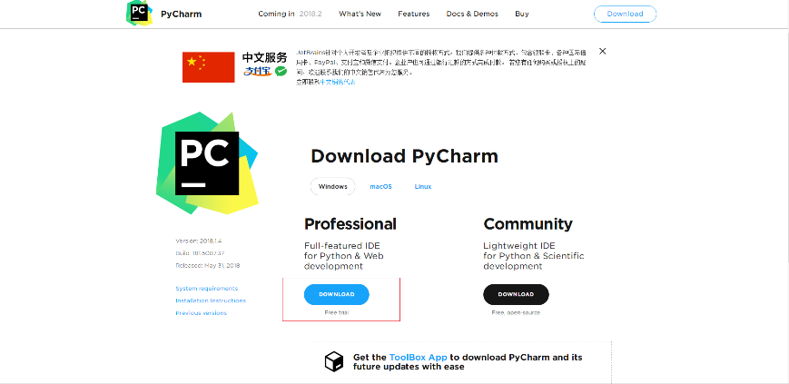
步骤二：双击下载好的exe文件进行安装，直接点next，然后可以点击browse选择安装路径，切换好安装路径后点击next，然后选择红色表示框的内容（32位电脑就勾选第一个32bit）,点击next,再点击install等待安装完成；
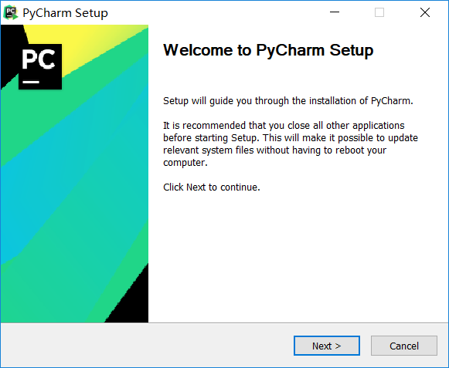

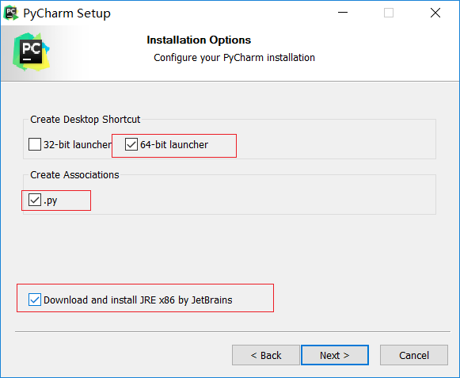

步骤三：安装完成后，勾选run pycharm,点击finish，再点击ok，再将右侧滑块滑到底点击accept，点击send,再选择红色表示框中显示的选项，将这个窗口缩小等待下一步破解；
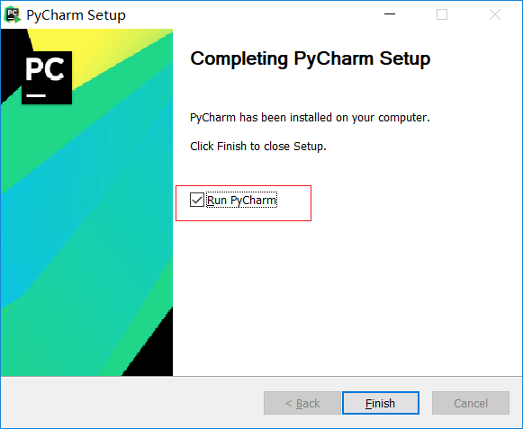
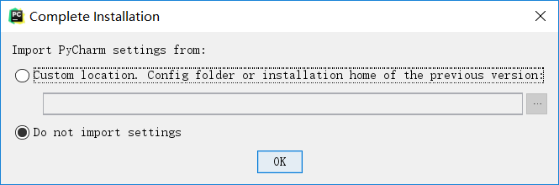
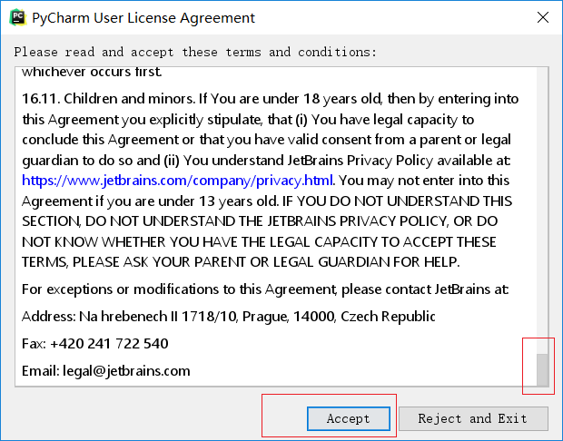
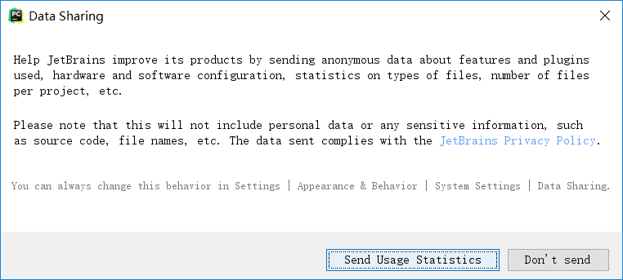
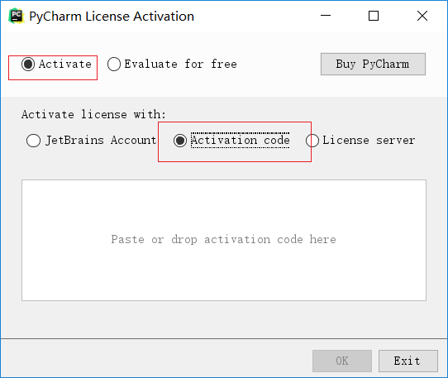
网上搜索到激活码，拷贝进来，就可以注册成功了
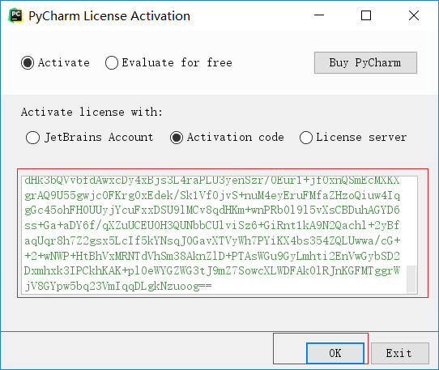
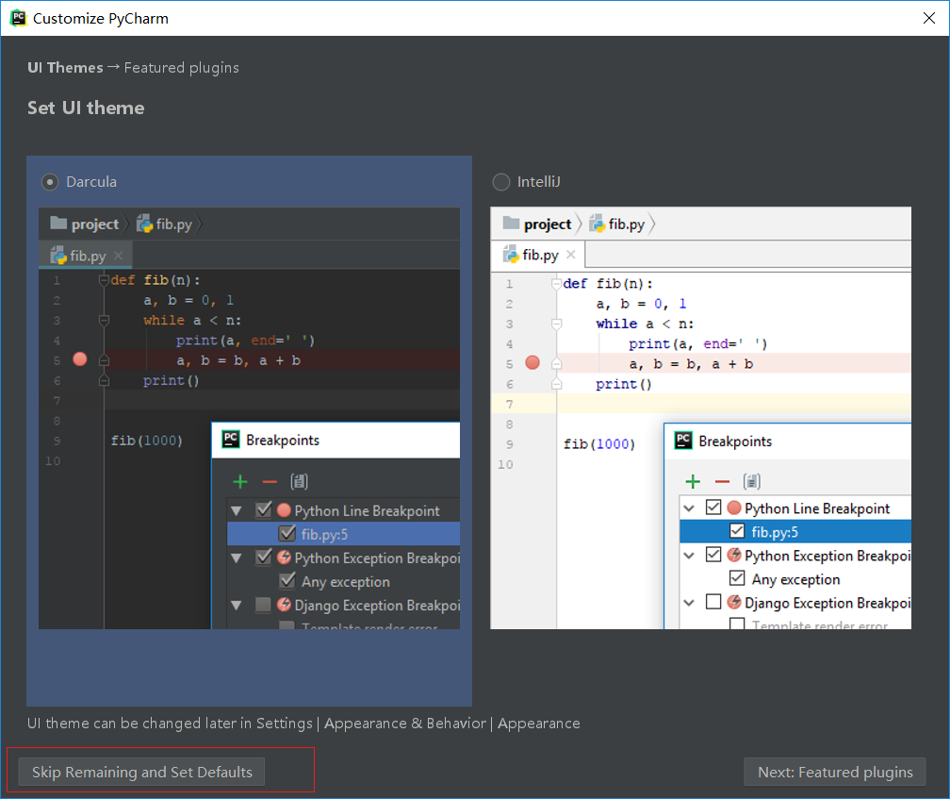
步骤五：创建项目并配置Anaconda，首先点击create new project，location为文件存储位置，project interpreter为解释器，也就是Anaconda中的python.exe，按图中步骤操作，最后点击create，创建完之后进入pycharm界面，点击close，在file选项中选择default setting,选择project interpreter并且按步骤选中Anaconda中的python.exe；
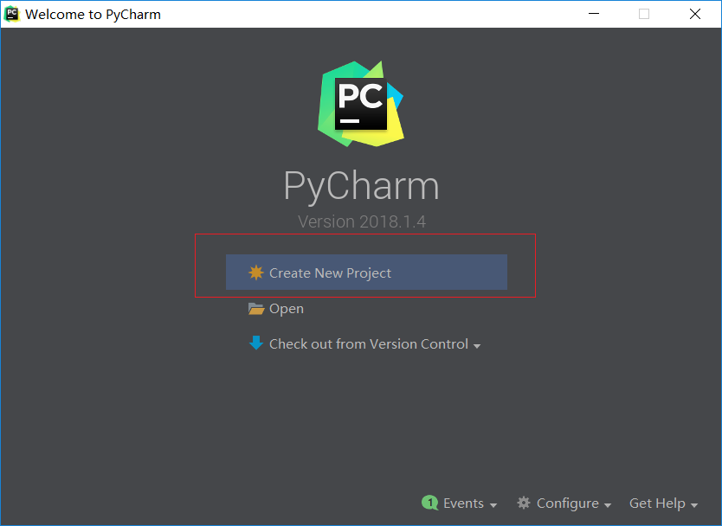
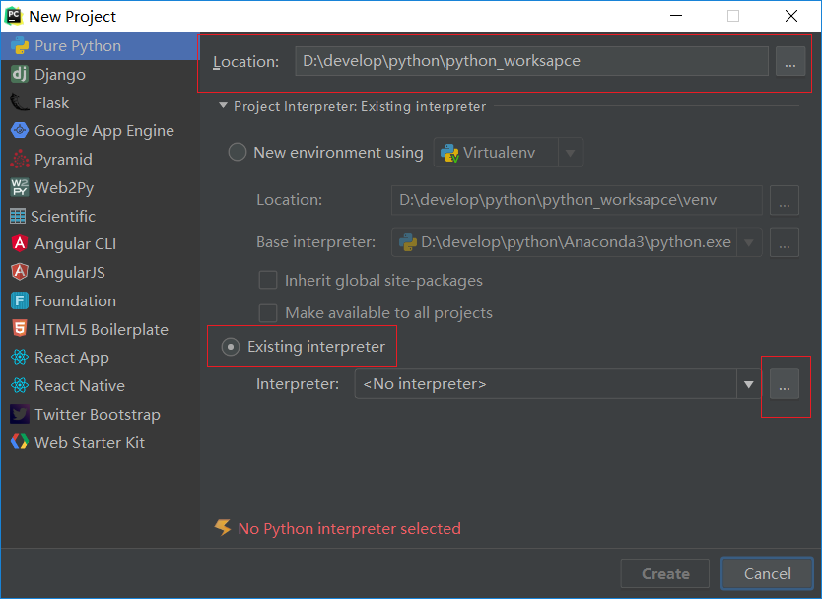
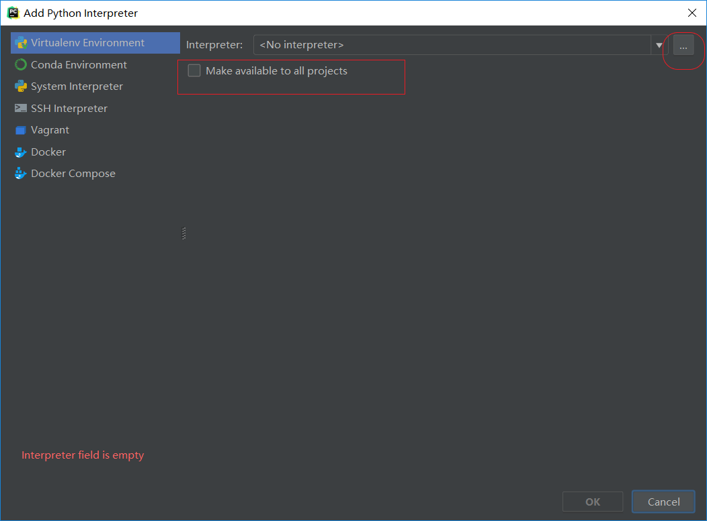
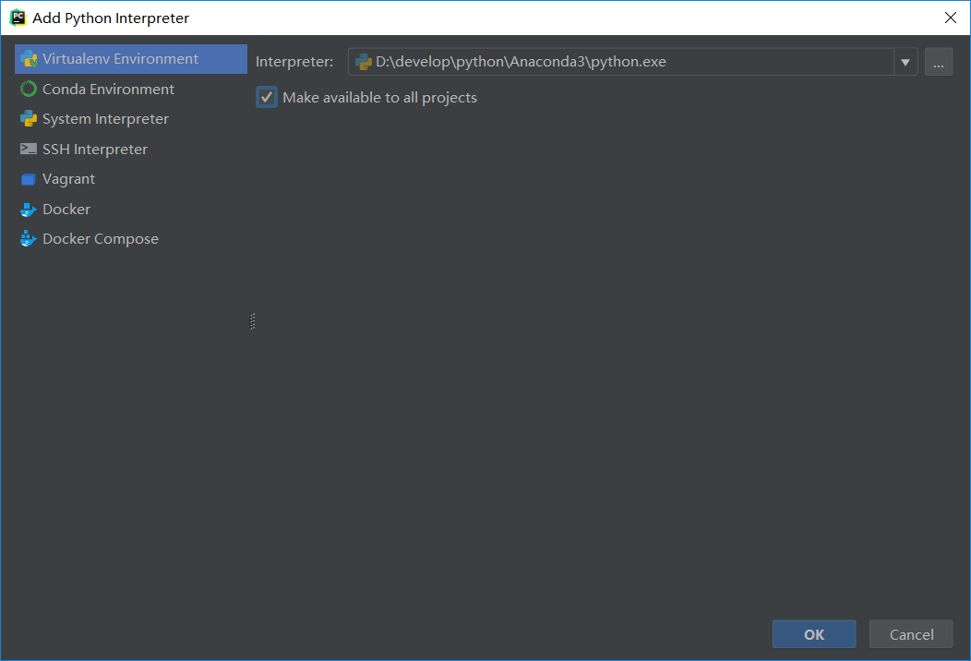
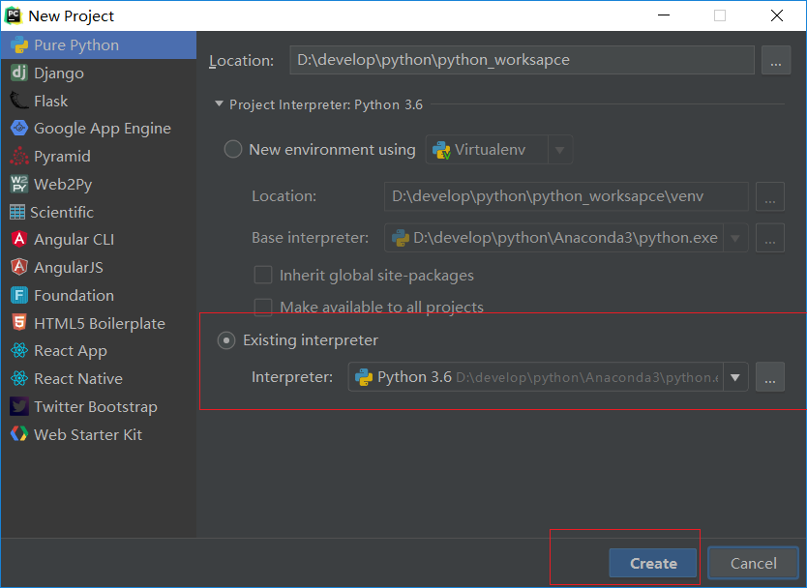
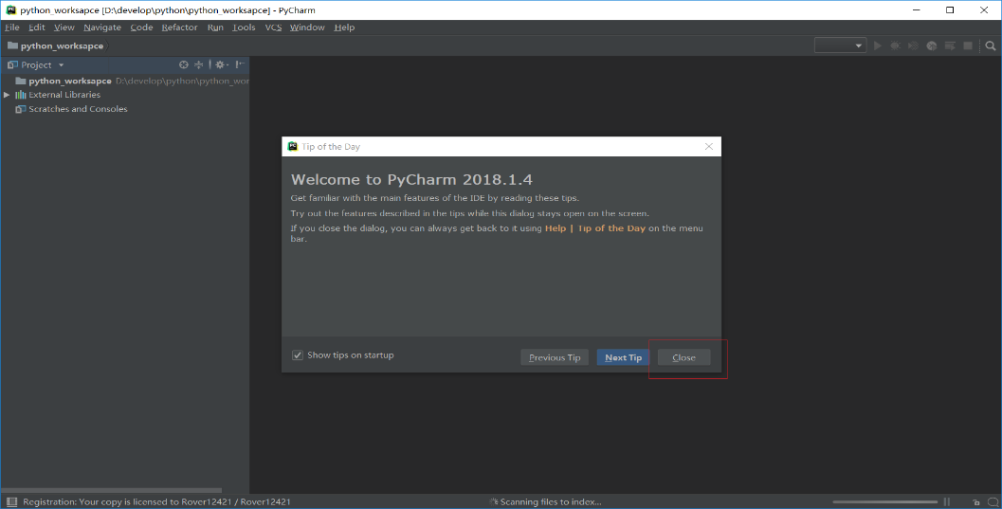

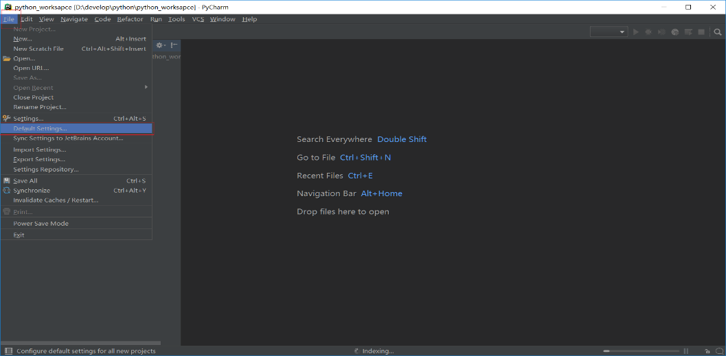

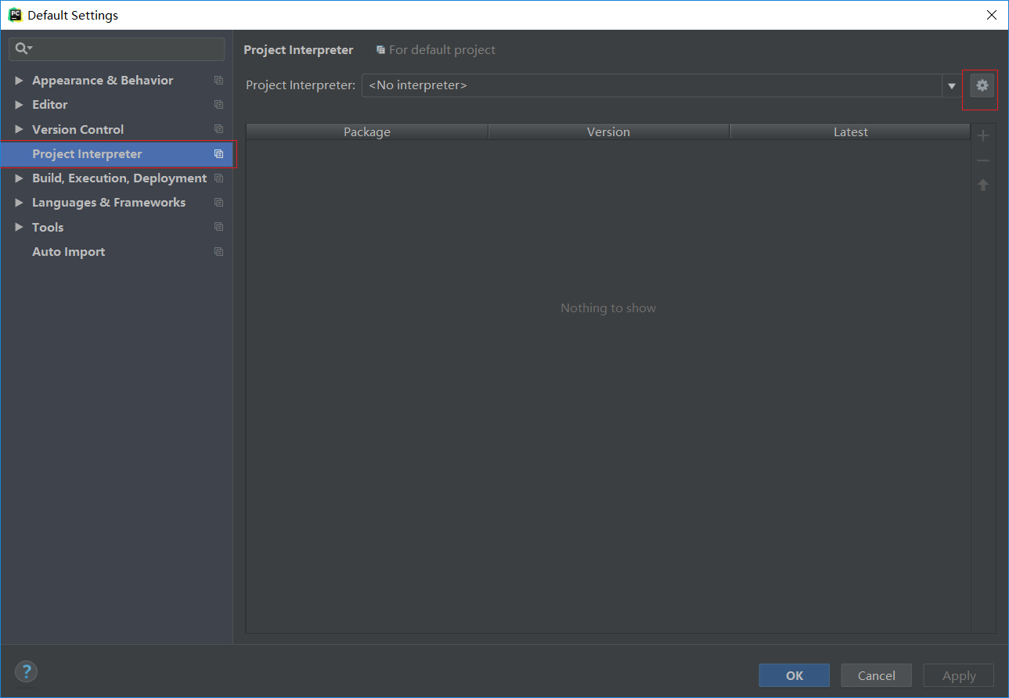

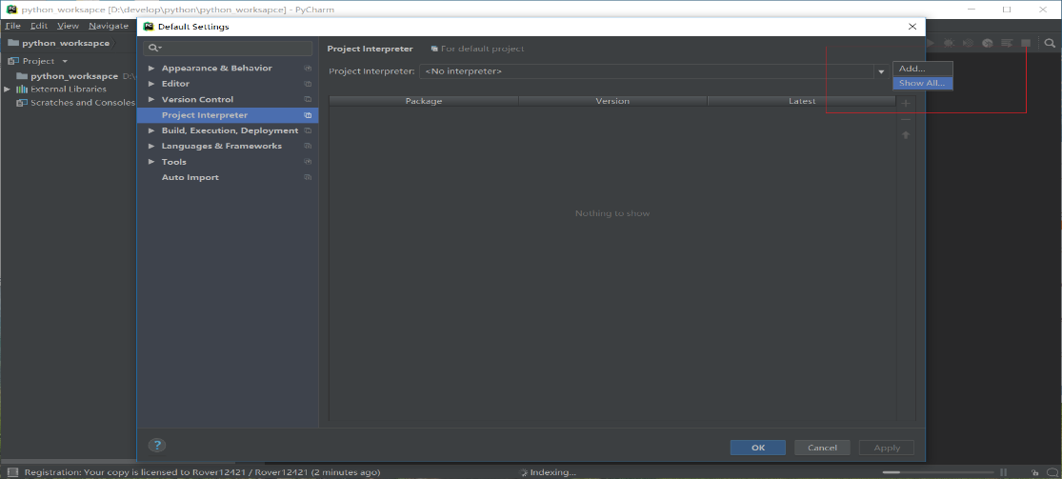
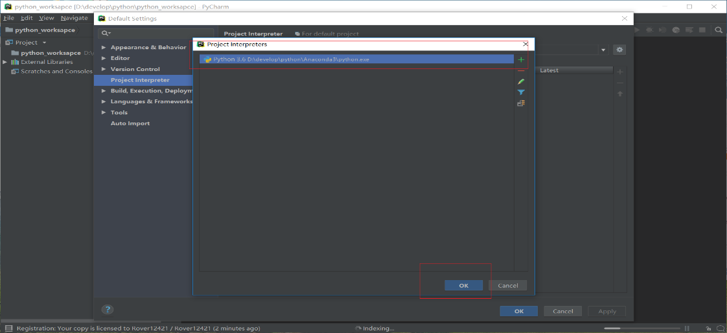
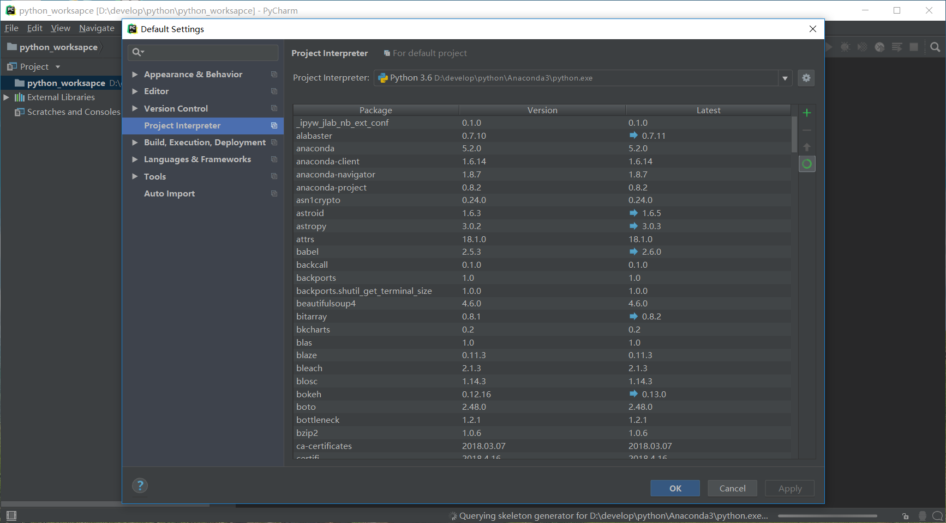
步骤六：编写第一个hello world,在创建好的工程那里右击依次选择new--python file--进行命名，输入print（“hello world！”），在界面右击选择run hello world,界面下就会显示运行结果；
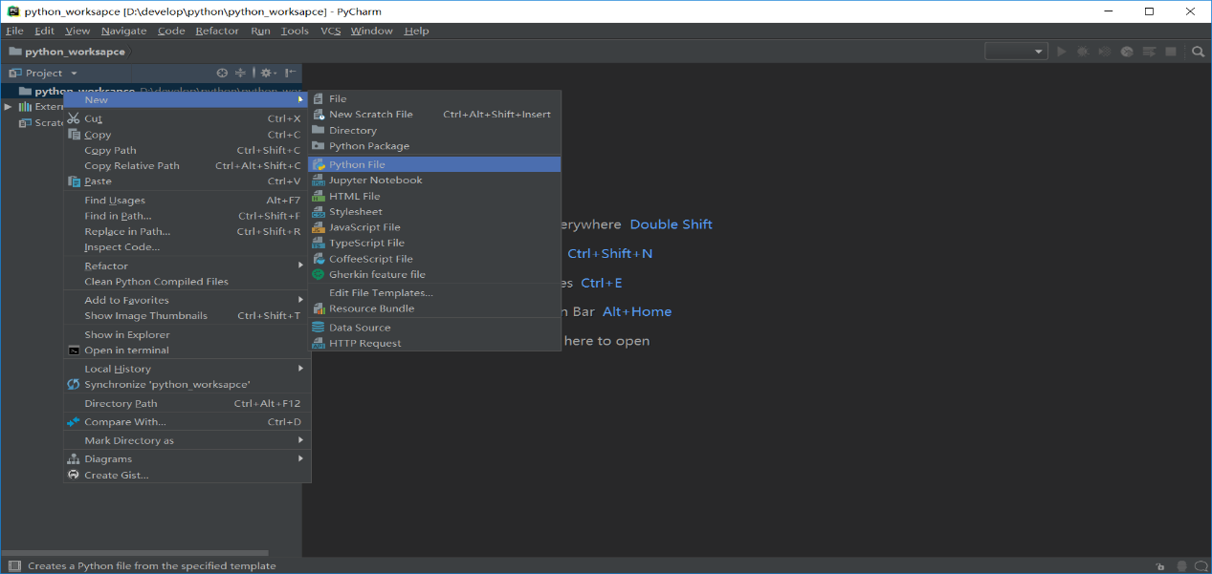
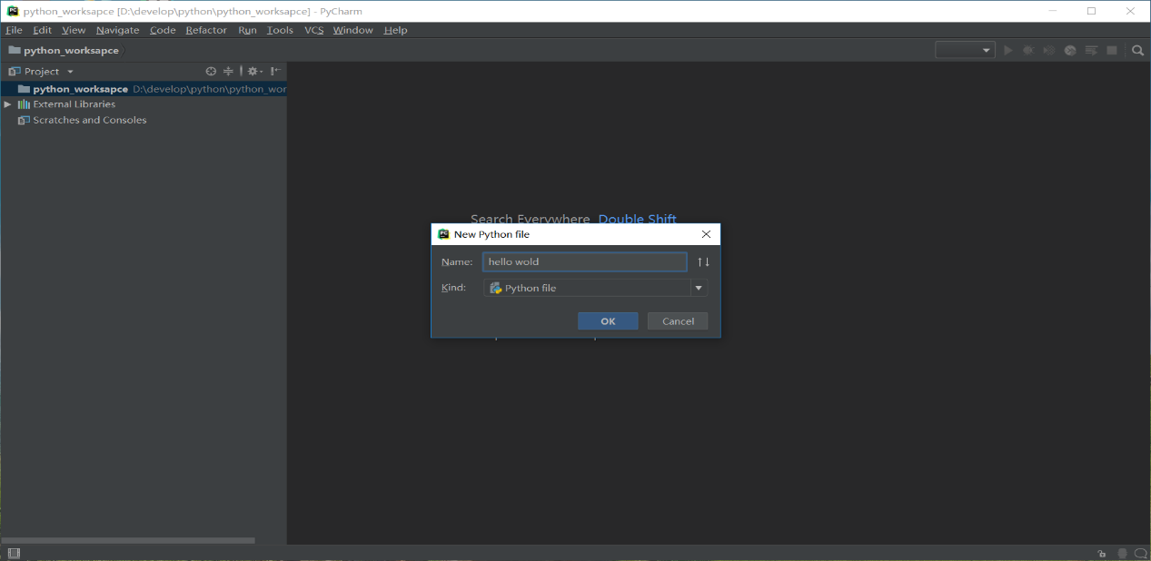
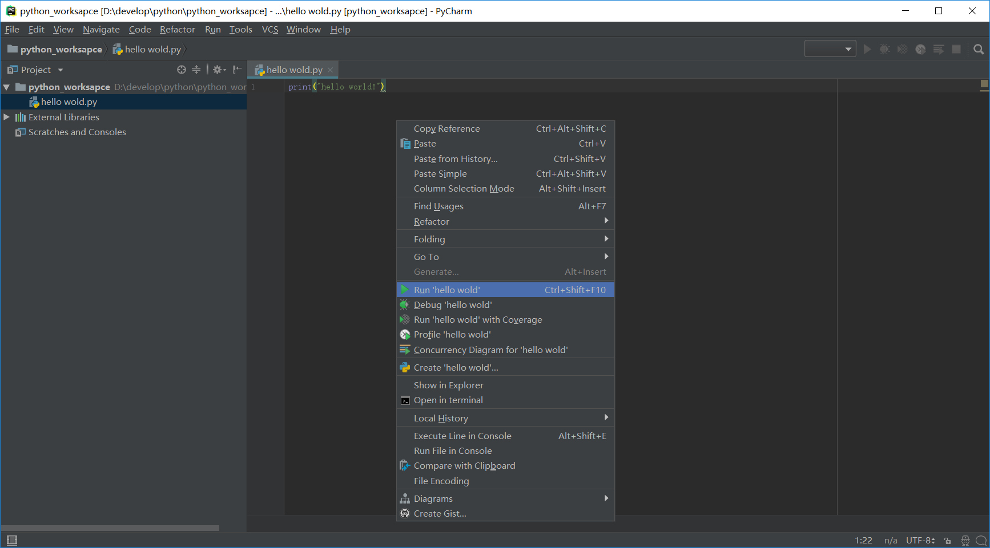
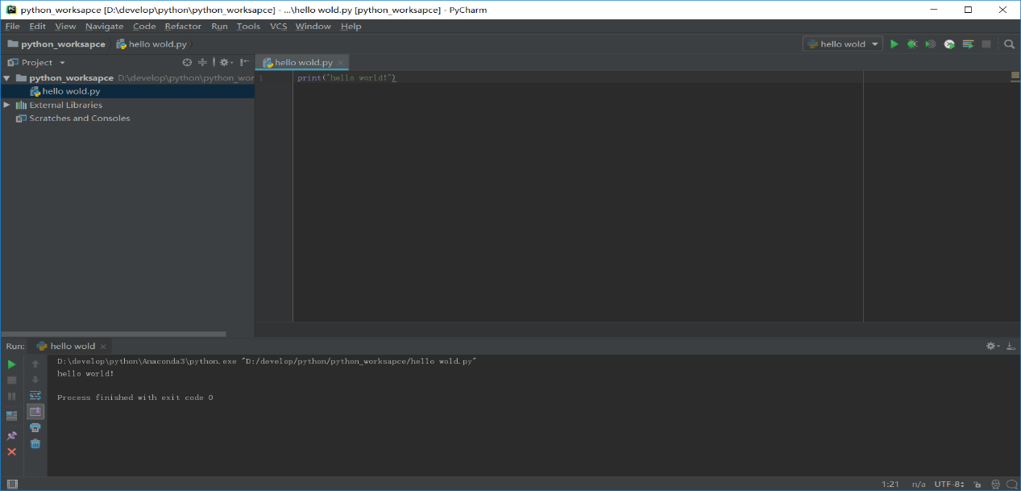
步骤七：设置界面字体大小和代码字体大小，依次选择file--settings--appearance & behaviors--勾选红色框中选项修改界面字体大小，依次选择editor--general--font修改代码字体大小。
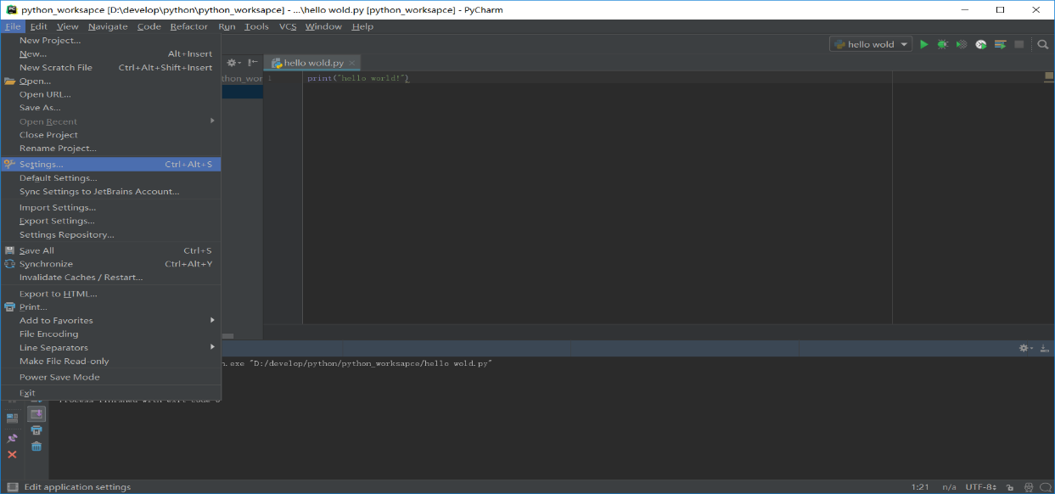
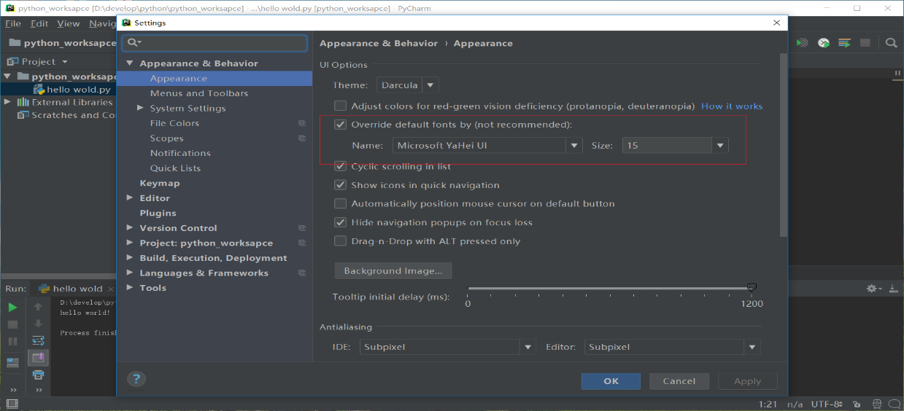
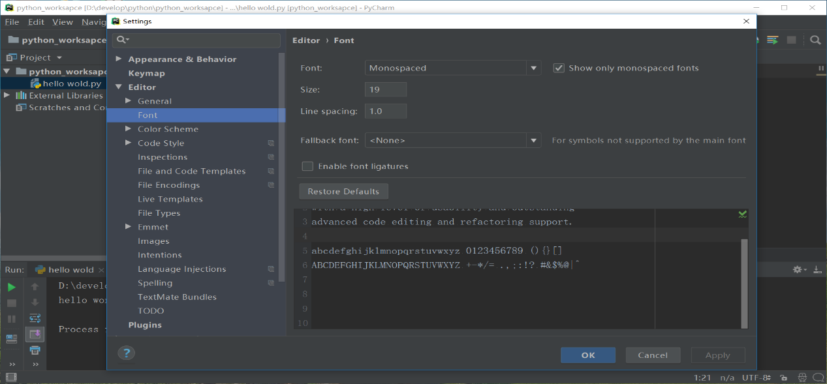

3、Python基础（以linux系统为例）
The programming assignments in this course will be written in Python, an interpreted, object-oriented language that shares some features with both Java and Scheme. This tutorial will walk through the primary syntactic constructions in Python, using short examples.
We encourage you to type all python shown in the tutorial onto your own machine. Make sure it responds the same way.
You may find the Troubleshooting section helpful if you run into problems. It contains a list of the frequent problems previous CS188 students have encountered when following this tutorial.

Invoking the Interpreter
Python can be run in one of two modes. It can either be used interactively, via an interpeter, or it can be called from the command line to execute a script. We will first use the Python interpreter interactively.
You invoke the interpreter using the command python at the Unix command prompt; or if you are using Windows that doesn’t work for you in Git Bash, using python -i.
(cs188) [cs188-ta@nova ~]$ python
Python 3.6.6 |Anaconda, Inc.| (default, Jun 28 2018, 11:07:29)
[GCC 4.2.1 Compatible Clang 4.0.1 (tags/RELEASE_401/final)] on darwin
Type "help", "copyright", "credits" or "license" for more information.
>>>

Operators
The Python interpreter can be used to evaluate expressions, for example simple arithmetic expressions. If you enter such expressions at the prompt (>>>) they will be evaluated and the result will be returned on the next line.
>>> 1 + 1
2
>>> 2 * 3
6
Boolean operators also exist in Python to manipulate the primitive True and False values.
>>> 1 == 0
False
>>> not (1 == 0)
True
>>> (2 == 2) and (2 == 3)
False
>>> (2 == 2) or (2 == 3)
True

Strings
Like Java, Python has a built in string type. The + operator is overloaded to do string concatenation on string values.
>>> 'artificial' + "intelligence"
'artificialintelligence'
There are many built-in methods which allow you to manipulate strings.
>>> 'artificial'.upper()
'ARTIFICIAL'
>>> 'HELP'.lower()
'help'
>>> len('Help')
4
Notice that we can use either single quotes ' ' or double quotes " " to surround string. This allows for easy nesting of strings.
We can also store expressions into variables.
>>> s = 'hello world'
>>> print(s)
hello world
>>> s.upper()
'HELLO WORLD'
>>> len(s.upper())
11
>>> num = 8.0
>>> num += 2.5
>>> print(num)
10.5
In Python, you do not have declare variables before you assign to them.

Exercise: Dir and Help
Learn about the methods Python provides for strings. To see what methods Python provides for a datatype, use the dir and help commands:
>>> s = 'abc'

>>> dir(s)
['__add__', '__class__', '__contains__', '__delattr__', '__doc__', '__eq__', '__ge__', '__getattribute__', '__getitem__', '__getnewargs__', '__getslice__', '__gt__', '__hash__', '__init__', '__le__', '__len__', '__lt__', '__mod__', '__mul__', '__ne__', '__new__', '__reduce__', '__reduce_ex__', '__repr__', '__rmod__', '__rmul__', '__setattr__', '__str__', 'capitalize', 'center', 'count', 'decode', 'encode', 'endswith', 'expandtabs', 'find', 'index', 'isalnum', 'isalpha', 'isdigit', 'islower', 'isspace', 'istitle', 'isupper', 'join', 'ljust', 'lower', 'lstrip', 'replace', 'rfind', 'rindex', 'rjust', 'rsplit', 'rstrip', 'split', 'splitlines', 'startswith', 'strip', 'swapcase', 'title', 'translate', 'upper', 'zfill']

>>> help(s.find)
Help on built-in function find:

find(...) method of builtins.str instance
S.find(sub[, start[, end]]) -> int

Return the lowest index in S where substring sub is found,
such that sub is contained within S[start:end]. Optional
arguments start and end are interpreted as in slice notation.

Return -1 on failure.

>>> s.find('b')
1
Try out some of the string functions listed in dir (ignore those with underscores ‘_’ around the method name).

Built-in Data Structures
Python comes equipped with some useful built-in data structures, broadly similar to Java’s collections package.

Lists
Lists store a sequence of mutable items:
>>> fruits = ['apple', 'orange', 'pear', 'banana']
>>> fruits[0]
'apple'
We can use the + operator to do list concatenation:
>>> otherFruits = ['kiwi', 'strawberry']
>>> fruits + otherFruits
>>> ['apple', 'orange', 'pear', 'banana', 'kiwi', 'strawberry']
Python also allows negative-indexing from the back of the list. For instance, fruits[-1] will access the last element 'banana':
>>> fruits[-2]
'pear'
>>> fruits.pop()
'banana'
>>> fruits
['apple', 'orange', 'pear']
>>> fruits.append('grapefruit')
>>> fruits
['apple', 'orange', 'pear', 'grapefruit']
>>> fruits[-1] = 'pineapple'
>>> fruits
['apple', 'orange', 'pear', 'pineapple']
We can also index multiple adjacent elements using the slice operator. For instance, fruits[1:3], returns a list containing the elements at position 1 and 2. In general fruits[start:stop] will get the elements in start, start+1, ..., stop-1. We can also do fruits[start:] which returns all elements starting from the start index. Also fruits[:end] will return all elements before the element at position end:
>>> fruits[0:2]
['apple', 'orange']
>>> fruits[:3]
['apple', 'orange', 'pear']
>>> fruits[2:]
['pear', 'pineapple']
>>> len(fruits)
4
The items stored in lists can be any Python data type. So for instance we can have lists of lists:
>>> lstOfLsts = [['a', 'b', 'c'], [1, 2, 3], ['one', 'two', 'three']]
>>> lstOfLsts[1][2]
3
>>> lstOfLsts[0].pop()
'c'
>>> lstOfLsts
[['a', 'b'], [1, 2, 3], ['one', 'two', 'three']]

Exercise: Lists
Play with some of the list functions. You can find the methods you can call on an object via the dir and get information about them via the help command:
>>> dir(list)
['__add__', '__class__', '__contains__', '__delattr__', '__delitem__',
'__delslice__', '__doc__', '__eq__', '__ge__', '__getattribute__',
'__getitem__', '__getslice__', '__gt__', '__hash__', '__iadd__', '__imul__',
'__init__', '__iter__', '__le__', '__len__', '__lt__', '__mul__', '__ne__',
'__new__', '__reduce__', '__reduce_ex__', '__repr__', '__reversed__',
'__rmul__', '__setattr__', '__setitem__', '__setslice__', '__str__',
'append', 'count', 'extend', 'index', 'insert', 'pop', 'remove', 'reverse',
'sort']

>>> help(list.reverse)
Help on built-in function reverse:

reverse(...)
L.reverse() -- reverse \*IN PLACE\*

>>> lst = ['a', 'b', 'c']
>>> lst.reverse()
>>> ['c', 'b', 'a']`
Note: Ignore functions with underscores “_” around the names; these are private helper methods. Press ‘q’ to back out of a help screen.

Tuples
A data structure similar to the list is the tuple, which is like a list except that it is immutable once it is created (i.e. you cannot change its content once created). Note that tuples are surrounded with parentheses while lists have square brackets.
>>> pair = (3, 5)
>>> pair[0]
3
>>> x, y = pair
>>> x
3
>>> y
5
>>> pair[1] = 6
TypeError: object does not support item assignment
The attempt to modify an immutable structure raised an exception. Exceptions indicate errors: index out of bounds errors, type errors, and so on will all report exceptions in this way.

Sets
A set is another data structure that serves as an unordered list with no duplicate items. Below, we show how to create a set:
>>> shapes = ['circle', 'square', 'triangle', 'circle']
>>> setOfShapes = set(shapes)
Another way of creating a set is shown below:
>>> setOfShapes = {‘circle’, ‘square’, ‘triangle’, ‘circle’}
Next, we show how to add things to the set, test if an item is in the set, and perform common set operations (difference, intersection, union):
>>> setOfShapes
set(['circle', 'square', 'triangle'])
>>> setOfShapes.add('polygon')
>>> setOfShapes
set(['circle', 'square', 'triangle', 'polygon'])
>>> 'circle' in setOfShapes
True
>>> 'rhombus' in setOfShapes
False
>>> favoriteShapes = ['circle', 'triangle', 'hexagon']
>>> setOfFavoriteShapes = set(favoriteShapes)
>>> setOfShapes - setOfFavoriteShapes
set(['square', 'polygon'])
>>> setOfShapes & setOfFavoriteShapes
set(['circle', 'triangle'])
>>> setOfShapes | setOfFavoriteShapes
set(['circle', 'square', 'triangle', 'polygon', 'hexagon'])
Note that the objects in the set are unordered; you cannot assume that their traversal or print order will be the same across machines!

Dictionaries
The last built-in data structure is the dictionary which stores a map from one type of object (the key) to another (the value). The key must be an immutable type (string, number, or tuple). The value can be any Python data type.
Note: In the example below, the printed order of the keys returned by Python could be different than shown below. The reason is that unlike lists which have a fixed ordering, a dictionary is simply a hash table for which there is no fixed ordering of the keys (like HashMaps in Java). The order of the keys depends on how exactly the hashing algorithm maps keys to buckets, and will usually seem arbitrary. Your code should not rely on key ordering, and you should not be surprised if even a small modification to how your code uses a dictionary results in a new key ordering.
>>> studentIds = {'knuth': 42.0, 'turing': 56.0, 'nash': 92.0}
>>> studentIds['turing']
56.0
>>> studentIds['nash'] = 'ninety-two'
>>> studentIds
{'knuth': 42.0, 'turing': 56.0, 'nash': 'ninety-two'}
>>> del studentIds['knuth']
>>> studentIds
{'turing': 56.0, 'nash': 'ninety-two'}
>>> studentIds['knuth'] = [42.0, 'forty-two']
>>> studentIds
{'knuth': [42.0, 'forty-two'], 'turing': 56.0, 'nash': 'ninety-two'}
>>> studentIds.keys()
['knuth', 'turing', 'nash']
>>> studentIds.values()
[[42.0, 'forty-two'], 56.0, 'ninety-two']
>>> studentIds.items()
[('knuth', [42.0, 'forty-two']), ('turing',56.0), ('nash', 'ninety-two')]
>>> len(studentIds)
3
As with nested lists, you can also create dictionaries of dictionaries.

Exercise: Dictionaries
Use dir and help to learn about the functions you can call on dictionaries.

Writing Scripts
Now that you’ve got a handle on using Python interactively, let’s write a simple Python script that demonstrates Python’s for loop. Open the file called foreach.py, which should contain the following code:
# This is what a comment looks like
fruits = ['apples', 'oranges', 'pears', 'bananas']
for fruit in fruits:
print(fruit + ' for sale')

fruitPrices = {'apples': 2.00, 'oranges': 1.50, 'pears': 1.75}
for fruit, price in fruitPrices.items():
if price < 2.00:
print('%s cost %f a pound' % (fruit, price))
else:
print(fruit + ' are too expensive!')
At the command line, use the following command in the directory containing foreach.py:
[cs188-ta@nova ~/tutorial]$ python foreach.py
apples for sale
oranges for sale
pears for sale
bananas for sale
apples are too expensive!
oranges cost 1.500000 a pound
pears cost 1.750000 a pound
Remember that the print statements listing the costs may be in a different order on your screen than in this tutorial; that’s due to the fact that we’re looping over dictionary keys, which are unordered. To learn more about control structures (e.g., if and else) in Python, check out the official Python tutorial section on this topic.
If you like functional programming you might also like map and filter:
>>> list(map(lambda x: x * x, [1, 2, 3]))
[1, 4, 9]
>>> list(filter(lambda x: x > 3, [1, 2, 3, 4, 5, 4, 3, 2, 1]))
[4, 5, 4]
The next snippet of code demonstrates Python’s list comprehension construction:
nums = [1, 2, 3, 4, 5, 6]
plusOneNums = [x + 1 for x in nums]
oddNums = [x for x in nums if x % 2 == 1]
print(oddNums)
oddNumsPlusOne = [x + 1 for x in nums if x % 2 == 1]
print(oddNumsPlusOne)
This code is in a file called listcomp.py, which you can run:
[cs188-ta@nova ~]$ python listcomp.py
[1, 3, 5]
[2, 4, 6]

Exercise: List Comprehensions
Write a list comprehension which, from a list, generates a lowercased version of each string that has length greater than five. You can find the solution in listcomp2.py.

Beware of Indendation!
Unlike many other languages, Python uses the indentation in the source code for interpretation. So for instance, for the following script:
if 0 == 1:
print('We are in a world of arithmetic pain')
print('Thank you for playing')
will output: Thank you for playing
But if we had written the script as
if 0 == 1:
print('We are in a world of arithmetic pain')
print('Thank you for playing')
there would be no output. The moral of the story: be careful how you indent! It’s best to use four spaces for indentation – that’s what the course code uses.

Tabs vs Spaces
Because Python uses indentation for code evaluation, it needs to keep track of the level of indentation across code blocks. This means that if your Python file switches from using tabs as indentation to spaces as indentation, the Python interpreter will not be able to resolve the ambiguity of the indentation level and throw an exception. Even though the code can be lined up visually in your text editor, Python “sees” a change in indentation and most likely will throw an exception (or rarely, produce unexpected behavior).
This most commonly happens when opening up a Python file that uses an indentation scheme that is opposite from what your text editor uses (aka, your text editor uses spaces and the file uses tabs). When you write new lines in a code block, there will be a mix of tabs and spaces, even though the whitespace is aligned. For a longer discussion on tabs vs spaces, see this discussion on StackOverflow.

Writing Functions
As in Java, in Python you can define your own functions:
fruitPrices = {'apples': 2.00, 'oranges': 1.50, 'pears': 1.75}

def buyFruit(fruit, numPounds):
if fruit not in fruitPrices:
print("Sorry we don't have %s" % (fruit))
else:
cost = fruitPrices[fruit] * numPounds
print("That'll be %f please" % (cost))

# Main Function
if __name__ == '__main__':
buyFruit('apples', 2.4)
buyFruit('coconuts', 2)
Rather than having a main function as in Java, the __name__ == '__main__' check is used to delimit expressions which are executed when the file is called as a script from the command line. The code after the main check is thus the same sort of code you would put in a main function in Java.
Save this script as fruit.py and run it:
(cs188) [cs188-ta@nova ~]$ python fruit.py
That'll be 4.800000 please
Sorry we don't have coconuts

Advanced Exercise
Write a quickSort function in Python using list comprehensions. Use the first element as the pivot. You can find the solution in quickSort.py.

Object Basics
Although this isn’t a class in object-oriented programming, you’ll have to use some objects in the programming projects, and so it’s worth covering the basics of objects in Python. An object encapsulates data and provides functions for interacting with that data.

Defining Classes
Here’s an example of defining a class named FruitShop:
class FruitShop:

def __init__(self, name, fruitPrices):
"""
name: Name of the fruit shop

fruitPrices: Dictionary with keys as fruit
strings and prices for values e.g.
{'apples': 2.00, 'oranges': 1.50, 'pears': 1.75}
"""
self.fruitPrices = fruitPrices
self.name = name
print('Welcome to %s fruit shop' % (name))

def getCostPerPound(self, fruit):
"""
fruit: Fruit string
Returns cost of 'fruit', assuming 'fruit'
is in our inventory or None otherwise
"""
if fruit not in self.fruitPrices:
return None
return self.fruitPrices[fruit]

def getPriceOfOrder(self, orderList):
"""
orderList: List of (fruit, numPounds) tuples

Returns cost of orderList, only including the values of
fruits that this fruit shop has.
"""
totalCost = 0.0
for fruit, numPounds in orderList:
costPerPound = self.getCostPerPound(fruit)
if costPerPound != None:
totalCost += numPounds * costPerPound
return totalCost

def getName(self):
return self.name
The FruitShop class has some data, the name of the shop and the prices per pound of some fruit, and it provides functions, or methods, on this data. What advantage is there to wrapping this data in a class?
- Encapsulating the data prevents it from being altered or used inappropriately,
- The abstraction that objects provide make it easier to write general-purpose code.

Using Objects
So how do we make an object and use it? Make sure you have the FruitShop implementation in shop.py. We then import the code from this file (making it accessible to other scripts) using import shop, since shop.py is the name of the file. Then, we can create FruitShop objects as follows:
import shop

shopName = 'the Berkeley Bowl'
fruitPrices = {'apples': 1.00, 'oranges': 1.50, 'pears': 1.75}
berkeleyShop = shop.FruitShop(shopName, fruitPrices)
applePrice = berkeleyShop.getCostPerPound('apples')
print(applePrice)
print('Apples cost $%.2f at %s.' % (applePrice, shopName))

otherName = 'the Stanford Mall'
otherFruitPrices = {'kiwis': 6.00, 'apples': 4.50, 'peaches': 8.75}
otherFruitShop = shop.FruitShop(otherName, otherFruitPrices)
otherPrice = otherFruitShop.getCostPerPound('apples')
print(otherPrice)
print('Apples cost $%.2f at %s.' % (otherPrice, otherName))
print("My, that's expensive!")
This code is in shopTest.py; you can run it like this:
[cs188-ta@nova ~]$ python shopTest.py
Welcome to the Berkeley Bowl fruit shop
1.0
Apples cost $1.00 at the Berkeley Bowl.
Welcome to the Stanford Mall fruit shop
4.5
Apples cost $4.50 at the Stanford Mall.
My, that's expensive!
So what just happended? The import shop statement told Python to load all of the functions and classes in shop.py. The line berkeleyShop = shop.FruitShop(shopName, fruitPrices) constructs an instance of the FruitShop class defined in shop.py, by calling the __init__ function in that class. Note that we only passed two arguments in, while __init__ seems to take three arguments: (self, name, fruitPrices). The reason for this is that all methods in a class have self as the first argument. The self variable’s value is automatically set to the object itself; when calling a method, you only supply the remaining arguments. The self variable contains all the data (name and fruitPrices) for the current specific instance (similar to this in Java). The print statements use the substitution operator (described in the Python docs if you’re curious).

Static vs Instance Variables
The following example illustrates how to use static and instance variables in Python.
Create the person_class.py containing the following code:
class Person:
population = 0

def __init__(self, myAge):
self.age = myAge
Person.population += 1

def get_population(self):
return Person.population

def get_age(self):
return self.age
We first compile the script:
[cs188-ta@nova ~]$ python person_class.py
Now use the class as follows:
>>> import person_class
>>> p1 = person_class.Person(12)
>>> p1.get_population()
1
>>> p2 = person_class.Person(63)
>>> p1.get_population()
2
>>> p2.get_population()
2
>>> p1.get_age()
12
>>> p2.get_age()
63
In the code above, age is an instance variable and population is a static variable. population is shared by all instances of the Person class whereas each instance has its own age variable.

More Python Tips and Tricks
This tutorial has briefly touched on some major aspects of Python that will be relevant to the course. Here are some more useful tidbits:
- Use range to generate a sequence of integers, useful for generating traditional indexed for loops:
- for index in range(3):
- print(lst[index])
- After importing a file, if you edit a source file, the changes will not be immediately propagated in the interpreter. For this, use the reload command:
- >>> reload(shop)

Troubleshooting
These are some problems (and their solutions) that new Python learners commonly encounter.
- Problem: ImportError: No module named py
Solution: For import statements with import <package-name>, do not include the file extension (i.e. the .py string). For example, you should use: import shop NOT: import shop.py
- Problem: NameError: name ‘MY VARIABLE’ is not defined Even after importing you may see this.
Solution: To access a member of a module, you have to type MODULE NAME.MEMBER NAME, where MODULE NAME is the name of the .py file, and MEMBER NAME is the name of the variable (or function) you are trying to access.
- Problem: TypeError: ‘dict’ object is not callable
Solution: Dictionary looks up are done using square brackets: [ and ]. NOT parenthesis: ( and ).
- Problem: ValueError: too many values to unpack
Solution: Make sure the number of variables you are assigning in a for loop matches the number of elements in each item of the list. Similarly for working with tuples.
For example, if pair is a tuple of two elements (e.g. pair =('apple', 2.0)) then the following code would cause the “too many values to unpack error”:
(a, b, c) = pair
Here is a problematic scenario involving a for loop:
pairList = [('apples', 2.00), ('oranges', 1.50), ('pears', 1.75)]
for fruit, price, color in pairList:
print('%s fruit costs %f and is the color %s' % (fruit, price, color))
- Problem: AttributeError: ‘list’ object has no attribute ‘length’ (or something similar)
Solution: Finding length of lists is done using len(NAME OF LIST).
- Problem: Changes to a file are not taking effect.
Solution:
  - Make sure you are saving all your files after any changes.
  - If you are editing a file in a window different from the one you are using to execute python, make sure you reload(_YOUR_MODULE_) to guarantee your changes are being reflected. reload works similarly to import.
Python学习的其他参考资料：
https://www.runoob.com/python3/python3-tutorial.html
Eric Matthes - Python编程 _ 从入门到实践 = Python Crash Course-人民邮电出版社, 2016.（网盘中有电子版）

4、自动打分
To get you familiarized with the autograder, we will ask you to code, test, and submit solutions for three questions.
You can download all of the files associated the autograder tutorial as a zip archive: tutorial.zip (note this is different from the zip file used in the UNIX and Python mini-tutorials, python_basics.zip). Unzip this file and examine its contents:
[cs188-ta@nova ~]$ unzip tutorial.zip
[cs188-ta@nova ~]$ cd tutorial
[cs188-ta@nova ~/tutorial]$ ls
addition.py
autograder.py
buyLotsOfFruit.py
grading.py
projectParams.py
shop.py
shopSmart.py
testClasses.py
testParser.py
test_cases
tutorialTestClasses.py
This contains a number of files you’ll edit or run:
- addition.py: source file for question 1
- buyLotsOfFruit.py: source file for question 2
- shop.py: source file for question 3
- shopSmart.py: source file for question 3
- autograder.py: autograding script (see below)
and others you can ignore:
- test_cases: directory contains the test cases for each question
- grading.py: autograder code
- testClasses.py: autograder code
- tutorialTestClasses.py: test classes for this particular project
- projectParams.py: project parameters
The command python autograder.py grades your solution to all three problems. If we run it before editing any files we get a page or two of output:
[cs188-ta@nova ~/tutorial]$ python autograder.py
Starting on 1-21 at 23:39:51

Question q1
===========
*** FAIL: test_cases/q1/addition1.test
*** add(a, b) must return the sum of a and b
*** student result: "0"
*** correct result: "2"
*** FAIL: test_cases/q1/addition2.test
*** add(a, b) must return the sum of a and b
*** student result: "0"
*** correct result: "5"
*** FAIL: test_cases/q1/addition3.test
*** add(a, b) must return the sum of a and b
*** student result: "0"
*** correct result: "7.9"
*** Tests failed.

### Question q1: 0/1 ###

Question q2
===========
*** FAIL: test_cases/q2/food_price1.test
*** buyLotsOfFruit must compute the correct cost of the order
*** student result: "0.0"
*** correct result: "12.25"
*** FAIL: test_cases/q2/food_price2.test
*** buyLotsOfFruit must compute the correct cost of the order
*** student result: "0.0"
*** correct result: "14.75"
*** FAIL: test_cases/q2/food_price3.test
*** buyLotsOfFruit must compute the correct cost of the order
*** student result: "0.0"
*** correct result: "6.4375"
*** Tests failed.

### Question q2: 0/1 ###

Question q3
===========
Welcome to shop1 fruit shop
Welcome to shop2 fruit shop
*** FAIL: test_cases/q3/select_shop1.test
*** shopSmart(order, shops) must select the cheapest shop
*** student result: "None"
*** correct result: "<FruitShop: shop1>"
Welcome to shop1 fruit shop
Welcome to shop2 fruit shop
*** FAIL: test_cases/q3/select_shop2.test
*** shopSmart(order, shops) must select the cheapest shop
*** student result: "None"
*** correct result: "<FruitShop: shop2>"
Welcome to shop1 fruit shop
Welcome to shop2 fruit shop
Welcome to shop3 fruit shop
*** FAIL: test_cases/q3/select_shop3.test
*** shopSmart(order, shops) must select the cheapest shop
*** student result: "None"
*** correct result: "<FruitShop: shop3>"
*** Tests failed.

### Question q3: 0/1 ###

Finished at 23:39:51

Provisional grades
==================
Question q1: 0/1
Question q2: 0/1
Question q3: 0/1
------------------
Total: 0/3

Your grades are NOT yet registered. To register your grades, make sure
to follow your instructor's guidelines to receive credit on your project.
For each of the three questions, this shows the results of that question’s tests, the questions grade, and a final summary at the end. Because you haven’t yet solved the questions, all the tests fail. As you solve each question you may find some tests pass while other fail. When all tests pass for a question, you get full marks.
Looking at the results for question 1, you can see that it has failed three tests with the error message “add(a, b) must return the sum of a and b”. The answer your code gives is always 0, but the correct answer is different. We’ll fix that in the next tab.

问题1：Adding
Open addition.py and look at the definition of add:
def add(a, b):
"Return the sum of a and b"
"*** YOUR CODE HERE ***"
return 0
The tests called this with a and b set to different values, but the code always returned zero. Modify this definition to read:
def add(a, b):
"Return the sum of a and b"
print("Passed a = %s and b = %s, returning a + b = %s" % (a, b, a + b))
return a + b
Now rerun the autograder (omitting the results for questions 2 and 3):
[cs188-ta@nova ~/tutorial]$ python autograder.py -q q1
Starting on 1-21 at 23:52:05

Question q1
===========
Passed a = 1 and b = 1, returning a + b = 2
*** PASS: test_cases/q1/addition1.test
*** add(a, b) returns the sum of a and b
Passed a = 2 and b = 3, returning a + b=5
*** PASS: test_cases/q1/addition2.test
*** add(a, b) returns the sum of a and b
Passed a = 10 and b = -2.1, returning a + b = 7.9
*** PASS: test_cases/q1/addition3.test
*** add(a, b) returns the sum of a and b

### Question q1: 1/1 ###

Finished at 23:41:01

Provisional grades
==================
Question q1: 1/1
Question q2: 0/1
Question q3: 0/1
------------------
Total: 1/3

You now pass all tests, getting full marks for question 1. Notice the new lines “Passed a=…” which appear before “*** PASS: …”. These are produced by the print statement in add. You can use print statements like that to output information useful for debugging.

问题2：buyLotsOfFruit function
Add a buyLotsOfFruit(orderList) function to buyLotsOfFruit.py which takes a list of (fruit,pound) tuples and returns the cost of your list. If there is some fruit in the list which doesn’t appear in fruitPrices it should print an error message and return None. Please do not change the fruitPrices variable.
Run python autograder.py until question 2 passes all tests and you get full marks. Each test will confirm that buyLotsOfFruit(orderList) returns the correct answer given various possible inputs. For example, test_cases/q2/food_price1.test tests whether:
Cost of [('apples', 2.0), ('pears', 3.0), ('limes', 4.0)] is 12.25

问题3：shopSmart function
Fill in the function shopSmart(orders,shops) in shopSmart.py, which takes an orderList (like the kind passed in to FruitShop.getPriceOfOrder) and a list of FruitShop and returns the FruitShop where your order costs the least amount in total. Don’t change the file name or variable names, please. Note that we will provide the shop.pyimplementation as a “support” file, so you don’t need to submit yours.
Run python autograder.py until question 3 passes all tests and you get full marks. Each test will confirm that shopSmart(orders,shops) returns the correct answer given various possible inputs. For example, with the following variable definitions:
orders1 = [('apples', 1.0), ('oranges', 3.0)]
orders2 = [('apples', 3.0)]
dir1 = {'apples': 2.0, 'oranges': 1.0}
shop1 = shop.FruitShop('shop1',dir1)
dir2 = {'apples': 1.0, 'oranges': 5.0}
shop2 = shop.FruitShop('shop2', dir2)
shops = [shop1, shop2]
test_cases/q3/select_shop1.test tests whether: shopSmart.shopSmart(orders1, shops) == shop1
and test_cases/q3/select_shop2.test tests whether: shopSmart.shopSmart(orders2, shops) == shop2

提交
将三个文件放入文件夹“实验0-姓名”中进行提交

实验1：Search
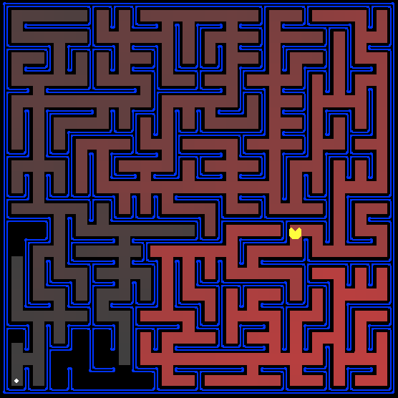

简要介绍
在这个项目中，学生设计的吃豆人Agent将在迷宫世界寻找路径，到达一个特定的地点并有效地收集食物。学生将构建通用的搜索算法并将其应用于Pacman场景。
和Project 0一样，这个项目包括一个自动评分机，学生可以在自己的机器上给答案打分。通过以下命令运行：
python autograder.py
重要：如果在使用autograder.py时遇到了问题，请参见如下做法：
问题提示 | 出现位置 | 措施
module 'cgi' has no attribute 'escape' | grading.py | ①在文件开头加入 import html；  ②将文件中cgi.escape改为html.escape
No module named 'imp' | autograder.py | ①在文件开头加入 import importlib；  ②将文件中loadModuleFile函数实现中的  return imp.import_module(moduleName, f, "%s.py" % moduleName, (".py", "rb", importlib.PY_SOURCE))  改为：  return importlib.machinery.SourceFileLoader(moduleName, filePath).load_module()

关于使用autograder的更多信息，请参阅实验 0中的autograder教程。
本组实验代码由几个Python文件组成，为了完成任务，学生需要阅读和理解其中一些文件，还有一些可以忽略。所有代码和支持文件从网盘中下载压缩包search.zip。
Files you'll edit:
search.py | Where all of your search algorithms will reside.
searchAgents.py | Where all of your search-based agents will reside.
Files you might want to look at:
pacman.py | The main file that runs Pacman games. This file describes a Pacman GameState type, which you use in this project.
game.py | The logic behind how the Pacman world works. This file describes several supporting types like AgentState, Agent, Direction, and Grid.
util.py | Useful data structures for implementing search algorithms.
Supporting files you can ignore:
graphicsDisplay.py | Graphics for Pacman
graphicsUtils.py | Support for Pacman graphics
textDisplay.py | ASCII graphics for Pacman
ghostAgents.py | Agents to control ghosts
keyboardAgents.py | Keyboard interfaces to control Pacman
layout.py | Code for reading layout files and storing their contents
autograder.py | Project autograder
testParser.py | Parses autograder test and solution files
testClasses.py | General autograding test classes
test_cases/ | Directory containing the test cases for each question
searchTestClasses.py | Project 1 specific autograding test classes

需要编辑并提交的文件：填写压缩包tutorial.zip 中如下三个文件的相应部分： search.py和searchAgents.py 。最终提交包括了代码和注释的这三个文件。请不要修改其他的文件，也不要提交除此之外的其他文件。
评价:提交的代码将根据技术正确性自动评分。请不要在代码中更改任何提供的函数或类的名称，否则将对autograder造成严重破坏。然而，执行正确性并不是自动评分能够判断的。如有需要，我们会单独检查并给与评分，以确保你的工作得到应有的学分。
学术不诚实:我们将检查你的代码与其他提交在类逻辑冗余。如果复制别人的代码然后只做很小的修改，将会被检测出来。这些作弊探测器很难被骗，所以请不要尝试。我们相信大家只提交自己的作品。
寻求帮助:如果你发现自己卡在什么东西上，联系课程实验助教寻求帮助。办公时间、微信群等都有您的支持。希望这些实验项目是有益的和指导性的。

Question 1 (3 points): Finding a Fixed Food Dot using Depth First Search
In searchAgents.py, you’ll find a fully implemented SearchAgent, which plans out a path through Pacman’s world and then executes that path step-by-step. The search algorithms for formulating a plan are not implemented – that’s your job.
First, test that the SearchAgent is working correctly by running:
python pacman.py -l tinyMaze -p SearchAgent -a fn=tinyMazeSearch
The command above tells the SearchAgent to use tinyMazeSearch as its search algorithm, which is implemented in search.py. Pacman should navigate the maze successfully.
Now it’s time to write full-fledged generic search functions to help Pacman plan routes! Pseudocode for the search algorithms you’ll write can be found in the lecture slides. Remember that a search node must contain not only a state but also the information necessary to reconstruct the path (plan) which gets to that state.
注意：一个搜索节点不仅包括状态，还包括构建到达该状态的路径（计划）所需的其他信息。
Important note: All of your search functions need to return a list of actions that will lead the agent from the start to the goal. These actions all have to be legal moves (valid directions, no moving through walls).
Important note: Make sure to use the Stack, Queue and PriorityQueue data structures provided to you in util.py! These data structure implementations have particular properties which are required for compatibility with the autograder.
Hint: Each algorithm is very similar. Algorithms for DFS, BFS, UCS, and A* differ only in the details of how the fringe is managed. So, concentrate on getting DFS right and the rest should be relatively straightforward. Indeed, one possible implementation requires only a single generic search method which is configured with an algorithm-specific queuing strategy. (Your implementation need not be of this form to receive full credit).
Implement the depth-first search (DFS) algorithm in the depthFirstSearch function in search.py. To make your algorithm complete, write the graph search version of DFS, which avoids expanding any already visited states.
Your code should quickly find a solution for:
python pacman.py -l tinyMaze -p SearchAgent

python pacman.py -l mediumMaze -p SearchAgent

python pacman.py -l bigMaze -z .5 -p SearchAgent
The Pacman board will show an overlay of the states explored, and the order in which they were explored (brighter red means earlier exploration). Is the exploration order what you would have expected? Does Pacman actually go to all the explored squares on his way to the goal?
Hint: If you use a Stack as your data structure, the solution found by your DFS algorithm for mediumMaze should have a length of 130 (provided you push successors onto the fringe in the order provided by getSuccessors; you might get 246 if you push them in the reverse order). Is this a least cost solution? If not, think about what depth-first search is doing wrong.

Question 2 (3 points): Breadth First Search
Implement the breadth-first search (BFS) algorithm in the breadthFirstSearch function in search.py. Again, write a graph search algorithm that avoids expanding any already visited states. Test your code the same way you did for depth-first search.
python pacman.py -l mediumMaze -p SearchAgent -a fn=bfs

python pacman.py -l bigMaze -p SearchAgent -a fn=bfs -z .5
Does BFS find a least cost solution? If not, check your implementation.
Hint: If Pacman moves too slowly for you, try the option --frameTime 0.
Note: If you’ve written your search code generically, your code should work equally well for the eight-puzzle search problem without any changes.
python eightpuzzle.py

Question 3 (3 points): Varying the Cost Function
While BFS will find a fewest-actions path to the goal, we might want to find paths that are “best” in other senses. Consider mediumDottedMaze and mediumScaryMaze.
通过改变代价函数，我们可以让pacman寻找不同的路径。例如，可以
By changing the cost function, we can encourage Pacman to find different paths. For example, we can charge more for dangerous steps in ghost-ridden areas or less for steps in food-rich areas, and a rational Pacman agent should adjust its behavior in response.
Implement the uniform-cost graph search algorithm in the uniformCostSearch function in search.py. We encourage you to look through util.py for some data structures that may be useful in your implementation. You should now observe successful behavior in all three of the following layouts, where the agents below are all UCS agents that differ only in the cost function they use (the agents and cost functions are written for you):
python pacman.py -l mediumMaze -p SearchAgent -a fn=ucs
python pacman.py -l mediumDottedMaze -p StayEastSearchAgent
python pacman.py -l mediumScaryMaze -p StayWestSearchAgent
Note: You should get very low and very high path costs for the StayEastSearchAgent and StayWestSearchAgent respectively, due to their exponential cost functions (see searchAgents.py for details).

Question 4 (3 points): A* search
Implement A* graph search in the empty function aStarSearch in search.py. A* takes a heuristic function as an argument. Heuristics take two arguments: a state in the search problem (the main argument), and the problem itself (for reference information). The nullHeuristic heuristic function in search.py is a trivial example.

You can test your A* implementation on the original problem of finding a path through a maze to a fixed position using the Manhattan distance heuristic (implemented already as manhattanHeuristic in searchAgents.py).
python pacman.py -l bigMaze -z .5 -p SearchAgent -a fn=astar,heuristic=manhattanHeuristic
You should see that A* finds the optimal solution slightly faster than uniform cost search (about 549 vs. 620 search nodes expanded in our implementation, but ties in priority may make your numbers differ slightly). What happens on openMazefor the various search strategies?

Question 5 (选做): Finding All the Corners
A*真正的能力在更具挑战的问题上作用更大。下面要构建新问题并针对新问题设计启发函数。
角落迷宫问题，在四个角落各分布一个点。新的问题就是寻找最短路径到达四个角落（无论角落是否有食物）。Note that for some mazes like tinyCorners, the shortest path does not always go to the closest food first! Hint: the shortest path through tinyCornerstakes 28 steps.
Note: Make sure to complete Question 2 before working on Question 5, because Question 5 builds upon your answer for Question 2.
Implement the CornersProblem search problem in searchAgents.py. You will need to choose a state representation that encodes all the information necessary to detect whether all four corners have been reached. Now, your search agent should solve:
python pacman.py -l tinyCorners -p SearchAgent -a fn=bfs,prob=CornersProblem
python pacman.py -l mediumCorners -p SearchAgent -a fn=bfs,prob=CornersProblem
To receive full credit, you need to define an abstract state representation that does not encode irrelevant information (like the position of ghosts, where extra food is, etc.). In particular, do not use a Pacman GameState as a search state. Your code will be very, very slow if you do (and also wrong).
Hint: The only parts of the game state you need to reference in your implementation are the starting Pacman position and the location of the four corners.
Our implementation of breadthFirstSearch expands just under 2000 search nodes on mediumCorners. However, heuristics (used with A* search) can reduce the amount of searching required.

Question 6 (选做): Corners Problem: Heuristic
Note: Make sure to complete Question 4 before working on Question 6, because Question 6 builds upon your answer for Question 4.
Implement a non-trivial, consistent heuristic for the CornersProblem in cornersHeuristic.
python pacman.py -l mediumCorners -p AStarCornersAgent -z 0.5
Note: AStarCornersAgent is a shortcut for
-p SearchAgent -a fn=aStarSearch,prob=CornersProblem,heuristic=cornersHeuristic
Admissibility vs. Consistency: Remember, heuristics are just functions that take search states and return numbers that estimate the cost to a nearest goal. More effective heuristics will return values closer to the actual goal costs. To be admissible, the heuristic values must be lower bounds on the actual shortest path cost to the nearest goal (and non-negative). To be consistent, it must additionally hold that if an action has cost c, then taking that action can only cause a drop in heuristic of at most c.
Remember that admissibility isn’t enough to guarantee correctness in graph search – you need the stronger condition of consistency. However, admissible heuristics are usually also consistent, especially if they are derived from problem relaxations. Therefore it is usually easiest to start out by brainstorming admissible heuristics. Once you have an admissible heuristic that works well, you can check whether it is indeed consistent, too. The only way to guarantee consistency is with a proof. However, inconsistency can often be detected by verifying that for each node you expand, its successor nodes are equal or higher in in f-value. Moreover, if UCS and A* ever return paths of different lengths, your heuristic is inconsistent. This stuff is tricky!
Non-Trivial Heuristics: The trivial heuristics are the ones that return zero everywhere (UCS) and the heuristic which computes the true completion cost. The former won’t save you any time, while the latter will timeout the autograder. You want a heuristic which reduces total compute time, though for this assignment the autograder will only check node counts (aside from enforcing a reasonable time limit).
Grading: Your heuristic must be a non-trivial non-negative consistent heuristic to receive any points. Make sure that your heuristic returns 0 at every goal state and never returns a negative value. Depending on how few nodes your heuristic expands, you’ll be graded:
Number of nodes expanded | Grade
more than 2000 | 0/3
at most 2000 | 1/3
at most 1600 | 2/3
at most 1200 | 3/3
Remember: If your heuristic is inconsistent, you will receive no credit, so be careful!

Question 7 (选做): Eating All The Dots
接下来要解决尽可能少的步骤解决所有pacman食物的问题。对此，需要定义新的食物清除问题，即searchAgents.py中的FoodSearchProblem。解就是能够吃到所有食物的路径。该问题中，不需要考虑鬼怪或者能量盘，只决定于墙壁的位置、常规食物和Pacman的位置。如果你已经写出了通用搜索问题方法， A* with a null heuristic (equivalent to uniform-cost search) should quickly find an optimal solution to testSearch with no code change on your part (total cost of 7).
python pacman.py -l testSearch -p AStarFoodSearchAgent
Note: AStarFoodSearchAgent is a shortcut for
-p SearchAgent -a fn=astar,prob=FoodSearchProblem,heuristic=foodHeuristic
You should find that UCS starts to slow down even for the seemingly simple tinySearch. As a reference, our implementation takes 2.5 seconds to find a path of length 27 after expanding 5057 search nodes.
Note: Make sure to complete Question 4 before working on Question 7, because Question 7 builds upon your answer for Question 4.
Fill in foodHeuristic in searchAgents.py with a consistent heuristic for the FoodSearchProblem. Try your agent on the trickySearch board:
python pacman.py -l trickySearch -p AStarFoodSearchAgent
Our UCS agent finds the optimal solution in about 13 seconds, exploring over 16,000 nodes.
Any non-trivial non-negative consistent heuristic will receive 1 point. Make sure that your heuristic returns 0 at every goal state and never returns a negative value. Depending on how few nodes your heuristic expands, you’ll get additional points:
Number of nodes expanded | Grade
more than 15000 | 1/4
at most 15000 | 2/4
at most 12000 | 3/4
at most 9000 | 4/4 (full credit; medium)
at most 7000 | 5/4 (optional extra credit; hard)
Remember: If your heuristic is inconsistent, you will receive no credit, so be careful! Can you solve mediumSearch in a short time? If so, we’re either very, very impressed, or your heuristic is inconsistent.

Question 8 (选做): Suboptimal Search
Sometimes, even with A* and a good heuristic, finding the optimal path through all the dots is hard. In these cases, we’d still like to find a reasonably good path, quickly. In this section, you’ll write an agent that always greedily eats the closest dot.
ClosestDotSearchAgent is implemented for you in searchAgents.py, but it’s missing a key function that finds a path to the closest dot.
Implement the function findPathToClosestDot in searchAgents.py. Our agent solves this maze (suboptimally!) in under a second with a path cost of 350:
python pacman.py -l bigSearch -p ClosestDotSearchAgent -z .5
Hint: The quickest way to complete findPathToClosestDot is to fill in the AnyFoodSearchProblem, which is missing its goal test. Then, solve that problem with an appropriate search function. The solution should be very short!
Your ClosestDotSearchAgent won’t always find the shortest possible path through the maze. Make sure you understand why and try to come up with a small example where repeatedly going to the closest dot does not result in finding the shortest path for eating all the dots.

提交
将文件放入文件夹“实验1-姓名”中进行提交

竞赛1（选做）：Multi-Agent Pacman
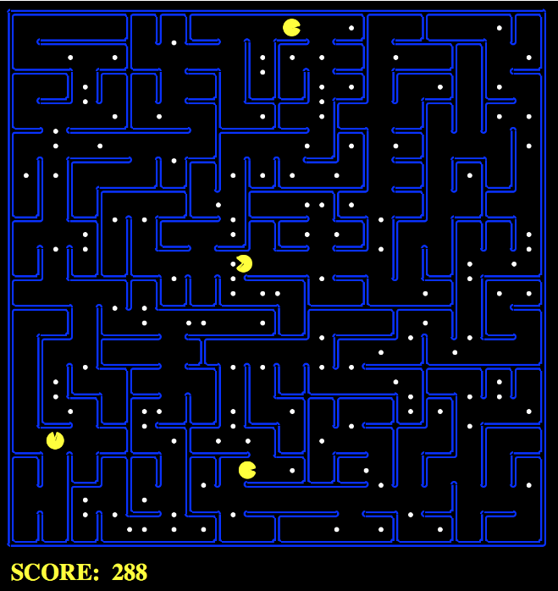

概览
在这个小型竞赛中，将应用Project 1中实现的搜索算法和问题来处理更困难的场景，包括控制多个Pacman Agent和在时间限制下进行规划。这个实验中没有固定的解决方案，你可以使用自己独特的想法。我们非常期待看到你提出什么!

加分
额外的分数是在实验1的25分基础上获得的。例如，如果你通过这个竞赛获得了1分的加分，而你的实验1成绩是25分/25分，那么你的P1成绩就是26分/25分。你会收到:
- 0.5 points per staff bot beaten in the final ranking
- 0.5 points for submitting a bot that scores more than 500 points on the leaderboard
Students that perform well in the final leaderboard will receive the following extra credit:
- 1st place: 2 points
- 2nd and 3rd place: 1.5 points
- 4th to 10th place: 1 point
Note: A good implementation of the bot in the “Quick Start Guide” below should easily score more than 500 points on the leaderboard.

介绍

基本代码与Project 1几乎相同，但做了一些较小的修改，包括支持多个Pacman Agent。竞赛代码以zip文件(网盘中的minicontest1.zip)的形式提供。一些关键的不同点:
- 你将同时控制环境中的N个吃豆人。你的代码必须能够支持多个Agent。
- 将考虑一个代价：与吃豆人“思考”的时间有关(计算成本)。更多细节见Scoring部分。
Files you'll edit:
myAgents.py | What will be submitted. Contains all of the code needed for your agent.
Files you might want to look at:
searchProblems.py | The same code as in P1, with some slight modifications.
search.py | The same code as in P1.
pacman.py | The main file that runs Pacman games. This file describes a Pacman GameState type, which you use in this project.
需要编辑并提交的文件：填写并提交myAgents.py
评价:提交的代码将根据技术正确性自动评分。请不要在代码中更改任何提供的函数或类的名称，否则将对autograder造成严重破坏。然而，执行正确性并不是自动评分能够判断的。如有需要，我们会单独检查并给与评分，以确保你的工作得到应有的学分。
学术不诚实:我们将检查你的代码与其他提交在类逻辑冗余。如果复制别人的代码然后只做很小的修改，将会被检测出来。这些作弊探测器很难被骗，所以请不要尝试。我们相信大家只提交自己的作品。
寻求帮助:如果你发现自己卡在什么问题上，联系助教老师寻求帮助。办公时间、微信群等都有您的支持。希望这些实验项目是有益的和指导性的。

Rules

Layout
There are a variety of layouts in the layouts directory. Agents will be exposed to a variety of maps of different sizes and amounts of food.

Scoring
问题1中的得分规则继续保留，即吃掉每个能量盘加10分，全部吃完加500分；
修改的地方包括
- 动作代价：每做一个动作减去0.4分，
- 思考代价：（计算下一个行动所消耗的秒数×1000）
每个Agent的初始得分都是100。
Each agent also starts with 100 points.

Observations
Each agent can see the entire state of the game, such as food pellet locations, all pacman locations, etc. See the GameStatesection of the code for more details.

Winning and Losing
Win: You win if you collect all food pellets. Your score is the current amount of points.
Lose: You lose if your score reaches zero. This can be caused by not finding pellets quickly enough, or spending too much time on compute. Your score for this game is zero. If your agent crashes, it automatically receives a score of zero.

Designing Agents

File Format
You should include your agents in a file of the same format as myAgents.py. Your agents must be completely contained in this one file, although you may use the functions in search.py

Interface
The GameState in pacman.py should look familiar, but contains some modifications to support multiple Pacman agents. The major change to note is that many GameState methods now have an extra argument, agentIndex, which is to identify which Pacman agent it needs. For example, state.getPacmanPosition(0) will get the position of the first pacman agent. For more information, see the GameState class in pacman.py.

Agent
To get started designing your own agent, we recommend subclassing the Agent class in game.py (this has already been done by default). This provides to one important variable, self.index, which is the agentIndex of the current agent. For example, if we have 2 agents, each agent will be created with a unique index, [MyAgent(index=0), MyAgent(index=1)], that can be used when deciding on actions.
The autograder will call the createAgents function to create your team of pacmen. By default, it is set to create N identical pacmen, but you may modify the code to return a diverse team of multiple types of agents.

Restrictions
Please respect the APIs and keep all of your implementation within myAgents.py.

Getting Started
By default, the game runs with the ClosestDotAgent implemented in the Quick Start Guide. To run your own agent, change agent for the createAgents method in myAgents.py
python pacman.py
A wealth of options are available to you:
python pacman.py --help
To run a game with your agent, do:
python pacman.py --pacman myAgents.py

Testing
The layouts folder contains all of the test cases that will be executed on the autograder. There are no hidden tests. To see how you perform on any single map, you can run:
python pacman.py --layout test1.lay
You can run the autograder by running the command below. Your score from the autograder may vary due to differences between machines or differences in staff vs. student search implementations.
python autograder.py --pacman myAgents.py

提交
将文件放入文件夹“竞赛1-姓名”中进行提交

关于竞赛1代码的内容：从pacman.py作为入口进入后，会生成相应的Agent，其数量从layout.py里读取，字母P对应一个Agent，多少个P就是多少个Agent。

实验2：Multi-Agent Search
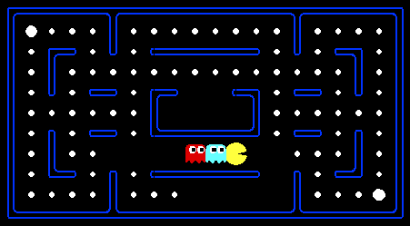

简要介绍
在这个实验中，您将为经典版本的Pacman游戏设计Agents，也包括ghosts。在此过程中，您将同时实现minimax和expectimax搜索，并尝试进行评估函数设计。
代码库与前一个实验项目相比没有太大的变化，但请重新安装后开始，而不是和项目1中的文件混合在一起。
与实验1中一样，实验2也包括一个自动评分机，你可以在你的机器上给你的答案评分，通过如下命令在所有问题上运行：
python autograder.py
重要：如果在使用autograder.py时遇到了问题，请参见如下做法：
问题提示 | 出现位置 | 措施
module 'cgi' has no attribute 'escape' | grading.py | ①在文件开头加入 import html；  ②将文件中cgi.escape改为html.escape
No module named 'imp' | autograder.py | ①在文件开头加入 import importlib；  ②将文件中loadModuleFile函数实现中的  return imp.import_module(moduleName, f, "%s.py" % moduleName, (".py", "rb", importlib.PY_SOURCE))  改为：  return importlib.machinery.SourceFileLoader(moduleName, filePath).load_module()

还可以通过如下命令运行某一个具体问题，如q2：
python autograder.py -q q2
也可以通过如下命令只运行某一个具体测试：
python autograder.py -t test_cases/q2/0-small-tree
默认情况下，autograder使用-t选项显示图形，使用-q 选项为不显示。您可以使用 --graphics标志强制图形，或者使用-no-graphics 标志强制不使用图形。
有关使用autograder的更多信息，请参阅实验0中的autograder教程。
此实验的代码为网盘中的multiagent.zip。
Files you'll edit:
multiAgents.py | Where all of your multi-agent search agents will reside.
Files you might want to look at:
pacman.py | The main file that runs Pacman games. This file also describes a Pacman GameState type, which you will use extensively in this project.
game.py | The logic behind how the Pacman world works. This file describes several supporting types like AgentState, Agent, Direction, and Grid.
util.py | Useful data structures for implementing search algorithms. You don't need to use these for this project, but may find other functions defined here to be useful.
Supporting files you can ignore:
graphicsDisplay.py | Graphics for Pacman
graphicsUtils.py | Support for Pacman graphics
textDisplay.py | ASCII graphics for Pacman
ghostAgents.py | Agents to control ghosts
keyboardAgents.py | Keyboard interfaces to control Pacman
layout.py | Code for reading layout files and storing their contents
autograder.py | Project autograder
testParser.py | Parses autograder test and solution files
testClasses.py | General autograding test classes
test_cases/ | Directory containing the test cases for each question
multiagentTestClasses.py | Project 2 specific autograding test classes

需要编辑并提交的文件： multiAgents.py
评价:提交的代码将根据技术正确性自动评分。请不要在代码中更改任何提供的函数或类的名称，否则将对autograder造成严重破坏。然而，执行正确性并不是自动评分能够判断的。如有需要，我们会单独检查并给与评分，以确保你的工作得到应有的学分。
学术不诚实:我们将检查你的代码与其他提交在类逻辑冗余。如果复制别人的代码然后只做很小的修改，将会被检测出来。这些作弊探测器很难被骗，所以请不要尝试。我们相信大家只提交自己的作品。
寻求帮助:如果你发现自己卡在什么问题上，联系助教老师寻求帮助。办公时间、微信群等都有您的支持。希望这些实验项目是有益的和指导性的。

Welcome to Multi-Agent Pacman
First, play a game of classic Pacman by running the following command:
python pacman.py
and using the arrow keys to move. Now, run the provided ReflexAgent in multiAgents.py
python pacman.py -p ReflexAgent
Note that it plays quite poorly even on simple layouts:
python pacman.py -p ReflexAgent -l testClassic
Inspect its code (in multiAgents.py) and make sure you understand what it’s doing.

问题1（4分）：反射Agent
您可以改进multiAgents.py中的ReflexAgent，让Agent表现得更好。原先提供的反射Agent代码提供了部分有用的方法使用案例，例如查询GameState以获得问题的信息。一个功能强大的Agent需要考虑食物的位置和鬼怪的位置，以表现得较好。当然，你设计的Agent应该快速有效地清除testClassic布局。通过如下命令：
python pacman.py -p ReflexAgent -l testClassic
完成之后可以在默认的mediumClassic布局上测试你的简单反射Agent，通过如下代码可以选择1个或2个鬼怪。
python pacman.py --frameTime 0 -p ReflexAgent -k 1
python pacman.py --frameTime 0 -p ReflexAgent -k 2
通过观察，是不是你的Agent经常在遇到两个鬼怪情况下被吃掉，除非你的评估函数设计的非常好。
How does your agent fare? It will likely often die with 2 ghosts on the default board, unless your evaluation function is quite good.
Note: Remember that newFood has the function asList()
Note: As features, try the reciprocal of important values (such as distance to food) rather than just the values themselves.
Note: The evaluation function you’re writing is evaluating state-action pairs; in later parts of the project, you’ll be evaluating states.
Note: You may find it useful to view the internal contents of various objects for debugging. You can do this by printing the objects’ string representations. For example, you can print newGhostStates with print(newGhostStates).
Options: Default ghosts are random; you can also play for fun with slightly smarter directional ghosts using -g DirectionalGhost. If the randomness is preventing you from telling whether your agent is improving, you can use -fto run with a fixed random seed (same random choices every game). You can also play multiple games in a row with -n. Turn off graphics with –q to run lots of games quickly.
Grading: We will run your agent on the openClassic layout 10 times. You will receive 0 points if your agent times out, or never wins. You will receive 1 point if your agent wins at least 5 times, or 2 points if your agent wins all 10 games. You will receive an addition 1 point if your agent’s average score is greater than 500, or 2 points if it is greater than 1000. You can try your agent out under these conditions with
python autograder.py -q q1
To run it without graphics, use:
python autograder.py -q q1 --no-graphics
Don’t spend too much time on this question, though, as the meat of the project lies ahead.

Question 2 (5 points): Minimax
Now you will write an adversarial search agent in the provided MinimaxAgent class stub in multiAgents.py. Your minimax agent should work with any number of ghosts, so you’ll have to write an algorithm that is slightly more general than what you’ve previously seen in lecture. In particular, your minimax tree will have multiple min layers (one for each ghost) for every max layer.
Your code should also expand the game tree to an arbitrary depth. Score the leaves of your minimax tree with the supplied self.evaluationFunction, which defaults to scoreEvaluationFunction. MinimaxAgent extends MultiAgentSearchAgent, which gives access to self.depth and self.evaluationFunction.
Make sure your minimax code makes reference to these two variables where appropriate as these variables are populated in response to command line options.
Important: A single search ply is considered to be one Pacman move and all the ghosts’ responses, so depth 2 search will involve Pacman and each ghost moving two times.
Grading: We will be checking your code to determine whether it explores the correct number of game states. This is the only reliable way to detect some very subtle bugs in implementations of minimax. As a result, the autograder will be very picky about how many times you call GameState.generateSuccessor. If you call it any more or less than necessary, the autograder will complain. To test and debug your code, run
python autograder.py -q q2
This will show what your algorithm does on a number of small trees, as well as a pacman game. To run it without graphics, use:
python autograder.py -q q2 --no-graphics

Hints and Observations
- Hint: Implement the algorithm recursively using helper function(s).
- The correct implementation of minimax will lead to Pacman losing the game in some tests. This is not a problem: as it is correct behaviour, it will pass the tests.
- The evaluation function for the Pacman test in this part is already written (self.evaluationFunction). You shouldn’t change this function, but recognize that now we’re evaluating states rather than actions, as we were for the reflex agent. Look-ahead agents evaluate future states whereas reflex agents evaluate actions from the current state.
- The minimax values of the initial state in the minimaxClassic layout are 9, 8, 7, -492 for depths 1, 2, 3 and 4 respectively. Note that your minimax agent will often win (665/1000 games for us) despite the dire prediction of depth 4 minimax.
python pacman.py -p MinimaxAgent -l minimaxClassic -a depth=4
- Pacman is always agent 0, and the agents move in order of increasing agent index.
- All states in minimax should be GameStates, either passed in to getAction or generated via GameState.generateSuccessor. In this project, you will not be abstracting to simplified states.
- On larger boards such as openClassic and mediumClassic (the default), you’ll find Pacman to be good at not dying, but quite bad at winning. He’ll often thrash around without making progress. He might even thrash around right next to a dot without eating it because he doesn’t know where he’d go after eating that dot. Don’t worry if you see this behavior, question 5 will clean up all of these issues.
- When Pacman believes that his death is unavoidable, he will try to end the game as soon as possible because of the constant penalty for living. Sometimes, this is the wrong thing to do with random ghosts, but minimax agents always assume the worst:
python pacman.py -p MinimaxAgent -l trappedClassic -a depth=3
Make sure you understand why Pacman rushes the closest ghost in this case.

Question 3 (5 points): Alpha-Beta Pruning
Make a new agent that uses alpha-beta pruning to more efficiently explore the minimax tree, in AlphaBetaAgent. Again, your algorithm will be slightly more general than the pseudocode from lecture, so part of the challenge is to extend the alpha-beta pruning logic appropriately to multiple minimizer agents.
You should see a speed-up (perhaps depth 3 alpha-beta will run as fast as depth 2 minimax). Ideally, depth 3 on smallClassic should run in just a few seconds per move or faster.
python pacman.py -p AlphaBetaAgent -a depth=3 -l smallClassic
The AlphaBetaAgent minimax values should be identical to the MinimaxAgent minimax values, although the actions it selects can vary because of different tie-breaking behavior. Again, the minimax values of the initial state in the minimaxClassic layout are 9, 8, 7 and -492 for depths 1, 2, 3 and 4 respectively.
Grading: Because we check your code to determine whether it explores the correct number of states, it is important that you perform alpha-beta pruning without reordering children. In other words, successor states should always be processed in the order returned by GameState.getLegalActions. Again, do not call GameState.generateSuccessor more than necessary.
You must not prune on equality in order to match the set of states explored by our autograder. (Indeed, alternatively, but incompatible with our autograder, would be to also allow for pruning on equality and invoke alpha-beta once on each child of the root node, but this will not match the autograder.)
The pseudo-code below represents the algorithm you should implement for this question.
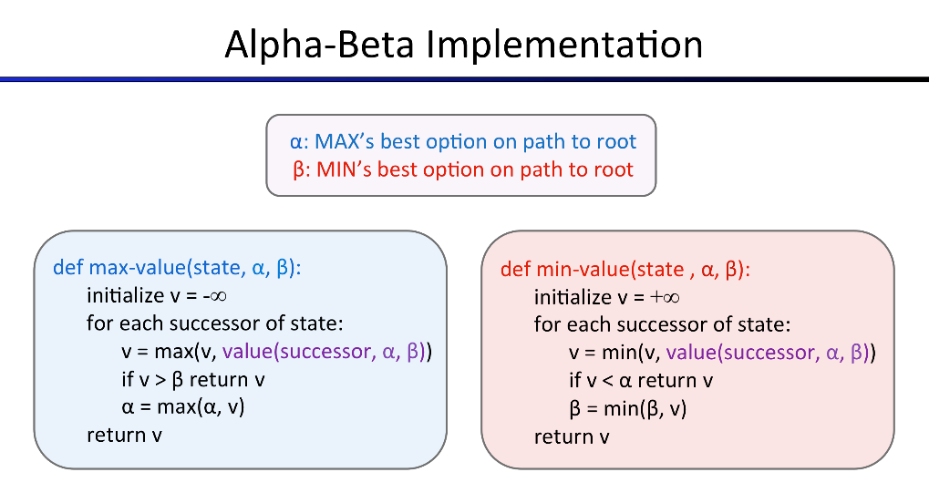
To test and debug your code, run
python autograder.py -q q3
This will show what your algorithm does on a number of small trees, as well as a pacman game. To run it without graphics, use:
python autograder.py -q q3 --no-graphics
The correct implementation of alpha-beta pruning will lead to Pacman losing some of the tests. This is not a problem: as it is correct behaviour, it will pass the tests.

Question 4 (5 points): Expectimax
Minimax和alpha-beta很好，但是都是假设对手也是做出最优选择。然而通常并不是这样，在该问题下就需要实现ExpectimaxAgent，用于对做出次优选择的Agent进行行为建模。

As with the search and constraint satisfaction problems covered so far in this class, the beauty of these algorithms is their general applicability. To expedite your own development, we’ve supplied some test cases based on generic trees. You can debug your implementation on small the game trees using the command:
python autograder.py -q q4
可以在较小的操作性强的测试用例上进行实验，有助于快速找到bug。
一旦算法在小型树上成功了，你可以在pacman上开展测试。随机的ghost当然不是最优的minimax agent。因此，使用minimax搜索可能不合适。ExpectimaxAgent对于对手的选择就不是选择所有行动中最小值，而是根据你对ghost建模后的期望值。为了简化代码，假设你是仅仅和一个在所有合法行动中归一化随机选择行动的对手在对战。
Debugging on these small and manageable test cases is recommended and will help you to find bugs quickly.
Once your algorithm is working on small trees, you can observe its success in Pacman. Random ghosts are of course not optimal minimax agents, and so modeling them with minimax search may not be appropriate. ExpectimaxAgent, will no longer take the min over all ghost actions, but the expectation according to your agent’s model of how the ghosts act. To simplify your code, assume you will only be running against an adversary which chooses amongst their getLegalActionsuniformly at random.
To see how the ExpectimaxAgent behaves in Pacman, run:
python pacman.py -p ExpectimaxAgent -l minimaxClassic -a depth=3
You should now observe a more cavalier approach in close quarters with ghosts. In particular, if Pacman perceives that he could be trapped but might escape to grab a few more pieces of food, he’ll at least try. Investigate the results of these two scenarios:
python pacman.py -p AlphaBetaAgent -l trappedClassic -a depth=3 -q -n 10

python pacman.py -p ExpectimaxAgent -l trappedClassic -a depth=3 -q -n 10
You should find that your ExpectimaxAgent wins about half the time, while your AlphaBetaAgent always loses. Make sure you understand why the behavior here differs from the minimax case.
The correct implementation of expectimax will lead to Pacman losing some of the tests. This is not a problem: as it is correct behaviour, it will pass the tests.

Question 5 (6 points): Evaluation Function
在提供的betterEvaluationFunction框架中为pacman写一个更好的评价函数。该评价函数应当评价状态，而非反射Agent评价函数中的对行动进行评价。
The evaluation function should evaluate states, rather than actions like your reflex agent evaluation function did. You may use any tools at your disposal for evaluation, including your search code from the last project. With depth 2 search, your evaluation function should clear the smallClassic layout with one random ghost more than half the time and still run at a reasonable rate (to get full credit, Pacman should be averaging around 1000 points when he’s winning).
Grading: the autograder will run your agent on the smallClassic layout 10 times. We will assign points to your evaluation function in the following way:
- If you win at least once without timing out the autograder, you receive 1 points. Any agent not satisfying these criteria will receive 0 points.
- +1 for winning at least 5 times, +2 for winning all 10 times
- +1 for an average score of at least 500, +2 for an average score of at least 1000 (including scores on lost games)
- +1 if your games take on average less than 30 seconds on the autograder machine, when run with --no-graphics. The autograder is run on EC2, so this machine will have a fair amount of resources, but your personal computer could be far less performant (netbooks) or far more performant (gaming rigs).
- The additional points for average score and computation time will only be awarded if you win at least 5 times.
You can try your agent out under these conditions with
python autograder.py -q q5
To run it without graphics, use:
python autograder.py -q q5 --no-graphics

提交
将文件放入文件夹“实验2-姓名”中进行提交

竞赛2：Multi-Agent Adversarial Pacman
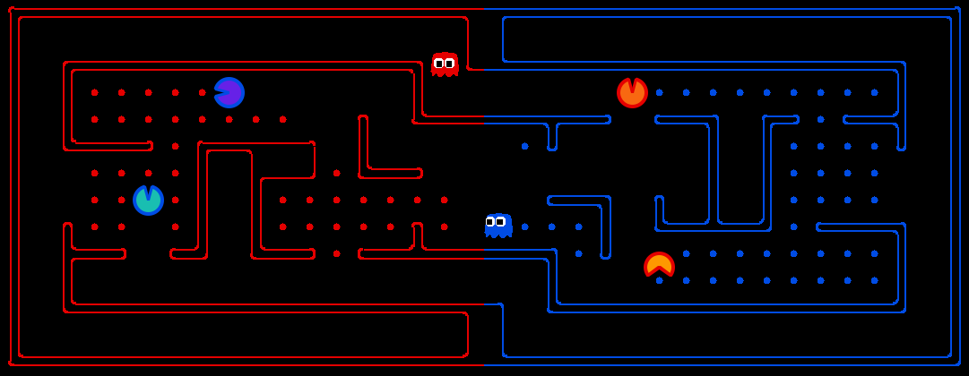

概览
这个竞赛在Pacman基础上做了修改：Agent需要协调的团队整体策略来控制Pacman和ghosts。你的队伍会试图吃掉地图远端的食物，同时保护自己家乡的食物。竞赛代码以zip文件(网盘中的minicontest2.zip)的形式提供。
你可以选择独自工作，也可以选择与一个人合作。你可以带着自己独特的想法，没有固定的解决方案。非常期待看到你提出什么!

Extra Credit
Extra credit points are earned on top of the 25 points available in P2. E.g. if you earn 1 point of EC through the mini-contest and had a 25/25 on P2, then you’ll have 26/25 on P2.
Your agent will be tested against the baseline and a few staff agents on several selected maps in layouts/.
- 0.5 points for over 51% winning rate against the provided baseline agent in baselineTeam.py.
- 0.5 points for over 51% winning rate against “Staff Agent 1”.
- 0.5 points for over 51% winning rate against “Staff Agent 2”.
- 0.5 points for over 51% winning rate against “Staff Agent 3”.
Students that perform well in the final leaderboard, ranked by “final score” metric, will receive the following:
- 1st place: 2 points
- 2nd and 3rd place: 1.5 points
- 4th to 10th place: 1 point

Introduction
The primary change between the first and second mini-contests is that mini-contest 2 is an adversarial game, involving two teams competing against each other. Your team will try to eat the food on the far side of the map, while defending the food on your home side.
Your agents are in the form of ghosts on your home side and Pacmen on your opponent’s side. Also, you are now able to eat your opponent when you are a ghost. If a Pacman is eaten by a ghost before reaching his own side of the board, he will explode into a cloud of food dots that will be deposited back onto the board.
Note that the mini-contest framework, provided in minicontest2.zip, has changed slightly from Mini-Contest 1. The functions and interfaces are nearly the same, but maps now include power capsules and you can eat your opponents.
Files you'll edit:
myTeam.py | What will be submitted. Contains all of the code needed for your agent.
Files you might want to look at:
baselineTeam.py | Example code that defines two very basic reflex agents, to help you get started.
capture.py | The main file that runs games locally. This file also describes the new capture the flag GameState type and rules.
captureAgents.py | Specification and helper methods for capture agents.
Supporting files you can ignore (do not modify):
captureGraphicsDisplay.py | Graphics specific to capture-the-flag variant of Pacman.
distanceCalculator.py | Computes shortest paths between all maze positions.
game.py | The logic behind how the Pacman world works. This file describes several supporting types like AgentState, Agent, Direction, and Grid.
graphicsDisplay.py | Graphics for Pacman.
graphicsUtils.py | Support for Pacman graphics.
keyboardAgents.py | Keyboard interfaces to control Pacman.
layout.py | Code for reading layout files and storing their contents.
mazeGenerator.py | Code for generating Pacman maze layouts.
textDisplay.py | ASCII graphics for Pacman.
util.py | Useful data structures for implementing search algorithms.
Files to Edit and Submit: You will fill and submit myTeam.py. Please do not change the other files in this distribution or submit any of our original files other than this file.
External libraries: In this contest, you are allowed to use numpy as a dependency.
Academic Dishonesty: We will be checking your code against other submissions in the class for logical redundancy. If you copy someone else’s code and submit it with minor changes, we will know. These cheat detectors are quite hard to fool, so please don’t try. We trust you all to submit your own work only; please don’t let us down. If you do, we will pursue the strongest consequences available to us.
Getting Help: You are not alone! If you find yourself stuck on something, contact the course staff for help. Office hours, section, and the discussion forum are there for your support; please use them. If you can’t make our office hours, let us know and we will schedule more. We want these contests to be rewarding and instructional, not frustrating and demoralizing. But, we don’t know when or how to help unless you ask.
Discussion: Please be careful not to post spoilers.

Rules

Layout
The Pacman map is now divided into two halves: blue (right) and red (left). Red agents (which all have even indices) must defend the red food while trying to eat the blue food. When on the red side, a red agent is a ghost. When crossing into enemy territory, the agent becomes a Pacman.
There are a variety of layouts in the layouts directory.

Scoring
As a Pacman eats food dots, those food dots are stored up inside of that Pacman and removed from the board. When a Pacman returns to his side of the board, he “deposits” the food dots he is carrying, earning one point per food pellet delivered. Red team scores are positive, while Blue team scores are negative.
If Pacman gets eaten by a ghost before reaching his own side of the board, he will explode into a cloud of food dots that will be deposited back onto the board.
关于得分：因为Pacman吃掉豆子以后，这些豆子就存在Pacman里面并且从棋盘上移除。当它返回到本方区域后，就把它携带的豆子存起来，每个豆子得一分。红队的得分是正的，蓝队的得分是负数。

Power Capsules
If Pacman eats a power capsule, agents on the opposing team become “scared” for the next 40 moves, or until they are eaten and respawn, whichever comes sooner. Agents that are “scared” are susceptible while in the form of ghosts (i.e. while on their own team’s side) to being eaten by Pacman. Specifically, if Pacman collides with a “scared” ghost, Pacman is unaffected and the ghost respawns at its starting position (no longer in the “scared” state).

Observations
Each agent can see the entire state of the game, such as food pellet locations, all Pacman locations, all ghost locations, etc. See the GameState section for more details.

Winning
In this adversarial game, a team wins when they return all but two of the opponents’ dots. Games are also limited to 1200 agent moves (moves can be unequally shared depending on different speeds - faster agents get more moves). If this move limit is reached, whichever team has returned the most food wins.
If the score is zero (i.e., tied), the game is recorded as a tie.

Computation Time
Each agent has 1 second to return each action. Each move which does not return within one second will incur a warning. After three warnings, or any single move taking more than 3 seconds, the game is forfeited. There will be an initial start-up allowance of 15 seconds (use the registerInitialState function).

Designing Agents
An agent now has the more complex job of trading off offense versus defense and effectively functioning as both a ghost and a Pacman in a team setting. The added time limit of computation introduces new challenges.

Baseline Team
To kickstart your agent design, we have provided you with a team of two baseline agents, defined in baselineTeam.py. They are quite bad. The OffensiveReflexAgent simply moves toward the closest food on the opposing side. The DefensiveReflexAgent wanders around on its own side and tries to chase down invaders it happens to see.

File Format
You should include your agents in a file of the same format as myTeam.py. Your agents must be completely contained in this one file.

Interface
The GameState in capture.py should look familiar, but contains new methods like getRedFood, which gets a grid of food on the red side (note that the grid is the size of the board, but is only true for cells on the red side with food). Also, note that you can list a team’s indices with getRedTeamIndices, or test membership with isOnRedTeam.

Distance Calculation
To facilitate agent development, we provide code in distanceCalculator.py to supply shortest path maze distances.

CaptureAgent Methods
To get started designing your own agent, we recommend subclassing the CaptureAgent class. This provides access to several convenience methods. Some useful methods are:

getFood(self, gameState)
Returns the food you’re meant to eat. This is in the form of a matrix where m[x][y]=True if there is food you can eat (based on your team) in that square.

getFoodYouAreDefending(self, gameState)
Returns the food you’re meant to protect (i.e., that your opponent is supposed to eat). This is in the form of a matrix where m[x][y]=True if there is food at (x,y) that your opponent can eat.

getOpponents(self, gameState)
Returns agent indices of your opponents. This is the list of the numbers of the agents (e.g., red might be [1,3]).

getTeam(self, gameState)
Returns agent indices of your team. This is the list of the numbers of the agents (e.g., blue might be [1,3]).

getScore(self, gameState)
Returns how much you are beating the other team by in the form of a number that is the difference between your score and the opponents score. This number is negative if you’re losing.

getMazeDistance(self, pos1, pos2)
Returns the distance between two points; These are calculated using the provided distancer object. If distancer.getMazeDistances() has been called, then maze distances are available. Otherwise, this just returns Manhattan distance.

getPreviousObservation(self)
Returns the GameState object corresponding to the last state this agent saw (the observed state of the game last time this agent moved).

getCurrentObservation(self)
Returns the GameState object corresponding this agent’s current observation (the observed state of the game).

debugDraw(self, cells, color, clear=False)
Draws a colored box on each of the cells you specify. If clear is True, this function will clear all old drawings before drawing on the specified cells. This is useful for debugging the locations that your code works with. color is a list of RGB values between 0 and 1 (i.e. [1,0,0] for red), cells is a list of game positions to draw on (i.e. [(20,5), (3,22)])

Restrictions
You are free to design any agent you want. However, you will need to respect the provided APIs if you want to participate in the contest. Agents which compute during the opponent’s turn will be disqualified. In particular, any form of multi-threading is disallowed, because we have found it very hard to ensure that no computation takes place on the opponent’s turn.
Please respect the APIs and keep all of your implementation within myTeam.py.

Getting Started
By default, you can run a game with the simple baselineTeam that the staff has provided:
python capture.py
A wealth of options are available to you:
python capture.py --help
There are four slots for agents, where agents 0 and 2 are always on the red team, and 1 and 3 are on the blue team. Agents are created by agent factories (one for Red, one for Blue). See the section on designing agents for a description of the agents invoked above. The only team that we provide is the baselineTeam. It is chosen by default as both the red and blue team, but command line options allow you to choose teams:
python capture.py -r baselineTeam -b baselineTeam
python capture.py -r myteam2020-2 -b myteam2020-11

In this case, we specify that the red team -r and the blue team -b are both created from baselineTeam.py. To control one of the four agents with the keyboard, pass the appropriate option:
python capture.py --keys0
The arrow keys control your character, which will change from ghost to Pacman when crossing the center line.

Layouts
By default, all games are run on the defaultcapture layout. To test your agent on other layouts, use the -l option. In particular, you can generate random layouts by specifying RANDOM[seed]. For example, -l RANDOM13 will use a map randomly generated with seed 13.

Recordings
You can record local games using the --record option, which will write the game history to a file named by the time the game was played. You can replay these histories using the --replay option and specifying the file to replay.

提交
将文件放入文件夹“竞赛2-姓名”中进行提交

实验3（选做）：Reinforcement Learning

简要介绍
在此实验中，你将实现值迭代（value iteration）和Q学习（Q-learning）方法，并在三个环境中进行验证：Gridworld、Crawler、Pacman。
与以前的项目一样，这个实验包括一个自动评分机，可以在自己的机器上对解决方案进行评分。通过以下命令运行：
还可以通过如下命令运行某一个具体问题，如q2：
python autograder.py -q q2
也可以通过如下命令只运行某一个具体测试：
python autograder.py -t test_cases/q2/1-bridge-grid
此实验的代码为网盘中的reinforcement.zip。

Files you'll edit:
valueIterationAgents.py | A value iteration agent for solving known MDPs.
qlearningAgents.py | Q-learning agents for Gridworld, Crawler and Pacman.
analysis.py | A file to put your answers to questions given in the project.
Files you should read but NOT edit:
mdp.py | Defines methods on general MDPs.
learningAgents.py | Defines the base classes ValueEstimationAgent and QLearningAgent, which your agents will extend.
util.py | Utilities, including util.Counter, which is particularly useful for Q-learners.
gridworld.py | The Gridworld implementation.
featureExtractors.py | Classes for extracting features on (state, action) pairs. Used for the approximate Q-learning agent (in qlearningAgents.py).
Files you can ignore:
environment.py | Abstract class for general reinforcement learning environments. Used by gridworld.py.
graphicsGridworldDisplay.py | Gridworld graphical display.
graphicsUtils.py | Graphics utilities.
textGridworldDisplay.py | Plug-in for the Gridworld text interface.
crawler.py | The crawler code and test harness. You will run this but not edit it.
graphicsCrawlerDisplay.py | GUI for the crawler robot.
autograder.py | Project autograder
testParser.py | Parses autograder test and solution files
testClasses.py | General autograding test classes
test_cases/ | Directory containing the test cases for each question
reinforcementTestClasses.py | Project 3 specific autograding test classes
需要编辑并提交的文件：填写压缩包tutorial.zip 中如下三个文件的相应部分： search.py和searchAgents.py 。最终提交包括了代码和注释的这三个文件。请不要修改其他的文件，也不要提交除此之外的其他文件。
评价:提交的代码将根据技术正确性自动评分。请不要在代码中更改任何提供的函数或类的名称，否则将对autograder造成严重破坏。然而，执行正确性并不是自动评分能够判断的。如有需要，我们会单独检查并给与评分，以确保你的工作得到应有的学分。
学术不诚实:我们将检查你的代码与其他提交在类逻辑冗余。如果复制别人的代码然后只做很小的修改，将会被检测出来。这些作弊探测器很难被骗，所以请不要尝试。我们相信大家只提交自己的作品。
寻求帮助:如果你发现自己卡在什么问题上，联系助教老师寻求帮助。办公时间、微信群等都有您的支持。希望这些实验项目是有益的和指导性的。

MDPs
To get started, run Gridworld in manual control mode, which uses the arrow keys:
python gridworld.py -m
You will see the two-exit layout from class. The blue dot is the agent. Note that when you press up, the agent only actually moves north 80% of the time. Such is the life of a Gridworld agent!
You can control many aspects of the simulation. A full list of options is available by running:
python gridworld.py -h
The default agent moves randomly
python gridworld.py -g MazeGrid
You should see the random agent bounce around the grid until it happens upon an exit. Not the finest hour for an AI agent.
Note: The Gridworld MDP is such that you first must enter a pre-terminal state (the double boxes shown in the GUI) and then take the special ‘exit’ action before the episode actually ends (in the true terminal state called TERMINAL_STATE, which is not shown in the GUI). If you run an episode manually, your total return may be less than you expected, due to the discount rate (-d to change; 0.9 by default).
Look at the console output that accompanies the graphical output (or use -t for all text). You will be told about each transition the agent experiences (to turn this off, use -q).
As in Pacman, positions are represented by (x,y) Cartesian coordinates and any arrays are indexed by [x][y], with 'north' being the direction of increasing y, etc. By default, most transitions will receive a reward of zero, though you can change this with the living reward option (-r).

Question 1 (4 points): Value Iteration
Recall the value iteration state update equation:
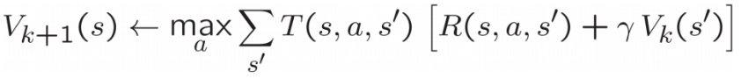
Write a value iteration agent in ValueIterationAgent, which has been partially specified for you in valueIterationAgents.py. Your value iteration agent is an offline planner, not a reinforcement learning agent, and so the relevant training option is the number of iterations of value iteration it should run (option -i) in its initial planning phase. ValueIterationAgent takes an MDP on construction and runs value iteration for the specified number of iterations before the constructor returns.
Value iteration computes k-step estimates of the optimal values, Vk. In addition to running value iteration, implement the following methods for ValueIterationAgent using Vk.
- computeActionFromValues(state) computes the best action according to the value function given by self.values.
- computeQValueFromValues(state, action) returns the Q-value of the (state, action) pair given by the value function given by self.values.
These quantities are all displayed in the GUI: values are numbers in squares, Q-values are numbers in square quarters, and policies are arrows out from each square.
Important: Use the “batch” version of value iteration where each vector Vk is computed from a fixed vector Vk−1 (like in lecture), not the “online” version where one single weight vector is updated in place. This means that when a state’s value is updated in iteration kk based on the values of its successor states, the successor state values used in the value update computation should be those from iteration k−1 (even if some of the successor states had already been updated in iteration kk). The difference is discussed in Sutton & Barto in Chapter 4.1 on page 91.
Note: A policy synthesized from values of depth kk (which reflect the next kk rewards) will actually reflect the next k+1rewards (i.e. you return πk+1). Similarly, the Q-values will also reflect one more reward than the values (i.e. you return Qk+1).
You should return the synthesized policy πk+1.
Hint: You may optionally use the util.Counter class in util.py, which is a dictionary with a default value of zero. However, be careful with argMax: the actual argmax you want may be a key not in the counter!
Note: Make sure to handle the case when a state has no available actions in an MDP (think about what this means for future rewards).
To test your implementation, run the autograder:
python autograder.py -q q1
The following command loads your ValueIterationAgent, which will compute a policy and execute it 10 times. Press a key to cycle through values, Q-values, and the simulation. You should find that the value of the start state (V(start), which you can read off of the GUI) and the empirical resulting average reward (printed after the 10 rounds of execution finish) are quite close.
python gridworld.py -a value -i 100 -k 10
Hint: On the default BookGrid, running value iteration for 5 iterations should give you this output:
python gridworld.py -a value -i 5
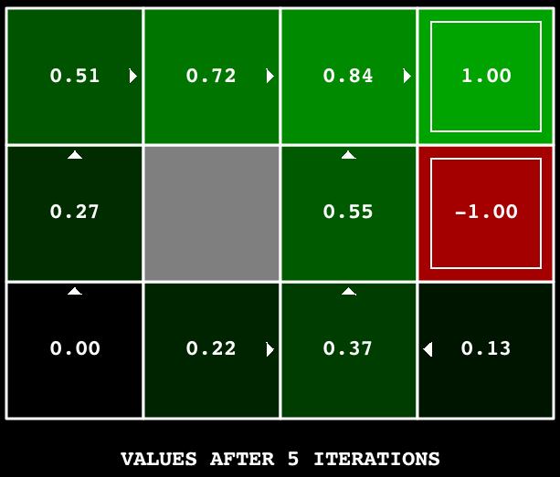
Grading: Your value iteration agent will be graded on a new grid. We will check your values, Q-values, and policies after fixed numbers of iterations and at convergence (e.g. after 100 iterations).

Question 2 (1 point): Bridge Crossing Analysis
BridgeGrid is a grid world map with the a low-reward terminal state and a high-reward terminal state separated by a narrow “bridge”, on either side of which is a chasm of high negative reward. The agent starts near the low-reward state. With the default discount of 0.9 and the default noise of 0.2, the optimal policy does not cross the bridge. Change only ONE of the discount and noise parameters so that the optimal policy causes the agent to attempt to cross the bridge. Put your answer in question2() of analysis.py. (Noise refers to how often an agent ends up in an unintended successor state when they perform an action.) The default corresponds to:
python gridworld.py -a value -i 100 -g BridgeGrid --discount 0.9 --noise 0.2
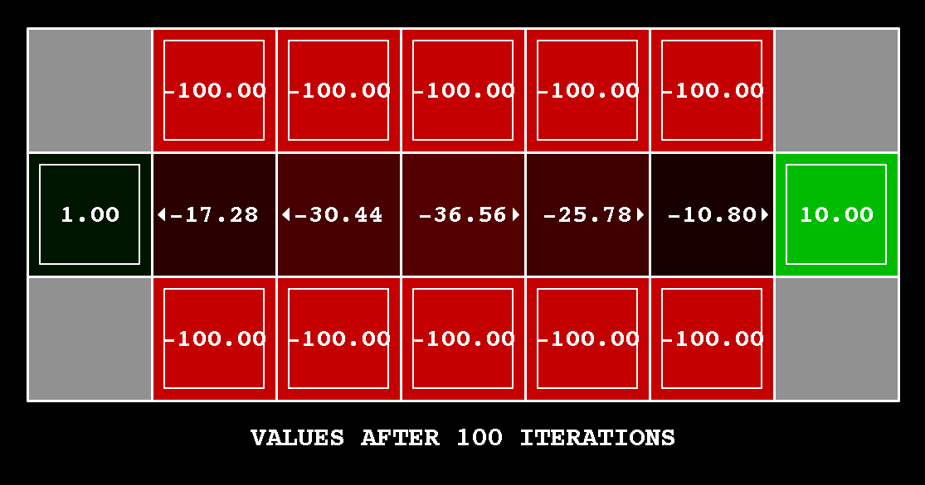
Grading: We will check that you only changed one of the given parameters, and that with this change, a correct value iteration agent should cross the bridge. To check your answer, run the autograder:
python autograder.py -q q2

Question 3 (5 points): Policies
Consider the DiscountGrid layout, shown below. This grid has two terminal states with positive payoff (in the middle row), a close exit with payoff +1 and a distant exit with payoff +10. The bottom row of the grid consists of terminal states with negative payoff (shown in red); each state in this “cliff” region has payoff -10. The starting state is the yellow square. We distinguish between two types of paths: (1) paths that “risk the cliff” and travel near the bottom row of the grid; these paths are shorter but risk earning a large negative payoff, and are represented by the red arrow in the figure below. (2) paths that “avoid the cliff” and travel along the top edge of the grid. These paths are longer but are less likely to incur huge negative payoffs. These paths are represented by the green arrow in the figure below.
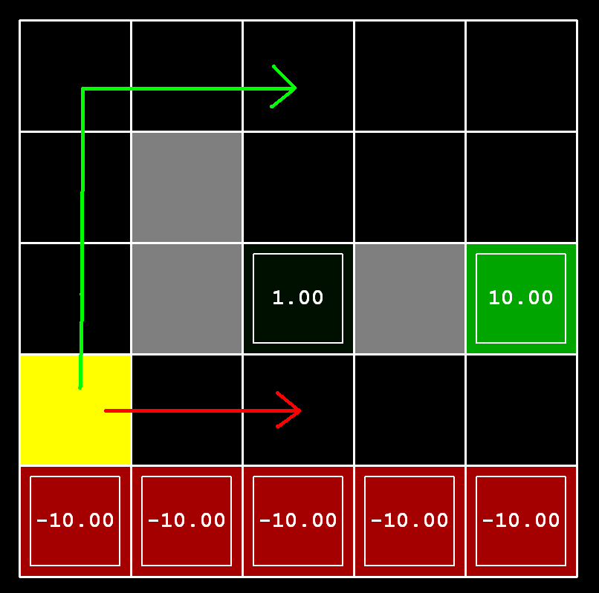
In this question, you will choose settings of the discount, noise, and living reward parameters for this MDP to produce optimal policies of several different types. Your setting of the parameter values for each part should have the property that, if your agent followed its optimal policy without being subject to any noise, it would exhibit the given behavior. If a particular behavior is not achieved for any setting of the parameters, assert that the policy is impossible by returning the string 'NOT POSSIBLE'.
Here are the optimal policy types you should attempt to produce:
- Prefer the close exit (+1), risking the cliff (-10)
- Prefer the close exit (+1), but avoiding the cliff (-10)
- Prefer the distant exit (+10), risking the cliff (-10)
- Prefer the distant exit (+10), avoiding the cliff (-10)
- Avoid both exits and the cliff (so an episode should never terminate)
To check your answers, run the autograder:
python autograder.py -q q3
question3a() through question3e() should each return a 3-item tuple of (discount, noise, living reward) in analysis.py.
Note: You can check your policies in the GUI. For example, using a correct answer to 3(a), the arrow in (0,1) should point east, the arrow in (1,1) should also point east, and the arrow in (2,1) should point north.
Note: On some machines you may not see an arrow. In this case, press a button on the keyboard to switch to qValue display, and mentally calculate the policy by taking the arg max of the available qValues for each state.
Grading: We will check that the desired policy is returned in each case.

Question 4 (1 point): Asynchronous Value Iteration
Write a value iteration agent in AsynchronousValueIterationAgent, which has been partially specified for you in valueIterationAgents.py. Your value iteration agent is an offline planner, not a reinforcement learning agent, and so the relevant training option is the number of iterations of value iteration it should run (option -i) in its initial planning phase. AsynchronousValueIterationAgent takes an MDP on construction and runs cyclic value iteration (described in the next paragraph) for the specified number of iterations before the constructor returns. Note that all this value iteration code should be placed inside the constructor (__init__ method).
The reason this class is called AsynchronousValueIterationAgent is because we will update only one state in each iteration, as opposed to doing a batch-style update. Here is how cyclic value iteration works. In the first iteration, only update the value of the first state in the states list. In the second iteration, only update the value of the second. Keep going until you have updated the value of each state once, then start back at the first state for the subsequent iteration. If the state picked for updating is terminal, nothing happens in that iteration. You can implement it as indexing into the states variable defined in the code skeleton.
As a reminder, here’s the value iteration state update equation:
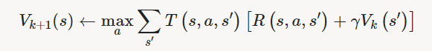
Value iteration iterates a fixed-point equation, as discussed in class. It is also possible to update the state values in different ways, such as in a random order (i.e., select a state randomly, update its value, and repeat) or in a batch style (as in Q1). In this question, we will explore another technique.
AsynchronousValueIterationAgent inherits from ValueIterationAgent from Q1, so the only method you need to implement is runValueIteration. Since the superclass constructor calls runValueIteration, overriding it is sufficient to change the agent’s behavior as desired.
Note: Make sure to handle the case when a state has no available actions in an MDP (think about what this means for future rewards).
To test your implementation, run the autograder. It should take less than a second to run. If it takes much longer, you may run into issues later in the project, so make your implementation more efficient now.
python autograder.py -q q4
The following command loads your AsynchronousValueIterationAgent in the Gridworld, which will compute a policy and execute it 10 times. Press a key to cycle through values, Q-values, and the simulation. You should find that the value of the start state (V(start), which you can read off of the GUI) and the empirical resulting average reward (printed after the 10 rounds of execution finish) are quite close.
python gridworld.py -a asynchvalue -i 1000 -k 10
Grading: Your value iteration agent will be graded on a new grid. We will check your values, Q-values, and policies after fixed numbers of iterations and at convergence (e.g., after 1000 iterations).

Question 5 (3 points): Prioritized Sweeping Value Iteration
You will now implement PrioritizedSweepingValueIterationAgent, which has been partially specified for you in valueIterationAgents.py. Note that this class derives from AsynchronousValueIterationAgent, so the only method that needs to change is runValueIteration, which actually runs the value iteration.
Prioritized sweeping attempts to focus updates of state values in ways that are likely to change the policy.
For this project, you will implement a simplified version of the standard prioritized sweeping algorithm, which is described in this paper. We’ve adapted this algorithm for our setting. First, we define the predecessors of a state s as all states that have a nonzero probability of reaching s by taking some action a. Also, theta, which is passed in as a parameter, will represent our tolerance for error when deciding whether to update the value of a state. Here’s the algorithm you should follow in your implementation.
- Compute predecessors of all states.
- Initialize an empty priority queue.
- For each non-terminal state s, do: (note: to make the autograder work for this question, you must iterate over states in the order returned by self.mdp.getStates())
  - Find the absolute value of the difference between the current value of s in self.values and the highest Q-value across all possible actions from s (this represents what the value should be); call this number diff. Do NOT update self.values[s] in this step.
  - Push s into the priority queue with priority -diff (note that this is negative). We use a negative because the priority queue is a min heap, but we want to prioritize updating states that have a higher error.
- For iteration in 0, 1, 2, ..., self.iterations - 1, do:
  - If the priority queue is empty, then terminate.
  - Pop a state s off the priority queue.
  - Update the value of s (if it is not a terminal state) in self.values.
  - For each predecessor p of s, do:
    - Find the absolute value of the difference between the current value of p in self.values and the highest Q-value across all possible actions from p (this represents what the value should be); call this number diff. Do NOT update self.values[p] in this step.
    - If diff > theta, push p into the priority queue with priority -diff (note that this is negative), as long as it does not already exist in the priority queue with equal or lower priority. As before, we use a negative because the priority queue is a min heap, but we want to prioritize updating states that have a higher error.
A couple of important notes on implementation:
- When you compute predecessors of a state, make sure to store them in a set, not a list, to avoid duplicates.
- Please use util.PriorityQueue in your implementation. The update method in this class will likely be useful; look at its documentation.
To test your implementation, run the autograder. It should take about 1 second to run. If it takes much longer, you may run into issues later in the project, so make your implementation more efficient now.
python autograder.py -q q5
You can run the PrioritizedSweepingValueIterationAgen in the Gridworld using the following command.
python gridworld.py -a priosweepvalue -i 1000
Grading: Your prioritized sweeping value iteration agent will be graded on a new grid. We will check your values, Q-values, and policies after fixed numbers of iterations and at convergence (e.g., after 1000 iterations).

Question 6 (4 points): Q-Learning
Note that your value iteration agent does not actually learn from experience. Rather, it ponders its MDP model to arrive at a complete policy before ever interacting with a real environment. When it does interact with the environment, it simply follows the precomputed policy (e.g. it becomes a reflex agent). This distinction may be subtle in a simulated environment like a Gridword, but it’s very important in the real world, where the real MDP is not available.
You will now write a Q-learning agent, which does very little on construction, but instead learns by trial and error from interactions with the environment through its update(state, action, nextState, reward) method. A stub of a Q-learner is specified in QLearningAgent in qlearningAgents.py, and you can select it with the option '-a q'. For this question, you must implement the update, computeValueFromQValues, getQValue, and computeActionFromQValues methods.
Note: For computeActionFromQValues, you should break ties randomly for better behavior. The random.choice() function will help. In a particular state, actions that your agent hasn’t seen before still have a Q-value, specifically a Q-value of zero, and if all of the actions that your agent has seen before have a negative Q-value, an unseen action may be optimal.
Important: Make sure that in your computeValueFromQValues and computeActionFromQValues functions, you only access Q values by calling getQValue . This abstraction will be useful for question 10 when you override getQValue to use features of state-action pairs rather than state-action pairs directly.
With the Q-learning update in place, you can watch your Q-learner learn under manual control, using the keyboard:
python gridworld.py -a q -k 5 -m
Recall that -k will control the number of episodes your agent gets to learn. Watch how the agent learns about the state it was just in, not the one it moves to, and “leaves learning in its wake.” Hint: to help with debugging, you can turn off noise by using the --noise 0.0 parameter (though this obviously makes Q-learning less interesting). If you manually steer Pacman north and then east along the optimal path for four episodes, you should see the following Q-values:
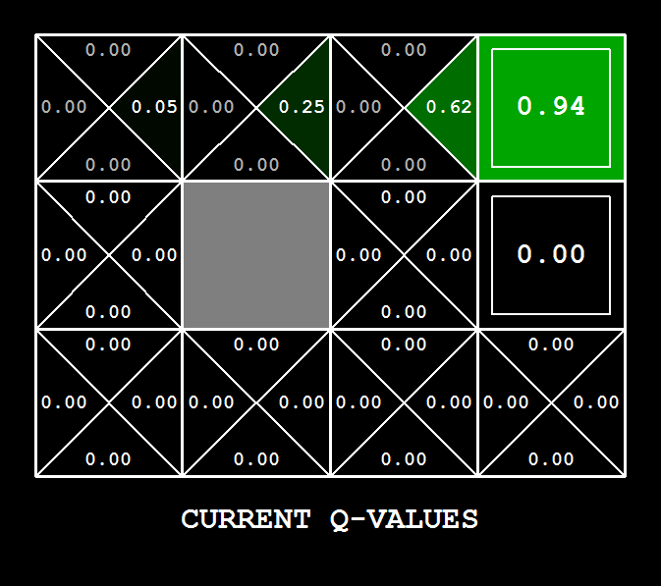
Grading: We will run your Q-learning agent and check that it learns the same Q-values and policy as our reference implementation when each is presented with the same set of examples. To grade your implementation, run the autograder:
python autograder.py -q q6

Question 7 (2 points): Epsilon Greedy
Complete your Q-learning agent by implementing epsilon-greedy action selection in getAction, meaning it chooses random actions an epsilon fraction of the time, and follows its current best Q-values otherwise. Note that choosing a random action may result in choosing the best action - that is, you should not choose a random sub-optimal action, but rather any random legal action.
You can choose an element from a list uniformly at random by calling the random.choice function. You can simulate a binary variable with probability p of success by using util.flipCoin(p), which returns True with probability p and False with probability 1-p.
After implementing the getAction method, observe the following behavior of the agent in gridworld (with epsilon = 0.3).
python gridworld.py -a q -k 100
Your final Q-values should resemble those of your value iteration agent, especially along well-traveled paths. However, your average returns will be lower than the Q-values predict because of the random actions and the initial learning phase.
You can also observe the following simulations for different epsilon values. Does that behavior of the agent match what you expect?
python gridworld.py -a q -k 100 --noise 0.0 -e 0.1

python gridworld.py -a q -k 100 --noise 0.0 -e 0.9
To test your implementation, run the autograder:
python autograder.py -q q7
With no additional code, you should now be able to run a Q-learning crawler robot:
python crawler.py
If this doesn’t work, you’ve probably written some code too specific to the GridWorld problem and you should make it more general to all MDPs.
This will invoke the crawling robot from class using your Q-learner. Play around with the various learning parameters to see how they affect the agent’s policies and actions. Note that the step delay is a parameter of the simulation, whereas the learning rate and epsilon are parameters of your learning algorithm, and the discount factor is a property of the environment.

Question 8 (1 point): Bridge Crossing Revisited
First, train a completely random Q-learner with the default learning rate on the noiseless BridgeGrid for 50 episodes and observe whether it finds the optimal policy.
python gridworld.py -a q -k 50 -n 0 -g BridgeGrid -e 1
Now try the same experiment with an epsilon of 0. Is there an epsilon and a learning rate for which it is highly likely (greater than 99%) that the optimal policy will be learned after 50 iterations? question8() in analysis.py should return EITHER a 2-item tuple of (epsilon, learning rate) OR the string 'NOT POSSIBLE' if there is none. Epsilon is controlled by -e, learning rate by -l.
Note: Your response should be not depend on the exact tie-breaking mechanism used to choose actions. This means your answer should be correct even if for instance we rotated the entire bridge grid world 90 degrees.
To grade your answer, run the autograder:
python autograder.py -q q8

Question 9 (1 point): Q-Learning and Pacman
Time to play some Pacman! Pacman will play games in two phases. In the first phase, training, Pacman will begin to learn about the values of positions and actions. Because it takes a very long time to learn accurate Q-values even for tiny grids, Pacman’s training games run in quiet mode by default, with no GUI (or console) display. Once Pacman’s training is complete, he will enter testing mode. When testing, Pacman’s self.epsilon and self.alpha will be set to 0.0, effectively stopping Q-learning and disabling exploration, in order to allow Pacman to exploit his learned policy. Test games are shown in the GUI by default. Without any code changes you should be able to run Q-learning Pacman for very tiny grids as follows:
python pacman.py -p PacmanQAgent -x 2000 -n 2010 -l smallGrid
Note that PacmanQAgent is already defined for you in terms of the QLearningAgent you’ve already written. PacmanQAgentis only different in that it has default learning parameters that are more effective for the Pacman problem (epsilon=0.05, alpha=0.2, gamma=0.8). You will receive full credit for this question if the command above works without exceptions and your agent wins at least 80% of the time. The autograder will run 100 test games after the 2000 training games.
Hint: If your QLearningAgent works for gridworld.py and crawler.py but does not seem to be learning a good policy for Pacman on smallGrid, it may be because your getAction and/or computeActionFromQValues methods do not in some cases properly consider unseen actions. In particular, because unseen actions have by definition a Q-value of zero, if all of the actions that have been seen have negative Q-values, an unseen action may be optimal. Beware of the argmax function from util.Counter!
Note: To grade your answer, run:
python autograder.py -q q9
Note: If you want to experiment with learning parameters, you can use the option -a, for example -a epsilon=0.1,alpha=0.3,gamma=0.7. These values will then be accessible as self.epsilon, self.gamma and self.alpha inside the agent.
Note: While a total of 2010 games will be played, the first 2000 games will not be displayed because of the option -x 2000, which designates the first 2000 games for training (no output). Thus, you will only see Pacman play the last 10 of these games. The number of training games is also passed to your agent as the option numTraining.
Note: If you want to watch 10 training games to see what’s going on, use the command:
python pacman.py -p PacmanQAgent -n 10 -l smallGrid -a numTraining=10
During training, you will see output every 100 games with statistics about how Pacman is faring. Epsilon is positive during training, so Pacman will play poorly even after having learned a good policy: this is because he occasionally makes a random exploratory move into a ghost. As a benchmark, it should take between 1000 and 1400 games before Pacman’s rewards for a 100 episode segment becomes positive, reflecting that he’s started winning more than losing. By the end of training, it should remain positive and be fairly high (between 100 and 350).
Make sure you understand what is happening here: the MDP state is the exact board configuration facing Pacman, with the now complex transitions describing an entire ply of change to that state. The intermediate game configurations in which Pacman has moved but the ghosts have not replied are not MDP states, but are bundled in to the transitions.
Once Pacman is done training, he should win very reliably in test games (at least 90% of the time), since now he is exploiting his learned policy.
However, you will find that training the same agent on the seemingly simple mediumGrid does not work well. In our implementation, Pacman’s average training rewards remain negative throughout training. At test time, he plays badly, probably losing all of his test games. Training will also take a long time, despite its ineffectiveness.
Pacman fails to win on larger layouts because each board configuration is a separate state with separate Q-values. He has no way to generalize that running into a ghost is bad for all positions. Obviously, this approach will not scale.

Question 10 (3 points): Approximate Q-Learning
Implement an approximate Q-learning agent that learns weights for features of states, where many states might share the same features. Write your implementation in ApproximateQAgent class in qlearningAgents.py, which is a subclass of PacmanQAgent.
Note: Approximate Q-learning assumes the existence of a feature function f(s,a)f(s,a) over state and action pairs, which yields a vector [f1(s,a), …, fi(s,a), …, fn(s,a)] of feature values. We provide feature functions for you in featureExtractors.py. Feature vectors are util.Counter (like a dictionary) objects containing the non-zero pairs of features and values; all omitted features have value zero.
The approximate Q-function takes the following form:
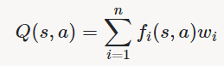
where each weight wiwi is associated with a particular feature fi(s,a)fi(s,a). In your code, you should implement the weight vector as a dictionary mapping features (which the feature extractors will return) to weight values. You will update your weight vectors similarly to how you updated Q-values:
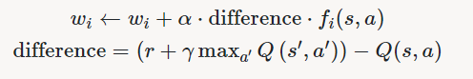
Note that the differencedifference term is the same as in normal Q-learning, and rr is the experienced reward.
By default, ApproximateQAgent uses the IdentityExtractor, which assigns a single feature to every (state,action)pair. With this feature extractor, your approximate Q-learning agent should work identically to PacmanQAgent. You can test this with the following command:
python pacman.py -p ApproximateQAgent -x 2000 -n 2010 -l smallGrid
Important:ApproximateQAgent is a subclass of QLearningAgent, and it therefore shares several methods like getAction. Make sure that your methods in QLearningAgent call getQValue instead of accessing Q-values directly, so that when you override getQValue in your approximate agent, the new approximate q-values are used to compute actions.
Once you’re confident that your approximate learner works correctly with the identity features, run your approximate Q-learning agent with our custom feature extractor, which can learn to win with ease:
python pacman.py -p ApproximateQAgent -a extractor=SimpleExtractor -x 50 -n 60 -l mediumGrid
Even much larger layouts should be no problem for your ApproximateQAgent (warning: this may take a few minutes to train):
python pacman.py -p ApproximateQAgent -a extractor=SimpleExtractor -x 50 -n 60 -l mediumClassic
If you have no errors, your approximate Q-learning agent should win almost every time with these simple features, even with only 50 training games.
Grading: We will run your approximate Q-learning agent and check that it learns the same Q-values and feature weights as our reference implementation when each is presented with the same set of examples. To grade your implementation, run the autograder:
python autograder.py -q q10
Congratulations! You have a learning Pacman agent!

提交
将文件放入文件夹“实验3-姓名”中进行提交

