# Journal of Physics: Conference Series

**PAPER • OPEN ACCESS**

Application of Java Technology in Dynamic Web Database Technology

To cite this article: Xiaona Qu 2021 *J. Phys.: Conf. Ser.* **1744** 042029

View the [article online](https://doi.org/10.1088/1742-6596/1744/4/042029) for updates and enhancements.

# You may also like

* A data seamless interaction scheme between electric power secondary business systems

Wenkai Ai and Feng Qian

* The Design and Implementation of Network Assistant System for Physical Education

Junwa Yang

* On ontology based data integration: problems and solutions

A Gusenkov, N Bukharaev and E Birialtsev



This content was downloaded from IP address 16.162.192.45 on 02/12/2021 at 05:16

**Application of Java Technology in Dynamic Web Database Technology**

## Xiaona Qu1,*

1Xi'an Haitang Vocational College, Shaanxi, China, 710038

*Corresponding author e-mail: [quxiaona@xahtxy.edu.cn](mailto:quxiaona@xahtxy.edu.cn)

**Abstract.** With the development of Internet technology, Java has been applied to a variety of software design, including Database technology (hereinafter referred to as DT), web technology, which can enhance enterprise information and data management. DT can improve the efficient operation of information system, which needs to ensure the access performance of database. With the rapid increase of data volume, the data transmission between dynamic web pages is busy, which will lead to more and more database data access. Therefore, we have higher and higher requirements for dynamic web DT, which requires fast and efficient data interaction with server database. Java is one of the most commonly used programming software, which can solve many problems of dynamic web database. Therefore, more and more attention has been paid to the research of database optimization technology by Java.

**Keywords:** Java, Dynamic Web Page, Database Technology

## Introduction

In the past decade, with the acceleration of the process of global economic integration. The practicality of Internet technology is a catalyst. In the 21st century, we have entered a new era of "Internet economy"[1]. At present, individuals, groups and enterprises must interact with each other through interconnection, so as to seek development or seek opportunities. Internet economy is an economy carried out through it technology, which can provide employees, customers and partners with the best way to connect. We can obtain the information through the Internet without the support of technology[2]. At the same time, in the Internet environment, people are no longer satisfied with the status quo of static hypertext mode for database applications, which can obtain static query results such as text, pictures and so on through the browser. Through Internet technology, we can put forward higher requirements for the interactivity of database applications. Java technology can better solve the problem of dynamic web DT, this paper mainly introduces the current application[3].

## Related concepts

* + 1. *Java applications*

Content from this work may be used under the terms of the Creative Commons Attribution 3.0 licence. Any further distribution of this work must maintain attribution to the author(s) and the title of the work, journal citation and DOI.



Published under licence by IOP Publishing Ltd 1

Java was officially launched by sun in 1995. At present, Java has developed from programming language to the world's largest general development platform. Java has been adopted by major companies in the computer industry, which is also accepted by many international technical standardization organizations. Java is a popular development language, which can develop web applications. Java language is object-oriented, which is a language that integrates the advantages of C and C++[4]. It not only enhances its own functions, but also can be transplanted to other platforms.

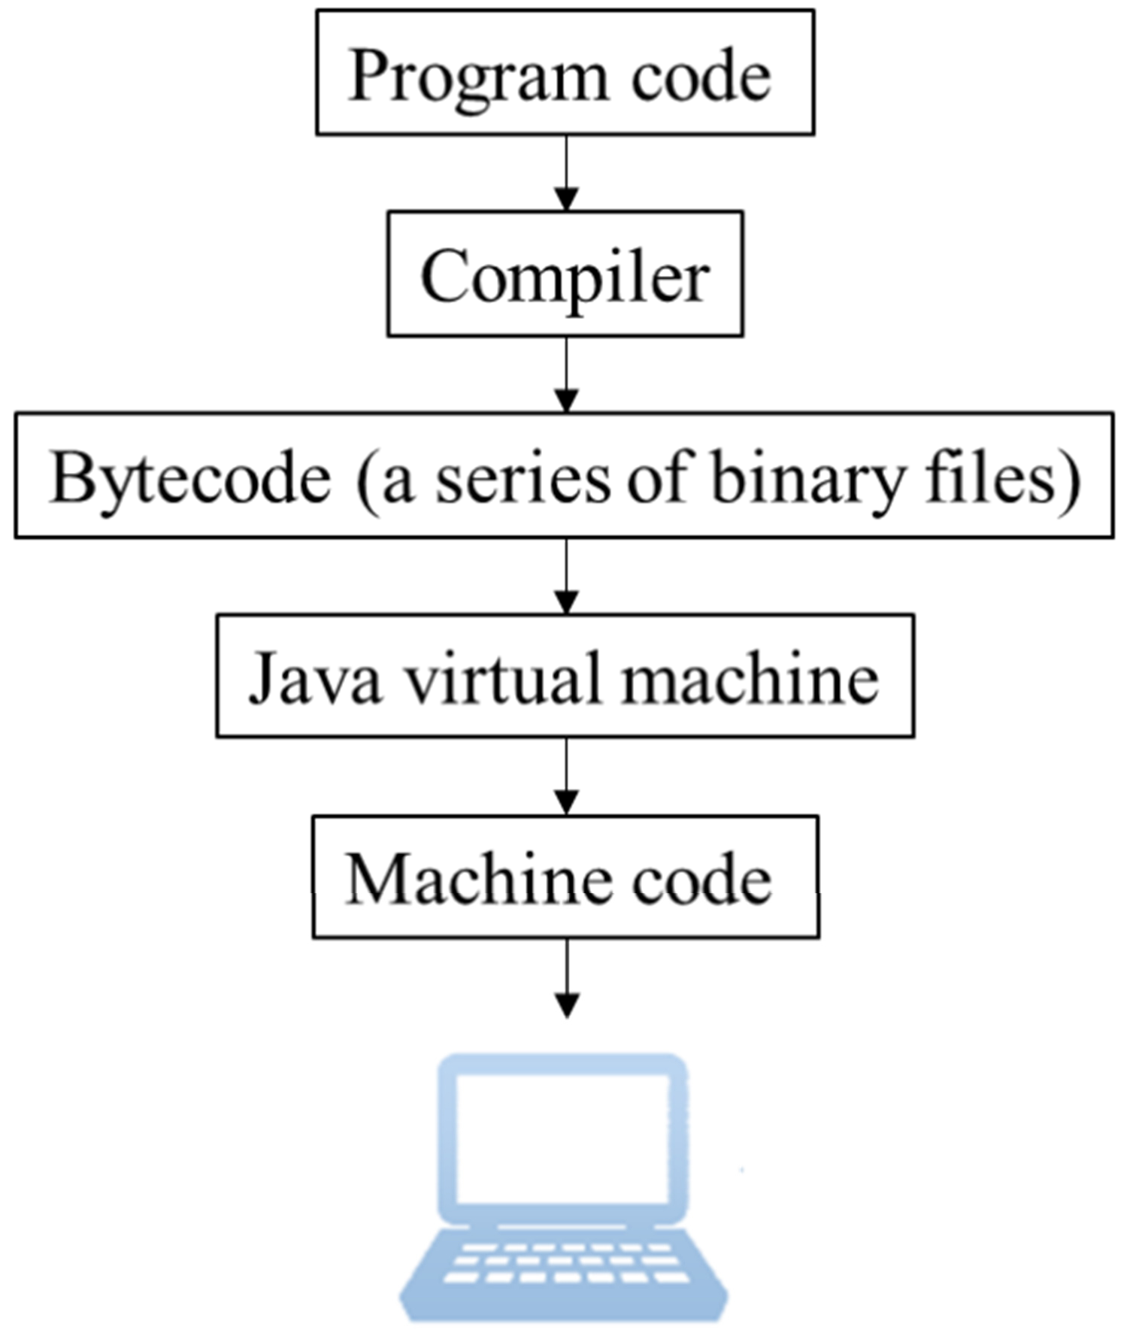Java web is the total technology of using Java technology to solve the related Web Internet field. Java applications in the client include Java applet, such as servlet, JSP and third-party framework. Java technology injects powerful power into the development of Web field. Although Java's Web frameworks are different, the basic principles are similar[5]. There are significant differences between Java and C in compiling and recycling mechanism, which is mainly reflected in the programming of network side, as shown in Figure 1.

**Figure 1.** The compilation and execution of Java.

* + 1. *Database connection pool technology*

The first step of database access is to establish a connection with the database, and the last step is to disconnect from the database. Therefore, database connection plays an important role in database access. Each connection must complete user authentication, security context configuration and other tasks, which need to occupy a certain amount of communication and memory resources. Therefore, database access technology is often the most time-consuming operation. Therefore, the database connection should choose the best connection mode, which can greatly improve the database performance of the system[6].

Database connection pool is a better database connection technology than JDBC direct connection technology. By establishing a buffer pool, we can store a certain number of database connection objects in it. Before the system accesses the database, we can request a database connection object from the connection pool. If there are free connection objects in the connection pool, the connection pool will allocate the idle objects to the system. After the system accesses the database, the connection pool releases the database connection and reclaims it. The core idea of database connection pool is connection reuse. Connection pool has its own mechanism, which can establish, manage and close connection objects. By controlling the number of connection objects and the duration of connection, connection pool will recycle the connection objects released after use to the connection pool for reuse, which can avoid frequent database connection establishment and closing in database access[7]. By

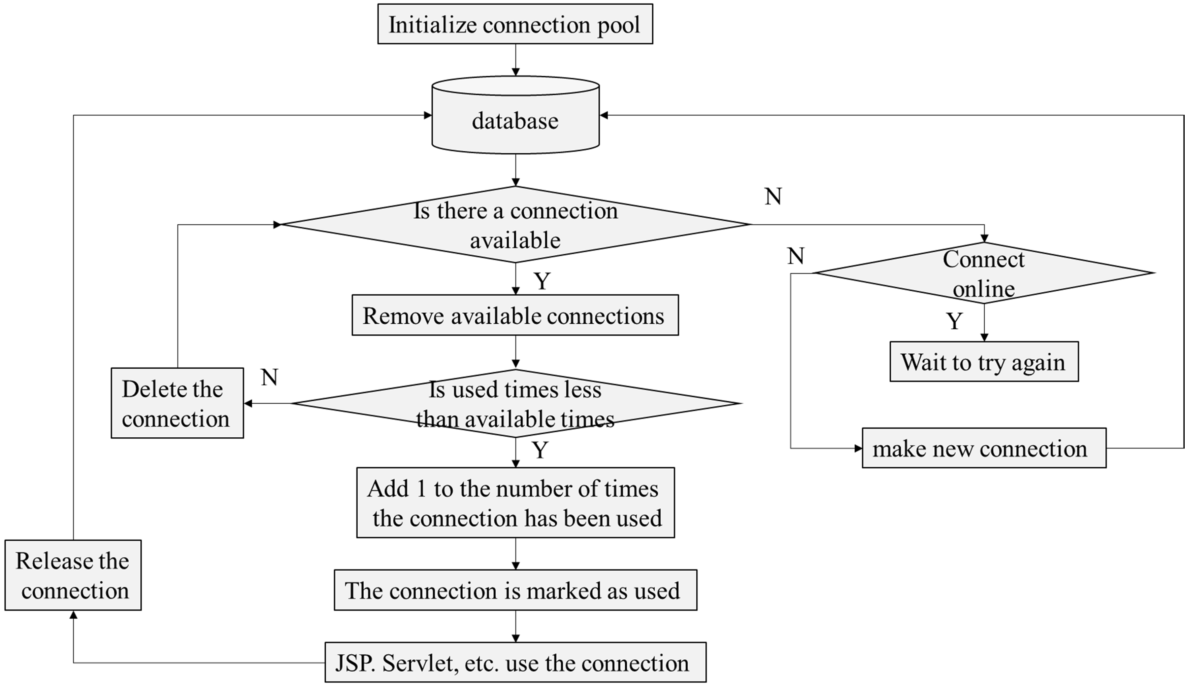recycling, connection pool saves access time and system overhead resources. The working mechanism of connection pool is shown in Figure 2.

**Figure 2.** How connection pooling works.

* + 1. *SQL statement tuning technology*

SQL is a standard computer language for accessing and processing databases. Under the condition of ensuring the correctness of SQL statement, we can adjust and optimize it properly, which can greatly save the time needed for the system to access the database. By changing the format of SQL statement, we can reduce the amount of data to be scanned in table query, which will find out the best query path. There are many subtle points in SQL statement tuning technology, which may affect the performance of the whole SQL statement. The most commonly used optimization methods for SQL are as follows. First, filter and then connect. According to the query criteria, we can filter out a large number of data in the table to be joined. Then, through the union of multiple tables, there is no need to re filter all the data. Second, avoid subqueries. Subquery is to query all data in another table under one condition. Therefore, the amount of data will be the product of two tables. If there is another level of nesting, the data flow will increase dramatically, which will lead to more inefficiency. SQL can avoid subqueries as much as possible, which can increase the speed of checking. Third, if subqueries are unavoidable, you need to filter as much data as possible using filter conditions. In MySQL database, the parsing order of where statement is from left to right without index. The more detailed the query conditions, the more data records can be filtered out, which will avoid full table scanning.

## Platform development process analysis

Before we start development, we need to analyze the development process of the platform, which will avoid major errors in the development process. According to the conventional development process, developers first need to build the running environment, including installing operating system, deploying Java running environment, deploying database running environment, preparing development tools, etc. Then, by copying the basic code to the relevant path, we can make the relevant configuration before development. By starting the service, we can start the program development of each function module. The development of the platform should be based on database design. Combined with the business management module, we can write the relevant client and server code.

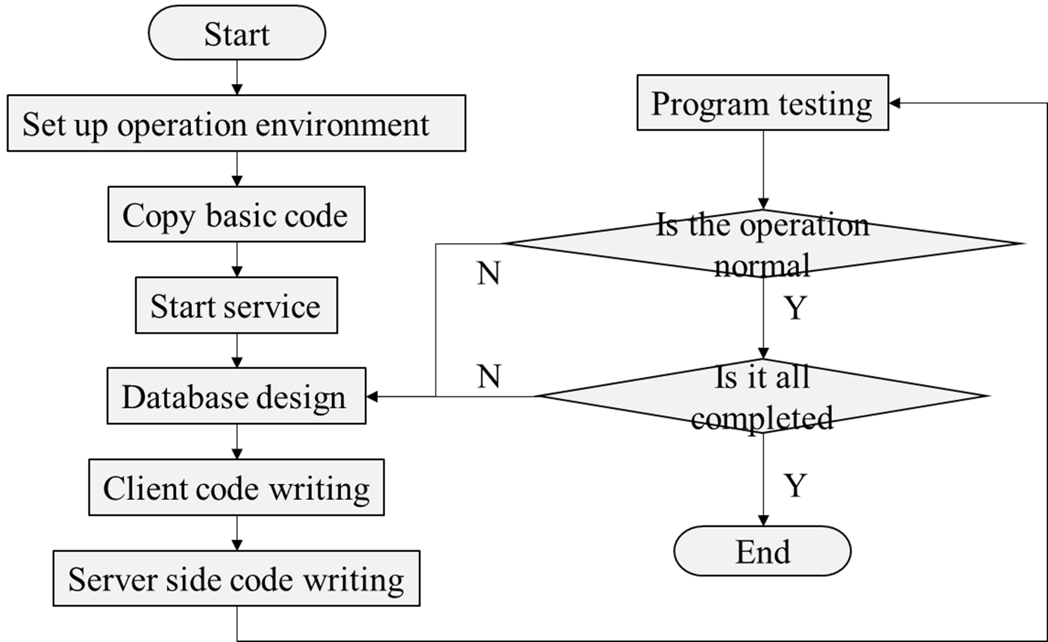Finally, through the overall test of the module, we can complete the platform development. The platform development flow chart is shown in Figure 3.

**Figure 3.** Platform development flow chart.

## Application of Java distributed computing technology in dynamic web database

* + 1. *Socket*

In the distributed environment, the socket mechanism of transport layer interface is used to realize communication between client and server. Socket is a network communication endpoint used for two-way data transmission between two program objects. It is generally identified by an address and a port number. Each service program provides a service on a well-known port, and the customer equation order that wants to use the service needs to join the port. Each computer provides reserved ports for many public services as well as other ports for creating user-defined service programs. The form of the data through socket is the original byte stream information. On this basis, the communication parties should format and interpret the data according to the way agreed by both parties to complete the specific application, which is the process of implementing a certain protocol. Socket communication mechanism provides two kinds of communication modes: connected mode and connectionless mode, which are respectively oriented to different application requirements. With the connection mode, both sides of the communication must carry out a connection process at the beginning to establish a communication link. After that, the network I/O operation on the connection will always be carried out between the same pair of processes. The communication link provides reliable, full duplex byte stream service. Using the connectionless mode, there is no connection process between the two sides of the communication. A network I/O is carried out in the form of a datagram, and each network I/O can be carried out between different processes of different hosts. The cost of connectionless mode is less than that of joined mode, but it is unreliable service and cannot guarantee that datagram will arrive at destination.

* + 1. *Java RMI*

Java Remote method call RMI is a distributed computing technology based on Java, which enables objects running in different hosts to make method calls to each other. It realizes method call between objects running in different "VMS". RMI uses Java Remote Message Exchange Protocol JRMP to communicate. JRMP is a protocol specially designed for Java remote objects. RMI enables the client to interact with the remote object by reference, and download the remote object to the client environment for operation. RMI uses the object serialization function in Java to transfer objects between the server and the client. RMI assigns a unique name to each RNiI object and binds it with the

actual object. This object relationship is registered in the registration form of RMI. The caller finds the corresponding object through the name of the object and calls its method without considering the physical storage location of the object. This not only conforms to people's usage habits, but also improves the scalability and robustness of the system. RMI registers the names of multiple RMI objects in the same register (listening to a port). One object has one or more methods for remote call, so that one port can provide multiple services and save the port resources of the system.

* + 1. *Java IDL*

Java IDL can realize the interaction between objects on different platforms on the network. The technology is based on CORBA specification of common object request broker architecture. IDL is a language independent interface definition language. All CORBA supported languages have IDL to language mapping. Java IDL supports mapping to the Java language. With Java IDL, CORBA objects can be defined, implemented and accessed in Java. For each java compiler, it generates a java interface and other necessary java files, including a client-side stub and a server-side skeleton. Through Java IDL, objects written in non Java language can be called remotely. Java IDL uses CORBA II IOP protocol. IIOP protocol can make objects generated in different languages on different platforms communicate in a standard way. In Java IDL, the client interacts with the remote object through the reference of the target object, that is, the client uses the stake to operate the object on the remote server, but does not copy the object on the server. Java IDL can ensure seamless interoperability and connectivity in heterogeneous computing.

## Conclusion

After the database management is given the web interactive interface, its storage management will rise to a new height, which allows authorized persons to operate in the database. As the advantages of dynamic web database are widely recognized, such as unified standards, simple development process, cross platform support and so on, developers more and more like to use java to program. This paper mainly discusses the application of Java technology in dynamic web DT.

## Acknowledgement

Research project on vocational education in shaanxi province in 2019 (szjyb19-309).

## References

1. Chen Zefeng. Processing strategies for improving database access efficiency in Java Web applications [J]. China financial computer, 2016 (4): 47-50.
2. Gu Qinghua. Database access based on Java language [J]. Computer technology and development, 2008 (4): 281-282.
3. Hong Chengyu, Chen Hao, Yang Shangqin. Design and implementation of unified database interface model [J]. Network new media technology, 2012, (3): 49-53.
4. Liu Bing. Research and implementation of database connection pool technology based on JDBC [J]. Computer and modernization, 2015(7):32-34.
5. Wang Yujie, Wang Feng, Yang Wenbin. Comparative test of database access performance based on database connection pool [J]. Industrial control computer, 2010 (1): 83-87.
6. Xie Zhongke. Database connection pool technology and its application [J]. Journal of Changsha University of science and Technology, 2015,02:67-71
7. Zhou Zhide. Research on SQL query optimization of Oracle database [J]. Computer and digital engineering, 2010(11):173-178.