·山西大学自动化与软件学院

课程　 软件质量保证与测试

作业名称 软件项目走查，开发组:游戏-飞机大战

学生班级/组别 软工2004班 2组

开发小组成员 张继 赵海乐 张伟 杨向征

分工

指导教师 郭新峰

2023年 4月 6日

参考资料

《零基础入门学习python》



目录

飞机大战 2

一.游戏设定 2

二.我方飞机 3

# 分别定义moveUp()、moveDown()、moveLeft()和moveRight()控制我方飞机上、下、左、右移动: 4

三.敌方飞机 4

四.发射子弹 6

五.发放补给包 7

六.主模块 8

# 生成我方飞机 9

# 生成敌方小型飞机 10

# 生成敌方中型飞机 10

# 生成敌方大型飞机 10

# 中弹图片索引 10

# 统计得分 10

# 标志是否暂停游戏 10

# 设置难度级别 10

# 全屏炸弹 10

# 每30秒发放一个补给包 10

# 超级子弹定时器 10

# 标志是否使用超级子弹 11

# 解除我方无敌状态定时器 11

# 生命数量 11

# 用于阻止重复打开记录文件 11

# 游戏结束画面 11

# 用于切换图片 11

# 用于延迟 11

# 根据用户的得分增加难度 12

# 增加3架小型敌机、2架中型敌机和1架大型敌机 12

# 增加5架小型敌机、3架中型敌机和2架大型敌机 12

# 增加5架小型敌机、3架中型敌机和2架大型敌机 12

# 增加5架小型敌机、3架中型敌机和2架大型敌机 12

# 检测用户的键盘操作 12

# 绘制全屏炸弹补给并检测是否获得 13

# 绘制超级子弹补给并检测是否获得 13

# 发射子弹 13

# 检测子弹是否击中敌机 13

# 绘制大型敌机 13

# 绘制血槽 14

# 当生命大于20%显示绿色，否则显示红色 14

# 即将出现在画面中，播放音效 14

# 毁 灭 14

# 绘制中型敌机： 14

# 绘制血槽 14

# 当生命大于20%显示绿色，否则显示红色 14

# 毁 灭 14

# 绘制小型敌机： 15

# 毁 灭 15

# 检测我方飞机是否被撞 15

# 绘制我方飞机 15

# 毁 灭 15

# 绘制全屏炸弹数量 15

# 绘制剩余生命数量 15

# 绘制得分 15

# 绘制游戏结束画面 15

# 背景音乐停止 15

# 停止全部音效 15

# 停止发放补给 16

# 读取历史最高得分 16

# 如果玩家得分高于历史最高得分，则存档 16

# 绘制结束画面 16

# 检测用户的鼠标操作 16

# 获取鼠标坐标 16

# 如果用户点击“重新开始” 16

# 调用main函数，重新开始游戏 16

# 如果用户点击“结束游戏” 16

# 绘制暂停按钮 16

# 切换图片 16

# 飞机大战

# 一.游戏设定

游戏界面如下图所示游戏的基本设定:

敌方共有大中小3款飞机，分为高中低三种速度; 子弹的射程并非全屏,而大概是屏幕长度的80%;

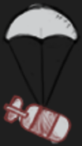消灭小飞机需要1发子弹,中飞机需要8发,大飞机需要20发子弹; 每消灭一架小飞机得1000分,中飞机6000分,大飞机10000分;

每隔30秒有一个随机的道具补给,分为两种道具，全屏炸弹和双倍子弹; 全屏炸弹最多只能存放3枚,双倍子弹可以维持18秒钟的效果;

【空格触发炸弹上限为3个，超出不计】

游戏将根据分数来逐步提高难度,难度的提高表现为飞机数量的增多以及速度的加快。

另外还对游戏做了一些改进,比如为中飞机和大飞机增加了血槽的显示,这样玩家可以直观地知道敌机快被消灭了没有;我方有 三次机会,每次被敌人消灭,新诞生的飞机会有3秒钟的安全期;游戏结束后会显示历史最高分数。

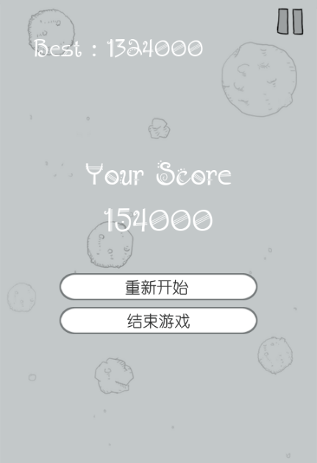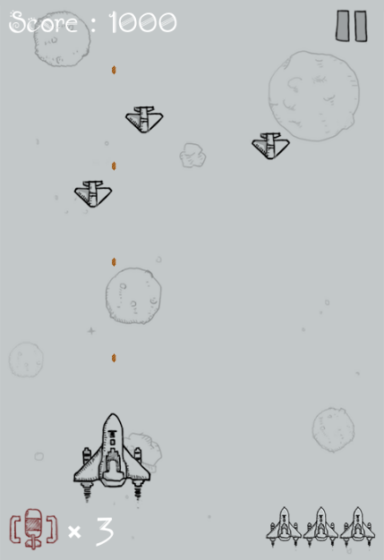

**双倍子弹触发**

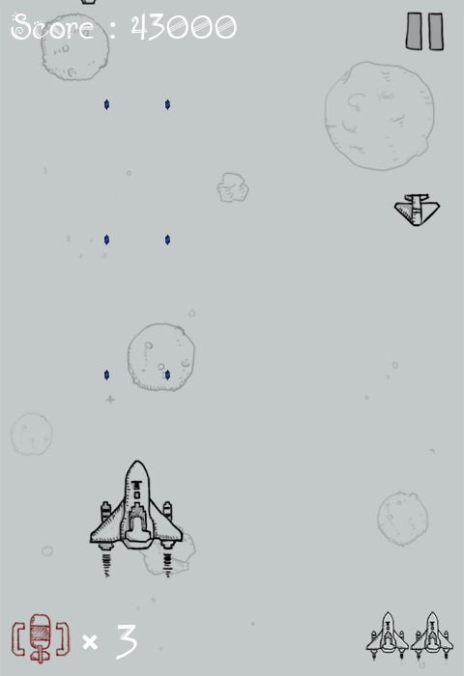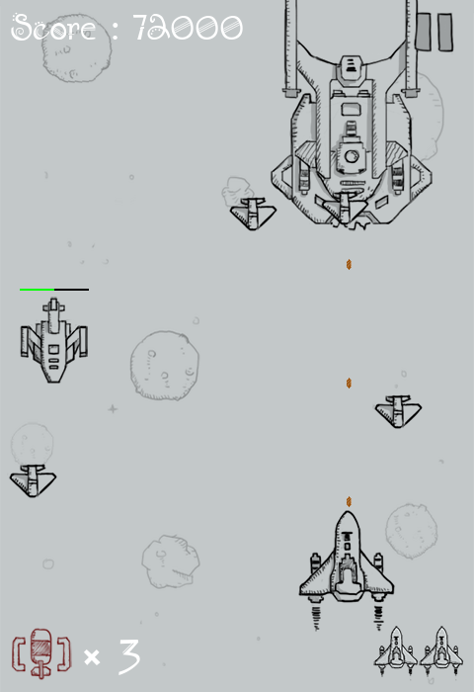

# 二.我方飞机

首先创建一个myplane. py模块来定义我方飞机:

import pygame

class MyPlane(pygame.sprite.Sprite): def init (self, bg_size):

pygame.sprite.Sprite. init (self)

self.image1 = pygame.image.load("images/me1.png").convert_alpha() self.image2 = pygame.image.load("images/me2.png").convert_alpha() self.destroy_images = []

self.destroy_images.extend([\ pygame.image.load("images/me_destroy_1.png").convert_alpha(), \ pygame.image.load("images/me_destroy_2.png").convert_alpha(), \ pygame.image.load("images/me_destroy_3.png").convert_alpha(), \ pygame.image.load("images/me_destroy_4.png").convert_alpha() \

])

self.rect = self.image1.get_rect()

self.width, self.height = bg_size[0], bg_size[1] self.rect.left, self.rect.top = \

(self.width - self.rect.width) // 2, \ self.height - self.rect.height - 60

self.speed = 10 self.active = True self.invincible = False

self.mask = pygame.mask.from_surface(self.image1)

## # 分别定义moveUp()、moveDown()、moveLeft()和moveRight()控制我方飞机上、下、左、右移动:

def moveUp(self):

if self.rect.top > 0: self.rect.top -= self.speed

else:

self.rect.top = 0

def moveDown(self):

if self.rect.bottom < self.height - 60: self.rect.top += self.speed

else:

self.rect.bottom = self.height - 60

def moveLeft(self):

if self.rect.left > 0: self.rect.left -= self.speed

else:

self.rect.left = 0

def moveRight(self):

if self.rect.right < self.width: self.rect.left += self.speed

else:

self.rect.right = self.width

def reset(self):

self.rect.left, self.rect.top = \

(self.width - self.rect.width) // 2, \ self.height - self.rect.height - 60

self.active = True self.invincible = True

# 三.敌方飞机

敌机分为小、中、大三个尺寸,它们的速度依次是快、中、慢,在游戏界面的上方位置创造位置随机的敌机,可以让它们不在同一排出现。将敌机的定义写在enemy. py模块中:

import pygame

from random import *

class SmallEnemy(pygame.sprite.Sprite): def init (self, bg_size):

pygame.sprite.Sprite. init (self)

self.image = pygame.image.load("images/enemy1.png").convert_alpha() self.destroy_images = []

self.destroy_images.extend([ \ pygame.image.load("images/enemy1_down1.png").convert_alpha(), \ pygame.image.load("images/enemy1_down2.png").convert_alpha(), \ pygame.image.load("images/enemy1_down3.png").convert_alpha(), \ pygame.image.load("images/enemy1_down4.png").convert_alpha() \

])

self.rect = self.image.get_rect()

self.width, self.height = bg_size[0], bg_size[1] self.speed = 2

self.active = True self.rect.left, self.rect.top = \

randint(0, self.width - self.rect.width), \ randint(-5 * self.height, 0)

self.mask = pygame.mask.from_surface(self.image)

def move(self):

if self.rect.top < self.height: self.rect.top += self.speed

else:

self.reset()

def reset(self): self.active = True

self.rect.left, self.rect.top = \

randint(0, self.width - self.rect.width), \ randint(-5 * self.height, 0)

class MidEnemy(pygame.sprite.Sprite): energy = 8

def init (self, bg_size): pygame.sprite.Sprite. init (self)

self.image = pygame.image.load("images/enemy2.png").convert_alpha() self.image_hit = pygame.image.load("images/enemy2_hit.png").convert_alpha() self.destroy_images = []

self.destroy_images.extend([ \ pygame.image.load("images/enemy2_down1.png").convert_alpha(), \ pygame.image.load("images/enemy2_down2.png").convert_alpha(), \ pygame.image.load("images/enemy2_down3.png").convert_alpha(), \ pygame.image.load("images/enemy2_down4.png").convert_alpha() \

])

self.rect = self.image.get_rect()

self.width, self.height = bg_size[0], bg_size[1] self.speed = 1

self.active = True self.rect.left, self.rect.top = \

randint(0, self.width - self.rect.width), \ randint(-10 * self.height, -self.height)

self.mask = pygame.mask.from_surface(self.image) self.energy = MidEnemy.energy

self.hit = False

def move(self):

if self.rect.top < self.height:

self.rect.top += self.speed else:

self.reset()

def reset(self): self.active = True

self.energy = MidEnemy.energy self.rect.left, self.rect.top = \

randint(0, self.width - self.rect.width), \ randint(-10 * self.height, -self.height)

class BigEnemy(pygame.sprite.Sprite): energy = 20

def init (self, bg_size): pygame.sprite.Sprite. init (self)

self.image1 = pygame.image.load("images/enemy3_n1.png").convert_alpha() self.image2 = pygame.image.load("images/enemy3_n2.png").convert_alpha() self.image_hit = pygame.image.load("images/enemy3_hit.png").convert_alpha() self.destroy_images = []

self.destroy_images.extend([ \ pygame.image.load("images/enemy3_down1.png").convert_alpha(), \ pygame.image.load("images/enemy3_down2.png").convert_alpha(), \ pygame.image.load("images/enemy3_down3.png").convert_alpha(), \ pygame.image.load("images/enemy3_down4.png").convert_alpha(), \ pygame.image.load("images/enemy3_down5.png").convert_alpha(), \ pygame.image.load("images/enemy3_down6.png").convert_alpha() \

])

self.rect = self.image1.get_rect()

self.width, self.height = bg_size[0], bg_size[1] self.speed = 1

self.active = True self.rect.left, self.rect.top = \

randint(0, self.width - self.rect.width), \ randint(-15 * self.height, -5 * self.height)

self.mask = pygame.mask.from_surface(self.image1) self.energy = BigEnemy.energy

self.hit = False

def move(self):

if self.rect.top < self.height: self.rect.top += self.speed

else:

self.reset()

def reset(self): self.active = True

self.energy = BigEnemy.energy self.rect.left, self.rect.top = \

randint(0, self.width - self.rect.width), \ randint(-15 * self.height, -5 * self.height)

# 四.发射子弹

接下来定义子弹,子弹分为两种: 一种是普通子弹一次只发射一颗; 另一种是补给发放的超级子弹一次可以发射两颗。

我们将子弹定义为独立的模块bullet.py:

import pygame

class Bullet1(pygame.sprite.Sprite): def init (self, position):

pygame.sprite.Sprite. init (self)

self.image = pygame.image.load("images/bullet1.png").convert_alpha() self.rect = self.image.get_rect()

self.rect.left, self.rect.top = position self.speed = 12

self.active = False

self.mask = pygame.mask.from_surface(self.image)

def move(self):

self.rect.top -= self.speed

if self.rect.top < 0: self.active = False

def reset(self, position):

self.rect.left, self.rect.top = position self.active = True

class Bullet2(pygame.sprite.Sprite): def init (self, position):

pygame.sprite.Sprite. init (self)

self.image = pygame.image.load("images/bullet2.png").convert_alpha() self.rect = self.image.get_rect()

self.rect.left, self.rect.top = position self.speed = 14

self.active = False

self.mask = pygame.mask.from_surface(self.image)

def move(self):

self.rect.top -= self.speed

if self.rect.top < 0: self.active = False

def reset(self, position):

self.rect.left, self.rect.top = position self.active = True

# 五.发放补给包

游戏设计每30秒随机发放一个补给包,可能是超级子弹,也可能是全屏炸弹。补给包有自己的图像和运动轨迹,不妨单独为其定义一个模块supply.py:

import pygame

from random import *

class Bullet_Supply(pygame.sprite.Sprite):

def init (self, bg_size): pygame.sprite.Sprite. init (self)

self.image = pygame.image.load("images/bullet_supply.png").convert_alpha() self.rect = self.image.get_rect()

self.width, self.height = bg_size[0], bg_size[1] self.rect.left, self.rect.bottom = \

randint(0, self.width - self.rect.width), -100 self.speed = 5

self.active = False

self.mask = pygame.mask.from_surface(self.image)

def move(self):

if self.rect.top < self.height: self.rect.top += self.speed

else:

self.active = False

def reset(self): self.active = True

self.rect.left, self.rect.bottom = \

randint(0, self.width - self.rect.width), -100

class Bomb_Supply(pygame.sprite.Sprite):

def init (self, bg_size): pygame.sprite.Sprite. init (self)

self.image = pygame.image.load("images/bomb_supply.png").convert_alpha() self.rect = self.image.get_rect()

self.width, self.height = bg_size[0], bg_size[1] self.rect.left, self.rect.bottom = \

randint(0, self.width - self.rect.width), -100 self.speed = 5

self.active = False

self.mask = pygame.mask.from_surface(self.image)

def move(self):

if self.rect.top < self.height: self.rect.top += self.speed

else:

self.active = False

def reset(self): self.active = True

self.rect.left, self.rect.bottom = \

randint(0, self.width - self.rect.width), -100

# 六.主模块

所有的模块编写完毕，接下来就该实现主模块了

# main.py import pygame import sys

import traceback import myplane import enemy import bullet import supply

from pygame.locals import * from random import *

pygame.init() pygame.mixer.init()

bg_size = width, height = 480, 700

screen = pygame.display.set_mode(bg_size) pygame.display.set_caption("飞机大战 – zj`s Game")

background = pygame.image.load("images/background.png").convert()

BLACK = (0, 0, 0)

WHITE = (255, 255, 255)

GREEN = (0, 255, 0)

RED = (255, 0, 0)

# 载入游戏音乐pygame.mixer.music.load("sound/game_music.ogg") pygame.mixer.music.set_volume(0.2)

bullet_sound = pygame.mixer.Sound("sound/bullet.wav") bullet_sound.set_volume(0.2)

bomb_sound = pygame.mixer.Sound("sound/use_bomb.wav") bomb_sound.set_volume(0.2)

supply_sound = pygame.mixer.Sound("sound/supply.wav") supply_sound.set_volume(0.2)

get_bomb_sound = pygame.mixer.Sound("sound/get_bomb.wav") get_bomb_sound.set_volume(0.2)

get_bullet_sound = pygame.mixer.Sound("sound/get_bullet.wav") get_bullet_sound.set_volume(0.2)

upgrade_sound = pygame.mixer.Sound("sound/upgrade.wav") upgrade_sound.set_volume(0.2)

enemy3_fly_sound = pygame.mixer.Sound("sound/enemy3_flying.wav") enemy3_fly_sound.set_volume(0.2)

enemy1_down_sound = pygame.mixer.Sound("sound/enemy1_down.wav") enemy1_down_sound.set_volume(0.2)

enemy2_down_sound = pygame.mixer.Sound("sound/enemy2_down.wav") enemy2_down_sound.set_volume(0.2)

enemy3_down_sound = pygame.mixer.Sound("sound/enemy3_down.wav") enemy3_down_sound.set_volume(0.5)

me_down_sound = pygame.mixer.Sound("sound/me_down.wav") me_down_sound.set_volume(0.2)

def add_small_enemies(group1, group2, num): for i in range(num):

e1 = enemy.SmallEnemy(bg_size) group1.add(e1)

group2.add(e1)

def add_mid_enemies(group1, group2, num): for i in range(num):

e2 = enemy.MidEnemy(bg_size) group1.add(e2) group2.add(e2)

def add_big_enemies(group1, group2, num): for i in range(num):

e3 = enemy.BigEnemy(bg_size) group1.add(e3) group2.add(e3)

def inc_speed(target, inc): for each in target:

each.speed += inc

def main():

pygame.mixer.music.play(-1)

## # 生成我方飞机

me = myplane.MyPlane(bg_size)

enemies = pygame.sprite.Group()

## # 生成敌方小型飞机

small_enemies = pygame.sprite.Group() add_small_enemies(small_enemies, enemies, 15)

## # 生成敌方中型飞机

mid_enemies = pygame.sprite.Group() add_mid_enemies(mid_enemies, enemies, 4)

## # 生成敌方大型飞机

big_enemies = pygame.sprite.Group() add_big_enemies(big_enemies, enemies, 2)

# 生成普通子弹bullet1 = [] bullet1_index = 0

BULLET1_NUM = 4

for i in range(BULLET1_NUM): bullet1.append(bullet.Bullet1(me.rect.midtop))

# 生成超级子弹bullet2 = [] bullet2_index = 0

BULLET2_NUM = 8

for i in range(BULLET2_NUM // 2): bullet2.append(bullet.Bullet2((me.rect.centerx - 33, me.rect.centery))) bullet2.append(bullet.Bullet2((me.rect.centerx + 30, me.rect.centery)))

clock = pygame.time.Clock()

## # 中弹图片索引

e1_destroy_index = 0

e2_destroy_index = 0

e3_destroy_index = 0

me_destroy_index = 0

## # 统计得分

score = 0

score_font = pygame.font.Font("font/font.ttf", 36)

## # 标志是否暂停游戏

paused = False

pause_nor_image = pygame.image.load("images/pause_nor.png").convert_alpha() pause_pressed_image = pygame.image.load("images/pause_pressed.png").convert_alpha() resume_nor_image = pygame.image.load("images/resume_nor.png").convert_alpha() resume_pressed_image = pygame.image.load("images/resume_pressed.png").convert_alpha() paused_rect = pause_nor_image.get_rect()

paused_rect.left, paused_rect.top = width - paused_rect.width - 10, 10 paused_image = pause_nor_image

## # 设置难度级别

level = 1

## # 全屏炸弹

bomb_image = pygame.image.load("images/bomb.png").convert_alpha() bomb_rect = bomb_image.get_rect()

bomb_font = pygame.font.Font("font/font.ttf", 48) bomb_num = 3

## # 每30秒发放一个补给包

bullet_supply = supply.Bullet_Supply(bg_size) bomb_supply = supply.Bomb_Supply(bg_size) SUPPLY_TIME = USEREVENT

pygame.time.set_timer(SUPPLY_TIME, 30 * 1000)

## # 超级子弹定时器

DOUBLE_BULLET_TIME = USEREVENT + 1

## # 标志是否使用超级子弹

is_double_bullet = False

## # 解除我方无敌状态定时器

INVINCIBLE_TIME = USEREVENT + 2

## # 生命数量

life_image = pygame.image.load("images/life.png").convert_alpha() life_rect = life_image.get_rect()

life_num = 3

## # 用于阻止重复打开记录文件

recorded = False

## # 游戏结束画面

gameover_font = pygame.font.Font("font/font.TTF", 48)

again_image = pygame.image.load("images/again.png").convert_alpha() again_rect = again_image.get_rect()

gameover_image = pygame.image.load("images/gameover.png").convert_alpha() gameover_rect = gameover_image.get_rect()

## # 用于切换图片

switch_image = True

## # 用于延迟

delay = 100 running = True

while running:

for event in pygame.event.get(): if event.type == QUIT:

pygame.quit() sys.exit()

elif event.type == MOUSEBUTTONDOWN:

if event.button == 1 and paused_rect.collidepoint(event.pos): paused = not paused

if paused:

pygame.time.set_timer(SUPPLY_TIME, 0) pygame.mixer.music.pause() pygame.mixer.pause()

else:

pygame.time.set_timer(SUPPLY_TIME, 30 * 1000) pygame.mixer.music.unpause() pygame.mixer.unpause()

elif event.type == MOUSEMOTION:

if paused_rect.collidepoint(event.pos): if paused:

paused_image = resume_pressed_image else:

paused_image = pause_pressed_image

else:

if paused:

paused_image = resume_nor_image else:

paused_image = pause_nor_image

elif event.type == KEYDOWN: if event.key == K_SPACE:

if bomb_num:

bomb_num -= 1 bomb_sound.play()  for each in enemies:

if each.rect.bottom > 0:

each.active = False

elif event.type == SUPPLY_TIME: supply_sound.play()

if choice([True, False]): bomb_supply.reset()

else:

bullet_supply.reset()

elif event.type == DOUBLE_BULLET_TIME: is_double_bullet = False pygame.time.set_timer(DOUBLE_BULLET_TIME, 0)

elif event.type == INVINCIBLE_TIME: me.invincible = False pygame.time.set_timer(INVINCIBLE_TIME, 0)

## # 根据用户的得分增加难度

if level == 1 and score > 50000: level = 2 upgrade_sound.play()

## # 增加3架小型敌机、2架中型敌机和1架大型敌机

add_small_enemies(small_enemies, enemies, 3)

add_mid_enemies(mid_enemies, enemies, 2)

add_big_enemies(big_enemies, enemies, 1) # 提升小型敌机的速度inc_speed(small_enemies, 1)

elif level == 2 and score > 300000: level = 3

upgrade_sound.play()

## # 增加5架小型敌机、3架中型敌机和2架大型敌机

add_small_enemies(small_enemies, enemies, 5)

add_mid_enemies(mid_enemies, enemies, 3)

add_big_enemies(big_enemies, enemies, 2) # 提升小型敌机的速度inc_speed(small_enemies, 1)

inc_speed(mid_enemies, 1)

elif level == 3 and score > 600000: level = 4

upgrade_sound.play()

## # 增加5架小型敌机、3架中型敌机和2架大型敌机

add_small_enemies(small_enemies, enemies, 5)

add_mid_enemies(mid_enemies, enemies, 3)

add_big_enemies(big_enemies, enemies, 2) # 提升小型敌机的速度inc_speed(small_enemies, 1)

inc_speed(mid_enemies, 1)

elif level == 4 and score > 1000000: level = 5

upgrade_sound.play()

## # 增加5架小型敌机、3架中型敌机和2架大型敌机

add_small_enemies(small_enemies, enemies, 5)

add_mid_enemies(mid_enemies, enemies, 3)

add_big_enemies(big_enemies, enemies, 2) # 提升小型敌机的速度inc_speed(small_enemies, 1)

inc_speed(mid_enemies, 1)

screen.blit(background, (0, 0))

if life_num and not paused:

## # 检测用户的键盘操作

key_pressed = pygame.key.get_pressed()

if key_pressed[K_w] or key_pressed[K_UP]: me.moveUp()

if key_pressed[K_s] or key_pressed[K_DOWN]:

me.moveDown()

if key_pressed[K_a] or key_pressed[K_LEFT]: me.moveLeft()

if key_pressed[K_d] or key_pressed[K_RIGHT]: me.moveRight()

## # 绘制全屏炸弹补给并检测是否获得

if bomb_supply.active: bomb_supply.move()

screen.blit(bomb_supply.image, bomb_supply.rect) if pygame.sprite.collide_mask(bomb_supply, me):

get_bomb_sound.play() if bomb_num < 3:

bomb_num += 1 bomb_supply.active = False

## # 绘制超级子弹补给并检测是否获得

if bullet_supply.active: bullet_supply.move()

screen.blit(bullet_supply.image, bullet_supply.rect) if pygame.sprite.collide_mask(bullet_supply, me):

get_bullet_sound.play() is_double_bullet = True

pygame.time.set_timer(DOUBLE_BULLET_TIME, 18 * 1000) bullet_supply.active = False

## # 发射子弹

if not (delay % 10): bullet_sound.play() if is_double_bullet:

bullets = bullet2

bullets[bullet2_index].reset((me.rect.centerx - 33, me.rect.centery)) bullets[bullet2_index + 1].reset((me.rect.centerx + 30, me.rect.centery)) bullet2_index = (bullet2_index + 2) % BULLET2_NUM

else:

bullets = bullet1 bullets[bullet1_index].reset(me.rect.midtop) bullet1_index = (bullet1_index + 1) % BULLET1_NUM

## # 检测子弹是否击中敌机

for b in bullets: if b.active:

b.move() screen.blit(b.image, b.rect)

enemy_hit = pygame.sprite.spritecollide(b, enemies, False, pygame.sprite.collide_mask) if enemy_hit:

b.active = False for e in enemy_hit:

if e in mid_enemies or e in big_enemies: e.hit = True

e.energy -= 1

if e.energy == 0: e.active = False

else:

e.active = False

## # 绘制大型敌机

for each in big_enemies: if each.active:

each.move() if each.hit:

screen.blit(each.image_hit, each.rect) each.hit = False

else:

if switch_image: screen.blit(each.image1, each.rect)

else:

screen.blit(each.image2, each.rect)

## # 绘制血槽

pygame.draw.line(screen, BLACK, \

(each.rect.left, each.rect.top - 5), \ (each.rect.right, each.rect.top - 5), \ 2)

## # 当生命大于20%显示绿色，否则显示红色

energy_remain = each.energy / enemy.BigEnemy.energy if energy_remain > 0.2:

energy_color = GREEN else:

energy_color = RED pygame.draw.line(screen, energy_color, \

(each.rect.left, each.rect.top - 5), \ (each.rect.left + each.rect.width * energy_remain, \ each.rect.top - 5), 2)

## # 即将出现在画面中，播放音效

if each.rect.bottom == -50: enemy3_fly_sound.play(-1)

else:

## # 毁 灭

if not (delay % 3):

if e3_destroy_index == 0: enemy3_down_sound.play()

screen.blit(each.destroy_images[e3_destroy_index], each.rect) e3_destroy_index = (e3_destroy_index + 1) % 6

if e3_destroy_index == 0: enemy3_fly_sound.stop() score += 10000 each.reset()

## # 绘制中型敌机：

for each in mid_enemies: if each.active:

each.move()

if each.hit:

screen.blit(each.image_hit, each.rect) each.hit = False

else:

screen.blit(each.image, each.rect)

## # 绘制血槽

pygame.draw.line(screen, BLACK, \

(each.rect.left, each.rect.top - 5), \ (each.rect.right, each.rect.top - 5), \ 2)

## # 当生命大于20%显示绿色，否则显示红色

energy_remain = each.energy / enemy.MidEnemy.energy if energy_remain > 0.2:

energy_color = GREEN else:

energy_color = RED pygame.draw.line(screen, energy_color, \

(each.rect.left, each.rect.top - 5), \ (each.rect.left + each.rect.width * energy_remain, \ each.rect.top - 5), 2)

else:

## # 毁 灭

if not (delay % 3):

if e2_destroy_index == 0: enemy2_down_sound.play()

screen.blit(each.destroy_images[e2_destroy_index], each.rect) e2_destroy_index = (e2_destroy_index + 1) % 4

if e2_destroy_index == 0:

score += 6000 each.reset()

## # 绘制小型敌机：

for each in small_enemies: if each.active:

each.move() screen.blit(each.image, each.rect)

else:

## # 毁 灭

if not (delay % 3):

if e1_destroy_index == 0: enemy1_down_sound.play()

screen.blit(each.destroy_images[e1_destroy_index], each.rect) e1_destroy_index = (e1_destroy_index + 1) % 4

if e1_destroy_index == 0: score += 1000 each.reset()

## # 检测我方飞机是否被撞

enemies_down = pygame.sprite.spritecollide(me, enemies, False, pygame.sprite.collide_mask) if enemies_down and not me.invincible:

me.active = False

for e in enemies_down: e.active = False

## # 绘制我方飞机

if me.active:

if switch_image: screen.blit(me.image1, me.rect)

else:

screen.blit(me.image2, me.rect)

else:

## # 毁 灭

if not (delay % 3):

if me_destroy_index == 0: me_down_sound.play()

screen.blit(me.destroy_images[me_destroy_index], me.rect) me_destroy_index = (me_destroy_index + 1) % 4

if me_destroy_index == 0: life_num -= 1 me.reset()

pygame.time.set_timer(INVINCIBLE_TIME, 3 * 1000)

## # 绘制全屏炸弹数量

bomb_text = bomb_font.render("× %d" % bomb_num, True, WHITE) text_rect = bomb_text.get_rect()

screen.blit(bomb_image, (10, height - 10 - bomb_rect.height)) screen.blit(bomb_text, (20 + bomb_rect.width, height - 5 - text_rect.height))

## # 绘制剩余生命数量

if life_num:

for i in range(life_num): screen.blit(life_image, \

(width - 10 - (i + 1) * life_rect.width, \ height - 10 - life_rect.height))

## # 绘制得分

score_text = score_font.render("Score : %s" % str(score), True, WHITE) screen.blit(score_text, (10, 5))

## # 绘制游戏结束画面

elif life_num == 0:

## # 背景音乐停止

pygame.mixer.music.stop()

## # 停止全部音效

pygame.mixer.stop()

## # 停止发放补给

pygame.time.set_timer(SUPPLY_TIME, 0)

if not recorded: recorded = True

## # 读取历史最高得分

with open("record.txt", "r") as f: record_score = int(f.read())

## # 如果玩家得分高于历史最高得分，则存档

if score > record_score:

with open("record.txt", "w") as f: f.write(str(score))

## # 绘制结束画面

record_score_text = score_font.render("Best : %d" % record_score, True, (255, 255, 255)) screen.blit(record_score_text, (50, 50))

gameover_text1 = gameover_font.render("Your Score", True, (255, 255, 255)) gameover_text1_rect = gameover_text1.get_rect()

gameover_text1_rect.left, gameover_text1_rect.top = \ (width - gameover_text1_rect.width) // 2, height // 3

screen.blit(gameover_text1, gameover_text1_rect)

gameover_text2 = gameover_font.render(str(score), True, (255, 255, 255)) gameover_text2_rect = gameover_text2.get_rect() gameover_text2_rect.left, gameover_text2_rect.top = \

(width - gameover_text2_rect.width) // 2, \ gameover_text1_rect.bottom + 10

screen.blit(gameover_text2, gameover_text2_rect)

again_rect.left, again_rect.top = \ (width - again_rect.width) // 2, \ gameover_text2_rect.bottom + 50

screen.blit(again_image, again_rect)

gameover_rect.left, gameover_rect.top = \ (width - again_rect.width) // 2, \ again_rect.bottom + 10

screen.blit(gameover_image, gameover_rect)

## # 检测用户的鼠标操作

# 如果用户按下鼠标左键

if pygame.mouse.get_pressed()[0]:

## # 获取鼠标坐标

pos = pygame.mouse.get_pos()

## # 如果用户点击“重新开始”

if again_rect.left < pos[0] < again_rect.right and \ again_rect.top < pos[1] < again_rect.bottom:

## # 调用main函数，重新开始游戏

main()

## # 如果用户点击“结束游戏”

elif gameover_rect.left < pos[0] < gameover_rect.right and \ gameover_rect.top < pos[1] < gameover_rect.bottom:

# 退出游戏pygame.quit() sys.exit()

## # 绘制暂停按钮

screen.blit(paused_image, paused_rect)

## # 切换图片

if not (delay % 5):

switch_image = not switch_image

delay -= 1

if not delay:

delay = 100

pygame.display.flip() clock.tick(60)

if name == " main ": try:

main()

except SystemExit: pass

except:

traceback.print_exc() pygame.quit()

input()

**测试注意事项：** 所有的模块应该放在同一个文件夹，最后运行主模块

# 七.改进对照与问题解决

## 1.首先面对的是pygame包的导入和使用，这里提供思路：

**安装Pygame**

Windows使用pip命令进行安装，如果使用conda 则需要在conda prompt中对已激活环境进行安装

pip install pygame

**导入Pygame模块**

**import** pygame

我们在使用Pygame设计一款游戏或动画的时候，需要包括三个部分：

**一、初始设置**

首先需要导入模块，创建游戏屏幕，然后初始化一些重要的变量

**二、游戏循环**

游戏循环使用while循环，使游戏持续更新屏幕和处理事件，除非用户退出程序，否则就会一直执行

**三、退出程序**

当用户想要停止程序的时候，使用一种方式来结束程序

最简单的就例如：去绘制一个圆

**import** pygame

*# 初始设置*

pygame**.**init() *# 初始化pygame*

screen **=** pygame**.**display**.**set_mode((800,600)) *# Pygame窗口*

pygame**.**display**.**set_caption("Pygame绘制图形") *# 标题*

keep_going **=** True

RED **=** (255,0,0) *# 红色，使用RGB颜色*

radius **=** 20 *# 半径*

*# 游戏循环*

**while** keep_going:

**for** event **in** pygame**.**event**.**get(): *# 遍历事件*

**if** event**.**type **==** pygame**.**QUIT: *# 退出事件*

keep_going **=** False

pygame**.**draw**.**circle(screen,RED,(200,300),radius)

pygame**.**display**.**update() *# 刷新屏幕*

*# 退出程序*

pygame**.**quit()

1.初始设置

这里我们首先导入了pygame模块，然后在使用pygame.init()对其进行初始化。pygame.display.set_mode((800,600))创建了一个800*600像素的显示窗口，保存到变量screen中，以后的程序中就可以直接调用变量screen即可。

pygame.display.set_caption("Pygame绘制图形")给屏幕窗口添加一个标题。

在Pygame中创建的游戏窗口，或者加载到窗口的图形都称为Surface。Surface screen即显示窗口，是绘制其他所有图形的主要窗口。

我们定义了一个布尔类型的标志，来控制程序的持续运行，想要暂停，只需要改变keep_going的值为False。

2.游戏循环

while keep_going:如果keep_going为True游戏一直持续进行，持续运行Pygame窗口，直到用户选择退出。

for event in pygame.event.get():这里使用for循环遍历Pygame中的所有事件，if event.type == pygame.QUIT:如果用户按下关闭按钮，退出程序，这样变量keep_going变为False，游戏结束。

游戏持续进行的时候，即用户没有触发关闭窗口的事件。我们开始在Pygame窗口绘制其他Surface图像，pygame.draw.circle(screen,RED,(200,300),radius)在屏幕窗口(200,300)位置上绘制半径为20的，填充颜色为RED的圆。

第一个参数screen，指定要在那个Surface上绘制图形。pygame.draw除了可以绘制圆（circle），还可以绘制矩形、线段等形状。

**3.加载图片**

将我们保存的图片加载到Surface屏幕上。注意图片保存的位置和我们.py文件在同一个目录下。

pic = pygame.image.load("logo_lofi.png")从一个文件载入图像，保存到变量pic中，在以后的程序中通过pic来引用这个图片。

将图片绘制到Surface屏幕上并且更新绘制窗口，确保所有内容出现在屏幕上。

screen**.**blit(pic,(100,100)) *# 在Surface上绘制图片*

pygame**.**display**.**update()

blit()方法将我们从文件中加载的图片pic绘制到screen屏幕的（100，100）位置上。

## 2.写到键盘控制，发现无法正常运行

def **cotral():**

for **event** in **pygame.event.get():**

if **event.type** == **quit:**

**print("exit")**

elif **event.type** == **KEYDOWN:**

if **event.type** == **K_LEFT** or **event.type** == **K_a:**

**print("left")**

elif **event.type** == **K_RIGHT** or **event.type** == **K_d:**

**print("right")**

elif **event.type** == **K_SPACE:**

**print("space")**

else**:**

**print("战机损毁...")**

在查阅资料后了解到需要将event.type改为使用event.key 按键事件类型方法使用不当，导致在按下按键后，战机无实际反应。

## 3.在处理这些问题之后，开始优化游戏逻辑，未考虑用户体验，在全组范围内综合讨论与分析后，决定作出以下更改：

1>增加战机类型，并设置按得分使得难度递增变化，由原来的一种类型变更为现在的大中小三型，并按照合适比例设置了战机血条显示，参考主模块文档。下面是对照图

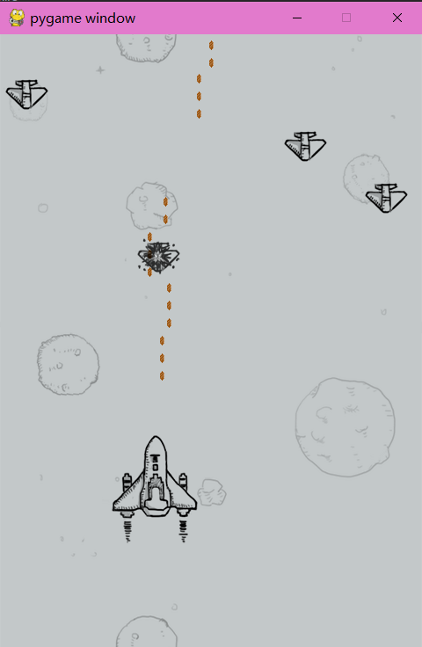



2>增加计分板，在每次游戏结束总得分以文本形式将得分记录在本地

3>新增暂停，重新开始退出等交互按键



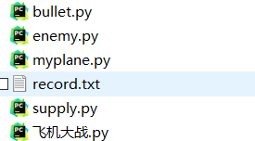

4>设置全屏炸弹及生命值，并显示在游戏框内，添加随机补给包，强化子弹补给以及炸弹补给

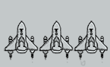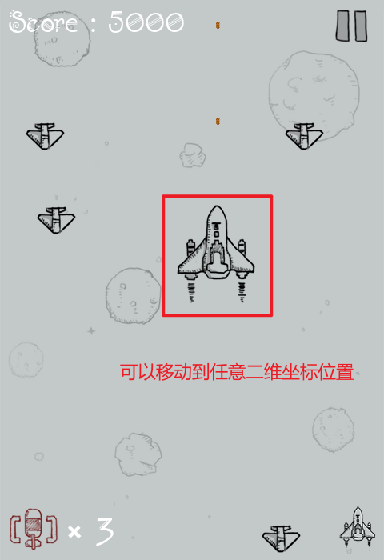

5>死亡动画并设置复活后无敌时间

6>新增游戏音效

7>优化我方战机移动策略，由固定纵轴变更为可以在画布上以水平和垂直四个方向进行运动