第4版 第10章 练习与实验答案
练习10
1.选择题
（1）B （2）A （3）C （4）D （5）A
2.简答题
略
实验10
- 源代码及效果图
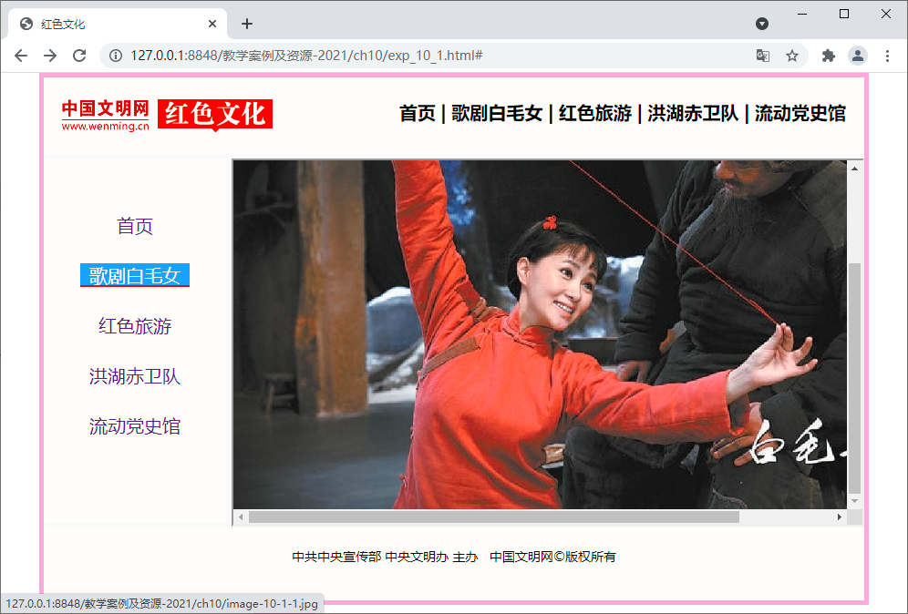
- HTML文件
<!-- exp_10_1.html -->
<!doctype html>
<html lang="en">
<head>
<meta charset="UTF-8">
<title>红色文化</title>
<link href="exp_10_1.css" rel="stylesheet" type="text/css" />
</head>
<body>
<div id="Container">
<div id="Header">
<a href="http://www.wenming.cn/hswh/"><img src="image-10-1-logo.png"></a>
<h4>
<span>首页</span>
<span>|</span>
<span>歌剧白毛女</span>
<span>|</span>
<span>红色旅游</span>
<span>|</span>
<span>洪湖赤卫队</span>
<span>|</span>
<span>流动党史馆</span>
</h4>
</div>
<div id="PageBody">
<div id="SideBar">
<ul>
<li><a href="#">首页</a></li>
<li><a href="image-10-1-1.jpg" target="iframe">歌剧白毛女</a></li>
<li><a href="image-10-1-2.jpg" target="iframe">红色旅游</a></li>
<li><a href="image-10-1-3.jpg" target="iframe">洪湖赤卫队</a></li>
<li><a href="image-10-1-4.jpg" target="iframe">流动党史馆</a></li>
</ul>
</div>
<div id="MainBody">
<iframe src="image-10-1-1.jpg" name="iframe" width="690px" height="400px"></iframe>
</div>
</div>
<div id="Footer">
<p>中共中央宣传部&nbsp;中央文明办&nbsp;主办&nbsp;&nbsp;&nbsp;中国文明网&copy;版权所有 </p>
</div>
</div>
</body>
</html>
- CSS文件
/* exp_10_1.css */
/* edu_10_1.html*/
body {
font-size: 18px;
margin: 0;
text-align: center;
}

h4 {
float: right;
padding-left: 50px;
vertical-align: top;
margin: 24px 20px;
}

p {
margin: 2px;
font-size: 14px;
}

#Container {
margin: 0 auto;
width: 900px;
background: #FEFDFA;
border:5px solid #FEADDE;
}

#Header {
height: 84px;
border-bottom: 5px;

border-bottom: 5px solid #FAFAFA;
}

#PageBody {
height: 400px;
border-bottom: 5px solid #FAFAFA;
}

#SideBar {
float: left;
width: 200px;
height: 400px;
text-align: center;
padding: 20px auto;
border-right: 5px solid #FAFAFA;
}

#MainBody {
float: right;
width: 695px;
height: 400px;
}

#Footer {
height: 60px;
text-align: center;
font-size: 18px;
padding-top: 20px;
}

#Header img {
margin: 24px 20px;
float: left;
}

span {
width: 100px;
height: 30px;
font-size: 20px;
vertical-align: middle;
text-align: center;
}

ul a {
width: 120px;
height: 24px;
font-size: 20px;
text-align: center;
}

ul {
list-style-type: none;
margin: 0px;
padding: 35px;
text-align: center;
}

li {
width: 120px;
height: 30px;
font-size: 20px;
margin: 25px auto;
}

h3 {
text-align: center;
color: red;
font-size: 24px;
background: #CFF000;
padding: 6px auto;
}

a:link,
a:visited,
a:active {
text-decoration: none;
display: block;
}

a:hover {
border-bottom: 2px solid #FF0000;
background: #55A0FF;
color: #FFFFFF;
}

2．源代码及效果图
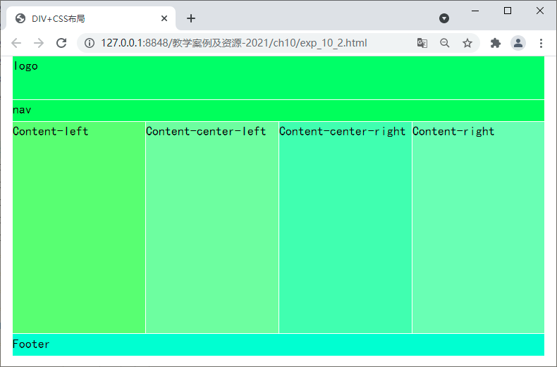
- Exp_10_2.html
<!-- exp_10_2.html -->
<!doctype html>
<html lang="en">
<head>
<meta charset="UTF-8">
<title>DIV+CSS布局</title>
<style type="text/css">
* {
font: 24px/1.5em 黑体;
margin: 0 auto;
padding: 0px;
}

#Container {
width: 1006px;
margin: 0 auto;
/*设置整个容器在浏览器中水平居中*/
}

#Header {
height: 124px;
/* background: #009933; */

}

#logo {
height: 80px;
background: #55ff55;
border-bottom: 2px solid white;
}

#nav {
height: 40px;
background-color: #56fe45;
border-bottom: 2px solid white;

}

#Content {
width: 100%;
height: 400px;
background: #00EEFF;
}

/*设置浮动，实现多列效果，div+Css布局中很重要的*/
#Content-left {
height: 400px;
width: 250px;
float: left;
background: #90FF66;
border-right: 2px solid white;
}

#Content-center-left {
height: 400px;
width: 250px;
float: left;
background: #99FB99;
border-right: 2px solid white;
}

#Content-center-right {
height: 400px;
width: 250px;
float: left;
background: #88FFAA;
border-right: 2px solid white;
}

#Content-right {
height: 400px;
width: 250px;
float: left;
background: #99FFAE;
}

#Footer {
height: 40px;
background: #66FFCC;
border-top: 2px solid white;
}

.Clear {
clear: both;
margin: 0 auto;
padding: 0px;
}
</style>
</head>
<body>
<div id="Container">
<div id="Header">
<div id="logo">logo</div>
<div id="nav">nav</div>
</div>
<div id="Content">
<div id="Content-left">Content-left</div>
<div id="Content-center-left">Content-center-left</div>
<div id="Content-center-right">Content-center-right</div>
<div id="Content-right">Content-right</div>
</div>
<div class="Clear">
<!--如何上面用到float,下面布局开始前最好清除一下。-->
</div>
<div id="Footer">Footer</div>
</div>
</body>
</html>

