Windows IP Configuration

Ethernet adapter vEthernet (Default Switch):

Connection-specific DNS Suffix . :
Link-local IPv6 Address . . . . . : fe80::430:fbd9:4587:ac73%33
IPv4 Address. . . . . . . . . . . : 172.22.80.1
Subnet Mask . . . . . . . . . . . : 255.255.240.0
Default Gateway . . . . . . . . . :

Ethernet adapter VirtualBox Host-Only Network:

Connection-specific DNS Suffix . :
Link-local IPv6 Address . . . . . : fe80::7c5c:5c50:e8c6:e40a%21
IPv4 Address. . . . . . . . . . . : 192.168.56.1
Subnet Mask . . . . . . . . . . . : 255.255.255.0
Default Gateway . . . . . . . . . :

Ethernet adapter Ethernet 2:

Connection-specific DNS Suffix . : wmii.local
Link-local IPv6 Address . . . . . : fe80::e8e2:4a7f:e2b4:ad1a%15
IPv4 Address. . . . . . . . . . . : 192.168.13.16
Subnet Mask . . . . . . . . . . . : 255.255.255.0
Default Gateway . . . . . . . . . : 192.168.13.1

Ethernet adapter VMware Network Adapter VMnet1:

Connection-specific DNS Suffix . :
Link-local IPv6 Address . . . . . : fe80::d1c7:c291:8bc0:1a43%17
Autoconfiguration IPv4 Address. . : 169.254.159.126
Subnet Mask . . . . . . . . . . . : 255.255.0.0
Default Gateway . . . . . . . . . :

Ethernet adapter VMware Network Adapter VMnet8:

Connection-specific DNS Suffix . :
Link-local IPv6 Address . . . . . : fe80::7e4d:7386:5dc4:ac0%11
Autoconfiguration IPv4 Address. . : 169.254.214.205
Subnet Mask . . . . . . . . . . . : 255.255.0.0
Default Gateway . . . . . . . . . :

Ethernet adapter Ethernet 3:

Media State . . . . . . . . . . . : Media disconnected
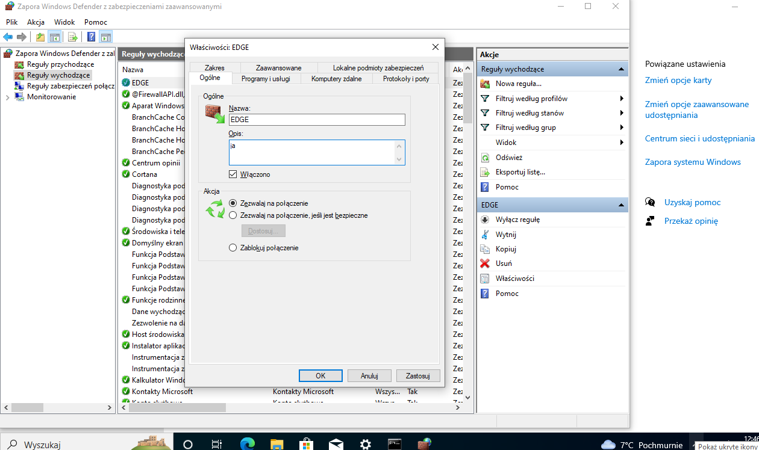
Connection-specific DNS Suffix . :

