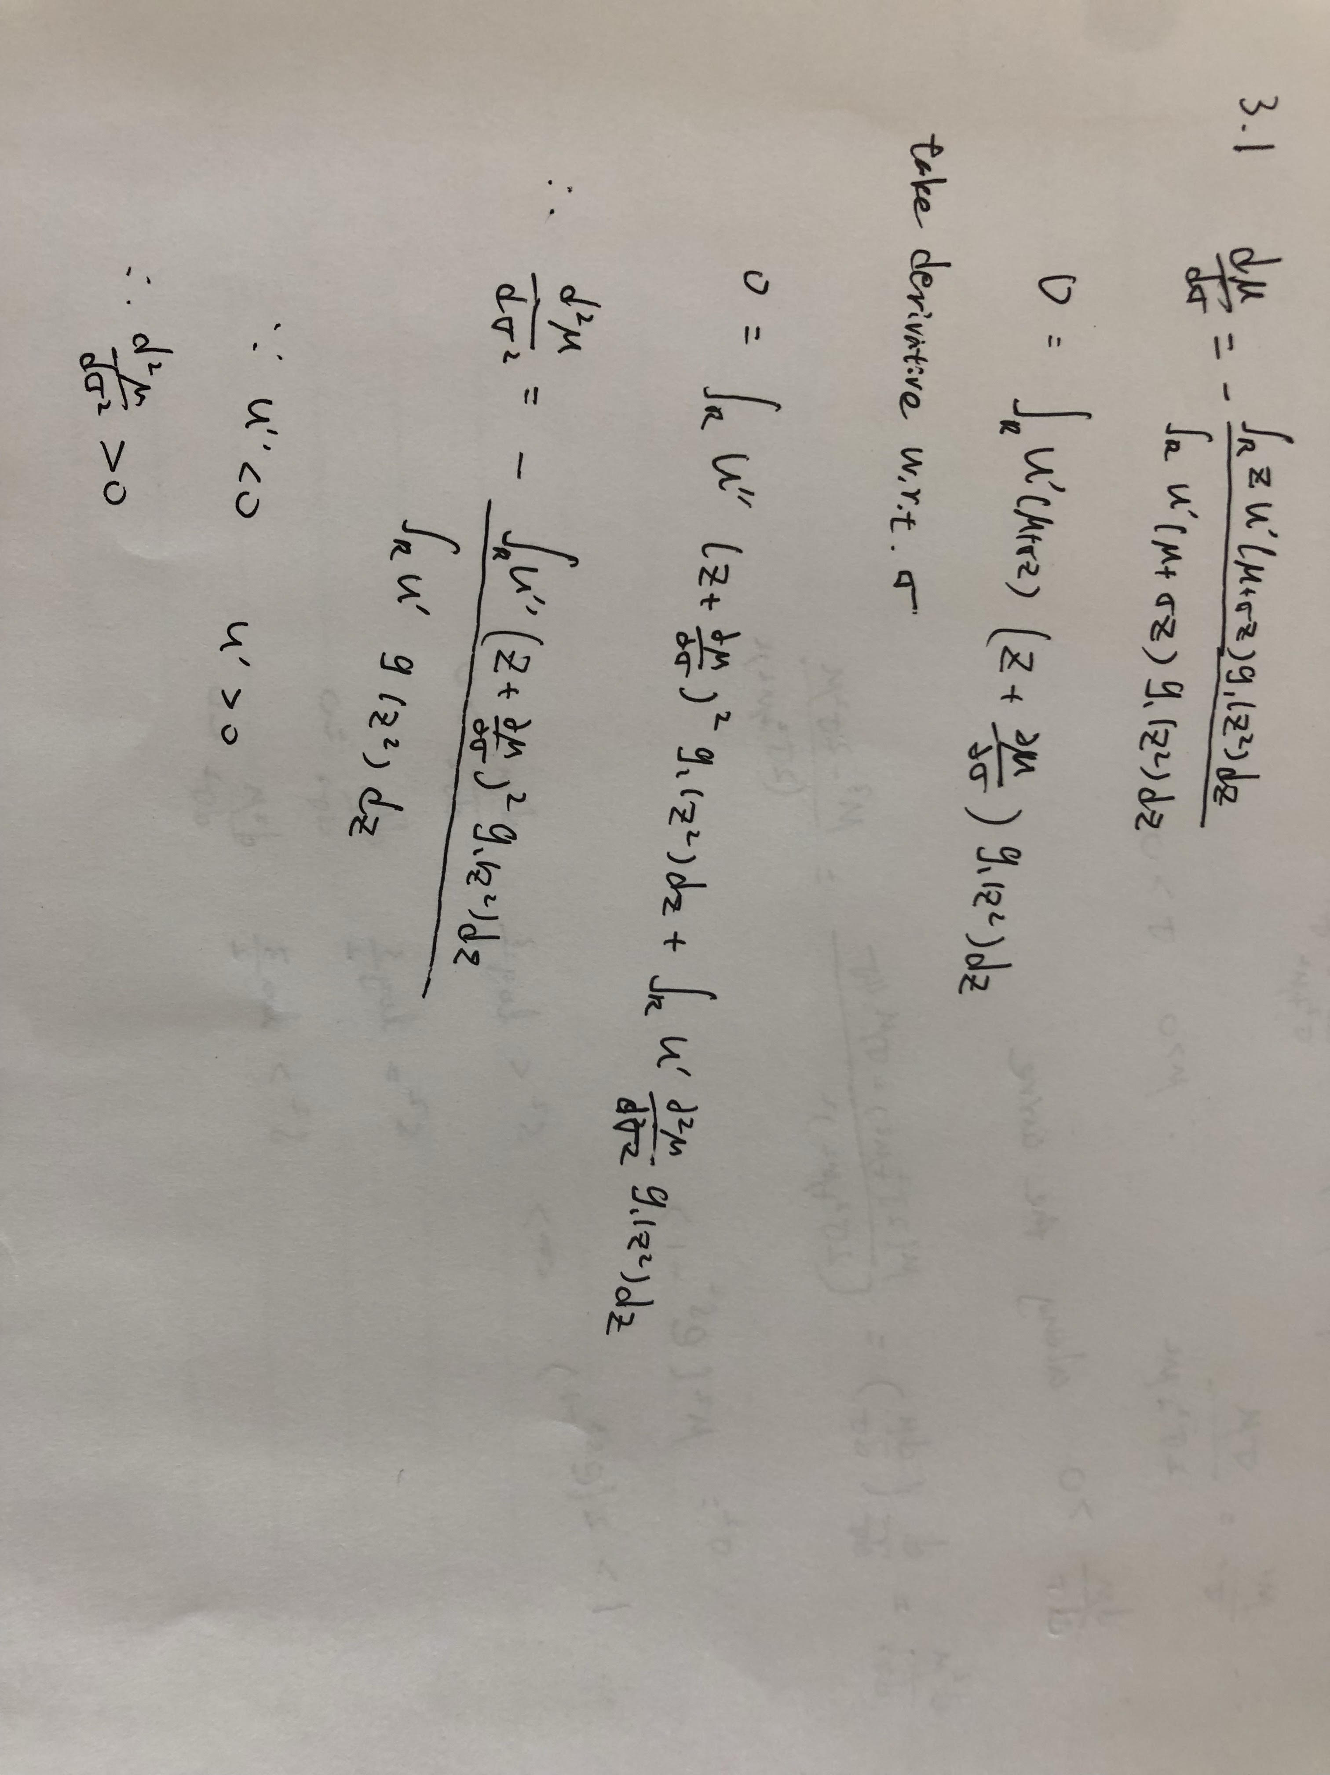
Chenyu Zhao homework3

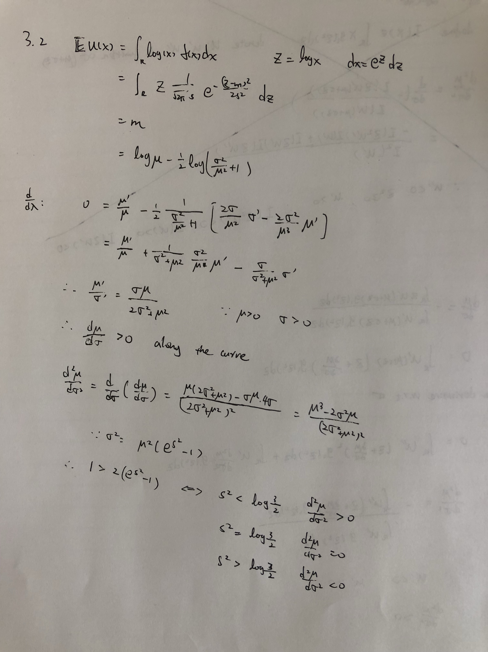
Plot the curve using m as x-axis and draw different lines corresponding to different s. The first plot is first derivative and the second plot is second derivative.

