**Practical No.2**

**Aim:** The aim of this practical exercise is to develop practical skills in querying a relational database. Through this practical we will gain hands-on experience in retrieving specific information from a database using SQL querie.

**Theory:**

The theory behind this practical exercise is to understand and apply Structured Query Language (SQL) for data retrieval. Participants will learn how to write SQL queries to extract specific data from relational databases, focusing on SELECT statements, filtering conditions, and pattern matching using SQL.

1) List the customer numbers (customer_no) and names (name) of all customers.

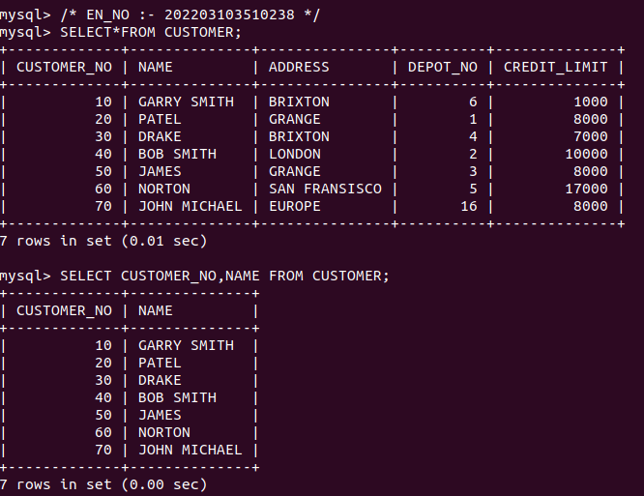

2) List all details of the product with a product number (product_no) of 121 and 136.

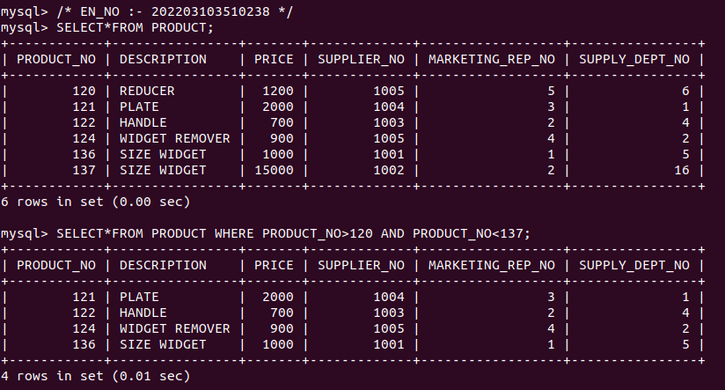

3) List all details of depots with rep 5 as their rep(rep_no).

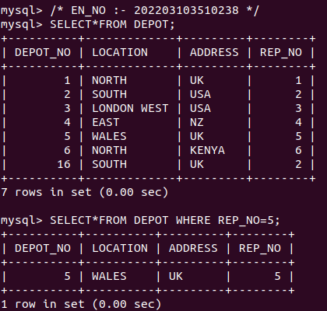

4) List the product number (product_no) and description only of all products from

supplier number 1005 (supplier_no).

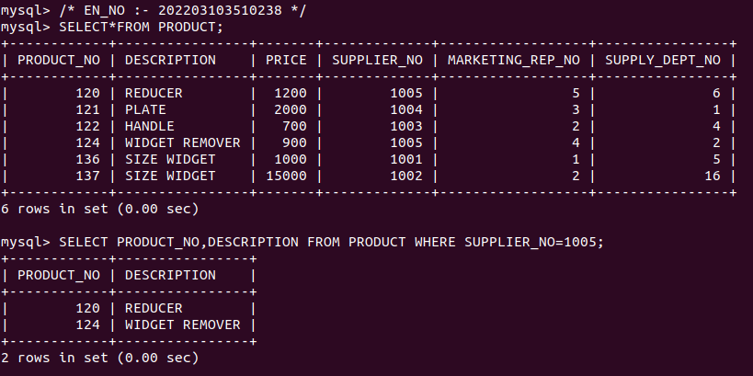

5) List all details for all customers with names (name) starting from ga followed by 2

character followed by y followed by anything.

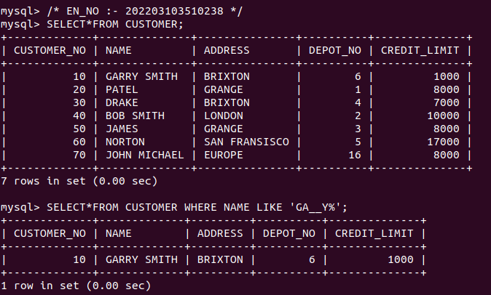

6) List all details for all orders with date_placed from 01-jan-1993 to 31-mar-1996.

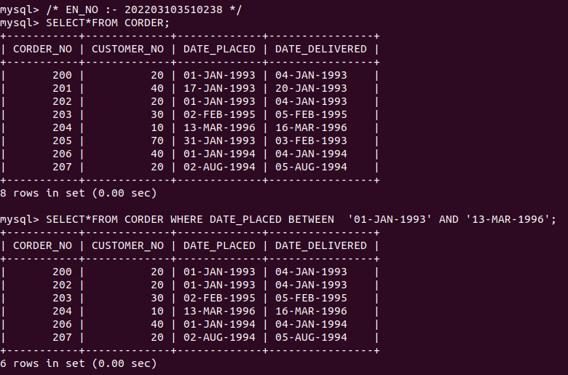

7) List the sales rep number (rep_no), depot number and address for depots located at

NORTH and address is UK.

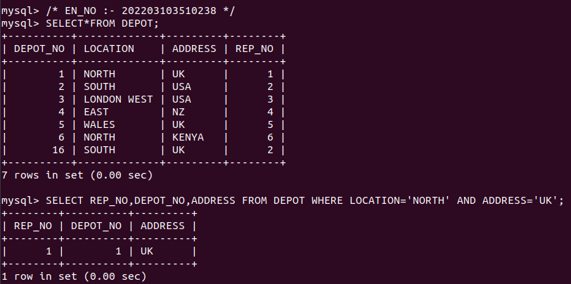

8) Give the total number of items (quantity) in stock in all depots.

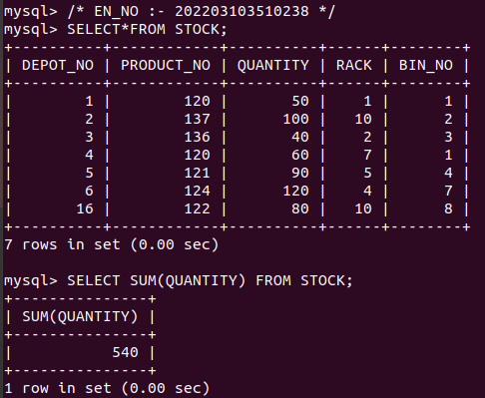

9) Give the total number of items (order line quantity) which have been ordered with

corder_no 200.

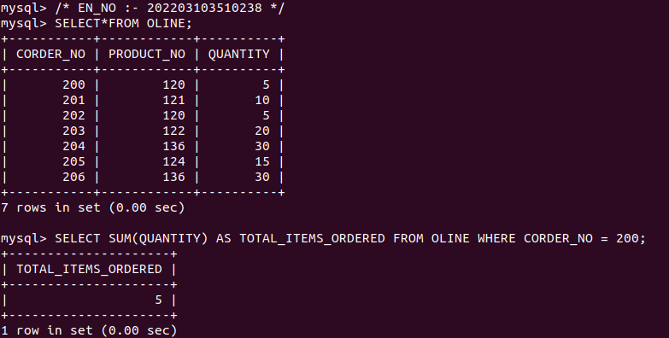

10) List product descriptions in reverse alphabetical order.

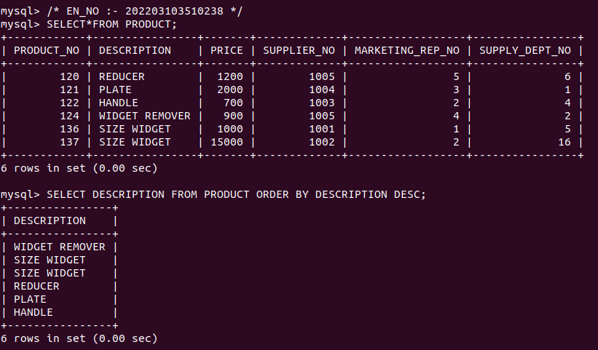

11) List the customer details with the name ending with N.

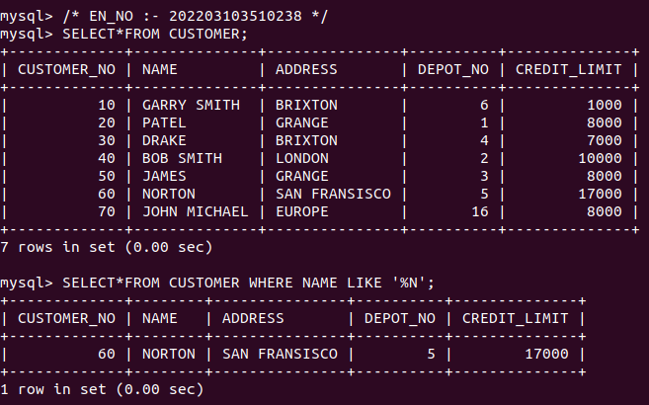

12) List the customers details with a CustomerName that have “r” in the second position:

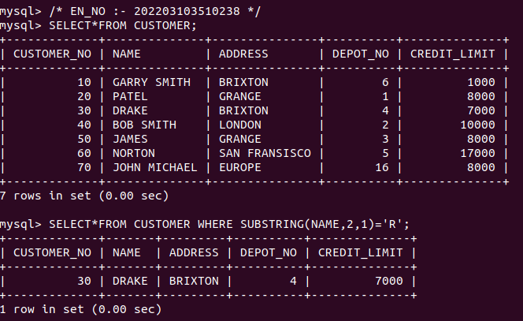

13) List the customers with a CustomerName that starts with “N” and is at least 4 characters in length.

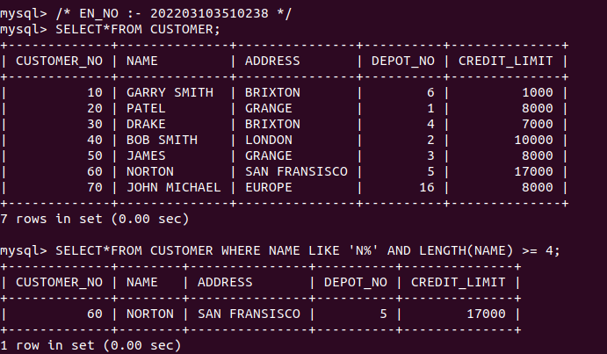

14) Find all suppliers with a City containing the pattern “ny”.

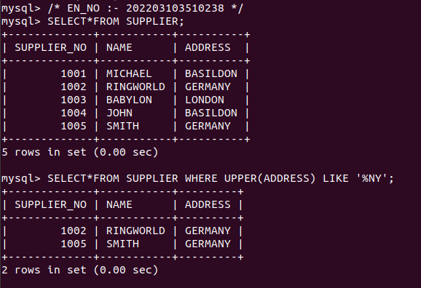

15) selects all customers with a City starting with “L”, followed by any character, followed by “n”, followed by 2 character, followed by “n”:

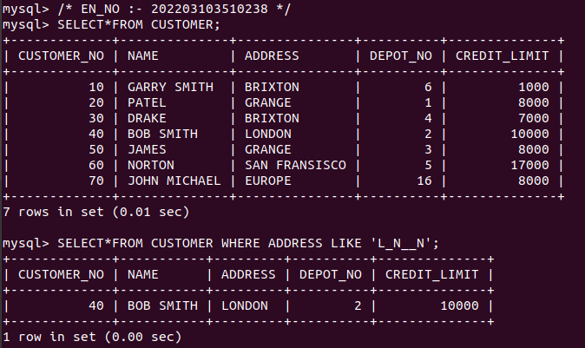

**Conclusion:**

In conclusion, this practical exercise provides valuable experience in using SQL for data retrieval. Through this practical we have successfully practiced writing SQL queries to retrieve data from the given database, demonstrating their ability to select and filter data based on specific criteria.