# ONLINE SHOPPING E- COMMERCE -PLATFORM

**STEP – 1:**

Create a new application named online Shopping platform.

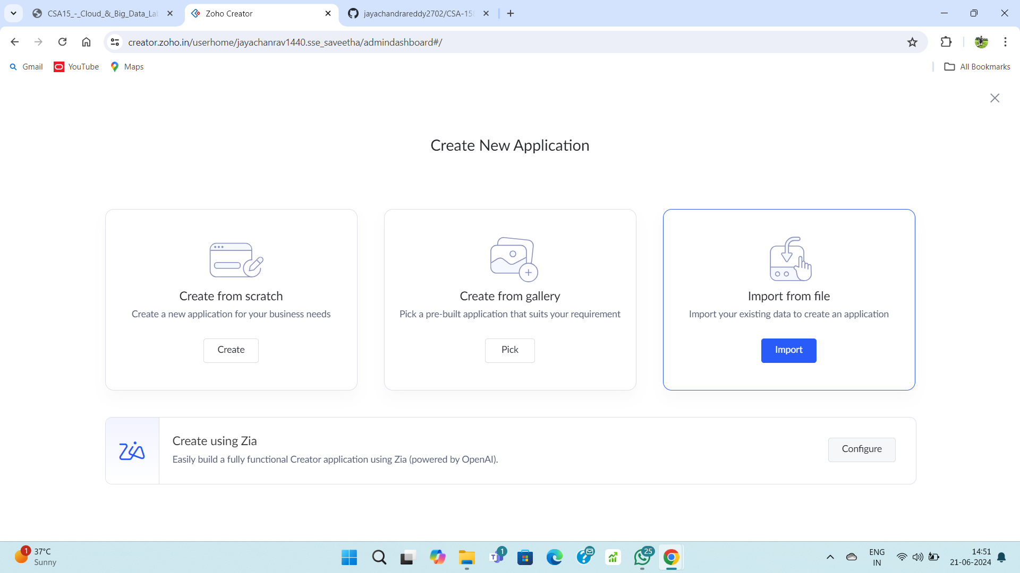

**STEP – 2:**

Create a login form

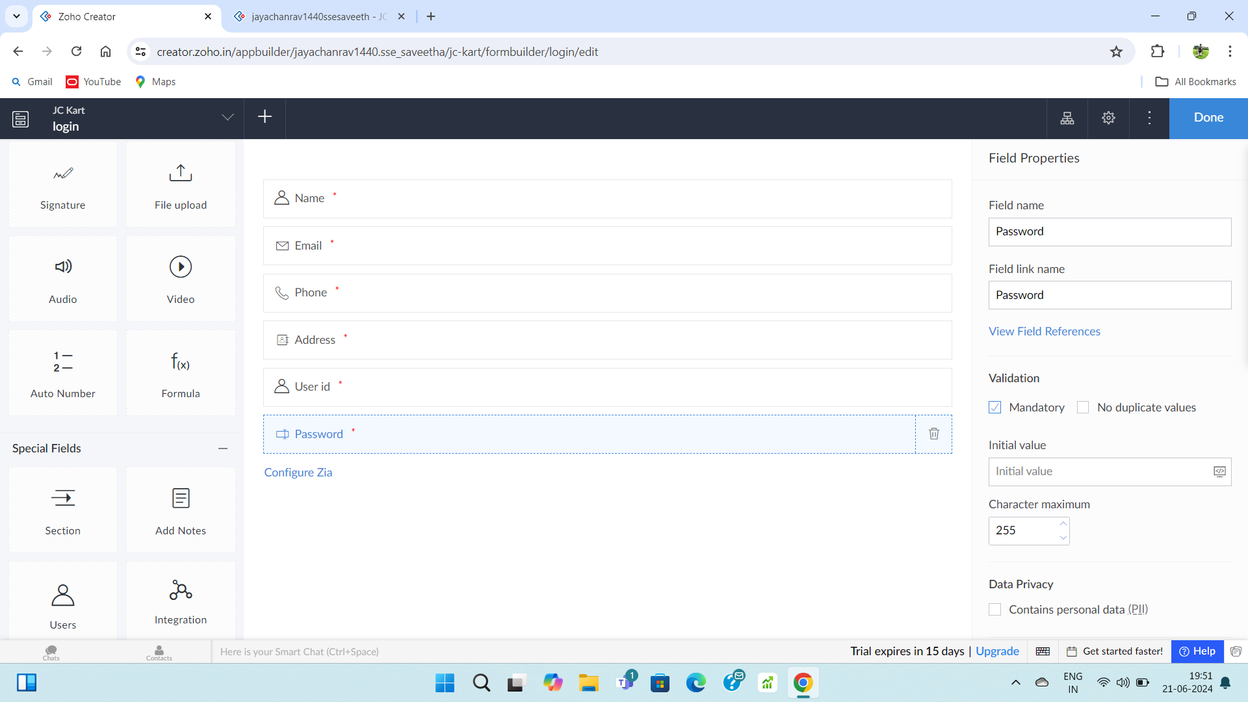

**STEP – 3:**

Fill upon the form.

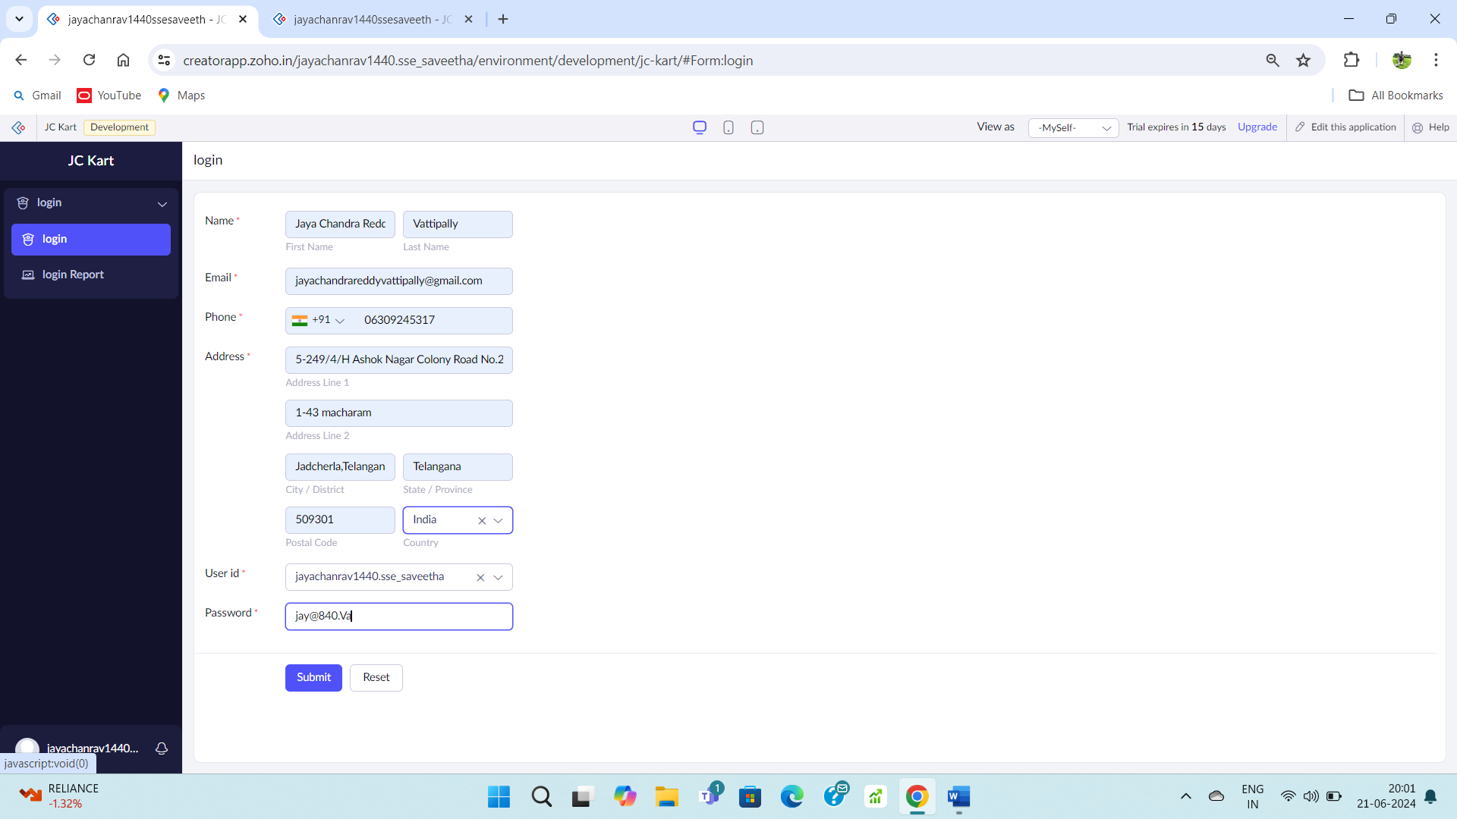

**STEP – 4:**

Go to the login form report to check the details.

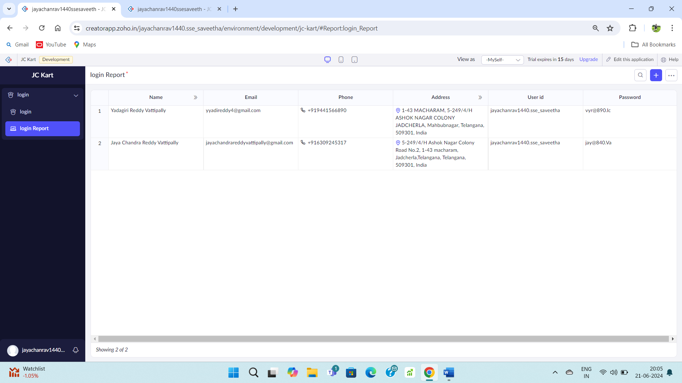

**STEP – 5:**

Create a shopping form

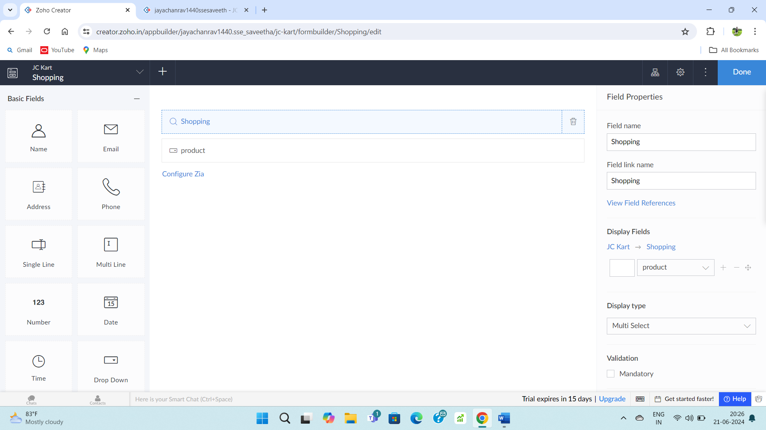

**STEP – 6:**

Fill upon the created form.

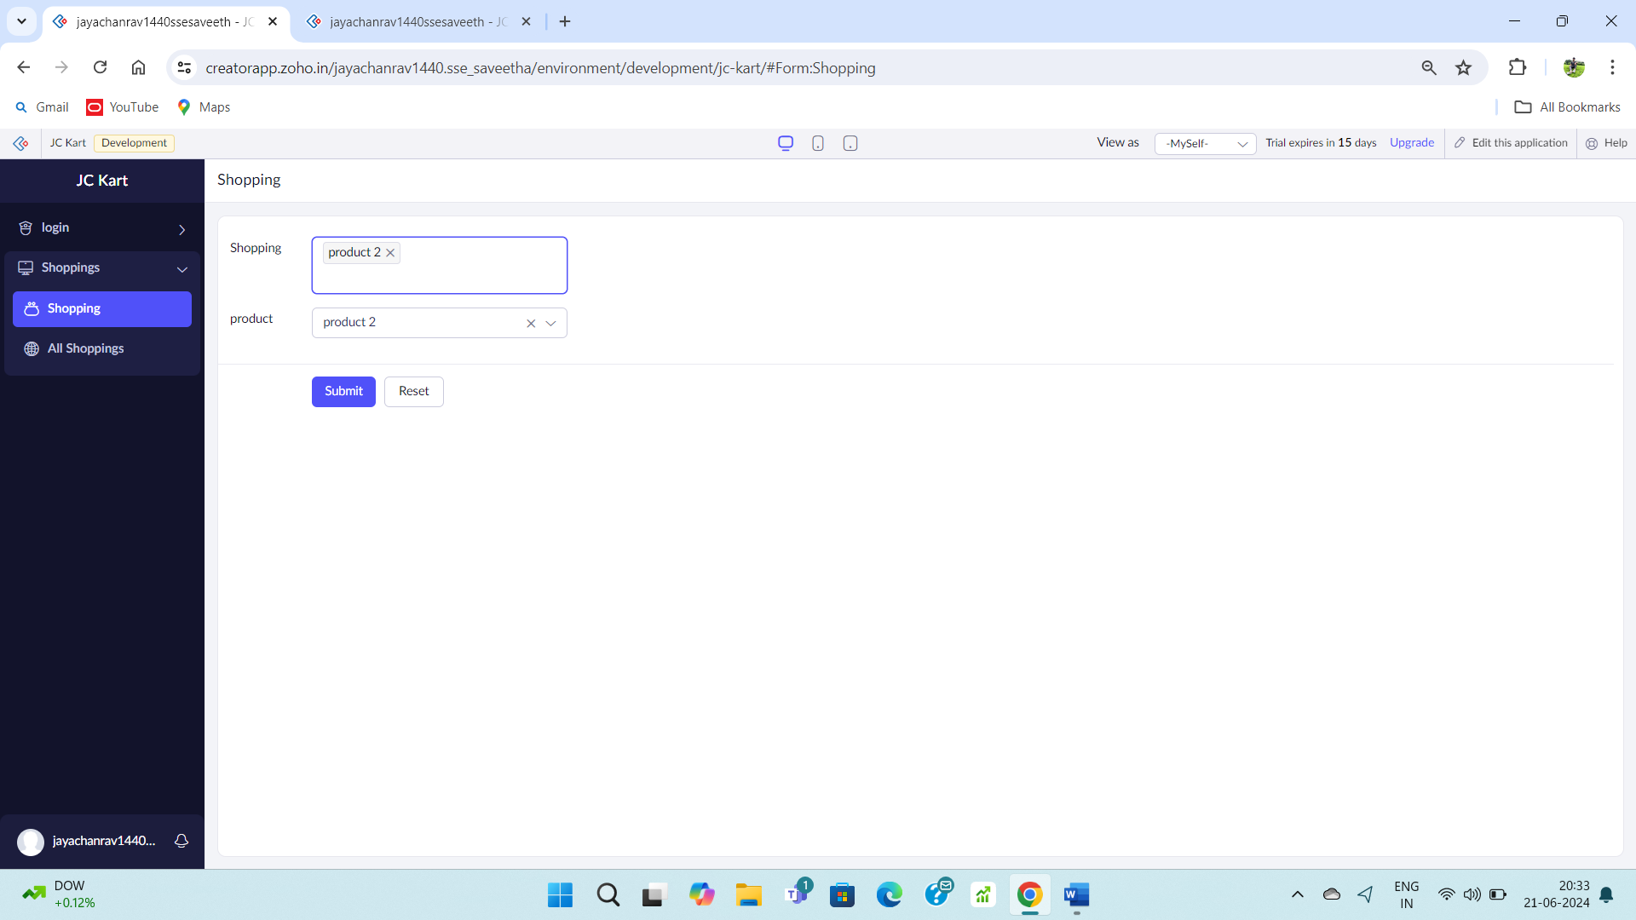

**STEP – 7:**

Go to shopping report form.

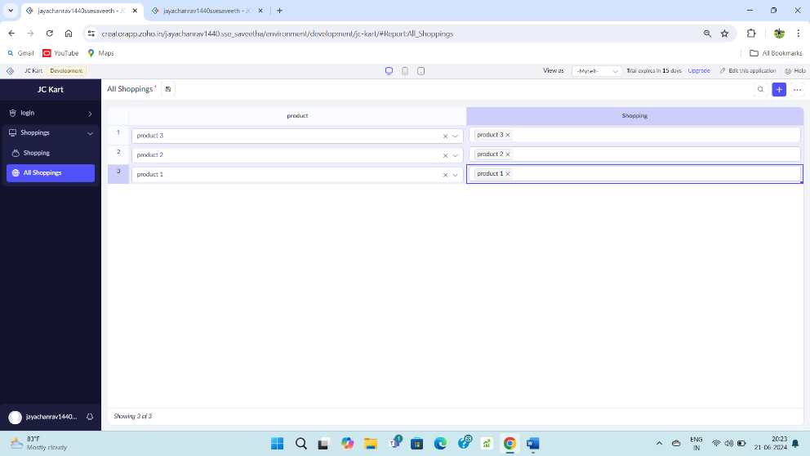

**STEP – 8:**

Create a payment form.

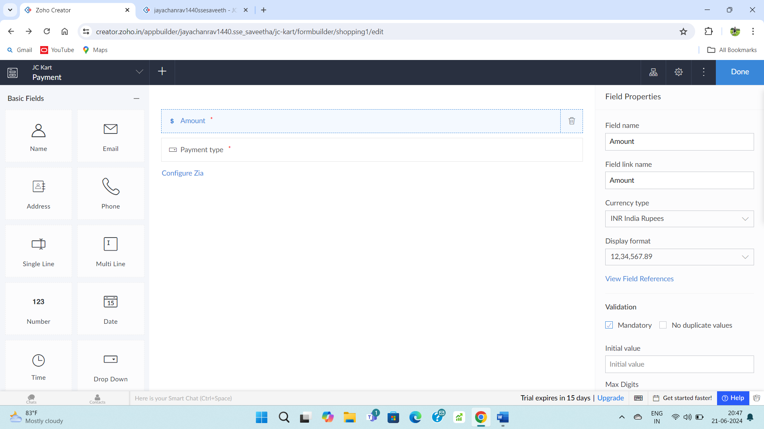

**STEP – 9:**

Fill upon the created form.

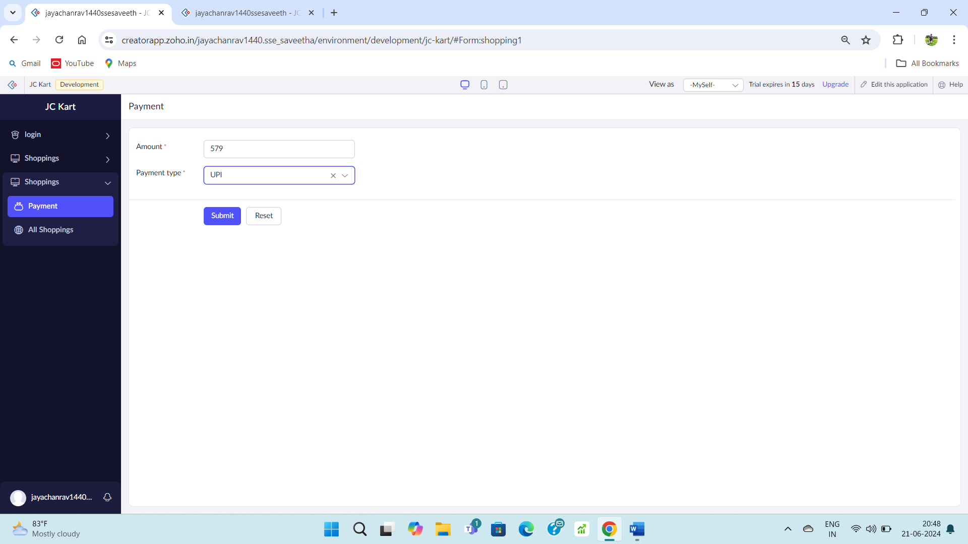

**STEP – 10:**

Go to payment report form.

