**Uploading Programming and Web Files to Live Website (K Drive)**

Log into BitBucket with an administrative account.

<https://bitbucket.org>

Under Repositories click on desired repository.

ie: For live website (without bin folder) choose linformatics/Library Website

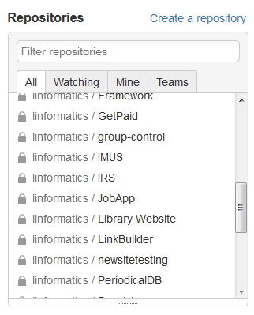



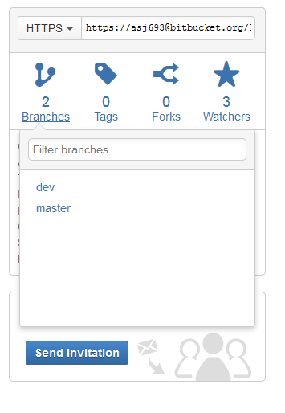

Click on 2 Branches and then choose dev.

Click on Merge

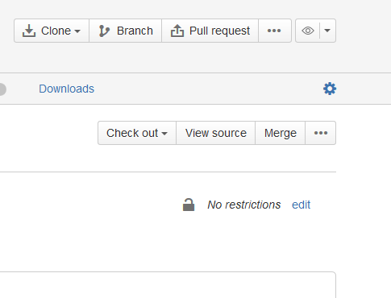

Make sure “Close source branch” is unchecked and click Merge.

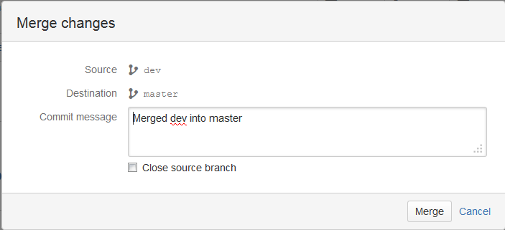

Open SourceTree on your computer.

Click on the desired site to update.

ie: For live site open live_website

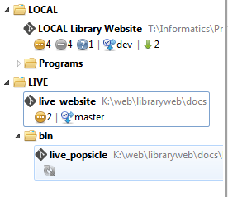

Click on Pull.

*Possible issues:

Sometimes you may need to turn off (close prepros).

Sometimes you may need to delete the file gitindex.lock from the K Drive

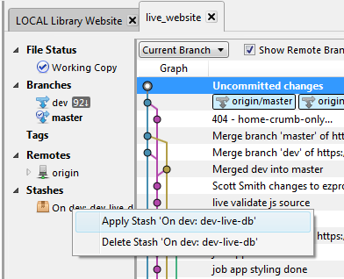If databases aren’t pulling correct data then Apply Stash as picture shows below.

Does this direction need to be on this page or different page?