Adding completed tutorials to DCOD:

When a tutorial is completed:

1. Log into DCOD

2. Search for previous entry and edit or "add content item"

3. Fill out the name - be sure to match the same title used on the website and/or file name. Use the code below to put in the name, substituting it for “Title here.”

<img id='TITLE HERE' align='absmiddle' src='http://library.olivet.edu/img/help/tutorial_movie.png' />TITLE HERE

4. Adjust the url according to the correct location

5. Do not use absolute links. This means to start the address right after the http://library.olivet.edu and include the "/" after ".edu"

6. Change the second url to call the correct graphic

/img/help/tutorial_pdf.png

/img/help/tutorial_movie.png

/img/help/tutorial_html.png

/img/help/tutorial_doc.png

7. Type in the You Tube url (must use full address here beginning with http://) in the “location” section so Ann can quickly locate the video

8. Choose the proper categories for the tutorial. You may need to consult with Ann. Always include “Help” and “Tutorial completed add to website” to prompt Ann to add to website. Also, categorize it as “Help: Benner Library” if it is a tutorial created by the library or “Help: Other organizations” if it is created by other organizations.

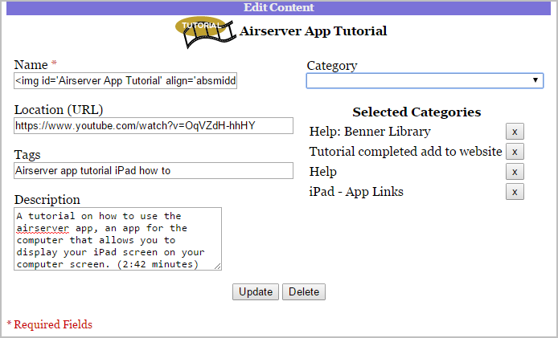

1. Cymone – powered by DCOD graphic & email graphic
2. Garrett & Emilie – Help pages
   1. Check for consistency of code above ie] How do I request items from the Illinois Catalog needs link on graphic
   2. Check all descriptions for accuracy and weird symbols
3. Christina, Phil, Bekah – Selected Sites pages
   1. Check for descriptions ie]Astronomy
   2. Fix broken urls
   3. Fix odd symbols
4. Everyone be prepared to come with kudos and development needs at next week’s meeting
5. Programmers –
   1. Look over how code was prepared for publication on OSS
   2. Be sure you understand user and administrative functionality with this program
   3. Development ideas
      1. Have DCOD detect whether links are on site or off and have the link open in new tab if it is not on site.
      2. Discuss removing requirement for http:// so that emergency site or moves will still work
      3. Make dropdown an option along with float/hover
      4. Make “powered by DCOD” an option like email is