Machine Learning-Lecture 1
P1.py
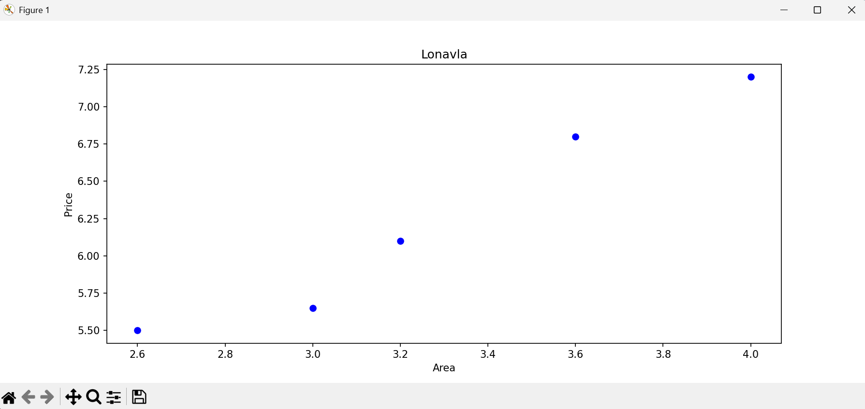

P2.py
C:\ml\L1>python p2.py
Enter Area 3.0
price = [5.87842466]

P3.py
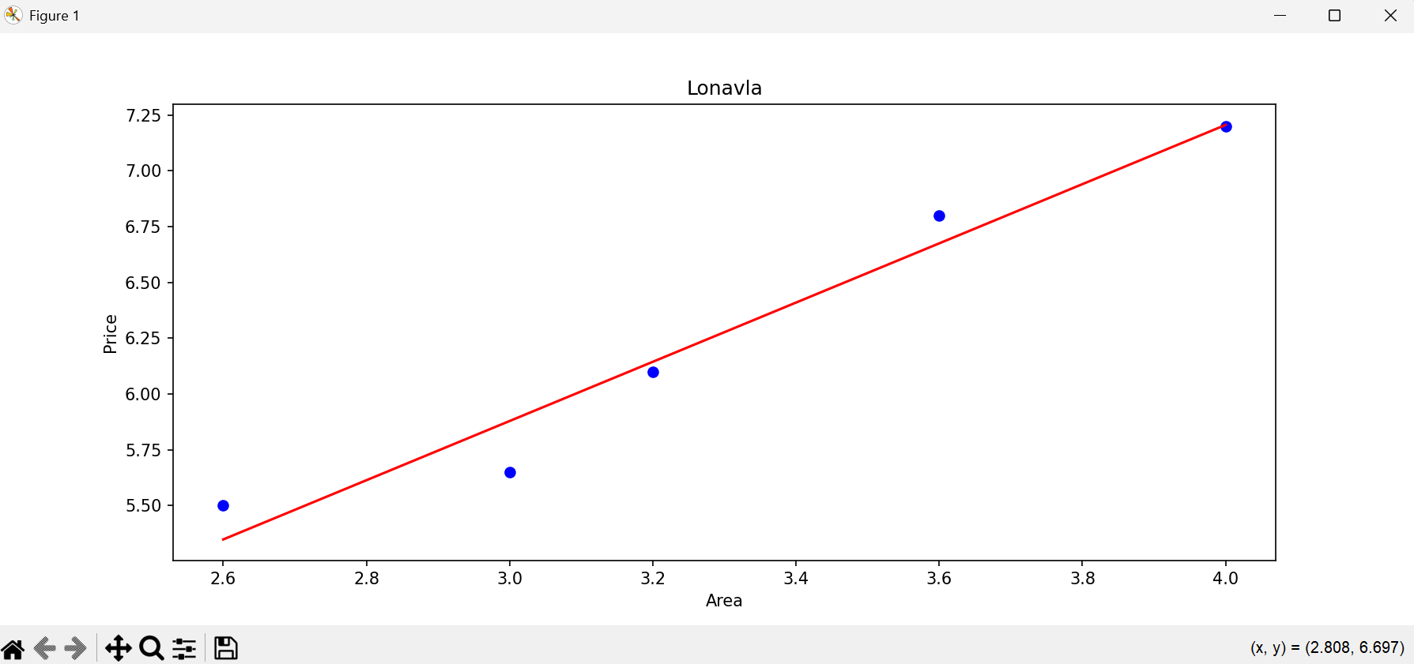

P4.py
C:\ml\L1>python p4.py
Enter Area 4.5
price = 7.8690068493150696

P5.py
C:\ml\L1>python p5.py
bO = 1.8972602739726012
b1 = 1.3270547945205484

P6.py
C:\ml\L1>python p6.py
99.05 %
enter area 5
8.59 crs

