

**SEMESTER PROJECT**

**Title: Smart Parking System Validation**

Course Code: CIS431

Batch: 15

Section: 16_A &15_B

Course Title: Software Quality Assurance and Testing

**Submitted to**

Mohammad Akter Ul Alam

Sr. Lecturer (Adjunct) and Sr. Assistant Director

Daffodil International University;

**Submitted by**

Nabila Sarkar

222-16-675

Department of CIS

Daffodil International University

Date of Submission 20.08.2025

**(1)Write Business Case:**

A smart parking booking form ensures users enter valid data before reserving a parking slot.

**Assumptions:**

1. **Vehicle Number Length** – must be between 6 and 10 characters.
2. **Parking Duration (Hours)** – must be between 1 and 24.
3. **Vehicle Height (cm)** – must be between 100 cm and 250 cm.
4. **Parking Fee (BDT)** – must be between 50 and 2,000.
5. **Driver Age** – must be between 18 and 75 years.

**(2)USER INTERFACE:**

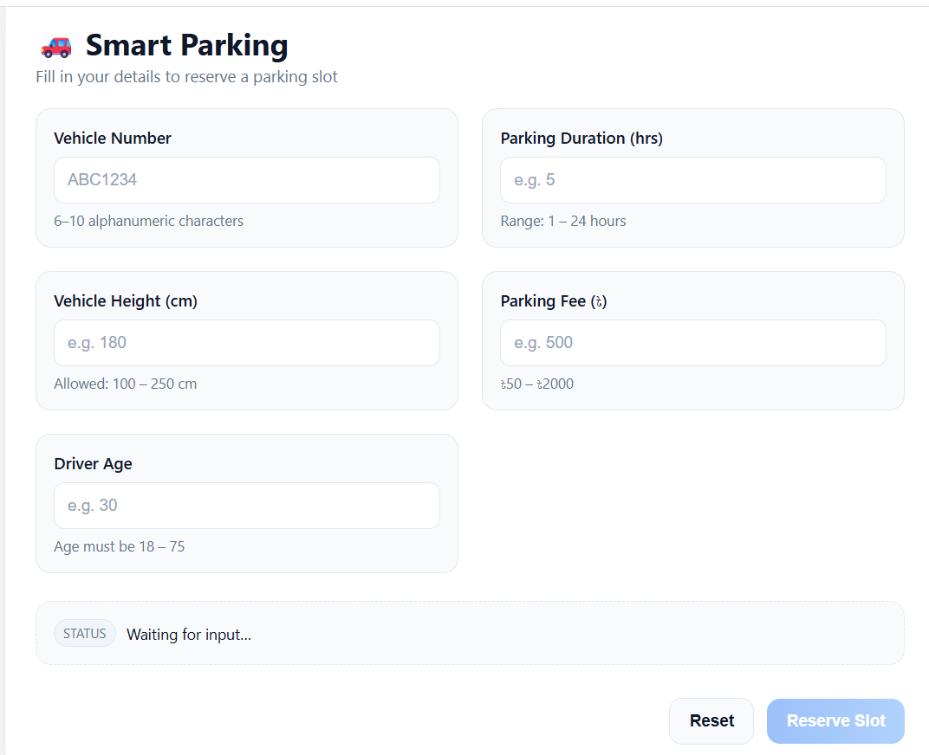

**3. FIND REPRESENTATIVES (BOUNDARY VALUE METHOD)**

**Field 1: Vehicle Number Length**  
Range: 6 ≤ length ≤ 10  
Boundary Values: 5, 6, 8, 10, 11

Diagram:

**5                     8                 11**

**—--------------|-----------------------------|------------------------|---------------**

**6                          10**

Valid Representatives: 6,8,10

Invalid Representatives: 5, 11, Fred (Non-Numeric Value)

**Field 2: Parking Duration (Hours)**  
Range: 1 ≤ hours ≤ 24  
Boundary Values: 0, 1, 12, 24, 25

Diagram:

**0                 12       25**

**—--------------|-----------------------------|------------------------|---------------**

1. **24**

Valid Representatives: 1,12,24

Invalid Representatives: 0, 25, Fred (Non-Numeric Value)

**Field 3: Vehicle Height (cm)**  
Range: 100 ≤ height ≤ 250  
Boundary Values: 99, 100, 180, 250, 251

Diagram:

**99                    180           251**

**—--------------|-----------------------------|------------------------|---------------**

**100                             250**

Valid Representatives: 100,180,250

Invalid Representatives: 99,251, Fred (Non-Numeric Value)

**Field 4: Parking Fee (BDT)**  
Range: 50 ≤ fee ≤ 2000  
Boundary Values: 49, 50, 1000, 2000, 2001

Diagram:

**49                  1000          2001**

**—--------------|-----------------------------|------------------------|---------------**

**50                          2000**

Valid Representatives: 50,1000,2000

Invalid Representatives: 49, 2001, Fred (Non-Numeric Value)

**Field 5: Driver Age**  
Range: 18 ≤ age ≤ 75  
Boundary Values: 17, 18, 40, 75, 76

Diagram:

**17                        40 76**

**—--------------|-----------------------------|------------------------|---------------**

**18                           75**

Valid Representatives: 18,40,75

Invalid Representatives: 17, 76, Fred (Non-Numeric Value)

1. **REPRESENTATIVES TABLE**

| **Variable** | **Equivalence Class** | **Status** | **Representatives** |
| --- | --- | --- | --- |
| **Vehicle Number Length** | EC₁₁: 6 ≤ len ≤ 10 | Valid | "KA1234" (6 chars) |
|  | EC₁₂: len < 6 | Invalid | "AB123" (5 chars) |
|  | EC₁₃: len > 10 | Invalid | "DHK12345678" (11 chars) |
| **Parking Duration** | EC₂₁: 1 ≤ x ≤ 24 | Valid | 12 |
|  | EC₂₂: x < 1 | Invalid | 0 |
|  | EC₂₃: x > 24 | Invalid | 25 |
| **Vehicle Height (cm)** | EC₃₁: 100 ≤ x ≤ 250 | Valid | 180 |
|  | EC₃₂: x < 100 | Invalid | 99 |
|  | EC₃₃: x > 250 | Invalid | 251 |
| **Parking Fee (BDT)** | EC₄₁: 50 ≤ x ≤ 2000 | Valid | 1000 |
|  | EC₄₂: x < 50 | Invalid | 49 |
|  | EC₄₃: x > 2000 | Invalid | 2001 |
| **Driver Age** | EC₅₁: 18 ≤ x ≤ 75 | Valid | 40 |
|  | EC₅₂: x < 18 | Invalid | 17 |
|  | EC₅₃: x > 75 | Invalid | 76 |

**5. WRITE TEST CASES**

**Test Case 1**  
Target Field: Vehicle Number Length  
Vehicle Number = "AB123"   
Parking Duration = 12  
Vehicle Height = 180  
Parking Fee = 1000  
Driver Age = 40  
Expected Result: ❌ Cannot Submit

**Test Case 2**  
Target Field: Vehicle Number Length  
Vehicle Number = "KA1234"   
Parking Duration = 12  
Vehicle Height = 180  
Parking Fee = 1000  
Driver Age = 40  
Expected Result: ✅ Can Submit

**Test Case 3**  
Target Field: Parking Duration  
Vehicle Number = "DHK1234"  
Parking Duration = 0  
Vehicle Height = 180  
Parking Fee = 1000  
Driver Age = 40  
Expected Result: ❌ Cannot Submit

**Test Case 4**  
Target Field: Parking Duration  
Vehicle Number = "DHK1234"  
Parking Duration = 24  
Vehicle Height = 180  
Parking Fee = 1000  
Driver Age = 40  
Expected Result: ✅ Can Submit

**Test Case 5**  
Target Field: Vehicle Height  
Vehicle Number = "DHK1234"  
Parking Duration = 12  
Vehicle Height = 99  
Parking Fee = 1000  
Driver Age = 40  
Expected Result: ❌ Cannot Submit

**Test Case 6**  
Target Field: Vehicle Height  
Vehicle Number = "DHK1234"  
Parking Duration = 12  
Vehicle Height = 150  
Parking Fee = 1000  
Driver Age = 40  
Expected Result: ✅Can Submit

**Test Case 7**  
Target Field: Parking Fee  
Vehicle Number = "DHK1234"  
Parking Duration = 12  
Vehicle Height = 180  
Parking Fee = 2000  
Driver Age = 40  
Expected Result: ✅ Can Submit

**Test Case 8**  
Target Field: Parking Fee  
Vehicle Number = "DHK1234"  
Parking Duration = 12  
Vehicle Height = 180  
Parking Fee = 20  
Driver Age = 40  
Expected Result: ❌ Cannot Submit

**Test Case 9**  
Target Field: Driver Age  
Vehicle Number = "DHK1234"  
Parking Duration = 12  
Vehicle Height = 180  
Parking Fee = 1000  
Driver Age = 17  
Expected Result: ❌ Cannot Submit

**Test Case 10**  
Target Field: Driver Age  
Vehicle Number = "DHK1234"  
Parking Duration = 12  
Vehicle Height = 180  
Parking Fee = 1000  
Driver Age = 75  
Expected Result: ✅ Can Submit

**6 . TEST CASE TABLE :**

| **Test Case ID** | **Vehicle No.** | **Parking Duration** | **Vehicle Height** | **Parking Fee** | **Driver Age** | **Expected Result** |
| --- | --- | --- | --- | --- | --- | --- |
| **TC01** | "AB123" (5 chars) | 12 | 180 | 1000 | 40 | ❌ Cannot Submit |
| **TC02** | "KA1234" (6 chars) | 12 | 180 | 1000 | 40 | ✅ Can Submit |
| **TC03** | "DHK1234" | 0 | 180 | 1000 | 40 | ❌ Cannot Submit |
| **TC04** | "DHK1234" | 24 | 180 | 1000 | 40 | ✅ Can Submit |
| **TC05** | "DHK1234" | 12 | 99 | 1000 | 40 | ❌ Cannot Submit |
| **TC06** | "DHK1234" | 12 | 150 | 2000 | 40 | ✅ Can Submit |
| **TC07** | "DHK1234" | 12 | 180 | 2000 | 40 | ✅ Can Submit |
| **TC08** | "DHK1234" | 12 | 180 | 20 | 40 | ❌ Cannot Submit |
| **TC09** | "DHK1234" | 12 | 180 | 1000 | 17 | ❌ Cannot Submit |
| **TC10** | "DHK1234" | 12 | 180 | 1000 | 75 | ✅ Can Submit |

| **Variable** | **Status** | **Representatives** | **T01** | **T02** | **T03** | **T04** | **T05** | **T06** | **T07** | **T08** | **T09** | **T10** |
| --- | --- | --- | --- | --- | --- | --- | --- | --- | --- | --- | --- | --- |
| **Vehicle Number** | Valid | KA1234 (6 chars) |  | * | * | * | * | * | * | * | * | * |
|  | Invalid | AB123 (5 chars) | * |  |  |  |  |  |  |  |  |  |
| **Parking Duration** | Valid | 12 | * | * |  |  | * | * | * | * | * | * |
|  | Valid | 24 |  |  |  | * |  |  |  |  |  |  |
|  | Invalid | 0 |  |  | * |  |  |  |  |  |  |  |
| **Vehicle Height** | Valid | 180 cm | * | * | * | * |  | * | * | * | * | * |
|  | Valid | 150 cm |  |  |  |  |  | * |  |  |  |  |
|  | Invalid | 99 cm |  |  |  |  | * |  |  |  |  |  |
| **Parking Fee** | Valid | 1000 | * | * | * | * | * |  |  |  | * | * |
|  | Valid | 2000 |  |  |  |  |  | * | * |  |  |  |
|  | Invalid | 20 |  |  |  |  |  |  |  | * |  |  |
| **Driver Age** | Valid | 40 | * | * | * | * | * | * | * | * |  |  |
|  | Invalid | 17 |  |  |  |  |  |  |  |  | * |  |
|  | Valid | 75 |  |  |  |  |  |  |  |  |  | * |
| **Expected Result** |  |  | N | Y | N | Y | N | Y | Y | N | N | Y |

| **Variable** | **Status** | **Representatives** | **T01** | **T02** | **T03** | **T04** | **T05** | **T06** | **T07** | **T08** | **T09** | **T10** |
| --- | --- | --- | --- | --- | --- | --- | --- | --- | --- | --- | --- | --- |
| **Student Age** | Valid | 25 | * | * | * | * | * | * | * | * |  |  |
|  | Invalid | 15 | * |  |  |  |  |  |  |  |  |  |
|  | Invalid | 36 |  |  |  |  |  |  |  |  | * |  |
| **Exam Duration (Minutes)** | Valid | 90 | * | * |  |  | * | * | * | * |  |  |
|  | Valid | 180 |  |  |  | * |  |  |  |  |  |  |
|  | Invalid | 29 |  |  | * |  |  |  |  |  |  |  |
|  | Invalid | 181 |  |  |  |  |  |  |  |  |  | * |
| **Number of Subjects** | Valid | 3 | * | * | * | * |  | * | * | * | * |  |
|  | Valid | 6 |  |  |  |  |  |  |  |  |  | * |
|  | Invalid | 0 |  |  |  |  | * |  |  |  |  |  |
|  | Invalid | 7 |  |  |  |  |  |  |  |  |  | * |
| **Registration Fee (BDT)** | Valid | 2500 | * | * | * | * | * |  | * | * | * |  |
|  | Valid | 5000 |  |  |  |  |  | * |  |  |  |  |
|  | Invalid | 499 |  |  |  |  |  |  |  |  |  | * |
|  | Invalid | 5001 |  |  |  |  |  |  |  |  |  | * |
| **Password Length** | Valid | Abcd1234 (8 chars) | * | * | * | * | * | * |  |  | * |  |
|  | Valid | Abcd1234efgh (12 chars) |  |  |  |  |  |  |  | * |  |  |
|  | Invalid | Abc123 (6 chars) |  |  |  |  |  |  | * |  |  |  |
|  | Invalid | Abcd1234efgh567 (16 chars) |  |  |  |  |  |  |  |  |  | * |
| **Expected Result** |  |  | ❌ | ✅ | ❌ | ✅ | ❌ | ✅ | ❌ | ✅ | ❌ | ❌ |