## Porto

**Institute of Industrial and Computer Management and**

**Research, Nigdi Pune**

**MCA**

**Department Academic**

**Year : 22-23**

**IT23: Advanced Internet Technologies**

**Lab Exercise-1**

**Name: Shashikant Subechand yadav Roll No:103**

**Division:CodeWarriors**

**Assignment-1**

## ATSS’s

## Institute of Industrial and Computer Management and Research, Nigdi Pune

# MCA Department

**INDEX**

## Students Name: Shashikant Subechand Yadav

## Roll No:103

|  |  |  |  |  |  |
| --- | --- | --- | --- | --- | --- |
| **Sr.** No | Program Title | Couse Outcome | Page No. | Teacher’ s Sign with Date | Remarks |
| 1. | **WAP to change font size of a text as per the ‘range’ control value, ranging from 8 to 40.** |  |  |  |  |
| 2. | **Write a program to embed audio and video elements use controls.** |  |  |  |  |
| 3. | WAP to draw a circle considering mouse click position as a centre.(Radius can be considered as 50) |  |  |  |  |
| 4. | **Write a program to draw the rectangle shape using SVG and apply animation effect.** |  |  |  |  |
| 5. | **Apply pseudo selectors to set the background color for visited and unvisited links to ‘lightblue’, and the background color for the hover and active link states to ‘green’.** |  |  |  |  |
| 6. | **Consider the heart shape as an image and apply Animation on hover effect where image will increase the size and revert back to original size with shadow effect.** |  |  |  |  |
| 7. | Apply transition and transformation to perform following task: **i. On hover of an image, it should rotate in 360 degrees.**  **ii. On hover of a div, text should increase the size and removing cursor from div, size of the text should be restored.** |  |  |  |  |
| 8. | **Write a PHP script to generate simple random password of 10 characters from a given string. Assume a string contains characters from A-Z, a-z, 0- 9. Generated password must contains at least 1 number, 1 capital letter and 1 small letter.** |  |  |  |  |
| 9. | Write a PHP script to print Fibonacci Series using both ways: loops, recursive function |  |  |  |  |
| 10. | **Create a table Emp with fileds empno, name, address, salary, deptno Design HTML & PHP pages for following a. Insert a record b. Delete record c View record d Display department number wise group report** |  |  |  |  |

**Name: Shashikant Subechand Yadav**

**Roll no: 103**

**Div: Codewarriors**

Q.1 WAP to change font size of a text as per the ‘range’ control value, ranging from 8 to 50

<!DOCTYPE html>

<html>

<head>

<title>Font Size Changer</title>

<style>

#text {

font-size: 16px;

}

</style>

</head>

<body>

<input type="range" id="fontRange" min="8" max="50" value="16">

<br>

<span id="text">Text</span>

<script>

var rangeInput = document.getElementById("fontRange");

var textElement = document.getElementById("text");

rangeInput.addEventListener("input", function() {

var fontSize = rangeInput.value + "px";

textElement.style.fontSize = fontSize;

});

</script>

</body>

</html>

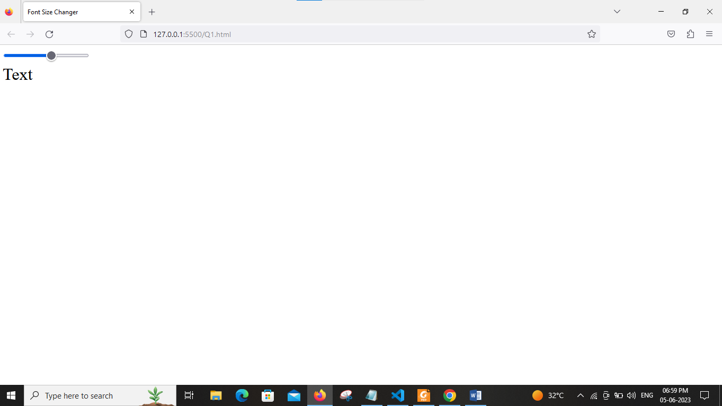

Q.2 Write a program to embed audio and video elements use controls.

<!DOCTYPE html>

<html lang="en">

<head>

<meta charset="UTF-8">

<meta http-equiv="X-UA-Compatible" content="IE=edge">

<meta name="viewport" content="width=device-width, initial-scale=1.0">

<title>Program3</title>

</head>

<body>

<audio controls loop autoplay >

<source src="music.mp3" type="audio/mp3">

</audio> <br>

<video width="320" height="240" controls>

<source src="nature.mp4" type="video/mp4">

</video>

</body>

</html>

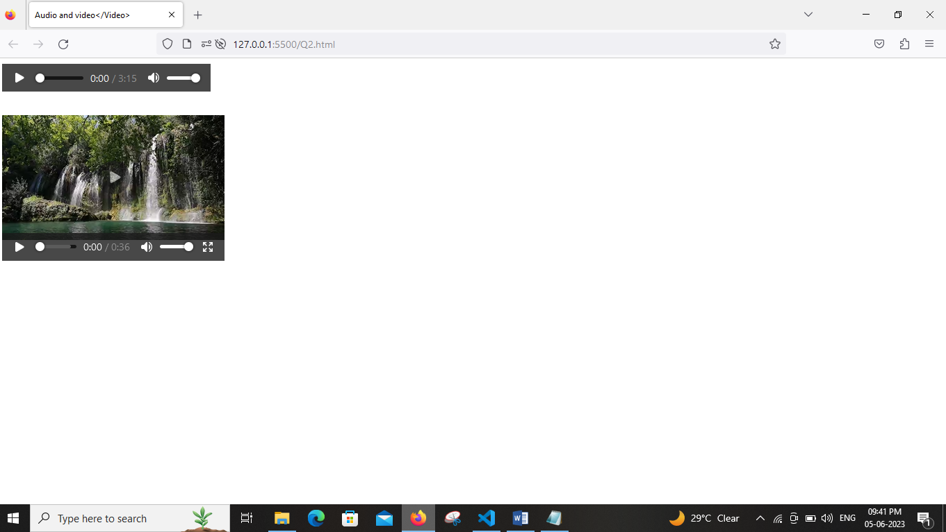

Q.3 WAP to draw a circle considering mouse click position as a centre.(Radius can be considered as 50)

<!DOCTYPE html>

<html lang="en">

<head>

<meta charset="UTF-8" />

<meta http-equiv="X-UA-Compatible" content="IE=edge" />

<meta name="viewport" content="width=device-width, initial-scale=1.0" />

<title>Document</title>

<style>

.myCanvas {

border: 1px solid black;

}

</style>

</head>

<body>

<canvas class="myCanvas" width="500" height="500"></canvas>

<script>

let canvas = document.querySelector('.myCanvas');

let ctx = canvas.getContext('2d');

canvas.addEventListener('click', function (e) {

let x = e.clientX;

let y = e.clientY;

ctx.beginPath();

ctx.arc(x, y, 40, 0, 2 * Math.PI);

ctx.fillStyle = '#222';

ctx.fill();

});

</script>

</body>

</html>

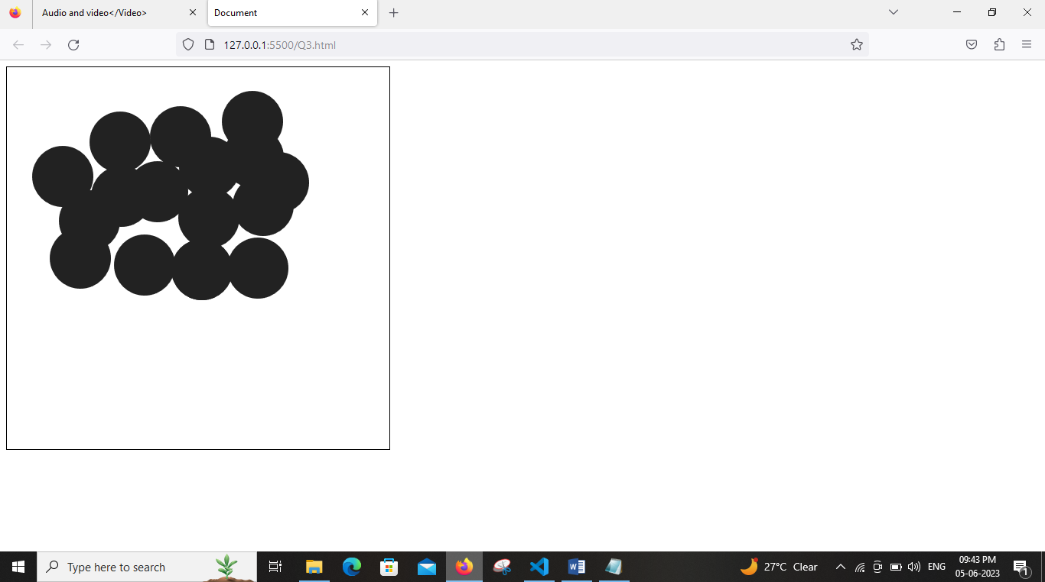

Q.4 Write a program to draw the rectangle shape using SVG and apply animation effect.

<!DOCTYPE html>

<html>

<head>

<title>Rectangle Drawing with Animation</title>

<style>

svg {

width: 400px;

height: 300px;

border: 1px solid black;

}

rect {

fill: olivedrab;

}

</style>

</head>

<body>

<svg id="mySvg">

<rect id="myRect" width="100" height="50" x="50" y="50" />

</svg>

<script>

var rect = document.getElementById("myRect");

rect.addEventListener("mouseover", function() {

rect.setAttribute("width", "200");

rect.setAttribute("height", "100");

rect.setAttribute("x", "0");

rect.setAttribute("y", "0");

});

rect.addEventListener("mouseout", function() {

rect.setAttribute("width", "100");

rect.setAttribute("height", "50");

rect.setAttribute("x", "50");

rect.setAttribute("y", "50");

});

</script>

</body>

</html>

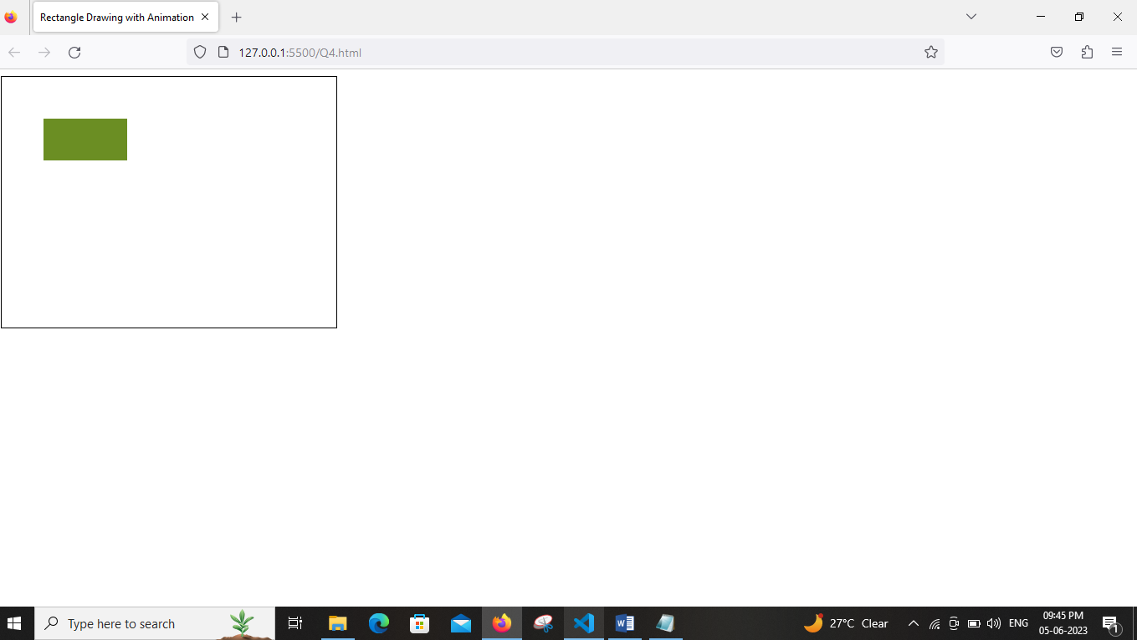

Q.5 Apply pseudo selectors to set the background color for visited and unvisited links to ‘lightblue’, and the background color for the hover and active link states to  
‘green’.

<!DOCTYPE html>

<html>

<head>

<title>Link Styles</title>

<style>

/* Unvisited Links */

a:link {

background-color: lightblue;

}

/* Visited Links */

a:visited {

background-color: lightblue;

}

/* Hovered Links */

a:hover {

background-color: green;

}

/* Active Links */

a:active {

background-color: green;

}

</style>

</head>

<body>

<a href="#">Unvisited Link</a>

<br>

<a href="#" visited>Visited Link</a>

</body>

</html>

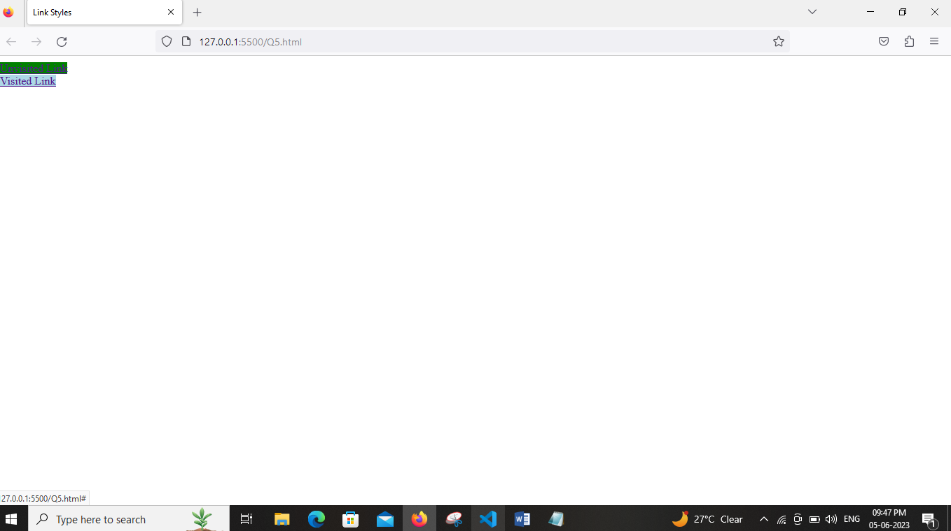

Q.6 Consider the heart shape as an image and apply Animation on hover effect where image will increasethe size and revert back to original size with shadow effect.

<!DOCTYPE html>

<html lang="en">

<head>

<meta charset="UTF-8" />

<meta http-equiv="X-UA-Compatible" content="IE=edge" />

<meta name="viewport" content="width=device-width, initial-scale=1.0" />

<title>Document</title>

<!-- styles -->

<style>

* {

margin: 0;

padding: 0;

box-sizing: border-box;

}

.image-container {

max-width: 768rem;

width: 90vw;

height: 50vh;

margin: auto;

display: grid;

place-items: center;

}

.img {

width: 10rem;

height: 10rem;

border-radius: 0.375rem;

transition: all 1s linear;

}

.img:hover {

width: 15rem;

height: 15rem;

box-shadow: 0 5px 15px rgba(0, 0, 0, 0.8);

}

</style>

</head>

<body>

<div class="image-container">

<img class="img" src="heart.jpg" alt="heart" />

</div>

</body>

</html>

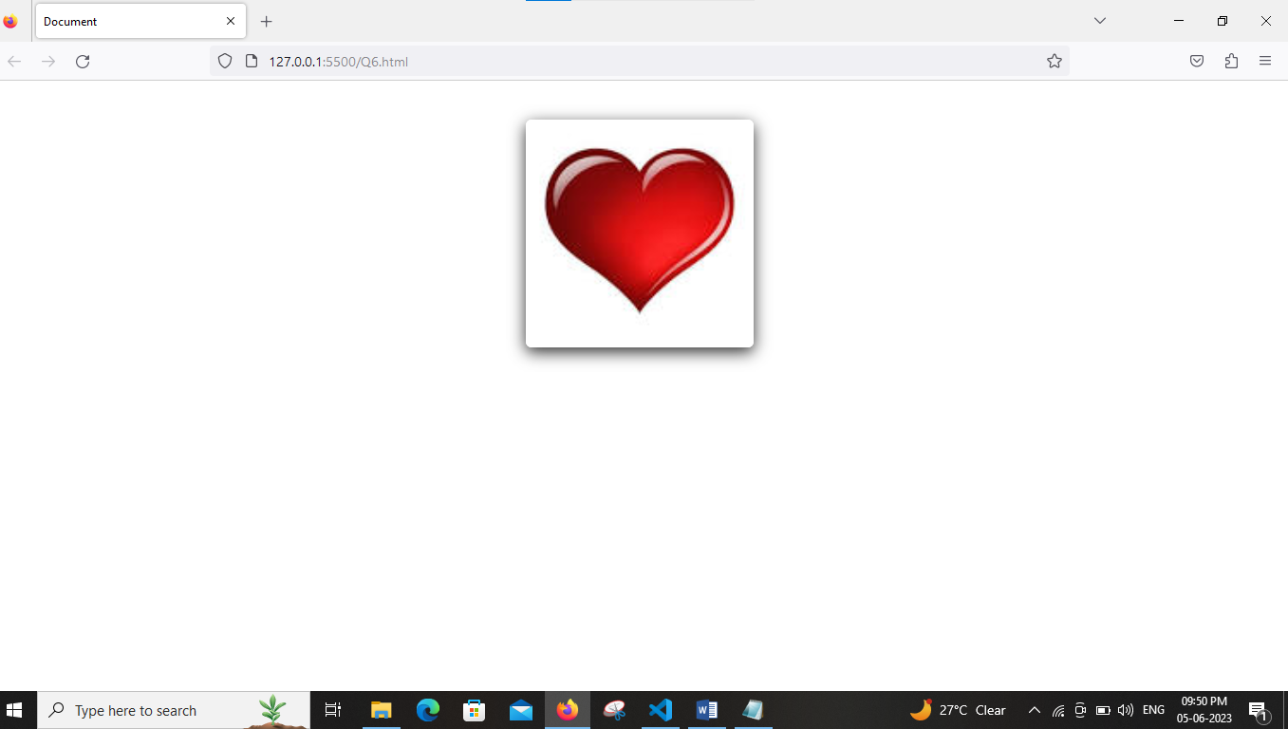

Q.7 Apply transition and transformation to perform following task:  
i. On hover of an image, it should rotate in 360 degrees.  
ii. On hover of a div, text should increase the size and removing cursor from div, size of the text should be restored.

<!DOCTYPE html>

<html>

<head>

<title>Hover Effects</title>

<style>

/* Image Hover Effect */

.image-container {

display: inline-block;

transition: transform 0.5s;

}

.image-container:hover {

transform: rotate(360deg);

}

/* Text Size Change */

.text-container {

display: inline-block;

transition: font-size 0.5s;

cursor: pointer;

}

.text-container:hover {

font-size: 24px;

cursor: default;

}

</style>

</head>

<body>

<div class="image-container">

<img src="image.jpg" alt="Image">

</div>

<br>

<div class="text-container">

Hover Me

</div>

</body>

</html>

Output

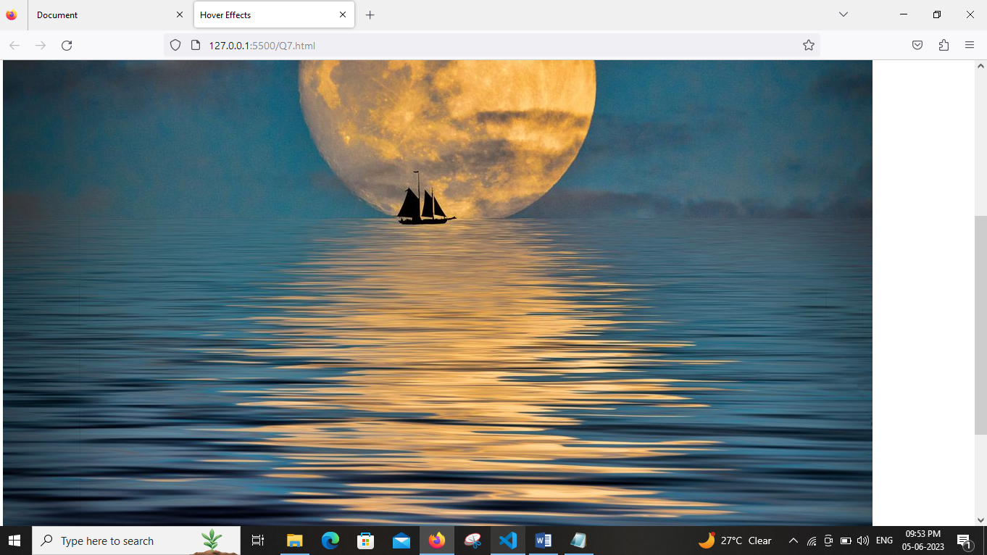

Q.8 Write a PHP script to generate simple random password of 10 characters from a  
given string. Assume astring contains characters from A-Z, a-z, 0- 9.

<?php

$small_alpha = "abcdefghijklmnopqrstuvwxyz";

$capital_alpha = "ABCDEFGHIJKLMNOPQRSTUVWXYZ";

$numbers = "0123456789";

$text = $small_alpha.$capital_alpha.$numbers;

function generatePassword(){

global $text;

$password = substr(str_shuffle($text), 0, 10 );

echo "password is " . $password . " <br>";

$pattern = '/(?=.*\d)(?=.*[a-z])(?=.*[A-Z])[a-zA-Z0-9]{10}/';

if (preg_match($pattern, $password)) {

return $password;

}

return generatePassword();

}

echo generatePassword();

?>

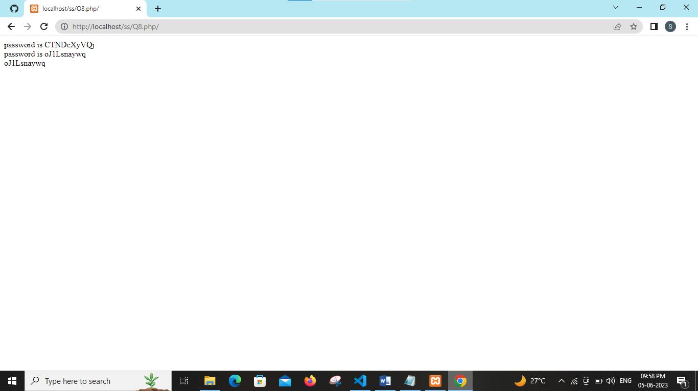

Q.9 Write a PHP script to print Fibonacci Series using both ways: loops, recursive  
function

<?php

// using loop

function fibonacci_using_loop($n){

$a = 0;

$b = 1;

echo $a . " ";

echo $b . " ";

for($i = 2; $i<$n; $i++){

$c= $a+$b;

echo $c . " ";

$a = $b;

$b = $c;

}

}

echo "fibonacci series using loop <br>";

fibonacci_using_loop(7);

// using recursion

function fibonacci_using_recursion($n, $a=0, $b=1){

if($n==0){

return;

}

echo $a . " ";

fibonacci_using_recursion($n-1, $b, $a+$b);

}

echo "<br> <br>";

echo "fibonacci series using recursion <br>";

echo fibonacci_using_recursion(7);

?>

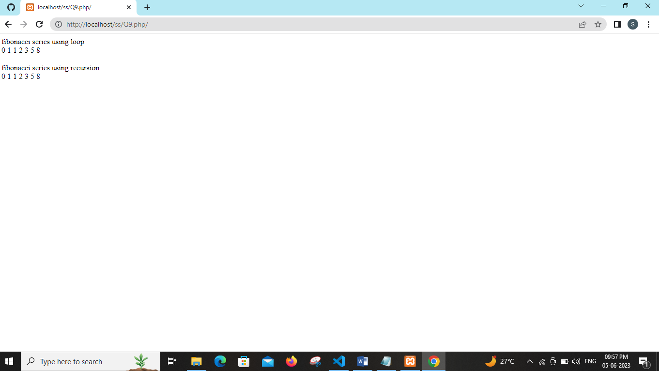

Q.10

Html code

<html>

<body>

<center>

<h2>Employee Registration form</h2>

<form method ="post" action="employee.php">

Employee No:

<input type="text" name="empno"><br><br><br>

Employee Name:

<input type="text" name="name"><br><br><br>

Address:

<input type="text" name="address"><br><br><br>

Salary

<input type="text" name="sal"><br><br><br>

Department No:

<input type="text" name="deptno"><br><br><br>

<input type="submit" name="save" value="save">

<input type="submit" name="delete" value="delete">

<input type="submit" name="view" value="view">

<input type="submit" name="display" value="display">

</form></center></body></html>

Php code

<?php

$servername='localhost';

$username='root';

$password='';

$dbname='mydb';

$conn=mysqli_connect($servername,$username,$password,$dbname);

if(!$conn)

{

die("could not connect mysql :".mysql_error());

}

if(isset($_POST['save']))

{

$empno=$_POST['empno'];

$name=$_POST['name'];

$address=$_POST['address'];

$sal=$_POST['sal'];

$deptno=$_POST['deptno'];

$sql="insert into employee values ($empno,'$name','$address',$sal,$deptno)";

if(mysqli_query($conn,$sql)){

echo "New Record Inserted";

}

else

{

echo "Error : ".$sql." ".mysqli_error($conn);

}

mysqli_close($conn);

}

if(isset($_POST['delete']))

{

$empno=$_POST['empno'];

//$name=$_POST['name'];

//$address=$_POST['address'];

//$sal=$_POST['sal'];

//$deptno=$_POST['deptno'];

$sql="delete from employee where empno = $empno";

if(mysqli_query($conn,$sql)){

echo " Record Deleted ";

}

else

{

echo "Error : ".$sql." ".mysqli_error($conn);

}

mysqli_close($conn);

}

if(isset($_POST['view']))

{

$empno=$_POST['empno'];

//$name=$_POST['name'];

//$address=$_POST['address'];

//$sal=$_POST['sal'];

//$deptno=$_POST['deptno'];

$sql="select * from employee where empno = $empno";

$result=mysqli_query($conn,$sql);

if(mysqli_num_rows($result)>0)

{

$row=mysqli_fetch_assoc($result);

echo "Employee no : ".$row['empno']."<br>";

echo "Name : ".$row['name']."<br>";

echo "Address : ".$row['address']."<br>";

echo "Salary : ".$row['sal']."<br>";

echo "Department no : ".$row['deptno']."<br>";

}

}

if(isset($_POST['display']))

{

$sql="select * from employee order by deptno";

$result=mysqli_query($conn,$sql);

if(mysqli_num_rows($result)>0)

{

?>

<table border=1>

<th>Employee no </th>

<th>Employee name </th>

<th>Address </th>

<th>Salary </th>

<th>Department no </th>

<?php

while($row=mysqli_fetch_assoc($result))

{

echo "<tr><td>".$row['empno']."</td><td>".$row['name']."</td><td>".$row['address']."</td><td>".$row['sal']."</td><td>".$row['deptno']."</td></tr>";

}

}

else{

echo "0 result";

}

mysqli_close($conn);

}

?>

