**EXPERIMENT-1**  
Ajay Kumar Tyagi  
500067403  
R171218008

Aim: Installation of Jenkins and execution of a simple job in Jenkins.

1) To download Jenkins on Redhat Linux, we first need to install java-11. To install java-11 use command yum install java-11-openjdk.x86_64 –yq. Then run the following commands to install Jenkins:

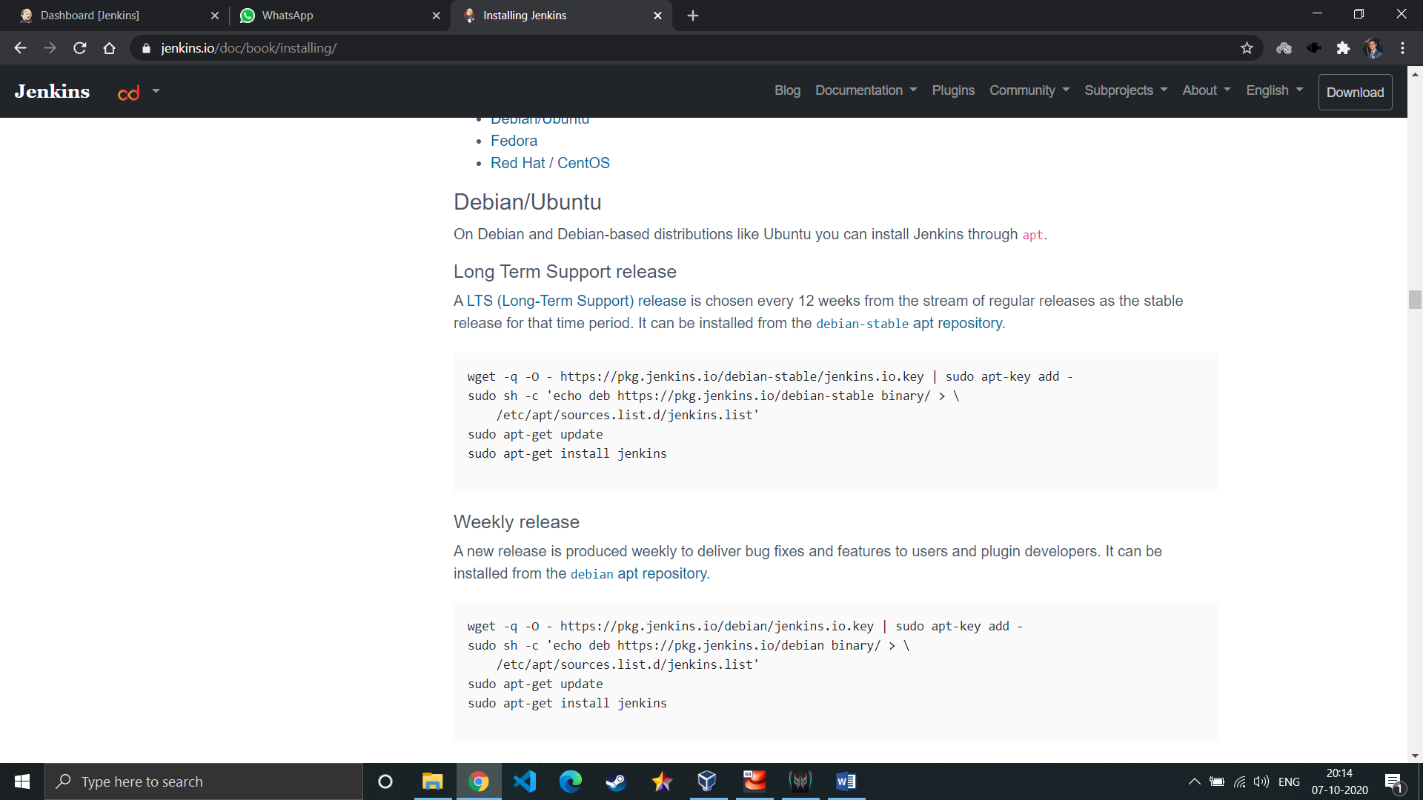

2) To start Jenkins, use command systemctl start jenkins.

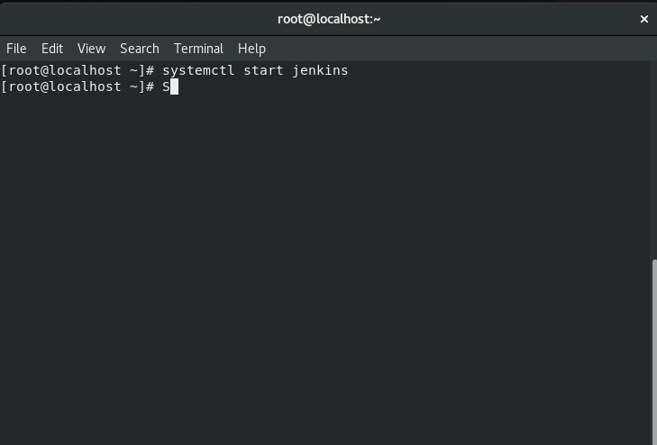

3) Jenkins will start now. We can open it on port 8080. Note that first time you will open the Jenkins, password will be provided in a file. This file location will be displayed on Jenkins.

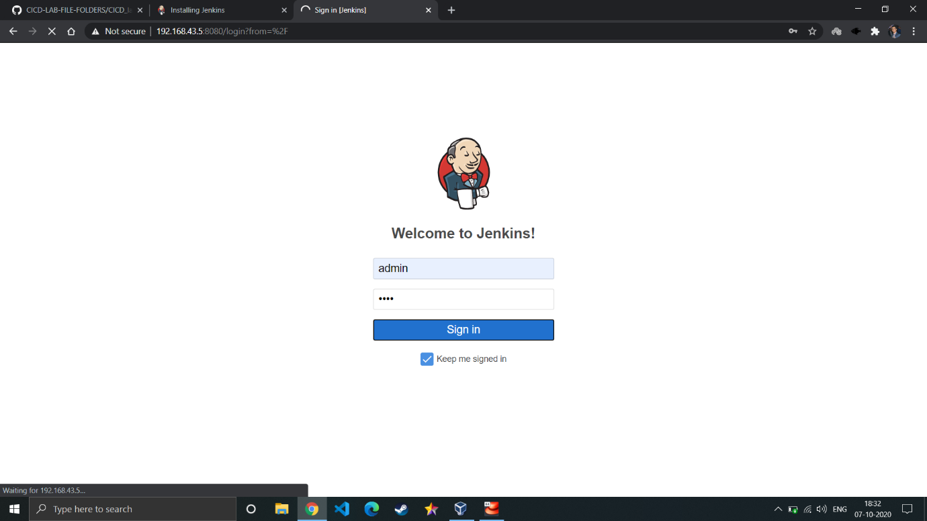

4) After login you will land on dashboard.

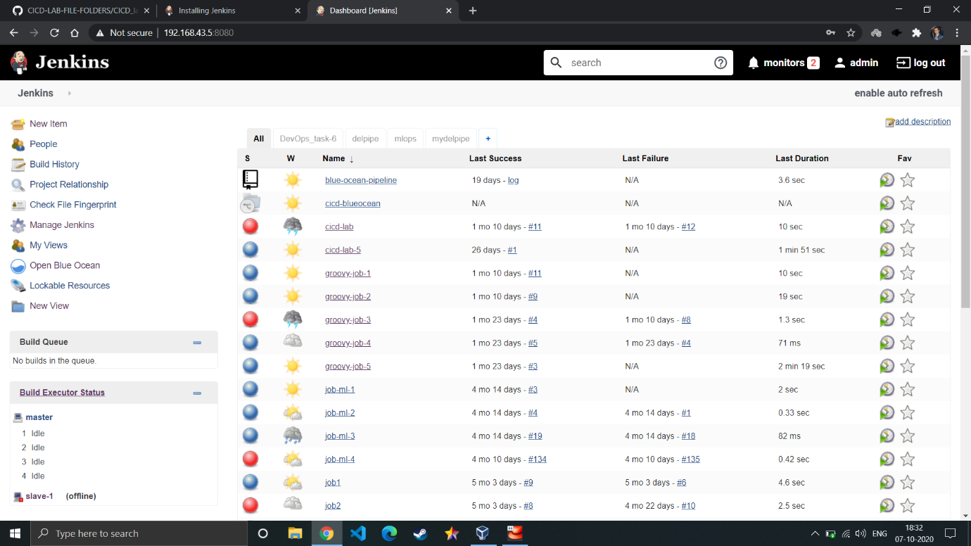

5) To create a job, click on new item. Now select job name and type of job you want to create.

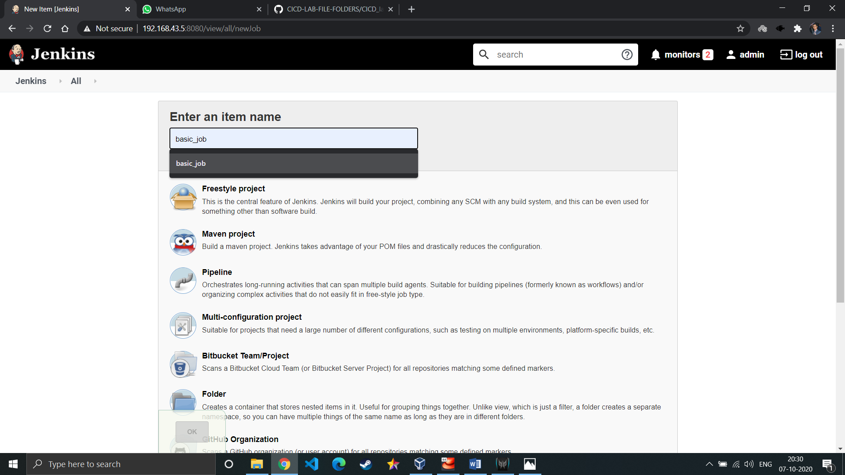

5) We will run just some basic command like printing something.

