**Name: Shashwat Kumar**

**Roll Number: R171218093**

**SAP ID: 500068392**

**Lab: 1**

**Installation of Jenkins and Execution of a simple job in Jenkins**

**Solution:**

Go to the download website for Jenkins: <https://www.jenkins.io/download/>

And download the binaries for Jenkins for Windows

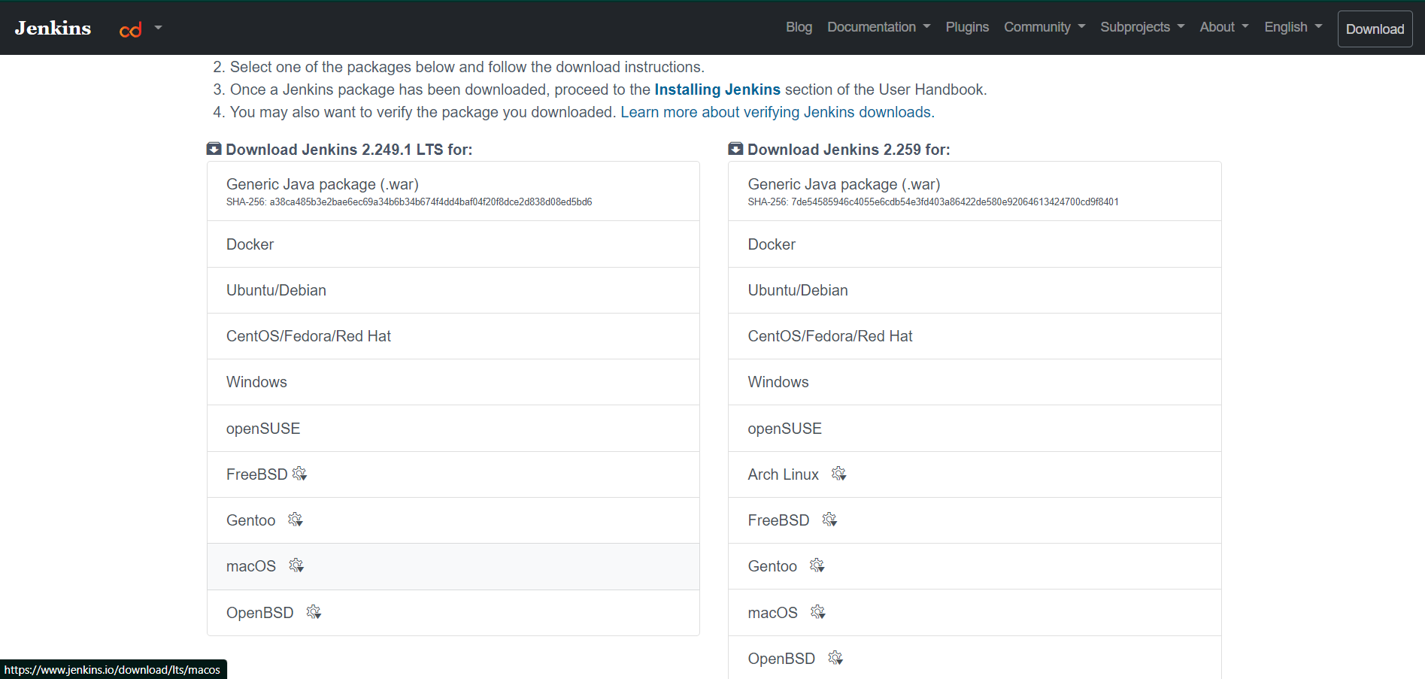

The download to produce a file named jenkins.war

Use this file to run Jenkins.

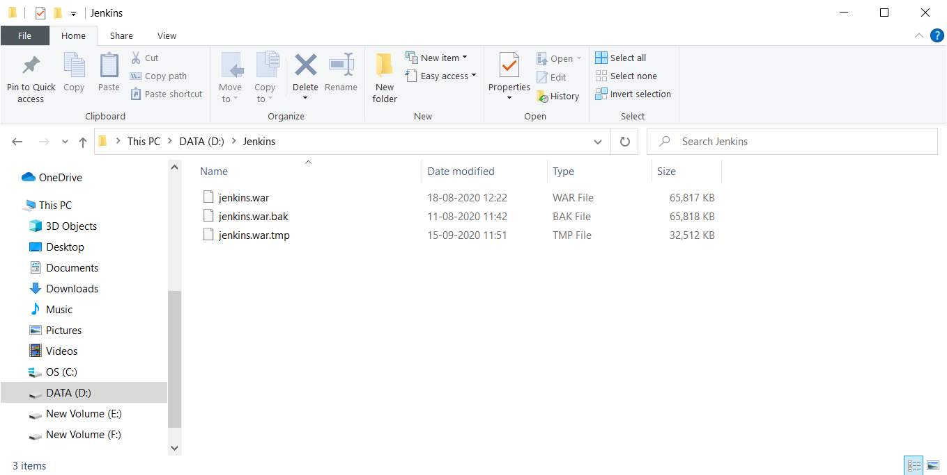

Open the command prompt.

Traverse to the directory containing the jenkins.war file

Type the command : java -jar jenkins.war

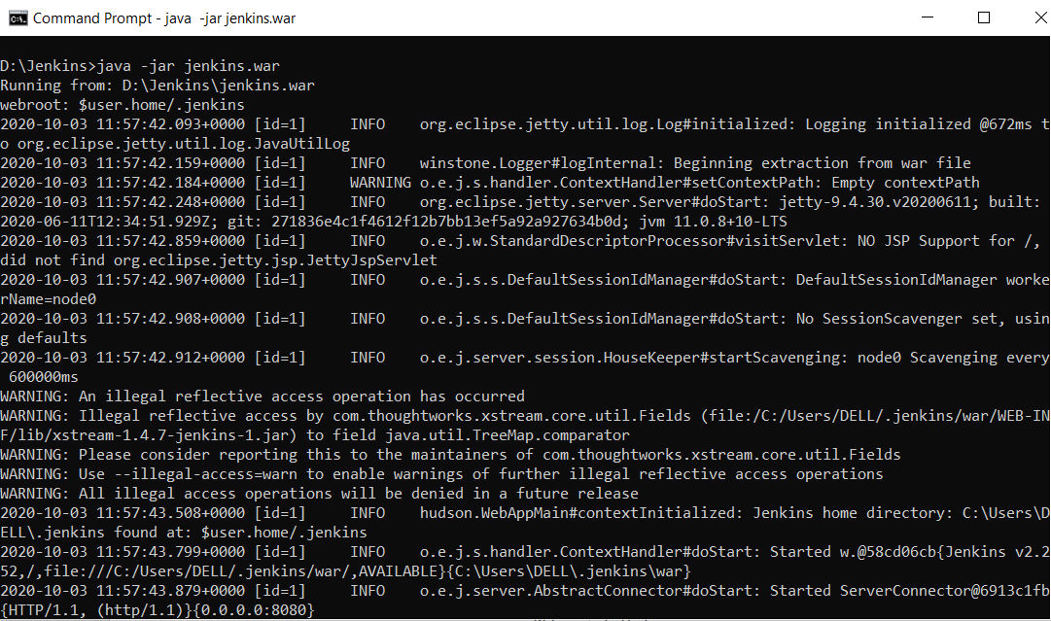

The command takes some to run.

Open the web browser.

Go to localhost:8080 -> This is the port on which Jenkins run

You would be prompted to input the administrator’s password and create a new user.

Log in into the Jenkins dashboard

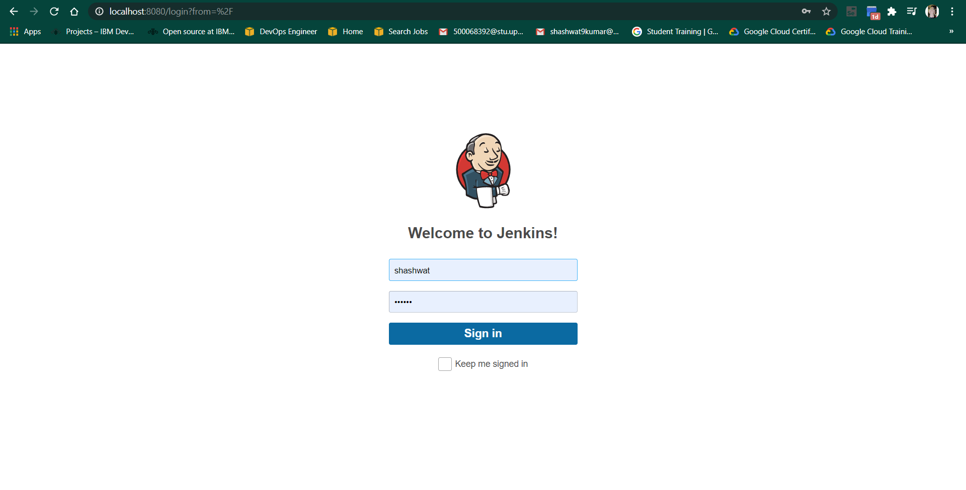

The Dashboard for Jenkins should look something like that:

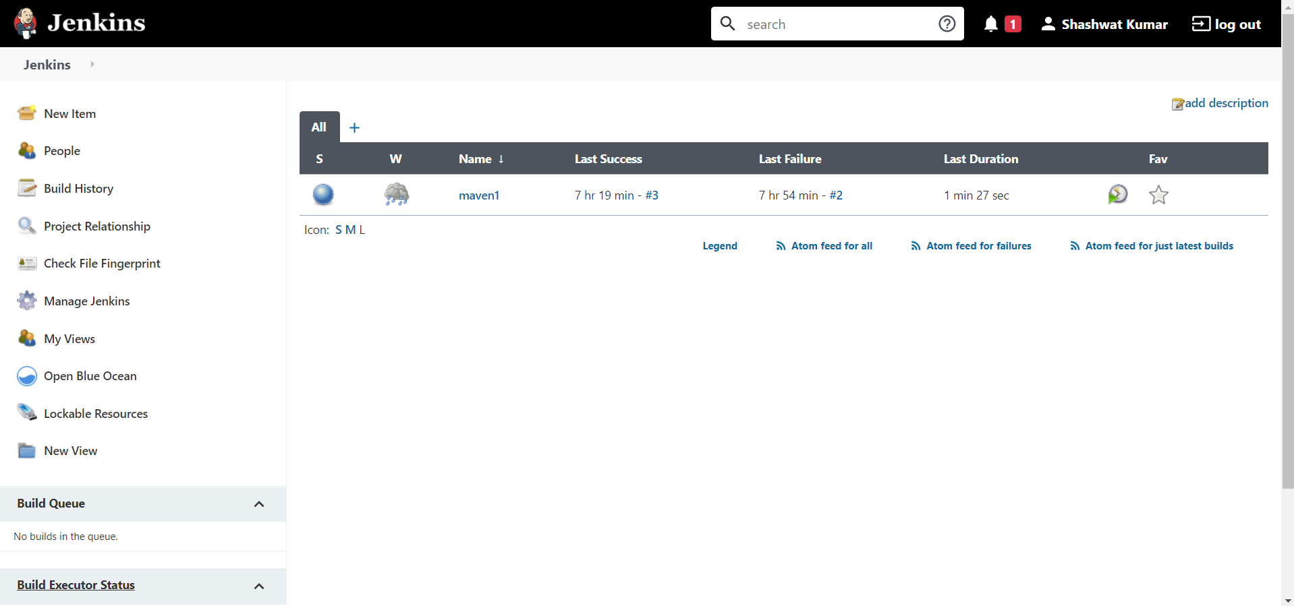

You will have to add the JDK installations and Maven installations to maven.

Go to manage Jenkins option

Go to global tool configuration

In the Java JDK section name the JDK and add the location of JAVA_HOME

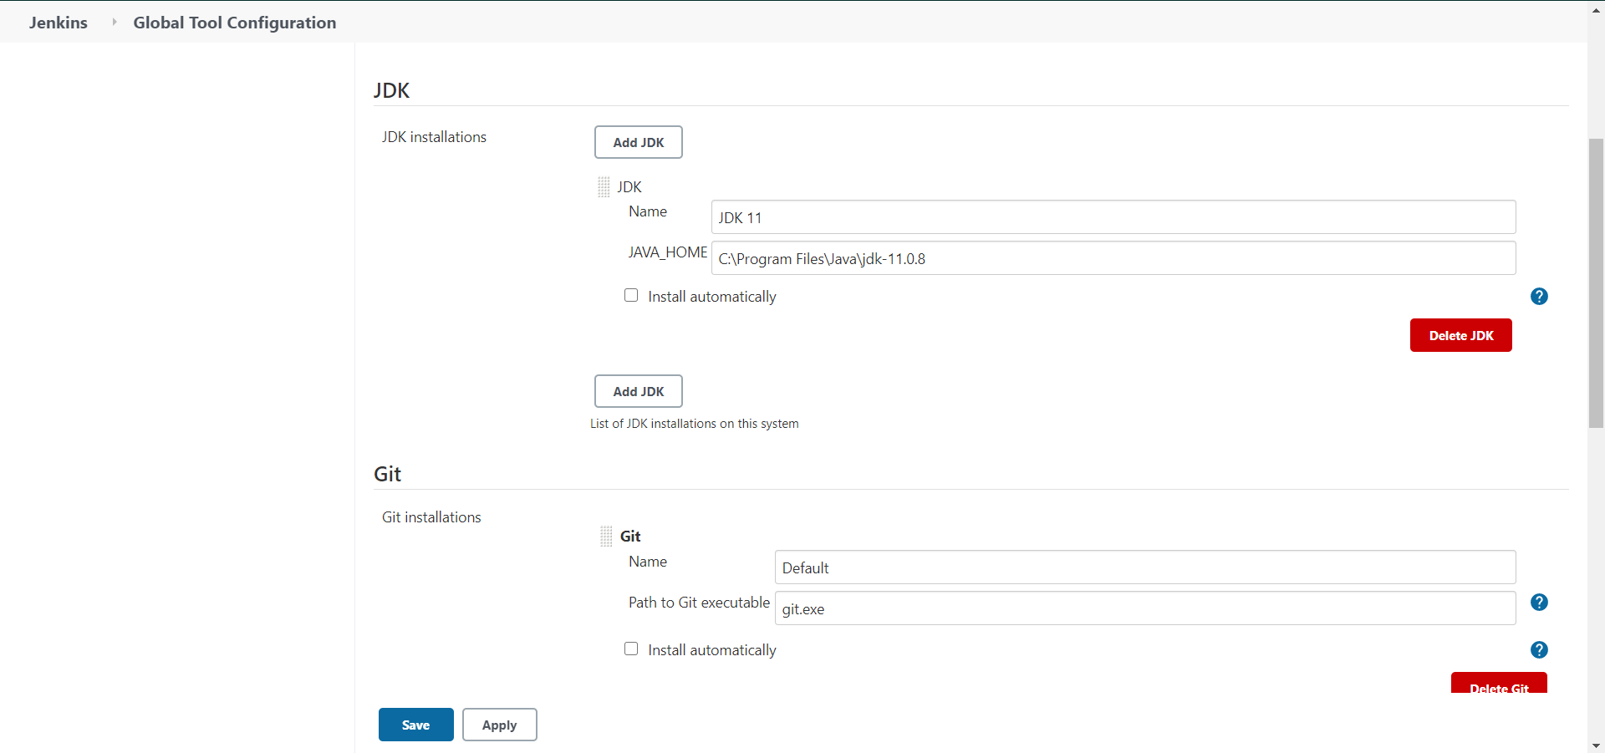

In the Maven Section

Add maven name and MAVEN_HOME location

Save and apply the changes

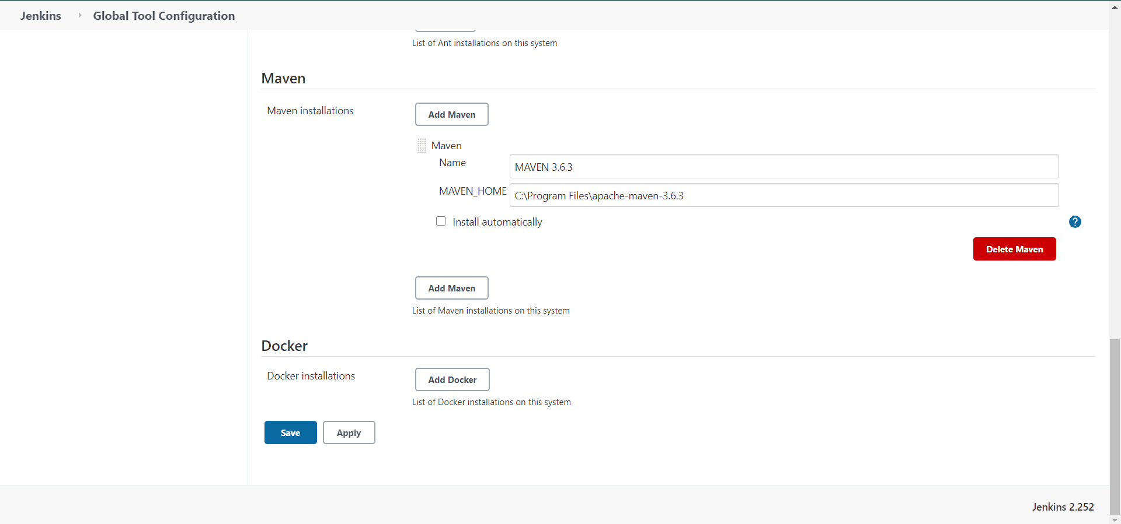

Go to Manage Jenkins again

Select the manage plugins option

Search maven plugin in the available plugins. Install the plugin

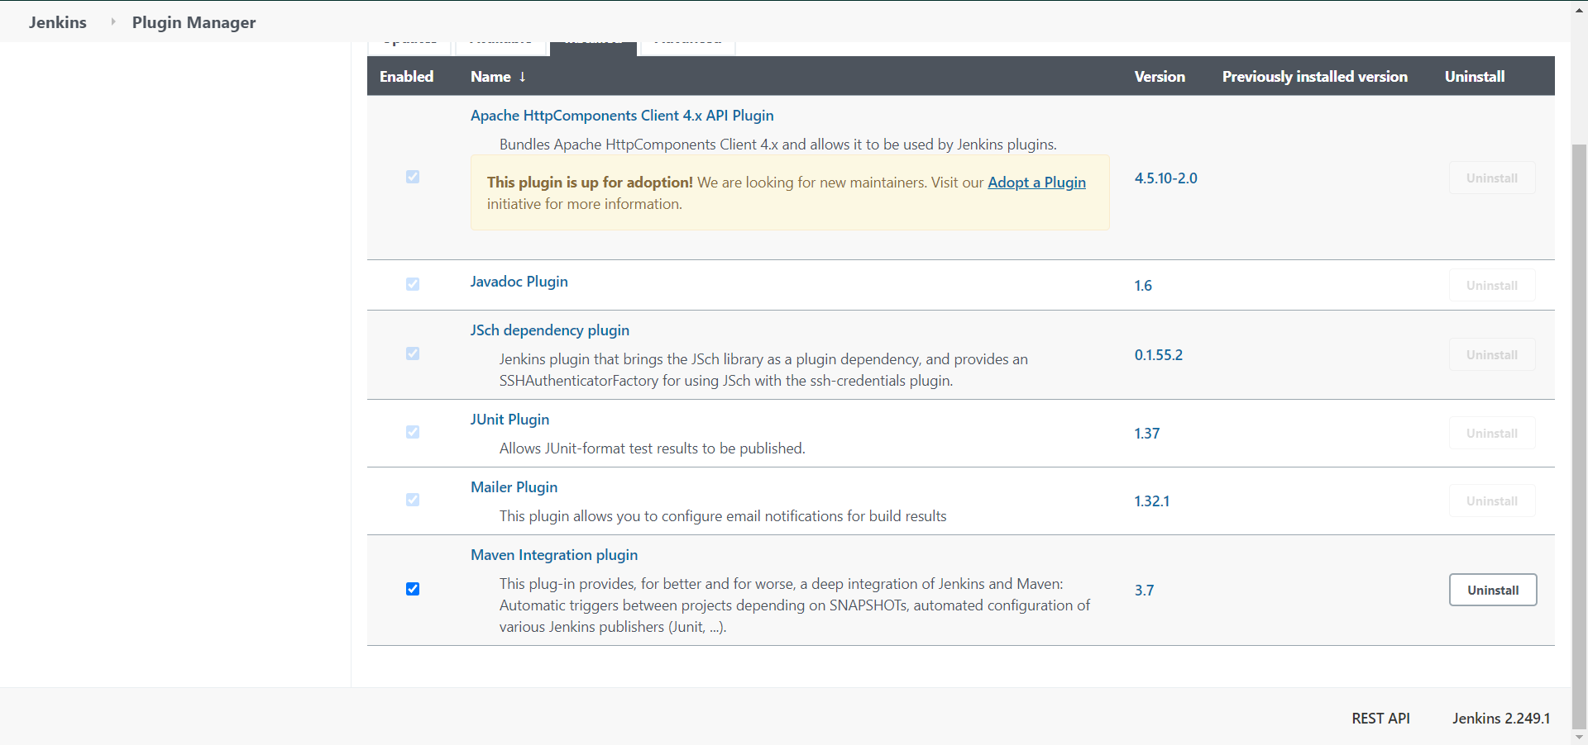

Now with everything set and configured, we are ready to create a Jenkins pipeline.

In the Jenkins dashboard, select new items option

Select a name for your pipeline and check the maven project option.

Click ok

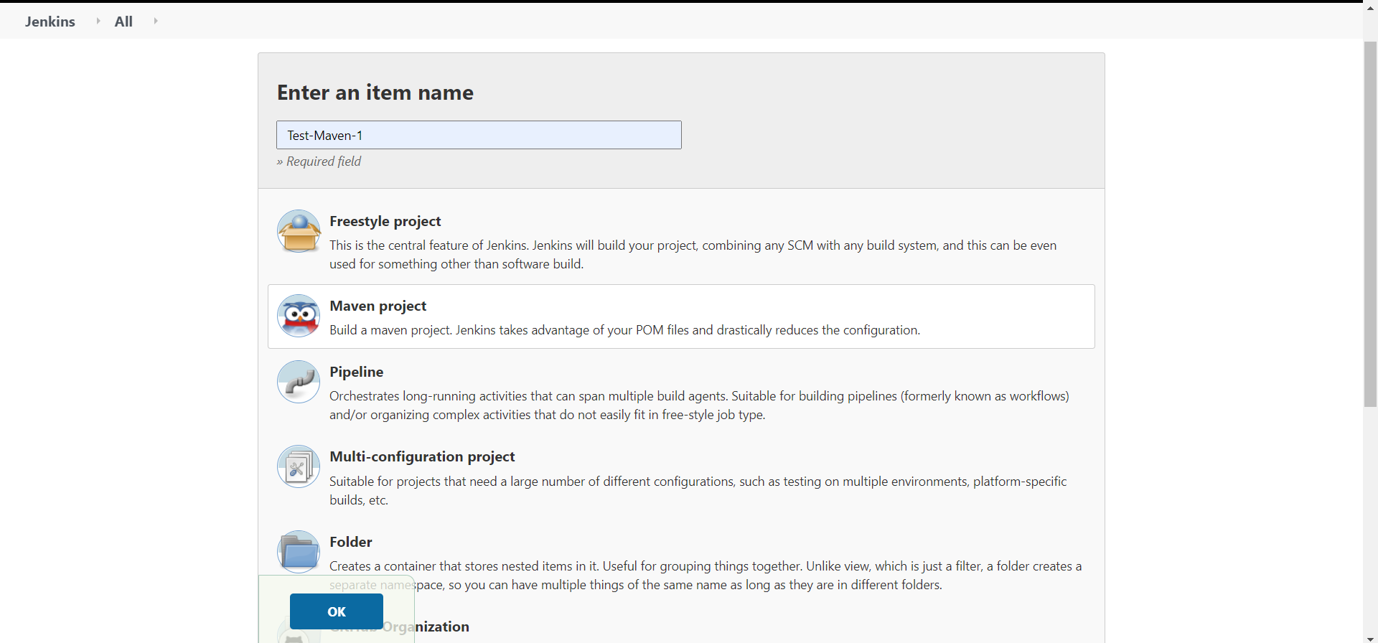

Specify a maven project to Jenkins

Specify the location of pom.xml location.

Specify the project directory

And apply the changes.

The created pipeline should look similar to one shown below:

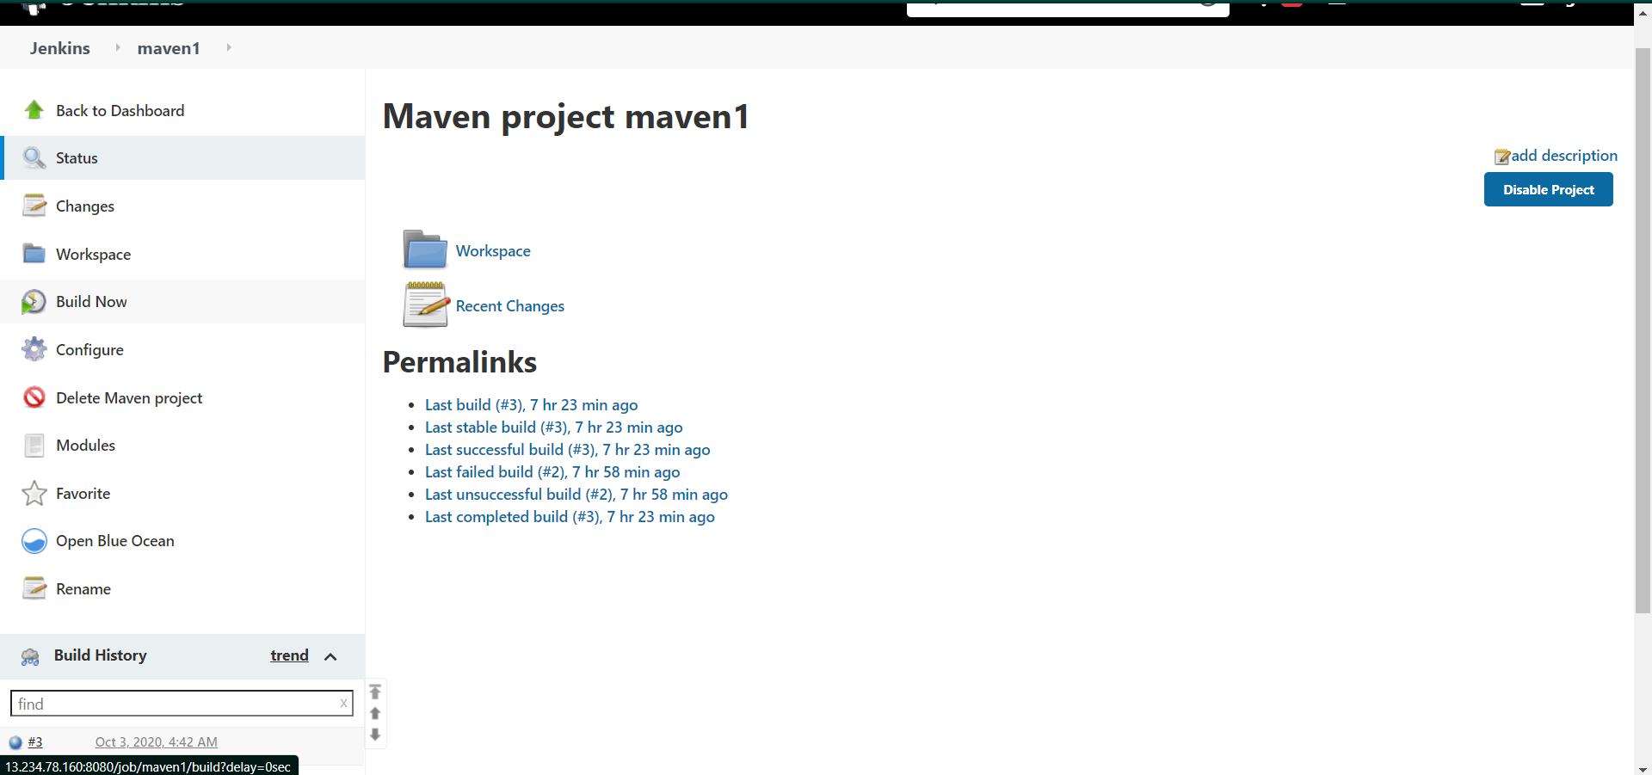

Click on Build now and check the console output for the project

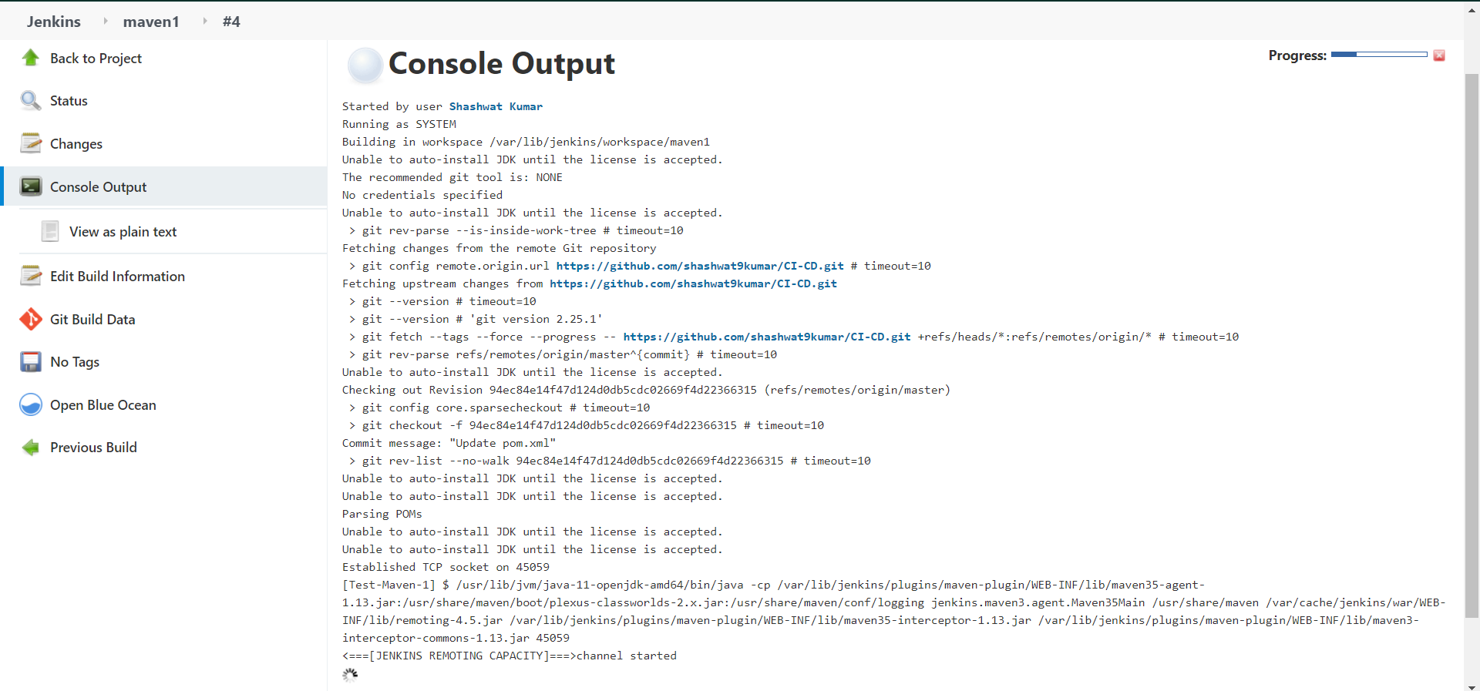

The project should build successfully and return “BUILD SUCCESSFUL”, if no errors were found.

