**Name: Shivani Tyagi**

**Roll Number: R171218097**

**SAP ID: 500067253**

**Lab: 7**

**Create Pipeline using Blue Oceans Plugin**

**Solution:**

Start the Jenkins service using the java -jar jenkins.war command in the command prompt

Go to the Jenkins dashboard at localhost:8080

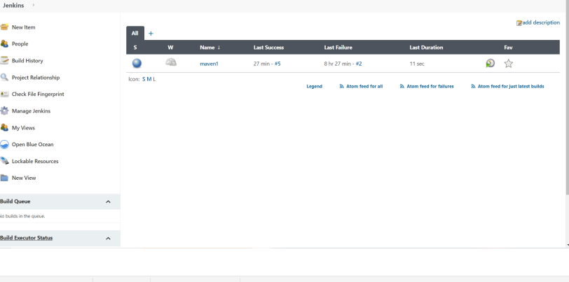

Go to Manage Jenkins and then to manage plugins

Find Blue Ocean plugin and install it in Jenkins

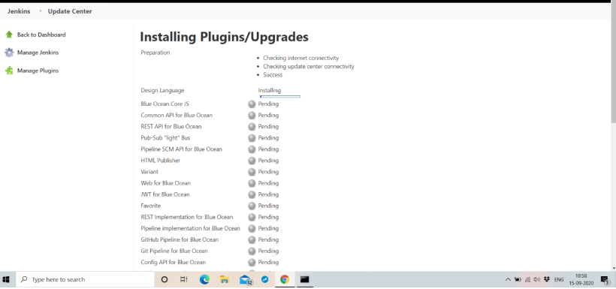

Go to Manage Jenkins and then to manage plugins

Find Blue Ocean plugin and install it in Jenkins

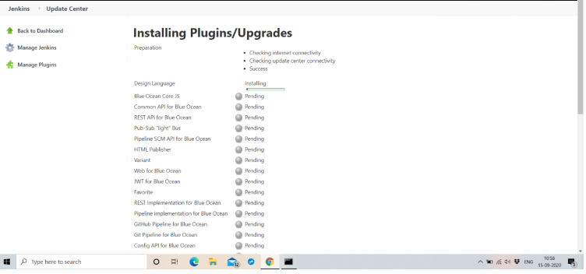

Now you’ll be able to see the Blue Oceans option on the main dashboard

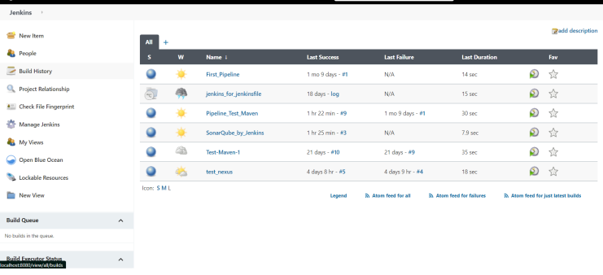

Go to the Blue Ocean Pipeline

You will land on a page very similar to this

Select Git as the SCM manager for the project

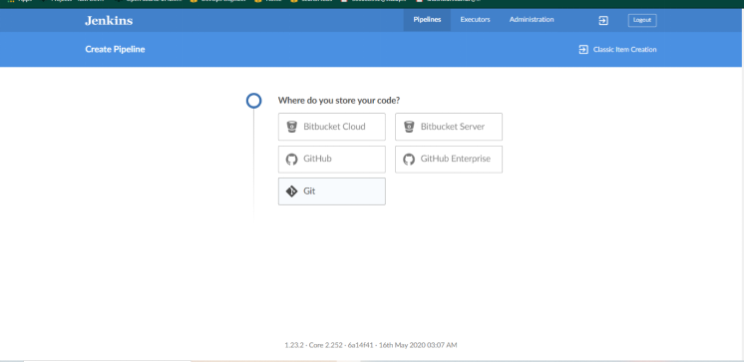

rovide the same repository URL in the required placeholder

Provide the username and password for your github account

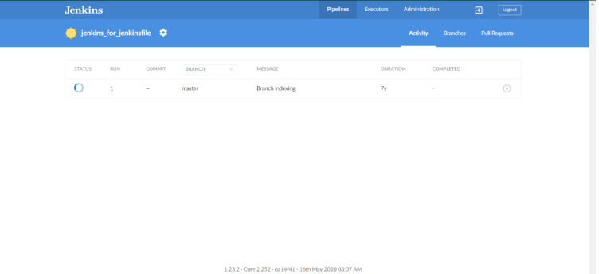

Once the Build process completes successfully, it would turn green

If any errors happens during the build process, the pipeline turns red.

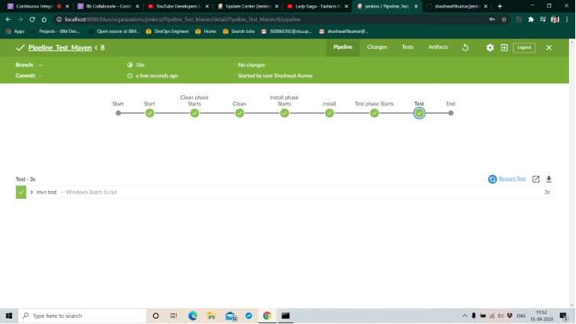

The commands executed can also be seen in the terminal provided in the bottom half of the window.

