**Name: Shivani Tyagi**

**Roll Number: R171218097**

**SAP ID: 500067253**

**Lab: 9**

**Uploading artifacts on Nexus server using command line**

**Solution:**

Head over to: sonatype.com/nexus/repository-oss/download to download nexus server

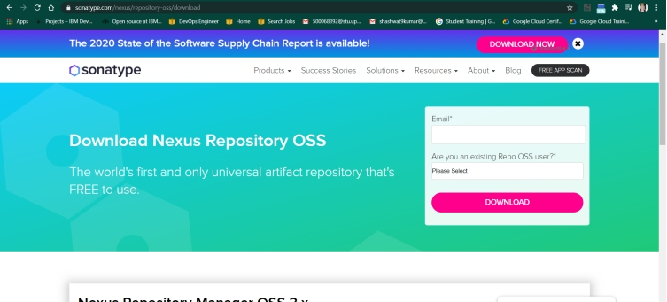

Go to the location where nexus is installed.

Open the bin folder to find nexus.exe file

Open command prompt in the same folder and run the following command :

Nexus.exe /run

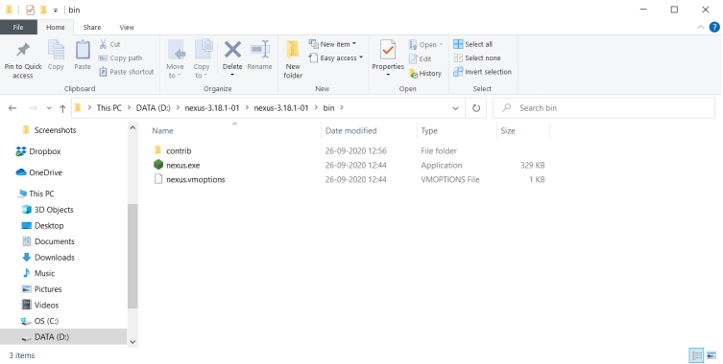

Once the command runs head to localhost:8081, the port where Nexus server runs

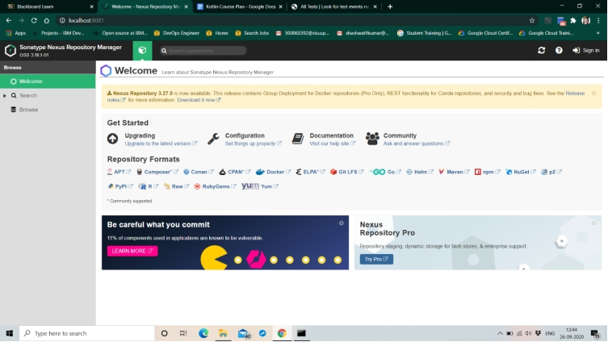

For the first time, nexus requests the admin password already given with the installation.

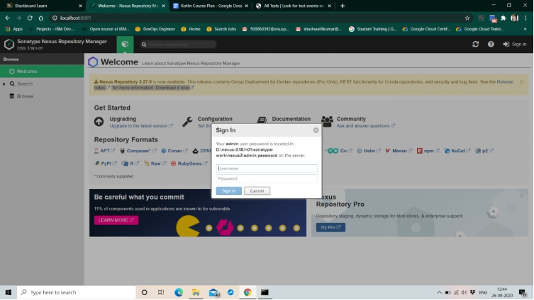

Find the default admin password at the sonatype-works/nexus3/ folder with the name admin.password

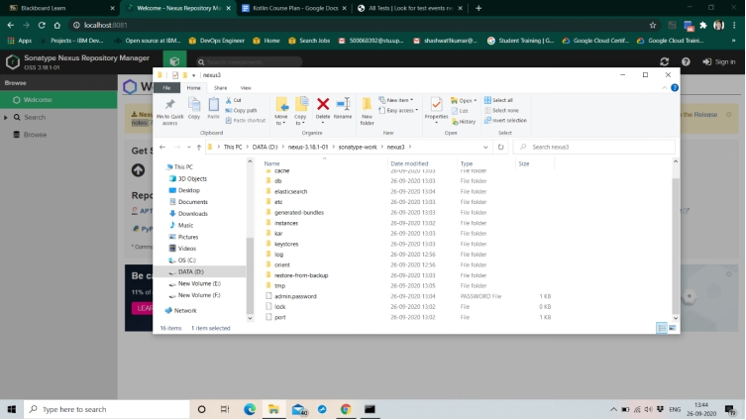

Complete the set-up, to create a new admin username and password and login

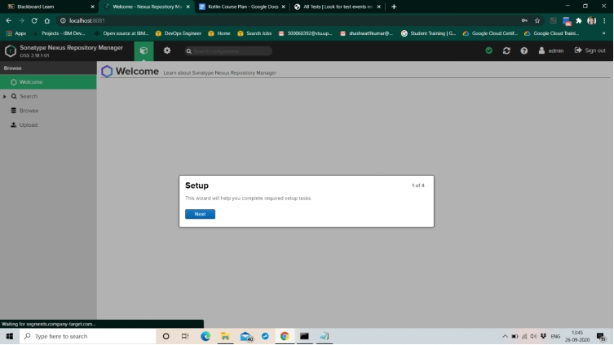

On login, Nexus server dashboard should look similar to this

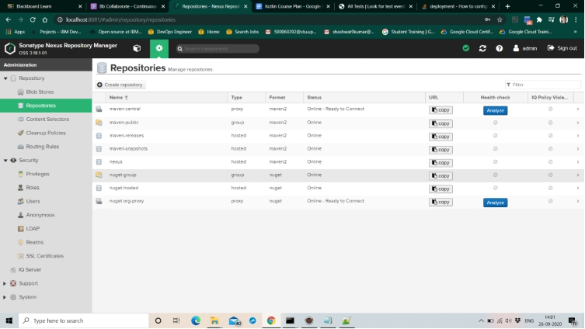

Create a new repository in Nexus (here called “nexus”) and copy its URL

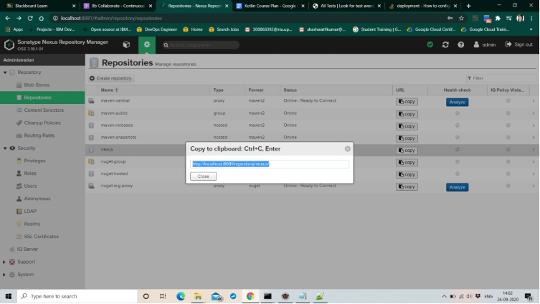

Open the pom.xml of the Maven project to be published to Nexus

Add the snapshotRepository tag into the pom.xml and give the URL of Nexus repository copied

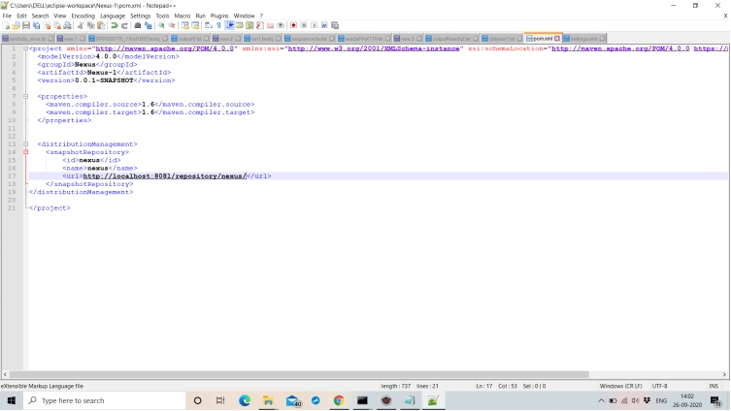

Now, open setting.xml in the “apache-maven-3.6.3” folder

Add the tag of server with the required credentials

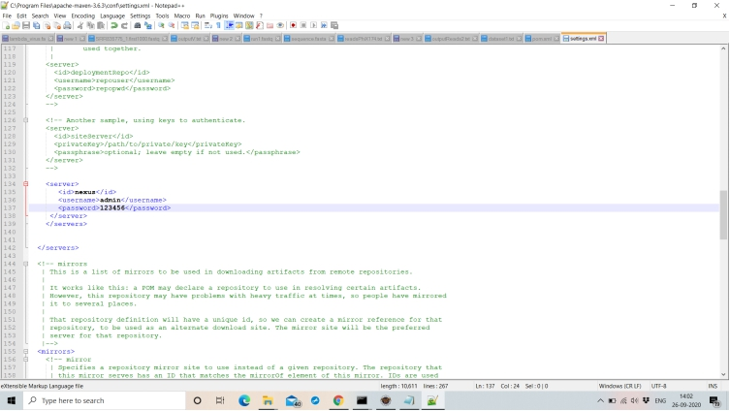

To check the working of the maven project, open it in the command prompt and run “mvn clean”, “mvn install”, etc. command on it

