**Name: Shivani Tyagi**

**Roll Number: R171218097**

**SAP ID: 500067253**

**Lab: 5**

**Jenkins integration with SonarQube**

**Solution:**

Go to the Jenkins dashboard at localhost:8080

Click on the new item option

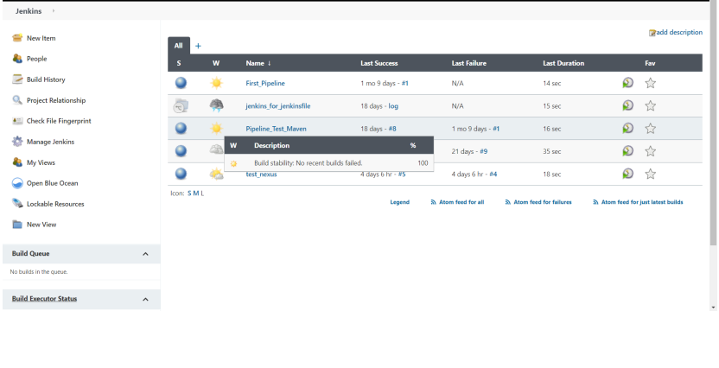

Enter the name for the project

Select project type as maven project

Click on OK

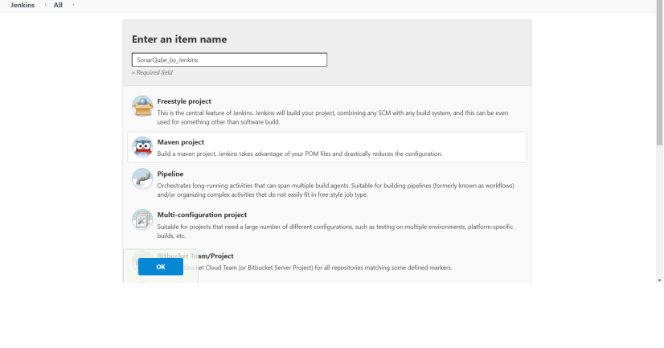

In the dashboard that appears, go the source code management and provide the location of the github repository that hold the Jenkinsfile for the maven command invocation.

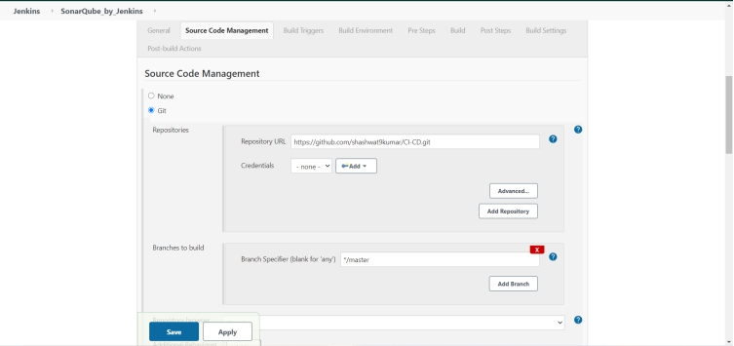

Provide the complete path of the pom.xml file.

If it lies inside a folder use {folder_name}/pom.xml

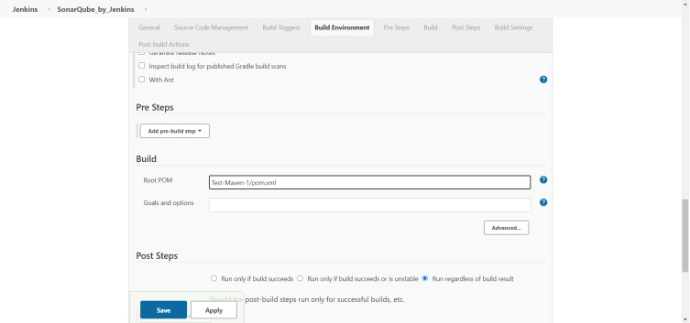

The Jenkinsfile for the project must contain a stage that defines the following command:

mvn sonar:sonar -Dsonar.host.url=http://localhost:9000 -Dsonar.analysis.mode=publish

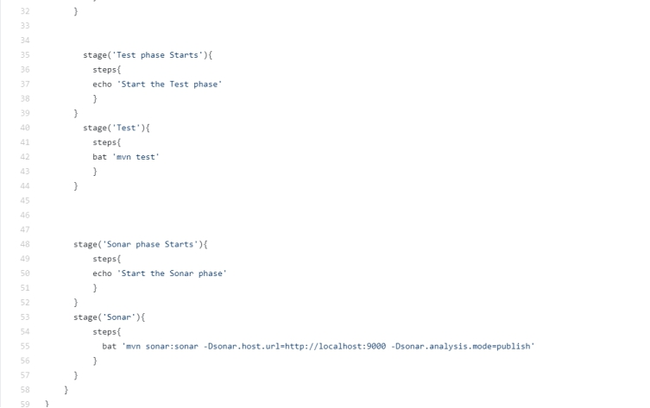

The project should lead you to a dashboard similar to this.

Click on the build now option

Click the option of console output to check the build process

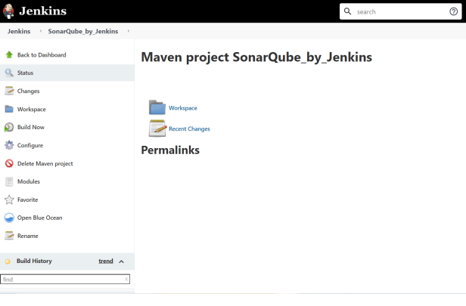

The build starts to happen

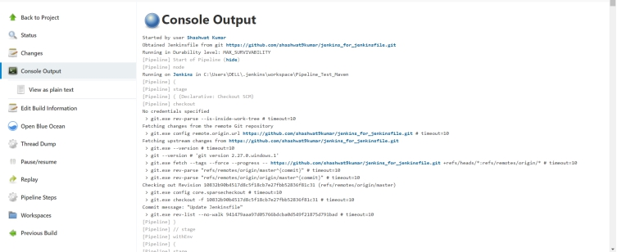

If the build becomes successful, then it would reflect “BUILD SUCCESS” and give the location (as a URL) where the code report is published.

As in this case it shows it is available at: <http://localhost:9000/dashboard?id=Sonar_Test%3ASonar_Test>

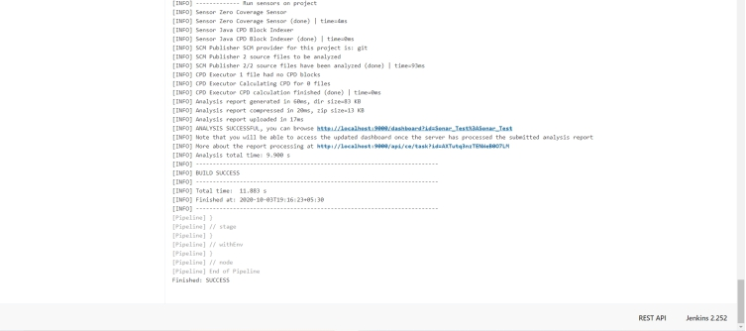

Visiting the given URL, it shows the report for the code compiled and published.

