**EXPERIMENT-1**

* **JENKINS SETUP**

**STEP-1**

Go to Link [**https://www.jenkins.io/download/**](https://www.jenkins.io/download/)

**STEP-2**

Click on Generic Java Package (.war):- This will download a (.war) file

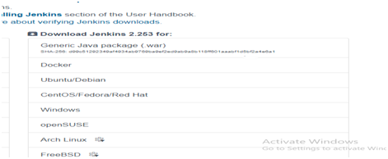

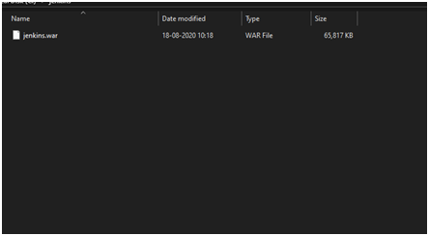

**STEP-3**

Open Command Prompt and go to Jenkins folder through CMD

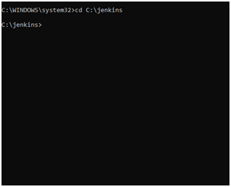

**STEP-4**

Now run command: — java –jar jenkins.war

· Note:- Your System should have JDK ( VERSION 8 TO 11 anyone )

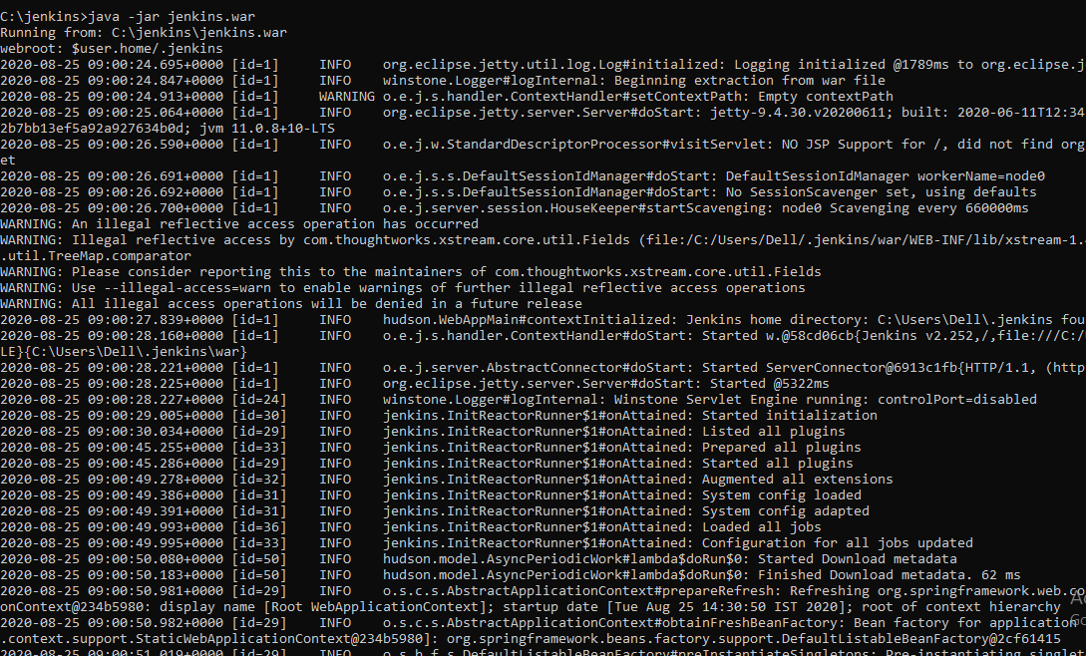

**STEP-5**

After running the command go to chrome and type: — **localhost:8080**

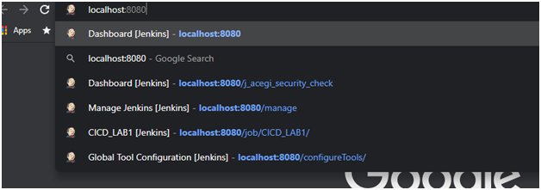

· This will Open your login page

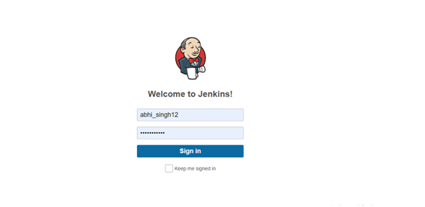

· After Logging Your Dashboard will be visible

