**EXPERIMENT-2**

**Setting up JENKINS environment using MAVEN AND GITHUB**

**Step: 1**

**Creating Github Repo.**

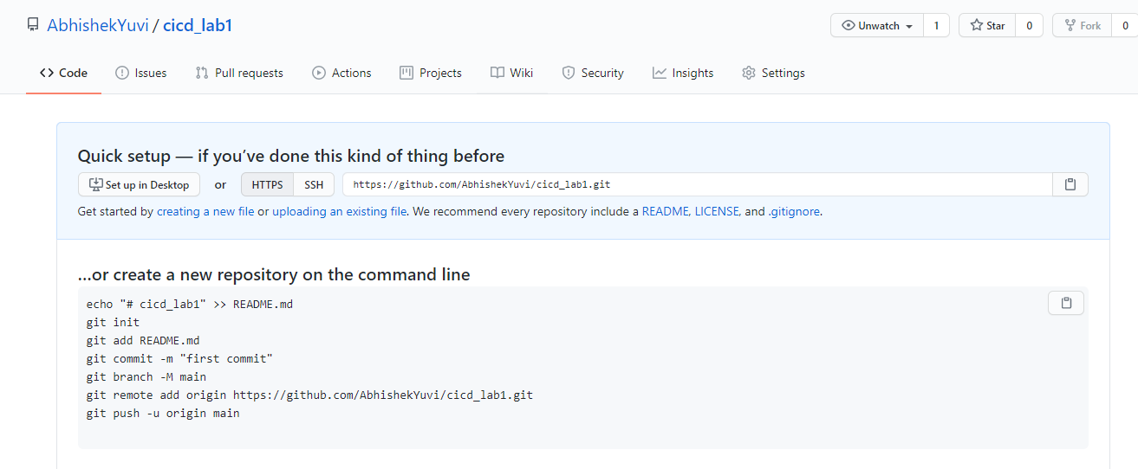

**Step: 2**

**Using Eclipse IDE Add Maven project to Github Repo you first created**

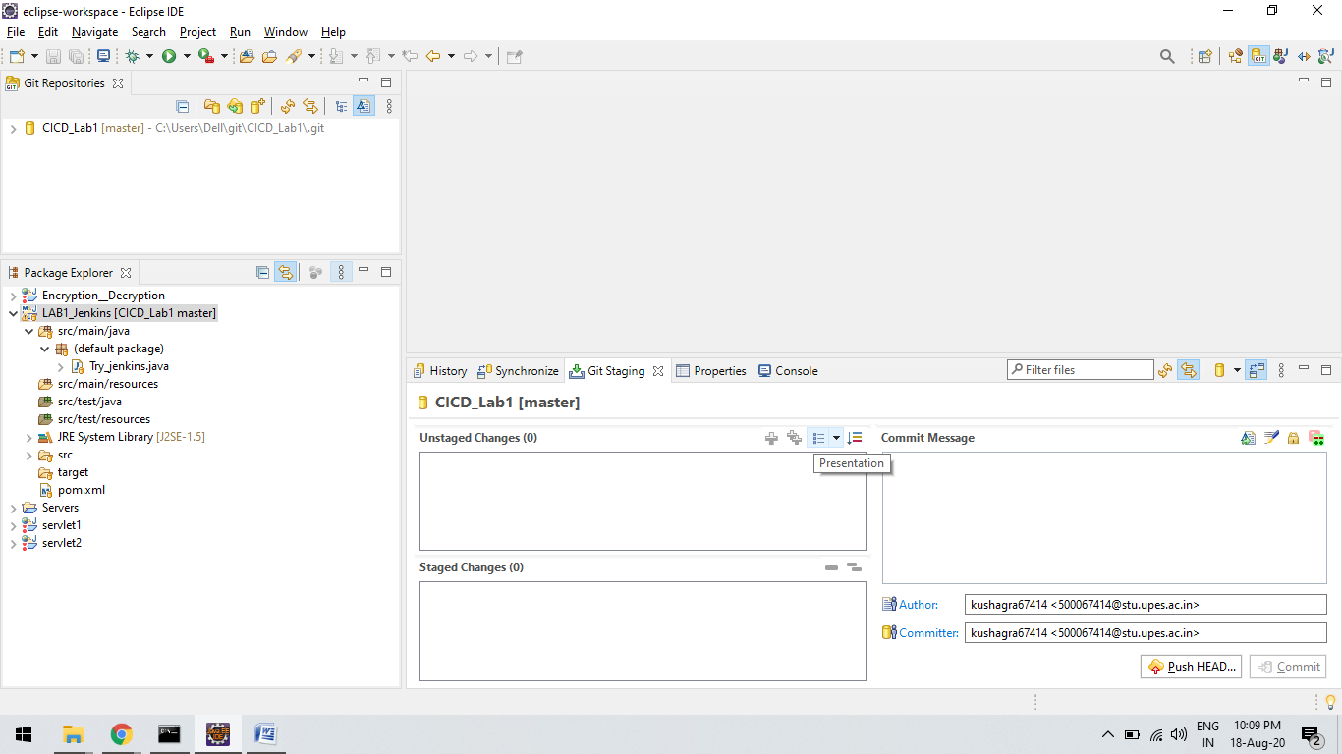

**Step 3 :** 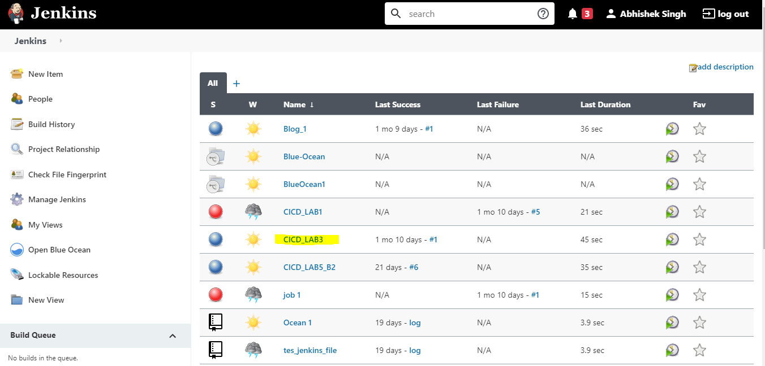

**Create a JOB on JENKINS AS “cicd_Lab3” and Configure it..**

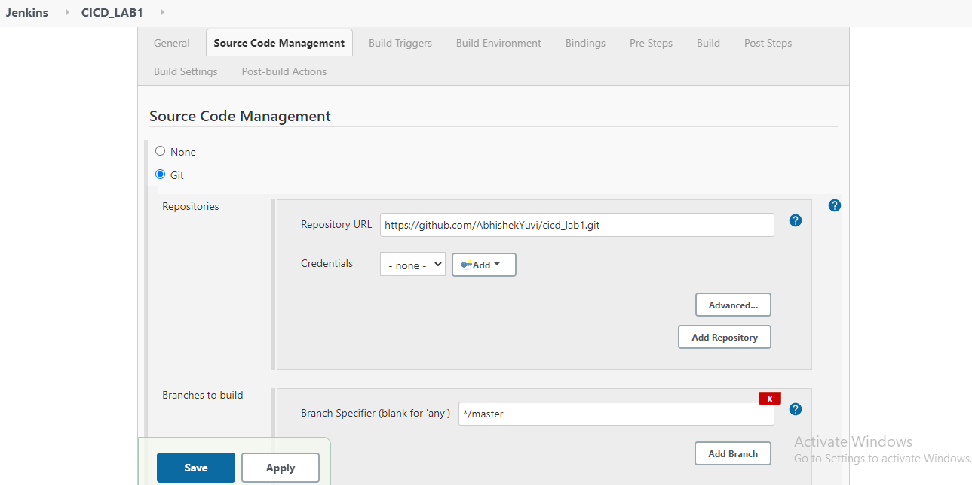

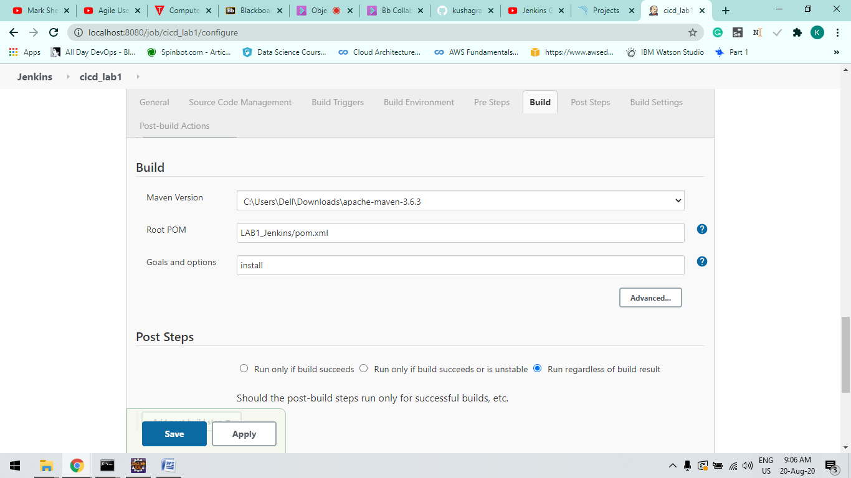

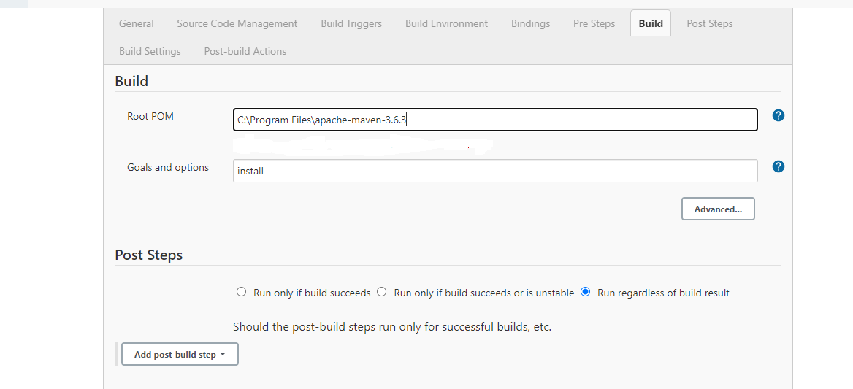

***Step-4 :***

**Now Click on Build now Option at Left Side of you window and verify the Build Success**

