**Expeiment-3**

**Using Static Code analysis Tool “SONARQUBE”**

STEP-1

For analysis you need to download a Software “SonarScanner”

Go to Link <https://docs.sonarqube.org/latest/analysis/scan/sonarscanner/>

STEP-2

Click on which system you want to download the software **(**I am doing it on [Windows 64-bit](https://binaries.sonarsource.com/Distribution/sonar-scanner-cli/sonar-scanner-cli-4.4.0.2170-windows.zip) **)**

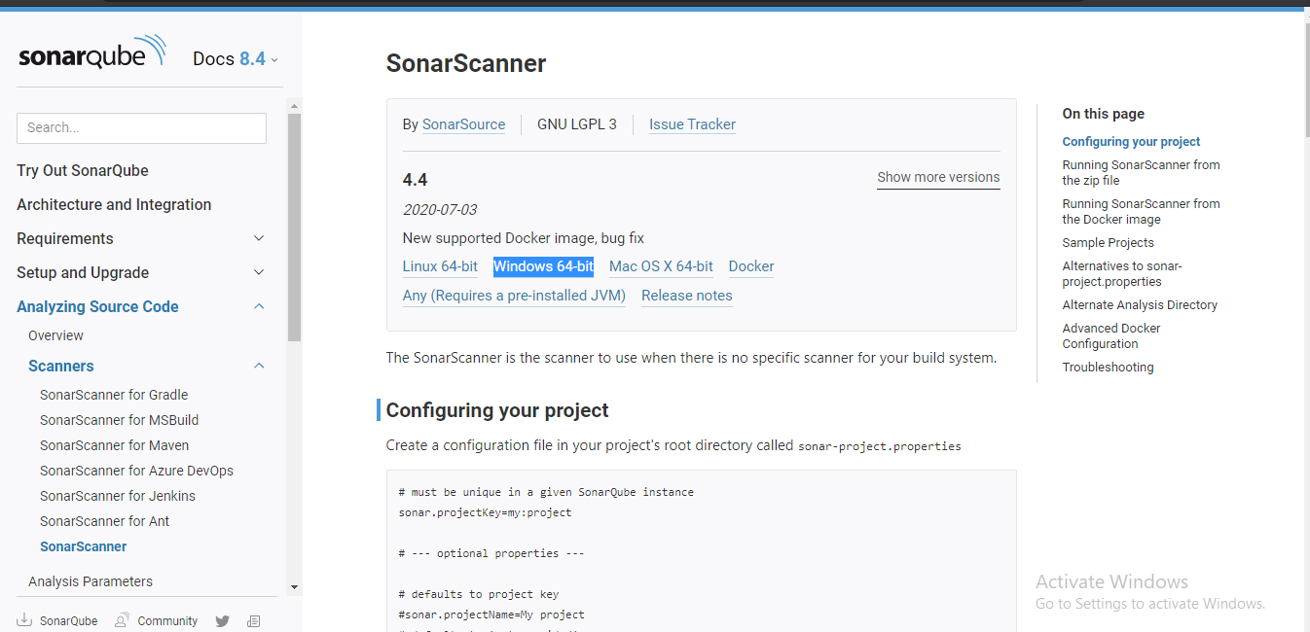

STEP-3

Extract your file

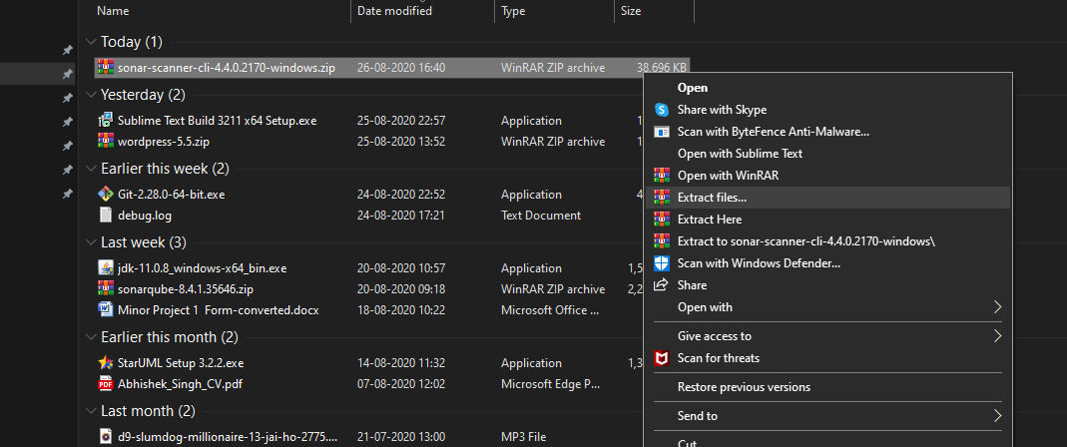

STEP-4

Make a project on eclipse which will be used for analysis

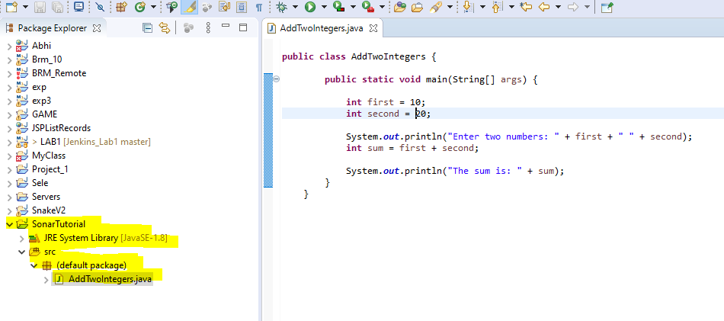

STEP-5

Go to SonarScanner configuration folder and edit sonar-scanner.properties

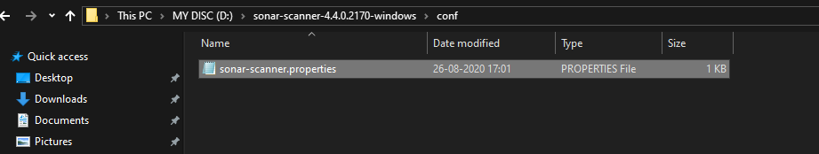

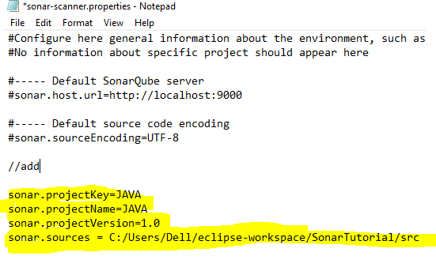

STEP-6

Now Open your COMMAND PROMPT and go to your project location and run command

“sonar-scanner.bat”

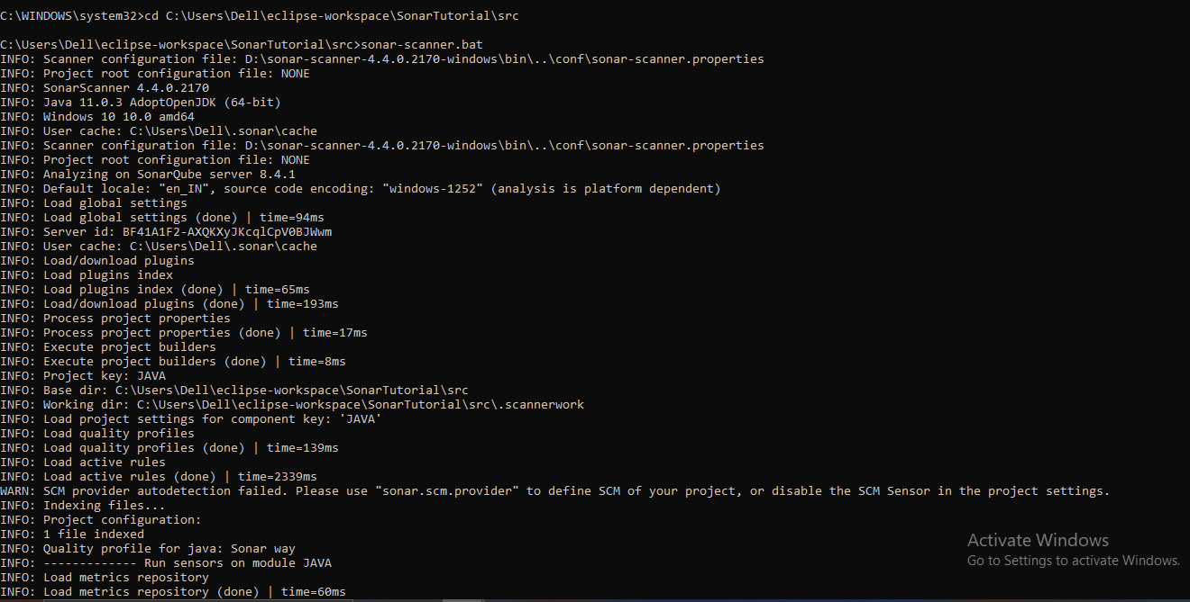

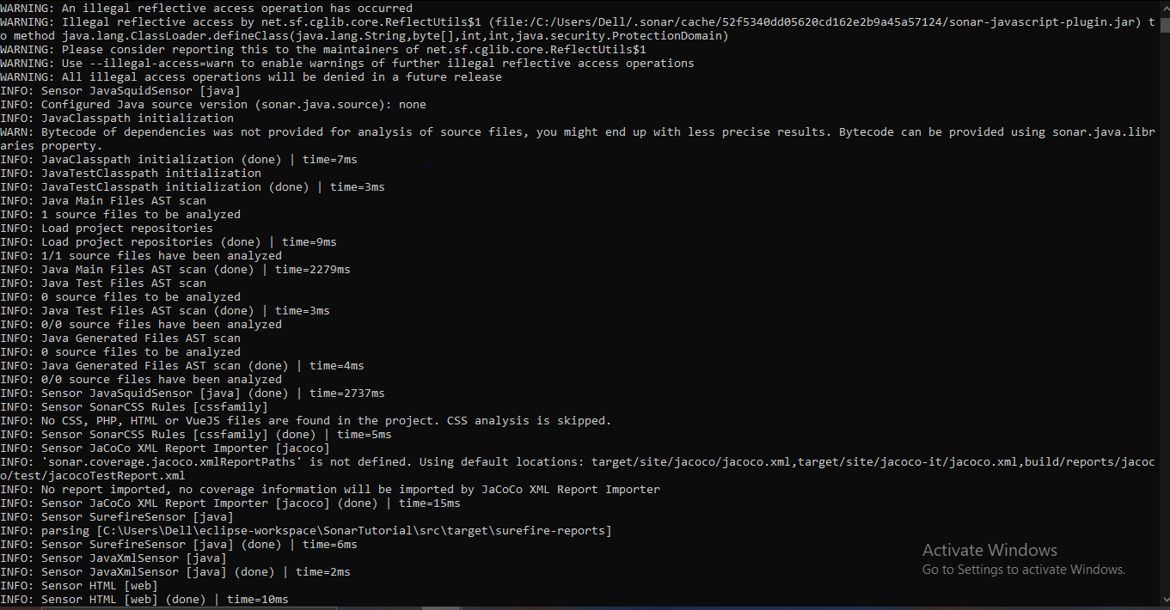

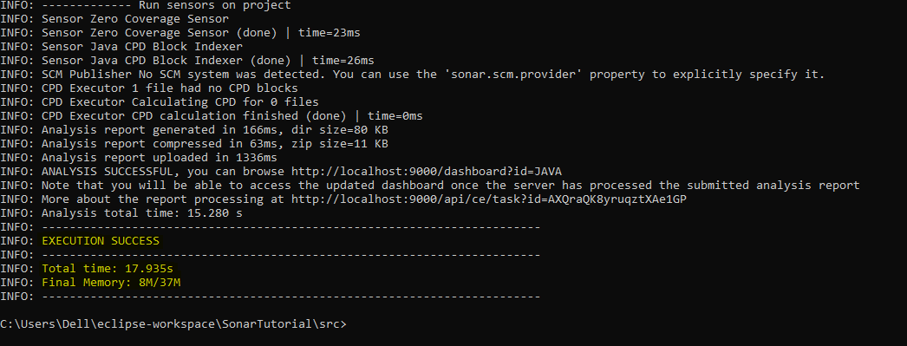

**YOU WILL GET EXECUTION SUCCESS!!!**

STEP-7

Check you “localhost” on chrome it show your project analysis

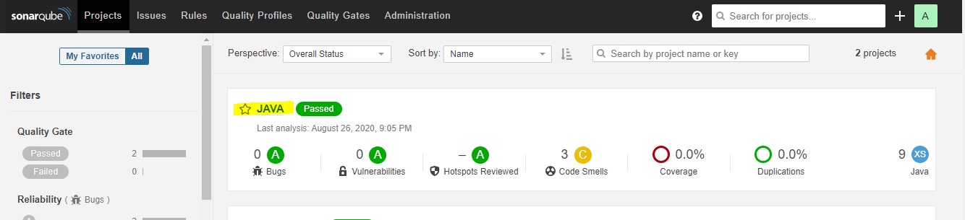

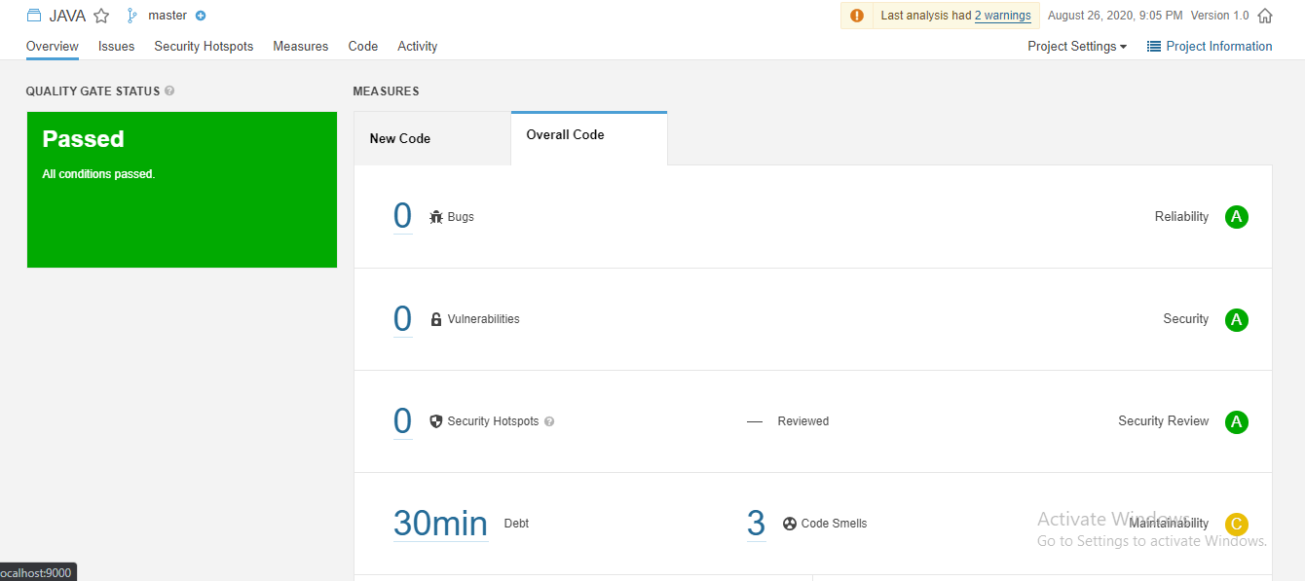

PROJECT ANALYSIS COMPLETE!!!!!!!!!