**EXPERIMENT-5 (TERRAFORM AND AWS )**

**Terraform :-**

* Terraform is a tool for building, changing, and versioning infrastructure safely and efficiently. Terraform can manage existing and popular service providers as well as custom in-house solutions.
* Configuration files describe to Terraform the components needed to run a single application or your entire datacenter.
* Terraform generates an execution plan describing what it will do to reach the desired state, and then executes it to build the described infrastructure.
* As the configuration changes, Terraform is able to determine what changed and create incremental execution plans which can be applied.

**AWS ( Amazon Web Service ) :-**

Amazon Web Services provides a highly reliable, scalable, low-cost infrastructure platform in the cloud that powers hundreds of thousands of businesses around the world.

 Industries are taking advantage of the following benefits :-

1. Low Cost

### Agility and Instant Elasticity

### Open and Flexible

### Secure

***Implementation are given in the following steps :-***

**Step 1 : Terraform Initializing**

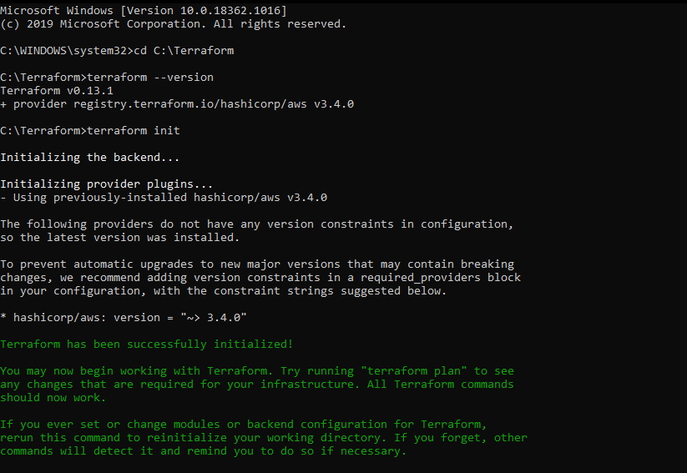

**Step 2 : Terraform Planing**

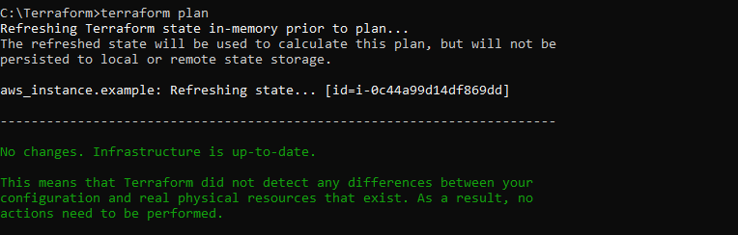

**Step 3 : Terraform Applying**

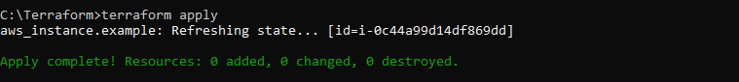

***Instance Running***

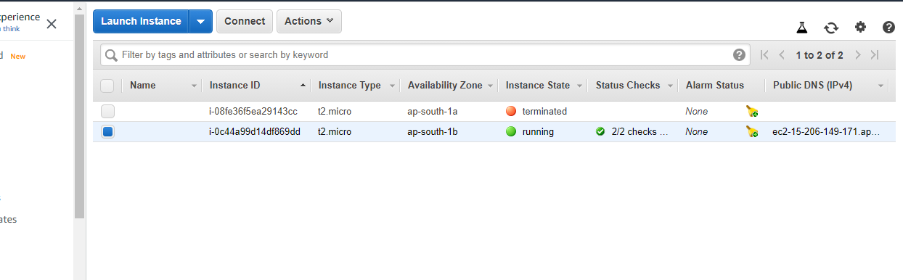

**Step 4 : Terraform Destroying**

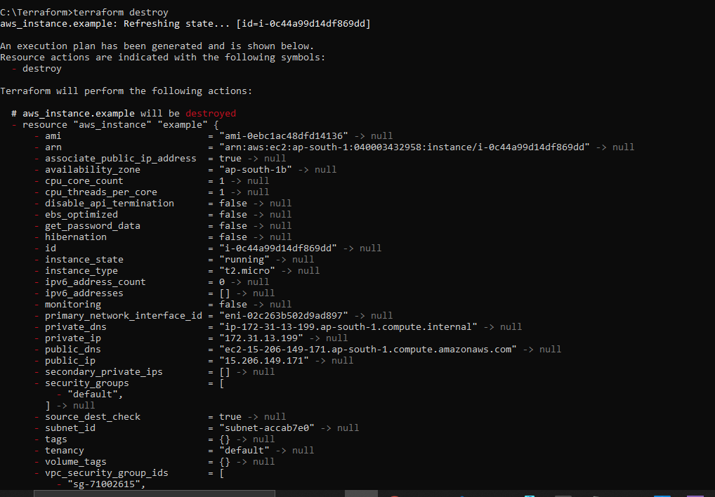

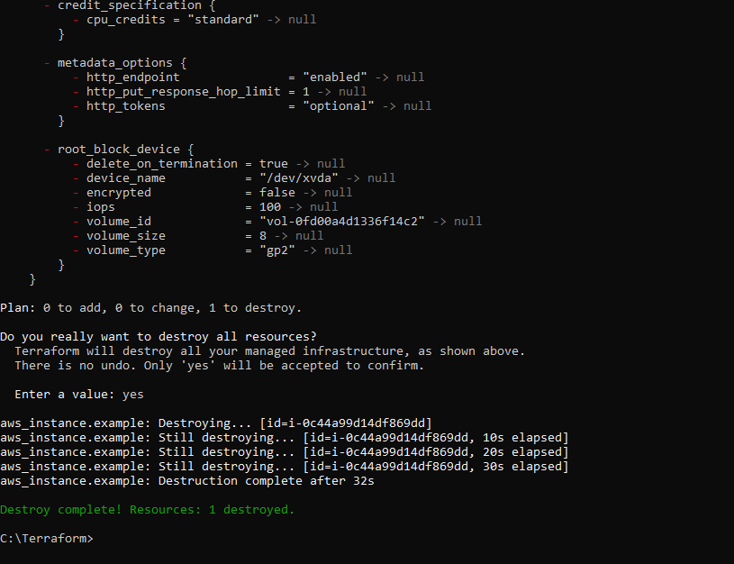

***Instance Terminated***

