**EXPERIMENT-6**

**Working of Slave-1 :-**

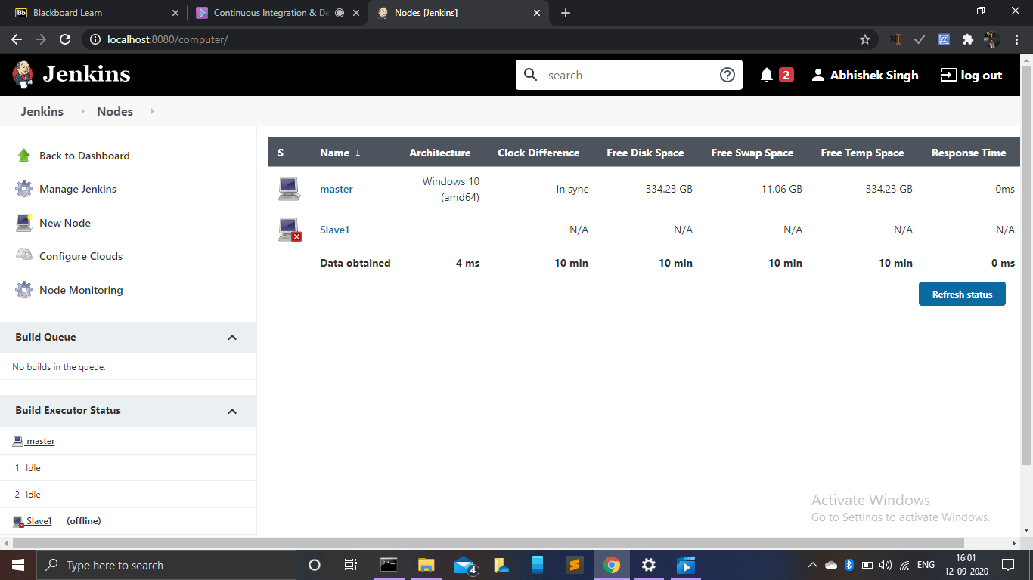

**After Running command on Terminal:**

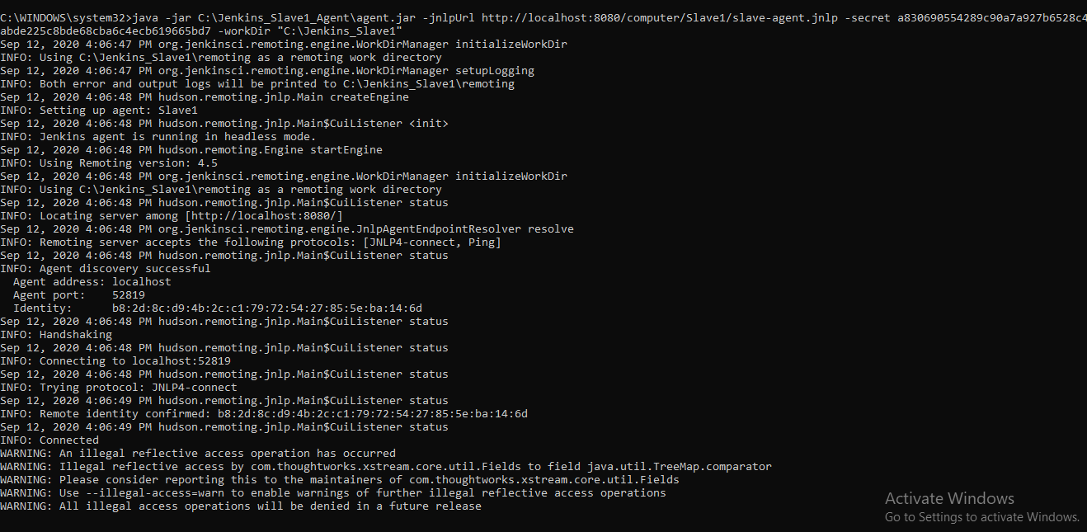

***Now***

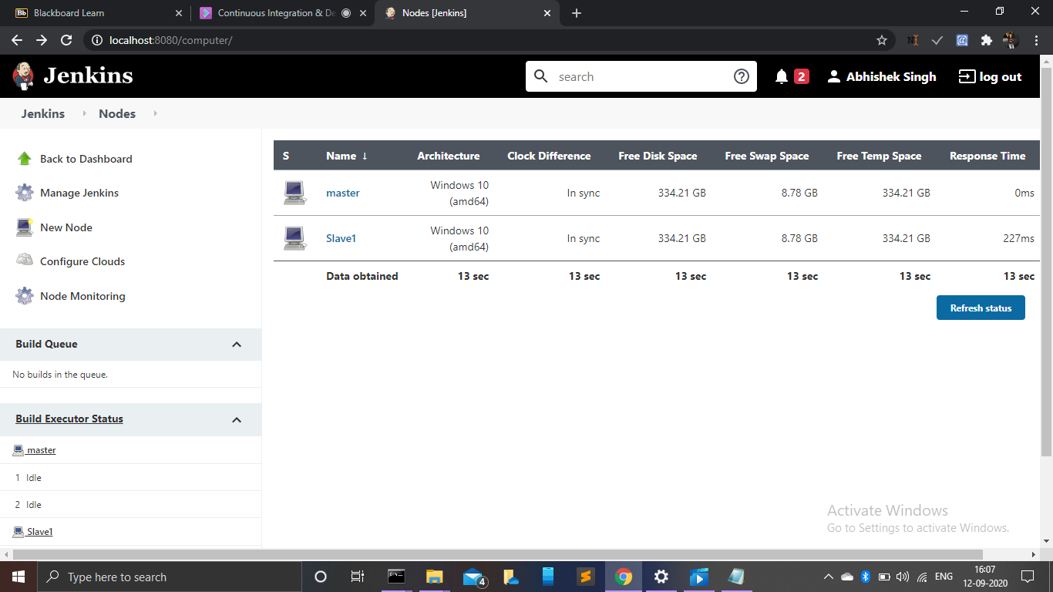

* After making slave BUILD your Maven project

***Console OutPut :-***

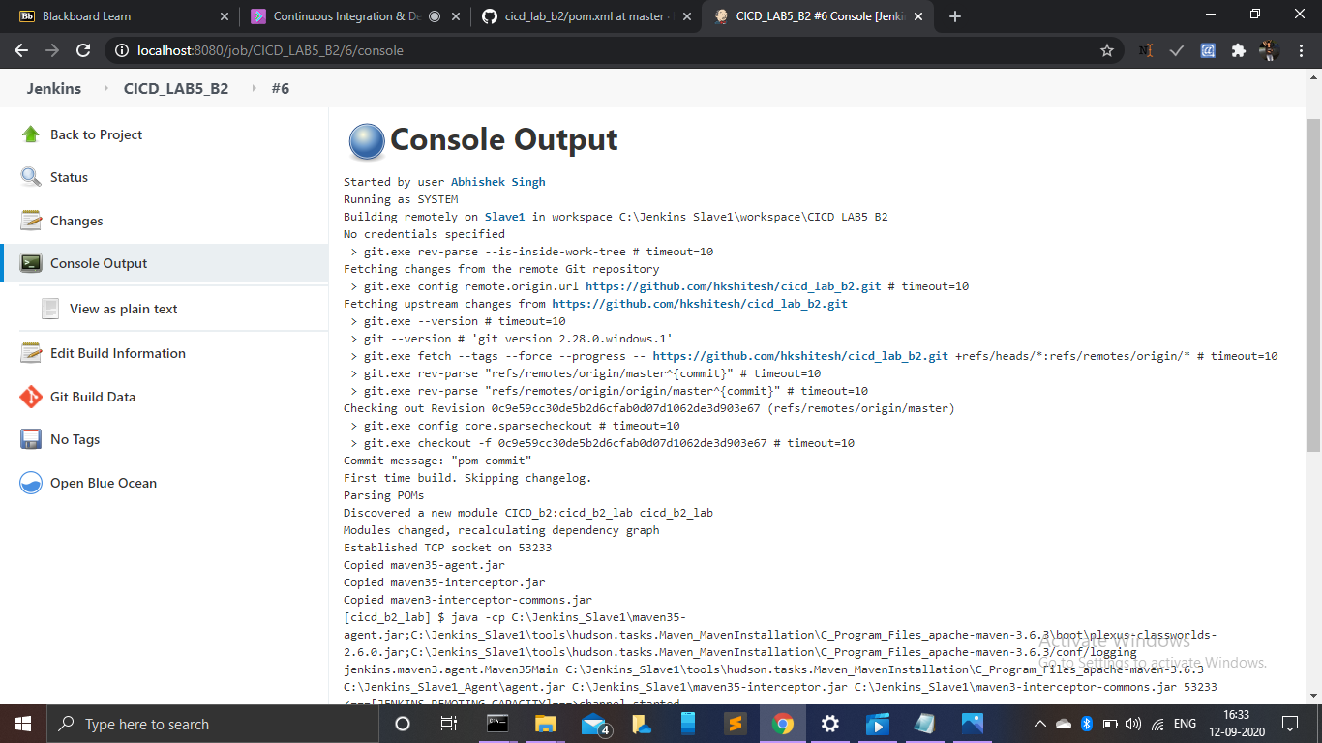

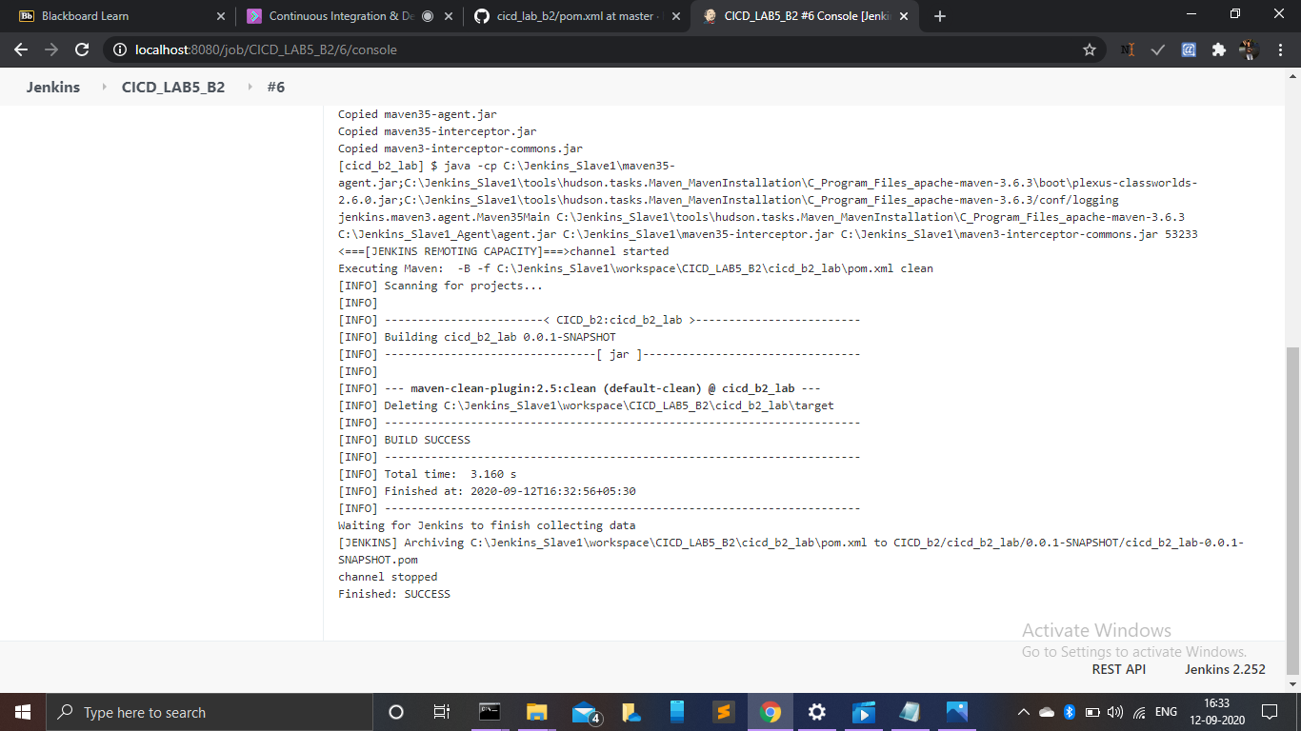

***NOW YOUR FOLDER***

***Jenkins_Slave1 Will look like***

