**EXPERIMENT-7**

BlueOcean Plugin Install:-

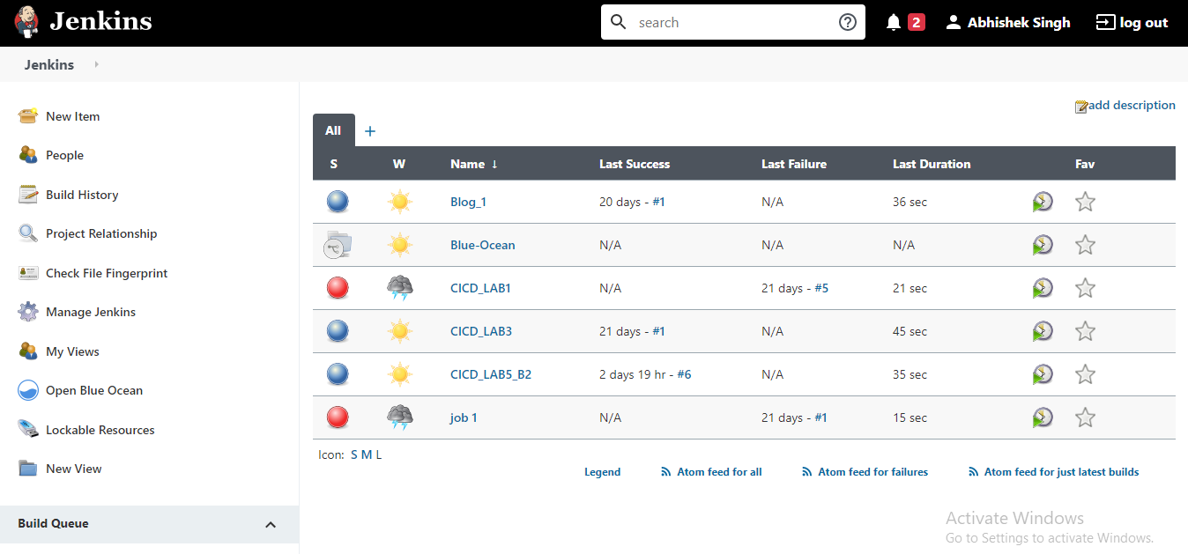

Jenkins File at GitHub:-

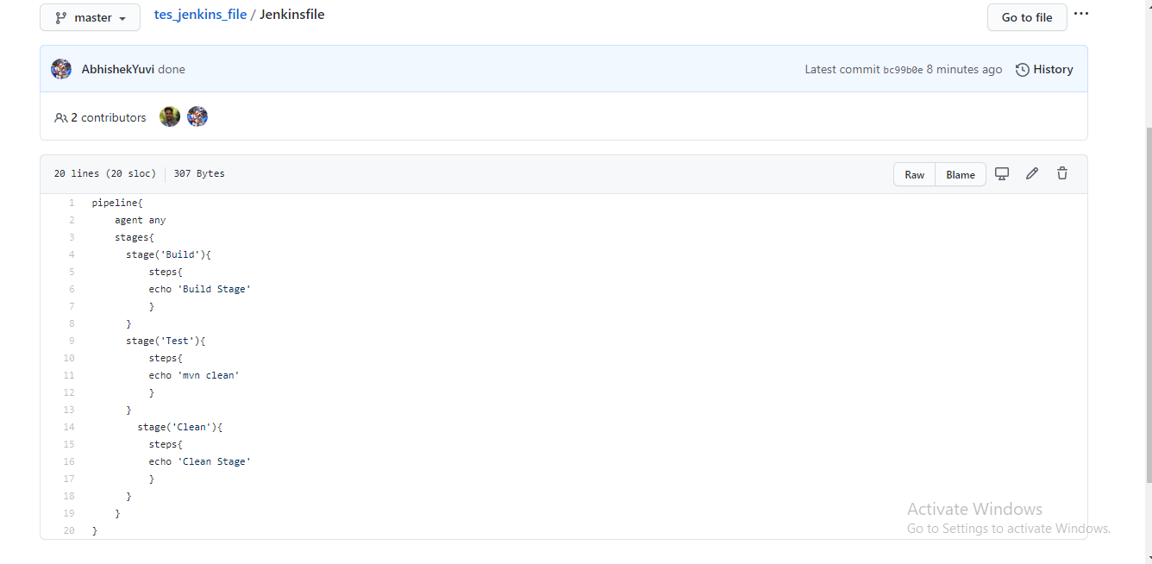

Pipeline Created:-

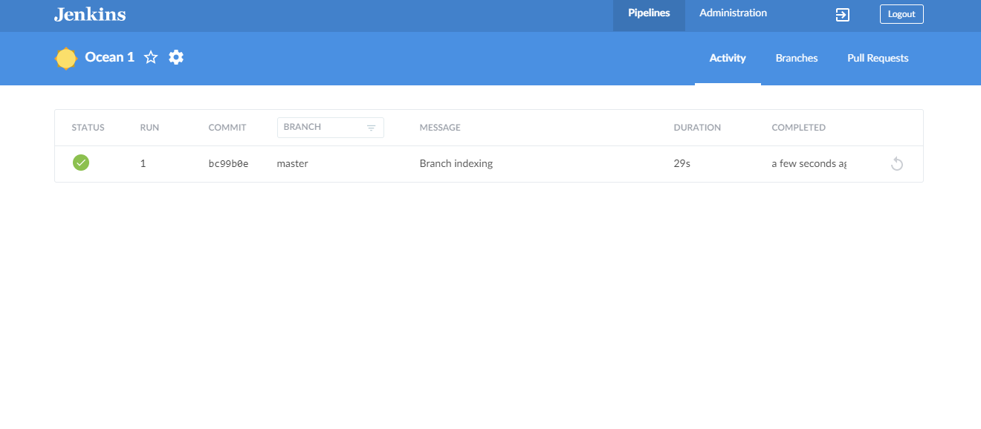

OUTPUT:-

