**Experiment-9**

**Jenkins integration with SonarQube**

Click on the new item option

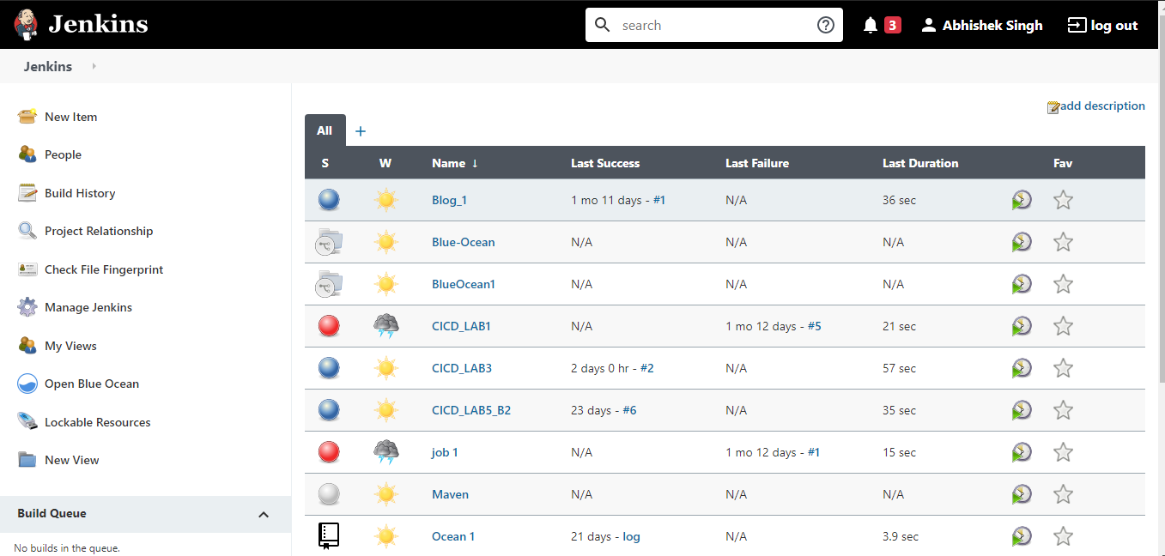

Enter the name for the project

Select project type as maven project

Click on OK

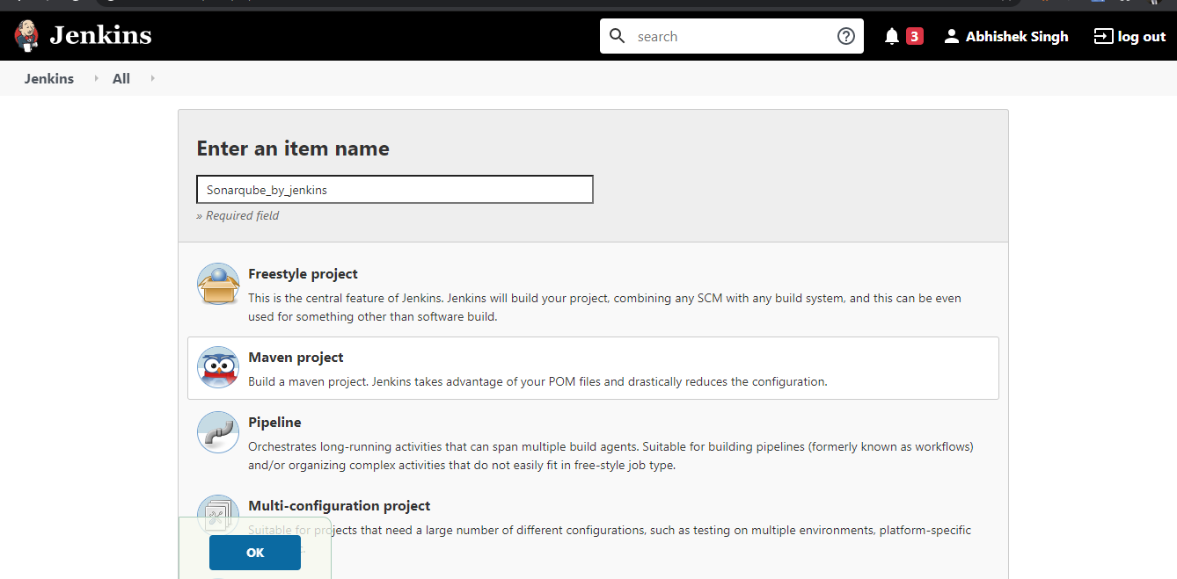

In the dashboard that appears, go the source code management and provide the location of the github repository that hold the Jenkinsfile for the maven command invocation.

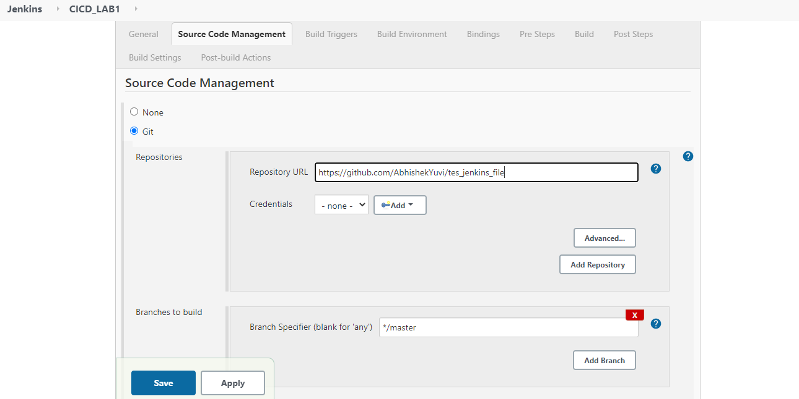

Provide the complete path of the pom.xml file.

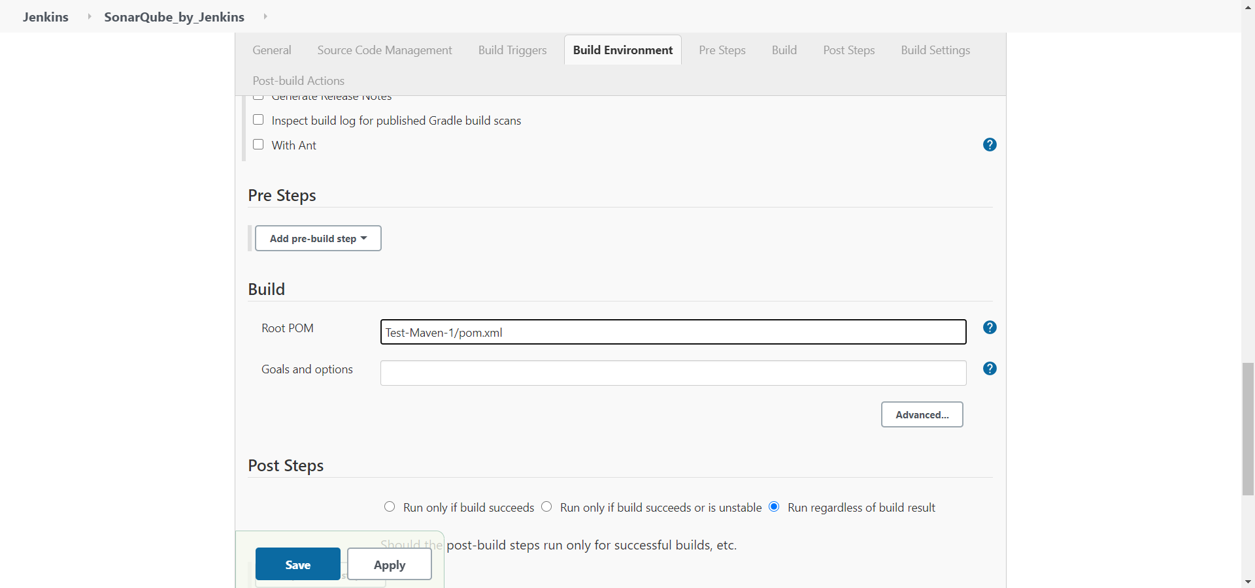

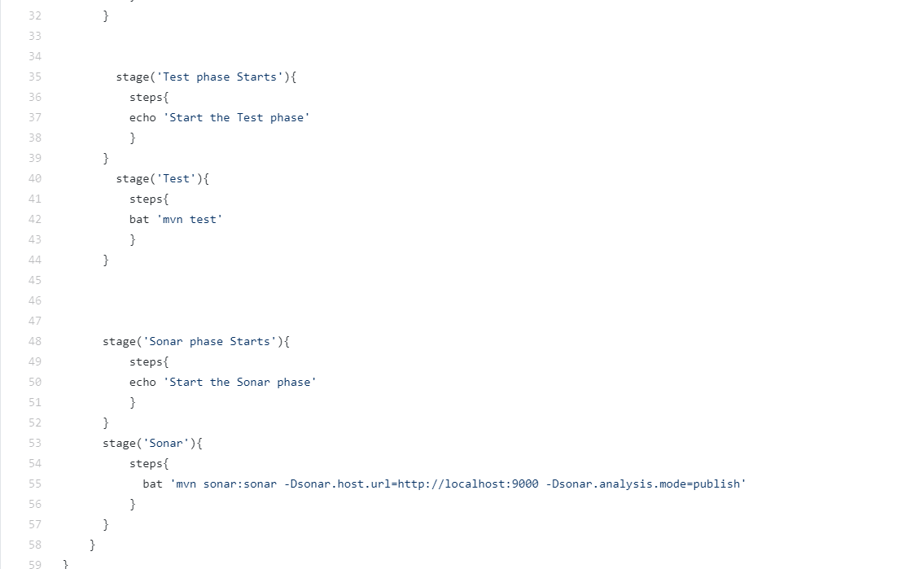

The project should lead you to a dashboard similar to this.

Click on the build now option

Click the option of console output to check the build process

The build starts to happen

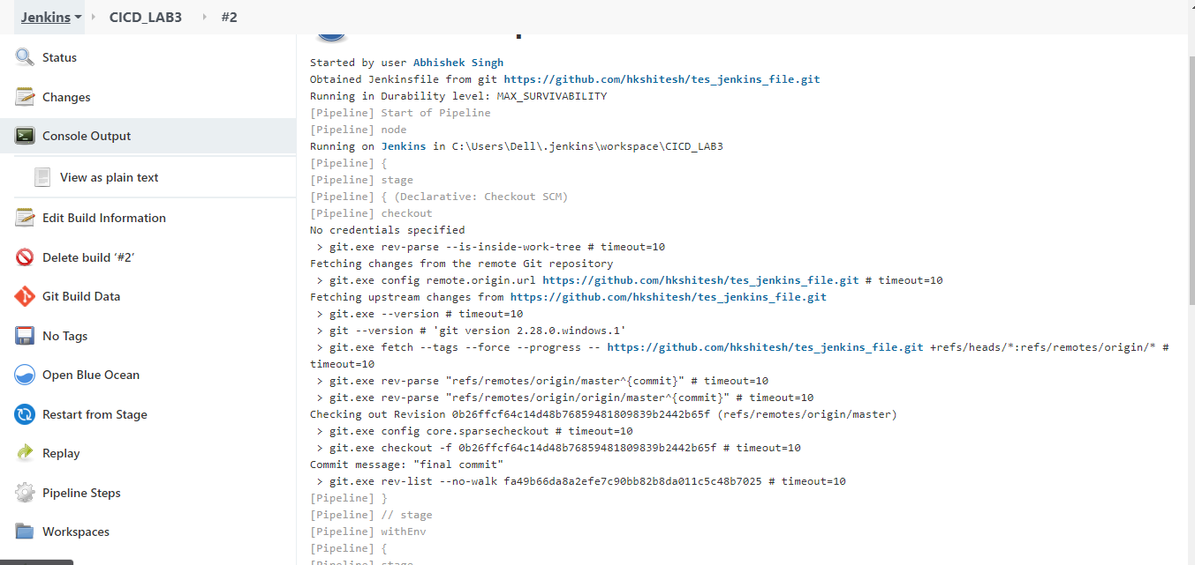

* BUILD SUCCESS

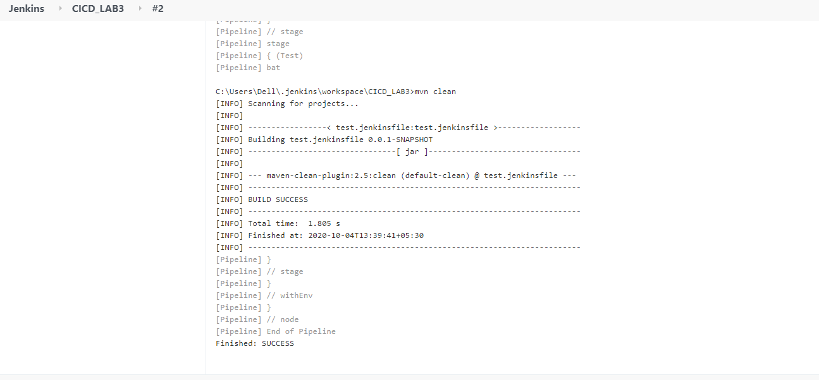

* **SONARQUBE DASHBOARD**

