SONARQUBE

* Definition

It’s an open source static testing analysis software. It is used by developers to manage source code quality and consistency. SonarQube saves the calculated measures in a database and showcases them in a rich web-based dashboard. Provides trends and leading indicators.

* Working

Sonar uses various static & dynamic code analysis tools such as Checkstyle, PMD, FindBugs, FxCop, Gendarme and many more to extract software metrics, which then can be used to improve software quality. Provides lots of plugins.

* Sonar Structure

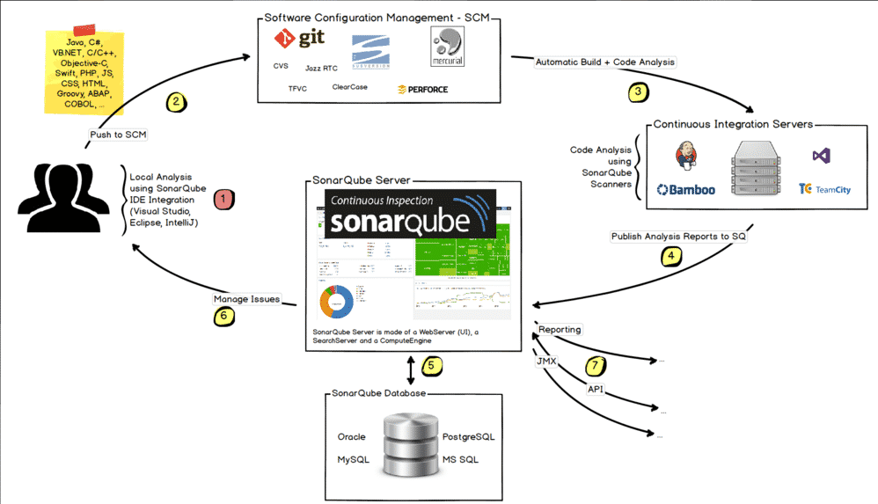

Note: - Above image taken from Google

* **Features**

1. **Supports languages:** Java, C/C++, Objective-C, C# , PHP, Flex, Groovy, JavaScript, Python, PL/SQL, COBOL, etc. (note that some of them are commercial)
2. Can also be used in Android development.
3. Offers reports on duplicated code, coding standards, unit tests, code coverage, code complexity, potential bugs, comments and design and architecture.
4. Records metrics history and provides evolution graphs (“time machine”) and differential views.
5. Provides fully automated analyses: integrates with Maven, Ant, Gradle and continuous integration tools (Atlassian Bamboo, Jenkins, Hudson, etc.).
6. Integrates with the Eclipse development environment
7. Integrates with external tools: JIRA, Mantis, LDAP, Fortify, etc.
8. Is expandable with the use of plugins.
9. Implements the [SQALE](https://en.wikipedia.org/wiki/SQALE) methodology to compute [technical debt](https://en.wikipedia.org/wiki/Technical_debt).

* Installation

STEP-1

Go to this Link <https://www.sonarqube.org/downloads/>

STEP-2

Click on Community Edition to download SonarQube

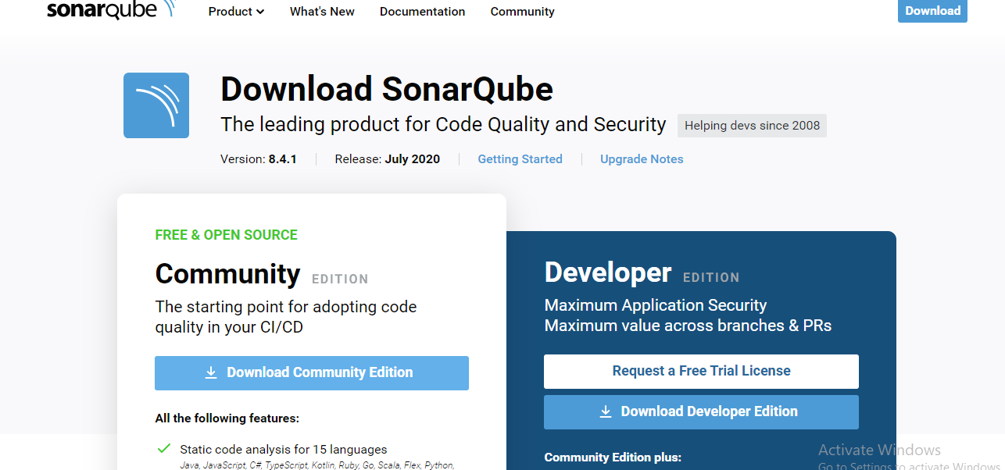

STEP-3

Extract Your File

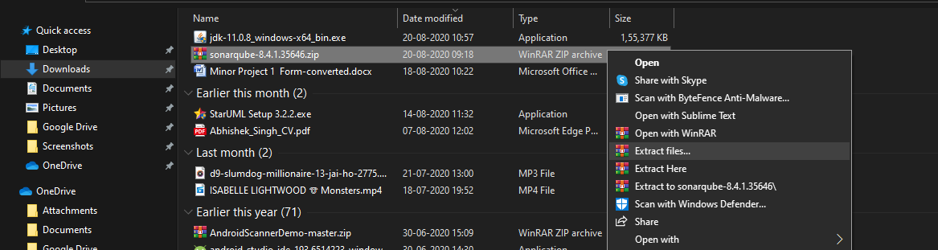

STEP-4

Now Open your COMMAND PROMPT and go to SonarQube folder on Command Prompt

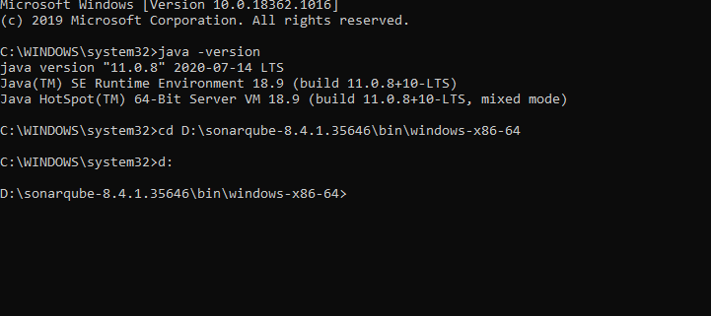

* Note:- Your System should have JDK 11 To run SonarQube so check your JAVA version by running command “**java –version**”

STEP-5

After going to SonarQube folder run Command “StarSonar.bat”

(This initiates your SonarQube)

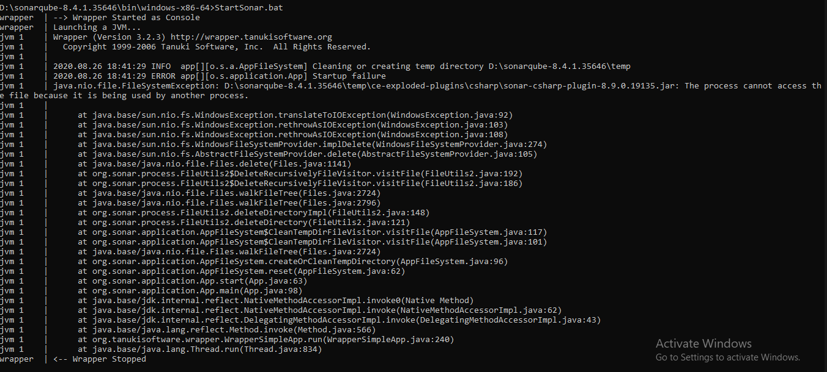

STEP-6

After running the command go to chrome and type: - **localhost:9000**

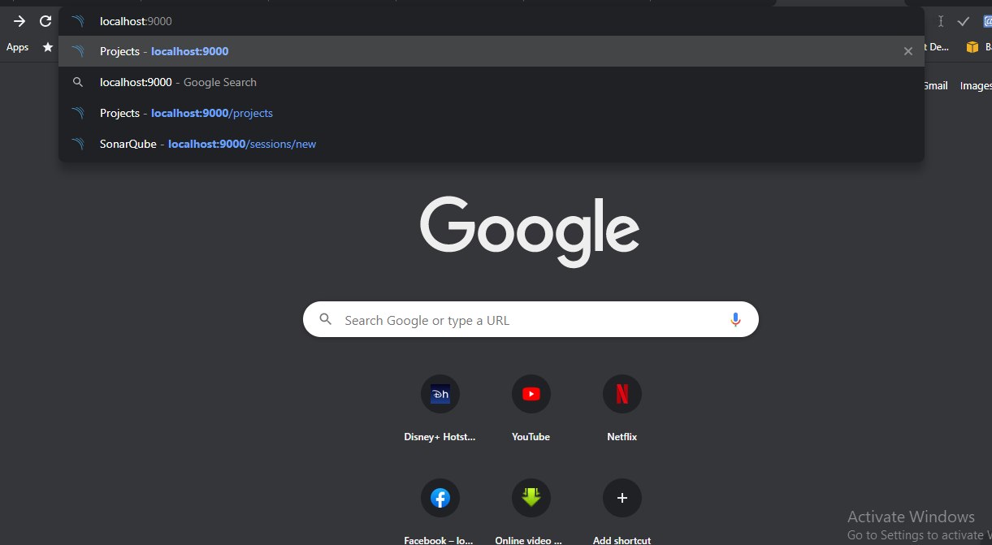

**This will open your Login page (Default ID- admin, Password- admin)**

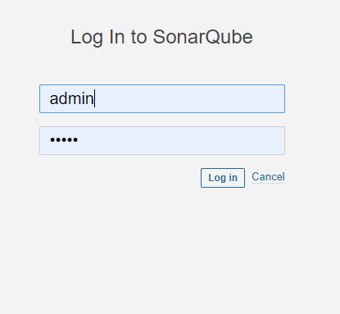

YOUR DASHBOARD WILL OPEN

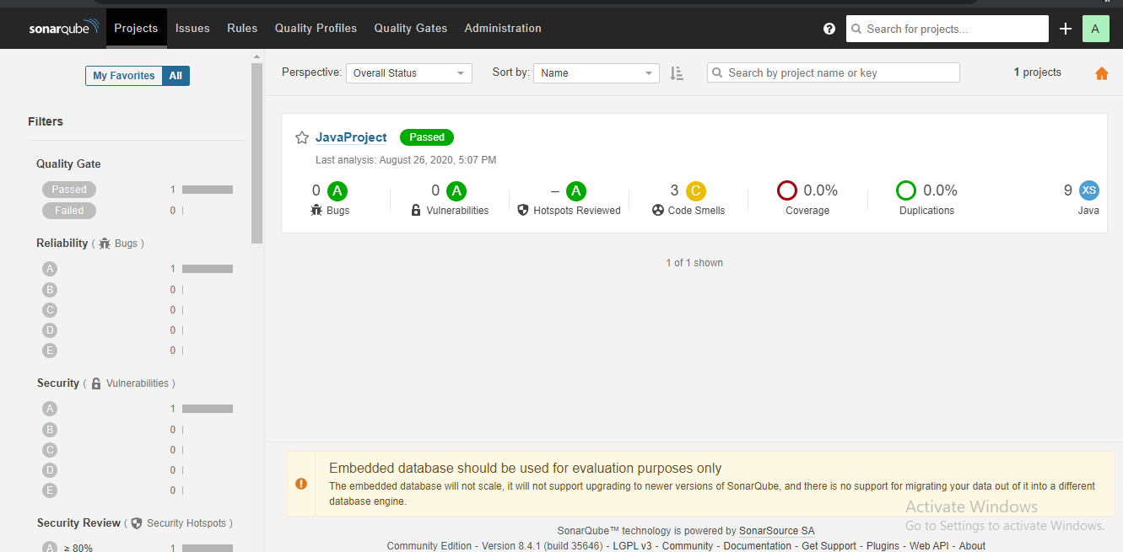

INSTALLATION COMPLETED!!!!!!!!!!!

Project analysis on SonarQube

STEP-1

For analysis you need to download a Software “SonarScanner”

Go to Link <https://docs.sonarqube.org/latest/analysis/scan/sonarscanner/>

STEP-2

Click on which system you want to download the software **(**I am doing it on [**Windows 64-bit**](https://binaries.sonarsource.com/Distribution/sonar-scanner-cli/sonar-scanner-cli-4.4.0.2170-windows.zip) **)**

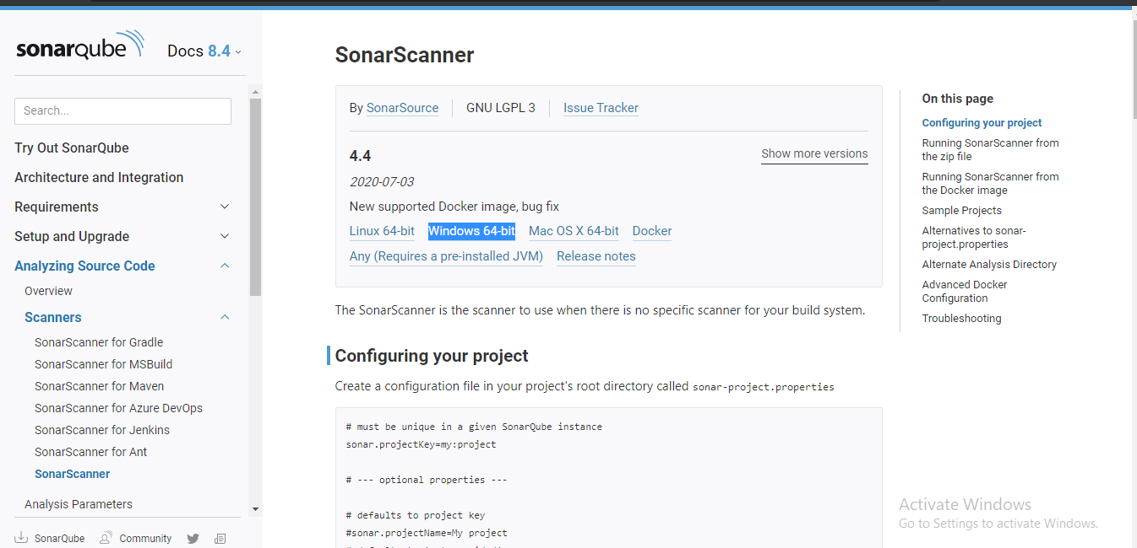

STEP-3

Extract your file

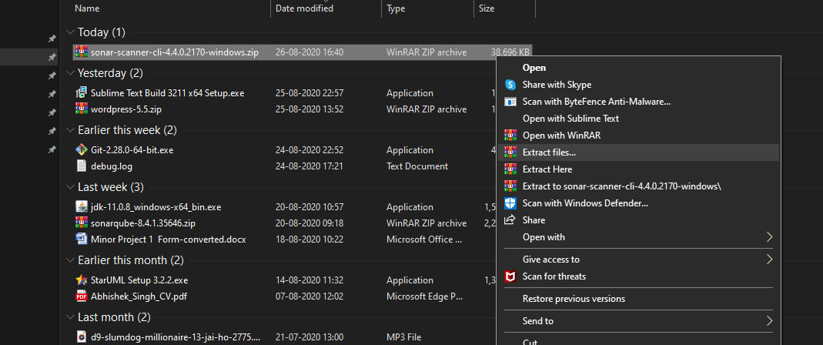

STEP-4

Make a project on eclipse which will be used for analysis

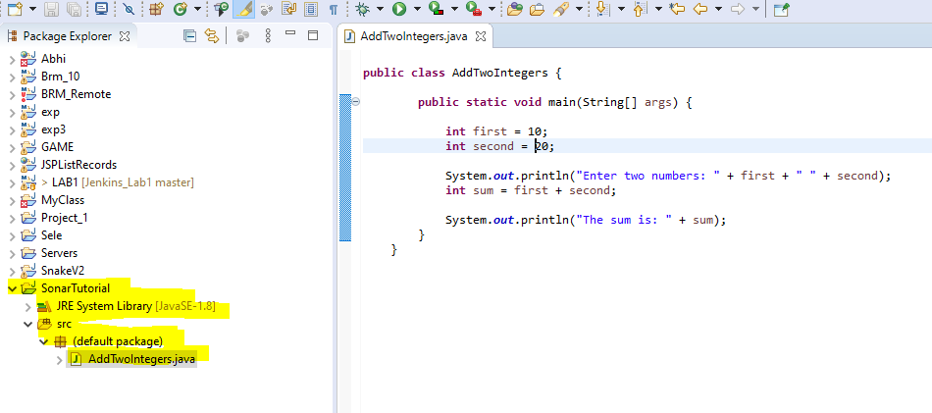

STEP-5

Go to SonarScanner configuration folder and edit sonar-scanner.properties

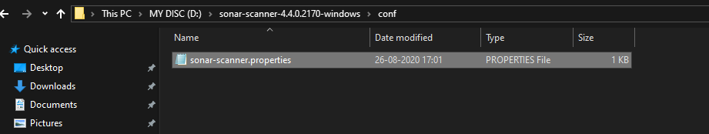

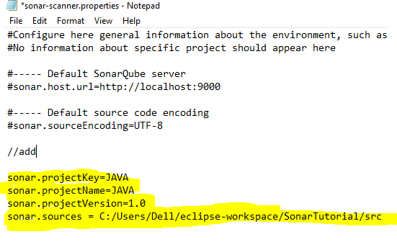

STEP-6

Now Open your COMMAND PROMPT and go to your project location and run command

“sonar-scanner.bat”

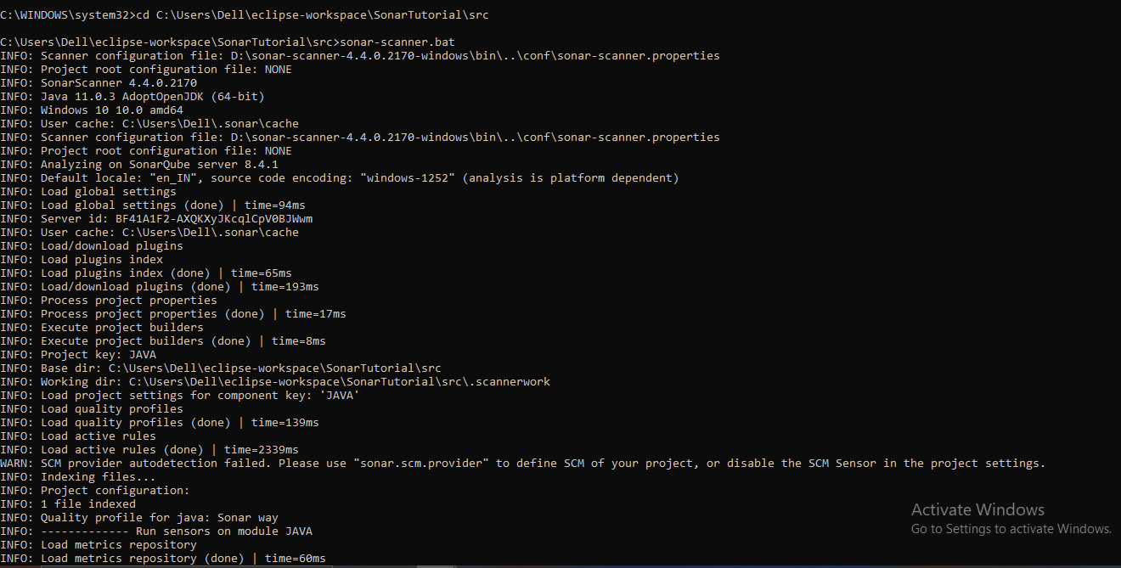

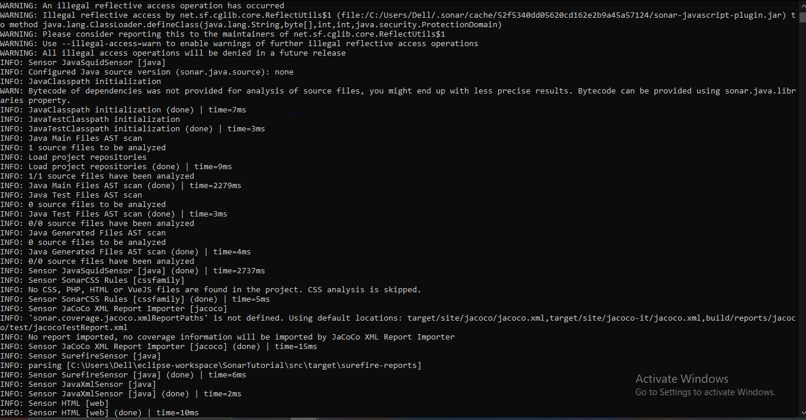

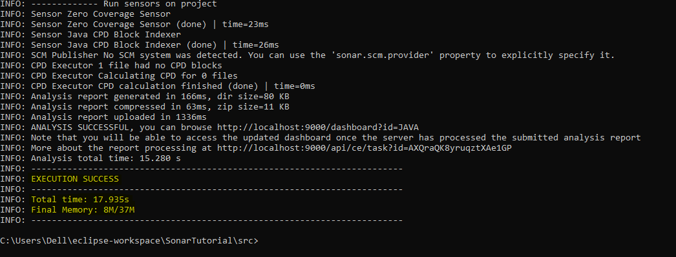

**YOU WILL GET EXECUTION SUCCESS!!!**

STEP-7

Check you “localhost” on chrome it show your project analysis

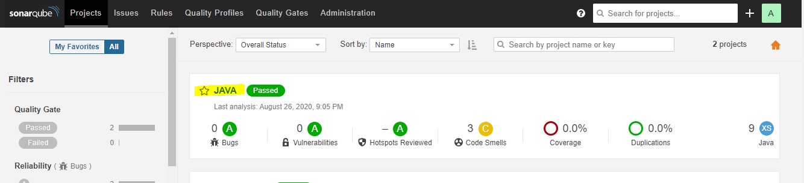

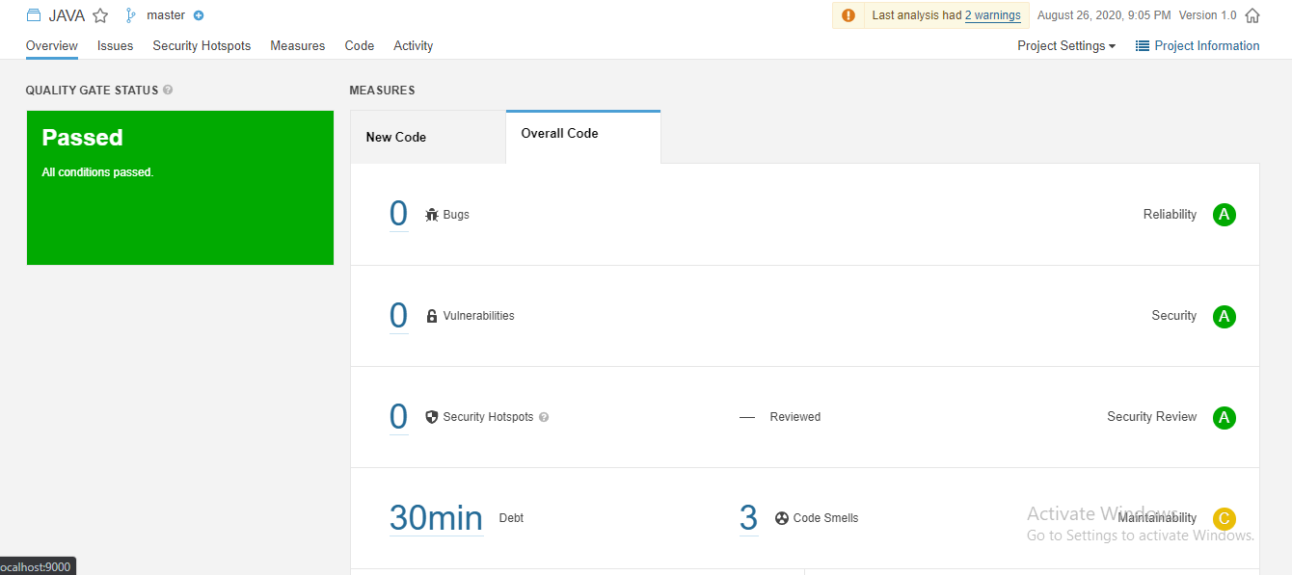

PROJECT ANALYSIS COMPLETE!!!!!!!!!