E-Commerce Lab Assignment

An e-commerce lab assignment submitted in partial fulfilment of the requirements for the award of the degree of

**Bachelor of Technology**

in

## Computer Science and Engineering

#### **by**

Suman Rana (17101104009)

*Submit to*

Prof. Srinibas Rana

Assistant Professor



# Department of Computer science and Engineering

# JALPAIGURI GOVERNMENT ENGINEERING COLLEGE

**July 2021**

# **1. Design and maintain few web pages including Home page using JSP.**

**Code:** <https://github.com/16sumanrana/e-commerce-lab/tree/master/question-1>

**Screenshots:**



Figure 1: Welcome page

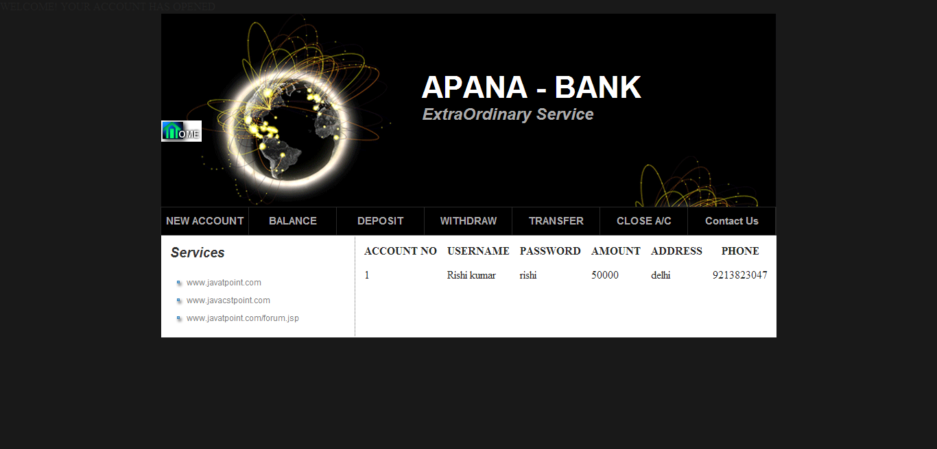

Figure 2: Create new account page

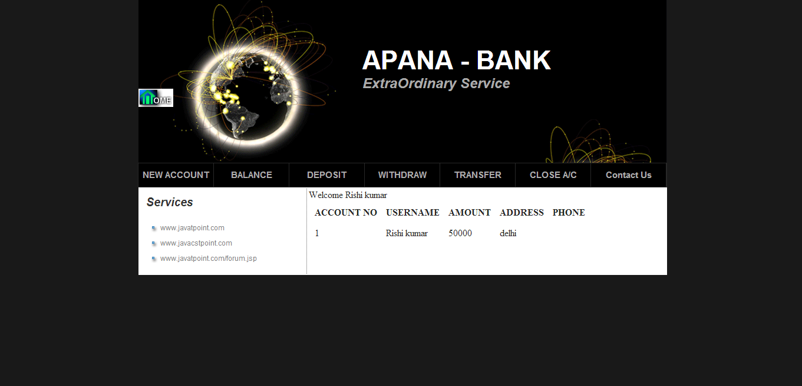

Figure 3: Check balance page

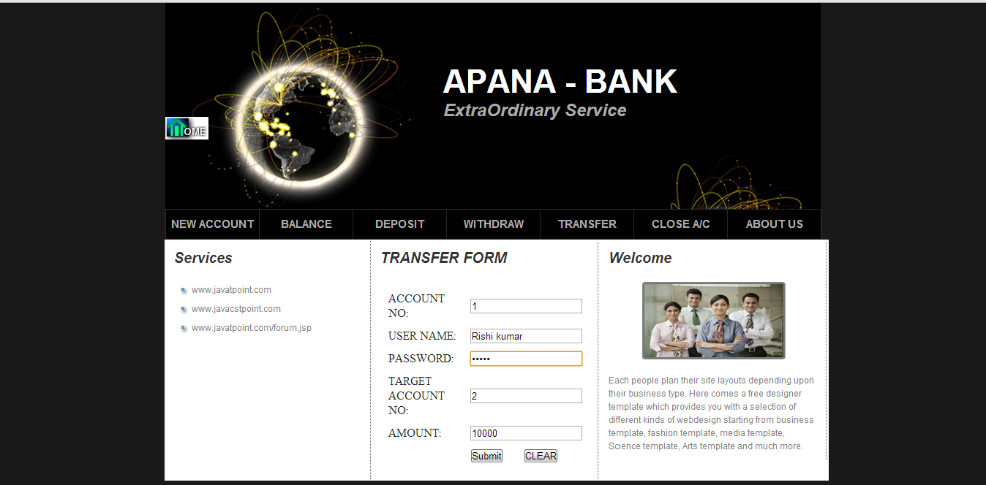

Figure 4: Transfer money page

# **2. Create registration and login form using JSP, JDBC and MySQL.**

**Code:** <https://github.com/16sumanrana/e-commerce-lab/tree/master/question-2>

**Screenshots:**

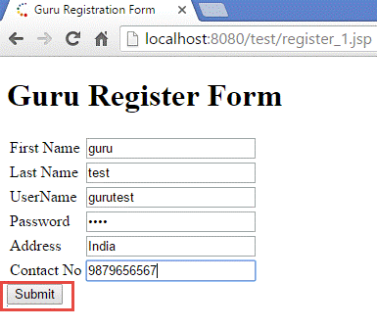

Figure 5: Registration form



Figure 6: Registration success

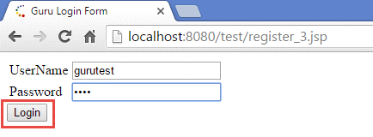

Figure 7: Login form

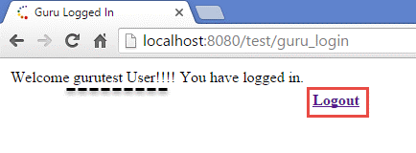

Figure 8: Login success

# **3. Design few components of simple B2C E-Commerce portal.**

**Code:** <https://github.com/16sumanrana/e-commerce-lab/tree/master/question-3-4-5>

**Screenshots:**

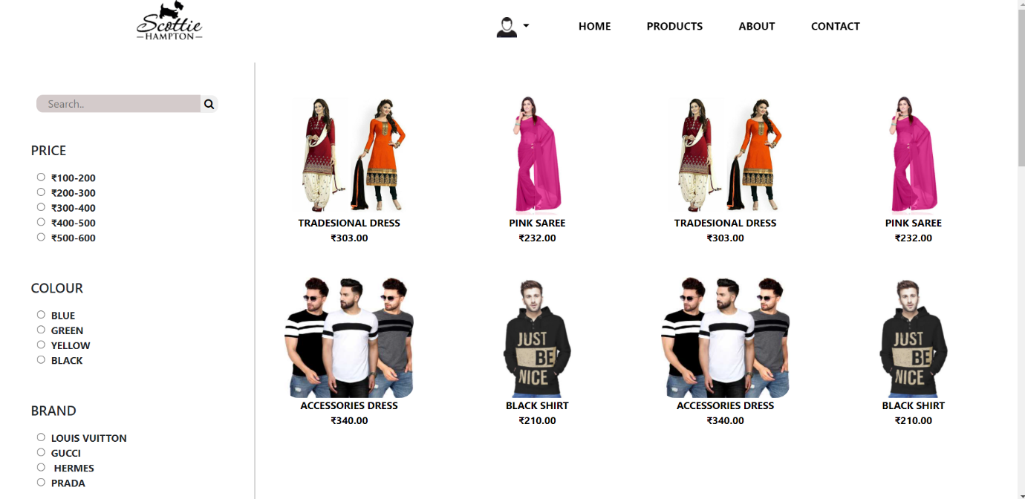

Figure 9: Products page

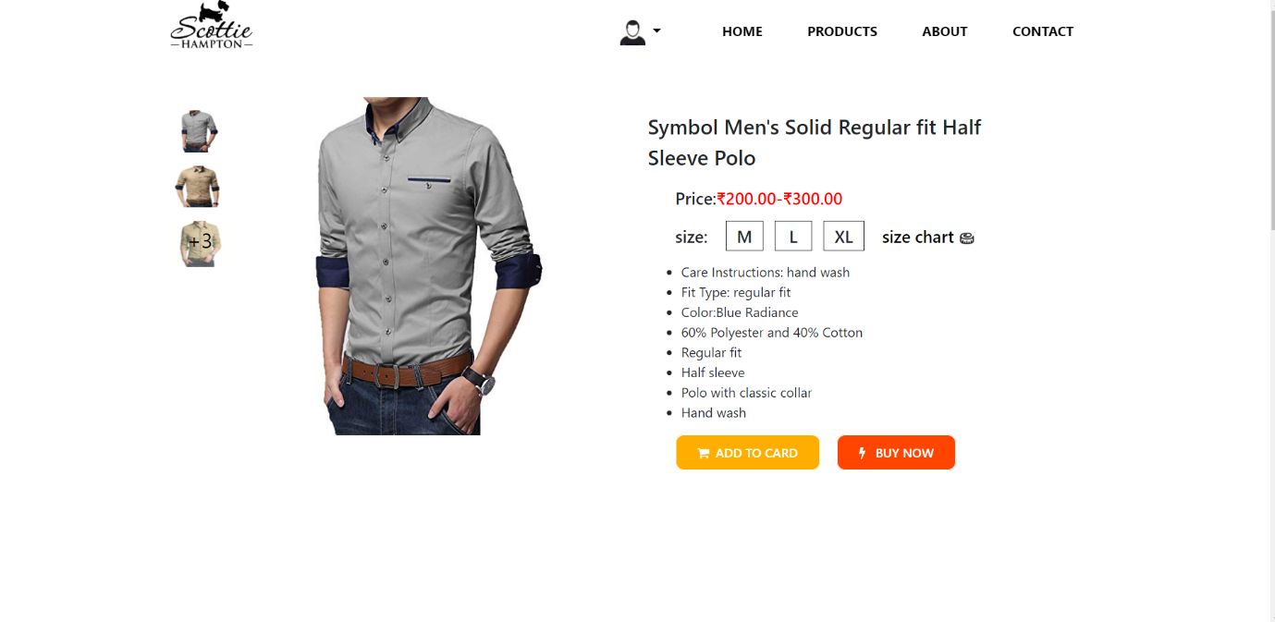

Figure 10: Single product page



Figure 11: Attract page

# **4. Create an e-commerce site, build an Online Store.**

**Code:** <https://github.com/16sumanrana/e-commerce-lab/tree/master/question-3-4-5>

**Sceenshots:**



Figure 12: Home page



Figure 13: About page

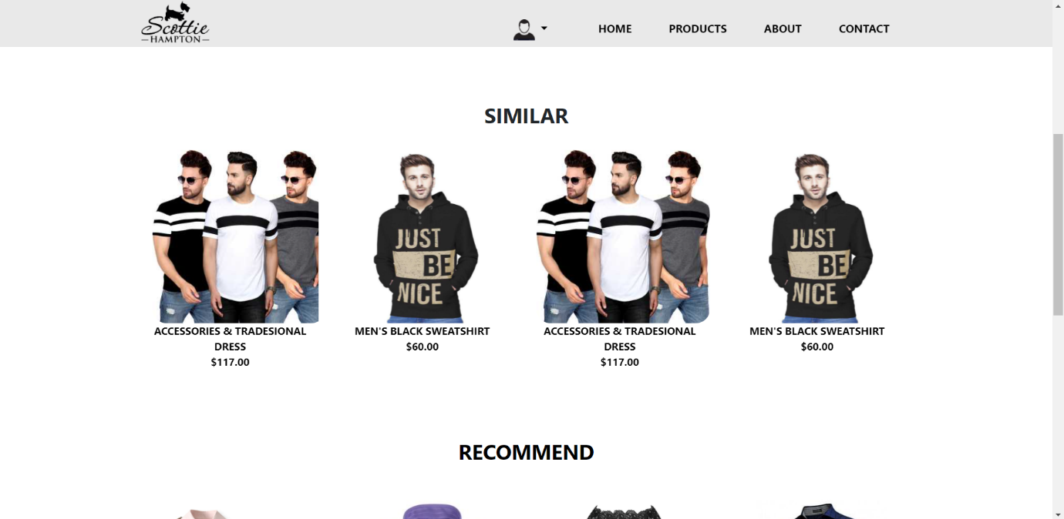

Figure 14: Similar recommendation page

# **5. Create a virtual shopping cart.**

**Code:** <https://github.com/16sumanrana/e-commerce-lab/tree/master/question-3-4-5>

**Sceenshots:**

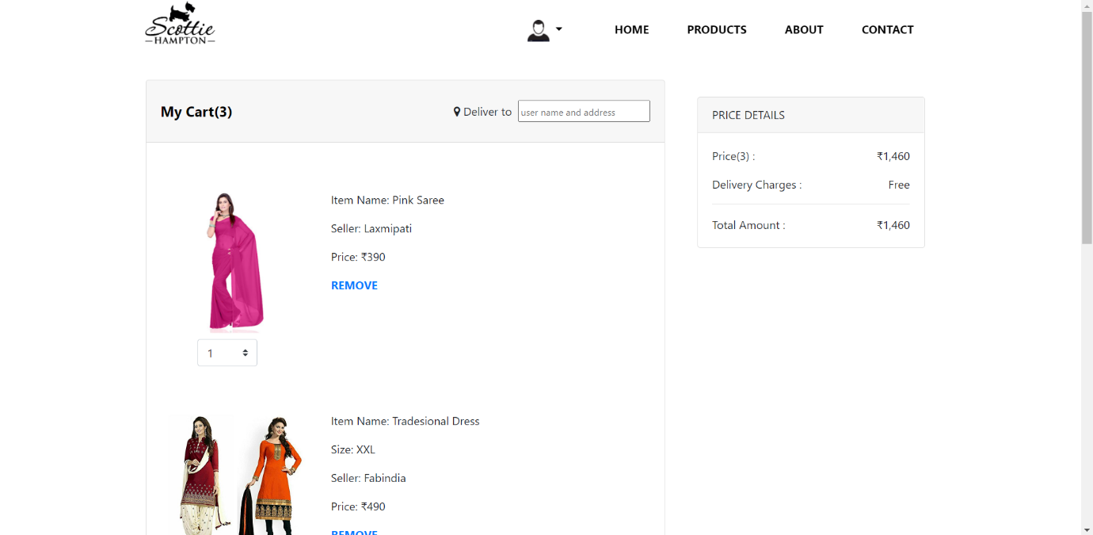

Figure 15: Cart page

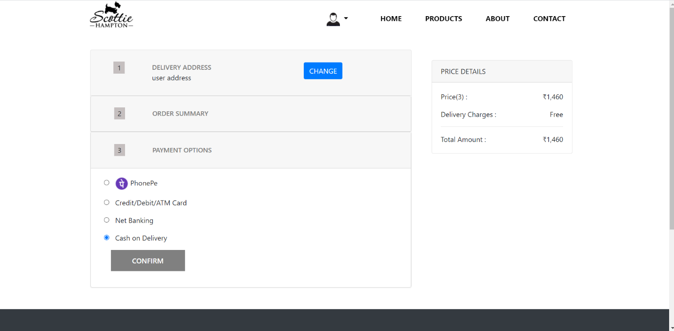

Figure 16: Payment page