

Name:Islame,Rafiqul Id:17-34438-1 Sec:C(HCI)

**AFFORDANCE:**

**• *Affordances* provide strong clues to the operation of a thing.**

**• In Microsoft Teams, there is a feature Calendar . Although its blank, basically the action of the Calendar would be containing data i.e class routine.**

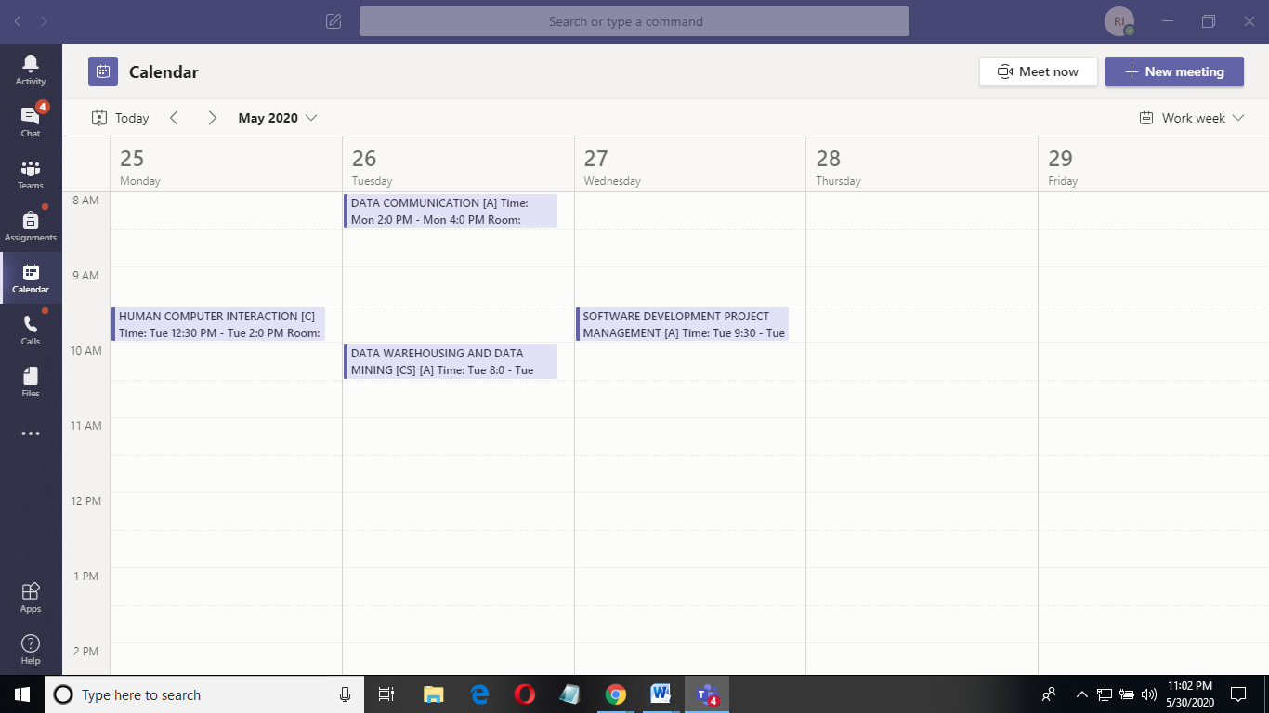

**VISIBILITY:**

**• Visibilities are the cause and effect of a system where a user needs to know the option and panels that they will use.**

**• In Microsoft Teams, whenever a meeting begins among different events one click on the exact course will lead to that meeting.**

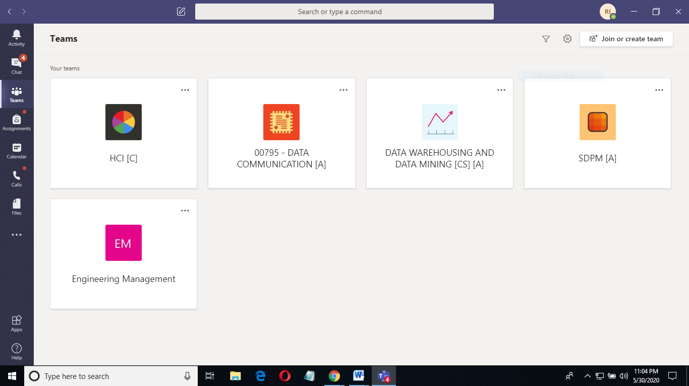

**VISIBILITY:**

**• One click will make the user enter the meeting and chat from from this figure and the figure just above.**

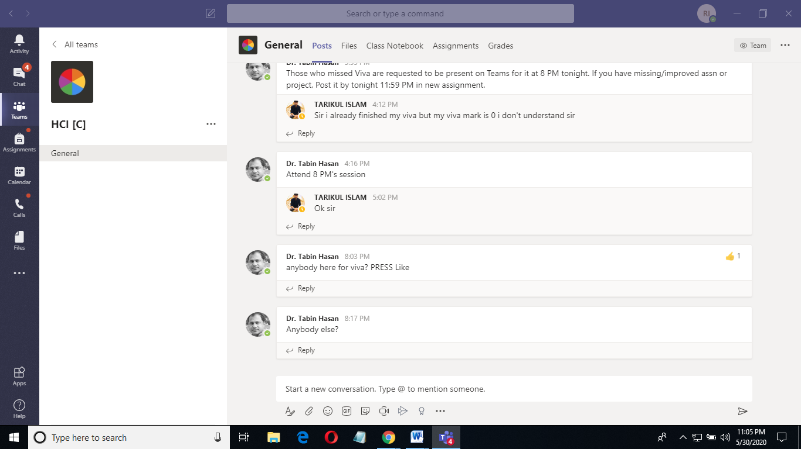

**MAPPING:**

**• Mapping generally means the relationship between two thing or many more.**

**• Basically it refers the relationship in between controls and its effects.Problem one when more message send then space is loss.**

**Second problem not click in message then message long time wait.**

**• In Microsoft Teams, the relationship between 2 user is shown on a audio call.**

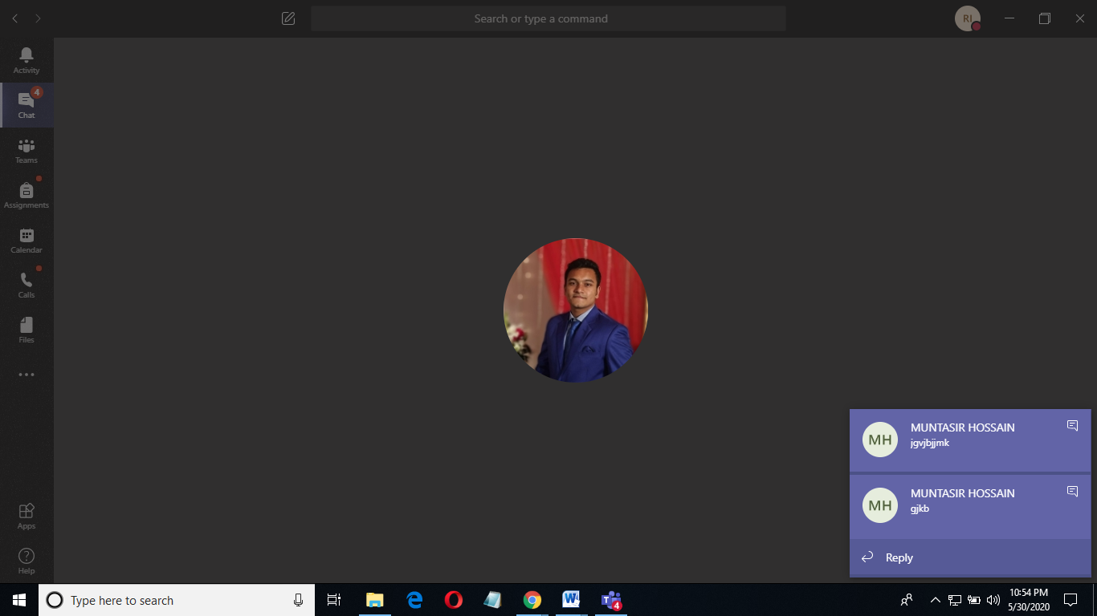

**System Image:**

**• The system image is the visible part of a device (including the physical structure, the documentation, instructions, etc)**

**• The designer only talks to the user through the system image**

**• If the system image doesn't make the design model clear, then the user will create a different model through their interaction.**

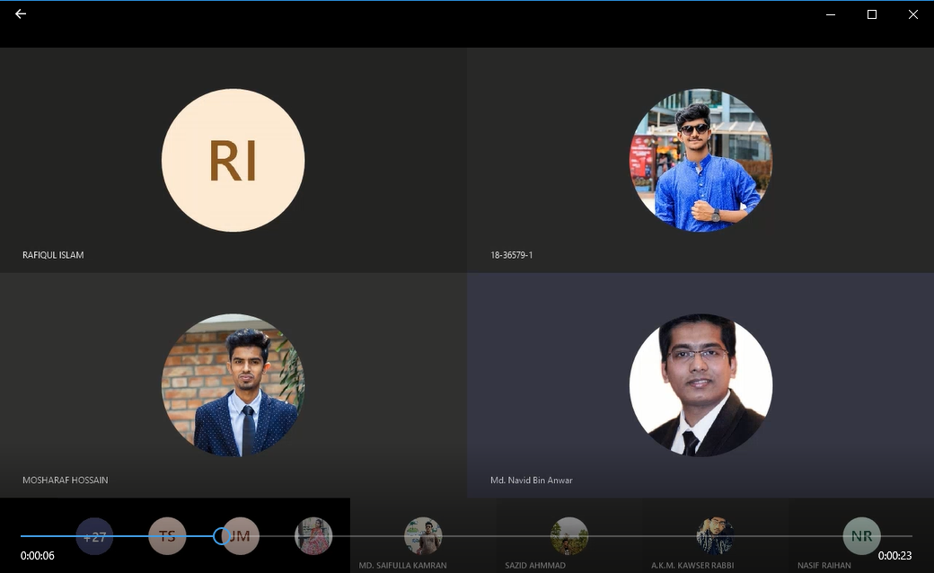

**GULF OF EXECUTION:**

**• Gulf of Execution is the gap between a user's goal for action and the means to execute that goal.**

**• In Microsoft Team, if a participant wants to share the screen the user must go through various steps like if he/she only wants to share the whole screen, or share any particular application elements.**

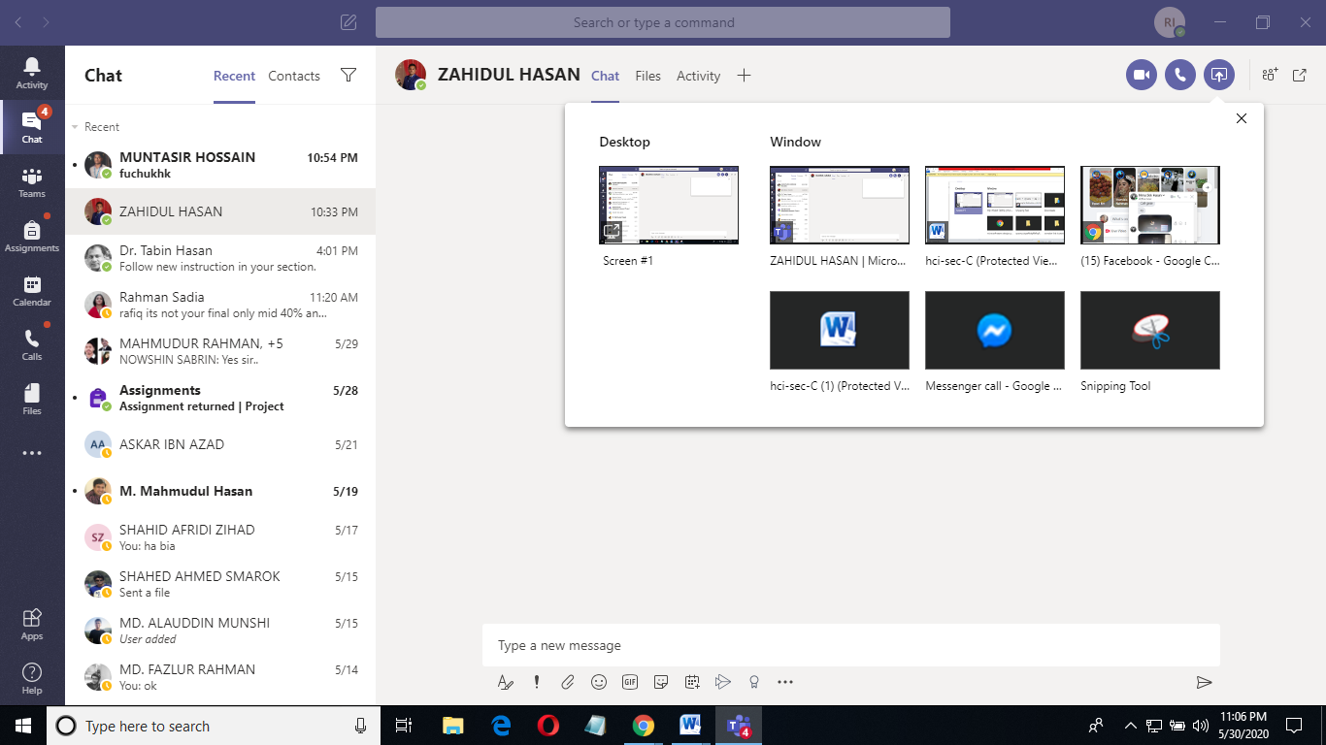

**GULF OF EVALUATION:**

**• Gulf of evaluation is the degree to which the system or artifact provides representations that can be directly perceived and interpreted in terms of the expectations and intentions of the user.**

**• In Microsoft Team, you can dial any digits through the Dialpad but actually it serves no purpose. You can just type but cannot send.**

