Name: Nasin Ayenul Akash

ID: 17-35060-2

Sec: E

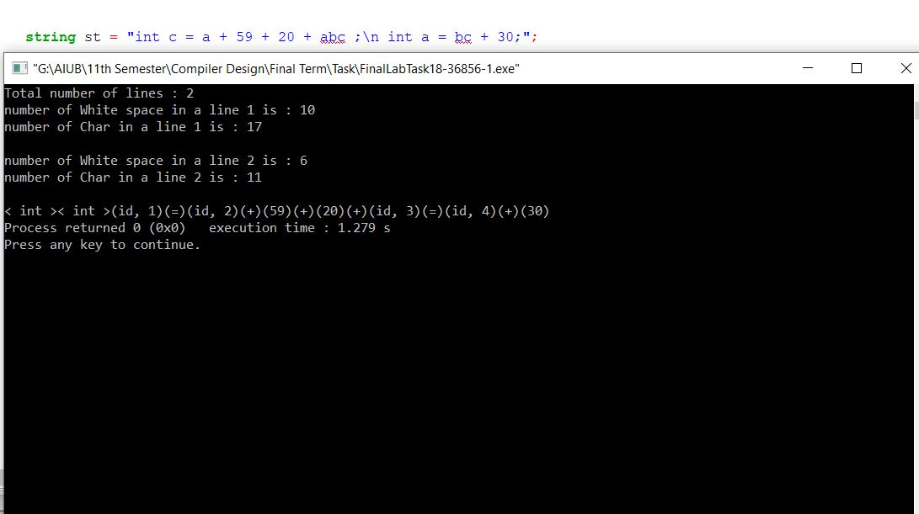

#include<iostream>

using namespace std;

int id=1;

string keyWords[7] = {"int","float","double","for","while","if","else"};

int esPerline[10],line = 0, charPerline[10];

void counts(string st,int length)

{

for(int i = 0;i<length;i++){

if(st[i]=='\t' || st[i] == ' ')

{

esPerline[line] +=1;

}

else if(st[i]=='\n'){

line++;

}

else{

charPerline[line] +=1;

}

}

}

bool isKeyWords(string temp)

{

for(int i=0;i<7;i++)

{

if(keyWords[i] == temp)

{

return true;

}

}

return false;

}

bool isOperator(char s)

{

if(s == '=' || s == '+' || s == '-' || s == '*' || s == '/'|| s == '^'|| s == '>'|| s == '<')

{

return true;

}

return false;

}

bool isVariable(string str){

bool flag = true;

if(isdigit(str[0])){

for(int i = 0;i<str.length();i++){

if(isdigit(str[i])){

flag = true;

}

else{

if(flag){

flag = false;

break;

}

}

}

}

return flag;

}

bool isValid(string str, int n)

{

char temp[100];

int k = 0;

if (!((str[0] >= 'a' && str[0] <= 'z')

|| (str[0] >= 'A' && str[0] <= 'Z')

|| str[0] == '_')

)

return false;

for (int i = 0; i<n; i++) {

if(isOperator(str[i])){

temp[k] = NULL;

k=0;

if(!isVariable(temp)){

return false;

}

}

else{

if(str[i]!=' '){

temp[k] = str[i];

k++;

}

}

}

return true;

}

void check(string s, int length)

{

string temp="";

int j;

if(isValid(s,length)){

for(int i=0;i<length;i++)

{

temp = "";

while(s[i] !=' ')

{

temp +=s[i];

i++;

}

if(isKeyWords(temp))

{

cout<<"< "<<temp<<" >";

}

}

}

else{

}

}

int main()

{

string st = "int c = a + 59 + 20 + abc ;\n int a = bc + 30;";

int length = st.size();

counts(st,length);

cout<<"Total number of lines : "<<line+1<<endl;

for(int i = 0;i<=line;i++)

{

cout<<"number of White space in a line "<<i+1<<" is : "<<esPerline[i]<<endl;

cout<<"number of Char in a line "<<i+1<<" is : " <<charPerline[i]<<endl<<endl;

}

check(st,length);

int k = 1;

bool digitStart = true;

bool variableStart = true;

if(isValid(st,length)){

for(int i=0;i<length;i++){

if(isOperator(st[i])){

cout<<")"<<"("<<st[i]<<")";

digitStart = true;

variableStart = true;

}

else if(isdigit(st[i])){

if(digitStart){

cout<<"(";

digitStart = false;

}

cout<<st[i];

}

else{

if(st[i]!=' ' && st[i]!=';'){

if(variableStart){

cout<<"(id, "<<k;

k++;

variableStart = false;

}

}

}

}

cout<<")";

}

else{

cout<<"statement is invalid!!!";

}

return 0;

}