**Function and features**

* Audios for the Gun (Gunshot Sfx, Reload Sfx) and the Enemies (Movement Sfx, Punch Sfx for both enemies).
* Animations for the Enemies (Movement, Punching)

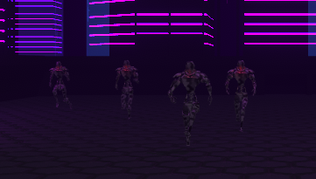Movement

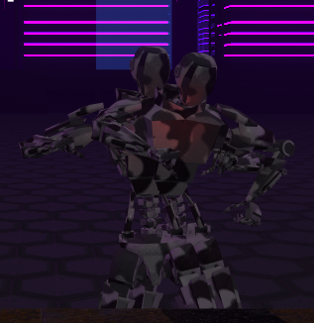Punching

**Branches and Merges**

* **Branches**

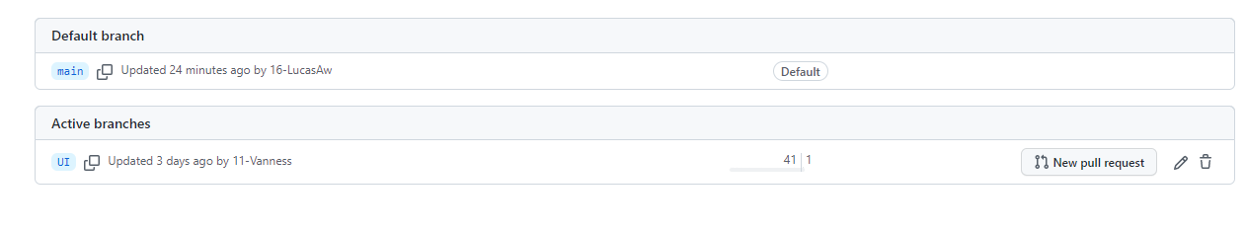

* **Merges**

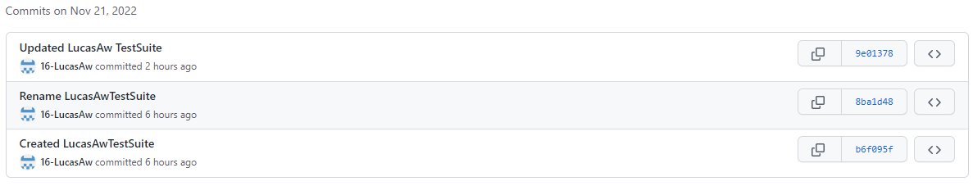

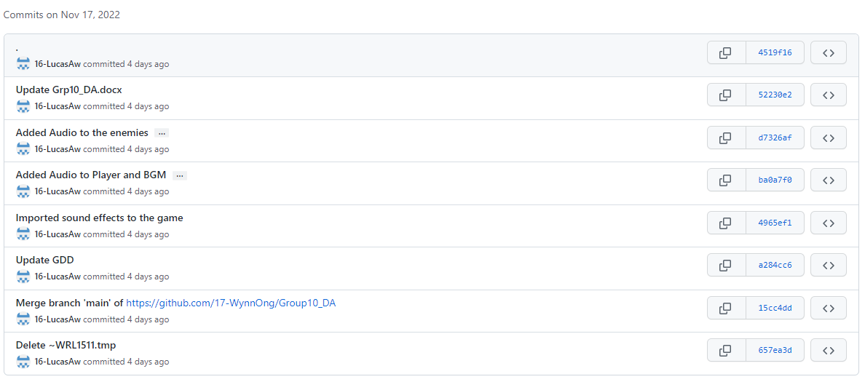

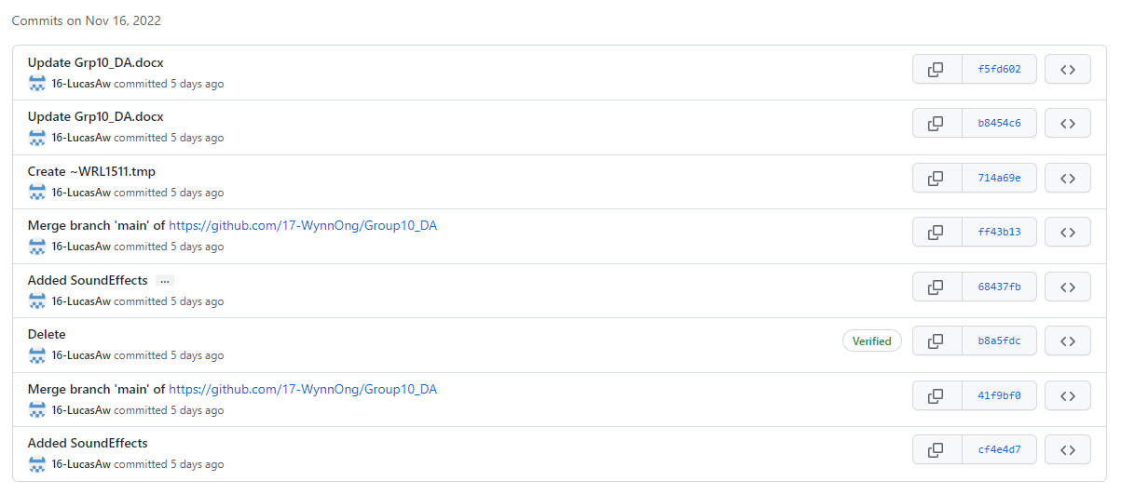

**Unity Test Runner**

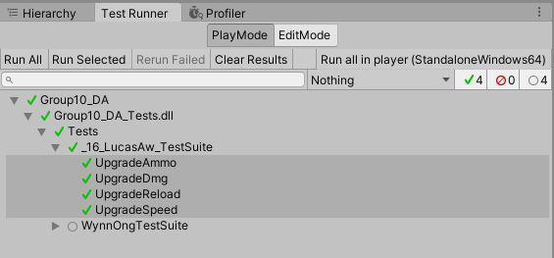

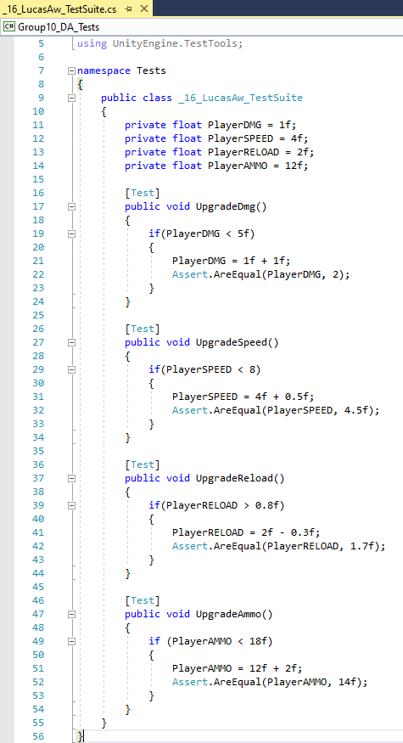

**Test Cases**

* 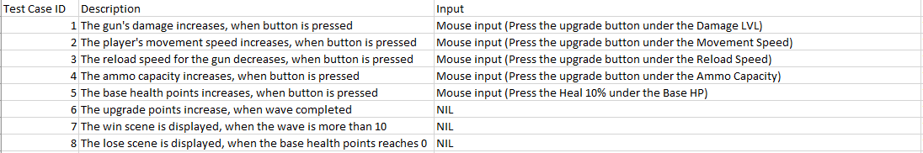Mohamad Hazwan Bin Mohamad Amin

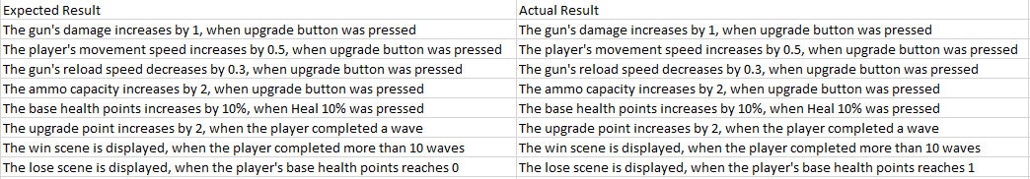

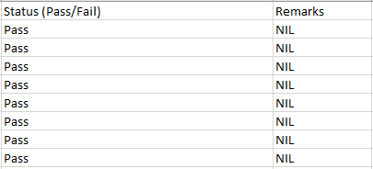

* 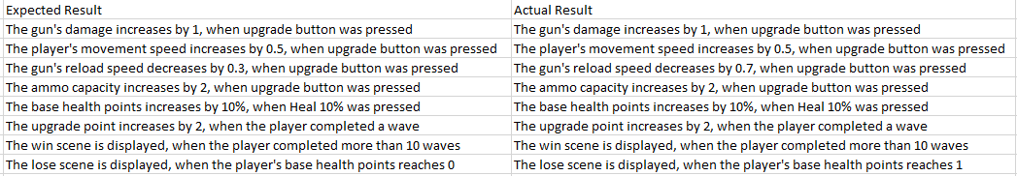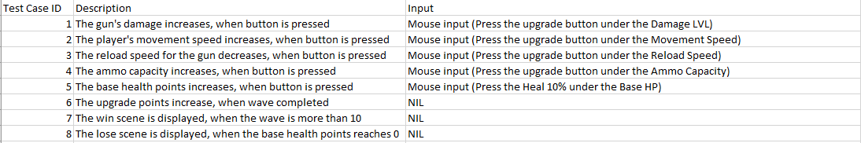Yap Kee Pin Julius

