**TITLE: Safe Haven**

**Game Idea:**

Our game will be a first person shooter. You can only move left and right. Enemies will start spawning in the level and starts walking towards the player. Player have to prevent the enemies to reach them.

**Game Mechanics**

Left click to shoot, press r to reload. after killing all the enemy player will automatically move to the next level. If the player clears all the level in the game they win, but if they lose all their lives before they reach the final level they lose the game.

**Features**

* Upgrade Menu (To upgrade weapon damage, increase movement speed, increase reload speed, increase ammo capacity, heal base health points)

**Art Style**

* Theme: Sci-fi

**Version Control**

* Git Hub

**Project Timeline**

* Lucas
* Wynn
* Vanness

**Sound Effects**

* Gunshot sound - <https://www.freewebtools.com/Gunshot-Sound-Effect-Single-Shot-download/>
* Reload sound - <https://www.youtube.com/watch?v=xmxof0mQI_Y>
* Ambience - <https://www.youtube.com/watch?v=XVbvE0PJyss>
* Robot 1 movement - <https://www.youtube.com/watch?v=0K7jGB_xKqY>
* Robot 2 movement - <https://www.youtube.com/watch?v=Dwf22lZEBK8>
* Robot 1 punch sound - <https://www.youtube.com/watch?v=NKcxfl2Is1s>
* Robot 2 punch sound - <https://www.youtube.com/watch?v=-AKVtiYZ83Y>

**Assets**

* Robot 1 - <https://assetstore.unity.com/packages/3d/characters/robots/futuristic-robot-mk-01-47458>
* Robot 2 - <https://assetstore.unity.com/packages/3d/characters/robots/robot-1-65726>
* Gun –
* Buildings - <https://sketchfab.com/3d-models/skyline-cutout-city-large-b00abd35578e4f628f4bcd3625ce5951#download>
* Buildings - <https://sketchfab.com/3d-models/scifi-building-1-0ae51cf0fd21473a98a26207cbc932df>
* Barricade - <https://sketchfab.com/3d-models/barricade-low-polly-42bf74c4d5e140aebf08accbf9646a20>

**Gantt Chart**

**Unity Profiler Screenshot**

* **CPU Usage**

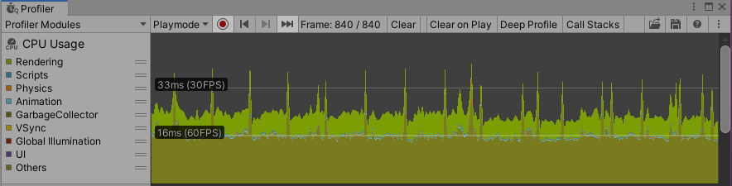

* **Memory**

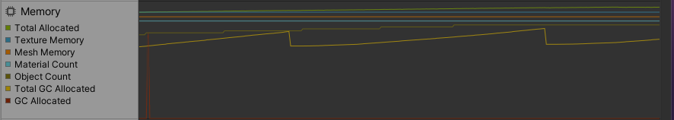

**Code optimization method**

* Refactoring method

**References**

Texture - <https://opengameart.org/content/4096-scifi-hex-tiles-pbr-texture>

Particles Effect - <https://assetstore.unity.com/packages/vfx/particles/hit-impact-effects-free-218385>